UNITED STATES

SECURITIES AND EXCHANGE COMMISSION

Washington, D.C. 20549

FORM 10-K

☒ ANNUAL REPORT PURSUANT TO SECTION 13 OR 15(d) OF THE SECURITIES EXCHANGE ACT OF 1934

For the fiscal year ended December 31 , 2023

or

☐ TRANSITION REPORT PURSUANT TO SECTION 13 OR 15(d) OF THE SECURITIES EXCHANGE ACT OF 1934

For the transition period from to

Commission file number 001-37983

TechnipFMC plc

(Exact name of registrant as specified in its charter)

United Kingdom |  |  | 98-1283037
(State or other jurisdiction of incorporation or organization) |  |  | (I.R.S. Employer Identification No.)
One Subsea Lane
Houston, Texas
United States of America |  |  | 77044
(Address of principal executive offices) |  |  | (Zip Code)

+ 1 281 - 591-4000

(Registrant’s telephone number, including area code)

Securities registered pursuant to Section 12(b) of the Act:
Title of Each Class |  |  |  |  |  | Trading Symbol |  |  | Name of Each Exchange on Which Registered
Ordinary shares, $1.00 par value per share |  |  |  |  |  | FTI |  |  | New York Stock Exchange
Securities registered pursuant to Section 12(g) of the Act: None.

Indicate by check mark if the registrant is a well-known seasoned issuer, as defined in Rule 405 of the Securities Act. Yes ý No ¨

Indicate by check mark if the registrant is not required to file reports pursuant to Section 13 or Section 15(d) of the Act. Yes ¨ No ý

Indicate by check mark whether the registrant (1) has filed all reports required to be filed by Section 13 or 15(d) of the Securities Exchange Act of 1934 during the preceding 12 months (or for such shorter period that the registrant was required to file such reports), and (2) has been subject to such filing requirements for the past 90 days. Yes ý No ¨

Indicate by check mark whether the registrant has submitted electronically every Interactive Data File required to be submitted pursuant to Rule 405 of Regulation S-T (§232.405 of this chapter) during the preceding 12 months (or for such shorter period that the registrant was required to submit such files). Yes ý No ¨

Indicate by check mark whether the registrant is a large accelerated filer, an accelerated filer, a non-accelerated filer, a smaller reporting company, or an emerging growth company. See the definitions of “large accelerated filer,” “accelerated filer,” “smaller reporting company,” and “emerging growth company” in Rule 12b-2 of the Exchange Act.

Large accelerated filer |  |  | ☒ |  |  | Accelerated filer |  |  | ☐
Non-accelerated filer |  |  | ☐ |  |  | Smaller reporting company |  |  | ☐
 |  |  |  |  |  | Emerging growth company |  |  | ☐

If an emerging growth company, indicate by check mark if the registrant has elected not to use the extended transition period for complying with any new or revised financial accounting standards provided pursuant to Section 13(a) of the Exchange Act. ¨

Indicate by check mark whether the registrant has filed a report on and attestation to its management’s assessment of the effectiveness of its internal control over financial reporting under Section 404(b) of the Sarbanes-Oxley Act (15 U.S.C. 7262(b)) by the registered public accounting firm that prepared or issued its audit report. ☒

If securities are registered pursuant to Section 12(b) of the Act, indicate by check mark whether the financial statements of the registrant included in the filing reflect the correction of an error to previously issued financial statements. ☐

Indicate by check mark whether any of those error corrections are restatements that required a recovery analysis of incentive-based compensation received by any of the registrant’s executive officers during the relevant recovery period pursuant to § 240.10D-1(b). ☐

Indicate by check mark whether the registrant is a shell company (as defined in Rule 12b-2 of the Act). YES ☐ NO ý

The aggregate market value of the registrant’s ordinary shares held by non-affiliates of the registrant, determined by multiplying the outstanding shares on June 30, 2023, by the closing price on such day of $16.62 as reported on the New York Stock Exchange, was $ 5.3 billion.

Class |  |  |  |  |  | Outstanding at February 22, 2024
Ordinary shares, $1.00 par value per share |  |  |  |  |  | 432,847,108

DOCUMENTS INCORPORATED BY REFERENCE

Portions of the registrant’s definitive Proxy Statement relating to its 2024 Annual General Meeting of Shareholders are incorporated by reference into Part III of this Annual Report on Form 10-K where indicated. The 2024 Proxy Statement will be filed with the U.S. Securities and Exchange Commission within 120 days after the end of the fiscal year to which this report relates.

TABLE OF CONTENTS

 |  |  | Page
PART I
Item 1. Business |  |  | 4
Item 1A. Risk Factors |  |  | 19
Item 1B. Unresolved Staff Comments |  |  | 35
Item 1C. Cybersecurity |  |  | 35
Item 2. Properties |  |  | 36
Item 3. Legal Proceedings |  |  | 38
Item 4. Mine Safety Disclosures |  |  | 38
PART II
Item 5. Market for Registrant’s Common Equity, Related Stockholder Matters and Issuer Purchases of Equity Securities |  |  | 38
Item 6. [Reserved] |  |  | 40
Item 7. Management’s Discussion and Analysis of Financial Condition and Results of Operations |  |  | 40
Item 7A. Quantitative and Qualitative Disclosures About Market Risk |  |  | 53
Item 8. Financial Statements and Supplementary Data |  |  | 55
Item 9. Changes in and Disagreements with Accountants on Accounting and Financial Disclosure |  |  | 106
Item 9A. Controls and Procedures |  |  | 106
Item 9B. Other Information |  |  | 106
Item 9C. Disclosure Regarding Foreign Jurisdictions that Prevent Inspections |  |  | 107
PART III
Item 10. Directors, Executive Officers and Corporate Governance |  |  | 107
Item 11. Executive Compensation |  |  | 108
Item 12. Security Ownership of Certain Beneficial Owners and Management and Related Stockholder Matters |  |  | 108
Item 13. Certain Relationships and Related Transactions, and Director Independence |  |  | 108
Item 14. Principal Accountant Fees and Services |  |  | 108
PART IV
Item 15. Exhibit and Financial Statement Schedules |  |  | 108
Item 16. Form 10-K Summary |  |  | 109
Signatures |  |  | 111

2

CAUTIONARY NOTE REGARDING FORWARD-LOOKING STATEMENTS

This Annual Report on Form 10-K contains “forward-looking statements” as defined in Section 27A of the United States Securities Act of 1933, as amended, and Section 21E of the United States Securities Exchange Act of 1934, as amended (the “Exchange Act”). Forward-looking statements usually relate to future events, market growth and recovery, growth of our new energies business and anticipated revenues, earnings, cash flows or other aspects of our operations or operating results. Forward-looking statements are often identified by the words “believe,” “expect,” “anticipate,” “plan,” “intend,” “foresee,” “should,” “would,” “could,” “may,” “estimate,” “outlook” and similar expressions, including the negative thereof. The absence of these words, however, does not mean that the statements are not forward-looking. These forward-looking statements are based on our current expectations, beliefs and assumptions concerning future developments and business conditions and their potential effect on us. While management believes these forward-looking statements are reasonable as and when made, there can be no assurance that future developments affecting us will be those that we anticipate.

All of our forward-looking statements involve risks and uncertainties (some of which are significant or beyond our control) and assumptions that could cause actual results to differ materially from our historical experience and our present expectations or projections. Known material factors that could cause actual results to differ materially from those contemplated in the forward-looking statements include our ability to close the Measurement Solutions transaction, on a timely basis, if at all and the risks associated therewith; unpredictable trends in the demand for and price of oil and natural gas; competition and unanticipated changes relating to competitive factors in our industry, including ongoing industry consolidation; our inability to develop, implement and protect new technologies and services and intellectual property related thereto, including new technologies and services for our New Energy business; the cumulative loss of major contracts, customers or alliances and unfavorable credit and commercial terms of certain contracts; disruptions in the political, regulatory, economic and social conditions of the countries in which we conduct business; the refusal of DTC to act as depository and clearing agency for our shares; the impact of our existing and future indebtedness and the restrictions on our operations by terms of the agreements governing our existing indebtedness; the risks caused by our acquisition and divestiture activities; additional costs or risks from increasing scrutiny and expectations regarding ESG matters; uncertainties related to our investments in New Energy business; the risks caused by fixed-price contracts; our failure to timely deliver our backlog; our reliance on subcontractors, suppliers and our joint venture partners; a failure or breach of our IT infrastructure or that of our subcontractors, suppliers or joint venture partners, including as a result of cyber-attacks; risks of pirates and maritime conflicts endangering our maritime employees and assets; any delays and cost overruns of new capital asset construction projects for vessels and manufacturing facilities; potential liabilities inherent in the industries in which we operate or have operated; our failure to comply with existing and future laws and regulations, including those related to environmental protection, climate change, health and safety, labor and employment, import/export controls, currency exchange, bribery and corruption, taxation, privacy, data protection and data security; the additional restrictions on dividend payouts or share repurchases as an English public limited company; uninsured claims and litigation against us; tax laws, treaties and regulations and any unfavorable findings by relevant tax authorities; potential departure of our key managers and employees; adverse seasonal, weather, and other climatic conditions and unfavorable currency exchange rates; risk in connection with our defined benefit pension plan commitments; and our inability to obtain sufficient bonding capacity for certain contracts, as well as those set forth in Part I, Item 1A, “Risk Factors” and elsewhere in this Annual Report on Form 10-K. We caution you not to place undue reliance on any forward-looking statements, which speak only as of the date hereof. We undertake no obligation to publicly update or revise any of our forward-looking statements after the date they are made, whether as a result of new information, future events or otherwise, except to the extent required by law.

Certain forward-looking and other statements in this Annual Report on Form 10-K are informed by various Environmental, Social and Governance (“ESG”) standards and frameworks (including standards for the measurement of underlying data) and the interests of various stakeholders. As such, such information may not, and should not be interpreted as necessarily being, “material” under the federal securities laws for the U.S. Securities and Exchange Commission (the “SEC”) reporting purposes, even if we use the word “material” or “materiality” in this document. ESG information is also often reliant on third-party information or methodologies that are subject to evolving expectations and best practices, and our approach to and discussion of these matters may continue to evolve as well. For example, our disclosures may change due to revisions in framework requirements, availability of information, changes in our business or applicable governmental policies, or other factors, some of which may be beyond our control.

3

PART I

ITEM 1. BUSINESS

Company Overview

TechnipFMC plc (“TechnipFMC,” the “Company,” “we,” or “our”) is a leading technology provider to the traditional and new energy industries, delivering fully integrated projects, products, and services. With our proprietary technologies and comprehensive solutions, we are transforming our clients’ project economics helping them unlock new possibilities to develop energy resources while reducing carbon intensity and supporting their energy transition ambitions.

Organized in two business segments — Subsea and Surface Technologies — we will continue driving change in the energy industry with our pioneering integrated ecosystems, technology leadership and digital innovation.

Each of our approximately 21,000 employees is driven by a commitment to our clients’ success and a culture of execution excellence, purposeful innovation, and challenging industry conventions.

History

On January 17, 2017, FMC Technologies, Inc. and Technip S.A. combined through a merger of equals to create a global subsea leader, TechnipFMC, that would drive change by redefining the development of the subsea infrastructure used in the production of oil and natural gas through a new integrated commercial model. By integrating the complementary work scopes of the subsea production system (“SPS”) with the subsea umbilicals, risers, and flowlines (“SURF”) and installation vessels, we can more efficiently deliver an entire subsea development utilizing our integrated engineering, procurement, construction and installation model, which we refer to as iEPCI™ (“iEPCI”).

As the only subsea provider to integrate these work scopes, we successfully created a new market and helped expand the deepwater opportunity set for our clients during a challenging market environment. iEPCI has since grown to represent nearly one-third of the addressable subsea market, validating the benefits of our unique business model aimed at improving project economics by lowering project costs and accelerating the delivery schedule of hydrocarbon production. We have created a differentiated platform for further expansion and value creation through our technology innovation, including our Subsea 2.0™ (“Subsea 2.0”) configure-to-order product suite, our vast network of customer partnerships, and our services business levered to serve our large and expanding installed base.

On February 16, 2021, we completed the separation of the Technip Energies business segment (the “Spin-off”). Technip Energies offered design, project management, and construction services spanning the entire downstream value chain. The separation created two industry-leading, independent, publicly traded companies, TechnipFMC and Technip Energies.

Following the separation of Technip Energies, the Company completed the voluntary delisting of our shares from Euronext Paris in February 2022. A single listing on the New York Stock Exchange was more consistent with the Company’s strategic refocus and the geographic location of our shareholder base and allowed the Company to better align with our most appropriate peer set.

BUSINESS SEGMENTS

Subsea

Our Subsea segment provides integrated design, engineering, procurement, manufacturing, fabrication, installation, and life of field services for subsea systems, subsea field infrastructure, and subsea pipeline systems used in oil and natural gas production and transportation.

4

We are an industry leader in front-end engineering and design (“FEED”), subsea production systems (“SPS”), subsea flexible pipe, subsea umbilicals, risers, and flowlines (“SURF”), and subsea robotics. We also have the capability to install and service these products and systems using our fleet of highly specialized vessels. We are able to drive even greater value to our clients by integrating the SPS and SURF through more efficient design and installation of subsea field architecture. The resulting improvement in project economics has enabled the successful market adoption of our integrated engineering, procurement, construction and installation model, iEPCI, which now serves as the industry standard for integrated project execution.

iEPCI is our unique, fully integrated approach to designing, managing, and executing subsea projects. By combining complementary skills with innovative technologies, we improve project economics by lowering costs and accelerating time to first oil and natural gas for our clients. iEPCI projects are partnerships based on mutual trust and sharing knowledge. Success is built on early engagement and a collaborative, cooperative approach, both internally and with our clients.

Our integrated commercial model often begins with an integrated FEED study, or iFEED™ (“iFEED”), where we are uniquely positioned to influence project concept and design through early client engagement, allowing for the highest degree of integration. Using innovative solutions for subsea architecture, including standardized configurable equipment, new technologies, digital services, and simplified installation, we can optimize field design and layout.

Our first-mover advantage and ability to convert iFEED studies into iEPCI contracts, often as direct awards, creates a unique set of opportunities for us. This allows us to deliver a fully integrated – and technologically differentiated – subsea system, and to better manage the complete work scope through a single contracting mechanism and a single interface.

Following project delivery, we continue to support our clients by offering aftermarket and life of field services, which include production optimization, asset life extension, debottlenecking, and condition-based maintenance. Our wide range of capabilities and solutions allow us to help clients increase oil and natural gas recovery and equipment uptime while reducing overall cost. Our integrated life of field offering, iLOF™, is designed to unlock the full potential of subsea infrastructures during operations by proactively addressing the challenges operators face over the life of subsea fields.

Subsea Segment Products and Services

Subsea Production Systems (SPS) . Our SPS are used in the offshore production of oil and natural gas. Systems are placed on the seafloor and are used to control the flow of oil and natural gas from the reservoir to a host processing facility, such as a floating production facility, a fixed platform, or an onshore facility.

Our products and integrated systems include subsea trees, chokes and flow modules, manifold pipeline systems, controls and automation systems, well access systems, multiphase and wet-gas flow meters, and additional technologies. We offer both electro-hydraulic and all-electric Subsea Production Systems, depending on the specific needs of the customer or field. The design and manufacture of our subsea systems requires a high degree of technical expertise and innovation. Some of our systems are designed to withstand exposure to the extreme hydrostatic pressure of deepwater environments, as well as internal pressures of up to 20,000 pounds per square inch (psi) and temperatures of up to 400º F. The development of our integrated subsea production systems includes initial engineering design studies and field development planning, and considers all relevant aspects and project requirements, including optimization of drilling programs and subsea architecture.

Subsea Processing Systems . Our subsea processing systems, which include subsea boosting, subsea gas compression, and subsea separation, are designed to accelerate production, increase recovery, extend field life, lower greenhouse gas emissions, and lower operators’ production costs for greenfield and brownfield applications.

Subsea Umbilicals, Risers and Flowlines (SURF) . We are a leading provider of SURF infrastructure. We develop, engineer, manufacture and install umbilicals, flexible, hybrid-flexible and rigid pipelines, connections, and tie-ins for subsea systems.

We offer a comprehensive range of umbilical systems including steel tube umbilicals, thermoplastic hose umbilicals, power and communication systems, and hybrid umbilicals.

5

We are the industry leader in the design and manufacture of flexible pipe that consists of the combination of plastic and steel layers that can be easily adapted to the diverse requirements of subsea developments. We are also the industry innovator in “hybrid-flexible” pipe, which utilizes unique and proprietary thermoplastic composite materials to meet the needs of the most challenging production environments. Our rigid pipes are designed to optimize flow assurance through innovative insulation coatings, electric trace heating, plastic liners, and pipe-in-pipe systems.

Vessels . We have a fleet of 16 vessels, which typically perform the installation of our products and systems. We have sole ownership of eight vessels, ownership of six vessels as part of joint ventures, and two vessels operated under charter agreements.

Subsea Services . Subsea Services provides a portfolio of Well and Asset services that drive value and efficiency throughout the life of our clients' subsea development cycle. Our vision is to deliver customer service excellence every day, with the purpose of maximizing the performance of our clients’ well and asset operations.

Well Services include the following offerings:

• Drilling: exploration and production wellhead systems and services;

• Installation: installation of subsea production and processing systems;

• Intervention: rig and vessel-based well intervention services;

• Plug and abandonment: rig- and vessel-based subsea equipment retrieval and plug and abandonment; and

• ROV: remotely operated vehicle (“ROV”) support services.

Asset Services include the following offerings:

• Maintenance: test, modification, refurbishment and upgrade of subsea equipment and tooling;

• Asset integrity: optimizing the performance of the subsea asset through product and field data, including inspection, maintenance, and repair ("IMR"); and

• Production management: enhanced well and field production, including real-time virtual metering and flow assurance services.

Robotics . Our Schilling Robotics business is the leading designer and manufacturer of Subsea Remotely Operated Vehicles (ROVs), ROV tooling systems, and robotic manipulator arms. We continue to revolutionize deepwater productivity – enabling safe and more challenging subsea developments through our advanced and industry-leading robotic technologies.

The Company manufactures GEMINI ® , a fully integrated, next generation ROV intervention system that provides unprecedented subsea productivity for our clients. The integration of ROV, manipulators and tooling, advanced automation, and computer vision technology, enables a transition to highly-automated subsea robotics, which reduces task time from hours to minutes, ensuring predictable results every time. GEMINI ® can easily access tools for subsea intervention operations without returning to deck to reconfigure tooling – maximizing productivity and significantly reducing operating time offshore.

Our robotic offerings also include the Athena™ manipulator system – the latest addition to the portfolio – which leverages a subset of GEMINI ® technologies and can be retrofitted to existing ROVs.

Subsea Studio™ Digital Platform . Through Subsea Studio™, we connect data, technology, and expertise to optimize the development, execution, and operation of current and future subsea fields. Our open ecosystem connects applications using common data models throughout a project’s lifecycle and can exchange data with suppliers, partners, and clients, providing immediate access to information to improve the efficiency and quality of decisions and planning.

Dependence on Key Customers

Generally, our customers in the Subsea segment are major integrated oil companies, national oil companies, and independent exploration and production companies. Petrobras accounted for more than 16 percent of our 2023 consolidated revenue. Our list of customers has expanded to more than 40 unique clients, which has allowed us to further diversify our dependence away from any single customer.

6

We actively pursue alliances with companies engaged in the subsea development of oil and natural gas to promote our integrated systems for subsea production. These alliances are typically related to the procurement of subsea production equipment, although some are related to engineering, procurement, construction, and installation services. Development of subsea fields, particularly in deepwater environments, involves substantial capital investments. Operators have also sought alliances with us to ensure timely and cost-effective delivery of subsea and other energy-related systems that provide integrated solutions to meet their needs.

Our alliances establish important ongoing relationships with our customers. While these alliances do not contractually obligate our customers to purchase our systems and services, they have resulted in a growing number of direct awards to the Company.

The commitment to our customers goes beyond project delivery, and we foster these alliances with transparency and collaboration to better understand their needs and ensure customer success.

Competition

We are the only fully integrated company that can provide the complete suite of SPS and SURF equipment with the installation and life of field services, enabling us to develop a subsea field as a single company. We compete with companies that supply various components and services of a subsea development. Our competitors include Baker Hughes Company, Dril-Quip, Inc., McDermott International, Inc., NOV Inc., Oceaneering International, Inc., SLB, and Subsea 7 S.A.

Seasonality

Seasonal weather conditions generally subdue drilling activity, reducing vessel utilization and demand for subsea services as certain activities cannot be performed. As a result, the level of offshore activity in our Subsea segment is negatively impacted during such periods.

Strategy

Our vision for Subsea is to focus on safely providing innovative technologies and integrated solutions that drive change, improving economics, enhancing performance, and reducing emissions.

Our offering is enabled by our digital solutions and products that unlock new possibilities for growth in energy resources. Through our established services and transformative offerings, including iEPCI and the Subsea 2.0™ Configure-to-Order (“CTO”) platform, we are making energy produced offshore more sustainable and competitive with alternative sources.

As we look to the future, we remain focused on innovation, client relationships, and execution excellence. Our success will be achieved in part by developing and empowering our people, becoming a data-centric organization, advancing automation and robotics, and delivering all-electric fields.

The energy landscape is evolving rapidly, and we are confident that oil and natural gas will remain a significant portion of the energy mix in the decades to come. By capitalizing on our subsea expertise, core competencies, and integration capabilities, we will continue to improve the project economics of both oil and natural gas and new energies, while reducing carbon emissions.

Product Development

We are industrializing our Subsea business with Subsea 2.0 by using pre-engineered modular architectures to achieve a fully flexible suite of product offerings, while making an evolutionary shift from unique project requirements to a CTO execution model.

Our Subsea 2.0 configurable product platform consists of pre-engineered products designed to provide the flexibility to accommodate client needs and functional requirements, combining field-proven and new technologies.

Our CTO execution model requires no product engineering work to deliver these configurable products to our clients, which ensures quality, manufacturing, supply chain, and services are fully industrialized in order to deliver the value offered with Subsea 2.0.

7

By pivoting from bespoke Engineer-to-Order solutions, to pre-engineered CTO products, we can leverage the efficiencies our execution model creates and bring value to our clients through reduced lead time, an optimized execution model, and improved predictability and reliability for delivery. CTO also allows us to drive manufacturing efficiency to improve throughput and increase capacity of the existing manufacturing assets.

Our CTO Subsea 2.0 program attributes include:

• Pre-engineered standard configurations;

• Pre-approved and qualified supply chain;

• Pre-defined quality, code, and surveillance requirements;

• Optimized manufacturing with dedicated capacity; and

• Pre-defined and developed services.

Our core Subsea 2.0 products include subsea trees, compact manifolds, flexible jumpers, distribution, controls, flexible pipe, umbilicals, and integrated connectors. Additional components of the subsea infrastructure will be made available on this configurable platform as we further industrialize our product offering.

We are also qualifying a new hybrid-flexible pipe technology that utilizes thermoplastic composite technology and is highly resistant to corrosive compounds. Hybrid flexible pipe brings many advantages to the market, including the ability to withstand the most corrosive production environments, but also significant operational advantages due to the lighter materials.

In the third quarter of 2022, we renewed the TechnipFMC and Halliburton technology alliance. This extends our agreement signed in 2017 with a focus on the development of innovative technologies for use in all-electric wells, subsea interventions, subsea fiber optics, and carbon transportation and storage. By collaborating on certain field domains, we are able to develop disruptive technologies to improve productivity, reduce cost, and lower emissions of our clients. We believe the alliance has a superior value proposition, leveraging TechnipFMC’s pioneering integrated ecosystems (such as iEPCI) and technology leadership with Halliburton’s subsurface, well completion, and production knowledge and service offering.

Acquisitions and disposals, Investments, and Partnerships

Acquisitions and disposals

We did not have any material acquisitions in 2023.

In August 2023, the Company completed the sale of the Apache II pipelay vessel for net cash proceeds of $54.4 million.

Investments

As part of our commitment to advancing the country's emerging energy industry, in April 2022, we officially opened our new service base in Georgetown, Guyana. More than 100 Guyanese women and men are at the heart of our world-class Service Center, with this number projected to grow in response to the increased activity in the area over the next several years. The Guyana Service Base consists of a low bay, storage, and testing capabilities for both drilling and completion activities.

Partnerships

Refer to the Other Business Information Relevant to Our Business Segments section of this Annual Report on Form 10-K for information about our partnerships.

Surface Technologies

Our Surface Technologies segment designs, manufactures, and services fully integrated products and systems used by companies involved in land and shallow water exploration and production of oil and natural gas, as well as specialized equipment supporting integrated carbon transportation and storage ("iCTS TM "), hydrogen storage, and geothermal production. Surface Technologies provides integrated solutions for onshore applications in drilling, stimulation, production, measurement, digital, and services globally.

8

Principal Products and Services

Drilling . We provide a full range of drilling and completion systems for both standard and custom-engineered applications. The client base for drilling and completion offerings is energy production, transportation, and storage companies.

Surface Wellheads and Production Trees . Our products are used to control and regulate the flow of oil and natural gas from the well. The wellhead is a system of spools and sealing devices from which the entire downhole well string hangs and provides the structural support for surface production trees. The production tree is comprised of valves, actuators and chokes which can be combined into various configurations, depending on client-specific requirements.

These systems are designed for onshore unconventional, onshore conventional, and offshore platform applications, and are typically sold directly to exploration and production operators during the drilling and completion phases of the well lifecycle. Our surface wellheads and production trees are used worldwide and include a full range of system configurations from conventional wellheads, to high-pressure, high-temperature production tree systems for extreme production applications.

We provide services for these systems, including service personnel and rental tooling, life of field maintenance, as well as digital monitoring and remote operational control and automation.

Our products are also used for geothermal production and CO 2 injection, and we have qualified designs to support underground hydrogen storage solutions.

Stimulation and Pressure Pumping . We design and manufacture equipment used in well completion and stimulation activities. Our iComplete™ offering is the first integrated pressure control system for the onshore unconventional stimulation market. Our extensive knowledge of flexible pipe, manifold, and check valve technologies has been adapted to make this a very reliable and predictable system. iComplete™ utilizes our digital offering CyberFrac™ to improve safety by reducing manpower in high-risk areas (“red zone”), boost efficiency by automating operations and reduce unplanned stoppages by using predictive analytics. Our system can also manage continuous pumping and multi-well operations and integrate data from adjacent wells. Together, this significantly reduces safety risks and the cost of operations for our clients.

Fracturing Tree and Manifold Systems . During the completion of a shale well, the well undergoes hydraulic fracturing. During this phase, durable and wear-resistant wellsite equipment is temporarily deployed.

Our equipment includes fracturing tree systems, fracturing valve greasing systems, hydraulic control units, fracturing manifold systems, and rigid and flexible flowlines, and is designed to sustain the high pressure and the highly erosive fracturing fluid which is pumped through the well in the formation. Exploration and production operators typically rent this equipment directly from the Company during the hydraulic fracturing activities. Fracturing equipment rental includes rig-up/rig-down field service personnel as well as oversight and operation of the equipment during the multiple fracturing stages.

Flexible Pipe . We have been a leading supplier of flexible pipe since the 1970s and our Coflexip ® product is an industry standard for drilling and stimulation operations offshore. We have adapted this product for use in high-pressure, high-volume stimulation. Our PumpFlex™, WellFlex™, and PadFlex™ products are incorporated into most shale operations and are an integral part of our iComplete™ system. Our product is the only mechanical solution available today and has demonstrated excellent wear resistance and durability.

Flowline . We are a leading supplier of flowline products and services to the oilfield industry. From the original Chiksan® and Weco® products to our revolutionary equipment designs and integrated services, our family of flowline products and services provides our clients with reliable and durable pressure pumping equipment. Our total solutions approach includes the InteServ tracking and management system, mobile inspection and repair, strategically located service centers, and Chiksan® and Weco® spare parts.

Production . Our upstream production offering includes well control, safety and integrity systems, multiphase meter modules, in-line separation and processing systems, compact ball valves for manifolds, and standard pumps. These offerings are differentiated by our comprehensive portfolio of in-house compact, modular, and digital technologies, and are designed to enhance field project economics and reduce operating expenditures with an integrated system that spans from wellhead to pipeline.

9

Our E-Mission TM suite addresses ways to reduce carbon intensity in the production of oil and natural gas products. By leveraging digital solutions to optimize the performance of assets on the production site, it helps to reduce flaring and CO 2 emissions, predicting methane escape events by using machine learning, thereby helping to prevent such events from ever happening.

Our iProduction TM system is the first automated integrated production platform for onshore unconventional resources. This system can be deployed at new and existing client sites to upgrade technology, improve safety, and reduce operating costs and carbon emissions.

Our digital systems leverage two of our core software products - our proprietary UCOS system for control and automation of assets, and InsiteX for data visualization and analytics. These systems are deployed in standalone applications, which address real client issues and can be integrated seamlessly to form an ecosystem or system level Digital Twin. These technologies help clients improve health and safety, reduce carbon intensity, reduce operating expense, reduce unplanned shutdowns, and increase productivity.

Well Control and Integrity Systems . We supply both hydraulic and electrical control components and safety systems designed to safely and efficiently run a well pad, offshore platform module, or production facility. Our systems are based on standardized, field-proven solutions and are designed for minimal maintenance during life of field operations.

Separation and Processing Systems . We provide industry-leading technology for the separation of oil, gas, sand, and water. These solutions are used in onshore production facilities and on offshore platforms worldwide. Our family of separation products delivers client success by increasing efficiency and throughput and reducing the footprint of processing facilities. Our separation systems offering includes internal components for oil and natural gas multiphase separation, in-line separation, and solids removal, as well as fully assembled separation modules and packages designed and fabricated for oil and natural gas separation, fracturing flowback treatment, solids removal, and primary produced water treatment.

Standard Pumps and Skid Systems . We provide complete skid solutions, from design consultation through startup and commissioning. We offer a diverse line of reciprocating pumps, customized according to the application with pressure ranges available up to 10,000 psi and flow rates up to 1,500 gallons per minute.

Measurement Solutions . We deliver accurate and reliable measurement solutions for the transportation, distribution, and storage of energy products by truck, rail, vessel, aircraft, and pipeline. We are making measurement smarter with integrated flow measurement and automation solutions. Our clients can also reduce complexity by working with one supplier that can provide measurement and control systems, automation, and key data insights.

Our systems are an industry standard in mechanical custody metering, and we are adapting technology for the emerging harsh gas environment in metering CO 2 and hydrogen, which will be critical to the energy transition.

Services . We offer our clients a comprehensive suite of service packages to ensure optimal performance and reliability of our upstream and midstream equipment. These service packages include all phases of the asset’s life cycle from early planning stages through testing and installation, commissioning, and operations, replacement and upgrade, maintenance, storage, preservation, intervention, integrity, decommissioning, and abandonment.

Dependence on Key Customers

Surface Technologies’ customers include major integrated oil companies, national oil companies, independent exploration and production companies and oil and natural gas service companies. No single Surface Technologies customer accounted for 10 percent or more of our 2023 consolidated revenue.

Competition

We are a market leader for many of our products and services. Some of the factors that distinguish TechnipFMC from other companies in the sector include our technological innovation, integrated solutions, reliability, and product quality. Surface Technologies competes with other companies that supply surface production equipment and pressure control products, including Baker Hughes Company, Cactus, Inc., Forum Energy Technologies, Inc., Gardner Denver, Inc., SLB, Halliburton Co, and SPM Oil & Gas.

10

Strategy

We serve the onshore and shallow water markets from well to export pipeline, providing our clients with reductions in cost, cycle time, and carbon intensity. We distinguish our offerings through three key strengths:

Core Technology . We are committed to applying technology within our core products to solve client problems, leveraging the benefits of smarter designs.

Decarbonization . We are developing new ways for our clients to make the production of oil and natural gas less carbon intensive.

Digital and Automation . We are leveraging simple, pragmatic digital solutions to improve health and safety, reduce carbon intensity, reduce operating cost, reduce non-productive time, and increase production .

Acquisitions and disposals, Investments, and Partnerships

Acquisitions and disposals

We did not have any material acquisitions in 2023.

In November 2023, TechnipFMC announced an agreement to sell the Company’s Measurement Solutions business to One Equity Partners for $205 million in cash, subject to customary adjustments at the closing of the transaction. As part of the Surface Technologies segment, the Measurement Solutions business encompasses terminal management solutions and metering products and systems and includes engineering and manufacturing locations in North America and Europe. This transaction is expected to be completed by the end of the first quarter of 2024.

Investments

In 2022, we started the manufacture of our first in-country orders in our new facility in Dhahran, Saudi Arabia. The facility is part of our continued investment in the Middle East and positions us to respond to the expected increase in activity in the area. The new facility extends our range of capabilities and offers greater in-country value-add, supporting our full portfolio with high technology equipment in the drilling, completion, production, and pressure control sectors.

We also committed to investing in new manufacturing space at our ICAD facility in Abu Dhabi in support of our 10-year framework agreement with ADNOC for the supply of surface wellheads, trees and associated services. We are the first company to be API6A qualified and in 2023, we became one of the first to secure a license to operate as a 100 percent foreign-owned entity in Abu Dhabi.

To support our developments in the Middle East, we are investing in hiring, training, and developing personnel in the region. These investments position us to respond to the increasing demand for local content and increasing opportunity in the region.

Partnerships

Refer to the Other Business Information Relevant to Our Business Segments section of this Annual Report on Form 10-K for information about our partnerships.

OTHER BUSINESS INFORMATION RELEVANT TO OUR BUSINESS SEGMENTS

Capitalizing on Energy Transition

Since our inception as an integrated company in 2017, TechnipFMC has been pursuing innovation to reduce emissions within the conventional energy space. We have also been exploring ways to position ourselves in the energy transition by delivering differentiated solutions and leveraging our core competencies and existing resources. This is the role of our New Energy business at TechnipFMC, where we will serve as system architect and integrator, from technology development through project delivery and life of field services. We believe offshore will be the next frontier of the energy transition, and our Company is ready to accelerate and grow our contribution.

We plan to be a key enabler of greenhouse gas removal, offshore floating renewables, and hydrogen solutions. To excel in these three pillars, we will leverage our onshore and offshore expertise and demonstrated capabilities in project integration. We will commercialize innovative solutions through our continued collaboration with energy companies and technology providers.

11

We will also utilize a configure-to-order (“CTO”) manufacturing model to create superior value for our clients.

Our contributions to greenhouse gas removal begin with carbon transportation and storage (“CTS”). Leveraging our existing equipment and integration expertise, we will safely transport and store carbon dioxide (“CO 2 ”) using our integrated carbon transportation and storage solution, or iCTS TM . CTO modules for CO 2 distribution and injection will reduce project-specific engineering while enabling custom storage system solutions to be built from pre-engineered products. Integrated control systems will provide flexibility to manage a wide range of functionalities, from surface and subsea injection equipment to downhole and seabed reservoir monitoring systems. We are also developing advanced digital solutions for onshore and offshore storage projects that will enable constant monitoring of CO 2 at both the storage site and in the subsurface, a critical element of the CTS value chain.

We also see strong integration potential across offshore renewable markets, driven by continued development of wind, wave, and tidal technologies. By leveraging our extensive experience in project integration throughout the water column, from the ocean surface to the seafloor, we will bring scalability to offshore renewable markets in our role as system architect.

When used as baseload generation, renewable power sources do increase variability to the system and require additional energy storage capacity to ensure continuity of supply. We believe that creating large scale storage solutions to overcome this challenge is fundamental to the expanded use of renewable power, and we have been developing our Long Duration Energy Storage (“LDES”) hydrogen solution for offshore renewables to help meet the growing demand for power.

We will approach integration opportunities in renewable markets with an execution model that builds on the success of our iEPCI model in oil and natural gas. By acting as system architect and integrator in a complex and rapidly changing environment, we can play a meaningful role in enabling offshore renewable solutions.

The Markets

Greenhouse gas removal. We believe one of the safest and most efficient storage locations for greenhouse gases is in naturally occurring reservoirs and saline aquifers.

Existing equipment developed by our Surface Technologies and Subsea businesses can be leveraged to achieve this aim. Our efforts and achievements in this area include:

• Development of our integrated carbon transportation and storage system, or iCTS TM ;

• Development and manufacturing of new gas transportation technologies, including thermoplastic composite pipe and hybrid flexible pipe;

• Agreement to commercialize PETRONAS’ unique natural gas processing membrane which reduces emissions of CO 2 and hydrogen sulfide by integrating the technology into our onshore and offshore production offering; and

• Awards for several commercial contracts for carbon injection wellheads to be used for permanent sequestration in the Middle East, Australia, and the Netherlands.

Offshore floating renewables. TechnipFMC aspires to lead the offshore floating renewables industry by leveraging our differentiated technologies, product standardization, and system integration approach. This emerging market is predicted to grow from very limited today, to an installed base of 11 gigawatts by 2030. Our efforts and achievements in this area include:

• Partnership with Magnora ASA, Magnora Offshore Wind, to develop floating offshore wind projects;

• Partnership with Floating Power Plant, a renewable energy technology company, for an offshore green hydrogen pilot in the Canary Islands which will leverage our Deep Purple TM system to deliver stable, renewable, and scalable energy offshore;

• Strategic investment in Orbital Marine Power, owner of the world's most powerful floating tidal energy turbine, which we believe to be the most mature tidal technology;

• Development of best-in-class 66KV dynamic inter array cables, (“DIAC”), which are a key component of our engineered system used by floating renewables infrastructure to transmit electricity generated offshore to the onshore power grid; and

• Development of advanced integrated water column solutions, including the engineering of the optimum coupled DIAC and mooring and anchoring system.

12

Hydrogen solutions. We believe hydrogen will become an important part of the global energy mix needed to reach Net Zero targets, driven in part by regulatory frameworks. Hydrogen as an energy carrier will bring reliability, stability, and efficiency to renewable sources. TechnipFMC’s extensive experience with oil and natural gas resources positions us well to develop new solutions for this emerging offshore market. Our strategy is focused on two main areas: the transportation and storage of green hydrogen produced offshore and in coastal areas, and LDES, where hydrogen is used as a battery solution that can exceed the traditional efficiency limits of lithium-ion technologies. Our efforts and achievements in this area include:

• Deep Purple™, which is our sustainable energy solution that provides renewable and scalable energy production offshore by integrating hydrogen production, compression, storage, and re-electrification via a fuel cell. An at-scale pilot program began in Norway in January 2022 and was successfully completed in October 2023;

• The Hardanger Hydrogen Project, with several partners including Statkraft, where TechnipFMC will qualify its subsea hydrogen storage pressure vessels and associated connection hardware, such as umbilicals and connectors. We may also provide hydrogen subsea storage for the next commercial phases of the project; and

• Hydrogen wellhead products and underground storage solutions as well as the integration of these systems including participation in Storengy’s Hydrogen Pilot STorage for large Ecosystem Replication (“HyPSTER”) project in France, where we have re-engineered and repurposed a Surface Technologies’ wellhead to facilitate the large-scale storage of green hydrogen in underground salt caverns.

Sources and Availability of Raw Materials

Our business segments purchase carbon steel, stainless steel, aluminum, steel castings and forgings, polymers, micro-processors, integrated circuits and various other materials from the global marketplace. We typically do not use single source suppliers for the majority of our raw material purchases; however, certain geographic areas of our businesses, or a project or group of projects, may heavily depend on certain suppliers for raw materials or supply of semi-finished goods. We believe the available supplies of raw materials are adequate to meet our needs, leveraging our CTO strategy.

Research and Development

We are engaged in research and development (“R&D”) activities directed toward the improvement of existing products and services, the design of specialized products to meet client needs, and the development of new products, processes, and services. A large part of our product development spending has focused on the improved design and standardization of our Subsea products to meet our client needs.

Patents, Trademarks, and Other Intellectual Property

We own a number of patents, trademarks, and licenses that are cumulatively important to our businesses. As part of our ongoing R&D focus, we seek patents when appropriate for new products, product improvements, and related service innovations. Further, we license intellectual property rights to or from third parties. We also own numerous trademarks and trade names worldwide.

We protect and promote our intellectual property portfolio and take actions we deem appropriate to enforce and defend our intellectual property rights. We do not believe, however, that the loss of any one patent, trademark, or license, or group of related patents, trademarks, or licenses would have a material adverse effect on our overall business.

Segment and Geographic Financial Information

The majority of our consolidated revenue and segment operating profit is generated in markets outside of the United States. Each segment’s revenue is dependent upon worldwide oil and natural gas exploration and production activity. Financial information about our segments and geographic areas is incorporated herein by reference from Note 6 to our consolidated financial statements in Part II, Item 8 of this Annual Report on Form 10-K.

Order Backlog

Information regarding order backlog is incorporated herein by reference from the section entitled “Inbound Orders and Order Backlog” in Part II, Item 7 of this Annual Report on Form 10-K.

13

Governmental Regulations

We are subject to a number of environmental and other governmental and regulatory requirements related to our operations globally. Refer to “Item 1(a) Risk Factors - Risks Related to Legal Proceedings, Tax and Regulatory Matters” and “Item 7 Management’s Discussion and Analysis of Financial Condition and Results of Operations – Other Matters,” both of which are incorporated by reference in this Item 1.

Website Access to Reports and Proxy Statement

Our Annual Reports on Form 10-K, Quarterly Reports on Form 10-Q, Current Reports on Form 8-K, Proxy Statements, and Forms 3, 4, and 5 filed on behalf of directors and executive officers, and amendments to each of those reports and statements, are available free of charge through our website at www.technipfmc.com, under “Investors” as soon as reasonably practicable after such material is electronically filed with, or furnished to, the SEC. Alternatively, our reports may be accessed through the website maintained by the SEC at www.sec.gov. Unless expressly noted, the information on our website or any other website is not incorporated by reference in this Annual Report on Form 10-K and should not be considered part of this Annual Report on Form 10-K or any other filing we make with the SEC.

HUMAN CAPITAL

Our people are at the heart of everything we do, and they drive our culture of strong execution, purposeful innovation and challenging industry conventions. We are committed to the development of our employees, and our employee guidelines are specified in our Code of Business Conduct, which applies to all employees, regardless of their roles, and no matter where they work.

We believe that all our employees are entitled to fair treatment and respect, wherever they work: in the office, offshore, on industrial and construction sites, or in client offices. We do not tolerate any form of abuse or harassment, and we will not tolerate any action, conduct, or behavior that is discriminating, intimidating, or hostile.

Furthermore, we are committed to hiring and employee development decisions that are fair, objective, and not based on protected characteristics. Our policy is for employment decisions to be based only on relevant qualifications, performance, demonstrated skills, experience, and other job-related factors, with our goal of creating a diverse, tolerant, equitable and inclusive workforce.

Workforce Overview

Our workforce consists of the following:

 |  |  | As of December 31,
 |  |  | 2023 |  |  |  |  |  | 2022 |  |  |  |  |  | 2021
Permanent employees |  |  | 21,469 |  |  |  |  |  | 20,301 |  |  |  |  |  | 19,103
Temporary employees (fixed-term) |  |  | 1,293 |  |  |  |  |  | 1,671 |  |  |  |  |  | 1,507
Employees on payroll |  |  | 22,762 |  |  |  |  |  | 21,972 |  |  |  |  |  | 20,610
Contracted workforce |  |  | 2,265 |  |  |  |  |  | 1,374 |  |  |  |  |  | 1,392
Total workforce |  |  | 25,027 |  |  |  |  |  | 23,346 |  |  |  |  |  | 22,002

Attracting Talent

Our Employee Value Proposition ("EVP") is part of the way we attract, engage and retain our people. It is an aspect of our employer brand that communicates the attributes and qualities that make our organization a great place to work, and helps us attract people who will contribute to, and thrive within TechnipFMC.

In 2023, we redefined our EVP in a way that reflects the company we are today. We sought extensive input and feedback from a cross-section of our employees, senior leadership team, and new recruits, and announced “The energy to transform” as our new EVP. Built on two pillars – relentless innovation and caring for the future – it is underpinned by our global collaborative culture. It links to our overall brand positioning, which is driving change in the energy industry, and it describes both what the company does and what it offers employees and potential employees.

14

We encouraged and included more people from our business to share their inspiring experiences and stories that truly reflect the diversity and plurality we have in the Company. People from different cultures, generations, genders, races, disabilities, and sexual preferences are represented by what they all have in common: inspiring experiences lived at TechnipFMC. We continue to explore how best we can share these experiences with external candidates as well as internally through different channels. Significant effort was put into improving candidate experiences when accessing our website’s new career page as well as on our internal EVP-dedicated web page.

Our global recruitment system is being optimized to provide a more dynamic, modern and attractive experience with relevant content. Our onboarding program will be further simplified, with better global alignment and more efficient communication to make the experience of new employees and line managers more streamlined and connected.

Key performance indicators linked to talent acquisition are now available and accessible to key stakeholders through our internal tracking platform. In 2023, we achieved a reduction in recruiting lead times, even in a year of increased hiring volume.

Developing and Keeping Talent

People development is a key focus at TechnipFMC, including providing learning, career development and knowledge sharing opportunities enabling our people to perform at their fullest potential, and develop capabilities for simplification, standardization and industrialization.

We focus on talent development through a process called “Talking Talents.” This program forms the basis for developing employees into our three main career pathways, Leadership, Project Management and Technology. Input from the Talking Talents process is also used for succession planning. As in previous years, in 2023 our leaders spent a considerable amount of time planning for succession, resulting in an increase in depth of succession, utilization of talents and cross-pollination between business units and functions. Representation of underrepresented nationalities and gender also increased, as represented by the percentage of succession plans that included the specified populations.

We believe that regular dialogue between managers and employees is key to driving performance and building trust and engagement. Our Check-In process is embedded in our culture, where managers and employees meet at least quarterly to discuss goals, share feedback and have in-depth discussion about the employee’s development, including creating individual development plans. This process focuses leaders on the development of people on their team and enables employees to own their career path and focus on the future. In 2022 and 2023, we conducted Check-in Conversation workshops across our business attended by a majority of our managers. Our tools for developing employees also includes a continuous feedback platform that enables feedback to be provided from peers, leaders and reporting employees.

Developing effective leaders at all levels of the organization is also a top priority at TechnipFMC. Leadership You is our internal leadership development model which focuses on four areas: engaging people, thinking strategically, driving results and embracing change. This program is available to all employees, self-directed, customizable and driven by a global, enterprise-wide learning and knowledge management ecosystem.

Both employee attrition and key talent attrition in 2023 were lower compared to 2022 at around 7 percent and 6 percent, respectively. This was a result of the initiatives above, our focus on competitive compensation and benefits programs, dedicated efforts on providing learning and development opportunities and key talent moves identified in succession plans. Our internal hiring rate (percentage of posted jobs filled by internal candidates) also improved in 2023.

Learning and Training

With the forecasted growth in our business, sharpening our focus on enabling our people to grow, develop, and share knowledge will be imperative. The importance of being able to offer learning and knowledge-sharing opportunities in a digital, 24/7, and global environment has been key to our success. Building on our solid foundations, we delivered impactful courses, initiatives, and solutions across all of our business segments, in addition to being particularly focused on leadership, technology, and project management.

Our iLearn learning platform continues to be the main hub for delivering our formal learning initiatives such as eLearning courses, videos, instructor led training, and resource materials. We continue to embrace our digital transformation and strive to deliver engaging content. In 2023, there were more than 32,000 pieces of creative and innovative learning content available, with ongoing releases of new and meaningful courses, to support skills development for our employees and enhance their performance in their roles. In 2023, almost 432,000 training

15

hours and 324,323 course completions were completed with 84 percent of completions being done online, which resulted in 18 training hours per employee. We also saw a substantial increase in the amount of training hours related to our technical and engineering training where 164,271 hours were completed. This was the result of a significant focus and strategy to better engage with our technical employees and provide additional learning opportunities.

We leverage our internal knowledge sharing tools, The Bridge and The Well, to collaborate across the Company. The Bridge has 49 chartered global knowledge-sharing networks, up from 44 networks in 2022. The related knowledge repository, The Well, has more than 5,450 pages (up from 5,100 in 2022), which received more than 1.3 million visits in 2023 (up from 824,000 in 2022). The Well is connected with the Company’s competency management platform and provides direct access to competency-based content. Employees in all regions access these and other knowledge management social learning tools such as an Experts Explain webinar series and Illuminate podcasts to increase their knowledge about business and technical topics, and to share their own knowledge.

Technical Expertise Program

The global Technical Expertise Program (“TEP”) recognizes employees (“Technical Experts”) who have demonstrated technical mastery in their discipline, as well as technical impact, people development, business impact and industry leadership. The TEP currently has about 859 members, and in 2023, we added new sub-disciplines to capture under-represented technical communities and activities.

Our Technology Fellows are the highest tier of the TEP and personify its mission of advancing the Company’s technical leadership by advising, innovating, enhancing operations, sharing knowledge, and inspiring others - within the company and across the industry. Each Fellow is a pillar in their field of expertise, setting standards across the industry, cultivating the next generation of experts and ensuring that TechnipFMC retains its market leadership and competitive advantage.

In 2023, our Fellows sponsored a significant global initiative on intellectual property called “Think IP.” Through this program, they will share their knowledge broadly across the Company’s learning ecosystem and drive initiatives to protect our competitive advantage and respect our Company’s intellectual property and the intellectual property of other companies.

Equal Opportunity and Fair Representation

Three of our Foundational Beliefs – integrity, respect, and sustainability – are tangibly embedded in our commitment to equal opportunity and fair representation. While we recognize the importance of equal opportunity and fair representation to our long-term value and performance, we also recognize the importance of pursuing these aims in legally compliant manners. It is our policy that employment decisions, including those related to recruitment, selection, evaluation, compensation, and development, among others, not be influenced by unlawful or unfair discrimination on the basis of race, religion, gender, age, ethnic origin, nationality, sexual orientation, gender identity or gender reassignment, marital status, disability, or any other legally protected characteristic. Our equal opportunity and fair representation efforts are part of our legal compliance considerations, and we are committed to only rewarding legal methods of promoting these efforts.

In 2023, TechnipFMC was named one of the World’s Top Companies for Women by Forbes, for the second year in a row.

It is our policy to encourage and give full and fair consideration to applications for employment from disabled people, and to assist with their training and development in light of their aptitudes and abilities. If an existing employee becomes disabled, it is the Company’s policy wherever practicable to provide continuing employment under our usual terms and conditions, and to provide training, career development, promotion opportunities and a safe work environment based on the requested, reasonable needs to disabled employees to the fullest extent possible.

In December 2023, we celebrated International Day of Persons with Disabilities. In recent years, we have had various initiatives to promote inclusion and respect featuring our colleagues throughout the globe, including:

• Inspiring stories featuring perspectives from leadership and people with disabilities;

• Creating awareness of disabilities through web-based learning experiences; and

16

• Webcast with a diversity and inclusion expert, that shared a personal testimonial on disability in the workplace.

Other global days marked by TechnipFMC in 2023 include International Women's Day, International Day of Persons with Disabilities, and International Women in Engineering Day, among others.

Employee Networks and Resource Groups (“ENRGs”)

TechnipFMC’s ENRGs aim to engage and reinforce our commitment to creating an environment where all employees can achieve their full potential. Our ENRGs are open to all of our employees and include BOLD (Black Organization for Leadership and Development), EmPower Women’s Network, Parents Network, ¡PODER! Latin Network, OPEM (Proud to be Myself), Military Veterans and Friends Network, XYZ Network for professional development and STRIVE and IDEA Networks for diversity and inclusion. We continue to promote ENRGs globally by improving participation and sponsorship. ENRGs contribute in three ways:

• Encouraging meaningful employee engagement and development of future leaders;

• Acting as a resource for attraction and retention of talent; and

• Sharing new ideas and perspectives for a changing workforce.

Giving Back to the Community

TechnipFMC is focused on making a long-term, positive impact in the communities where we live and work. We encourage our employees to actively engage in “doing something good'’ through active engagement in health, education, and local employment. Initiatives include our global volunteering program, which encourages employees to perform four hours of volunteering each year at the Company’s expense, and promoting science, technology, engineering and mathematics (“STEM”) careers.

Employee Engagement and Well-being

In 2023, we conducted a global employee engagement survey. 73 percent of employees participated in the survey, and there was an improvement in overall engagement score as compared to the previous survey in 2021. This was the result of global actions and communications including a focus on senior leadership engagement through regular webcasts, site visits and quarterly meetings, roll out of a global wellbeing program “Workplace Options,” and regular communication to employees on business prospects and long-term strategy. In addition, engagement survey information was also made available by managers, location and business units, and leaders had access to review results, identify improvement opportunities and put action plans in place.

As committed by our Chair and CEO, we annually mark the month of October as mental health awareness month with several activities to promote awareness. Our 2023 activities included Take 5 Moments, webinars, employees podcasts, a virtual yoga event and a Global Wellbeing Questionnaire, which allows people to learn more about their physical, emotional, and practical well-being. A new Global Wellbeing & Mental Health Viva Engage page was created for employees to stimulate discussions around the topic. Employees around the world are able to share their own stories to better assist and educate us as we continue to push the message that “it’s okay not to be okay.” Our global well-being program from Workplace Options provides all our employees with access to mental health resources, counseling and health coaching.

17

Internal Communication

We have a robust internal communications strategy and support communication channels that ensure that we communicate with our employees in a timely and effective manner. The effectiveness of internal communication is monitored and adjusted based on various forms of feedback from multiple levels across the Company. Digital tools help us gauge the effectiveness of our digital communication platforms—from email to intranet to internal social media. Employees are regularly consulted and provided with information on changes and events that may affect them through channels such as regular meetings, employee representatives, and the Company’s intranet site. These consultations and meetings ensure that employees are kept informed of the financial and economic factors affecting the Company’s performance and matters of concern to them.

Labor Relations and Collective Agreements

We seek to maintain constructive relationships and regular dialogue and consultation with works councils and trade unions, and to comply with relevant local laws and collective agreements in relation to collective or individual labor relations. The Company’s European Works Council (“EWC”) includes all our eligible European entities and meets at least twice a year with management.

INFORMATION ABOUT OUR EXECUTIVE OFFICERS

Information regarding our executive officers called for by Item 401(b) of Regulation S-K is hereby included in Part I, Item 1 “Business” of this Annual Report on Form 10-K.

The following table indicates the names and ages of our executive officers as of February 27, 2024, including all offices and positions held by each in the past five years:

Name |  |  |  |  |  | Age |  |  |  |  |  | Current Position and Business Experience (Start Date)
Douglas J. Pferdehirt (a) |  |  |  |  |  | 60 |  |  |  |  |  | Chair and Chief Executive Officer (2019)  Chief Executive Officer (2017)
Alf Melin (a) |  |  |  |  |  | 54 |  |  |  |  |  | Executive Vice President and Chief Financial Officer (2021)  Senior Vice President, Finance Operations (2017)  Senior Vice President, Surface Americas (2017)
Cristina Aalders (a) |  |  |  |  |  | 43 |  |  |  |  |  | Executive Vice President, Chief Legal Officer and Secretary (2023)  Vice President, Chief Compliance Officer (2021)  Vice President, Legal, Surface Technologies (2019)
Luana Duffé (a) |  |  |  |  |  | 42 |  |  |  |  |  | Executive Vice President, New Energy business (2021)  Vice President, Subsea Projects & Commercial and Country Manager for Brazil (2020)  Vice President, Subsea Projects and Brazil Country Manager (2019)  Vice President, Subsea Strategy (2018)  Corporate Development Director (2018)
Nisha Rai (a) |  |  |  |  |  | 48 |  |  |  |  |  | Executive Vice President, People and Culture (2021)  Vice President of Total Rewards (2020)  Vice President Head of Human Resources of MRC Global (2017)
Justin Rounce (a) |  |  |  |  |  | 57 |  |  |  |  |  | Executive Vice President and Chief Technology Officer (2018)  President, Valves & Measurement of Schlumberger Limited (2018)
Jonathan Landes (a) |  |  |  |  |  | 51 |  |  |  |  |  | President, Subsea (2020)  Senior Vice President, Subsea Commercial (2017)  President, Subsea Projects North America (2017)
Thierry Conti (a) |  |  |  |  |  | 40 |  |  |  |  |  | President, Surface Technologies (2022)  Senior Vice President, Subsea Commercial & Strategy (2020)  Senior Vice President, Subsea Product Management (2019)
David Light (b) |  |  |  |  |  | 39 |  |  |  |  |  | Senior Vice President, Controller and Chief Accounting Officer (2023)  Vice President, Internal Audit and Controls (2021)  Vice President, Integrated Internal Controls (2020)

(a) Member of the Executive Leadership Team and a Rule 3b-7 executive officer and Section 16 officer under the Exchange Act.

(b) Section 16 officer under the Exchange Act.

18

No family relationships exist among any of the above-listed officers, and there are no arrangements or understandings between any of the above-listed officers and any other person pursuant to which they serve as an officer. During the past 10 years, none of the above-listed officers was involved in any legal proceedings as defined in Item 401(f) of Regulation S-K. All officers are appointed by the Board of Directors to hold office until their successors are appointed.

ITEM 1A. RISK FACTORS

Important risk factors that could impact our ability to achieve our anticipated operating results and growth plan goals are presented below. The following risk factors should be read in conjunction with discussions of our business and the factors affecting our business located elsewhere in this Annual Report on Form 10-K and in our other filings with the SEC.

Summary Risk Factors

The following is a summary of some of the risks and uncertainties that could materially adversely affect our business, financial condition and results of operations. You should read this summary together with the more detailed description of each risk factor contained below.

Risks Related to Our Business and Industry

• Demand for our products and services depends on oil and natural gas industry activity and expenditure levels and the demand for and price of oil and natural gas.

• Competition and unanticipated changes relating to competitive factors in our industry, including ongoing industry consolidation, may impact our results of operations.

• Our success depends on our ability to develop, implement, and protect new technologies and services and intellectual property related thereto.

• Cumulative loss of several major contracts, customers, or alliances may have an adverse effect on us, and the credit and commercial terms of certain contracts may subject us to further risks.

• Disruptions in the political, regulatory, economic, and social conditions or public health crises in the countries in which we conduct business, could adversely affect our business or results of operations.

• The Depository Trust Company (“DTC”) may cease to act as a depository and clearing agency for our shares.

• Our existing and future debt may limit cash flows available to our operations and to service our outstanding debt, and the restrictive covenants thereof may restrict our ability to take certain corporate actions.

• Our acquisition and divestiture activities involve substantial risks.

• Increasing scrutiny and expectations regarding ESG matters could result in additional costs or risks or otherwise adversely affect our business.

• Uncertainties with respect to the energy transition may adversely affect our business.

Risks Related to Our Operations

• We may lose money on fixed-price contracts.

• Our failure to timely deliver our backlog could affect future sales, profitability, and customer relationships.

• We face risks relating to our reliance on subcontractors, suppliers, and our joint venture partners.

• A failure or breach of our IT infrastructure or that of our subcontractors, suppliers, or joint venture partners, including as a result of cyber-attacks, could adversely impact our business and results of operations.

• Pirates and maritime conflicts endanger our maritime employees and assets.

• New capital asset construction projects for vessels and manufacturing facilities are subject to risks, including delays and cost overruns.

Risks Related to Legal Proceedings, Tax, and Regulatory Matters

• The industries in which we operate or have operated expose us to potential liabilities, including the installation or use of our products, which may not be covered by insurance or may be in excess of policy limits, or for which expected recoveries may not be realized.

• Our operations require us to comply with existing and future laws and regulations, including laws and regulations related to environment, climate change and greenhouse gas emissions, privacy, data protection, and data security, violations of which could have a material adverse effect on our financial condition, results of operations, or cash flows.

19

• As an English public limited company, we must meet certain additional financial requirements before we may declare dividends or repurchase shares and certain capital structure decisions may require stockholder approval which may limit our flexibility to manage our capital structure.

• Uninsured claims and litigation against us could adversely impact our financial condition, results of operations, or cash flows.

• We are subject to compliance risk with tax laws of numerous jurisdictions, and challenges to our interpretation of, or future changes to, tax laws could adversely affect us.

General Risk Factors

• Our businesses are dependent on the continuing services of our key managers and employees.

• Seasonal, weather, and other climatic conditions could adversely affect demand for our services and operations.

• Currency exchange rate fluctuations could adversely affect our financial condition, results of operations, or cash flows.

• We are exposed to risks in connection with our defined benefit pension plan commitments.

• We may be unable to obtain sufficient bonding capacity for certain contracts, and the need for performance and surety bonds could reduce availability under our credit facility.

Risks Related to Our Business and Industry

Demand for our products and services depends on oil and natural gas industry activity and expenditure levels, which are directly affected by trends in the demand for and price of oil and natural gas.

We are substantially dependent on conditions in the oil and natural gas industry, including (i) the level of exploration, development, and production activity and (ii) capital spending. Any substantial or extended decline in these expenditures may result in the reduced pace of discovery and development of new reserves of oil and natural gas and the reduced exploration of existing wells, which could adversely affect demand for our products and services and, in certain instances, result in the cancellation, modification, or re-scheduling of existing orders in our backlog. These factors could have an adverse effect on our revenue and profitability. The level of exploration, development, and production activity is directly affected by trends in oil and natural gas prices, which historically have been volatile and are likely to continue to be volatile in the future.

Factors affecting the prices of oil and natural gas include, but are not limited to, the following:

• demand for hydrocarbons, which is affected by worldwide population growth, economic growth rates, and general economic and business conditions;

• costs of exploring for, producing, and delivering oil and natural gas;

• political and economic uncertainty, socio-political unrest and geopolitical conflicts, including the continued conflict between Russia and Ukraine, which has resulted in substantial reduction of natural gas imports from Russia to Europe and significant volatility in the costs of both wholesale gas and power;

• governmental laws, policies, regulations and subsidies related to or affecting the production, use, and exportation/importation of oil and natural gas;

• the ability or willingness of the Organization of Petroleum Exporting Countries and the 10 other oil producing countries, including Russia, Mexico and Kazakhstan (“OPEC+”) to set and maintain production level for oil;

• oil refining and transportation capacity and shifts in end-customer preferences toward fuel efficiency and the use of natural gas;

• technological advances affecting energy consumption;

• development, exploitation, relative price, and availability of alternative sources of energy and our customers’ shift of capital to the development of these sources;

• volatility in, and access to, capital and credit markets, which may affect our customers’ activity levels, and spending for our products and services;

• decrease in investors’ interest in hydrocarbon producers because of environmental and sustainability initiatives; and

• natural disasters.

The oil and natural gas industry has historically experienced periodic downturns, which have been characterized by diminished demand for oilfield services and downward pressure on the prices we charge. The oil and natural gas market remains quite volatile, and price recovery and business activity levels are dependent on variables beyond

20

our control, such as geopolitical stability, increasing attention to global climate change resulting in pressure upon shareholders, financial institutions and/or financial markets to modify their relationships with oil and natural gas companies and to limit investments and/or funding to such companies, increasing likelihood of governmental regulations, enforcement, and investigations and private litigation due to increasing attention to global climate change, OPEC+’s actions to regulate its production capacity, changes in demand patterns, and international sanctions and tariffs. Continued volatility or any future reduction in demand for oilfield services could further adversely affect our financial condition, results of operations, or cash flows.

We operate in a highly competitive environment and unanticipated changes relating to competitive factors in our industry, including ongoing industry consolidation, may impact our results of operations.

We compete on the basis of a number of different factors, such as product offerings, project execution, customer service, and price. In order to compete effectively, we must develop and implement innovative technologies and processes, including building artificial intelligence (“AI”) capabilities into our products and services, and execute our clients’ projects effectively. We can give no assurances that we will continue to be able to compete effectively with the products and services or prices offered by our competitors.

Our industry, including our customers and competitors, has experienced unanticipated changes in recent years. Moreover, the industry is undergoing consolidation to create economies of scale and to control the value chain, which may affect demand for our products and services because of price concessions from our competitors or decreased customer capital spending. This consolidation activity could impact our ability to maintain market share, maintain or increase pricing for our products and services or negotiate favorable contract terms with our customers and suppliers, which could have a significant negative impact on our financial condition, results of operations or cash flows. We are unable to predict what effect consolidations and other competitive factors in the industry may have on pricing, capital spending by our customers, our selling strategies, our competitive position, our ability to retain customers or our ability to negotiate favorable agreements with our customers and suppliers.

Our success depends on our ability to develop, implement, and protect new technologies and services and the intellectual property related thereto.

Our success depends on the ongoing development and implementation of new product designs, including the processes used by us to produce and market our products.

We continually attempt to develop new technologies for use in our business, including AI and machine learning. However, there is no guarantee of future demand for those technologies because the market for the new technologies may not develop or customers may be reluctant or unwilling to adopt our new technologies. In addition, we may also have difficulty negotiating satisfactory terms that would provide acceptable returns on our investment in the research and development of new technologies.

Development of new technology is critical to maintaining our competitiveness. However, we cannot assure that we will be able to successfully develop technology that our customers demand. Demand for our products and services may decline if we cannot keep pace with technological advances. Technology that is unavailable to us or that does not work as we expect, could adversely affect us. For example, the AI algorithms that we use may be flawed or may be based on datasets that are biased or insufficient, and our AI features may not achieve sufficient levels of accuracy or may not function as designed or have unintended consequences. New technologies, services or standards could render some of our products and services obsolete, which could reduce our competitiveness and have a material adverse impact on our business, financial condition, cash flows and results of operation.

Additionally, we are exploring opportunities in greenhouse gas removal, offshore floating renewables (wind, wave and tidal energy), and hydrogen. Many technologies involved in those projects are novel and will need to be further developed before we can determine whether a renewable energy project is technologically feasible.

Our success also depends on our ability to protect and maintain critical intellectual property assets related to these developments. If we are not able to obtain patents, maintain trade secrets or obtain other protection of our intellectual property rights, if our patents are unenforceable or the claims allowed under our patents are not sufficient to protect our technology, or if we are not able to adequately protect our patents or trade secrets, we may not be able to continue to develop our services, products and related technologies. There is also uncertainty around the validity and enforceability of intellectual property rights related to our use, development, and deployment of AI. Additionally, our competitors may be able to independently develop technology that is similar to ours without infringing on our patents or gaining access to our trade secrets. If any of these events occurs, we may be unable to

21

meet evolving industry requirements or do so at prices acceptable to our customers, which could adversely affect our financial condition, results of operations, or cash flows.

Due to the types of contracts we enter into and the markets in which we operate, the cumulative loss of several major contracts, customers, or alliances may have an adverse effect on our results of operations, and the credit and commercial terms of certain contracts may subject us to further risks.

We often enter into large, long-term contracts that, collectively, represent a significant portion of our revenue. These agreements, if terminated or breached, may have a larger impact on our operating results or our financial condition than shorter-term contracts due to the value at risk. Moreover, the global market for the production, transportation, and transformation of hydrocarbons and by-products, as well as the other industrial markets in which we operate, is dominated by a small number of companies. As a result, our business relies on a limited number of customers. If we were to lose several key contracts, customers, or alliances over a relatively short period of time, we could experience a significant adverse impact on our financial condition, results of operations, or cash flows.

Additionally, certain of our customers may require us to provide extended payment terms or other forms of financial support as a condition to obtaining commercial contracts. We have long-term contracts involving significant amounts to be paid by our customers toward the later stage of a project. Pursuant to these contracts, we may deliver products and services representing an important portion of the contract price before receiving any significant payment from the customer. Such arrangements could restrict the use of our cash and other resources for other projects and opportunities and our business could also be adversely affected if the financial condition of our customers erodes.

Disruptions in the political, regulatory, economic, and social conditions or public health crises in the countries in which we conduct business could adversely affect our business or results of operations.

We operate in various countries across the world. Instability and unforeseen changes in any of the markets in which we conduct business, including economically and politically volatile areas or conflict or rumor of conflict could have an adverse effect on the demand for our services and products, our financial condition, or our results of operations. These factors include, but are not limited to, the following:

• nationalization and expropriation;

• potentially burdensome taxation;

• inflationary and recessionary markets, including capital and equity markets;

• volatility in economic conditions including tightening of credit markets, inflation, rising interest rates, and currency exchange rate fluctuations and devaluations;

• civil unrest, labor issues, political instability, disease outbreaks, terrorist attacks, cyber terrorism, military activity, and wars, including the continued conflict between Russia and Ukraine and Hamas and Israel;

• public health crisis such as the COVID-19 pandemic;

• increasing attention to global climate change resulting in pressure from shareholders, financial institutions and/or financial markets;

• supply disruptions in key oil producing countries;

• the ability of OPEC+ to set and maintain production levels and pricing;

• trade restrictions, trade protection measures, price controls, or trade disputes;

• sanctions, such as prohibitions or restrictions by the United States against countries that are the targets of economic sanctions, or are designated as state sponsors of terrorism;

• foreign ownership restrictions;

• import or export licensing requirements;

• restrictions on operations, trade practices, trade partners (including as a result of the United Kingdom’s withdrawal from the European Union), and investment decisions resulting from domestic and foreign laws, and regulations;

• regime changes;

• changes in, and the administration of, treaties, laws, and regulations including in response to public health issues;

• inability to repatriate income or capital;

• reductions in the availability of qualified personnel;

• foreign currency fluctuations or currency restrictions; and

• fluctuations in the interest rate component of forward foreign currency rates.

22

DTC may cease to act as the depository and clearing agency for our shares.

Our shares were issued into the facilities of The Depository Trust Company (“DTC”) with respect to shares listed on the NYSE. DTC is a widely used mechanism that allows for rapid electronic transfers of securities between the participants in their respective systems, which include many large banks and brokerage firms. DTC has general discretion to cease to act as the depository and clearing agency for our shares. If DTC determines at any time that our shares are not eligible for continued deposit and clearance within its facilities, then we believe that our shares would not be eligible for continued listing on the NYSE, and trading in our shares would be disrupted. Any such disruption could have a material adverse effect on the trading price of our shares.

Our existing and future debt may limit cash flows available to invest in the ongoing needs of our business and could prevent us from fulfilling our obligations under our outstanding debt.

We have substantial existing debt. As of December 31, 2023, our total debt was $1.1 billion. We also have the capacity under our debt agreements to incur substantial additional debt.

Our level of debt could have important consequences. For example, it could:

• require us to dedicate a substantial portion of our cash flows from operations to the payment of debt service, reducing the availability of our cash flows to fund working capital, capital expenditures, acquisitions, distributions, and other general partnership purposes;

• increase our vulnerability to adverse economic or industry conditions;

• limit our ability to obtain additional financing to react to changes in our business; or

• place us at a competitive disadvantage compared to businesses in our industry that have less debt.

Additionally, any failure to meet required payments on our debt or to comply with any covenants in the instruments governing our debt, could result in an event of default under the terms of those instruments. In the event of such default, the holders of such debt could elect to declare all the amounts outstanding under such instruments to be due and payable. Such default could also trigger a cross default on our other debt.

Under our Revolving Credit Facility (see definition below), U.S. dollar-denominated loans bear interest, at the Company’s option, at a base rate or an adjusted rate linked to the Secured Overnight Financing Rate (“SOFR”) and Euro-denominated loans bear interest on an adjusted rate linked to the Euro interbank offered rate (“EURIBOR”). SOFR has limited history, and the future performance of SOFR cannot be predicted based on historical performance. SOFR, EURIBOR and certain other interest “benchmarks” may be subject to further regulatory guidance and/or reform that could cause interest rates under our current or future debt agreements to perform differently than in the past or cause other unanticipated consequences.

The terms of the agreements governing our existing indebtedness restrict our current and future operations, particularly our ability to respond to changes or to take certain actions.

The terms of the agreements governing our indebtedness contain a number of restrictive covenants that limit our flexibility in conducting our business and restrict our ability to take specific actions, including (subject to various exceptions) restrictions on incurring indebtedness, paying dividends, making certain loans and investments, selling assets or incurring liens which may limit our ability to compete effectively, or to take advantage of new business opportunities. In addition, the restrictive covenants in the credit agreement, dated February 16, 2021, (as amended) that governs our $1.25 billion senior secured multi-currency revolving credit facility (as amended, the “Revolving Credit Facility”) require us to maintain specified financial ratios and satisfy other financial condition tests.

A breach of the covenants or restrictions under our existing indebtedness could result in an event of default under the applicable indebtedness. Such default may allow the creditors to accelerate the related debt and may result in the acceleration of any other debt to which a cross-acceleration or cross-default provision applies. An event of default under our Revolving Credit Facility would also permit the lenders to terminate all commitments to extend further credit under that facility. Furthermore, if we were unable to repay the amounts due and payable under our Revolving Credit Facility, lenders thereunder could proceed against the collateral granted to them to secure that indebtedness. In the event our lenders or noteholders accelerate the repayment of our borrowings, we and our subsidiaries may not have sufficient assets to repay that indebtedness.

These restrictions may affect our ability to grow in accordance with our strategy. In addition, our financial results, our substantial indebtedness and our credit ratings could adversely affect the availability and terms of our financing.

23

Our acquisition and divestiture activities involve substantial risks.

We have made and expect to continue to pursue acquisitions, dispositions, or other investments that may strategically fit our business and/or growth objectives. We cannot provide assurances that we will be able to locate suitable acquisitions, dispositions, or investments, or that we will be able to consummate any such transactions on terms and conditions acceptable to us. Even if we do successfully execute such transactions, they may not result in anticipated benefits, which could have a material adverse effect on our financial results. If we are unable to successfully integrate and develop acquired businesses, we could fail to achieve anticipated synergies and cost savings, including any expected increases in revenues and operating results. We may not be able to successfully cause a buyer of a divested business to assume the liabilities of that business or, even if such liabilities are assumed, we may have difficulties enforcing our rights, contractual or otherwise, against the buyer. We may invest in companies or businesses that fail, causing a loss of all or part of our investment. In addition, if we determine that an other-than-temporary decline in the fair value exists for a company in which we have invested, we may have to write down that investment to its fair value and recognize the related write-down as an impairment loss.

In connection with the Spin-off, we agreed to indemnify Technip Energies for certain liabilities, and Technip Energies agreed to indemnify us for certain liabilities. If we are required to act on these indemnities to Technip Energies, our financial results could be negatively impacted. Additionally, any indemnity from Technip Energies may not be sufficient to insure us against the full amount of liabilities for which we are responsible, and Technip Energies may not be able to satisfy its indemnification obligations in the future.

Increasing scrutiny and expectations regarding ESG matters could result in additional costs or risks or otherwise adversely affect our business.

There has been increasing attention from stakeholders, investors, customers, regulators on renewable energy and ESG practices and disclosures, including practices and disclosures related to greenhouse gases and climate change, and diversity and inclusion initiatives and governance standards. Expectations regarding such practices and disclosures may result in increased costs (including but not limited to increased costs related to compliance, stakeholder engagement, contracting and insurance), changes in demand for certain product or service offerings, changes in the availability or cost of capital, enhanced compliance or disclosure obligations, or other impacts. In addition, negative attitudes toward or perceptions of fossil fuel products and their relationship to the environment and climate change may reduce the demand or authorization for production of oil and natural gas in areas of the world where our customers operate or otherwise limit our customers’ access to capital or ability to conduct operations, including via new regulation, and reduce future demand for our products and services. Any of these trends may, in turn, adversely affect our financial condition, results of operations and cash flows.

While we may at times engage in voluntary initiatives (such as voluntary disclosures, certifications, or goals, among others) or commitments to improve the ESG profile of our company and/or products or respond to stakeholder concerns, such initiatives or achievements of such commitments may be costly and may not have the desired effect. For example, expectations around company’s management of ESG matters continues to evolve rapidly, in many instances due to factors that are out of our control. In addition, we may commit to certain initiatives or goals, and we may not ultimately be able to achieve such commitments or goals, either on the timeframes or costs initially anticipated or at all, due to factors that are within or outside of our control. Moreover, actions or statements that we may take based on based on expectations, assumptions, or third-party information that we currently believe to be reasonable may subsequently be determined to be erroneous or be subject to misinterpretation. Even if this is not the case, our current actions may subsequently be determined to be insufficient by various stakeholders, and any failure, or perceived failure, to comply with or advance certain ESG initiatives (including the timeline and manner in which we complete such initiatives) may result in various adverse impacts, including reputational damage or, investor or regulator engagement on our ESG initiatives and disclosures, even if such initiatives are currently voluntary. The increasing attention and pressure from the shareholders, financial institutions and/or financial markets could also increase the likelihood of governmental investigations and private litigation.

Additionally, certain market participants, including major institutional investors and capital providers, use third-party benchmarks and scores to assess companies’ ESG profiles in making investment or voting decisions. Unfavorable ESG ratings could lead to increased negative investor sentiment towards us or our industry, which could negatively impact our share price as well as our access to and cost of capital. To the extent ESG matters negatively impact our reputation, it may also impede our ability to compete as effectively to attract and retain employees or customers, which may adversely impact our operations. We also expect there to be increasing ESG-related regulations, disclosure-related and otherwise, which could magnify any of the risks identified in this risk factor. For more

24

information, see our risk factor titled “Compliance with environmental and climate change-related laws and regulations may adversely affect our business and results of operations.” Simultaneously, there are efforts by some stakeholders to reduce companies’ efforts on certain ESG-related matters. Both advocates and opponents to certain ESG matters are increasingly resorting to a range of activism forms, including media campaigns and litigation, to advance their perspectives. To the extent we are subject to such activism, it may require us to incur costs or otherwise adversely impact our business. This and other stakeholder expectations will likely lead to increased costs as well as scrutiny that could heighten all of the risks identified in this risk factor. Our customers and suppliers may be subject to similar risks, which may also result in augmented or additional risks.

We are exploring investments in energy transition, and uncertainties with respect to these markets may adversely affect our business.

Uncertainties with respect to the energy transition may adversely affect our business. As a result of our evolution in the renewable energies arena, we are exploring opportunities in greenhouse gas removal, offshore floating renewables, and hydrogen. While we have subsea and surface expertise, as well as capabilities in project integration, we are exploring opportunities that are new to us, and therefore involve uncertainties and risks.

The market for alternative and renewable energy is also intensively competitive and rapidly evolving. If the demand for alternative and renewable energy sources fails to grow sufficiently, if new geopolitical, legislative or regulatory initiatives emerge and governments around the world reduce subsidies and economic incentives on renewable energy projects, or if market opportunities manifest themselves in areas that we do not focus on, our New Energy business may not succeed.

Limited operating experience or limited brand recognition in new energy markets may also limit our goals and targets on business expansion.

Risks Related to Our Operations

We may lose money on fixed-price contracts.

As is customary for some of our projects, we often agree to provide products and services under fixed-price contracts. We are subject to material risks in connection with such fixed-price contracts, including bearing greater risk of paying some, if not all, of any cost overruns. It is not possible to estimate with complete certainty the final cost or margin of a project at the time of bidding or during the early phases of its execution. Actual expenses incurred in executing these fixed-price contracts can vary substantially from those originally anticipated for several reasons including, but not limited to, the following:

• unforeseen additional costs related to the purchase of substantial equipment, material, and components necessary for contract fulfillment or labor shortages in the markets where the contracts are performed;

• increasing costs from inflation, rising interest rates as well as supply chain disruptions;

• mechanical failure of our production equipment and machinery;

• delays caused by local weather conditions and/or natural disasters (including earthquakes, floods and public health crises such as the COVID-19 pandemic), which may become more frequent or severe as a result of climate change; and

• a failure of suppliers, subcontractors, or joint venture partners to perform their contractual obligations.

The realization of any material risks and unforeseen circumstances could also lead to delays in the execution schedule of a project. We may be held liable to a customer should we fail to meet project milestones or deadlines or to comply with other contractual provisions. Additionally, delays in certain projects could lead to delays in subsequent projects that were scheduled to use equipment and machinery still being utilized on a delayed project.

Pursuant to the terms of fixed-price contracts, we are not always able to increase the price of the contract to reflect factors that were unforeseen at the time our bid was submitted, and this risk may be heightened for projects with longer terms. Depending on the size of a project, variations from estimated contract performance, or variations in multiple contracts, could have a significant impact on our financial condition, results of operations or cash flows.

Our failure to timely deliver our backlog could affect future sales, profitability, and relationships with our customers.

Many of the contracts we enter into with our customers require long manufacturing lead times due to complex technical and logistical requirements. These contracts may contain clauses related to liquidated damages or

25

financial incentives regarding on-time delivery, and a failure by us to deliver in accordance with customer expectations could subject us to liquidated damages or loss of financial incentives, reduce our margins on these contracts, or result in damage to existing customer relationships. The ability to meet customer delivery schedules for this backlog is dependent upon a number of factors, including, but not limited to, access to raw materials required for production, an adequately trained and capable workforce, subcontractor performance, project engineering expertise and execution, sufficient manufacturing plant capacity, and appropriate planning and scheduling of manufacturing resources. Failure to deliver backlog in accordance with expectations could negatively impact our financial performance.

We face risks relating to our reliance on subcontractors, suppliers, and our joint venture partners.

We generally rely on subcontractors, suppliers, and our joint venture partners for the performance of our contracts. Although we are not dependent upon any single supplier, certain geographic areas of our business or a project or group of projects may depend heavily on certain suppliers for raw materials or semi-finished goods.

Any difficulty in engaging suitable subcontractors or acquiring equipment and materials could compromise our ability to generate a significant margin on a project or to complete such project within the allocated time frame. If subcontractors, suppliers or joint venture partners refuse to adhere to their contractual obligations with us, or are unable to do so due to a deterioration of their financial condition or other event such as a major cyberattack, we may be unable to find a suitable replacement at a comparable price, or at all. Moreover, the failure of one of our joint venture partners to perform their obligations in a timely and satisfactory manner could lead to additional obligations and costs being imposed on us as we may be obligated to assume our defaulting partner’s obligations or compensate our customers.

Any delay, failure to meet contractual obligations, or other event beyond our control or not foreseeable by us, that is attributable to a subcontractor, supplier or joint venture partner, could lead to delays in the overall progress of the project and/or generate significant extra costs. Even if we are entitled to make a claim for these extra costs against the defaulting supplier, subcontractor or joint venture partner, we may be unable to recover the entirety of these costs and this could materially adversely affect our business, financial condition or results of operations.

A failure or breach of our IT infrastructure or that of our subcontractors, suppliers or joint venture partners, including as a result of cyber-attacks, could adversely impact our business and results of operations.

The efficient and successful operation of our business is dependent on the security and integrity of our physical assets and computing hardware, software, technology infrastructure, online sites and networks (collectively, “IT Systems”), and data about customers, employees and others, including personal information and proprietary business data (collectively, “Confidential Information”) that we process and maintain. Accordingly, we rely upon the capacity, reliability, and security of our IT Systems and our ability to expand and update such systems in response to changing needs and evolving threats.

We face numerous and evolving cybersecurity risks that threaten the confidentiality, integrity, and availability of our IT Systems and Confidential Information. We are continuously subject to cyber-attacks, including phishing, malware, ransomware, and other security incidents, and expect attacks and other incidents in the future. No attack or incident has had a material adverse effect on our business; however, this may not be the case with future attacks. There can be no assurance that our cybersecurity risk management program and processes, including our policies, controls or procedures, will be fully implemented, complied with or effective in protecting our IT Systems and Confidential Information. Accordingly, our IT Systems, Confidential Information, and physical assets are vulnerable to compromise and damage from such attacks, as well as from natural disasters, failures or security vulnerabilities in hardware or software, power fluctuations, unauthorized access to data and systems, theft, loss or destruction of data (including confidential customer, employee or contractor information), human error, and other similar disruptions. Hybrid working arrangements also present increased cybersecurity risks due to the prevalence of social engineering and other attacks in relation to non-corporate and home workers. If a cyber-attack, power outage, connectivity issue, or other event occurred that impacted our employees’ ability to work remotely, it may be difficult or, in certain cases, impossible, for us to continue our business for a substantial period of time.

We rely on third parties to provide IT Systems, for example, to support the operation of our IT hardware, software infrastructure, and cloud services, and in certain instances, we utilize web-based and software-as-a-service applications, across a broad array of services and functions (e.g., human resources, finance, data transmission, communications, risk compliance, among others). Third parties are also involved in helping us collect, process and maintain aspects of our Confidential Information. The security and privacy measures implemented by third parties on whom we rely for internal and external operations may not be sufficient to identify or prevent cyber-attacks, and

26

any such attacks may have a material adverse effect on our business. While our agreements with third parties, such as vendors, typically contain provisions that seek to eliminate or limit our exposure to liability for damages from a cyber-attack, we cannot ensure such provisions will withstand legal challenges or cover all or any such damages. We have acquired and continue to acquire companies with cybersecurity vulnerabilities and/or unsophisticated security measures, which exposes us to significant cybersecurity, operational, and financial risks.

Threats to our IT Systems and to those of our subcontractors, suppliers and joint venture partners arise from numerous sources, not all of which are within our or their control, including but not limited to fraud or malice on the part of insiders or third parties, accidental technological failure or unknown vulnerabilities in hardware or software, electrical or telecommunication outages, failures of computer servers or other damage to our property or assets, outbreaks of hostilities, terrorist acts, and social engineering (e.g., phishing). The frequency and magnitude of cyberattacks and other security incidents is expected to increase in the future and attackers are becoming more sophisticated. We, as well as other critical business partners, may be unable to anticipate, detect or prevent future attacks, particularly because the methodologies utilized by attackers change frequently or are not recognized until launched, and attackers are increasingly using techniques and tools (such as AI) designed to circumvent controls, to avoid detection, and to remove or obfuscate forensic evidence. The failure of our or others’ security controls and measures to prevent, detect, contain or remediate cyberattacks or other significant security incidents could disrupt our business and result in numerous adverse consequences, including reduced effectiveness and efficiency of operations, inappropriate disclosure of confidential and proprietary information, including personal data, litigation or regulatory investigations, actions and fines included for a breach of data protection laws, reputational harm, increased overhead costs including due to compliance requirements, and loss of important information, which could have a material adverse effect on our business and results of operations. In addition, we may be required to incur significant costs to protect against or to mitigate damage caused by these attacks, disruptions or other security incidents in the future. Our insurance coverage may not cover all of the costs and liabilities we incur as the result of these events, and if our business continuity and/or disaster recovery plans do not effectively and timely resolve issues resulting from a cyber-attack, we may suffer material adverse effects on our business.

Pirates and maritime conflicts endanger our maritime employees and assets.

We face material piracy and maritime conflict risks in the Gulf of Guinea, the Somali Basin, the Gulf of Aden, and the Red Sea, and, to a lesser extent, in Southeast Asia, Malacca, and the Singapore Straits. Piracy represents a risk for both our projects and our vessels, which operate and transport through sensitive maritime areas. We may face additional risks to the extent other maritime disputes or conflicts emerge, such as the conflict around the Houthis’ attacks in the Red Sea following the Israel/Hamas war. Such risks have the potential to significantly harm our crews and to negatively impact the execution schedule for our projects. If our maritime employees or assets are endangered, additional time may be required to find an alternative solution, which may delay project realization and negatively impact our business, financial condition, or results of operations.

New capital asset construction projects for vessels and manufacturing facilities are subject to risks, including delays and cost overruns, which could have a material adverse effect on our financial condition, or results of operations.

From time to time, we carry out capital asset construction projects to maintain, upgrade, and develop our asset base, and such projects are subject to risks of delay and cost overruns that are inherent in any large construction project, resulting from numerous factors including, but not limited to, the following:

• shortages of key equipment, materials or skilled labor;

• inflation, including rising costs of labor;

• delays in the delivery of ordered materials and equipment;

• design and engineering issues; and

• shipyard delays and performance issues.

Failure to complete construction in time, or the inability to complete construction in accordance with design specifications, may result in the loss of revenue. Additionally, capital expenditures for construction projects could materially exceed the initially planned investments, or there could be delays in putting such assets into operation.

27

Risks Related to Legal Proceedings, Tax and Regulatory Matters

The industries in which we operate or have operated expose us to potential liabilities, including as a result of the installation or use of our products, which may not be covered by insurance or may be in excess of policy limits, or for which expected recoveries may not be realized.

We are subject to potential liabilities arising from, among other possibilities, equipment malfunctions, equipment misuse, personal injuries, and natural disasters, any of which may result in hazardous situations, including uncontrollable flows of oil, gas or well fluids, or other sources of energy, fires, and explosions. Our insurance against these risks may not be adequate to cover our liabilities. Further, the insurance may not generally be available in the future or, if available, premiums may not be commercially justifiable. If we incur substantial liability and the damages are not covered by insurance or are in excess of policy limits, or if we were to incur liability at a time when we were not able to obtain liability insurance, such potential liabilities could have a material adverse effect on our business, results of operations, financial condition or cash flows.

Our operations require us to comply with numerous regulations, violations of which could have a material adverse effect on our financial condition, results of operations, or cash flows.

Our operations and manufacturing activities are governed by international, regional, transnational, and national laws and regulations in every place where we operate relating to matters such as environmental protection, health and safety, labor and employment, import/export controls, currency exchange, bribery and corruption, and taxation. These laws and regulations are complex, frequently change, and have tended to become more stringent over time. In the event the scope of these laws and regulations expand in the future, or we introduce new features in our products and services, such as AI, that subject us to new and evolving laws and regulations, the incremental cost of compliance could adversely impact our financial condition, results of operations, or cash flows.

Our international operations are subject to anti-corruption laws and regulations, such as the U.S. Foreign Corrupt Practices Act (“FCPA”), the U.K. Bribery Act of 2010 (the “Bribery Act”), the anti-corruption provisions of French law n° 2016-1691 dated December 9, 2016 relating to Transparency, Anti-corruption and Modernization of the Business Practice, the Brazilian law nº 12,846/13, or the Brazilian Anti-Bribery Act (also known as the Brazilian Clean Company Act), and economic and trade sanctions, including those administered by the United Nations, the European Union, the Office of Foreign Assets Control of the U.S. Department of the Treasury (“U.S. Treasury”), and the U.S. Department of State. The FCPA prohibits corruptly providing anything of value to foreign officials for the purposes of obtaining or retaining business or securing any improper business advantage. We may deal with both governments and state-owned business enterprises, the employees of which are considered foreign officials for purposes of the FCPA. The provisions of the Bribery Act extend beyond bribery of foreign public officials and are more onerous than the FCPA in a number of other respects, including jurisdiction, non-exemption of facilitation payments, and penalties. Economic and trade sanctions restrict our transactions or dealings with certain sanctioned countries, territories, and designated persons.

As a result of doing business in countries throughout the world, including through partners and agents, we are exposed to a risk of violating anti-corruption laws and sanctions regulations. Some of the international locations in which we currently operate or may operate, in the future, have developing legal systems and may have higher levels of corruption than more developed nations. Our continued expansion and worldwide operations, including in developing countries, our development of joint venture relationships worldwide, and the employment of local agents in the countries in which we operate increase the risk of violations of anti-corruption laws and economic and trade sanctions. Violations of anti-corruption laws and economic and trade sanctions are punishable by civil penalties, including fines, denial of export privileges, injunctions, asset seizures, debarment from government contracts (and termination of existing contracts), and revocations or restrictions of licenses, as well as criminal fines and imprisonment. In addition, any major violations could have a significant impact on our reputation and, consequently, on our ability to win future business.

We have implemented policies and procedures designed to minimize and detect potential violations of laws and regulations in a timely manner, but we can provide no assurance that such policies and procedures will be followed at all times or will effectively detect and prevent violations of the applicable laws by one or more of our employees, consultants, agents, or partners. The occurrence of any such violation could subject us to penalties and material adverse consequences on our business, financial condition, results of operations, or cash flows.

28

Compliance with environmental and climate change-related laws and regulations may adversely affect our business and results of operations.

Environmental laws and regulations in various countries affect the equipment, systems, and services we design, market, and sell, as well as the facilities where we manufacture our equipment and systems, and any other operations we undertake. We are required to invest financial and managerial resources to comply with environmental laws and regulations, and believe that we will continue to be required to do so in the future. Failure to comply with these laws and regulations may result in the assessment of administrative, civil, and criminal penalties, the imposition of remedial obligations, the issuance of orders enjoining our operations, or other claims and complaints. Additionally, our insurance and compliance costs may increase as a result of changes in environmental laws and regulations or changes in enforcement. These laws and regulations, as well as any new laws and regulations affecting exploration and development of drilling for oil and natural gas, are becoming increasingly strict and could adversely affect our business and operating results by increasing our costs, limiting the demand for our products and services, or restricting our operations.

Regulatory requirements related to ESG (including sustainability) matters have been, and are being, implemented in the European Union in particular, in relation to financial market participants. Such regulatory requirements are being implemented on a phased basis. We expect regulatory requirements related to, and investor focus on, ESG (including sustainability) matters to continue to expand in the EU, the United States, Brazil, and more globally. For example, in the United States, various policymakers, including the SEC and the State of California, have adopted (or are considering adopting) climate-related disclosure requirements addressing governance, strategy, risk management, emissions metrics, and financial impacts, among other things, which could require us to incur additional costs for monitoring and compliance.

Existing or future laws and regulations relating to greenhouse gas emissions and climate change may adversely affect our business.

Climate change continues to attract considerable public and scientific attention. As a result, numerous laws, regulations, and proposals have been made and are likely to continue to be made at the international, national, regional, and state levels of government to monitor and limit emissions of carbon dioxide, methane, and other “greenhouse gases” (“GHGs”). These efforts have included cap-and-trade programs, carbon taxes, GHG reporting and tracking programs and regulations that directly limit GHG emissions from certain sources. Such existing or future laws, regulations, and proposals concerning the release of GHGs or that concern climate change (including laws, regulations, and proposals that seek to mitigate the effects of climate change) may adversely impact demand for the equipment, systems and services we design, market and sell. For example, oil and natural gas exploration and production may decline as a result of such laws, regulations, and proposals, and as a consequence, demand for our equipment, systems and services may also decline. In addition, such laws, regulations, and proposals may also result in more onerous obligations with respect to our operations, including the facilities where we manufacture our equipment and systems. Such decline in demand for our equipment, systems and services and such onerous obligations in respect of our operations may adversely affect our financial condition, results of operations, or cash flows.

As an English public limited company, we must meet certain additional financial requirements before we may declare dividends or repurchase shares and certain capital structure decisions may require stockholder approval which may limit our flexibility to manage our capital structure. We may not be able to pay dividends or repurchase our ordinary shares in accordance with our announced intent, or at all.

Under English law, we will only be able to declare dividends, make distributions, or repurchase shares (other than out of the proceeds of a new issuance of shares for that purpose) out of “distributable profits.” Distributable profits are a company’s accumulated, realized profits, to the extent that they have not been previously utilized by distribution or capitalization, less its accumulated, realized losses, to the extent that they have not been previously written off in a reduction or reorganization of capital duly made. In addition, as a public limited company incorporated in England and Wales, we may only make a distribution if the amount of our net assets is not less than the aggregate of our called-up share capital and non-distributable reserves, to the extent that the distribution does not reduce the amount of those assets to less than that aggregate.

Our articles of association permit us by ordinary resolution of the stockholders to declare dividends, provided that the directors have made a recommendation as to its amount. The dividend shall not exceed the amount recommended by the Board of Directors. The directors may also decide to pay interim dividends if it appears to them that the profits available for distribution justify such payment. When recommending or declaring payment of a

29

dividend, the directors are required under English law to comply with their duties, including considering our future financial requirements.

In addition, the Board of Directors’ determinations regarding dividends and share repurchases will depend on a variety of other factors, including our net income, cash flows generated from operations or other sources, liquidity position, and potential alternative uses of cash, such as acquisitions, as well as economic conditions and expected future financial results. Our ability to declare and pay future dividends and make future share repurchases will depend on our future financial performance, which in turn depends on the successful implementation of our strategy and on financial, competitive, regulatory, technical, general economic conditions, demand and selling prices for our products and services, and other factors specific to our industry or specific projects, many of which are beyond our control. Therefore, our ability to generate cash depends on the performance of our operations and could be limited by decreases in our profitability or increases in costs, regulatory changes, capital expenditures, or debt servicing requirements.

Any failure to pay dividends or repurchase shares of our ordinary shares could negatively impact our reputation, harm investor confidence in us, and cause the market price of our ordinary shares to decline.

Uninsured claims and litigation against us, including product liability and personal injury claims and intellectual property litigation, could adversely impact our financial condition, results of operations, or cash flows.

We could be impacted by the outcome of pending litigation, as well as unexpected litigation or proceedings. We have insurance coverage against operating hazards, including product liability claims and personal injury claims related to our products or operating environments in which our employees operate, to the extent deemed prudent by our management and to the extent insurance is available. However, our insurance policies are subject to exclusions, limitations, and other conditions and may not apply in all cases, for example, where willful wrongdoing on our part is alleged. Additionally, the nature and amount of that insurance may not be sufficient to fully indemnify us against liabilities arising out of pending and future claims and litigation. Additionally, in individual circumstances, certain proceedings or cases may also lead to our formal or informal exclusion from tenders or the revocation or loss of business licenses or permits. Our financial condition, results of operations, or cash flows could be adversely affected by unexpected claims not covered by insurance.

In addition, the tools, techniques, methodologies, programs, and components we use to provide our services, including through our use of AI, may infringe upon the intellectual property rights of others. Infringement claims generally result in significant legal and other costs. The resolution of these claims could require us to pay damages, enter into license agreements or develop alternative technologies. The development of these technologies or the payment of royalties under licenses from third parties, if available, would increase our costs. If a license were not available, or we are not able to develop alternative technologies, we might not be able to continue providing a particular service or product, which could adversely affect our financial condition, results of operations, or cash flows.

We are subject to governmental regulation and other legal obligations related to privacy, data protection, and data security. Our actual or perceived failure to comply with such obligations could harm our business.

We are subject to international data protection laws, such as the General Data Protection Regulation 2016/679, or GDPR, in the European Economic Area, or EEA, the UK General Data Protection Regulation and Data Protection Act 2018 (collectively, the “UK GDPR”), certain U.S. state regulations, and the Lei Geral de Proteção de Dados (“LGPD”) in Brazil. The GDPR, UK GDPR and implementing legislation in the EEA impose several stringent requirements for controllers and processors of personal data which have increased our obligations, including, for example, by requiring more robust disclosures to individuals, notifications, in some cases, of data breaches to regulators and data subjects, and a record of processing and other policies and procedures to be maintained to adhere to the accountability principle.

In addition, we are subject to the GDPR and UK GDPR’s rules on transferring personal data outside of the EEA and UK (including to the United States). Case law from the Court of Justice of the European Union (“CJEU”) states that reliance on the standard contractual clauses—a standard form of contract approved by the European Commission as an adequate personal data transfer mechanism—alone may not necessarily be sufficient in all circumstances and that transfers must be assessed on a case-by-case basis. On October 7, 2022, President Biden signed an Executive Order on ‘Enhancing Safeguards for United States Intelligence Activities’ which introduced new redress mechanisms and binding safeguards to address the concerns raised by the CJEU in relation to data transfers from the EEA to the United States and which formed the basis of the new EU-US Data Privacy Framework (“DPF”), as

30

released on December 13, 2022. The European Commission adopted its Adequacy Decision in relation to the DPF on July 10, 2023, rendering the DPF effective as an EU GDPR transfer mechanism to U.S. entities self-certified under the DPF. On October 12, 2023, the UK Extension to the DPF came into effect (as approved by the UK Government), as a UK GDPR data transfer mechanism to U.S. entities self-certified under the UK Extension to the DPF. We currently rely on the standard contractual clauses to transfer personal data outside the EEA and the UK Addendum to the EU standard contractual clauses and the UK International Data Transfer Agreement to transfer personal data outside the EEA and the UK with respect to both intragroup and third-party transfers. The UK’s Information Commissioner’s Office has published new data transfer standard contracts for transfers from the UK under the UK GDPR. This new documentation has been mandatory for relevant, new data transfers since September 21, 2022; existing standard contractual clauses arrangements must be migrated to the new documentation by March 21, 2024. We will be required to implement the latest UK data transfer documentation for data transfers subject to the UK GDPR within the relevant time frames. We expect the existing legal complexity and uncertainty regarding international personal data transfers to continue. In particular, we expect the DPF Adequacy Decision to be challenged and international transfers to the United States and to other jurisdictions more generally to continue to be subject to enhanced scrutiny by regulators. As the enforcement landscape further develops, and supervisory authorities issue further guidance on personal data export mechanisms, including circumstances where the standard contractual clauses cannot be used, and/or start taking enforcement action, we could suffer additional costs, complaints and/or regulatory investigations or fines, we may have to stop using certain tools and vendors and make other operational changes, we have had to and will have to implement revised standard contractual clauses for existing customer arrangements within required time frames, and/or if we are otherwise unable to transfer personal data between and among countries and regions in which we operate, it could affect the manner in which we provide our services, the geographical location or segregation of our relevant systems and operations, and could adversely affect our financial results.

We are also subject to evolving EU and UK privacy laws on cookies, tracking technologies, and e-marketing. Recent European court and regulator decisions are driving increased attention to cookies and tracking technologies, regulators are also increasingly focusing on compliance with requirements in the online behavioral advertising ecosystem, and current national laws that implement the ePrivacy Directive are highly likely to be replaced by an EU regulation known as the ePrivacy Regulation which will significantly increase fines for non-compliance. If regulators start to enforce the strict approach to opt-in consent for all but essential use cases, as seen in recent guidance and decisions, this could lead to substantial costs, require significant systems changes. Violations of such laws could result in regulatory investigations, fines, orders to cease/change our use of such technologies, as well as civil claims including class actions, and reputational damage.

Failure to comply with the requirements of GDPR, UK GDPR and the local laws implementing or supplementing the GDPR could result in fines (for example, non-compliance with the GDPR or UK GDPR, specifically, may result in administrative fines or monetary penalties, by each regime, up to the greater of €20,000,000/ £17,000,000 or up to 4 percent of the total worldwide annual turnover of the preceding financial year). Since we are subject to the supervision of relevant data protection authorities under both the EU GDPR and the UK GDPR, we could be fined under each of those regimes independently in respect of the same breach. In addition, we may also face regulatory investigations and enforcement action, reputational damage, orders to cease/change our data processing activities, enforcement notices, assessment notices (for a compulsory audit), and/or civil claims including representative actions and other class action type litigation, potentially amounting to significant compensation or damages liabilities, as well as associated costs, diversion of internal resources, and reputational harm.

We are likely to be required to expend significant capital and other resources to ensure ongoing compliance with the GDPR, UK GDPR and other applicable data protection legislation, and we may be required to put in place additional control mechanisms which could be onerous and adversely affect our business, financial condition, results of operations, or cash flows.

The IRS may not agree that we should be treated as a foreign corporation for U.S. federal tax purposes and may seek to impose an excise tax on gains recognized by certain individuals.

Although we are incorporated in the United Kingdom, the U.S. Internal Revenue Service (the “IRS”) may assert that we should be treated as a U.S. “domestic” corporation (and, therefore, a U.S. tax resident) for U.S. federal income tax purposes pursuant to Section 7874 of the U.S. Internal Revenue Code of 1986, as amended (the “Code”). For U.S. federal income tax purposes, a corporation (i) is generally considered a “domestic” corporation (or U.S. tax resident) if it is organized in the United States or of any state or political subdivision therein, and (ii) is generally considered a “foreign” corporation (or non-U.S. tax resident) if it is not considered a domestic corporation. Because we are a U.K. incorporated entity, we would be considered a foreign corporation (and, therefore, a non-U.S. tax

31

resident) under these rules. Section 7874 of the Code (“Section 7874”) provides an exception under which a foreign incorporated entity may, in certain circumstances, be treated as a domestic corporation for U.S. federal income tax purposes.

We do not believe this exception applies. However, the Section 7874 rules are complex and subject to detailed regulations, the application of which is uncertain in various respects. It is possible that the IRS will not agree with our position. Should the IRS successfully challenge our position, it is also possible that an excise tax under Section 4985 of the Code (the “Section 4985 Excise Tax”) may be assessed against certain “disqualified individuals” (including former officers and directors of FMC Technologies, Inc.) on certain stock-based compensation held thereby. We may, if we determine that it is appropriate, provide disqualified individuals with a payment with respect to the Section 4985 Excise Tax, so that, on a net after-tax basis, they would be in the same position as if no such Section 4985 Excise Tax had been applied.

In addition, there can be no assurance that there will not be a change in law or interpretation, including with retroactive effect, which might cause us to be treated as a domestic corporation for U.S. federal income tax purposes.

U.S. tax laws and/or guidance could affect our ability to engage in certain acquisition strategies and certain internal restructurings.

Even if we are treated as a foreign corporation for U.S. federal income tax purposes, Section 7874, U.S. Treasury regulations, and other guidance promulgated thereunder may adversely affect our ability to engage in certain future acquisitions of U.S. businesses or to restructure the non-U.S. members of our group. These limitations, if applicable, may affect the tax efficiencies that otherwise might be achieved in such potential future transactions or restructurings.

We are subject to the tax laws of numerous jurisdictions; challenges to the interpretation of, or future changes to, such laws could adversely affect us.

We and our subsidiaries are subject to tax laws and regulations in the United Kingdom, the United States, France, and numerous other jurisdictions in which we and our subsidiaries operate. These laws and regulations are inherently complex, and we are, and will continue to be, obligated to make judgments and interpretations about the application of these laws and regulations to our operations and businesses. The interpretation and application of these laws and regulations could be challenged by the relevant governmental authorities, which could result in administrative or judicial procedures, actions, or sanctions, which could be material.

On December 22, 2017, the Tax Cuts and Jobs Act was signed into law in the United States, which made extensive changes to the U.S. taxation of multinational companies, and is subject to continuing regulatory and possible legislative changes. In addition, the U.S. Congress, the U.K. Government, the European Union, the Organization for Economic Co-operation and Development (the “OECD”), and other government agencies in jurisdictions where we and our affiliates do business have an extended focus on issues related to the taxation of multinational corporations. For instance, in October 2021, the OECD released additional proposals under Base Erosion and Profit Shifting that provide for a global minimum tax of 15 percent, so-called “pillar two,” and to date approximately 140 countries have tentatively signed a framework agreeing in principle to this initiative. The implementation of this global minimum tax, however, is contingent upon the independent actions of participating countries and is subject to further negotiation among OECD member states. In this respect, the Council of the European Union unanimously adopted the directive implementing “pillar two” on December 22, 2021 and that the European Union member States had to transpose this Directive into their national laws by December 31, 2023 for the rules to become applicable for fiscal years starting on or after December 31, 2023 (with the exception of the “under taxed payment rule”, which is to be applicable for fiscal years starting on or after December 31, 2024). In July 2023, as part of the Finance (No. 2) Act 2023, legislation was enacted in the United Kingdom which introduced a Pillar Two Income Inclusion Rule applicable to periods after December 31, 2023. We continue to assess and monitor legislative changes.

New tax initiatives, directives, and rules, such as the U.S. Tax Cuts and Jobs Act, the OECD’s Base Erosion and Profit Shifting initiative, and the European Union’s Anti-Tax Avoidance Directives, may increase our tax burden and require additional compliance-related expenditures. As a result, our financial condition, results of operations, or cash flows may be adversely affected. Moreover, the U.S. government, and other jurisdictions in which we do business, may enact significant changes to the taxation of business entities including, among others, the imposition of minimum taxes or surtaxes on certain types of income. The likelihood of these changes being enacted or implemented is unclear. Further changes, including with retroactive effect, in the tax laws of the United States (such as the recent United States Inflation Reduction Act which, among other changes, introduced a 15 percent corporate

32

minimum tax on certain United States corporations and a 1 percent excise tax on certain stock redemptions by United States corporations, which the U.S. Treasury indicated may also apply to certain stock redemptions by a foreign corporation funded by certain United States affiliates), the United Kingdom, the European Union, or other countries in which we and our affiliates do business could adversely affect us.

We may not qualify for benefits under tax treaties entered into between the United Kingdom and other countries.

We operate in a manner such that we believe we are eligible for benefits under tax treaties between the United Kingdom and other countries. However, our ability to qualify for such benefits will depend on whether we are treated as a UK tax resident, the requirements contained in each treaty and applicable domestic laws, on the facts and circumstances surrounding our operations and management, and on the relevant interpretation of the tax authorities and courts. For example, because of Brexit, we may lose some or all of the benefits of tax treaties between the United States and the remaining members of the European Union, and face higher tax liabilities, which may be significant. Another example is the Multilateral Convention to Implement Tax Treaty Related Measures to Prevent Base Erosion and Profit Shifting (the “MLI”), which entered into force for participating jurisdictions on July 1, 2018. The MLI recommends that countries adopt a “limitation-on-benefit” (“LOB”) rule and/or a “principal purpose test” (“PPT”) rule with regards to their tax treaties. The application of the LOB rule or the PPT rule could deny us treaty benefits (such as a reduced rate of withholding tax) that were previously available and as such there remains uncertainty as to whether and, if so, to what extent such treaty benefits will continue to be available. The position is likely to remain uncertain for a number of years.

The failure by us or our subsidiaries to qualify for benefits under tax treaties entered into between the United Kingdom and other countries could result in adverse tax consequences to us (including an increased tax burden and increased filing obligations) and could result in certain tax consequences of owning and disposing of our shares.

We intend to be treated exclusively as a resident of the United Kingdom for tax purposes, but French or other tax authorities may seek to treat us as a tax resident of another jurisdiction.

We are incorporated in the United Kingdom. English law currently provides that we will be regarded as a UK resident for tax purposes from incorporation and shall remain so unless (i) we are concurrently a resident in another jurisdiction (applying the tax residence rules of that jurisdiction) that has a double tax treaty with the United Kingdom and (ii) there is a tiebreaker provision in that tax treaty which allocates exclusive residence to that other jurisdiction.

In this regard, we had a permanent establishment in France to satisfy certain French tax requirements imposed by the French Tax Code with respect to the Merger. The assets and liabilities pertaining to this permanent establishment were contributed on December 27, 2022 to one of our French subsidiaries with retroactive effect as of January 1, 2022, in accordance with a tax ruling issued by the French tax authorities, as a result of which this permanent establishment has been deregistered before the close of the 2022 fiscal year. Although it is intended that we will be treated as having our exclusive place of tax residence in the United Kingdom, the French tax authorities may claim, for the period prior to the reorganization, that we were a tax resident of France if we were to have failed to maintain our “place of effective management” in the United Kingdom over that period as a result of the activities of such permanent establishment. Any such claim would be settled between the French and U.K. tax authorities pursuant to the mutual assistance procedure provided for by the tax treaty concluded between France and the United Kingdom. There is no assurance that these authorities would reach an agreement that we will remain exclusively a U.K. tax resident; an adverse determination could materially and adversely affect our business, financial condition, results of operations, or cash flows. A failure to maintain exclusive tax residency in the United Kingdom could result in adverse tax consequences to us and our subsidiaries and could result in certain adverse changes in the tax consequences of owning and disposing of our shares.

General Risk Factors

Our businesses are dependent on the continuing services of our key managers and employees.

We depend on key personnel. The loss of any key personnel could adversely impact our business if we are unable to implement key strategies or transactions in their absence. The loss of qualified employees or failure to recruit, retain and motivate additional highly skilled employees required for the operation and expansion of our business could hinder our operation and expansion, as well as our ability to successfully conduct research activities and develop marketable products and services.

33

Seasonal, weather, and other climatic conditions could adversely affect demand for our services and operations.

Our business may be materially affected by variation from normal weather patterns, such as cooler or warmer summers and winters. Adverse weather conditions, such as tropical storms in the Gulf of Mexico or Indo-Pacific or extreme winter conditions in Canada, and the North Sea, may interrupt or curtail our operations, or our customers’ operations, cause supply disruptions or loss of productivity, and may result in a loss of revenue or damage to our equipment and facilities, which may or may not be insured. In addition, acute or chronic physical impacts of climate change, such as sea level rise, coastal storm surge, inland flooding from intense rainfall and hurricane-strength winds may damage our facilities or the facilities of key third parties, or result in operational interruptions. Increasing concentrations of greenhouse gases in the Earth’s atmosphere may produce climate changes that increase variation from normal weather patterns, such as increased frequency and severity of storms, floods, droughts, and other climatic events, as well as longer-term climatic changes, such as shifting temperature and precipitation patterns, which could further impact our operations. Significant physical effects of climate change could also have a direct effect on our operations and an indirect effect on our business by interrupting the operations of those with whom we do business. Any of these events or outcomes could have a material adverse effect on our business, financial condition, cash flows, or results of operations.

Currency exchange rate fluctuations could adversely affect our financial condition, results of operations, or cash flows.

We conduct operations around the world in many different currencies. Because significant portions of our revenue and expenses are denominated in currencies other than our reporting currency, the U.S. dollar, changes in exchange rates will produce fluctuations in our revenue, costs, and earnings, and may also affect the book value of our assets and liabilities and related equity. We hedge transaction impacts on margins and earnings where a transaction is not in the functional currency of the business unit, but we do not hedge translation impacts on earnings. Our efforts to minimize our currency exposure through such hedging transactions may not be successful depending on market and business conditions. Moreover, our ability to hedge certain currencies in which we conduct operations, specifically currencies in countries such as Angola, Nigeria, and Argentina, may be limited; therefore, we may be subject to increased foreign currency exposures. As a result, fluctuations in foreign currency exchange rates may adversely affect our financial condition, results of operations, or cash flows.

We are exposed to risks in connection with our defined benefit pension plan commitments.

We have funded and unfunded defined benefit pension plans, which provide defined benefits based on years of service and salary. We are required to recognize the funded status of defined benefit post-retirement plans as an asset or liability in the consolidated balance sheet and recognize changes in that funded status in comprehensive income in the year in which the changes occur. Further, we are required to measure each plan’s assets and its obligations that determine its funded status as of the date of the consolidated balance sheet. Each defined benefit pension plan’s assets are invested in different asset classes and their value may fluctuate in accordance with market conditions. Any deterioration in the value of the defined benefit pension plan assets could therefore increase our obligations. Any such increases in our net pension obligations could adversely affect our financial condition due to increased additional outflow of funds to finance the pension obligations.

In addition, applicable law and/or the terms of the relevant defined benefit pension plan may require us to make cash contributions or provide financial support upon the occurrence of certain events. We cannot predict whether, or to what extent, changing market or economic conditions, regulatory changes or other factors will further increase our pension expense or funding obligations. For further information regarding our pension liabilities, see Note 22 for further information.

We may be unable to obtain sufficient bonding capacity for certain contracts, and the need for performance and surety bonds could reduce availability under our credit facility.

In line with industry practice, we are often required to post standby letters of credit to customers or enter into surety bond arrangements in favor of customers. Those letters of credit and surety bond arrangements generally protect customers against our failure to perform our obligations under the applicable contracts. If we are unable to renew or obtain a sufficient level of bonding capacity in the future, we may be precluded from bidding for certain contracts or contracting with certain customers. Additionally, even if we are able to successfully renew or obtain performance or payment bonds, we may be required to post letters of credit in connection with the bonds. The letters of credit would

34

reduce availability under our credit facility. Furthermore, under standard terms in the surety market, sureties issue bonds on a project-by-project basis and can decline to issue bonds at any time or require the posting of additional collateral as a condition to issuing or renewing any bonds. If we were to experience an interruption or reduction in the availability of bonding capacity as a result of these or any other reasons, we may be unable to compete for or work on projects that require bonding.

ITEM 1B. UNRESOLVED STAFF COMMENTS

None.

ITEM 1C. CYBERSECURITY

Cybersecurity Risk Management and Strategy

We have developed and implemented a cybersecurity risk management program intended to protect the confidentiality, integrity, and availability of our critical systems and information.

We design and assess our information security program with reference to the ISO27001:2022 standard. For interoperability, our controls leverage the National Institute of Standards and Technology Cybersecurity Framework (NIST CSF). This does not imply that we meet any particular technical standards, specifications, or requirements, only that we use ISO27001:2022 and NIST CSF as guides to help us identify, assess, and manage cybersecurity risks relevant to our business.

Our cybersecurity risk management program is integrated into our overall enterprise risk management program, and shares common methodologies, reporting channels and governance processes that apply across the enterprise risk management program to other legal, compliance, strategic, operational, and financial risk areas.

Key elements of our cybersecurity risk management program include but are not limited to the following:

• risk assessments designed to help identify material cybersecurity risks to our critical systems, information, and services;

• a security team principally responsible for managing (1) our cybersecurity risk assessment processes, (2) our security controls, and (3) our response to cybersecurity incidents;

• the use of external service providers, where appropriate, to assess, test or otherwise assist with aspects of our security controls;

• cybersecurity awareness training of our employees, incident response personnel, and senior management;

• a cybersecurity incident response plan that includes procedures for responding to cybersecurity incidents; and

• a third-party risk management process for service providers, suppliers, and vendors.

We face continuing and ongoing material risks from cybersecurity threats, which the U.S. Securities and Exchange Commission defines as any potential unauthorized occurrence on or conducted through our information systems that may result in adverse effects on the confidentiality, integrity, or availability of our information systems or any information residing therein. See "Risk Factors—A failure or breach of our IT infrastructure or that of our subcontractors, suppliers or joint venture partners, including as a result of cyber-attacks, could adversely impact our business and results of operations." Otherwise, however, we have not identified risks from known cybersecurity threats, including as a result of any prior cybersecurity incidents, that have materially affected or are reasonably likely to materially affect us, including our operations, business strategy, results of operations, or financial condition.

Cybersecurity Governance

Our Board considers cybersecurity risk as part of its risk oversight function and has delegated to the Audit Committee oversight of cybersecurity and other information technology risks.

The Audit Committee reviews and considers our risks relating to cybersecurity and receives and reviews from our Information Security Steering Committee (“ISSC”) regular reports on our cyber readiness, adversary assessment, risk profile status, and any countermeasures undertaken or considered by us. Our ISSC also updates the Audit Committee, as necessary, regarding any material cybersecurity incidents, as well as any incidents with lesser impact potential.

The Board receives regular updates from the Audit Committee on cybersecurity risks, often with the participation of the Chief Information Security Officer (“CISO”) to report on our information security activities. The full Board also receives briefings from management on our cyber risk management program. Board members receive

35

presentations on cybersecurity topics from our CISO or external experts as part of the Board’s continuing education on topics that impact public companies.

Our ISSC, including the Chief Technology Officer, Chief Legal Officer, Chief Information Officer and CISO, is responsible for assessing and managing our material risks from cybersecurity threats. The ISSC receives monthly reports and updates from the CISO on our cybersecurity risks and cybersecurity incidents. The team has primary responsibility for our overall cybersecurity risk management program and supervises both our internal cybersecurity personnel and our retained external cybersecurity consultants. Our ISSC includes team members who have previously completed ISO27001 certification for international companies as well as individuals with professional cybersecurity relevant certifications such as CISSP and CCISO.

Our ISSC assists our management team to stay informed about and monitor efforts to prevent, detect, mitigate, and remediate cybersecurity risks and incidents through various means, which may include briefings from internal security personnel, threat intelligence and other information obtained from governmental, public or private sources, including external consultants engaged by us, and alerts and reports produced by security tools deployed in the IT environment.

ITEM 2. PROPERTIES

Our corporate headquarters is in Newcastle, England. We also maintain corporate offices in Houston, Texas, where significant worldwide global support activity occurs. In addition, we own or lease numerous real estate properties, machinery, equipment, and other properties throughout the world.

We believe our properties and facilities are suitable for their present and intended purposes and are operating at a level consistent with the requirements of the industry in which we operate. We also believe that our real estate leases are at competitive or market rates and do not anticipate any difficulty in leasing suitable additional space upon expiration of our current lease terms.

The following table shows our principal real estate properties by reporting segment at December 31, 2023:

Location |  |  |  |  |  | Segment
Africa
Hassi Messaoud, Algeria |  |  |  |  |  | Surface
Lagos, Nigeria |  |  |  |  |  | Subsea
Lobito, Angola |  |  |  |  |  | Subsea
Luanda, Angola |  |  |  |  |  | Subsea
Malabo, Equatorial Guinea |  |  |  |  |  | Subsea
Port Harcourt, Nigeria |  |  |  |  |  | Subsea
Takoradi, Ghana |  |  |  |  |  | Subsea
Asia
Hyderabad, India |  |  |  |  |  | Subsea, Surface
Jakarta, Indonesia |  |  |  |  |  | Subsea, Surface
Johor, Malaysia |  |  |  |  |  | Subsea
Kuala Lumpur, Malaysia |  |  |  |  |  | Subsea
Noida, India |  |  |  |  |  | Subsea, Surface
Nusajaya, Malaysia |  |  |  |  |  | Subsea, Surface
Singapore |  |  |  |  |  | Subsea, Surface
Australia
Henderson, Australia |  |  |  |  |  | Subsea
Perth, Australia |  |  |  |  |  | Subsea
Europe
Aberdeen, United Kingdom |  |  |  |  |  | Subsea, Surface
Aktau, Kazakhstan |  |  |  |  |  | Subsea, Surface
Arnhem, The Netherlands |  |  |  |  |  | Surface
Atyrau, Kazakhstan |  |  |  |  |  | Subsea, Surface

36

Location |  |  |  |  |  | Segment
Bergen, Norway |  |  |  |  |  | Subsea
Courbevoie (Paris - La Défense), France |  |  |  |  |  | Subsea
Dunfermline, United Kingdom |  |  |  |  |  | Subsea, Surface
Ellerbek, Germany |  |  |  |  |  | Surface
Evanton, United Kingdom |  |  |  |  |  | Subsea
Horten, Norway |  |  |  |  |  | Subsea
Kongsberg, Norway |  |  |  |  |  | Subsea, Surface
Krakow, Poland |  |  |  |  |  | Subsea
Le Trait, France |  |  |  |  |  | Subsea
Lisbon, Portugal |  |  |  |  |  | Subsea
Lysaker, Norway |  |  |  |  |  | Subsea
Newcastle, United Kingdom |  |  |  |  |  | Subsea
Orkanger, Norway |  |  |  |  |  | Subsea
Sens, France |  |  |  |  |  | Surface
Stavanger, Norway |  |  |  |  |  | Subsea, Surface
Veenoord, Netherlands |  |  |  |  |  | Surface
Westhill, United Kingdom |  |  |  |  |  | Subsea
Middle East
Abu Dhabi, United Arab Emirates |  |  |  |  |  | Surface
Dhahran, Saudi Arabia |  |  |  |  |  | Surface
Doha, Qatar |  |  |  |  |  | Surface
North America
Brighton (Colorado), United States |  |  |  |  |  | Surface
Charleroi (Pennsylvania), United States |  |  |  |  |  | Surface
Davis (California), United States |  |  |  |  |  | Subsea
Erie (Pennsylvania), United States |  |  |  |  |  | Surface
Houston (Texas), United States |  |  |  |  |  | Subsea, Surface
Odessa (Texas), United States |  |  |  |  |  | Surface
San Antonio (Texas), United States |  |  |  |  |  | Surface
St. John’s (Newfoundland), Canada |  |  |  |  |  | Subsea
Stephenville (Texas), United States |  |  |  |  |  | Surface
Theodore (Alabama), United States |  |  |  |  |  | Subsea
Veracruz, Mexico |  |  |  |  |  | Surface
South America
Georgetown, Guyana |  |  |  |  |  | Subsea
Macaé, Brazil |  |  |  |  |  | Subsea
Neuquén, Argentina |  |  |  |  |  | Surface
Rio de Janeiro, Brazil |  |  |  |  |  | Subsea, Surface
São João da Barra, Brazil |  |  |  |  |  | Subsea
Vitória, Brazil |  |  |  |  |  | Subsea
Yopal, Colombia |  |  |  |  |  | Surface

37

The following table shows marine vessels in which we held an interest or operated as of December 31, 2023:

Vessel Name |  |  |  |  |  | Vessel Type |  |  |  |  |  | Special Equipment
Deep Blue |  |  |  |  |  | PLSV |  |  |  |  |  | Reeled pipelay/flexible pipelay/umbilical systems
Deep Energy |  |  |  |  |  | PLSV |  |  |  |  |  | Reeled pipelay/flexible pipelay/umbilical systems
Deep Orient |  |  |  |  |  | HCV |  |  |  |  |  | Construction/installation systems
North Sea Atlantic |  |  |  |  |  | HCV |  |  |  |  |  | Construction/installation systems
Skandi Africa |  |  |  |  |  | HCV |  |  |  |  |  | Construction/installation systems
Deep Arctic |  |  |  |  |  | DSV/HCV |  |  |  |  |  | Diver support systems
Deep Discoverer |  |  |  |  |  | DSV/HCV |  |  |  |  |  | Diver support systems
Deep Explorer |  |  |  |  |  | DSV/HCV |  |  |  |  |  | Diver support systems
Skandi Vitória |  |  |  |  |  | PLSV |  |  |  |  |  | Flexible pipelay/umbilical systems
Skandi Niterói |  |  |  |  |  | PLSV |  |  |  |  |  | Flexible pipelay/umbilical systems
Coral do Atlantico |  |  |  |  |  | PLSV |  |  |  |  |  | Flexible pipelay/umbilical systems
Deep Star |  |  |  |  |  | PLSV |  |  |  |  |  | Flexible pipelay/umbilical systems
Skandi Açu |  |  |  |  |  | PLSV |  |  |  |  |  | Flexible pipelay/umbilical systems
Skandi Búzios |  |  |  |  |  | PLSV |  |  |  |  |  | Flexible pipelay/umbilical systems
Skandi Olinda |  |  |  |  |  | PLSV |  |  |  |  |  | Flexible pipelay/umbilical systems
Skandi Recife |  |  |  |  |  | PLSV |  |  |  |  |  | Flexible pipelay/umbilical systems

PLSV: Pipelay Support Vessel

HCV: Heavy Duty Construction Vessel

DSV: Diving Support Vessel

ITEM 3. LEGAL PROCEEDINGS

We are involved in various pending or potential legal actions or disputes in the ordinary course of our business. These actions and disputes can involve our agents, suppliers, clients, and join venture partners and can include claims related to payment of fees, service quality, and ownership arrangements, including certain put or call options. Management is unable to predict the ultimate outcome of these actions because of their inherent uncertainty. However, management believes that the most probable, ultimate resolution of these matters will not have a material adverse effect on our consolidated financial position, results of operations, or cash flows.

ITEM 4. MINE SAFETY DISCLOSURES

Not applicable.

PART II

ITEM 5. MARKET FOR REGISTRANT’S COMMON EQUITY, RELATED STOCKHOLDER MATTERS AND ISSUER PURCHASES OF EQUITY SECURITIES

Our ordinary shares are listed on the NYSE and are traded under the symbol “FTI.”

For information about dividends, see Note 17 “Stockholders’ Equity” to the Consolidated Financial Statements in Item 8.

In July 2023, the Company announced the initiation of a quarterly cash dividend and stated its intent to pay dividends on a quarterly basis. Our Board of Directors authorized and declared the following dividend during the three months ended December 31, 2023.

As of February 22, 2024, according to data provided by our transfer agent, there were 3,524 shareholders of record. However, many of our shareholders hold their shares in "street name" by a nominee of Depository Trust Company, which is a single shareholder of record. We estimate that there were approximately 80,000 shareholders whose shares were held in “street name” by banks, brokers, or other financial institutions as of February 22, 2024.

We had no unregistered sales of equity securities during the year ended December 31, 2023.

38

Issuer Purchases of Equity Securities

The following table summarizes repurchases of our ordinary shares during the three months ended December 31, 2023:

ISSUER PURCHASES OF EQUITY SECURITIES
Period |  |  | Total Number of  Shares  Purchased (a) |  |  |  |  |  | Average Price  Paid per  Share |  |  |  |  |  | Total Number of  Shares Purchased as  Part of Publicly  Announced Plans or  Programs |  |  |  |  |  | Maximum Number  of Shares That May  Yet Be Purchased  Under the Plans or  Programs
October 1, 2023—October 31, 2023 |  |  | 210,000 |  |  |  |  |  | $ | 21.44 |  |  |  |  | 210,000 |  |  |  |  |  | 25,334,002
November 1, 2023—November 30, 2023 |  |  | 1,529,005 |  |  |  |  |  | $ | 21.18 |  |  |  |  | 1,529,005 |  |  |  |  |  | 24,748,264
December 1, 2023—December 31, 2023 |  |  | 932,761 |  |  |  |  |  | $ | 19.42 |  |  |  |  | 932,761 |  |  |  |  |  | 24,561,303
Total |  |  | 2,671,766 |  |  |  |  |  | $ | 20.59 |  |  |  |  | 2,671,766 |  |  |  |  |  | 24,561,303
___________________

(a) On July 27, 2022, we announced a repurchase plan approved by our Board of Directors authorizing the repurchase of up to $400.0 million of our issued and outstanding ordinary shares through open market purchases. Additional share repurchase of up to $400.0 million was authorized by the Board of Directors on July 26, 2023, increasing the total share repurchase authorization to $800.0 million. For the three months ended December 31, 2023, we repurchased 2,671,766 shares for a total cost of $55.0 million at an average price of $20.59 per share.

39

Performance Graph

The graph below compares the cumulative total shareholder return on our ordinary shares for the period from January 1, 2019 to December 31, 2023 with the Standard & Poor’s 500 Index (“S&P 500 Index”) and PHLX Oil Services Index. The comparison assumes $100 was invested, including reinvestment of dividends, if any, in our ordinary shares on January 1, 2019 and in both of the indexes on the same date. The results shown in the graph below are not necessarily indicative of future performance.

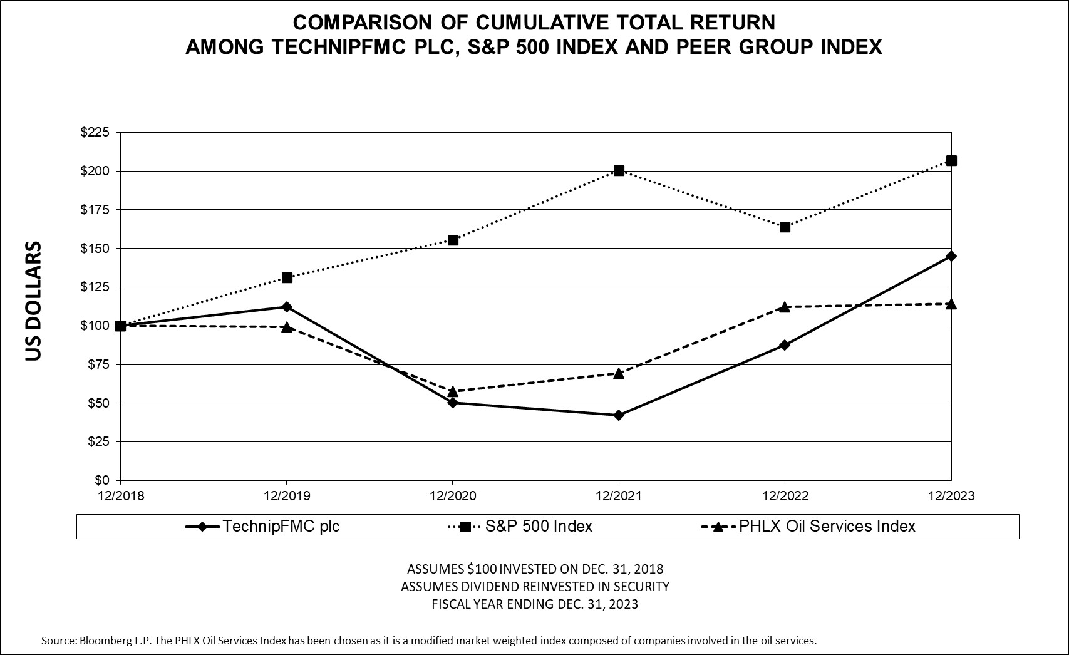

 |  |  | As of December 31,
 |  |  | 2019 |  |  |  |  |  | 2020 |  |  |  |  |  | 2021 |  |  |  |  |  | 2022 |  |  |  |  |  | 2023
TechnipFMC plc |  |  | $ | 112.07 |  |  |  |  | $ | 50.15 |  |  |  |  | $ | 42.45 |  |  |  |  | $ | 87.41 |  |  |  |  | $ | 145.16
S&P 500 Index |  |  | 131.48 |  |  |  |  |  | 155.65 |  |  |  |  |  | 200.29 |  |  |  |  |  | 163.99 |  |  |  |  |  | 207.05
PHLX Oil Services Index |  |  | 99.45 |  |  |  |  |  | 57.60 |  |  |  |  |  | 69.55 |  |  |  |  |  | 112.31 |  |  |  |  |  | 114.47

ITEM 6. [RESERVED]

ITEM 7. MANAGEMENT’S DISCUSSION AND ANALYSIS OF FINANCIAL CONDITION AND RESULTS OF OPERATIONS

EXECUTIVE OVERVIEW

We are a global leader in energy projects, technologies, systems and services. We have manufacturing operations worldwide, strategically located to facilitate efficient delivery of these products, technologies, systems and services to our customers. We report our results of operations in two segments: Subsea and Surface Technologies. Management’s determination of our reporting segments was made on the basis of our strategic priorities

and corresponds to the manner in which our Chief Executive Officer reviews and evaluates operating performance to make decisions about resource allocations to each segment.

A summarized description of our products and services and annual financial data for each segment can be found in Note 6 to our consolidated financial statements.

40

Total Company

• Inbound orders improved to $11.0 billion, driven largely by growth in offshore activity

• Cash flow from operations of $693.0 million, increased year-over-year by $340.9 million and free cash flow of $467.8 million more than doubled when compared to the prior year

• Initiated quarterly cash dividend that represented $0.20 per share on an annualized basis, and authorized additional share repurchase of up to $400.0 million, which increased total authorization to $800.0 million

• Established new commitment to return more than 60% of annual free cash flow to shareholders through at least 2025

• Received the National Ocean Industries Association’s ESG Excellence Award, which recognized our commitment to ESG actions, including efforts in fair representation and inclusion and in energy transition technologies

Subsea

• Inbound orders increased 45% year-over-year to $9.7 billion, driven by growth in both projects and services activity

• Record year of integrated project awards for our Company, including our largest iEPCI™ contract ever for Equinor’s Raia project (formerly BM-C-33), following a successful iFEED™

• Direct awards, iEPCI™ projects and Subsea Services exceeded 70% of total Subsea orders, reflecting the positive outcomes of our differentiated offerings, strong client relationships, and project selectivity

• Increased adoption of Subsea 2.0™ product platform, including three new clients – Equinor, ExxonMobil and Chevron

Surface

• Inbound orders of $1.2 billion primarily supported by international markets

• Continued ramp up in production at our Saudi Arabia facility, as well as successful execution on our 10-year framework agreement with Abu Dhabi National Oil Company

• Experienced increased client adoption of our E-Mission™ solution, the industry’s only real-time monitoring and control system that reduces methane flaring by up to 50% and maximizes oil production

Several new energy initiatives progressed with the award of multiple commercial contracts for surface wellheads and tree systems for onshore CO 2 injection in the Middle East, Netherlands, and Australia. In addition, we delivered a hydrogen wellhead for HyPSTER and completed and commissioned our Deep Purple Pilot™ project in Norway, which is our solution for Long Duration Energy Storage (LDES) using hydrogen as the energy carrier to help meet the growing demand for power.

We finished the year having delivered on many notable achievements. Importantly, these results reflect major milestones on our more ambitious journey ahead. We enter 2024 with a strong market outlook and a further step-up in our targeted financial performance.

BUSINESS OUTLOOK

Overall Outlook – The global economy remains resilient as we enter the new year despite multiple headwinds, including aggressive monetary tightening undertaken to curb high inflation. Interest rates remain elevated, but inflation has eased and central banks are poised to shift to more accommodative policies in an effort to maintain stable economic growth. These actions are anticipated to support continued growth in energy demand in 2024.

With long-term energy demand also forecast to increase, the conflicts in Ukraine and Israel have further highlighted the need for greater energy security across the globe. As a result, the energy industry has accelerated its efforts to address the essential need for hydrocarbons today to ensure the continuity of affordable energy while also playing an essential role in the energy transition.

The price of oil has been supported by regional geopolitical tensions and the industry’s more disciplined capital spend, particularly for OPEC+ countries focused on production levels that support both economic growth and energy investment. This includes Aramco’s recent decision to forego an expansion in its productive capacity above the current level of 12 million barrels per day (MMBD). An extended period of underinvestment also contributed to a supply deficit that has required increased upstream spending, lending support to a constructive view on the longer-term outlook for oil and natural gas prices.

41

We see continued strength ahead, driven by the resiliency and durability of the current market. The demand for energy will continue to grow. However, we believe the market’s evolution will differ from the past, driven by three major trends. First, a shift in capital flows, which we believe will largely be directed to the offshore and Middle East markets. Second, an increased role for new technologies to drive further innovation and market expansion, particularly in the offshore market. And third, an expanded role for subsea services, driven by the needs of growing and aging infrastructure. These trends allow TechnipFMC to leverage our full suite of integrated solutions, differentiated technologies, and the industry’s most comprehensive subsea services offering.

While we are confident that conventional resources will remain a large part of the energy mix for an extended period, we are also committed to the energy transition. Here, we believe that offshore will play a meaningful role in the transition to renewable energy resources and reduction of carbon emissions. We are making real progress through our three main pillars of greenhouse gas removal, offshore floating renewables and hydrogen solutions. We have also been successful in building on our partnerships and alliances to further position ourselves as the leading architect for offshore energy.

Our most recent success was driven by our leadership in subsea processing, technology innovation, and integrated solutions with the award of the Mero 3 HISEP® project, which is the first iEPCI contract ever awarded by Petrobras. The significance of this project for the subsea industry cannot be overstated, as this will be the first to use subsea processing to capture CO 2 rich dense gases directly from the well stream for injection back into the reservoir. This also allows all of the work scope to take place on the seafloor. In addition to reducing greenhouse gas emission intensity, HISEP® technologies will increase production capacity by debottlenecking the gas processing plant that currently resides on the floating production storage and offloading unit (“FPSO”). By moving the gas processing entirely to the seafloor, future FPSO and topside designs can be further simplified, driving significant improvement in project economics.

With the award of the Mero 3 HISEP® contract in January 2024, our New Energy business has now achieved more than $1 billion of inbound orders – nearly two years earlier than previously anticipated. We continue to further refine our positioning and mature our offering, particularly in carbon transportation and storage, an area we believe could drive further near-term orders.

Subsea – Innovative approaches to subsea projects, like our iEPCI solution, have improved project economics through more efficient design and installation of the entire subsea field architecture. Our integrated commercial model, iEPCI, brought together the complementary work scopes of the subsea production system (“SPS”) with the subsea umbilicals, risers, and flowlines (“SURF”) and installation vessels. iEPCI created a new market and helped expand the deepwater opportunity set for our clients and has grown to represent nearly one-third of the addressable subsea market.

As the subsea industry continues to evolve, we are driving simplification, standardization, and industrialization to reduce cycle times and further reduce costs. An example of this is Subsea 2.0, our pre-engineered configurable product offering. This technology provides simplification of unique project requirements by leveraging a configure-to-order (CTO) model that further improves the economics of our customer’s projects while driving greater efficiencies for TechnipFMC.

With CTO, we have designed an environment, process, culture, and tools which are scalable and, more importantly, are transformational to the future of our company. CTO has allowed us to redefine our sourcing strategy and transform our manufacturing flow, resulting in up to 25 percent lower product cost and a shortened 12-month delivery time for subsea production equipment – savings that are both real and sustainable. This has paved the way for other products to adopt a similar operating model, enabling an enterprise-wide way of working.

Given the significant improvement in project economics, many offshore discoveries can be developed economically well below today’s oil prices. We believe these changes are fundamental and sustainable as a result of new business models and technology pioneered by our company.

There is also exploration activity occurring in new offshore frontiers. In Suriname, five major discoveries have been made through the successful appraisal of two oilfields, with confirmed combined recoverable resources of approximately 700 million barrels of oil. In Namibia, there has also been a major discovery with multiple operators beginning their drilling campaigns. We believe additional countries will become producers of deepwater resources during this decade.

42

Offshore development is likely to remain a significant part of many of our customers’ portfolios. We estimate over 35 MMBD of new oil production will be required by 2040 to meet future energy demand, including approximately 10 MMBD of new deepwater production.

Our Subsea inbound orders grew to $9.7 billion in 2023, an increase of 45 percent versus the prior year. The robust inbound benefited from a record level of iEPCI projects, and when including all other direct awards and Subsea Services, the combination represented more than 70 percent of total segment orders. This growth in orders also drove a 50% increase in Subsea backlog to over $12.2 billion, with high quality inbound supportive of further improvement in our financial returns.

Surface Technologies – Inbound orders of $1.2 billion in 2023 were primarily supported by international markets. We continue to benefit from our exposure to the North Sea, Asia Pacific and the Middle East. International markets represented a significant portion of total segment revenue in 2023, totaling 59 percent. TechnipFMC’s unique capabilities in these markets, which demand higher specification equipment, global services, and local content, provide a platform for us to extend our leadership positions.

Drilling activity in international markets is less cyclical than North America as most activities are undertaken by national oil companies which tend to maintain a longer-term view that exhibits less variability in capital spend. We experienced a continued ramp up in production at our Saudi Arabia facility, as well as successful execution on our 10-year framework agreement with Abu Dhabi National Oil Company.

The shift to renewable energy resources will take time. During this transition, we believe that natural gas will provide a bridge between current conventional energy supply and future renewable energy supply. The transition is expected to drive growth in the surface market, led by large natural gas projects in the Middle East. We also expect North America to play an important role in meeting increased natural gas demand due in part to sanctions placed upon Russian supply.

43

CONSOLIDATED RESULTS OF OPERATIONS

This section of this Annual Report on Form 10-K generally discusses 2023 and 2022 items and year-to-year comparisons between 2023 and 2022. Discussions of 2021 items and year-to-year comparisons between 2022 and 2021 that are not included in this Annual Report on Form 10-K can be found in “Management’s Discussion and Analysis of Financial Condition and Results of Operations” in Part II, Item 7 of our Annual Report on Form 10-K for the year ended December 31, 2022.

We report our results of operations in U.S. dollars; however, our earnings are generated in various currencies worldwide. In order to provide worldwide consolidated results, the earnings of subsidiaries functioning in their local currencies are translated into U.S. dollars based upon the average exchange rate during the period. While the U.S. dollar results reported reflect the actual economics of the period reported upon, the variances from prior periods include the impact of translating earnings at different rates.

 |  |  | Year Ended December 31, |  |  |  |  |  |  |  |  |  |  |  |  |  |  |  |  |  | Change
(In millions, except percentages) |  |  | 2023 |  |  |  |  |  | 2022 |  |  |  |  |  | 2021 |  |  |  |  |  | 2023 vs. 2022 |  |  |  |  |  |  |  |  |  |  |  | 2022 vs. 2021
Revenue |  |  | $ | 7,824.2 |  |  |  |  | $ | 6,700.4 |  |  |  |  | $ | 6,403.5 |  |  |  |  | $ | 1,123.8 |  |  |  |  | 16.8 |  | % |  |  |  | $ | 296.9 |  |  |  |  | 4.6 |  | %
Costs and expenses
Cost of sales |  |  | 6,550.1 |  |  |  |  |  | 5,804.1 |  |  |  |  |  | 5,579.6 |  |  |  |  |  | 746.0 |  |  |  |  |  | 12.9 |  | % |  |  |  | 224.5 |  |  |  |  |  | 4.0 |  | %
Selling, general and administrative expense |  |  | 675.9 |  |  |  |  |  | 616.8 |  |  |  |  |  | 644.9 |  |  |  |  |  | 59.1 |  |  |  |  |  | 9.6 |  | % |  |  |  | (28.1) |  |  |  |  |  | (4.4) |  | %
Research and development expense |  |  | 69.0 |  |  |  |  |  | 67.0 |  |  |  |  |  | 78.4 |  |  |  |  |  | 2.0 |  |  |  |  |  | 3.0 |  | % |  |  |  | (11.4) |  |  |  |  |  | (14.5) |  | %
Restructuring, impairment and other expenses |  |  | 20.0 |  |  |  |  |  | 15.2 |  |  |  |  |  | 66.7 |  |  |  |  |  | 4.8 |  |  |  |  |  | 31.6 |  | % |  |  |  | (51.5) |  |  |  |  |  | (77.2) |  | %
Total costs and expenses |  |  | 7,315.0 |  |  |  |  |  | 6,503.1 |  |  |  |  |  | 6,369.6 |  |  |  |  |  | 811.9 |  |  |  |  |  | 12.5 |  | % |  |  |  | 133.5 |  |  |  |  |  | 2.1 |  | %
Other income (expense), net |  |  | (248.3) |  |  |  |  |  | 5.4 |  |  |  |  |  | 46.6 |  |  |  |  |  | (253.7) |  |  |  |  |  | (4,698.1) |  | % |  |  |  | (41.2) |  |  |  |  |  | (88.4) |  | %
Income from equity affiliates |  |  | 34.4 |  |  |  |  |  | 44.6 |  |  |  |  |  | 0.6 |  |  |  |  |  | (10.2) |  |  |  |  |  | (22.9) |  | % |  |  |  | 44.0 |  |  |  |  |  | 7,333.3 |  | %
Income (loss) from investment in Technip Energies |  |  | — |  |  |  |  |  | (27.7) |  |  |  |  |  | 322.2 |  |  |  |  |  | 27.7 |  |  |  |  |  | 100.0 |  | % |  |  |  | (349.9) |  |  |  |  |  | (108.6) |  | %
Loss on early extinguishment of debt |  |  | — |  |  |  |  |  | (29.8) |  |  |  |  |  | (61.9) |  |  |  |  |  | 29.8 |  |  |  |  |  | 100.0 |  | % |  |  |  | 32.1 |  |  |  |  |  | 51.9 |  | %
Net interest expense |  |  | (88.7) |  |  |  |  |  | (120.9) |  |  |  |  |  | (143.3) |  |  |  |  |  | 32.2 |  |  |  |  |  | 26.6 |  | % |  |  |  | 22.4 |  |  |  |  |  | 15.6 |  | %
Income before income taxes |  |  | 206.6 |  |  |  |  |  | 68.9 |  |  |  |  |  | 198.1 |  |  |  |  |  | 137.7 |  |  |  |  |  | 199.9 |  | % |  |  |  | (129.2) |  |  |  |  |  | (65.2) |  | %
Provision for income taxes |  |  | 154.7 |  |  |  |  |  | 105.4 |  |  |  |  |  | 111.1 |  |  |  |  |  | 49.3 |  |  |  |  |  | 46.8 |  | % |  |  |  | (5.7) |  |  |  |  |  | (5.1) |  | %
Income (loss) from continuing operations |  |  | 51.9 |  |  |  |  |  | (36.5) |  |  |  |  |  | 87.0 |  |  |  |  |  | 88.4 |  |  |  |  |  | 242.2 |  | % |  |  |  | (123.5) |  |  |  |  |  | (142.0) |  | %
(Income) loss from continuing operations attributable to non-controlling interests |  |  | 4.3 |  |  |  |  |  | (25.4) |  |  |  |  |  | 0.8 |  |  |  |  |  | 29.7 |  |  |  |  |  | 116.9 |  | % |  |  |  | (26.2) |  |  |  |  |  | (3,275.0) |  | %
Income (loss) from continuing operations attributable to TechnipFMC plc |  |  | 56.2 |  |  |  |  |  | (61.9) |  |  |  |  |  | 87.8 |  |  |  |  |  | 118.1 |  |  |  |  |  | 190.8 |  | % |  |  |  | (149.7) |  |  |  |  |  | (170.5) |  | %
Loss from discontinued operations |  |  | — |  |  |  |  |  | (45.3) |  |  |  |  |  | (72.6) |  |  |  |  |  | 45.3 |  |  |  |  |  | 100.0 |  | % |  |  |  | 27.3 |  |  |  |  |  | 37.6 |  | %
Income from discontinued operations attributable to non-controlling interests |  |  | — |  |  |  |  |  | — |  |  |  |  |  | (1.9) |  |  |  |  |  | — |  |  |  |  |  | — |  | % |  |  |  | 1.9 |  |  |  |  |  | 100.0 |  | %
Net income (loss) attributable to TechnipFMC plc |  |  | $ | 56.2 |  |  |  |  | $ | (107.2) |  |  |  |  | $ | 13.3 |  |  |  |  | $ | 163.4 |  |  |  |  | 152.4 |  | % |  |  |  | $ | (120.5) |  |  |  |  | (906.0) |  | %

Results of Operations in 2023 Compared to 2022

Revenue

Revenue increased $1,123.8 million in 2023, compared to the same period in 2022. Subsea revenue increased $973.6 million, driven by a 24.5% higher backlog as of December 31, 2022, when compared to December 31, 2021 , and included increased revenue year-over-year from flexible pipe and subsea production equipment combined with higher installation activities . Surface Technologies revenue increased $150.2 million, year-over-year, as a result of increased operator activity across the world, primarily from the Middle East.

44

Gross Profit

Gross profit (revenue less cost of sales) increased to $1,274.1 million in 2023 compared to $896.3 million in 2022. Subsea gross profit increased year-over-year by $324.5 million, of which $123.4 million was due to volume increase and $201.1 million due to a favorable activity mix. Surface Technologies gross profit increased year-over-year by $51.3 million, of which $18.3 million was driven by North America’s improved operational performance, $25.6 million due to higher activity in the Middle East and $7.6 million from improved performance in the rest of the world.

Selling, General and Administrative Expense

Selling, general and administrative expense increased by $59.1 million year-over-year, as a result of increased activity in both segments.

Other Income (Expense), Net

Other income (expense), net includes gains and losses associated with the remeasurement of net cash positions, gains and losses on sales of property, plant and equipment and non-operating gains and losses. The change from Other income, net of $5.4 million in 2022 to Other expense, net of $248.3 million in 2023 was mainly due to a $126.5 million non-recurring legal settlement charges (see Note 2 0 ) and a net foreign exchange loss of $119.0 million in 2023. The net foreign exchange loss was primarily a result of exposure to certain currencies with limited derivative hedging markets such as the Argentine peso and Angolan kwanza. Additional losses resulted from balance sheet remeasurements and cost of carry.

Income from Equity Affiliates

For the years ended December 31, 2023 and 2022, we recorded income of $34.4 million and $44.6 million, respectively, from equity method affiliates. Income generated by our equity method investments during 2023 decreased year-over-year, driven by a decrease in operational activity of our joint ventures. See Note 3 to our consolidated financial statements for further details.

Income (Loss) from Investment in Technip Energies

For the year ended December 31, 2022 we recorded a loss of $27.7 million as a result of our investment in Technip Energies. The amounts recognized represented the fair value revaluation gains (losses) of our investment. See Note 12 to our consolidated financial statements for further details.

Loss on Early Extinguishment of Debt

We recognized a $29.8 million loss on early extinguishment of debt for the year ended December 31, 2022, which related to premium paid and write-off of debt issuance costs in connection with the repurchase of the 2021 Notes and the repayment of our 3.45% Senior Notes due 2022. See Note 16 to our consolidated financial statements for further details.

Net Interest Expense

Net interest expense decreased by $32.2 million in 2023, compared to 2022, largely due to the reduction in outstanding debt and higher interest income.

Provision for Income Taxes

Our provision for income taxes for 2023 and 2022 reflected effective tax rates of 74.9% and 153.1%, respectively. The year-over-year decrease in the effective tax rate was largely due to the change in geographical profit mix year over year, tax adjustments related to the reassessment of prior year tax accruals and changes of valuation allowances on some of our deferred tax assets.

Our effective tax rate can fluctuate depending on our country mix of earnings, since our foreign earnings are generally subject to higher tax rates than in the United Kingdom.

Discontinued Operations

Loss from discontinued operations, net of income taxes, was $45.3 million for the year ended December 31, 2022. See Note 25 t o our consolidated financial statements for further details.

45

OPERATING RESULTS OF BUSINESS SEGMENTS

Segment operating profit is defined as total segment revenue less segment operating expenses. Certain items have been excluded in computing segment operating profit and are included in corporate items. See Note 6 to our consolidated financial statements for further details.

Subsea

 |  |  | Year Ended December 31, |  |  |  |  |  |  |  |  |  |  |  |  |  |  |  |  |  | Favorable/(Unfavorable)
(In millions, except %) |  |  | 2023 |  |  |  |  |  | 2022 |  |  |  |  |  | 2021 |  |  |  |  |  | 2023 vs. 2022 |  |  |  |  |  |  |  |  |  |  |  | 2022 vs. 2021
Revenue |  |  | $ | 6,434.8 |  |  |  |  | $ | 5,461.2 |  |  |  |  | $ | 5,329.1 |  |  |  |  | $ | 973.6 |  |  |  |  | 17.8 |  | % |  |  |  | $ | 132.1 |  |  |  |  | 2.5 |  | %
Operating profit (loss) |  |  | $ | 543.6 |  |  |  |  | $ | 317.6 |  |  |  |  | $ | 141.4 |  |  |  |  | $ | 226.0 |  |  |  |  | 71.2 |  | % |  |  |  | $ | 176.2 |  |  |  |  | 124.6 |  | %
Operating profit (loss) as a percentage of revenue |  |  | 8.4 |  | % |  |  |  | 5.8 |  | % |  |  |  | 2.7 |  | % |  |  |  |  |  |  |  |  |  | 2.6 |  | pts. |  |  |  |  |  |  |  |  |  | 3.1 |  | pts.

Subsea revenue increased $973.6 million during the year ended December 31, 2023 , compared to the same period in 2022, driven by an increase in backlog during 2022, related to higher energy demand and upstream spending, further aided by our unique commercial offerings. $630.0 million of the increase in revenue came from Brazil, $257.1 million from United States and $229.9 million from Norway, due to increased supply of flexible pipe, subsea production equipment combined with higher installation activities across these geographies. The increase in revenue in Brazil, the United States and Norway was offset by a net $143.4 million decrease from the rest of the world primarily from lower activity as projects reached completion.

Subsea operating profit for the year ended December 31, 2023, increased by $226.0 million, of which $123.4 million came from volume, combined with $201.1 million due to a favorable activity mix, partially offset by a $98.5 million increase in operating expense.

Surface Technologies

 |  |  | Year Ended December 31, |  |  |  |  |  |  |  |  |  |  |  |  |  |  |  |  |  | Favorable/(Unfavorable)
(In millions, except %) |  |  | 2023 |  |  |  |  |  | 2022 |  |  |  |  |  | 2021 |  |  |  |  |  | 2023 vs. 2022 |  |  |  |  |  |  |  |  |  |  |  | 2022 vs. 2021
Revenue |  |  | $ | 1,389.4 |  |  |  |  | $ | 1,239.2 |  |  |  |  | $ | 1,074.4 |  |  |  |  | $ | 150.2 |  |  |  |  | 12.1 |  | % |  |  |  | $ | 164.8 |  |  |  |  | 15.3 |  | %
Operating profit (loss) |  |  | $ | 114.6 |  |  |  |  | $ | 58.3 |  |  |  |  | $ | 42.0 |  |  |  |  | $ | 56.3 |  |  |  |  | 96.6 |  | % |  |  |  | $ | 16.3 |  |  |  |  | 38.8 |  | %
Operating profit (loss) as a percentage of revenue |  |  | 8.2 |  | % |  |  |  | 4.7 |  | % |  |  |  | 3.9 |  | % |  |  |  |  |  |  |  |  |  | 3.5 |  | pts. |  |  |  |  |  |  |  |  |  | 0.8 |  | pts.

Surface Technologies revenue increased $150.2 million, during the year ended December 31, 2023, compared to the same period in 2022, $76.0 million in the Middle East, $22.1 million in North America, $31.8 million in Europe and Central Asia, and $20.3 million in the rest of the world. The increase in the Middle East resulted from recent project awards in support of longer term customer production targets in the region driving increased supply of drilling and completions products. The increased revenue in North America was driven by improved commercial conditions supporting higher drilling and completions activity. The increase in Europe, Central Asia and the rest of the world is the result of increased operator activity on projects in these geographies.

Surface Technologies operating profit increased by $56.3 million. $21.3 million of the increase was due to improved operational performance in North America, $27.4 million was the result of higher activity in the Middle East and North Sea, and $7.6 million from improved operational performance in the rest of the world.

Corporate Items

 |  |  | Year Ended December 31, |  |  |  |  |  |  |  |  |  |  |  |  |  |  |  |  |  | Favorable/(Unfavorable)
(In millions, except %) |  |  | 2023 |  |  |  |  |  | 2022 |  |  |  |  |  | 2021 |  |  |  |  |  | 2023 vs. 2022 |  |  |  |  |  |  |  |  |  |  |  | 2022 vs. 2021
Corporate expense |  |  | $ | (243.9) |  |  |  |  | $ | (104.7) |  |  |  |  | $ | (118.1) |  |  |  |  | $ | (139.2) |  |  |  |  | (133.0) |  | % |  |  |  | $ | 13.4 |  |  |  |  | 11.3 |  | %

46

Corporate expense increased by $139.2 million year-over-year, mostly due to a non-recurring legal settlement charge of $126.5 million incurred during 2023. The remaining increase is primarily attributable to an increase in corporate staff expense.

INBOUND ORDERS AND ORDER BACKLOG

Inbound orders — Inbound orders represent the estimated sales value of confirmed customer orders received during the reporting period.

Inbound Orders
Year Ended December 31,
(In millions) |  |  | 2023 |  |  |  |  |  | 2022
Subsea |  |  | $ | 9,749.0 |  |  |  |  | $ | 6,738.3
Surface Technologies |  |  | 1,233.9 |  |  |  |  |  | 1,340.8
Total inbound orders |  |  | $ | 10,982.9 |  |  |  |  | $ | 8,079.1

Order backlog — Order backlog is calculated as the estimated sales value of unfilled, confirmed customer orders at the reporting date. Backlog reflects the current expectations for the timing of project execution. See Note 5 to our consolidated financial statements for further details.

Order Backlog
December 31,
(In millions) |  |  | 2023 |  |  |  |  |  | 2022
Subsea |  |  | $ | 12,164.1 |  |  |  |  | $ | 8,131.5
Surface Technologies |  |  | 1,066.9 |  |  |  |  |  | 1,221.5
Total order backlog |  |  | $ | 13,231.0 |  |  |  |  | $ | 9,353.0

Subsea — Order backlog for Subsea as of December 31, 2023, increased by $4.0 billion from December 31, 2022. Subsea backlog of $12.2 billion as of December 31, 2023, was composed of various subsea projects, including Petrobras Buzios 6, Mero I, Mero II and Marlim; Total Energies Mozambique LNG, Lapa North East and Clov 3; ExxonMobil Yellowtail and Uaru; AkerBP Utsira; Azule Energy Agogo; Shell Jackdaw and Dover; Husky West White Rose; Equinor Raia, Rosebank and Irpa, Verdande; Tullow Jubilee South East; Wintershall Maria and Dvalin; and Harbour Talbot.

Surface Technologies — Order backlog for Surface Technologies as of December 31, 2023 decreased by $154.6 million, compared to December 31, 2022. Surface Technologies’ backlog of $1.1 billion as of December 31, 2023, was composed primarily of projects in the Middle East, namely Aramco and ADNOC. The remaining backlog was composed of various projects in the rest of the world.

LIQUIDITY AND CAPITAL RESOURCES

Most of our cash is managed centrally and flows through bank accounts controlled and maintained by TechnipFMC globally in various jurisdictions to best meet the liquidity needs of our global operations.

Net Debt — Net debt is a non-GAAP financial measure reflecting cash and cash equivalents, net of debt. Management uses this non-GAAP financial measure to evaluate our capital structure and financial leverage. We believe net debt is a meaningful financial measure that may assist investors in understanding our financial condition and recognizing underlying trends in our capital structure. Net debt should not be considered an alternative to, or more meaningful than, cash and cash equivalents as determined in accordance with GAAP or as an indicator of our operating performance or liquidity.

47

The following table provides a reconciliation of our cash and cash equivalents to net debt, utilizing details of classifications from our consolidated balance sheets.

 |  |  | Year Ended December 31,
(In millions) |  |  | 2023 |  |  |  |  |  | 2022
Cash and cash equivalents |  |  | $ | 951.7 |  |  |  |  | $ | 1,057.1
Short-term debt and current portion of long-term debt |  |  | (153.8) |  |  |  |  |  | (367.3)
Long-term debt, less current portion |  |  | (913.5) |  |  |  |  |  | (999.3)
Net debt |  |  | $ | (115.6) |  |  |  |  | $ | (309.5)

Cash Flows

Cash flows for the years ended December 31, 2023, 2022 and 2021 were as follows:

 |  |  | Year Ended December 31,
(In millions) |  |  | 2023 |  |  |  |  |  | 2022 |  |  |  |  |  | 2021
Cash provided by operating activities from continuing operations |  |  | $ | 693.0 |  |  |  |  | $ | 352.1 |  |  |  |  | $ | 715.0
Cash provided (required) by investing activities from continuing operations |  |  | (125.6) |  |  |  |  |  | 162.2 |  |  |  |  |  | 821.8
Cash required by financing activities from continuing operations |  |  | (656.5) |  |  |  |  |  | (796.7) |  |  |  |  |  | (1,447.3)
Net cash attributable to discontinued operations |  |  | — |  |  |  |  |  | — |  |  |  |  |  | (3,555.9)
Effect of exchange rate changes on cash and cash equivalents |  |  | (16.3) |  |  |  |  |  | 12.1 |  |  |  |  |  | (14.0)
Decrease in cash and cash equivalents |  |  | $ | (105.4) |  |  |  |  | $ | (270.3) |  |  |  |  | $ | (3,480.4)
(Increase) decrease in working capital from continuing operations |  |  | $ | 302.2 |  |  |  |  | $ | (81.1) |  |  |  |  | $ | 497.5
Free cash flow from continuing operations |  |  | $ | 467.8 |  |  |  |  | $ | 194.2 |  |  |  |  | $ | 523.3

Operating cash flows from continuing operations — During 2023 and 2022, we generated $693.0 million and $352.1 million, respectively, in operating cash flows from continuing operations. The increase of $340.9 million in cash generated by operating activities from continuing operations in 2023, as compared to 2022, was due to timing differences on project milestones, payments to vendors for inventory, fluctuations in derivative assets and liabilities and timing of income tax payments.

Investing cash flows from continuing operations — We used $125.6 million of cash in investing activities from continuing operations during 2023 as compared to $162.2 million cash generated in investing cash flows from continuing operations during 2022. The decrease of $287.8 million in cash from investing activities was primarily due to the absence of $288.5 million proceeds received from sales of our investment in Technip Energies during 2022 and an increase in capital expenditures of $67.3 million. This cash use was partially offset by an increase in proceeds from sales of assets of $54.5 million during 2023 primarily related to the sale of the Apache II pipelay vessel and other investing activities.

Financing cash flows from continuing operations — Financing activities from continuing operations used $656.5 million and $796.7 million in 2023 and 2022, respectively. The decrease of $140.2 million in cash used for financing activities was mainly due to the decreased debt pay down and issuance activity of $249.6 million during 2023, partially offset by $104.9 million of increase of share repurchases during 2023.

The change in working capital represents total changes in current assets and liabilities.

48

Free cash flow from continuing operations is defined as operating cash flows from continuing operations less capital expenditures. Management uses this non-GAAP financial measure to evaluate our financial condition. We believe free cash flow from continuing operations is a meaningful financial measure that may assist investors in understanding our financial condition and results of operations. The following table reconciles cash provided by operating activities from continuing operations, which is the most directly comparable financial measure determined in accordance with GAAP, to free cash flow (non-GAAP measure).
 |  |  | Year Ended December 31,
(In millions) |  |  | 2023 |  |  |  |  |  | 2022 |  |  |  |  |  | 2021
Cash provided by operating activities from continuing operations |  |  | $ | 693.0 |  |  |  |  | $ | 352.1 |  |  |  |  | $ | 715.0
Capital expenditures |  |  | (225.2) |  |  |  |  |  | (157.9) |  |  |  |  |  | (191.7)
Free cash flow from continuing operations |  |  | $ | 467.8 |  |  |  |  | $ | 194.2 |  |  |  |  | $ | 523.3

Debt and Liquidity

We are committed to maintaining a capital structure that provides sufficient cash resources to support future operating and investment plans. We maintain a level of liquidity sufficient to allow us to meet our cash needs in both the short term and long term. During 2023, we reduced our total debt position primarily through the full repayment of $270.2 million of our 3.15% 2013 Private Placement Notes.

Availability of borrowings under the Revolving Credit Facility is reduced by the outstanding letters of credit issued against the facility. As of December 31, 2023 there were $54.2 million letters of credit outstanding and availability of borrowings under the Revolving Credit Facility was $1,195.8 million.

As of December 31, 2023 TechnipFMC was in compliance with all debt covenants. See Note 16 to our consolidated financial statements for further detail.

Credit Ratings - Our credit ratings with Standard and Poor’s (“S&P”) are BB+ for our long-term unsecured, guaranteed debt (2021 Notes) and BB for our long-term unsecured debt (the Private Placement Notes). Our credit rating with Moody’s is Ba1 for our long-term unsecured, guaranteed debt. See Note 16 for further details regarding our debt.

Credit Risk Analysis

For the purposes of mitigating the effect of the changes in exchange rates, we hold derivative financial instruments. Valuations of derivative assets and liabilities reflect the fair value of the instruments, including the values associated with counterparty risk. These values must also take into account our credit standing, thus including the valuation of the derivative instrument and the value of the net credit differential between the counterparties to the derivative contract. Adjustments to our derivative assets and liabilities related to credit risk were not material for any period presented.

The income approach was used as the valuation technique to measure the fair value of foreign currency derivative instruments on a recurring basis. This approach calculates the present value of the future cash flow by measuring the change from the derivative contract rate and the published market indicative currency rate, multiplied by the contract notional values. Credit risk is then incorporated by reducing the derivative’s fair value in asset positions by the result of multiplying the present value of the portfolio by the counterparty’s published credit spread. Portfolios in a liability position are adjusted by the same calculation; however, a spread representing our credit spread is used.

Our credit spread, and the credit spread of other counterparties not publicly available, are approximated using the spread of similar companies in the same industry, of similar size, and with the same credit rating. See Notes 23 and 24 to our consolidated financial statements for further details.

At this time, we have no credit-risk-related contingent features in our agreements with the financial institutions that would require us to post collateral for derivative positions in a liability position.

Contractual and Other Obligations

The Company’s principal contractual commitments include purchase obligations, repayments of long-term debt and related interest, and payments under operating leases. As of December 31, 2023, we had $1.6 billion of purchase obligations, more than 93 percent of which is short-term. Substantially all of these commitments are associated with

49

purchases made to fulfill our customer’s orders, the costs associated with these agreements will ultimately be reflected in cost of sales in our consolidated statements of income.

Refer to respective notes to the consolidated financial statements for further information about our share repurchase program ( Note 18 ), long-term debt obligations ( Note 16 ), guarantees ( Notes 12 and 20 ) and lease payment obligations ( Note 4 ).

Financial Position Outlook

We are committed to a strong balance sheet. We continue to maintain sufficient liquidity to support the needs of the business through growth, cyclicality and unforeseen events. We continue to maintain and drive sustainable leverage to preserve access to capital throughout the cycle. Our capital expenditures can be adjusted and managed to match market demand and activity levels. Projected capital expenditures do not include any contingent capital that may be needed to respond to contract awards. In maintaining our commitment to sustainable leverage and liquidity, we expect to be able to continue to generate cash flow available for investment in growth and distribution to shareholders through the business cycle.

CRITICAL ACCOUNTING ESTIMATES

The preparation of financial statements in conformity with GAAP requires management to make certain estimates, judgments and assumptions about future events that affect the reported amounts of assets and liabilities at the date of the financial statements, the reported amounts of revenue and expenses during the periods presented and the related disclosures in the accompanying notes to the financial statements. Management has reviewed these critical accounting estimates with the Audit Committee of our Board of Directors. We believe the following critical accounting estimates used in preparing our financial statements address all important accounting areas where the nature of the estimates or assumptions is material due to the levels of subjectivity and judgment necessary to account for highly uncertain matters or the susceptibility of such matters to change. See Note 1 to our consolidated financial statements for further details.

Revenue Recognition

The majority of our revenue is derived from long-term contracts that can span several years. We account for revenue in accordance with Accounting Standard Codification (“ASC”) Topic 606, Revenues from Contracts with Customers. The unit of account in ASC Topic 606 is a performance obligation. A contract’s transaction price is allocated to each distinct performance obligation and recognized as revenue when, or as, the performance obligation is satisfied. Our performance obligations are satisfied over time as work progresses or at a point in time.

A significant portion of our total revenue recognized over time relates to our Subsea segment, for the subsea exploration and production equipment projects that involve the design, engineering, manufacturing, construction, and assembly of complex systems. Because of control transferring over time, revenue is recognized based on the extent of progress towards completion of the performance obligation. The selection of the method to measure progress towards completion requires judgment and is based on the nature of the products or services to be provided. We generally use the cost-to-cost measure of progress for our contracts because it best depicts the transfer of control to the customer that occurs as we incur costs on our contracts. Under the cost-to-cost measure of progress, the extent of progress towards completion is measured based on the ratio of costs incurred to date to the total estimated costs at completion of the performance obligation. Revenues are recorded proportionally as costs are incurred.

Due to the nature of the work required to be performed on many of our performance obligations, the estimation of total revenue and cost at completion is complex, subject to many variables, and requires significant judgment. It is common for our long-term contracts to contain award fees, incentive fees, or other provisions that can either increase or decrease the transaction price. We include estimated amounts in the transaction price when we believe we have an enforceable right to the modification, the amount can be estimated reliably, and its realization is probable. The estimated amounts are included in the transaction price to the extent it is probable that a significant reversal of cumulative revenue recognized will not occur when the uncertainty associated with the variable consideration is resolved.

50

We execute contracts with our customers that clearly describe the equipment, systems, and/or services. After analyzing the drawings and specifications of the contract requirements, our project engineers estimate total contract costs based on their experience with similar projects and then adjust these estimates for specific risks associated with each project, such as technical risks associated with a new design. Costs associated with specific risks are estimated by assessing the probability that conditions arising from these specific risks will affect our total cost to complete the project. After work on a project begins, assumptions that form the basis for our calculation of total project cost are examined on a regular basis and our estimates are updated to reflect the most current information and management’s best judgment.

Adjustments to estimates of contract revenue, total contract cost, or extent of progress toward completion are often required as work progresses under the contract and as experience is gained, even though the scope of work required under the contract may not change. The nature of accounting for long-term contracts is such that refinements of the estimating process for changing conditions and new developments are continuous and characteristic of the process. Consequently, the amount of revenue recognized over time is sensitive to changes in our estimates of total contract costs. There are many factors, including, but not limited to, the ability to properly execute the engineering and design phases consistent with our customers’ expectations, the availability and costs of labor and material resources, productivity, and weather, all of which can affect the accuracy of our cost estimates, and ultimately, our future profitability.

Our gross profit for the year ended December 31, 2023 was negatively impacted on a net basis by approximately $92.3 million , as a result of aggregate changes in contract estimates related to projects that were in progress as of December 31, 2022 with $91.0 million and $1.3 million in our Subsea and Surface Technologies segments, respectively. Certain projects that were significantly impacted negatively by changes to estimated project costs during this period totaled $106.1 million. These were offset partially by projects with material positive impacts from favorable negotiations of variable considerations of $39.1 million. The remaining other changes resulted in a net negative impact of $25.3 million.

Accounting for Income Taxes

Our income tax expense, deferred tax assets and liabilities, and reserves for uncertain tax positions reflect management’s best assessment of estimated future taxes to be paid. We are subject to income taxes in the United Kingdom and numerous foreign jurisdictions. Significant judgments and estimates are required in determining our consolidated income tax expense.

In determining our current income tax provision, we assess temporary differences resulting from differing treatments of items for tax and accounting purposes. These differences result in deferred tax assets and liabilities, which are recorded in our consolidated balance sheets. When we maintain deferred tax assets, we must assess the likelihood that these assets will be recovered through adjustments to future taxable income. To the extent we believe recovery is not likely, we establish a valuation allowance. We record a valuation allowance to reduce the asset to a value we believe will be recoverable based on our expectation of future taxable income. We believe the accounting estimate related to the valuation allowance is a critical accounting estimate because it is highly susceptible to change from period to period, requires management to make assumptions about our future income over the lives of the deferred tax assets, and finally, the impact of increasing or decreasing the valuation allowance is potentially material to our results of operations.

Forecasting future income requires us to use a significant amount of judgment. In estimating future income, we use our internal operating budgets and long-range planning projections. We develop our budgets and long-range projections based on recent results, trends, economic and industry forecasts influencing our segments’ performance, our backlog, planned timing of new product launches and customer sales commitments. Significant changes in our judgment related to the expected realizability of a deferred tax asset results in an adjustment to the associated valuation allowance.

As of December 31, 2023, we have provided a valuation allowance against the related deferred tax assets where we believe it is not more likely than not that we will generate future taxable income sufficient to realize such assets.

The calculation of our income tax expense involves dealing with uncertainties in the application of complex tax laws and regulations in numerous jurisdictions in which we operate. We recognize tax benefits related to uncertain tax positions when, in our judgment, it is more likely than not that such positions will be sustained on examination, including resolutions of any related appeals or litigation, based on the technical merits. We adjust our liabilities for uncertain tax positions when our judgment changes as a result of new information previously unavailable. Due to the complexity of some of these uncertainties, their ultimate resolution may result in payments that are materially

51

different from our current estimates. Any such differences will be reflected as adjustments to income tax expense in the periods in which they are determined.

Accounting for Pension and Other Post-retirement Benefit Plans

The determination of the projected benefit obligations of our pension and other post-retirement benefit plans are important to the recorded amounts of such obligations in our consolidated balance sheets and to the amount of pension expense in our consolidated statements of income. In order to measure the obligations and expense associated with our pension benefits, management must make a variety of estimates, including discount rates used to value certain liabilities, expected return on plan assets set aside to fund these costs, rate of compensation increase, employee turnover rates, retirement rates, mortality rates and other factors. We update these estimates on an annual basis or more frequently upon the occurrence of significant events. These accounting estimates bear the risk of change due to the uncertainty and difficulty in estimating these measures. Different estimates used by management could result in our recognition of different amounts of expense over different periods of time.

Due to the specialized and statistical nature of these calculations which attempt to anticipate future events, we engage third-party specialists to assist management in evaluating our assumptions as well as appropriately measuring the costs and obligations associated with these pension benefits. The discount rate and expected long-term rate of return on plan assets are based on investment yields available and the historical performance of our plan assets, respectively. The timing and amount of cash outflows related to the bonds included in the indices matches estimated defined benefits payments. These measures are critical accounting estimates because they are subject to management’s judgment and can materially affect net income.

The actuarial assumptions and estimates made by management in determining our pension benefit obligations may materially differ from actual results as a result of changing market and economic conditions and changes in plan participant assumptions. While we believe the assumptions and estimates used are appropriate, differences in actual experience or changes in plan participant assumptions may materially affect our financial position or results of operations.

The following t able illustrates the sensitivity of changes in the discount rate and expected long-term return on plan assets on pension expense and the projected benefit obligation:

(In millions, except basis points) |  |  | Increase (Decrease) in 2023 Pension Expense Before Income Taxes |  |  |  |  |  | Increase (Decrease) in Projected Benefit Obligation as of December 31, 2023
25 basis point decrease in discount rate |  |  | $ | 1.4 |  |  |  |  | $ | 25.9
25 basis point increase in discount rate |  |  | $ | (1.3) |  |  |  |  | $ | (24.7)
25 basis point decrease in expected long-term rate of return on plan assets |  |  | $ | 1.9 |  |  |  |  | N/A
25 basis point increase in expected long-term rate of return on plan assets |  |  | $ | (1.9) |  |  |  |  | N/A

Impairment of Long-Lived and Intangible Assets

Long-lived assets, including vessels, property, plant and equipment, identifiable intangible assets being amortized, and capitalized software costs are reviewed for impairment whenever events or changes in circumstances indicate the carrying amount of the long-lived asset may not be recoverable. The carrying amount of a long-lived asset is not recoverable if it exceeds the sum of the undiscounted cash flows expected to result from the use and eventual disposition of the asset. If it is determined that an impairment loss has occurred, the loss is measured as the amount by which the carrying amount of the long-lived asset exceeds its fair value. The determination of future cash flows as well as the estimated fair value of long-lived assets involves significant estimates on the part of management. Because there usually is a lack of quoted market prices for long-lived assets, fair value of impaired assets is typically determined based on the present values of expected future cash flows using discount rates believed to be consistent with those used by principal market participants or based on a multiple of operating cash flows validated with historical market transactions of similar assets where possible. The expected future cash flows used for impairment reviews and related fair value calculations are based on judgmental assessments of revenue, forecasted utilization, operating costs and capital decisions and all available information at the date of review. If future market conditions deteriorate beyond our current expectations and assumptions, impairments of long-lived assets may be identified if we conclude that the carrying amounts are no longer recoverable.

52

OTHER MATTERS

On June 25, 2019, we announced a global resolution to pay a total of $301.3 million to the U.S. Department of Justice (“DOJ”), the SEC, and Brazilian authorities (Federal Prosecution Service (“MPF”), the Comptroller General of Brazil (“CGU”) and the Attorney General of Brazil (“AGU”)) to resolve these anti-corruption investigations related to historic conduct by Technip S.A. in Brazil and historic conduct by FMC Technologies concerning services provided by a vendor, Unaoil S.A.M. We were not required to have a monitor and instead, provided reports on our anti-corruption program to the Brazilian and U.S. authorities for two and three years, respectively.

As part of this resolution, we entered into a three-year Deferred Prosecution Agreement (“DPA”) with the DOJ related to charges of conspiracy to violate the FCPA related to conduct in Brazil and with Unaoil. In addition, Technip USA, Inc., a U.S. subsidiary, pled guilty to one count of conspiracy to violate the FCPA related to conduct in Brazil. We also consented to the entry of an Administrative Order issued by the SEC related to Unaoil.

In Brazil, on June 25, 2019, our subsidiaries Technip Brasil - Engenharia, Instalações E Apoio Marítimo Ltda. and Flexibrás Tubos Flexíveis Ltda. entered into leniency agreements with both the MPF and the CGU/AGU. We made, as part of those agreements, certain enhancements to the compliance programs in Brazil during the two-year self-reporting period, which aligned with our commitment to cooperation and transparency with the compliance community in Brazil and globally.

On December 8, 2022, the Company received notice of the official release from all obligations and charges by CGU, having successfully completed all of the self-reporting requirements in the leniency agreements and the case was closed. On December 27, 2022, the DOJ filed a Motion to Dismiss the charges against TechnipFMC related to conspiracy to violate the FCPA, noting to the Court that the Company had fully met and completed all of its obligations under the DPA. The Dismissal Order was signed by the Court on January 4, 2023, thereby closing the case. All obligations to regulatory authorities related to the enforcement matters in the United States and Brazil have been completed and the Company has been unconditionally released by both jurisdictions.

As previously disclosed, we have also resolved an investigation by French authorities (the Parquet National Financier (“PNF”)). On June 22, 2023, the Company, through its subsidiary Technip UK Limited, along with Technip Energies SAS, a subsidiary of Technip Energies NV, reached a resolution with the PNF of all outstanding matters, including its investigations into historical projects in Equatorial Guinea, Ghana, and Angola. The resolution took the form of a convention judiciaire d'interet public, (“CJIP”), which does not involve any admission of liability or guilt.

Under the terms of the CJIP, Technip UK and Technip Energies France will pay a public interest fine of €154.8 million and €54.1 million, respectively, for a total of €208.9 million. Under the companies’ separation agreements, TechnipFMC is responsible for €179.45 million to be paid in installments through July 2024, and Technip Energies is responsible for the remaining €29.45 million. During the three-months ended June 30, 2023, we recorded a $126.5 million liability incremental to our existing provision. After making a scheduled installment payment of €24.7 million on July 13, 2023, we have an outstanding balance of €154.8 million that is translated to $171.1 million and is recorded in other current liabilities in our consolidated balance sheet as of December 31, 2023.

TechnipFMC fully cooperated with the PNF and was not required to retain a monitor. The CJIP received final approval by the President of the Tribunal Judiciaire of Paris at a hearing on June 28, 2023.

RECENTLY ISSUED ACCOUNTING STANDARDS

See Note 2 to our consolidated financial statements for further details.

ITEM 7A. QUANTITATIVE AND QUALITATIVE DISCLOSURES ABOUT MARKET RISK

We are subject to financial market risks, including fluctuations in foreign currency exchange rates an d interest rates. In order to manage and mitigate our exposure to these risks, we may use derivative financial instruments in accordance with established policies and procedures. We do not use derivative financial instruments for speculative purposes. As of December 31, 2023 and 2022, substantially all of our derivative holdings consisted of foreign currency forward contracts and foreign currency instruments embedded in purchase and sale contracts.

53

These disclosures only address potential impacts from market risks as they affect our financial instruments and do not include other potential effects that could impact our business as a result of changes in foreign currency exchange rates, interest rates, commodity prices or equity prices.

Foreign Currency Exchange Rate Risk

We conduct operations around the world in a number of different currencies. Many of our significant foreign subsidiaries have designated the local currency as their functional currency. Our earnings are, therefore, subject to change due to fluctuations in foreign currency exchange rates when the earnings in foreign currencies are translated into U.S. dollars. We do not hedge this translation impact on earnings. A 10% increase or decrease in the average exchange rates of all foreign currencies over 2023 would have changed our revenue and income before income taxes attributable to TechnipFMC by approximately $381.8 million and $21.4 million, respectively.

We apply highly inflationary accounting to the results of operations of our subsidiaries in Argentina as the cumulative inflation rate in these economies for a three-year period meets or exceeds 100%, in accordance with U.S. GAAP. As a result, monetary assets and liabilities denominated in local currencies are remeasured to the U.S. Dollar at each balance sheet date, with remeasurement gains and losses recognized in consolidated statements of income.

The Central Bank of Argentina has maintained certain currency controls that limited our ability to access U.S. dollars in Argentina and to remit cash from our Argentine operations. The new president of Argentina was inaugurated on December 10, 2023, and proposed certain significant economic changes that had a significant impact on the foreign currency-related effects of business transactions in Argentina. Due to the Argentine Peso devaluation, primarily following the Presidential Inauguration, we recognized a foreign exchange loss of $14.5 million during the fourth quarter of 2023 and approximately $23.8 million for the year ended December 31, 2023. We have taken various actions to address the situation to reduce our foreign exchange exposure.

When transactions are denominated in currencies other than our subsidiaries’ respective functional currencies, we manage these exposures through the use of derivative instruments. We use foreign currency forward contracts to hedge the foreign currency fluctuation associated with firmly committed and forecasted foreign currency denominated payments and receipts. The derivative instruments associated with these anticipated transactions are usually designated and qualify as cash flow hedges, and as such the gains and losses associated with these instruments are recorded in other comprehensive income until such time that the underlying transactions are recognized. Unless these cash flow contracts are deemed to be ineffective or are not designated as cash flow hedges at inception, changes in the derivative fair value will not have an immediate impact on our results of operations since the gains and losses associated with these instruments are recorded in other comprehensive income. When the anticipated transactions occur, these changes in value of derivative instrument positions will be offset against changes in the value of the underlying transaction. When an anticipated transaction in a currency other than the functional currency of an entity is recognized as an asset or liability on the balance sheet, we also hedge the foreign currency fluctuation of these assets and liabilities with derivative instruments after netting our exposures worldwide. These derivative instruments do not qualify as cash flow hedges.

For our foreign currency forward contracts hedging anticipated transactions that are accounted for as cash flow hedges, a 10% increase in the value of the U.S. dollar would have resulted in an additional loss of approximately $115.3 million in the net fair value of cash flow hedges reflected in our consolidated balance sheet as of December 31, 2023.

Interest Rate Risk

We assess effectiveness of forward foreign currency contracts designated as cash flow hedges based on changes in fair value attributable to changes in spot rates. We exclude the impact attributable to changes in the difference between the spot rate and the forward rate for the assessment of hedge effectiveness and recognize the change in fair value of this component immediately in earnings. To the extent any one interest rate increases by 10% across all tenors and other countries’ interest rates remain fixed, and assuming no change in discount rates, we would expect to recognize a decrease of $3.8 million in unrealized earnings from foreign currency contracts designated as cash flow hedges in the period of change. Based on our portfolio as of December 31, 2023, we have material positions with exposure to interest rates in the United States, Brazil, the United Kingdom, Singapore, and Norway.

54

ITEM 8. FINANCIAL STATEMENTS AND SUPPLEMENTARY DATA

Report of Independent Registered Public Accounting Firm

To the Board of Directors and Stockholders of TechnipFMC plc

Opinions on the Financial Statements and Internal Control over Financial Reporting

We have audited the accompanying consolidated balance sheets of TechnipFMC plc and its subsidiaries (the “Company”) as of December 31, 2023 and 2022, and the related consolidated statements of income, of comprehensive income, of changes in stockholders’ equity and of cash flows for each of the three years in the period ended December 31, 2023, including the related notes and financial statement schedule listed in the index appearing under Item 15(a)(2) (collectively referred to as the “consolidated financial statements”). We also have audited the Company's internal control over financial reporting as of December 31, 2023, based on criteria established in Internal Control - Integrated Framework (2013) issued by the Committee of Sponsoring Organizations of the Treadway Commission (COSO).

In our opinion, the consolidated financial statements referred to above present fairly, in all material respects, the financial position of the Company as of December 31, 2023 and 2022, and the results of its operations and its cash flows for each of the three years in the period ended December 31, 2023 in conformity with accounting principles generally accepted in the United States of America. Also in our opinion, the Company maintained, in all material respects, effective internal control over financial reporting as of December 31, 2023, based on criteria established in Internal Control - Integrated Framework (2013) issued by the COSO.

Basis for Opinions

The Company's management is responsible for these consolidated financial statements, for maintaining effective internal control over financial reporting, and for its assessment of the effectiveness of internal control over financial reporting, included in Management’s Annual Report on Internal Control over Financial Reporting appearing under Item 9A. Our responsibility is to express opinions on the Company’s consolidated financial statements and on the Company's internal control over financial reporting based on our audits. We are a public accounting firm registered with the Public Company Accounting Oversight Board (United States) (PCAOB) and are required to be independent with respect to the Company in accordance with the U.S. federal securities laws and the applicable rules and regulations of the Securities and Exchange Commission and the PCAOB.

We conducted our audits in accordance with the standards of the PCAOB. Those standards require that we plan and perform the audits to obtain reasonable assurance about whether the consolidated financial statements are free of material misstatement, whether due to error or fraud, and whether effective internal control over financial reporting was maintained in all material respects.

Our audits of the consolidated financial statements included performing procedures to assess the risks of material misstatement of the consolidated financial statements, whether due to error or fraud, and performing procedures that respond to those risks. Such procedures included examining, on a test basis, evidence regarding the amounts and disclosures in the consolidated financial statements. Our audits also included evaluating the accounting principles used and significant estimates made by management, as well as evaluating the overall presentation of the consolidated financial statements. Our audit of internal control over financial reporting included obtaining an understanding of internal control over financial reporting, assessing the risk that a material weakness exists, and testing and evaluating the design and operating effectiveness of internal control based on the assessed risk. Our audits also included performing such other procedures as we considered necessary in the circumstances. We believe that our audits provide a reasonable basis for our opinions.

Definition and Limitations of Internal Control over Financial Reporting

A company’s internal control over financial reporting is a process designed to provide reasonable assurance regarding the reliability of financial reporting and the preparation of financial statements for external purposes in accordance with generally accepted accounting principles. A company’s internal control over financial reporting includes those policies and procedures that (i) pertain to the maintenance of records that, in reasonable detail, accurately and fairly reflect the transactions and dispositions of the assets of the company; (ii) provide reasonable assurance that transactions are recorded as necessary to permit preparation of financial statements in accordance with generally accepted accounting principles, and that receipts and expenditures of the company are being made

55

only in accordance with authorizations of management and directors of the company; and (iii) provide reasonable assurance regarding prevention or timely detection of unauthorized acquisition, use, or disposition of the company’s assets that could have a material effect on the financial statements.

Because of its inherent limitations, internal control over financial reporting may not prevent or detect misstatements. Also, projections of any evaluation of effectiveness to future periods are subject to the risk that controls may become inadequate because of changes in conditions, or that the degree of compliance with the policies or procedures may deteriorate.

Critical Audit Matters

The critical audit matter communicated below is a matter arising from the current period audit of the consolidated financial statements that was communicated or required to be communicated to the audit committee and that (i) relates to accounts or disclosures that are material to the consolidated financial statements and (ii) involved our especially challenging, subjective, or complex judgments. The communication of critical audit matters does not alter in any way our opinion on the consolidated financial statements, taken as a whole, and we are not, by communicating the critical audit matter below, providing a separate opinion on the critical audit matter or on the accounts or disclosures to which it relates.

Revenue Recognition - Determination of Estimated Costs to Complete for Long-Term Contracts

As described in Note 1 to the consolidated financial statements, approximately 64% of the total revenue of $7.8 billion for the year ended December 31, 2023 is generated from long-term contracts. As disclosed by management, for the Company’s long-term contracts, because of control transferring over time, revenue is recognized based on the extent of progress towards completion of the performance obligation. The selection of the method to measure progress towards completion requires judgment and is based on the nature of the products or services to be provided. The Company generally uses the cost-to-cost measure of progress for its contracts because it best depicts the transfer of control to the customer that occurs as the Company incurs costs on the contracts. Under the cost-to-cost measure of progress, the extent of progress towards completion is measured based on the ratio of costs incurred to date to the total estimated costs at completion of the performance obligation. Revenues are recorded proportionally as costs are incurred. Due to the nature of the work required to be performed on many of the performance obligations, management’s estimation of total revenue and cost at completion is complex, subject to many variables and requires significant judgment. There are many factors, including, but not limited to, the ability to properly execute the engineering and design phases consistent with customers’ expectations, the availability and costs of labor and materials resources, productivity, and weather, all of which can affect the accuracy of cost estimates, and ultimately, future profitability.

The principal considerations for our determination that performing procedures relating to revenue recognition - determination of estimated costs to complete for long-term contracts is a critical audit matter are (i) the significant judgment by management when determining the estimated costs to complete for long-term contracts, and (ii) a high degree of auditor judgment, subjectivity and effort in performing procedures and evaluating management’s significant assumptions related to the estimated costs to complete.

Addressing the matter involved performing procedures and evaluating audit evidence in connection with forming our overall opinion on the consolidated financial statements. These procedures included testing the effectiveness of controls relating to the revenue recognition process, including controls over the determination of estimated costs to complete for long-term contracts. These procedures also included, among others, testing management’s process for determining the estimated costs to complete for a selection of long-term contracts by (i) obtaining executed purchase orders and agreements; (ii) evaluating the appropriateness of the method to measure progress towards completion; (iii) testing the completeness and accuracy of the underlying data used by management; and (iv) evaluating the reasonableness of significant assumptions related to the estimated costs to complete. Evaluating the reasonableness of significant assumptions involved assessing management’s ability to reasonably estimate costs to complete long-term contracts, as applicable, by (i) performing procedures to assess the reasonableness of estimated costs to complete; (ii) testing management’s process to evaluate the timely identification of circumstances which may warrant a modification to a previous cost estimate; (iii) testing management’s process to evaluate contract contingencies relative to the contractual terms and actual progress of contracts; and (iv) performing procedures to assess the reasonableness of changes in life of project margin.

56

/s/ PricewaterhouseCoopers LLP

Houston, Texas

February 27, 2024

We have served as the Company’s auditor since 2017.

57

TECHNIPFMC PLC AND CONSOLIDATED SUBSIDIARIES

CONSOLIDATED STATEMENTS OF INCOME

 |  |  | Year Ended
(In millions, except per share data) |  |  | 2023 |  |  |  |  |  | 2022 |  |  |  |  |  | 2021
Revenue
Service revenue |  |  | $ | 4,283.3 |  |  |  |  | $ | 3,628.3 |  |  |  |  | $ | 3,440.7
Product revenue |  |  | 3,267.4 |  |  |  |  |  | 2,857.0 |  |  |  |  |  | 2,804.4
Lease revenue |  |  | 273.5 |  |  |  |  |  | 215.1 |  |  |  |  |  | 158.4
Total revenue |  |  | 7,824.2 |  |  |  |  |  | 6,700.4 |  |  |  |  |  | 6,403.5
Costs and expenses
Cost of service revenue |  |  | 3,425.3 |  |  |  |  |  | 3,042.2 |  |  |  |  |  | 3,084.7
Cost of product revenue |  |  | 2,936.3 |  |  |  |  |  | 2,595.7 |  |  |  |  |  | 2,366.5
Cost of lease revenue |  |  | 188.5 |  |  |  |  |  | 166.2 |  |  |  |  |  | 128.4
Selling, general and administrative expense |  |  | 675.9 |  |  |  |  |  | 616.8 |  |  |  |  |  | 644.9
Research and development expense |  |  | 69.0 |  |  |  |  |  | 67.0 |  |  |  |  |  | 78.4
Restructuring, impairment and other expenses (Note 19) |  |  | 20.0 |  |  |  |  |  | 15.2 |  |  |  |  |  | 66.7
Total costs and expenses |  |  | 7,315.0 |  |  |  |  |  | 6,503.1 |  |  |  |  |  | 6,369.6
Other income (expense), net (Note 20) |  |  | ( 248.3 ) |  |  |  |  |  | 5.4 |  |  |  |  |  | 46.6
Income from equity affiliates (Note 12) |  |  | 34.4 |  |  |  |  |  | 44.6 |  |  |  |  |  | 0.6
Income (loss) from Investment in Technip Energies |  |  | — |  |  |  |  |  | ( 27.7 ) |  |  |  |  |  | 322.2
Income before net interest expense and income taxes |  |  | 295.3 |  |  |  |  |  | 219.6 |  |  |  |  |  | 403.3
Interest income |  |  | 33.5 |  |  |  |  |  | 17.8 |  |  |  |  |  | 14.0
Interest expense |  |  | ( 122.2 ) |  |  |  |  |  | ( 138.7 ) |  |  |  |  |  | ( 157.3 )
Loss on early extinguishment of debt |  |  | — |  |  |  |  |  | ( 29.8 ) |  |  |  |  |  | ( 61.9 )
Income before income taxes |  |  | 206.6 |  |  |  |  |  | 68.9 |  |  |  |  |  | 198.1
Provision for income taxes (Note 21) |  |  | 154.7 |  |  |  |  |  | 105.4 |  |  |  |  |  | 111.1
Income (loss) from continuing operations |  |  | 51.9 |  |  |  |  |  | ( 36.5 ) |  |  |  |  |  | 87.0
(Income) loss from continuing operations attributable to non-controlling interests |  |  | 4.3 |  |  |  |  |  | ( 25.4 ) |  |  |  |  |  | 0.8
Income (loss) from continuing operations attributable to TechnipFMC plc |  |  | 56.2 |  |  |  |  |  | ( 61.9 ) |  |  |  |  |  | 87.8
Loss from discontinued operations |  |  | — |  |  |  |  |  | ( 45.3 ) |  |  |  |  |  | ( 72.6 )
Income from discontinued operations attributable to non-controlling interests |  |  | — |  |  |  |  |  | — |  |  |  |  |  | ( 1.9 )
Net income (loss) attributable to TechnipFMC plc |  |  | $ | 56.2 |  |  |  |  | $ | ( 107.2 ) |  |  |  |  | $ | 13.3
Earnings (loss) per share from continuing operations attributable to TechnipFMC plc
Basic |  |  | $ | 0.13 |  |  |  |  | $ | ( 0.14 ) |  |  |  |  | $ | 0.19
Diluted |  |  | $ | 0.12 |  |  |  |  | $ | ( 0.14 ) |  |  |  |  | $ | 0.19
Earnings (loss) per share from discontinued operations attributable to TechnipFMC
Basic |  |  | $ | — |  |  |  |  | $ | ( 0.10 ) |  |  |  |  | $ | ( 0.17 )
Diluted |  |  | $ | — |  |  |  |  | $ | ( 0.10 ) |  |  |  |  | $ | ( 0.16 )
Total earnings (loss) per share attributable to TechnipFMC plc
Basic |  |  | $ | 0.13 |  |  |  |  | $ | ( 0.24 ) |  |  |  |  | $ | 0.03
Diluted |  |  | $ | 0.12 |  |  |  |  | $ | ( 0.24 ) |  |  |  |  | $ | 0.03
Weighted average shares outstanding (Note 7)
Basic |  |  | 438.6 |  |  |  |  |  | 449.5 |  |  |  |  |  | 450.5
Diluted |  |  | 452.3 |  |  |  |  |  | 449.5 |  |  |  |  |  | 454.6

The accompanying notes are an integral part of the consolidated financial statements.

58

TECHNIPFMC PLC AND CONSOLIDATED SUBSIDIARIES

CONSOLIDATED STATEMENTS OF COMPREHENSIVE INCOME

 |  |  | Year Ended
(In millions) |  |  | 2023 |  |  |  |  |  | 2022 |  |  |  |  |  | 2021
Net income (loss) attributable to TechnipFMC plc |  |  | $ | 56.2 |  |  |  |  | $ | ( 107.2 ) |  |  |  |  | $ | 13.3
(Income) loss from continuing operations attributable to non-controlling interests |  |  | 4.3 |  |  |  |  |  | ( 25.4 ) |  |  |  |  |  | 0.8
Income from discontinued operations attributable to non-controlling interests |  |  | — |  |  |  |  |  | — |  |  |  |  |  | ( 1.9 )
Net income (loss) attributable to TechnipFMC plc, including non-controlling interests |  |  | 51.9 |  |  |  |  |  | ( 81.8 ) |  |  |  |  |  | 14.4
Foreign currency translation adjustments
Net gains (losses) arising during the period |  |  | 68.0 |  |  |  |  |  | ( 20.2 ) |  |  |  |  |  | 27.6
Reclassification adjustment for net gains included in net loss |  |  | ( 7.0 ) |  |  |  |  |  | ( 3.2 ) |  |  |  |  |  | —
Foreign currency translation adjustments (a) |  |  | 61.0 |  |  |  |  |  | ( 23.4 ) |  |  |  |  |  | 27.6
Net gains (losses) on hedging instruments
Net gains (losses) arising during the period |  |  | 41.6 |  |  |  |  |  | ( 25.1 ) |  |  |  |  |  | ( 19.8 )
Reclassification adjustment for net (gains) losses included in net income |  |  | ( 3.6 ) |  |  |  |  |  | 25.3 |  |  |  |  |  | ( 11.8 )
Net gains (losses) on hedging instruments (b) |  |  | 38.0 |  |  |  |  |  | 0.2 |  |  |  |  |  | ( 31.6 )
Pension and other post-retirement benefits
Net gains (losses) arising during the period |  |  | ( 44.7 ) |  |  |  |  |  | 13.3 |  |  |  |  |  | 71.2
Prior service cost arising during the period |  |  | — |  |  |  |  |  | — |  |  |  |  |  | ( 0.4 )
Reclassification adjustment for settlement losses included in net income |  |  | — |  |  |  |  |  | 0.6 |  |  |  |  |  | 2.7
Reclassification adjustment for amortization of prior service cost included in net income |  |  | 0.3 |  |  |  |  |  | 0.2 |  |  |  |  |  | 0.4
Reclassification adjustment for amortization of net actuarial loss included in net income |  |  | 8.9 |  |  |  |  |  | 8.3 |  |  |  |  |  | 14.9
Net pension and other post-retirement benefits (c) |  |  | ( 35.5 ) |  |  |  |  |  | 22.4 |  |  |  |  |  | 88.8
Other comprehensive income (loss), net of tax |  |  | 63.5 |  |  |  |  |  | ( 0.8 ) |  |  |  |  |  | 84.8
Comprehensive income (loss) |  |  | 115.4 |  |  |  |  |  | ( 82.6 ) |  |  |  |  |  | 99.2
Comprehensive (income) loss attributable to non-controlling interests |  |  | 0.5 |  |  |  |  |  | ( 21.3 ) |  |  |  |  |  | 0.5
Comprehensive income (loss) attributable to TechnipFMC plc |  |  | $ | 115.9 |  |  |  |  | $ | ( 103.9 ) |  |  |  |  | $ | 99.7

(a)

See accompanying Report of Independent Registered Public Accounting Firm.

ITEM 16. SUMMARY

None.

109

INDEX OF EXHIBITS

Exhibit  Number |  |  |  |  |  | Exhibit Description
2.1 |  |  |  |  |  | Business Combination Agreement, dated as of June 14, 2016, by and among FMC Technologies, Inc., TechnipFMC plc (f/k/a FMC Technologies SIS Limited) and Technip S.A. (incorporated by reference from Annex A-1 to the Registration Statement on Form S-4, as amended, filed on October 21, 2016) (File No. 333-213067)
2.1a |  |  |  |  |  | Amendment No. 1 to Business Combination Agreement, dated as of December 14, 2016, by and among FMC Technologies, Inc., TechnipFMC plc (f/k/a TechnipFMC Limited) and Technip S.A. (incorporated by reference from Exhibit 2.1 to the Current Report on Form 8-K filed on December 14, 2016) (File No. 333-213067)
2.2 |  |  |  |  |  | Joinder Agreement, dated as of December 14, 2016, by and among FMC Technologies, Inc., TechnipFMC plc (f/k/a TechnipFMC Limited), Technip S.A., TechnipFMC Holdings Limited, TechnipFMC US Holdings LLC and TechnipFMC US Merger Sub LLC (incorporated by reference from Exhibit 2.2 to the Current Report on Form 8-K filed on December 14, 2016) (File No. 333-213067)
3.1 |  |  |  |  |  | Articles of Association of TechnipFMC plc (incorporated by reference from Exhibit 3.1 to the Current Report on Form 8-K filed on January 17, 2017) (File No. 001-37983)
4.1 |  |  |  |  |  | Indenture, dated January 29, 2021, between TechnipFMC plc and U.S. Bank National Association, as trustee (including the form of 6.500% Senior Note due 2026) (incorporated by reference from Exhibit 4.1 to the Current Report on Form 8-K filed on January 29, 2021 (File No. 001-37983)
4.1a |  |  |  |  |  | Supplemental Indenture, dated February 16, 2021, by and among TechnipFMC plc, the guarantors party thereto, and U.S. Bank National Association, as trustee (incorporated by reference from Exhibit 4.1 to the Current Report on Form 8-K filed on February 16, 2021) (File No. 001-37983)
4.2 |  |  |  |  |  | Description of Registrant’s Securities Registered Pursuant to Section 12 of the Securities Exchange Act of 1934, as amended (incorporated by reference from Exhibit 4.2 to the Annual Report on Form 10-K filed on March 3, 2020) (File No. 001-37983)
4.3 |  |  |  |  |  | Supplemental Indenture, dated May 4, 2022, by and among TechnipFMC plc and U.S. Bank Trust Company, National Association (successor in interest to U.S. Bank National Association), as trustee (incorporated by reference from Exhibit 4.1 to the Current Report on Form 8-K filed on May 10, 2022) (File No. 001-37983).
10.1* |  |  |  |  |  | Amended and Restated Supplemental Retirement Savings Plan, effective January 1, 2024.
10.2* |  |  |  |  |  | Amended and Restated TechnipFMC plc Incentive Award Plan (incorporated by reference from Exhibit 10.2 to the Annual Report on Form 10-K filed on March 11, 2019) (File No. 001-37983)
10.3* |  |  |  |  |  | TechnipFMC plc 2022 Incentive Award Plan (incorporated by reference from Appendix A to the Definitive Proxy Statement on Schedule 14A filed on March 18, 2022) (File No. 001-37983)
10.4* |  |  |  |  |  | Form of Nonqualified Stock Option Agreement pursuant to the TechnipFMC plc Incentive Award Plan (Employee) (incorporated by reference from Exhibit 10.4 to the Quarterly Report on Form 10-Q filed on August 4, 2017) (File No. 001-37983)
10.5* |  |  |  |  |  | Form of Nonqualified Stock Option Agreement pursuant to the Amended and Restated TechnipFMC plc Incentive Award Plan (Employee) (incorporated by reference from Exhibit 10.3 to the Quarterly Report on Form 10-Q filed on May 9, 2019) (File No. 001-37983)
10.6* |  |  |  |  |  | Form of Restricted Stock Unit Agreement pursuant to the TechnipFMC plc Incentive Award Plan (Employee) (incorporated by reference from Exhibit 10.1 to the Quarterly Report on Form 10-Q filed on May 4, 2020) (File No. 001-37983)
10.6a* |  |  |  |  |  | Form of Performance Stock Unit Agreement pursuant to the TechnipFMC plc Incentive Award Plan (Employee) (incorporated by reference from Exhibit 10.2 to the Quarterly Report on Form 10-Q filed on May 4, 2020) (File No. 001-37983)
10.7* |  |  |  |  |  | Form of Restricted Stock Unit Agreement for Directors pursuant to the TechnipFMC plc Incentive Award Plan (incorporated by reference from Exhibit 10.2 to the Quarterly Report on Form 10-Q filed on July 29, 2022) (File No. 001-37983)
10.7a* |  |  |  |  |  | Form of Restricted Stock Unit Agreement pursuant to the TechnipFMC plc Incentive Award Plan (incorporated by reference from Exhibit 10.3 to the Quarterly Report on Form 10-Q filed on July 29, 2022) (File No. 001-37983)
10.7b* |  |  |  |  |  | Form of Performance Stock Unit Agreement pursuant to the TechnipFMC plc Incentive Award Plan (incorporated by reference from Exhibit 10.4 to the Quarterly Report on Form 10-Q filed on July 29, 2022) (File No. 001-37983)
10.7c* |  |  |  |  |  | Form of Performance Stock Unit Agreement (Magma) (incorporated by reference from Exhibit 10.5 to the Quarterly Report on Form 10-Q filed on July 29, 2022) (File No. 001-37983)
10.8* |  |  |  |  |  | Form of Restricted Stock Unit Agreement pursuant to the Amended and Restated TechnipFMC plc Incentive Award Plan (Non-Employee Director) (incorporated by reference from Exhibit 10.1 to the Quarterly Report on Form 10-Q filed on April 27, 2023) (File No. 001-37983)
10.8a* |  |  |  |  |  | Form of Restricted Stock Unit Agreement pursuant to the Amended and Restated TechnipFMC plc Incentive Award Plan (Employee) (incorporated by reference from Exhibit 10.2 to the Quarterly Report on Form 10-Q filed on April 27, 2023) (File No. 001-37983)
10.8b* |  |  |  |  |  | Form of Performance Stock Unit Agreement pursuant to the Amended and Restated TechnipFMC plc Incentive Award Plan (Employee) (incorporated by reference from Exhibit 10.3 to the Quarterly Report on Form 10-Q filed on April 27, 2023) (File No. 001-37983)
10.9* |  |  |  |  |  | 2016 Technip Incentive and Reward Plan (Stock Option Plan Rules) July 1, 2016 allocation (incorporated by reference from Exhibit 99.11 to the Registration Statement on Form S-8 of TechnipFMC plc, filed on February 27, 2017) (File No. 333-216289)
10.10* |  |  |  |  |  | Form of TechnipFMC plc Executive Severance Agreement (incorporated by reference from Exhibit 10.1 to the Current Report on Form 8-K filed on January 29, 2024) (File No. 001-37983)
10.11* |  |  |  |  |  | Form of Executive Director Appointment Letter (incorporated by reference from Exhibit 10.2 to the Current Report on Form 8-K filed on January 17, 2017) (File No. 001-37983)
10.12* |  |  |  |  |  | Form of Non-Executive Director Appointment Letter (incorporated by reference from Exhibit 10.3 to the Current Report on Form 8-K filed on January 17, 2017) (File No. 001-37983)
10.13* |  |  |  |  |  | Form of Director Deed of Indemnity (Directors) (incorporated by reference from Exhibit 10.2 to the Current Report on Form 8-K filed on January 17, 2017) (File No. 001-37983)
10.14* |  |  |  |  |  | Form of Deed of Indemnity (Executive Officers) (incorporated by reference from Exhibit 10.3 to the Current Report on Form 8-K filed on January 17, 2017) (File No. 001-37983)
10.15* |  |  |  |  |  | Form of Director Deed of Indemnity (Executive Directors) (incorporated by reference from Exhibit 10.4 to the Current Report on Form 8-K filed on January 17, 2017) (File No. 001-37983)
10.16* |  |  |  |  |  | TechnipFMC plc Directors Deferred Compensation Plan (incorporated by reference from Exhibit 10.25 to the Annual Report on Form 10-K filed on March 5, 2021) (File No. 001-37983)
10.17 |  |  |  |  |  | Commitment Letter, dated as of January 7, 2021, by and among the Company and the financial institutions party thereto (incorporated by reference from Exhibit 10.4 to the Current Report on Form 8-K filed on January 12, 2021) (File No. 001-37983)
10.18 |  |  |  |  |  | Tax Matters Agreement, dated as of February 16, 2021 by and between TechnipFMC plc and Technip Energies B.V. (incorporated by reference from Exhibit 10.1 to the Current Report on Form 8-K filed on February 16, 2021) (File No. 001-37983)
10.19 |  |  |  |  |  | Employee Matters Agreement, dated as of February 15, 2021, by and between TechnipFMC plc and Technip Energies B.V. (incorporated by reference from Exhibit 10.2 to the Current Report on Form 8-K filed on February 16, 2021) (File No. 001-37983)
10.20 |  |  |  |  |  | Transition Services Agreement, dated as of February 15, 2021 by and between TechnipFMC plc and Technip Energies B.V. (incorporated by reference from Exhibit 10.3 to the Current Report on Form 8-K filed on February 16, 2021) (File No. 001-37983)
10.24 |  |  |  |  |  | Patent License Agreement, dated as of February 15, 2021 by and between TechnipFMC plc and Technip Energies B.V. (incorporated by reference from Exhibit 10.4 to the Current Report on Form 8-K filed on February 16, 2021) (File No. 001-37983)
10.21 |  |  |  |  |  | Coexistence and Trademark Matters Agreement, dated as of February 15, 2021 by and between TechnipFMC plc and Technip Energies B.V. (incorporated by reference from Exhibit 10.5 to the Current Report on Form 8-K filed on February 16, 2021) (File No. 001-37983)
10.22^ |  |  |  |  |  | Credit Agreement, dated February 16, 2021, by and among TechnipFMC plc, JPMorgan Chase Bank, N.A., Citigroup Global Markets Inc. or an affiliate, DNB Capital, LLC or an affiliate, Société Générale, Sumitomo Mitsui Banking Corporation, Wells Fargo Securities, LLC and BofA Securities, Inc., collectively, as lead arrangers, JPMorgan Chase Bank, N.A., as administrative agent, Standard Chartered Bank, as documentation agent, and the lenders party thereto (incorporated by reference from Exhibit 10.6 to the Current Report on Form 8-K filed on February 16, 2021) (File No. 001-37983)
10.22a^ |  |  |  |  |  | First Amendment, dated April 29, 2021, to the Credit Agreement, dated February 16, 2021, by and among TechnipFMC plc, JPMorgan Chase Bank, N.A., Citigroup Global Markets Inc. or an affiliate, DNB Capital, LLC or an affiliate, Société Générale, Sumitomo Mitsui Banking Corporation, Wells Fargo Securities, LLC and BofA Securities, Inc., collectively, as lead arrangers, JPMorgan Chase Bank, N.A., as administrative agent, Standard Chartered Bank, as documentation agent, and the lenders party thereto (incorporated by reference from Exhibit 10.1 to the Quarterly Report on Form 10-Q filed on July 29, 2021) (File No. 001-37983)
10.22b^ |  |  |  |  |  | Second Amendment, dated October 6, 2021, to the Credit Agreement, dated February 16, 2021, by and among TechnipFMC plc, JPMorgan Chase Bank, N.A., Citigroup Global Markets Inc. or an affiliate, DNB Capital, LLC or an affiliate, Société Générale, Sumitomo Mitsui Banking Corporation, Wells Fargo Securities, LLC and BofA Securities, Inc., collectively, as lead arrangers, JPMorgan Chase Bank, N.A., as administrative agent, Standard Chartered Bank, as documentation agent, and the lenders party thereto (incorporated by reference from Exhibit 10.1 to the Quarterly Report on Form 10-Q filed on October 27, 2021) (File No. 001-37983)
10.22c^^ |  |  |  |  |  | Third Amendment, dated November 9, 2021, to the Credit Agreement, dated February 16, 2021, by and among TechnipFMC plc, JPMorgan Chase Bank, N.A., Citigroup Global Markets Inc. or an affiliate, DNB Capital, LLC or an affiliate, Société Générale, Sumitomo Mitsui Banking Corporation, Wells Fargo Securities, LLC and BofA Securities, Inc., collectively, as lead arrangers, JPMorgan Chase Bank, N.A., as administrative agent, Standard Chartered Bank, as documentation agent, and the lenders party thereto
10.22d |  |  |  |  |  | Fourth Amendment, dated April 19, 2022, to the Credit Agreement, dated February 16, 2021, by and among TechnipFMC plc, JPMorgan Chase Bank, N.A., Citigroup Global Markets Inc. or an affiliate, DNB Capital, LLC or an affiliate, Société Générale, Sumitomo Mitsui Banking Corporation, Wells Fargo Securities, LLC and BofA Securities, Inc., collectively, as lead arrangers, JPMorgan Chase Bank, N.A., as administrative
10.22e^ |  |  |  |  |  | Amendment No. 5 to the Credit Agreement, dated April 24, 2023, by and among TechnipFMC plc, FMC Technologies, Inc. and TechnipFMC Finance Limited as borrowers, JPMorgan Chase Bank, N.A., BofA Securities Inc., Citibank, N.A., as joint lead arrangers and joint bookrunners, JPMorgan Chase Bank, N.A., as administrative agent, Société Générale, Standard Chartered Bank, Sumitomo Mitsui Banking Corporation and Wells Fargo Bank, National Association, as co-documentation agents, and the lenders party thereto (incorporated by reference from Exhibit 10.1 to the Current Report on Form 8-K filed on April 25, 2023) (File No. 001-37983)
10.22f^ |  |  |  |  |  | Performance LC Credit Agreement, dated April 24, 2023, by and among TechnipFMC plc, FMC Technologies, Inc. and TechnipFMC Finance Limited as borrowers, the lenders and Issuing Banks party thereto, DNB Bank ASA, New York Branch, as administrative agent and DNB Markets, Inc., Deutsche Bank AG, New York Branch, Société Générale and Wells Fargo Bank, National Association as joint lead arrangers and joint bookrunners (incorporated by reference from Exhibit 10.2 to the Current Report on Form 8-K filed on April 25, 2023) (File No. 001-37983)
10.23 |  |  |  |  |  | Form of Share Purchase Contract (filed as Appendix A to TechnipFMC plc’s Definitive Proxy Statement on Schedule 14A filed on April 9, 2021, File No. 001-37983, and incorporated herein by reference)
10.24 |  |  |  |  |  | Form of Rule 10b-5 Share Repurchase Contract (filed as Appendix B to TechnipFMC plc’s Definitive Proxy Statement on Schedule 14A filed on April 9, 2021, File No. 001-37983, and incorporated herein by reference)
10.25* |  |  |  |  |  | Separation, Release and Waiver of Claims and Restrictive Covenant Agreement (incorporated by reference from Exhibit 10.1 to the Current Report on Form 8-K filed on July 31, 2023) (File No. 001-37983)
10.26* |  |  |  |  |  | Form of TechnipFMC plc Executive Severance Agreement (incorporated by reference from Exhibit 10.1 to the Current Report on Form 8-K filed on January 29, 2024) (File No. 001-37983)
21.1 |  |  |  |  |  | List of Significant Subsidiaries
23.1 |  |  |  |  |  | Consent of PricewaterhouseCoopers LLP
31.1 |  |  |  |  |  | Certification of Chief Executive Officer
31.2 |  |  |  |  |  | Certification of Chief Financial Officer
32.1† |  |  |  |  |  | Certification of Chief Executive Officer pursuant to 18 U.S.C.
32.2† |  |  |  |  |  | Certification of Chief Financial Officer pursuant to 18 U.S.C.
97.1 |  |  |  |  |  | Policy for Recovery of Erroneously Awarded Compensation
101.INS |  |  |  |  |  | XBRL Instance Document – the instance document does not appear in the Interactive Data File because its XBRL tags are embedded within the Inline XBRL document.
101.SCH |  |  |  |  |  | Inline XBRL Taxonomy Extension Schema Document.
101.CAL |  |  |  |  |  | Inline XBRL Taxonomy Extension Calculation Linkbase Document.
101.DEF |  |  |  |  |  | Inline XBRL Taxonomy Extension Definition Linkbase Document.
101.LAB |  |  |  |  |  | Inline XBRL Taxonomy Extension Label Linkbase Document.
101.PRE |  |  |  |  |  | Inline XBRL Taxonomy Extension Presentation Linkbase Document.
104 |  |  |  |  |  | Cover Page Interactive Data File (formatted as Inline XBRL and contained in Exhibit 101).

* Indicates a management contract or compensatory plan or arrangement.

^ Certain schedules and annexes have been omitted pursuant to Item 601(a)(5) of Regulation S-K and will be provided to the Securities and Exchange Commission upon request.

^^ Certain personal information contained in this exhibit has been redacted pursuant to Item 601(a)(6) of Regulation S-K.

† Furnished with this Form 10-K.

110

SIGNATURES

Pursuant to the requirements of Section 13 or 15(d) of the Securities Exchange Act of 1934, the registrant has duly caused this report to be signed on its behalf by the undersigned, thereunto duly authorized.

TechnipFMC plc
(Registrant)
 |  |  | By: |  |  | / S / David Light
Date: February 27, 2024 |  |  |  |  |  | David Light  Senior Vice President, Controller and Chief Accounting Officer  (Principal Accounting Officer and a Duly Authorized Officer)

Pursuant to the requirements of the Securities Exchange Act of 1934, this report has been signed below by the following persons on behalf of the registrant and in the capacities and on the dates indicated.

Signature |  |  |  |  |  | Title |  |  |  |  |  | Date
/S/ DOUGLAS J. PFERDEHIRT |  |  |  |  |  | Chair and Chief Executive Officer  (Principal Executive Officer) |  |  |  |  |  | February 27, 2024
Douglas J. Pferdehirt
/S/ ALF MELIN |  |  |  |  |  | Executive Vice President, Chief Financial Officer  (Principal Financial Officer) |  |  |  |  |  | February 27, 2024
Alf Melin
/S/ DAVID LIGHT |  |  |  |  |  | Senior Vice President, Controller and Chief Accounting Officer  (Controller and Principal Accounting Officer) |  |  |  |  |  | February 27, 2024
David Light
/S/ ELEAZAR DE CARVALHO FILHO |  |  |  |  |  | Director |  |  |  |  |  | February 27, 2024
Eleazar de Carvalho Filho
/S/ CLAIRE S. FARLEY |  |  |  |  |  | Director |  |  |  |  |  | February 27, 2024
Claire S. Farley
/S/ ROBERT G. GWIN |  |  |  |  |  | Director |  |  |  |  |  | February 27, 2024
Robert G. Gwin
/S/ JOHN O’LEARY |  |  |  |  |  | Director |  |  |  |  |  | February 27, 2024
John O’Leary
/S/ MARGARETH ØVRUM |  |  |  |  |  | Director |  |  |  |  |  | February 27, 2024
Margareth Øvrum
/S/ KAY G. PRIESTLY |  |  |  |  |  | Director |  |  |  |  |  | February 27, 2024
Kay G. Priestly
/S/ JOHN YEARWOOD |  |  |  |  |  | Director |  |  |  |  |  | February 27, 2024
John Yearwood
/S/ SOPHIE ZURQUIYAH |  |  |  |  |  | Director |  |  |  |  |  | February 27, 2024
Sophie Zurquiyah

111

TECHNIPFMC
Supplemental Retirement Savings Plan
As Amended and Restated, Effective January 1, 2024

TABLE OF CONTENTS

ARTICLE I INTRODUCTION |  |  |  |  |  |  |  |  | 1
Section 1.1 |  |  |  |  |  | Name; Purpose |  |  | 1
Section 1.2 |  |  |  |  |  | Administration of the Plan |  |  | 1
ARTICLE II DEFINITIONS |  |  |  |  |  |  |  |  | 2
ARTICLE III PLAN PARTICIPATION |  |  |  |  |  |  |  |  | 4
Section 3.1 |  |  |  |  |  | Eligibility |  |  | 4
Section 3.2 |  |  |  |  |  | Participation |  |  | 4
Section 3.3 |  |  |  |  |  | Transfer of Assets |  |  | 4
ARTICLE IV DEFERRAL CONTRIBUTIONS |  |  |  |  |  |  |  |  | 5
Section 4.1 |  |  |  |  |  | Deferral Contributions |  |  | 5
Section 4.2 |  |  |  |  |  | Deferral Contributions Account |  |  | 5
ARTICLE V EMPLOYER CONTRIBUTIONS AND NONELECTIVE CONTRIBUTIONS |  |  |  |  |  |  |  |  | 5
Section 5.1 |  |  |  |  |  | Employer Contributions |  |  | 5
Section 5.2 |  |  |  |  |  | Employer Contributions Account |  |  | 5
Section 5.3 |  |  |  |  |  | Nonelective Contributions |  |  | 6
Section 5.4 |  |  |  |  |  | Nonelective Contributions Account |  |  | 6
ARTICLE VI DEEMED EARNINGS ON ACCOUNT BALANCES |  |  |  |  |  |  |  |  | 6
Section 6.1 |  |  |  |  |  | Deemed Investments |  |  | 6
Section 6.2 |  |  |  |  |  | Crediting of Deferrals and Contributions |  |  | 7
Section 6.3 |  |  |  |  |  | Statement of Accounts |  |  | 7
ARTICLE VII ESTABLISHMENT OF TRUST |  |  |  |  |  |  |  |  | 7
Section 7.1 |  |  |  |  |  | Establishment of Trust |  |  | 7
Section 7.2 |  |  |  |  |  | Status of Trust |  |  | 8
ARTICLE VIII DISTRIBUTION OF PLAN BENEFITS |  |  |  |  |  |  |  |  | 8
Section 8.1 |  |  |  |  |  | Vesting of Accounts |  |  | 8
Section 8.2 |  |  |  |  |  | Payment of Account Balances |  |  | 8
Section 8.3 |  |  |  |  |  | Payments in the Event of Unforeseeable Emergency |  |  | 10
Section 8.4 |  |  |  |  |  | Forfeitures |  |  | 10
Section 8.5 |  |  |  |  |  | Designation of Beneficiaries |  |  | 10
ARTICLE IX AMENDMENT AND TERMINATION |  |  |  |  |  |  |  |  | 11

i

Section 9.1 |  |  |  |  |  | Amendment and Termination |  |  | 11
ARTICLE X GENERAL PROVISIONS |  |  |  |  |  |  |  |  | 11
Section 10.1 |  |  |  |  |  | Non-Alienation of Benefits |  |  | 11
Section 10.2 |  |  |  |  |  | Withholding for Taxes |  |  | 11
Section 10.3 |  |  |  |  |  | Claims Procedures |  |  | 11
Section 10.4 |  |  |  |  |  | Immunity of Committee Members |  |  | 12
Section 10.5 |  |  |  |  |  | Plan Not to Affect Employment Relationship |  |  | 12
Section 10.6 |  |  |  |  |  | Action by the Employers |  |  | 12
Section 10.7 |  |  |  |  |  | Effect on Other Employee Benefit Plans |  |  | 13
Section 10.8 |  |  |  |  |  | Employer Liability |  |  | 13
Section 10.9 |  |  |  |  |  | Notices |  |  | 13
Section 10.10 |  |  |  |  |  | Gender, Number and Headings |  |  | 13
Section 10.11 |  |  |  |  |  | Controlling Law |  |  | 13
Section 10.12 |  |  |  |  |  | Successors |  |  | 13
Section 10.13 |  |  |  |  |  | Severability |  |  | 13
Section 10.14 |  |  |  |  |  | Subsequent Changes |  |  | 13
Section 10.15 |  |  |  |  |  | Benefits Payable to Minors, Incompetents and Others |  |  | 14
Section 10.16 |  |  |  |  |  | 409A Compliance |  |  | 14

-ii-

TechnipFMC
Supplemental Retirement Savings Plan

Article I
Introduction
Section 1.1 Name; Purpose . The Company previously established the TechnipFMC Supplemental Retirement Savings Plan (formerly known as the TechnipFMC Non-Qualified Retirement Savings Plan and the FMC Technologies, Inc. Non-Qualified Savings and Investment Plan) (the “Plan”), which was originally effective as of September 28, 2001. The Plan has since been amended, and was most recently amended and restated, effective January 1, 2022. Although a rabbi trust may be established in connection with the Plan, the Plan constitutes an unfunded, non-qualified arrangement providing deferred compensation to a select group of management or highly compensated employees (as defined for purposes of Title I of ERISA) of the Company and of certain of the Company’s affiliates. Effective January 1, 2024, the Plan is hereby amended and restated as set forth herein.
Section 1.2 Administration of the Plan . The Plan is administered by the Company or, as delegated by the Board, by the Committee. The duties and authority of the Committee include:
(a) interpreting and applying the Plan’s terms;
(b) adopting any rules or regulations the Committee deems necessary or desirable to operate the Plan;
(c) making whatever determinations are permitted or required to maintain or administer the Plan; and
(d) taking any other actions that prove necessary to administer the Plan properly, in accordance with its terms.
Any decision of the Committee as to any matter within its authority will be final, binding and conclusive upon the Company, any Employer and each Participant, former Participant, designated beneficiary or other person claiming under or through any Participant or designated beneficiary. No additional authorization or ratification by the Board is necessary for the Committee to act on any matter within its authority. An action taken by the Committee as to a Participant will not be binding on the Committee regarding an action to be taken as to any other Participant. A member of the Committee may be a Participant, but he or she may not participate in any decision that directly affects his or her rights under the Plan, or the computation of his or her Plan benefits. Each determination required or permitted under the Plan will be made by the Committee in its sole and absolute discretion. The Committee may delegate some or all of its duties or responsibilities.

Article II
Definitions
Section 2.1 Account . With respect to all amounts credited to a Participant under the Plan prior to January 1, 2024, Account means a bookkeeping Account maintained by the Company for a Participant, including his or her Deferral Contributions Account, Employer Contributions Account and Nonelective Contributions Account.
Section 2.2 Account Balance . Account Balance means the value, as of a specified date, of the account maintained by the Company on behalf of the Participant’s Account, applicable Class Year Account, Deferral Contributions Account, applicable Deferral Contributions Class Year Account, Employer Contributions Account, applicable Employer Contributions Class Year Account, or Nonelective Contributions Account or applicable Nonelective Contributions Class Year Account.
Section 2.3 Accounting Date . Accounting Date means each business day of the Plan Year.
Section 2.4 Adopting Affiliate . Adopting Affiliate means an entity that, together with the Company, is considered as a single employer under Section 414(b), (c), (m) or (o) of the Code, and has adopted the Savings Plan for its employees.
Section 2.5 Affiliated Group . Affiliated Group the group that consists of the Company and every other entity that, together with the Company, is considered as a single employer under Section 414(b), (c), (m) or (o) of the Code.
Section 2.6 Board . Board means the Board of Directors of the Company.
Section 2.7 Class Year Account . Effective on and after January 1, 2024, for each Plan Year, a Participant shall have a separate account hereinafter known as a Class Year Account (for example, for the 2024 Plan Year, the account shall be known as the 2024 Class Year Account, for the 2025 Plan Year, the account shall be known as the 2025 Class Year Account, and so on), to which all amounts credited to a Participant under the Plan with respect to such Plan Year will be credited, with such Class Year Account meaning a bookkeeping account maintained by the Company for a Participant which consists of the Participant’s applicable Deferral Contributions Class Year Account, applicable Employer Contributions Class Year Account and applicable Nonelective Contributions Class Year Account.
Section 2.8 Code . Code means the Internal Revenue Code of 1986, as amended.
Section 2.9 Committee . Committee means the FMC Technologies, Inc. Employee Benefits Committee, or its delegate.
Section 2.10 Company . Company means FMC Technologies, Inc.
Section 2.11 Compensation . Compensation has such meaning as is given to such term under the Savings Plan, but without regard to the annual compensation limit set forth in Section 401(a)(17) of the Code, as adjusted for a given Plan Year.
-2-

Section 2.12 Deferral Contributions . Deferral Contributions means the deferral contributions credited to a Participant’s Deferral Contributions Account (effective on and after January 1, 2024, the Participant’s applicable Deferral Contributions Class Year Account) maintained by the Company on behalf of the Participant pursuant to Section 4.1.
Section 2.13 Deferral Contributions Account . Deferral Contributions Account means the Account maintained on behalf of a Participant by the Company to represent the amount of the Deferral Contributions credited in his or her behalf prior to January 1, 2024, as adjusted to account for deemed gains and losses, withdrawals and distributions.
Section 2.14 Deferral Contributions Class Year Account . Effective on and after January 1, 2024, for each Plan Year, a Participant shall have a separate account hereinafter known as a Deferral Contributions Class Year Account (for example, for the 2024 Plan Year, the account shall be known as the 2024 Deferral Contributions Class Year Account, for the 2025 Plan Year, the account shall be known as the 2025 Deferral Contributions Class Year Account, and so on) to which all Deferral Contributions with respect to the Participant that are attributable to such Plan Year shall be credited, with such Deferral Contributions Class Year Account to be adjusted to account for deemed gains and losses, withdrawals and distributions.
Section 2.15 Effective Date . Effective Date means January 1, 2024, the effective date of this amended and restated Plan. The Plan was originally effective September 28, 2001.
Section 2.16 Employer . Employer means the Company and/or any Adopting Affiliate.
Section 2.17 Employer Contributions . Employer Contributions means the contributions credited to a Participant’s Employer Contributions Account (effective on and after January 1, 2024, the Participant’s applicable Employer Contributions Class Year Account) maintained by the Company on behalf of the Participant pursuant to Section 5.1.
Section 2.18 Employer Contributions Account . Employer Contributions Account means the Account maintained on behalf of a Participant by the Company to represent the amount of Employer Contributions credited in his or her behalf prior to January 1, 2024 (including Matching Contributions credited in the Participant’s behalf under the Plan prior to January 1, 2009), as adjusted to account for deemed gains and losses, withdrawals and distributions.
Section 2.19 Employer Contributions Class Year Account . Effective on and after January 1, 2024, for each Plan Year, a Participant shall have a separate account hereinafter known as an Employer Contributions Class Year Account (for example, for the 2024 Plan Year, the account shall be known as the 2024 Employer Contributions Class Year Account, for the 2025 Plan Year, the account shall be known as the 2025 Employer Contributions Class Year Account, and so on) to which all Employer Contributions with respect to the Participant that are attributable to such Plan Year shall be credited, with such Employer Contributions Class Year Account to be adjusted to account for deemed gains and losses, withdrawals and distributions.
Section 2.20 ERISA . ERISA means the Employee Retirement Income Security Act of 1974, as amended.
-3-

Section 2.21 Excess Compensation. Excess Compensation means Compensation in excess of the annual compensation limit set forth under Section 401(a)(17) of the Code, as adjusted, for a given Plan Year.
Section 2.22 Nonelective Contributions . Nonelective Contributions means the contributions credited to a Participant’s Nonelective Contributions Account (effective on and after January 1, 2024, the Participant’s applicable Nonelective Contributions Class Year Account) maintained by the Company on behalf of the Participant pursuant to Section 5.3.
Section 2.23 Nonelective Contributions Account . Nonelective Contributions Account means the Account maintained on behalf of a Participant by the Company to represent the amount of Nonelective Contributions credited in his or her behalf prior to January 1, 2024, as adjusted to account for deemed gains and losses, withdrawals and distributions.
Section 2.24 Nonelective Contributions Class Year Account . Effective on and after January 1, 2024, for each Plan Year, a Participant shall have a separate account hereinafter known as a Nonelective Contributions Class Year Account (for example, for the 2024 Plan Year, the account shall be known as the 2024 Nonelective Contributions Class Year Account, for the 2025 Plan Year, the account shall be known as the 2025 Nonelective Contributions Class Year Account, and so on) to which all Nonelective Contributions with respect to the Participant that are attributable to such Plan Year shall be credited, with such Nonelective Contributions Class Year Account to be adjusted to account for deemed gains and losses, withdrawals and distributions.
Section 2.25 Participant . Participant means any eligible employee of an Employer who participates in the Plan pursuant to Article III.
Section 2.26 Permitted Investment . Permitted Investment means a notional fund or type of notional investment approved by the Plan Investment Committee for Plan purposes.
Section 2.27 Plan . Plan means this TechnipFMC Supplemental Retirement Savings Plan (formerly known as the TechnipFMC Non-Qualified Retirement Savings Plan and the FMC Technologies, Inc Non-Qualified Savings and Investment Plan).
Section 2.28 Plan Investment Committee . Plan Investment Committee means the FMC Technologies, Inc. Plan Investment Committee, or its delegate.
Section 2.29 Plan Year . Plan Year means the calendar year.
Section 2.30 Savings Plan . Savings Plan means the TechnipFMC Retirement Savings Plan, as amended from time to time, the applicable terms of which are hereby incorporated herein by reference.
Section 2.31 Separation From Service . Separation From Service has such meaning ascribed to such phrase under Code Section 409A.
Section 2.32 Year of Service . Year of Service means, as to a Participant, the Participant’s number of calendar months of employment by the Affiliated Group (including any interruption of employment of up to 12 months) divided by 12. A partial month counts as a
-4-

whole month, and any fractional year of service is ignored. A period longer than 12 months for which a Participant does not receive Compensation, including (without limitation) any unpaid leave of absence is not counted in determining the Participant’s Years of Service, nor does any other interruption of employment longer than 12 months.
Article III
Plan Participation
Section 3.1 Eligibility . An employee of an Employer will be eligible to participate in any Plan Year if he or she meets all of the following conditions:
(a) the employee is part of a select group of management or highly compensated employees, within the meaning of Title I of ERISA;
(b) the employee is eligible to participate in the Savings Plan for the Plan Year; and
(c) the Committee, or its delegate, designates the employee as eligible to participate in the Plan.
Section 3.2 Participation . An employee who meets the conditions of Section 3.1 becomes a Participant effective January 1 of the Plan Year following the Plan Year in which the employee satisfies such conditions; provided, however, in order to make Deferral Contributions under Article IV of the Plan and be eligible to receive Employer Contributions under Section 5.1 of the Plan for a given Plan Year, an eligible employee must be selected by the Committee to participate in such portion of the Plan for the Plan Year and must execute and file with the Company a deferral election for such Plan Year, in the manner determined by the Company and at the time required under Article IV. Once an individual is a Participant, he or she will remain a Participant for so long as he or she has an Account Balance, although a Participant may continue to make Deferral Contributions and receive allocations under the Plan only so long as he or she remains an eligible employee by satisfying the conditions of Article III.
Section 3.3 Transfer of Assets . Effective June 1, 2021, the accounts, assets and liabilities under the Technip USA, Inc. Executive Retirement Plan (the “Technip USA Plan”) of each Participant who is a TFMC Employee or a Former TFMC Employee (or their respective plan payees) (the “TFMC Transferred Participants”), as such terms are defined in the Employee Matters Agreement between TechnipFMC PLC and Technip Energies N.V. (which agreement is hereby incorporated herein by reference for purposes of such definitions), are hereby transferred from the Technip USA Plan to the Plan. The accounts, assets and liabilities so transferred shall at all times be fully vested, with distribution of a TFMC Transferred Participant’s account to commence within 90 days following Separation From Service and paid in the form of 10 annual installments, provided, in the event the TFMC Transferred Participant dies prior to commencement of distribution, distribution shall be made to the TFMC Transferred Participant’s beneficiary within 90 days following the TFMC Transferred Participant’s date of death in the form of a single, lump sum distribution.

-5-

Article IV
Deferral Contributions
Section 4.1 Deferral Contributions . Each eligible employee as defined under Section 3.1 who has made an election to defer a portion of his or her Compensation under the Savings Plan for a Plan Year may elect to defer an additional amount under this Plan for that Plan Year, as Deferral Contributions. A Deferral Contribution is an amount, between 1% and 75% of the Participant’s Compensation.
A Participant’s Deferral Contributions for a Plan Year may not exceed his or her Compensation. A Participant must make his or her deferral election for a Plan Year no later than the last day of the preceding Plan Year, and may not change his or her deferral election during the Plan Year, provided, with respect to the deferral of any Compensation representing “bonus” Compensation, the deferral election must be made no later than the last day of the Plan Year preceding the Plan Year in which the performance of services giving rise to the bonus commences. Notwithstanding the foregoing, when an employee first becomes an eligible employee, he or she may make a deferral election no later than thirty days after becoming an eligible employee, so long as the deferral election applies to Compensation earned during the Plan Year after the date of the deferral election.
Section 4.2 Deferral Contributions Account and Deferral Contributions Class Year Account . The Committee will establish and maintain a Deferral Contributions Account on behalf of each Participant who elects to make Deferral Contributions. The Deferral Contributions Account will be a bookkeeping account maintained by the Company, and will reflect the Deferral Contributions the Participant has elected to make to the Plan, as adjusted pursuant to Article VI to reflect deemed gains and losses, withdrawals and distributions. Notwithstanding the preceding to the contrary, effective on and after January 1, 2024, a Participant’s Deferral Contributions for a particular Plan Year shall be credited to the Participant’s applicable Deferral Contributions Class Year Account.
Article V
Employer Contributions and Nonelective Contributions
Section 5.1 Employer Contributions . With respect to each Plan Year for which an employee remains an eligible employee and satisfies the conditions of Article III for such Plan Year, the Participant will be credited with an Employer Contribution in an amount equal to (a) 100% of the first 5% of the Participant’s Compensation deferred under the Plan for such Plan Year, less (b) the matching contributions the Participant received under the Savings Plan for such Plan Year, provided such Employer Contribution for a particular Plan Year shall be made only if the Participant has elected to defer, and does defer, the maximum amount of Compensation under the Savings Plan that is eligible to receive matching contributions under the Savings Plan for such Plan Year.
Section 5.2 Employer Contributions Account and Employer Contributions Class Year Account . The Committee will establish and maintain an Employer Contributions Account on behalf of each Participant who is credited with Employer Contributions. The
-6-

Employer Contributions Account will be a bookkeeping account maintained by the Company, and will reflect the Employer Contributions that have been credited to the Participant (and Matching Contributions credited to the Participant under the Plan prior to January 1, 2009), as adjusted pursuant to Article VI to reflect deemed gains and losses, withdrawals and distributions. Notwithstanding the preceding to the contrary, effective on and after January 1, 2024, Employer Contributions credited to a Participant with respect to a particular Plan Year shall be credited to the Participant’s applicable Employer Contributions Class Year Account.
Section 5.3 Nonelective Contributions . With respect to each Plan Year for which an employee (a) remains an eligible employee, (b) satisfies the conditions of Article III for such Plan Year, (c) makes Deferral Contributions pursuant to Section 4.1, and (d) remains either (i) an active employee of the Company or (ii) an employee on a Company-approved leave of absence of the Company, as of December 31 of such Plan Year, the Participant will be credited with a Nonelective Contribution in an amount as shall be determined by the Company, in its discretion (which amount may be $-0-), provided such Nonelective Contribution for a particular Plan Year shall be made only if the Participant has elected to defer, and does defer, the maximum amount of Compensation under the Savings Plan that is eligible to receive matching contributions under the Savings Plan for such Plan Year. Any Nonelective Contribution that a Participant is to be credited with for a particular Plan Year will be reduced by the Nonelective Contribution the Participant received under the Savings Plan for such Plan Year.
Section 5.4 Nonelective Contributions Account and Nonelective Contributions Class Year Account . The Committee will establish and maintain a Nonelective Contributions Account on behalf of each Participant who is credited with Nonelective Contributions. The Nonelective Contributions Account will be a bookkeeping account maintained by the Company, and will reflect the Nonelective Contributions that have been credited to the Participant, as adjusted pursuant to Article VI to reflect deemed gains and losses, withdrawals and distributions. Notwithstanding the preceding to the contrary, effective on and after January 1, 2024, Nonelective Contributions credited to a Participant with respect to a particular Plan Year shall be credited to the Participant’s applicable Nonelective Contributions Class Year Account.
Article VI
Deemed Earnings on Account Balances
Section 6.1 Deemed Investments .
(a) Each Participant may designate from time to time, in the manner prescribed by the Committee, that all or a portion of his or her Deferral Contributions Account, Deferral Contributions Class Year Account, Employer Contributions Account, Employer Contributions Class Year Account, Nonelective Contributions Account and Nonelective Contributions Class Year Account be deemed to be invested in one or more Permitted Investments. The Plan Investment Committee will establish rules governing the dates as of which amounts will be deemed to be invested in the Permitted Investments chosen by the Participant, and
-7-

the time and manner in which amounts will be deemed to be transferred from one Permitted Investment to another, pursuant to a Participant’s election to change his or her deemed investments. The Plan Investment Committee will also establish a default Permitted Investment, in which the Deferral Contributions Account, Deferral Contributions Class Year Account, Employer Contributions Account, Employer Contributions Class Year Account, Nonelective Contributions Account and Nonelective Contributions Class Year Account of a Participant who fails to make an investment election will be deemed to be invested. The Plan Investment Committee’s Plan investment election rules permit a Participant to transfer any or all of his or her Account or applicable Class Year Account from one investment option to another investment option.
(b) Each Account and Class Year Account will be deemed to receive all interest, dividends, earnings and other property that would be received by it if it were actually invested in the Permitted Investment in which it is deemed to be invested. Similarly, each Account and Class Year Account will be deemed to suffer all investment losses and other diminutions it would suffer if it were actually invested in the Permitted Investment in which it is deemed to be invested. Gains and losses will be credited to or debited from each Account and Class Year Account at the times and in the manner specified by the Plan Investment Committee.
(c) Elections required or permitted to be made pursuant to this Article VI must be made only by the Participant. Notwithstanding the foregoing, if a Participant dies before his or her entire Account Balance is distributed, or if the Committee determines that a Participant is legally incompetent or otherwise incapable of managing his or her own affairs, the Committee may itself make Plan elections on behalf of the Participant, or may declare that the Participant’s designated beneficiary, legal representative or near relative will be permitted to make Plan elections on behalf of the Participant.
(d) Neither the Company nor the Plan need make any Permitted Investment. If, from time to time, the Company actually makes an investment similar to a Permitted Investment, that investment will be solely for the Company’s own account, and the Participant will have no right, title or interest in that investment. Each Participant has only the rights of an unsecured creditor of the Company or any Employer, as to any amount owing to him or her under the Plan.
Section 6.2 Crediting of Deferrals and Contributions . The Company will credit all deemed Deferral Contributions to a Participant’s Deferral Contributions Account (effective on and after January 1, 2024, the Participant’s applicable Deferral Contributions Class Year Account) within a reasonable period of time after the date they would have been paid to the Participant if the Participant had not elected to defer them. The Company will credit all deemed Employer Contributions made on a Participant’s behalf to the Participant’s Employer Contributions Account (effective on and after January 1, 2024, the Participant’s applicable
-8-

Employer Contributions Class Year Account) within a reasonable period after the end of the Plan Year. The Company will credit all deemed Nonelective Contributions made on a Participant’s behalf to the Participant’s Nonelective Contributions Account (effective on and after January 1, 2024, the Participant’s applicable Nonelective Contributions Class Year Account) within a reasonable period after the end of the Plan Year.
Section 6.3 Statement of Accounts . Within a reasonable period of time after the end of each calendar quarter, the Company will provide each Participant with an electronic statement showing the value of his or her Account and Class Year Accounts as of the end of that calendar quarter.
Article VII
Establishment of Trust
Section 7.1 Establishment of Trust . The Company has, in its sole discretion, established a grantor trust in order to accumulate assets to pay Plan obligations. The assets and income of any trust established under this Plan will be subject to the claims of the Company’s general creditors, and the Employers’ general creditors, but only to the extent such assets are attributable to the contributions made on behalf of employees employed by such Employer.
The establishment or maintenance of a Plan trust will not affect the Employers’ liability to pay Plan benefits, except as and to the extent amounts from the trust are actually used to pay a Participant’s Plan benefits. If the Company does establish a trust under the Plan, the Company will determine how much will be contributed to the trust and when, and trust assets will be invested in accordance with the terms of the trust.
Section 7.1 Status of Trust . A Participant will have no direct or secured claim in any asset of the trust, or in specific assets of the Company or of his or her Employer, and will have the status of a general unsecured creditor of his or her Employer, for any amounts due under this Plan.
Article VIII
Distribution of Plan Benefits
Section 8.1 Vesting of Accounts . Each Participant will at all times be fully vested in his or her deemed Deferral Contributions Account, deemed Deferral Contributions Class Year Accounts, deemed Employer Contributions Account and deemed Employer Contributions Class Year Accounts.

A Participant’s vested interest in his or her deemed Nonelective Contributions Account and deemed Nonelective Contributions Class Year Accounts is determined according to the following schedule:

-9-

Years of Service |  |  | Percent Vested
Fewer than 3 |  |  | 0%
3 or more |  |  | 100%

Section 8.2 Payment of Account Balances .
(a) Generally, the vested portion of a Participant’s Account Balance will be paid to him or her (or, if the Participant has died, to his or her designated beneficiary) in cash, in a single lump sum.
(b) Notwithstanding Section 8.2(a), a Participant to whom this Section 8.2 applies may elect to have the vested portion of his or her Account paid in annual, quarterly or monthly installments over a 5-year-period; provided, such election is made no later than 30 days after the Participant commences initial participation in the Plan or such election is made in accordance with the requirements of Section 8.2(e); with respect to a Participant who makes an election in accordance with the requirements of Section 8.2(e), such Participant may also elect to have the vested portion of the Participant’s Account paid in annual, quarterly or monthly installments over a period not to exceed ten (10) years . For purposes of Code Section 409A, to the extent that any payment payable under the Plan is to be paid in installments, each such payment shall be treated as a separate identified payment.
(c) Notwithstanding Section 8.2(a), with respect to a Participant’s Class Year Accounts, a Participant to whom this Section 8.2 applies shall be permitted to make a separate distribution election with respect to each applicable Class Year Account. A separate distribution election with respect to an applicable Class Year Account (i) must be made no later than by December 31 of the Plan Year prior to Plan Year for which Deferral Contributions, Employer Contributions and Nonelective Contributions are credited to the Participant’s applicable Class Year Account and (ii) applies only to the applicable Class Year Account for which it is made. The separate distribution election permitted to be made by this Section 8.2(c) is an election to have the vested portion of the Participant’s applicable Class Year Account paid in annual, quarterly or monthly installments over a period not to exceed ten (10) years. The Participant shall be permitted to change any such election in accordance with the requirements of Section 8.2(e). For purposes of Code Section 409A, to the extent that any payment payable under the Plan is to be paid
-10-

in installments, each such payment shall be treated as a separate identified payment.
(d) Payment to the Participant of the lump sum or installments shall commence as soon as administratively possible, but in any event no later than 90 days following Separation From Service for any reason. Notwithstanding a Participant’s election to the contrary, payment to the Participant’s beneficiary shall be made in a single lump sum payment, such lump sum payment to be made within 90 days following the Participant’s date of death. Notwithstanding the foregoing, except for payments made upon separation due to death, no payments shall he made to a Participant who is a “specified employee” (as defined in Code Section 409A) of the Affiliated Group until on or after the first day of the seventh calendar month following the Participant’s Separation From Service, and any amounts required to be so delayed shall be paid in the form of a lump sum on the first day of the seventh calendar month following the Participant’s Separation From Service. Notwithstanding any provision herein to the contrary, if a separated Participant’s vested Account Balance, in the aggregate, is not greater than $10,000, then such aggregated Account Balance shall be paid to the Participant in a lump sum within 90 days following Separation From Service.
(e) A Participant may change the form and time of payment that he or she previously elected, by notice filed with the Administrator provided:
(i) Such election shall not take effect until at least 12 months after the date on which the election is made;
(ii) The first payment with respect to such election must be deferred for a period of not less than five years from the date such payment would otherwise have been made;
(iii) The new payment election shall not be effective if made less than 12 months prior to the date of the first scheduled payment; and
(iv) The Participant may file a new payment election only while employed by the Company or any other Employer.
Notwithstanding the general distribution election rules under Code Section 409A or the above to the contrary, pursuant to the transition rules set forth in Treasury regulations promulgated pursuant to Code Section 409A and other IRS guidance issued in connection with Code Section 409A thereto, a Participant shall be permitted to make a new payment election with respect to the form of payment of the Participant’s Account, provided, such election (1) is made on or before December 31, 2005, December 31, 2006, December 31, 2007 or December 31, 2008, as applicable, (2) shall apply only to amounts that would not otherwise be payable in 2005, 2006, 2007 or 2008, respectively, and (3) shall not cause an
-11-

amount to be paid in 2005, 2006, 2007 or 2008, respectively, that would not otherwise be payable in such year.
Section 8.3 Payments in the Event of Unforeseeable Emergency . A Participant may request, in the manner and within the time constraints established by the Committee, to receive an emergency payment of some or all of his or her vested Account Balance. The Committee will authorize an emergency payment under this Section 8.3 only if the Participant experiences an unforeseeable emergency consistent with the rules promulgated pursuant to Section 409A of the Code. An emergency payment must be limited to the amount the Participant reasonably needs to satisfy the unforeseeable emergency. An unforeseeable emergency is severe financial hardship to the Participant resulting from:
(a) a sudden and unexpected illness or accident to the Participant or to his or her dependent (as defined in Code Section 152(a)); or
(b) the Participant’s losing his or her property due to casualty.
Whether a Participant suffers an unforeseeable emergency depends upon the facts of each case; in no event, however, may the Participant receive an emergency payment if his or her hardship is or may be relieved through reimbursement or compensation by insurance or otherwise, by liquidation of the Participant’s assets (to the extent liquidation of those assets would not itself cause severe financial hardship) or by ceasing to make deferrals under the Plan. The need to send a Participant’s child to college or the desire to purchase a home are not unforeseeable emergencies.
Section 8.4 Forfeitures . The portion of a Participant’s Nonelective Contributions Account or Nonelective Contributions Class Year Accounts that is not fully vested will be forfeited if the requirements for vesting under Section 8.1 of the Plan are not satisfied.
Section 8.5 Designation of Beneficiaries . Each Participant may name any person or persons to whom his or her vested Account Balance will be paid if the Participant dies before they have been fully distributed. Each beneficiary designation will revoke all prior beneficiary designations made by that Participant. The Committee will designate the time and manner in which a Participant must made a beneficiary designation, but will not require a Participant to obtain the consent of his or her current beneficiary to the naming a new or additional beneficiaries. A beneficiary designation will be effective only if it meets the requirements specified by the Committee. If a Participant fails to designate a beneficiary, or if the Participant’s beneficiary dies before the Participant does or before receiving the full amount to which he or she is entitled, the Committee may, in its discretion, pay the vested portion of the Participant’s Account Balance (or the portion that remains unpaid) to one or more of the Participant’s relatives by blood, adoption or marriage, in the proportions it determines, or to the legal representative of the estate of the later to die of the Participant and his or her designated beneficiary.
-12-

Article IX
Amendment and Termination
Section 9.1 Amendment and Termination . The Company has the right to amend or terminate the Plan by action of the Board, or by action of a committee authorized by the Board to amend or terminate the Plan. Any Employer may terminate its participation in the Plan at any time by appropriate action, in its discretion. The Plan will automatically terminate as to any Employer upon termination of the Employer’s participation in the Savings Plan. Notwithstanding the foregoing, no Plan amendment or termination may adversely affect the right of a Participant (or his or her designated beneficiary) to vested benefits already accrued in the Participant’s behalf under this Plan, unless the Participant (or beneficiary) consents to the amendment. Any amendment or termination of the Plan shall be done in a manner so as to comply with Section 409A of the Code, related Treasury regulations and any other IRS guidance promulgated thereunder.
Article X
General Provisions
Section 10.1 Non-Alienation of Benefits . A Participant’s rights to the amounts credited to his or her Account and Class Year Accounts under the Plan cannot be granted, transferred, pledged or otherwise assigned, in whole or in part, by the voluntary or involuntary acts of any person, or by operation of law, and will not be liable or taken for any obligation of the Participant. Any attempted grant, transfer, pledge or assignment of a Participant’s rights to Plan benefits will be null and void and without any legal effect.
Section 10.2 Withholding for Taxes . Notwithstanding anything contained in this Plan to the contrary, each Employer will withhold from any distribution, deferral or accrual under the Plan whatever amount or amounts may be required to comply with the tax withholding provisions of the Code or any State income tax act for purposes of paying any income, estate, inheritance, employment or other tax attributable to any amounts distributable or creditable under the Plan.
Section 10.3 Claims Procedures .
(a) Initial Claims. Any person who believes he or she is being denied any rights or benefits under the Plan may file a claim in writing with the Committee. If the claim is denied (in whole or part), the Committee will notify the claimant of its decision in writing. The notification will be written in a manner intended to be understood by the claimant and will contain (i) reasons for the denial, (ii) reference to pertinent Plan provisions, (iii) a description of additional material or information that is needed, and (iv) information as to the steps to be taken if the claimant wishes to submit a request for review. The notification will be given within ninety (90) days after the claim is received by the Committee (or within one hundred eighty (180) days, if special circumstances require an extension of time for processing the claim, and if written notice of the extension and circumstances is given to the claimant within the initial ninety (90) day period). If notification is not given within this period, the
-13-

claim will be considered denied as of the last day of such period and the claimant may request review of the claim.
(b) Review of Denied Claim. Within sixty (60) days of the receipt by the claimant of the written notice of denial of the claim, or within sixty (60) days after the claim is deemed denied, if applicable, the claimant may file a written request with the Committee that it conduct a review of the claim, including the conducting of a hearing, if considered necessary by the Committee. In connection with the claimant's appeal of the denial of a benefit, the claimant may review pertinent documents and may submit issues and comments in writing. The Committee shall make a decision on the claim appeal not later than sixty (60) days after the receipt of the claimant's request for review, unless special circumstances (such as the need to hold a hearing, if necessary) require an extension of time for processing, in which case the sixty (60) day period may be extended to one hundred and twenty (120) days. The Committee shall notify the claimant in writing of any extension. The decision upon review shall (i) include specific reasons for the decision, (ii) be written in a manner intended to be understood by the claimant, and (iii) contain references to the Plan provisions on which the decision is based.
Section 10.4 Immunity of Committee Members . The members of the Committee and the Plan Investment Committee may rely upon any information, report or opinion supplied to them by any officer of an Employer or any legal counsel, independent public accountant or actuary, and will be fully protected in relying on any such information, report or opinion. No member of the Committee or the Plan Investment Committee will have any liability to the Company, any Employer or any Participant, former Participant, designated beneficiary, person claiming under or through any Participant or designated beneficiary, or other person interested or concerned in connection with any Plan decision made by that member of the Committee or the Plan Investment Committee, so long as the decision was based on any such information, report or opinion, and the Committee or Plan Investment Committee member relied on it in good faith.
Section 10.5 Plan Not to Affect Employment Relationship . Neither the adoption of the Plan nor its operation will in any way affect the right and power of an Employer to dismiss or otherwise terminate the employment, or change the terms of employment or amount of compensation, of any Participant at any time, for any reason or without cause. By accepting any payment under this Plan, each Participant, former Participant, and designated beneficiary, and each person claiming under or through a Participant, former Participant or designated beneficiary, is conclusively bound by any action or decision taken or made under the Plan by the Committee, the Plan Investment Committee, the Company or any Employer.
Section 10.6 Action by the Employers . Any action required or permitted to be taken under the Plan by an Employer must be taken by its Board of Directors, by a duly authorized committee of its Board of Directors, or by a person or persons authorized by its Board of Directors or an authorized committee.
-14-

Section 10.7 Effect on Other Employee Benefit Plans . Any compensation deferred or accrued under this Plan, and any amount credited to a Participant’s Account and Class Year Accounts under this Plan, will not be included in the Participant’s compensation or earnings for purposes of computing benefits under any other employee benefit plan maintained or contributed to by the Employer, except as and to the extent required under the terms of that employee benefit plan or applicable law.
Section 10.8 Employer Liability . Each Employer is liable to pay the Plan benefits earned or accrued for its eligible employees who are Participants. With the consent of the Board (or of a duly appointed delegate of the Board), any Employer may assume any other Employer’s Plan liabilities and obligations. To the extent that an Employer assumes another Employer’s Plan liabilities or obligations, the second Employer will be released from any continuing obligation under the Plan. At the Company’s request, a Participant or designated beneficiary will sign any documents reasonably required by the Company to effectuate the purposes of this Section 10.8.
Section 10.9 Notices . Any notice required to be given by the Company, any Employer, the Committee or the Plan Investment Committee must be in writing and must be delivered in person, by registered mail, return receipt requested, or by regular mail, telecopy or electronic mail. Any notice given by mail will be deemed to have been given on the date it was mailed, correctly addressed to the last known address of the person to whom the notice is to be given.
Section 10.10 Gender, Number and Headings . Except where the context otherwise requires, in this Plan the masculine gender includes the feminine, the feminine includes the masculine, the singular includes the plural, and the plural includes the singular. Headings are inserted for convenience only, are not part of the Plan, and are not to be considered in the Plan’s construction.
Section 10.11 Controlling Law . The Plan will be construed according to the internal laws of Delaware, to the extent they are not preempted by any applicable federal law.
Section 10.12 Successors . The Plan is binding on all persons entitled to benefits under it, on their respective heirs and legal representatives, on the Committee and the Plan Investment Committee and its successor, and on any Employer and its successor, whether by way of merger, consolidation, purchase or otherwise.
Section 10.13 Severability . If any provision of the Plan is held to be illegal or invalid for any reason, that illegality or invalidity will not affect the remaining provisions of the Plan, and the Plan will be enforced and administered, from that point forward, as if the invalid provisions had never been part of it.
Section 10.14 Subsequent Changes . All benefits to which any Participant, designated beneficiary or other person is entitled under this Plan will be determined according to the terms of the Plan as in effect when the Participant ceases to be an eligible employee, and will not be affected by any subsequent change in Plan provisions, unless the Participant again becomes an eligible employee, or unless and to the extent the subsequent change expressly
-15-

applies to the Participant, his or her designated beneficiary or other person claiming through or on behalf of the Participant or designated beneficiary.
Section 10.15 Benefits Payable to Minors, Incompetents and Others . If any benefit is payable to a minor, an incompetent, or a person otherwise under a legal disability, or to a person the Committee reasonably believes to be physically or mentally incapable of handling and disposing of his or her property, the Committee has the power to apply all or any part of the benefit directly to the care, comfort, maintenance, support, education or use of the person, or to pay all or any part of the benefit to the person’s parent, guardian, committee, conservator or other legal representative, to the individual with whom the person is living, or to any other individual or entity having the care and control of the person. The Plan, the Committee, the Company, any Employer and their employees and agents will have fully discharged their responsibilities to the Participant or beneficiary entitled to a payment by making payment under this Section 10.15.
Section 10.16 409A Compliance . Notwithstanding any Plan provisions herein to the contrary, the Plan shall be interpreted, construed and administered in such a manner so as to comply with the provisions of Code Section 409A, Treasury Regulations and any other related Internal Revenue Service guidance promulgated thereunder.
IN WITNESS WHEREOF, the Company has caused this Plan to be executed in its name and behalf on this 10 day of October, 2023 to be effective, as amended and restated, January 1, 2024.
FMC TECHNOLOGIES, INC.

By: /s/ Sebastian Skalany
Its: Plan Administrator

-16-

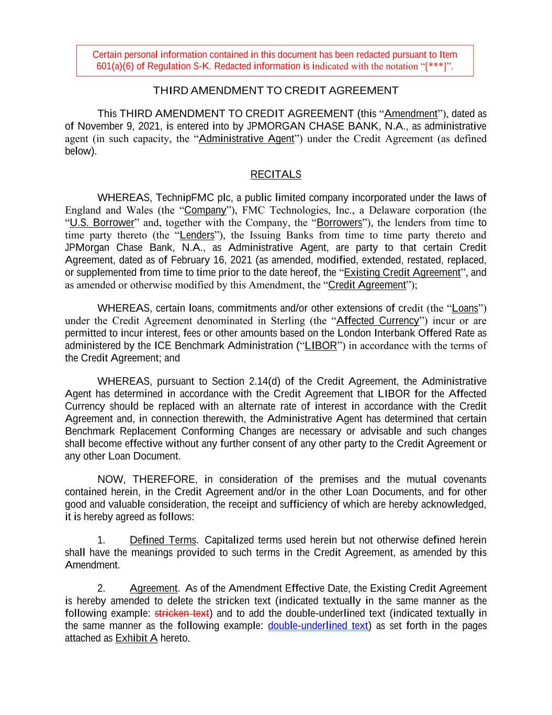
THIRD AMENDMENT TO CREDIT AGREEMENT This THIRD AMENDMENT TO CREDIT AGREEMENT (this “Amendment”), dated as of November 9, 2021, is entered into by JPMORGAN CHASE BANK, N.A., as administrative agent (in such capacity, the “Administrative Agent”) under the Credit Agreement (as defined below). RECITALS WHEREAS, TechnipFMC plc, a public limited company incorporated under the laws of England and Wales (the “Company”), FMC Technologies, Inc., a Delaware corporation (the “U.S. Borrower” and, together with the Company, the “Borrowers”), the lenders from time to time party thereto (the “Lenders”), the Issuing Banks from time to time party thereto and JPMorgan Chase Bank, N.A., as Administrative Agent, are party to that certain Credit Agreement, dated as of February 16, 2021 (as amended, modified, extended, restated, replaced, or supplemented from time to time prior to the date hereof, the “Existing Credit Agreement”, and as amended or otherwise modified by this Amendment, the “Credit Agreement”); WHEREAS, certain loans, commitments and/or other extensions of credit (the “Loans”) under the Credit Agreement denominated in Sterling (the “Affected Currency”) incur or are permitted to incur interest, fees or other amounts based on the London Interbank Offered Rate as administered by the ICE Benchmark Administration (“LIBOR”) in accordance with the terms of the Credit Agreement; and WHEREAS, pursuant to Section 2.14(d) of the Credit Agreement, the Administrative Agent has determined in accordance with the Credit Agreement that LIBOR for the Affected Currency should be replaced with an alternate rate of interest in accordance with the Credit Agreement and, in connection therewith, the Administrative Agent has determined that certain Benchmark Replacement Conforming Changes are necessary or advisable and such changes shall become effective without any further consent of any other party to the Credit Agreement or any other Loan Document. NOW, THEREFORE, in consideration of the premises and the mutual covenants contained herein, in the Credit Agreement and/or in the other Loan Documents, and for other good and valuable consideration, the receipt and sufficiency of which are hereby acknowledged, it is hereby agreed as follows: 1. Defined Terms. Capitalized terms used herein but not otherwise defined herein shall have the meanings provided to such terms in the Credit Agreement, as amended by this Amendment. 2. Agreement. As of the Amendment Effective Date, the Existing Credit Agreement is hereby amended to delete the stricken text (indicated textually in the same manner as the following example: stricken text) and to add the double-underlined text (indicated textually in the same manner as the following example: double-underlined text) as set forth in the pages attached as Exhibit A hereto. Certain personal information contained in this document has been redacted pursuant to Item 601(a)(6) of Regulation S-K. Redacted information is indicated with the notation “[***]”.

3. Conditions Precedent. This Amendment shall be effective upon delivery to the Borrowers and the Lenders and, in all cases, from and after January 1, 2022 (the “Amendment Effective Date”). 4. Reference to and Effect on the Loan Documents. (a) From and after the Amendment Effective Date, each reference in the Credit Agreement to “hereunder,” “hereof,” “this Agreement” or words of like import and each reference in the other Loan Documents to “Credit Agreement,” “thereunder,” “thereof” or words of like import shall, unless the context otherwise requires, mean and be a reference to the Credit Agreement as amended by this Amendment. This Amendment is a Loan Document. (b) The execution, delivery and effectiveness of this Amendment shall not, except as expressly provided herein, operate as a waiver of any right, power or remedy of any Lender or the Administrative Agent under any of the Loan Documents, nor constitute a waiver of any provision of any of the Loan Documents. (c) In the event of any conflict between the terms of this Amendment and the terms of the Credit Agreement or the other Loan Documents, the terms hereof shall control. 5. Governing Law; Jurisdiction; Consent to Service of Process; Waiver of Jury Trial, Etc. (a) This Amendment and any claim, controversy, dispute, or cause of action (whether in contract or tort or otherwise) based upon, arising out of or relating to this Amendment and the transactions contemplated hereby shall be governed by, and construed in accordance with, the law of the State of New York. (b) SECTIONS 9.09(b)–(e) and 9.10 OF THE CREDIT AGREEMENT ARE HEREBY INCORPORATED HEREIN MUTATIS MUTANDIS AS IF SUCH SECTIONS WERE SET FORTH IN FULL HEREIN. 6. Amendments; Headings; Severability. This Amendment may not be amended nor may any provision hereof be waived except pursuant to a writing signed by the Administrative Agent and, if the terms of the Credit Agreement would so require, the other Loan Parties. The Section headings used herein are for convenience of reference only, are not part of this Amendment and are not to affect the construction of, or to be taken into consideration in interpreting this Amendment. Any provision of this Amendment held to be invalid, illegal or unenforceable in any jurisdiction shall, as to such jurisdiction, be ineffective to the extent of such invalidity, illegality or unenforceability without affecting the validity, legality and enforceability of the remaining provisions hereof, and the invalidity of a particular provision in a particular jurisdiction shall not invalidate such provision in any other jurisdiction. The Administrative Agent shall endeavor in good-faith to replace the invalid, illegal or unenforceable provisions with valid provisions, the economic effect of which comes as close as possible to that of the invalid, illegal or unenforceable provisions.

2

Executed and delivered as of the date first above written by: JPMORGAN CHASE BANK, N.A., as Administrative Agent By: /s/ Anson Williams Name: Anson Williams Title: Authorized Signatory

[Signature Page to Third Amendment]

Exhibit A (Attached hereto)

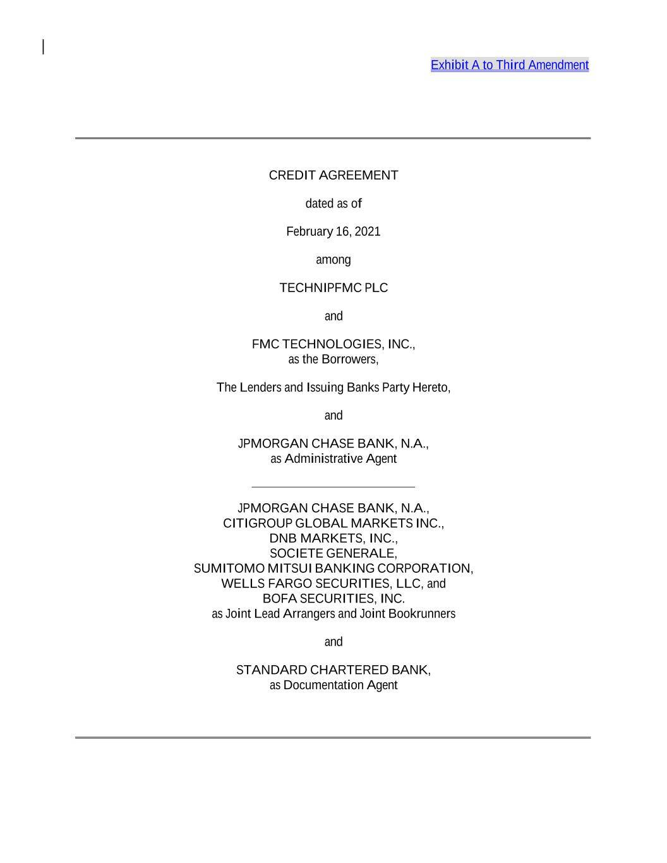
Exhibit A to Third Amendment CREDIT AGREEMENT dated as of February 16, 2021 among TECHNIPFMC PLC and FMC TECHNOLOGIES, INC., as the Borrowers, The Lenders and Issuing Banks Party Hereto, and JPMORGAN CHASE BANK, N.A., as Administrative Agent JPMORGAN CHASE BANK, N.A., CITIGROUP GLOBAL MARKETS INC., DNB MARKETS, INC., SOCIETE GENERALE, SUMITOMO MITSUI BANKING CORPORATION, WELLS FARGO SECURITIES, LLC, and BOFA SECURITIES, INC. as Joint Lead Arrangers and Joint Bookrunners and STANDARD CHARTERED BANK, as Documentation Agent

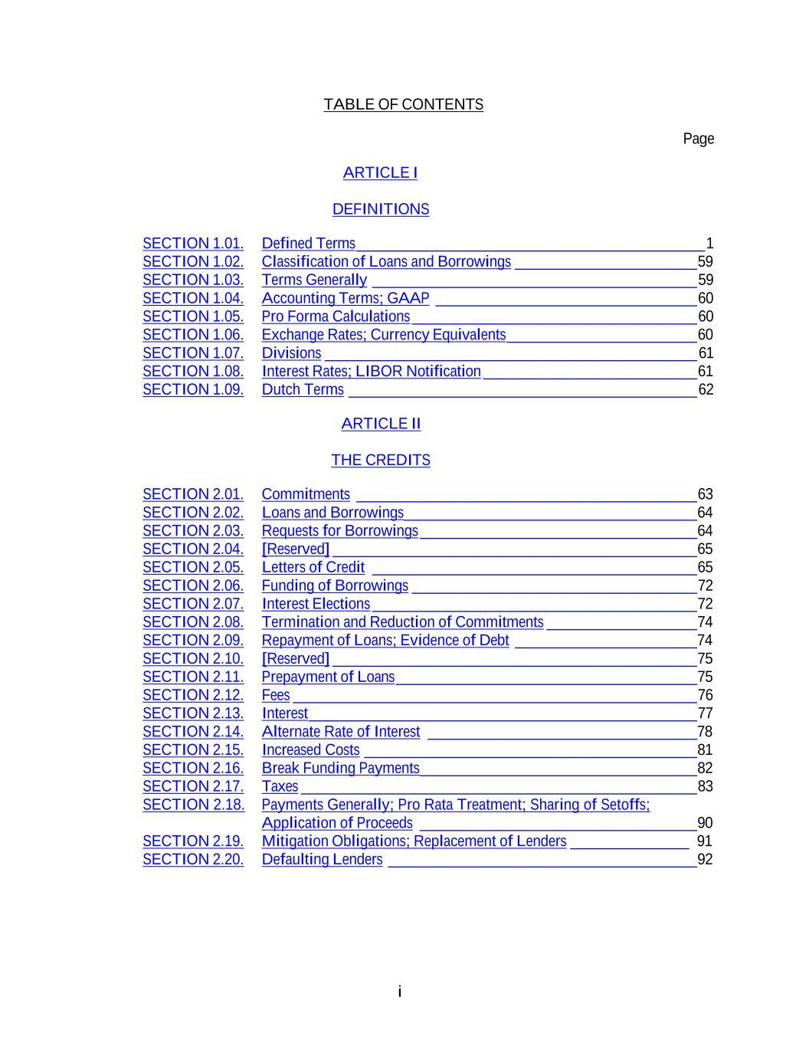
i TABLE OF CONTENTS ARTICLE I Page DEFINITIONS SECTION 1.01. Defined Terms ____________________________________________ 1 SECTION 1.02. Classification of Loans and Borrowings _______________________ 59 SECTION 1.03. Terms Generally _________________________________________ 59 SECTION 1.04. Accounting Terms; GAAP _________________________________ 60 SECTION 1.05. Pro Forma Calculations ____________________________________ 60 SECTION 1.06. Exchange Rates; Currency Equivalents ________________________ 60 SECTION 1.07. Divisions _______________________________________________ 61 SECTION 1.08. Interest Rates; LIBOR Notification ___________________________ 61 SECTION 1.09. Dutch Terms ____________________________________________ 62 ARTICLE II THE CREDITS SECTION 2.01. Commitments ___________________________________________ 63 SECTION 2.02. Loans and Borrowings _____________________________________ 64 SECTION 2.03. Requests for Borrowings ___________________________________ 64 SECTION 2.04. [Reserved] ______________________________________________ 65 SECTION 2.05. Letters of Credit _________________________________________ 65 SECTION 2.06. Funding of Borrowings ____________________________________ 72 SECTION 2.07. Interest Elections _________________________________________ 72 SECTION 2.08. Termination and Reduction of Commitments ___________________ 74 SECTION 2.09. Repayment of Loans; Evidence of Debt _______________________74 SECTION 2.10. [Reserved] ______________________________________________ 75 SECTION 2.11. Prepayment of Loans ______________________________________ 75 SECTION 2.12. Fees ___________________________________________________ 76 SECTION 2.13. Interest _________________________________________________ 77 SECTION 2.14. Alternate Rate of Interest __________________________________78 SECTION 2.15. Increased Costs __________________________________________ 81 SECTION 2.16. Break Funding Payments ___________________________________ 82 SECTION 2.17. Taxes __________________________________________________ 83 SECTION 2.18. Payments Generally; Pro Rata Treatment; Sharing of Setoffs; Application of Proceeds ___________________________________ 90 SECTION 2.19. Mitigation Obligations; Replacement of Lenders _______________ 91 SECTION 2.20. Defaulting Lenders _______________________________________ 92

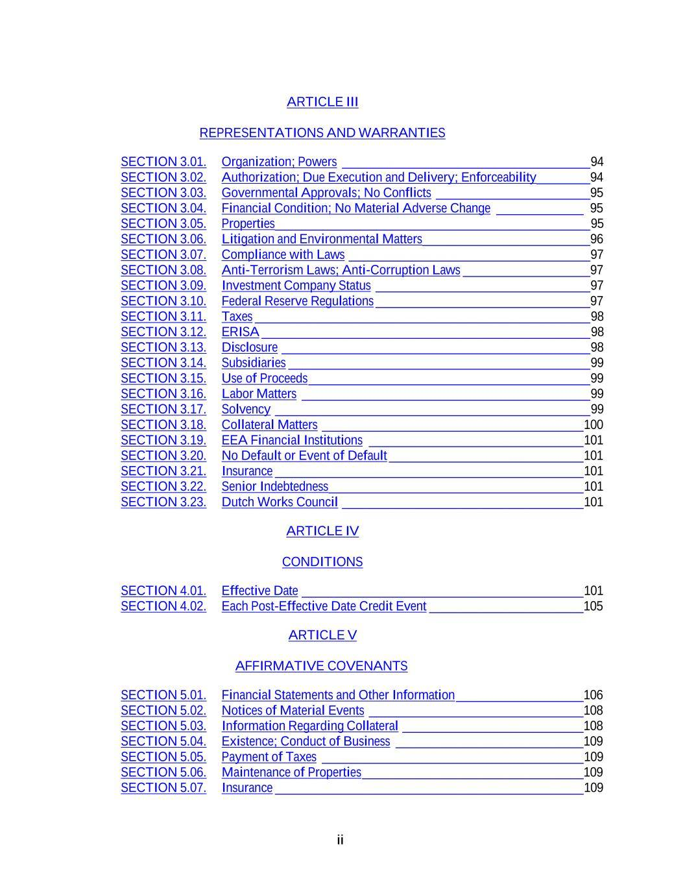
ii ARTICLE III REPRESENTATIONS AND WARRANTIES SECTION 3.01. Organization; Powers _____________________________________ 94 SECTION 3.02. Authorization; Due Execution and Delivery; Enforceability ________94 SECTION 3.03. Governmental Approvals; No Conflicts _______________________95 SECTION 3.04. Financial Condition; No Material Adverse Change _____________ 95 SECTION 3.05. Properties _______________________________________________ 95 SECTION 3.06. Litigation and Environmental Matters _________________________96 SECTION 3.07. Compliance with Laws ____________________________________ 97 SECTION 3.08. Anti-Terrorism Laws; Anti-Corruption Laws ___________________97 SECTION 3.09. Investment Company Status ________________________________ 97 SECTION 3.10. Federal Reserve Regulations ________________________________97 SECTION 3.11. Taxes __________________________________________________ 98 SECTION 3.12. ERISA _________________________________________________ 98 SECTION 3.13. Disclosure ______________________________________________ 98 SECTION 3.14. Subsidiaries _____________________________________________ 99 SECTION 3.15. Use of Proceeds __________________________________________ 99 SECTION 3.16. Labor Matters ___________________________________________ 99 SECTION 3.17. Solvency _______________________________________________ 99 SECTION 3.18. Collateral Matters _______________________________________ 100 SECTION 3.19. EEA Financial Institutions ________________________________ 101 SECTION 3.20. No Default or Event of Default _____________________________ 101 SECTION 3.21. Insurance ______________________________________________ 101 SECTION 3.22. Senior Indebtedness ______________________________________ 101 SECTION 3.23. Dutch Works Council ____________________________________ 101 ARTICLE IV CONDITIONS SECTION 4.01. Effective Date __________________________________________ 101 SECTION 4.02. Each Post-Effective Date Credit Event _______________________105 ARTICLE V AFFIRMATIVE COVENANTS SECTION 5.01. Financial Statements and Other Information ___________________106 SECTION 5.02. Notices of Material Events ________________________________108 SECTION 5.03. Information Regarding Collateral ___________________________108 SECTION 5.04. Existence; Conduct of Business ____________________________109 SECTION 5.05. Payment of Taxes _______________________________________ 109 SECTION 5.06. Maintenance of Properties _________________________________109 SECTION 5.07. Insurance ______________________________________________ 109

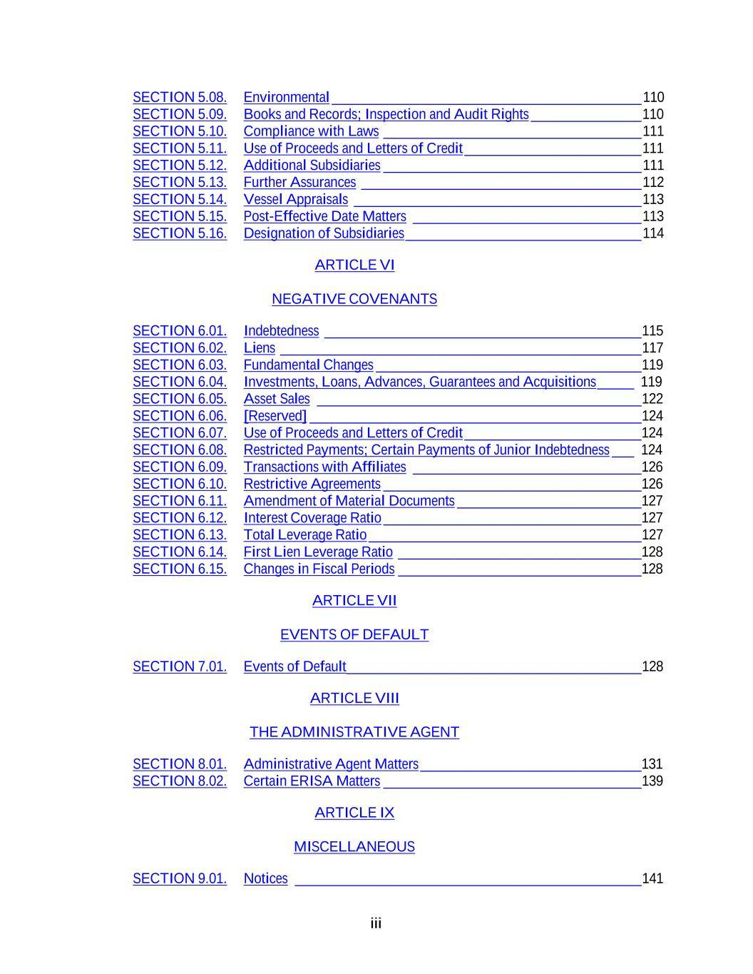
iii SECTION 5.08. Environmental __________________________________________ 110 SECTION 5.09. Books and Records; Inspection and Audit Rights _______________ 110 SECTION 5.10. Compliance with Laws ___________________________________ 111 SECTION 5.11. Use of Proceeds and Letters of Credit ________________________ 111 SECTION 5.12. Additional Subsidiaries ___________________________________ 111 SECTION 5.13. Further Assurances ______________________________________ 112 SECTION 5.14. Vessel Appraisals _______________________________________ 113 SECTION 5.15. Post-Effective Date Matters _______________________________ 113 SECTION 5.16. Designation of Subsidiaries ________________________________ 114 ARTICLE VI NEGATIVE COVENANTS SECTION 6.01. Indebtedness ___________________________________________ 115 SECTION 6.02. Liens _________________________________________________ 117 SECTION 6.03. Fundamental Changes ____________________________________ 119 SECTION 6.04. Investments, Loans, Advances, Guarantees and Acquisitions _____ 119 SECTION 6.05. Asset Sales ____________________________________________ 122 SECTION 6.06. [Reserved] _____________________________________________ 124 SECTION 6.07. Use of Proceeds and Letters of Credit ________________________124 SECTION 6.08. Restricted Payments; Certain Payments of Junior Indebtedness ___ 124 SECTION 6.09. Transactions with Affiliates _______________________________126 SECTION 6.10. Restrictive Agreements ___________________________________126 SECTION 6.11. Amendment of Material Documents _________________________127 SECTION 6.12. Interest Coverage Ratio ___________________________________127 SECTION 6.13. Total Leverage Ratio _____________________________________ 127 SECTION 6.14. First Lien Leverage Ratio _________________________________128 SECTION 6.15. Changes in Fiscal Periods _________________________________128 ARTICLE VII EVENTS OF DEFAULT SECTION 7.01. Events of Default ________________________________________ 128 ARTICLE VIII THE ADMINISTRATIVE AGENT SECTION 8.01. Administrative Agent Matters ______________________________131 SECTION 8.02. Certain ERISA Matters ___________________________________ 139 ARTICLE IX MISCELLANEOUS SECTION 9.01. Notices _______________________________________________ 141

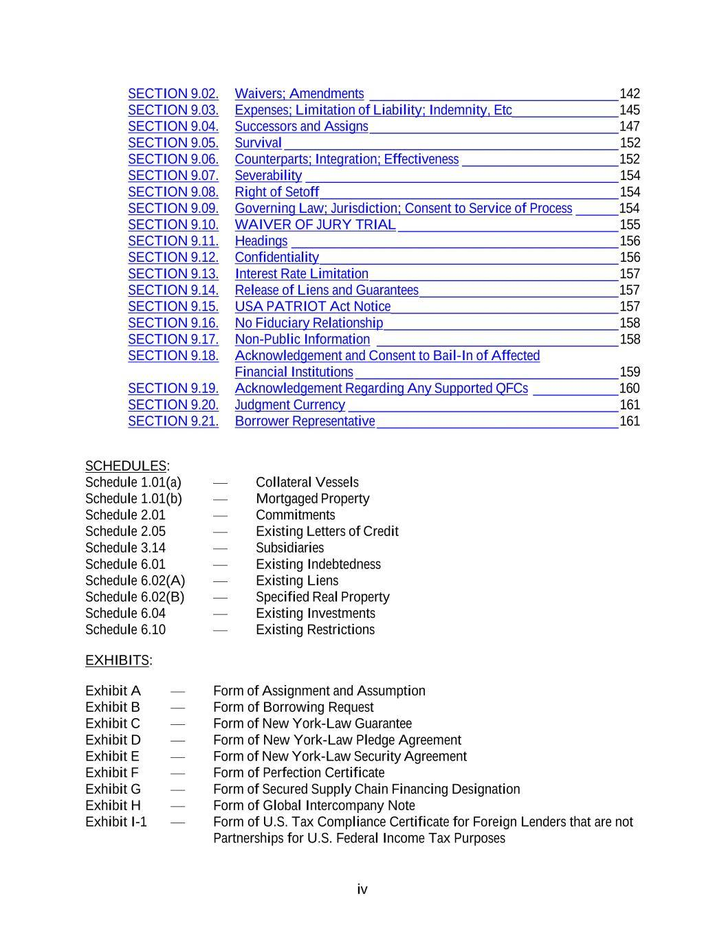
iv SECTION 9.02. Waivers; Amendments ___________________________________ 142 SECTION 9.03. Expenses; Limitation of Liability; Indemnity, Etc_______________ 145 SECTION 9.04. Successors and Assigns ___________________________________ 147 SECTION 9.05. Survival _______________________________________________ 152 SECTION 9.06. Counterparts; Integration; Effectiveness ______________________ 152 SECTION 9.07. Severability ____________________________________________ 154 SECTION 9.08. Right of Setoff __________________________________________ 154 SECTION 9.09. Governing Law; Jurisdiction; Consent to Service of Process ______ 154 SECTION 9.10. WAIVER OF JURY TRIAL _______________________________ 155 SECTION 9.11. Headings ______________________________________________ 156 SECTION 9.12. Confidentiality __________________________________________ 156 SECTION 9.13. Interest Rate Limitation ___________________________________ 157 SECTION 9.14. Release of Liens and Guarantees ____________________________ 157 SECTION 9.15. USA PATRIOT Act Notice ________________________________ 157 SECTION 9.16. No Fiduciary Relationship _________________________________ 158 SECTION 9.17. Non-Public Information __________________________________ 158 SECTION 9.18. Acknowledgement and Consent to Bail-In of Affected Financial Institutions _____________________________________ 159 SECTION 9.19. Acknowledgement Regarding Any Supported QFCs ____________ 160 SECTION 9.20. Judgment Currency ______________________________________ 161 SECTION 9.21. Borrower Representative __________________________________ 161 SCHEDULES: Schedule 1.01(a) — Collateral Vessels Schedule 1.01(b) — Mortgaged Property Schedule 2.01 — Commitments Schedule 2.05 — Existing Letters of Credit Schedule 3.14 — Subsidiaries Schedule 6.01 — Existing Indebtedness Schedule 6.02(A) — Existing Liens Schedule 6.02(B) — Specified Real Property Schedule 6.04 — Existing Investments Schedule 6.10 — Existing Restrictions EXHIBITS: Exhibit A — Form of Assignment and Assumption Exhibit B — Form of Borrowing Request Exhibit C — Form of New York-Law Guarantee Exhibit D — Form of New York-Law Pledge Agreement Exhibit E — Form of New York-Law Security Agreement Exhibit F — Form of Perfection Certificate Exhibit G — Form of Secured Supply Chain Financing Designation Exhibit H — Form of Global Intercompany Note Exhibit I-1 — Form of U.S. Tax Compliance Certificate for Foreign Lenders that are not Partnerships for U.S. Federal Income Tax Purposes

v Exhibit I-2 — Form of U.S. Tax Compliance Certificate for Non-U.S. Participants that are Partnerships for U.S. Federal Income Tax Purposes Exhibit I-3 — Form of U.S. Tax Compliance Certificate for Non-U.S. Participants that are not Partnerships for U.S. Federal Income Tax Purposes Exhibit I-4 — Form of U.S. Tax Compliance Certificate for Foreign Lenders that are Partnerships for U.S. Federal Income Tax Purposes Exhibit J — Form of Note Exhibit K — Form of Solvency Certificate

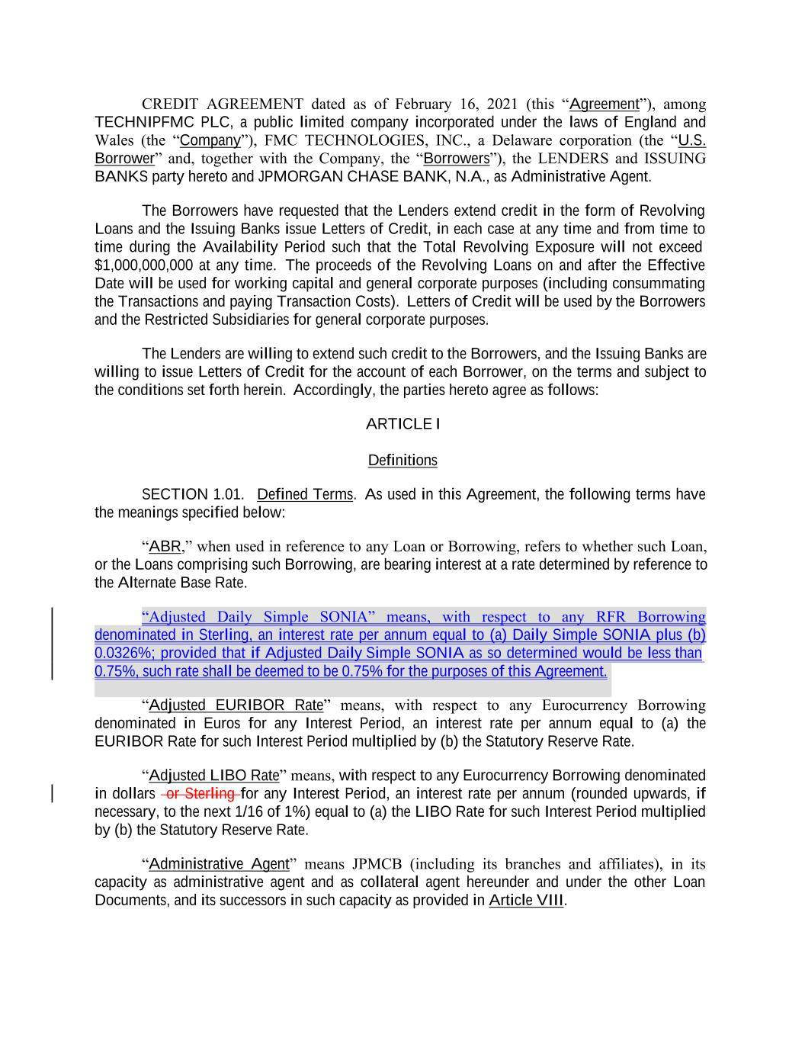
CREDIT AGREEMENT dated as of February 16, 2021 (this “Agreement”), among TECHNIPFMC PLC, a public limited company incorporated under the laws of England and Wales (the “Company”), FMC TECHNOLOGIES, INC., a Delaware corporation (the “U.S. Borrower” and, together with the Company, the “Borrowers”), the LENDERS and ISSUING BANKS party hereto and JPMORGAN CHASE BANK, N.A., as Administrative Agent. The Borrowers have requested that the Lenders extend credit in the form of Revolving Loans and the Issuing Banks issue Letters of Credit, in each case at any time and from time to time during the Availability Period such that the Total Revolving Exposure will not exceed $1,000,000,000 at any time. The proceeds of the Revolving Loans on and after the Effective Date will be used for working capital and general corporate purposes (including consummating the Transactions and paying Transaction Costs). Letters of Credit will be used by the Borrowers and the Restricted Subsidiaries for general corporate purposes. The Lenders are willing to extend such credit to the Borrowers, and the Issuing Banks are willing to issue Letters of Credit for the account of each Borrower, on the terms and subject to the conditions set forth herein. Accordingly, the parties hereto agree as follows: ARTICLE I Definitions SECTION 1.01. Defined Terms. As used in this Agreement, the following terms have the meanings specified below: “ABR,” when used in reference to any Loan or Borrowing, refers to whether such Loan, or the Loans comprising such Borrowing, are bearing interest at a rate determined by reference to the Alternate Base Rate. “Adjusted Daily Simple SONIA” means, with respect to any RFR Borrowing denominated in Sterling, an interest rate per annum equal to (a) Daily Simple SONIA plus (b) 0.0326%; provided that if Adjusted Daily Simple SONIA as so determined would be less than “Adjusted EURIBOR Rate” means, with respect to any Eurocurrency Borrowing denominated in Euros for any Interest Period, an interest rate per annum equal to (a) the EURIBOR Rate for such Interest Period multiplied by (b) the Statutory Reserve Rate. “Adjusted LIBO Rate” means, with respect to any Eurocurrency Borrowing denominated in dollars or Sterling for any Interest Period, an interest rate per annum (rounded upwards, if necessary, to the next 1/16 of 1%) equal to (a) the LIBO Rate for such Interest Period multiplied by (b) the Statutory Reserve Rate. “Administrative Agent” means JPMCB (including its branches and affiliates), in its capacity as administrative agent and as collateral agent hereunder and under the other Loan Documents, and its successors in such capacity as provided in Article VIII. 0.75%, such rate shall be deemed to be 0.75% for the purposes of this Agreement.

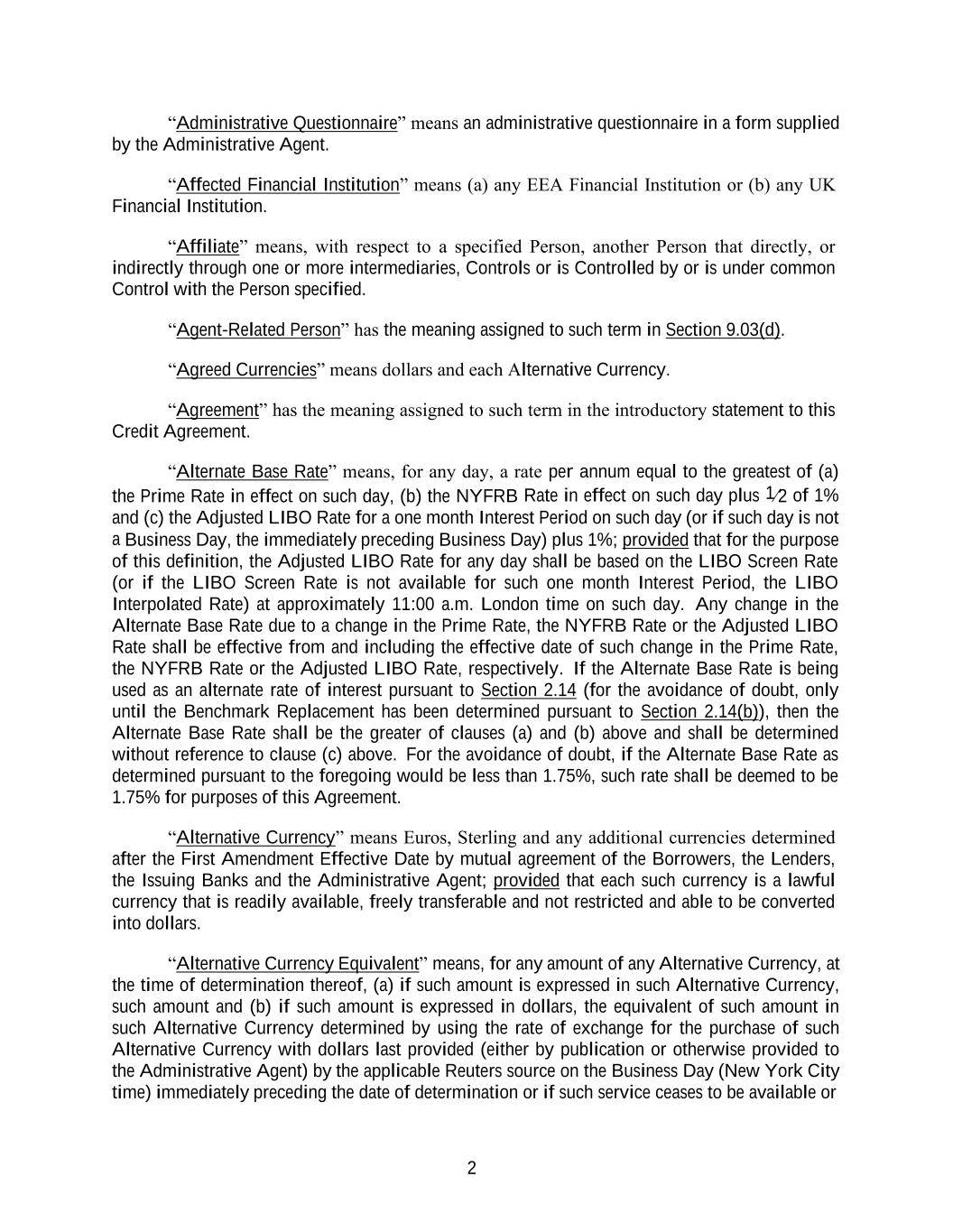
2 “Administrative Questionnaire” means an administrative questionnaire in a form supplied by the Administrative Agent. “Affected Financial Institution” means (a) any EEA Financial Institution or (b) any UK Financial Institution. “Affiliate” means, with respect to a specified Person, another Person that directly, or indirectly through one or more intermediaries, Controls or is Controlled by or is under common Control with the Person specified. “Agent-Related Person” has the meaning assigned to such term in Section 9.03(d). “Agreed Currencies” means dollars and each Alternative Currency. “Agreement” has the meaning assigned to such term in the introductory statement to this Credit Agreement. “Alternate Base Rate” means, for any day, a rate per annum equal to the greatest of (a) the Prime Rate in effect on such day, (b) the NYFRB Rate in effect on such day plus 1⁄2 of 1% and (c) the Adjusted LIBO Rate for a one month Interest Period on such day (or if such day is not a Business Day, the immediately preceding Business Day) plus 1%; provided that for the purpose of this definition, the Adjusted LIBO Rate for any day shall be based on the LIBO Screen Rate (or if the LIBO Screen Rate is not available for such one month Interest Period, the LIBO Interpolated Rate) at approximately 11:00 a.m. London time on such day. Any change in the Alternate Base Rate due to a change in the Prime Rate, the NYFRB Rate or the Adjusted LIBO Rate shall be effective from and including the effective date of such change in the Prime Rate, the NYFRB Rate or the Adjusted LIBO Rate, respectively. If the Alternate Base Rate is being used as an alternate rate of interest pursuant to Section 2.14 (for the avoidance of doubt, only until the Benchmark Replacement has been determined pursuant to Section 2.14(b)), then the Alternate Base Rate shall be the greater of clauses (a) and (b) above and shall be determined without reference to clause (c) above. For the avoidance of doubt, if the Alternate Base Rate as determined pursuant to the foregoing would be less than 1.75%, such rate shall be deemed to be 1.75% for purposes of this Agreement. “Alternative Currency” means Euros, Sterling and any additional currencies determined after the First Amendment Effective Date by mutual agreement of the Borrowers, the Lenders, the Issuing Banks and the Administrative Agent; provided that each such currency is a lawful currency that is readily available, freely transferable and not restricted and able to be converted into dollars. “Alternative Currency Equivalent” means, for any amount of any Alternative Currency, at the time of determination thereof, (a) if such amount is expressed in such Alternative Currency, such amount and (b) if such amount is expressed in dollars, the equivalent of such amount in such Alternative Currency determined by using the rate of exchange for the purchase of such Alternative Currency with dollars last provided (either by publication or otherwise provided to the Administrative Agent) by the applicable Reuters source on the Business Day (New York City time) immediately preceding the date of determination or if such service ceases to be available or

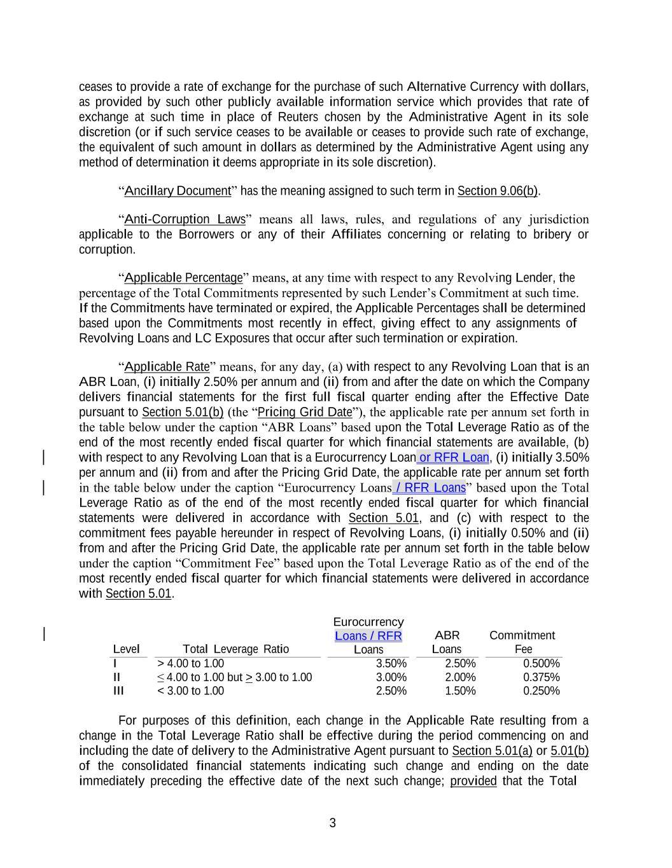
3 ceases to provide a rate of exchange for the purchase of such Alternative Currency with dollars, as provided by such other publicly available information service which provides that rate of exchange at such time in place of Reuters chosen by the Administrative Agent in its sole discretion (or if such service ceases to be available or ceases to provide such rate of exchange, the equivalent of such amount in dollars as determined by the Administrative Agent using any method of determination it deems appropriate in its sole discretion). “Ancillary Document” has the meaning assigned to such term in Section 9.06(b). “Anti-Corruption Laws” means all laws, rules, and regulations of any jurisdiction applicable to the Borrowers or any of their Affiliates concerning or relating to bribery or corruption. “Applicable Percentage” means, at any time with respect to any Revolving Lender, the percentage of the Total Commitments represented by such Lender’s Commitment at such time. If the Commitments have terminated or expired, the Applicable Percentages shall be determined based upon the Commitments most recently in effect, giving effect to any assignments of Revolving Loans and LC Exposures that occur after such termination or expiration. “Applicable Rate” means, for any day, (a) with respect to any Revolving Loan that is an ABR Loan, (i) initially 2.50% per annum and (ii) from and after the date on which the Company delivers financial statements for the first full fiscal quarter ending after the Effective Date pursuant to Section 5.01(b) (the “Pricing Grid Date”), the applicable rate per annum set forth in the table below under the caption “ABR Loans” based upon the Total Leverage Ratio as of the end of the most recently ended fiscal quarter for which financial statements are available, (b) with respect to any Revolving Loan that is a Eurocurrency Loan or RFR Loan, (i) initially 3.50% per annum and (ii) from and after the Pricing Grid Date, the applicable rate per annum set forth in the table below under the caption “Eurocurrency Loans / RFR Loans” based upon the Total Leverage Ratio as of the end of the most recently ended fiscal quarter for which financial statements were delivered in accordance with Section 5.01, and (c) with respect to the commitment fees payable hereunder in respect of Revolving Loans, (i) initially 0.50% and (ii) from and after the Pricing Grid Date, the applicable rate per annum set forth in the table below under the caption “Commitment Fee” based upon the Total Leverage Ratio as of the end of the most recently ended fiscal quarter for which financial statements were delivered in accordance with Section 5.01. For purposes of this definition, each change in the Applicable Rate resulting from a change in the Total Leverage Ratio shall be effective during the period commencing on and including the date of delivery to the Administrative Agent pursuant to Section 5.01(a) or 5.01(b) of the consolidated financial statements indicating such change and ending on the date immediately preceding the effective date of the next such change; provided that the Total Level Total Leverage Ratio Eurocurrency Loans / RFR Loans ABR Loans Commitment Fee I > 4.00 to 1.00 3.50% 2.50% 0.500% II ≤ 4.00 to 1.00 but > 3.00 to 1.00 3.00% 2.00% 0.375% III < 3.00 to 1.00 2.50% 1.50% 0.250%

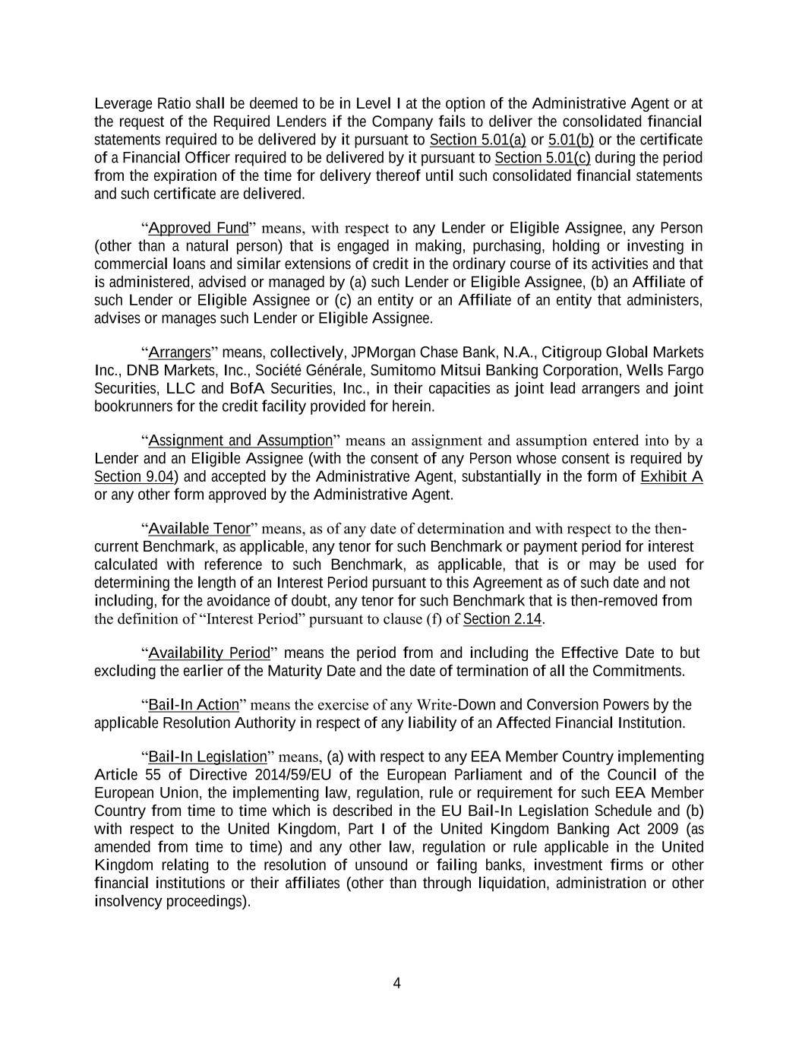
4 Leverage Ratio shall be deemed to be in Level I at the option of the Administrative Agent or at the request of the Required Lenders if the Company fails to deliver the consolidated financial statements required to be delivered by it pursuant to Section 5.01(a) or 5.01(b) or the certificate of a Financial Officer required to be delivered by it pursuant to Section 5.01(c) during the period from the expiration of the time for delivery thereof until such consolidated financial statements and such certificate are delivered. “Approved Fund” means, with respect to any Lender or Eligible Assignee, any Person (other than a natural person) that is engaged in making, purchasing, holding or investing in commercial loans and similar extensions of credit in the ordinary course of its activities and that is administered, advised or managed by (a) such Lender or Eligible Assignee, (b) an Affiliate of such Lender or Eligible Assignee or (c) an entity or an Affiliate of an entity that administers, advises or manages such Lender or Eligible Assignee. “Arrangers” means, collectively, JPMorgan Chase Bank, N.A., Citigroup Global Markets Inc., DNB Markets, Inc., Société Générale, Sumitomo Mitsui Banking Corporation, Wells Fargo Securities, LLC and BofA Securities, Inc., in their capacities as joint lead arrangers and joint bookrunners for the credit facility provided for herein. “Assignment and Assumption” means an assignment and assumption entered into by a Lender and an Eligible Assignee (with the consent of any Person whose consent is required by Section 9.04) and accepted by the Administrative Agent, substantially in the form of Exhibit A or any other form approved by the Administrative Agent. “Available Tenor” means, as of any date of determination and with respect to the then- current Benchmark, as applicable, any tenor for such Benchmark or payment period for interest calculated with reference to such Benchmark, as applicable, that is or may be used for determining the length of an Interest Period pursuant to this Agreement as of such date and not including, for the avoidance of doubt, any tenor for such Benchmark that is then-removed from the definition of “Interest Period” pursuant to clause (f) of Section 2.14. “Availability Period” means the period from and including the Effective Date to but excluding the earlier of the Maturity Date and the date of termination of all the Commitments. “Bail-In Action” means the exercise of any Write-Down and Conversion Powers by the applicable Resolution Authority in respect of any liability of an Affected Financial Institution. “Bail-In Legislation” means, (a) with respect to any EEA Member Country implementing Article 55 of Directive 2014/59/EU of the European Parliament and of the Council of the European Union, the implementing law, regulation, rule or requirement for such EEA Member Country from time to time which is described in the EU Bail-In Legislation Schedule and (b) with respect to the United Kingdom, Part I of the United Kingdom Banking Act 2009 (as amended from time to time) and any other law, regulation or rule applicable in the United Kingdom relating to the resolution of unsound or failing banks, investment firms or other financial institutions or their affiliates (other than through liquidation, administration or other insolvency proceedings).

5 “Bank Levy” means any amount payable by any Lender or any of its Affiliates on the basis of, or in relation to, its balance sheet or capital base or any part of that person or its liabilities or minimum regulatory capital or any combination thereof, including, without limitation, the UK bank levy contained in the Finance Act 2011, the French taxe pour le financement du fonds de soutien aux collectivités territoriales as set out in Article 235 ter ZE bis of the French Tax Code, the German bank levy as set out in the German Restructuring Fund Act 2010 (Restrukturierungsfondsgesetz), the Spanish bank levy (Impuesto sobre los Depósitos en las Entidades de Crédito) as set out in the Law 16/2012 of 27 December 2012, or any levy or tax with a similar basis or a similar purpose or any financial activities taxes (or other levies) of a kind imposed by any jurisdiction in the form existing at the Effective Date and/or which has been formally announced as proposed as at the Effective Date, or (if applicable) as at the date the relevant Lender accedes as a Lender to this Agreement. “Bankruptcy Code” means Title 11 of the United States Code entitled “Bankruptcy,” as now or hereafter in effect, or any successor thereto. “Bankruptcy Event” means, with respect to any Person, such Person becomes the subject of a voluntary or involuntary bankruptcy or insolvency proceeding, or has had a receiver, conservator, trustee, administrator, custodian, assignee for the benefit of creditors or similar Person charged with the reorganization or liquidation of its business appointed for it, or, in the good faith determination of the Administrative Agent, has taken any action in furtherance of, or indicating its consent to, approval of, or acquiescence in, any such proceeding or appointment or has had any order for relief in such proceeding entered in respect thereof; provided that a Bankruptcy Event shall not result solely by virtue of any ownership interest, or the acquisition of any ownership interest, in such Person by a Governmental Authority or instrumentality thereof, unless such ownership interest results in or provides such Person with immunity from the jurisdiction of courts within the United States or from the enforcement of judgments or writs of attachment on its assets or permits such Person (or such Governmental Authority or instrumentality) to reject, repudiate, disavow or disaffirm any contracts or agreements made by such Person. “Benchmark” means, initially, the Relevant Rate; provided that if a Benchmark Transition Event, a Term SOFR Transition Event, a Term ESTR Transition Event or an Early Opt-in Election, as applicable, and its related Benchmark Replacement Date have occurred with respect to the Relevant Rate or the then-current Benchmark, then “Benchmark” means the applicable Benchmark Replacement to the extent that such Benchmark Replacement has replaced such prior benchmark rate pursuant to clause (b) or clause (c) of Section 2.14. “Benchmark Replacement” means, for any Available Tenor, the first alternative set forth in the order below that can be determined by the Administrative Agent for the applicable Benchmark Replacement Date; provided that, in the case of any Loan denominated in an Other Agreed Currency, “Benchmark Replacement” shall mean the alternative set forth in (3) below: (1)

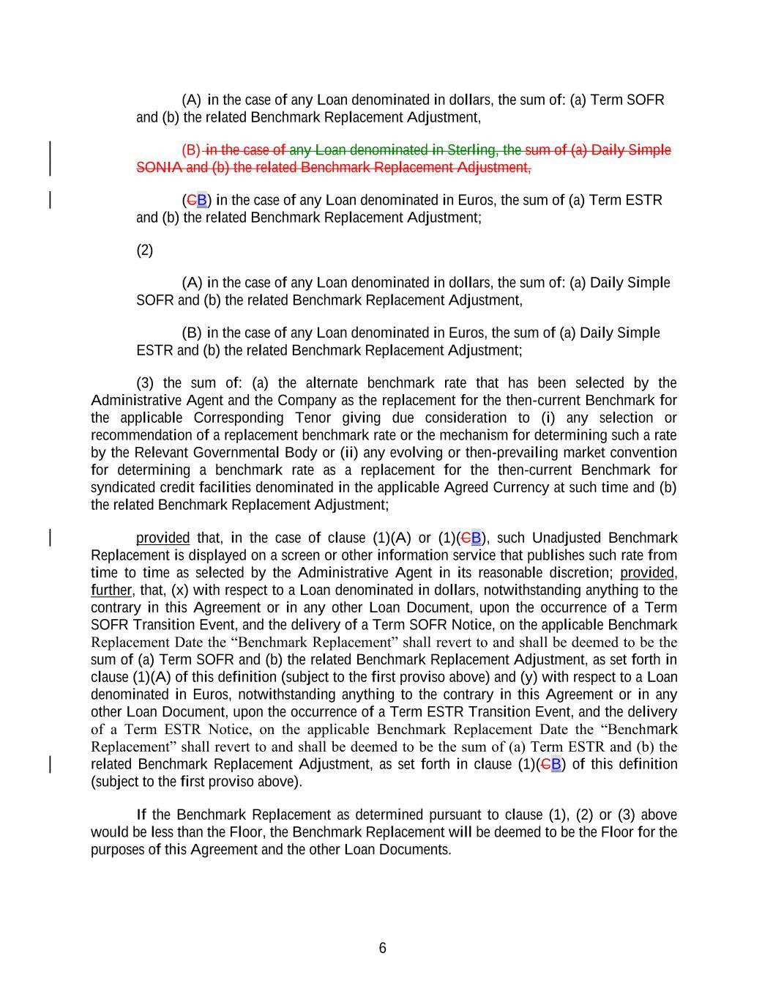
6 (A) in the case of any Loan denominated in dollars, the sum of: (a) Term SOFR and (b) the related Benchmark Replacement Adjustment, (B) in the case of any Loan denominated in Sterling, the sum of (a) Daily Simple SONIA and (b) the related Benchmark Replacement Adjustment, (CB) in the case of any Loan denominated in Euros, the sum of (a) Term ESTR and (b) the related Benchmark Replacement Adjustment; (2) (A) in the case of any Loan denominated in dollars, the sum of: (a) Daily Simple SOFR and (b) the related Benchmark Replacement Adjustment, (B) in the case of any Loan denominated in Euros, the sum of (a) Daily Simple ESTR and (b) the related Benchmark Replacement Adjustment; (3) the sum of: (a) the alternate benchmark rate that has been selected by the Administrative Agent and the Company as the replacement for the then-current Benchmark for the applicable Corresponding Tenor giving due consideration to (i) any selection or recommendation of a replacement benchmark rate or the mechanism for determining such a rate by the Relevant Governmental Body or (ii) any evolving or then-prevailing market convention for determining a benchmark rate as a replacement for the then-current Benchmark for syndicated credit facilities denominated in the applicable Agreed Currency at such time and (b) the related Benchmark Replacement Adjustment; provided that, in the case of clause (1)(A) or (1)(CB), such Unadjusted Benchmark Replacement is displayed on a screen or other information service that publishes such rate from time to time as selected by the Administrative Agent in its reasonable discretion; provided, further, that, (x) with respect to a Loan denominated in dollars, notwithstanding anything to the contrary in this Agreement or in any other Loan Document, upon the occurrence of a Term SOFR Transition Event, and the delivery of a Term SOFR Notice, on the applicable Benchmark Replacement Date the “Benchmark Replacement” shall revert to and shall be deemed to be the sum of (a) Term SOFR and (b) the related Benchmark Replacement Adjustment, as set forth in clause (1)(A) of this definition (subject to the first proviso above) and (y) with respect to a Loan denominated in Euros, notwithstanding anything to the contrary in this Agreement or in any other Loan Document, upon the occurrence of a Term ESTR Transition Event, and the delivery of a Term ESTR Notice, on the applicable Benchmark Replacement Date the “Benchmark Replacement” shall revert to and shall be deemed to be the sum of (a) Term ESTR and (b) the related Benchmark Replacement Adjustment, as set forth in clause (1)(CB) of this definition (subject to the first proviso above). If the Benchmark Replacement as determined pursuant to clause (1), (2) or (3) above would be less than the Floor, the Benchmark Replacement will be deemed to be the Floor for the purposes of this Agreement and the other Loan Documents.

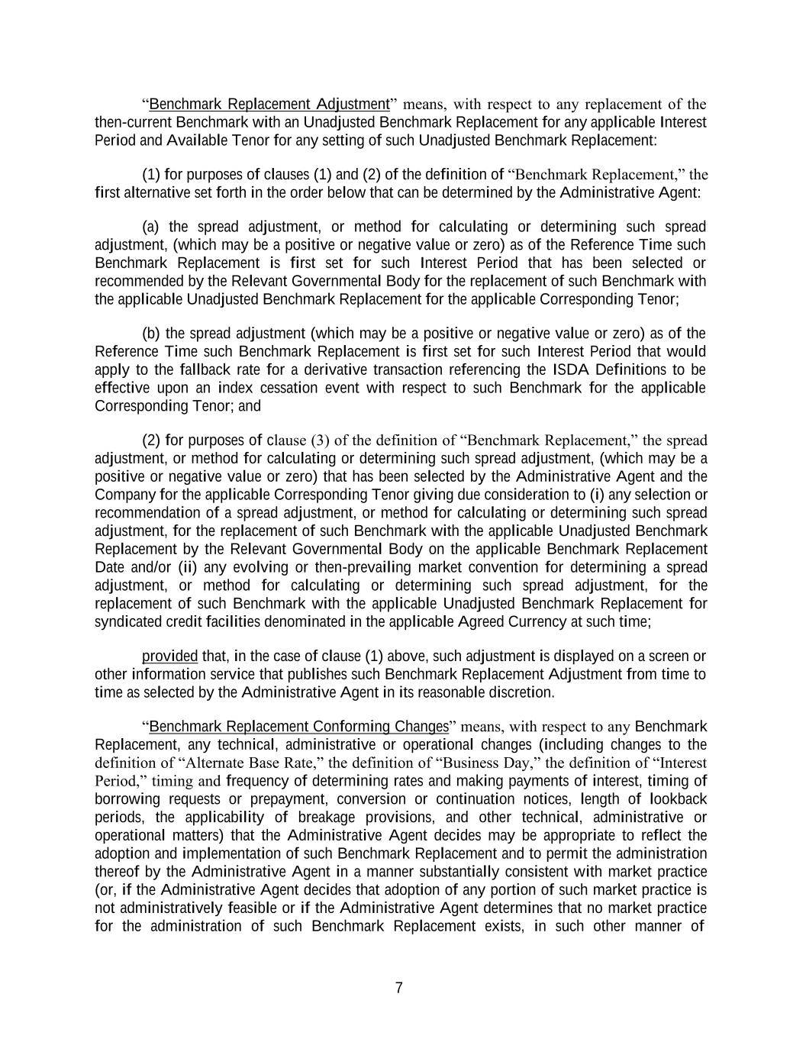
7 “Benchmark Replacement Adjustment” means, with respect to any replacement of the then-current Benchmark with an Unadjusted Benchmark Replacement for any applicable Interest Period and Available Tenor for any setting of such Unadjusted Benchmark Replacement: (1) for purposes of clauses (1) and (2) of the definition of “Benchmark Replacement,” the first alternative set forth in the order below that can be determined by the Administrative Agent: (a) the spread adjustment, or method for calculating or determining such spread adjustment, (which may be a positive or negative value or zero) as of the Reference Time such Benchmark Replacement is first set for such Interest Period that has been selected or recommended by the Relevant Governmental Body for the replacement of such Benchmark with the applicable Unadjusted Benchmark Replacement for the applicable Corresponding Tenor; (b) the spread adjustment (which may be a positive or negative value or zero) as of the Reference Time such Benchmark Replacement is first set for such Interest Period that would apply to the fallback rate for a derivative transaction referencing the ISDA Definitions to be effective upon an index cessation event with respect to such Benchmark for the applicable Corresponding Tenor; and (2) for purposes of clause (3) of the definition of “Benchmark Replacement,” the spread adjustment, or method for calculating or determining such spread adjustment, (which may be a positive or negative value or zero) that has been selected by the Administrative Agent and the Company for the applicable Corresponding Tenor giving due consideration to (i) any selection or recommendation of a spread adjustment, or method for calculating or determining such spread adjustment, for the replacement of such Benchmark with the applicable Unadjusted Benchmark Replacement by the Relevant Governmental Body on the applicable Benchmark Replacement Date and/or (ii) any evolving or then-prevailing market convention for determining a spread adjustment, or method for calculating or determining such spread adjustment, for the replacement of such Benchmark with the applicable Unadjusted Benchmark Replacement for syndicated credit facilities denominated in the applicable Agreed Currency at such time; provided that, in the case of clause (1) above, such adjustment is displayed on a screen or other information service that publishes such Benchmark Replacement Adjustment from time to time as selected by the Administrative Agent in its reasonable discretion. “Benchmark Replacement Conforming Changes” means, with respect to any Benchmark Replacement, any technical, administrative or operational changes (including changes to the definition of “Alternate Base Rate,” the definition of “Business Day,” the definition of “Interest Period,” timing and frequency of determining rates and making payments of interest, timing of borrowing requests or prepayment, conversion or continuation notices, length of lookback periods, the applicability of breakage provisions, and other technical, administrative or operational matters) that the Administrative Agent decides may be appropriate to reflect the adoption and implementation of such Benchmark Replacement and to permit the administration thereof by the Administrative Agent in a manner substantially consistent with market practice (or, if the Administrative Agent decides that adoption of any portion of such market practice is not administratively feasible or if the Administrative Agent determines that no market practice for the administration of such Benchmark Replacement exists, in such other manner of

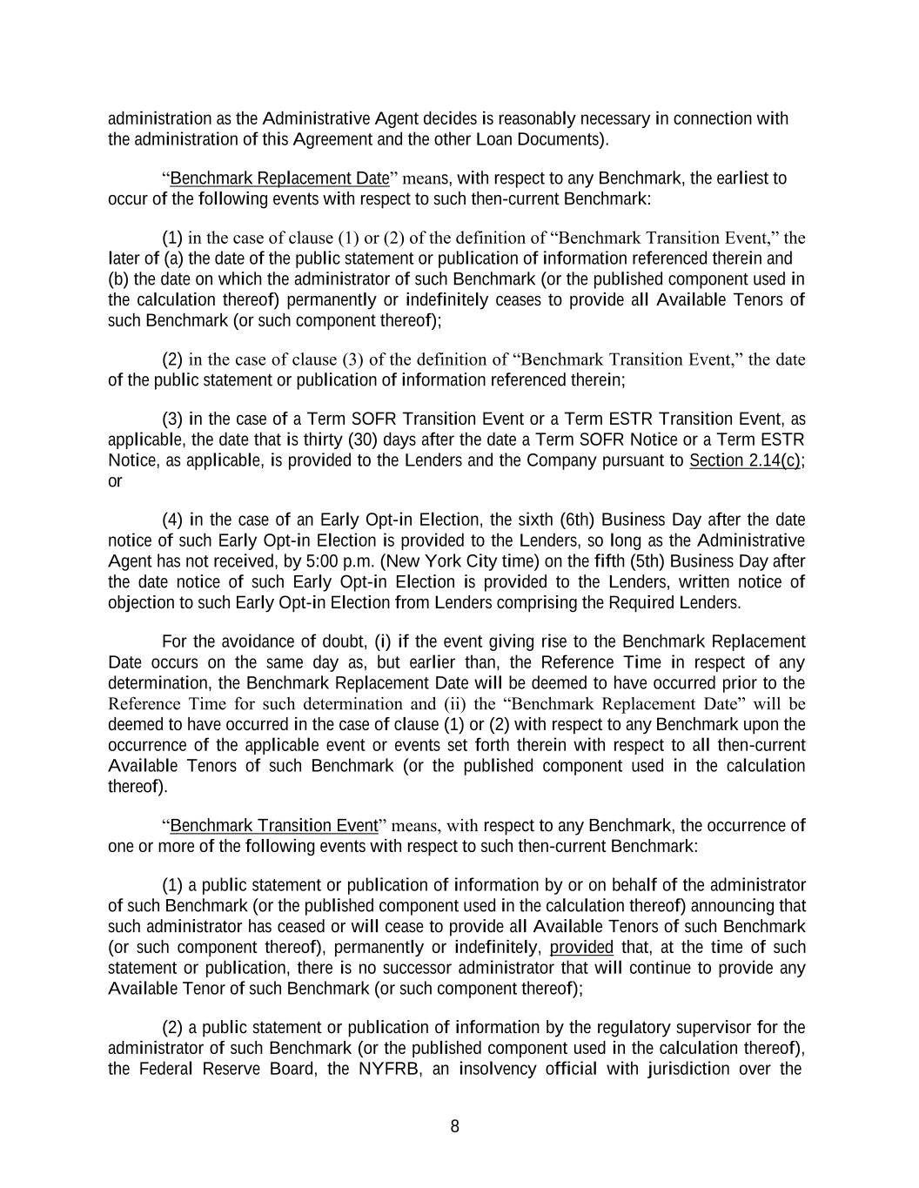
8 administration as the Administrative Agent decides is reasonably necessary in connection with the administration of this Agreement and the other Loan Documents). “Benchmark Replacement Date” means, with respect to any Benchmark, the earliest to occur of the following events with respect to such then-current Benchmark: (1) in the case of clause (1) or (2) of the definition of “Benchmark Transition Event,” the later of (a) the date of the public statement or publication of information referenced therein and (b) the date on which the administrator of such Benchmark (or the published component used in the calculation thereof) permanently or indefinitely ceases to provide all Available Tenors of such Benchmark (or such component thereof); (2) in the case of clause (3) of the definition of “Benchmark Transition Event,” the date of the public statement or publication of information referenced therein; (3) in the case of a Term SOFR Transition Event or a Term ESTR Transition Event, as applicable, the date that is thirty (30) days after the date a Term SOFR Notice or a Term ESTR Notice, as applicable, is provided to the Lenders and the Company pursuant to Section 2.14(c); or (4) in the case of an Early Opt-in Election, the sixth (6th) Business Day after the date notice of such Early Opt-in Election is provided to the Lenders, so long as the Administrative Agent has not received, by 5:00 p.m. (New York City time) on the fifth (5th) Business Day after the date notice of such Early Opt-in Election is provided to the Lenders, written notice of objection to such Early Opt-in Election from Lenders comprising the Required Lenders. For the avoidance of doubt, (i) if the event giving rise to the Benchmark Replacement Date occurs on the same day as, but earlier than, the Reference Time in respect of any determination, the Benchmark Replacement Date will be deemed to have occurred prior to the Reference Time for such determination and (ii) the “Benchmark Replacement Date” will be deemed to have occurred in the case of clause (1) or (2) with respect to any Benchmark upon the occurrence of the applicable event or events set forth therein with respect to all then-current Available Tenors of such Benchmark (or the published component used in the calculation thereof). “Benchmark Transition Event” means, with respect to any Benchmark, the occurrence of one or more of the following events with respect to such then-current Benchmark: (1) a public statement or publication of information by or on behalf of the administrator of such Benchmark (or the published component used in the calculation thereof) announcing that such administrator has ceased or will cease to provide all Available Tenors of such Benchmark (or such component thereof), permanently or indefinitely, provided that, at the time of such statement or publication, there is no successor administrator that will continue to provide any Available Tenor of such Benchmark (or such component thereof); (2) a public statement or publication of information by the regulatory supervisor for the administrator of such Benchmark (or the published component used in the calculation thereof), the Federal Reserve Board, the NYFRB, an insolvency official with jurisdiction over the

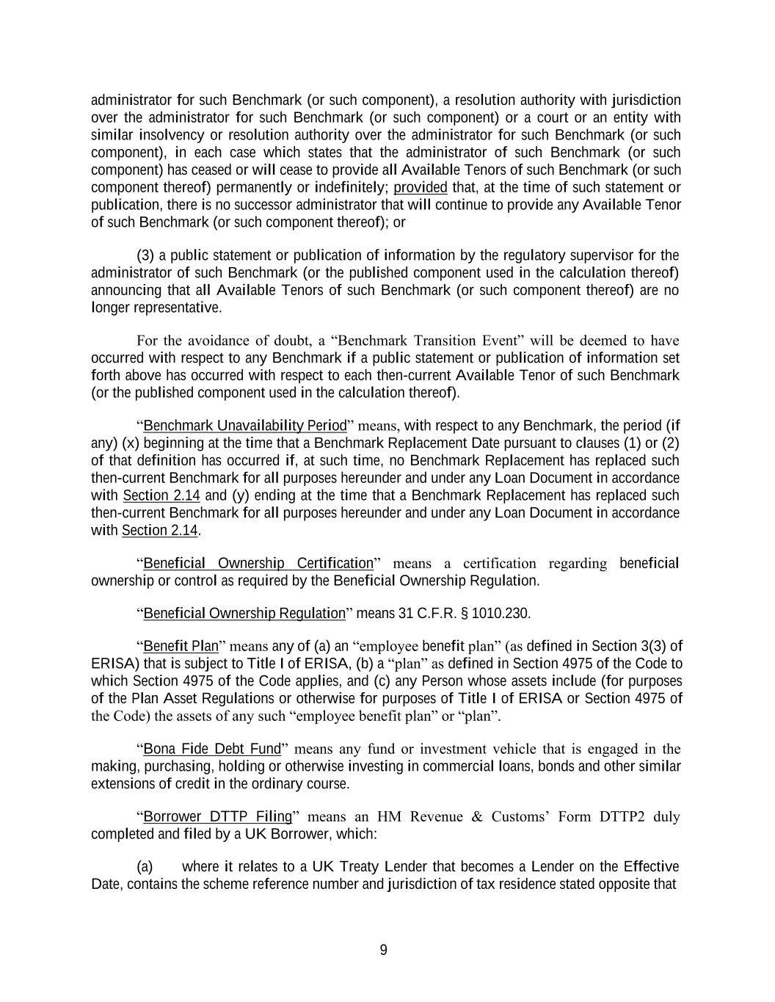
9 administrator for such Benchmark (or such component), a resolution authority with jurisdiction over the administrator for such Benchmark (or such component) or a court or an entity with similar insolvency or resolution authority over the administrator for such Benchmark (or such component), in each case which states that the administrator of such Benchmark (or such component) has ceased or will cease to provide all Available Tenors of such Benchmark (or such component thereof) permanently or indefinitely; provided that, at the time of such statement or publication, there is no successor administrator that will continue to provide any Available Tenor of such Benchmark (or such component thereof); or (3) a public statement or publication of information by the regulatory supervisor for the administrator of such Benchmark (or the published component used in the calculation thereof) announcing that all Available Tenors of such Benchmark (or such component thereof) are no longer representative. For the avoidance of doubt, a “Benchmark Transition Event” will be deemed to have occurred with respect to any Benchmark if a public statement or publication of information set forth above has occurred with respect to each then-current Available Tenor of such Benchmark (or the published component used in the calculation thereof). “Benchmark Unavailability Period” means, with respect to any Benchmark, the period (if any) (x) beginning at the time that a Benchmark Replacement Date pursuant to clauses (1) or (2) of that definition has occurred if, at such time, no Benchmark Replacement has replaced such then-current Benchmark for all purposes hereunder and under any Loan Document in accordance with Section 2.14 and (y) ending at the time that a Benchmark Replacement has replaced such then-current Benchmark for all purposes hereunder and under any Loan Document in accordance with Section 2.14. “Beneficial Ownership Certification” means a certification regarding beneficial ownership or control as required by the Beneficial Ownership Regulation. “Beneficial Ownership Regulation” means 31 C.F.R. § 1010.230. “Benefit Plan” means any of (a) an “employee benefit plan” (as defined in Section 3(3) of ERISA) that is subject to Title I of ERISA, (b) a “plan” as defined in Section 4975 of the Code to which Section 4975 of the Code applies, and (c) any Person whose assets include (for purposes of the Plan Asset Regulations or otherwise for purposes of Title I of ERISA or Section 4975 of the Code) the assets of any such “employee benefit plan” or “plan”. “Bona Fide Debt Fund” means any fund or investment vehicle that is engaged in the making, purchasing, holding or otherwise investing in commercial loans, bonds and other similar extensions of credit in the ordinary course. “Borrower DTTP Filing” means an HM Revenue & Customs’ Form DTTP2 duly completed and filed by a UK Borrower, which: (a) where it relates to a UK Treaty Lender that becomes a Lender on the Effective Date, contains the scheme reference number and jurisdiction of tax residence stated opposite that

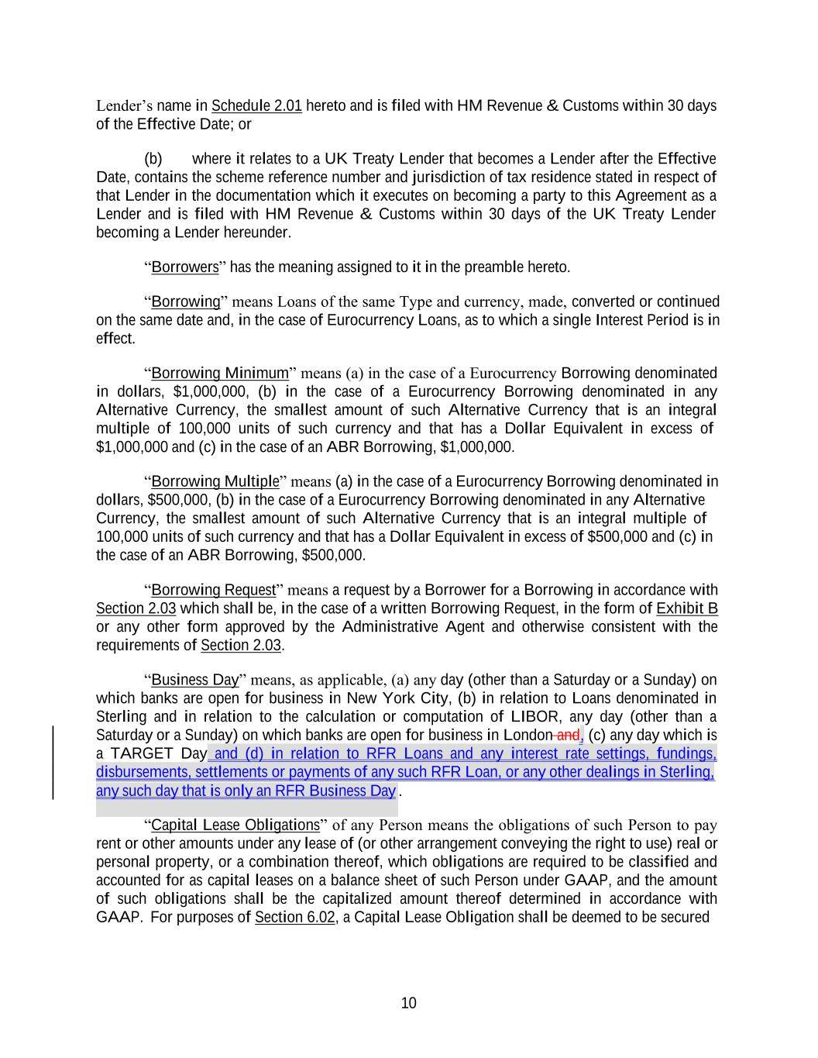
10 Lender’s name in Schedule 2.01 hereto and is filed with HM Revenue & Customs within 30 days of the Effective Date; or (b) where it relates to a UK Treaty Lender that becomes a Lender after the Effective Date, contains the scheme reference number and jurisdiction of tax residence stated in respect of that Lender in the documentation which it executes on becoming a party to this Agreement as a Lender and is filed with HM Revenue & Customs within 30 days of the UK Treaty Lender becoming a Lender hereunder. “Borrowers” has the meaning assigned to it in the preamble hereto. “Borrowing” means Loans of the same Type and currency, made, converted or continued on the same date and, in the case of Eurocurrency Loans, as to which a single Interest Period is in effect. “Borrowing Minimum” means (a) in the case of a Eurocurrency Borrowing denominated in dollars, $1,000,000, (b) in the case of a Eurocurrency Borrowing denominated in any Alternative Currency, the smallest amount of such Alternative Currency that is an integral multiple of 100,000 units of such currency and that has a Dollar Equivalent in excess of $1,000,000 and (c) in the case of an ABR Borrowing, $1,000,000. “Borrowing Multiple” means (a) in the case of a Eurocurrency Borrowing denominated in dollars, $500,000, (b) in the case of a Eurocurrency Borrowing denominated in any Alternative Currency, the smallest amount of such Alternative Currency that is an integral multiple of 100,000 units of such currency and that has a Dollar Equivalent in excess of $500,000 and (c) in the case of an ABR Borrowing, $500,000. “Borrowing Request” means a request by a Borrower for a Borrowing in accordance with Section 2.03 which shall be, in the case of a written Borrowing Request, in the form of Exhibit B or any other form approved by the Administrative Agent and otherwise consistent with the requirements of Section 2.03. “Business Day” means, as applicable, (a) any day (other than a Saturday or a Sunday) on which banks are open for business in New York City, (b) in relation to Loans denominated in Sterling and in relation to the calculation or computation of LIBOR, any day (other than a Saturday or a Sunday) on which banks are open for business in London and, (c) any day which is a TARGET Day and (d) in relation to RFR Loans and any interest rate settings, fundings, disbursements, settlements or payments of any such RFR Loan, or any other dealings in Sterling, . “Capital Lease Obligations” of any Person means the obligations of such Person to pay rent or other amounts under any lease of (or other arrangement conveying the right to use) real or personal property, or a combination thereof, which obligations are required to be classified and accounted for as capital leases on a balance sheet of such Person under GAAP, and the amount of such obligations shall be the capitalized amount thereof determined in accordance with GAAP. For purposes of Section 6.02, a Capital Lease Obligation shall be deemed to be secured any such day that is only an RFR Business Day

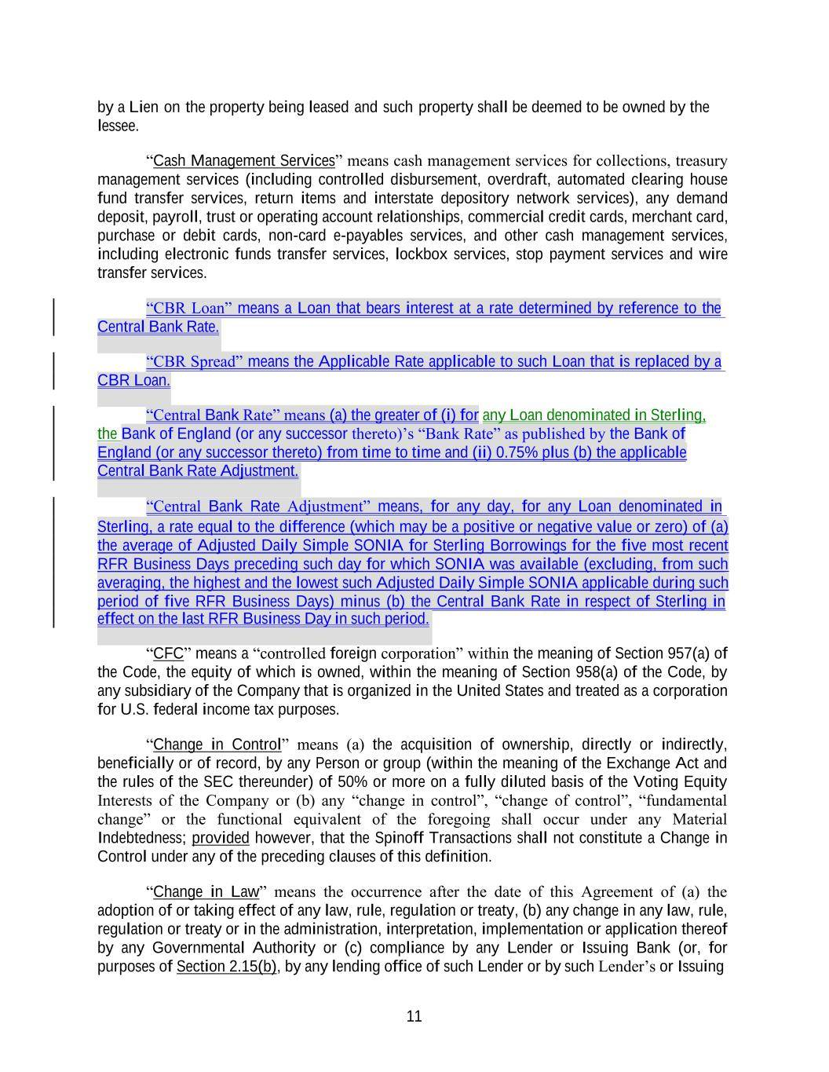
11 Central Bank Rate Adjustment. by a Lien on the property being leased and such property shall be deemed to be owned by the lessee. “Cash Management Services” means cash management services for collections, treasury management services (including controlled disbursement, overdraft, automated clearing house fund transfer services, return items and interstate depository network services), any demand deposit, payroll, trust or operating account relationships, commercial credit cards, merchant card, purchase or debit cards, non-card e-payables services, and other cash management services, including electronic funds transfer services, lockbox services, stop payment services and wire transfer services. “CBR Loan” means a Loan that bears interest at a rate determined by reference to the “CBR Spread” means the Applicable Rate applicable to such Loan that is replaced by a “Central Bank Rate” means (a) the greater of (i) for any Loan denominated in Sterling, the Bank of England (or any successor thereto)’s “Bank Rate” as published by the Bank of England (or any successor thereto) from time to time and (ii) 0.75% plus (b) the applicable “Central Bank Rate Adjustment” means, for any day, for any Loan denominated in Sterling, a rate equal to the difference (which may be a positive or negative value or zero) of (a) the average of Adjusted Daily Simple SONIA for Sterling Borrowings for the five most recent RFR Business Days preceding such day for which SONIA was available (excluding, from such averaging, the highest and the lowest such Adjusted Daily Simple SONIA applicable during such period of five RFR Business Days) minus (b) the Central Bank Rate in respect of Sterling in “CFC” means a “controlled foreign corporation” within the meaning of Section 957(a) of the Code, the equity of which is owned, within the meaning of Section 958(a) of the Code, by any subsidiary of the Company that is organized in the United States and treated as a corporation for U.S. federal income tax purposes. “Change in Control” means (a) the acquisition of ownership, directly or indirectly, beneficially or of record, by any Person or group (within the meaning of the Exchange Act and the rules of the SEC thereunder) of 50% or more on a fully diluted basis of the Voting Equity Interests of the Company or (b) any “change in control”, “change of control”, “fundamental change” or the functional equivalent of the foregoing shall occur under any Material Indebtedness; provided however, that the Spinoff Transactions shall not constitute a Change in Control under any of the preceding clauses of this definition. “Change in Law” means the occurrence after the date of this Agreement of (a) the adoption of or taking effect of any law, rule, regulation or treaty, (b) any change in any law, rule, regulation or treaty or in the administration, interpretation, implementation or application thereof by any Governmental Authority or (c) compliance by any Lender or Issuing Bank (or, for purposes of Section 2.15(b), by any lending office of such Lender or by such Lender’s or Issuing effect on the last RFR Business Day in such period. CBR Loan. Central Bank Rate.

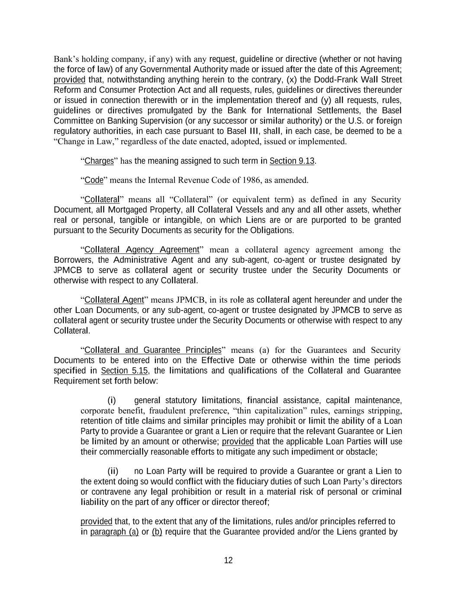
12 Bank’s holding company, if any) with any request, guideline or directive (whether or not having the force of law) of any Governmental Authority made or issued after the date of this Agreement; provided that, notwithstanding anything herein to the contrary, (x) the Dodd-Frank Wall Street Reform and Consumer Protection Act and all requests, rules, guidelines or directives thereunder or issued in connection therewith or in the implementation thereof and (y) all requests, rules, guidelines or directives promulgated by the Bank for International Settlements, the Basel Committee on Banking Supervision (or any successor or similar authority) or the U.S. or foreign regulatory authorities, in each case pursuant to Basel III, shall, in each case, be deemed to be a “Change in Law,” regardless of the date enacted, adopted, issued or implemented. “Charges” has the meaning assigned to such term in Section 9.13. “Code” means the Internal Revenue Code of 1986, as amended. “Collateral” means all “Collateral” (or equivalent term) as defined in any Security Document, all Mortgaged Property, all Collateral Vessels and any and all other assets, whether real or personal, tangible or intangible, on which Liens are or are purported to be granted pursuant to the Security Documents as security for the Obligations. “Collateral Agency Agreement” mean a collateral agency agreement among the Borrowers, the Administrative Agent and any sub-agent, co-agent or trustee designated by JPMCB to serve as collateral agent or security trustee under the Security Documents or otherwise with respect to any Collateral. “Collateral Agent” means JPMCB, in its role as collateral agent hereunder and under the other Loan Documents, or any sub-agent, co-agent or trustee designated by JPMCB to serve as collateral agent or security trustee under the Security Documents or otherwise with respect to any Collateral. “Collateral and Guarantee Principles” means (a) for the Guarantees and Security Documents to be entered into on the Effective Date or otherwise within the time periods specified in Section 5.15, the limitations and qualifications of the Collateral and Guarantee Requirement set forth below: (i) general statutory limitations, financial assistance, capital maintenance, corporate benefit, fraudulent preference, “thin capitalization” rules, earnings stripping, retention of title claims and similar principles may prohibit or limit the ability of a Loan Party to provide a Guarantee or grant a Lien or require that the relevant Guarantee or Lien be limited by an amount or otherwise; provided that the applicable Loan Parties will use their commercially reasonable efforts to mitigate any such impediment or obstacle; (ii) no Loan Party will be required to provide a Guarantee or grant a Lien to the extent doing so would conflict with the fiduciary duties of such Loan Party’s directors or contravene any legal prohibition or result in a material risk of personal or criminal liability on the part of any officer or director thereof; provided that, to the extent that any of the limitations, rules and/or principles referred to in paragraph (a) or (b) require that the Guarantee provided and/or the Liens granted by

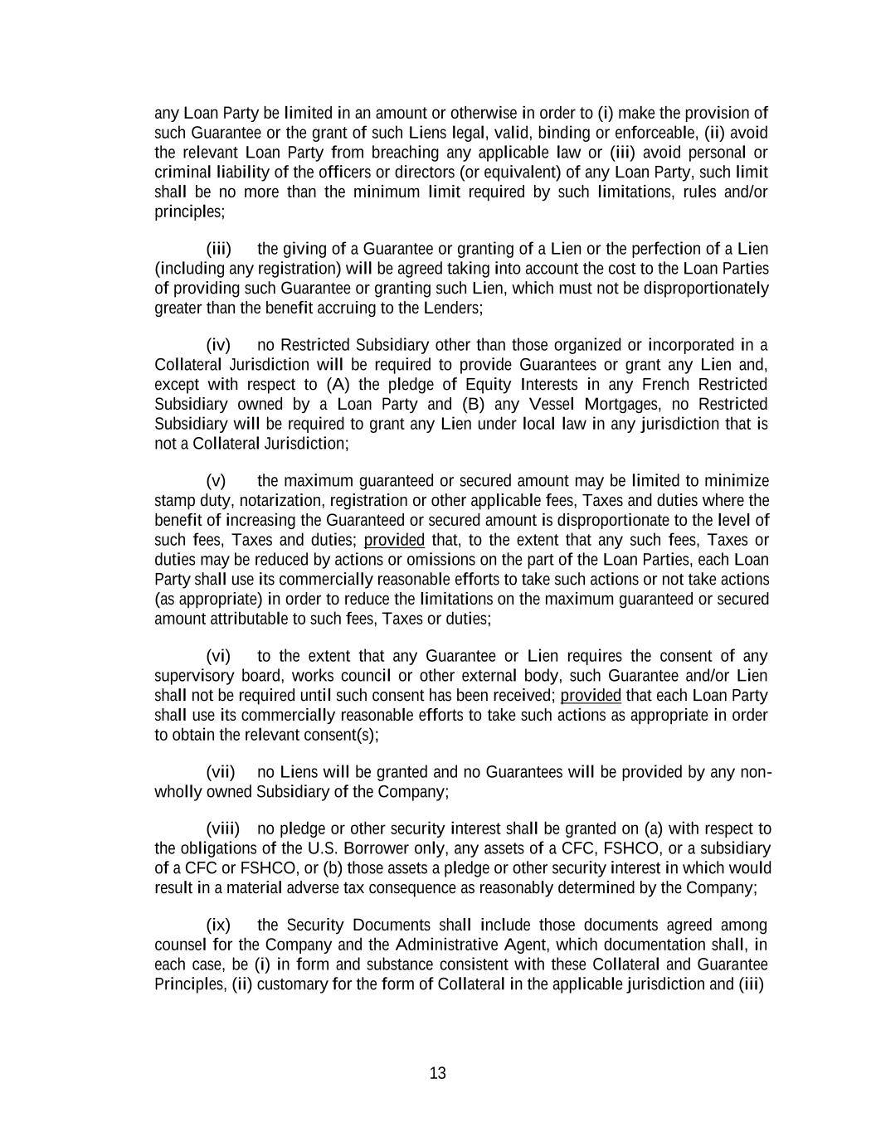
13 any Loan Party be limited in an amount or otherwise in order to (i) make the provision of such Guarantee or the grant of such Liens legal, valid, binding or enforceable, (ii) avoid the relevant Loan Party from breaching any applicable law or (iii) avoid personal or criminal liability of the officers or directors (or equivalent) of any Loan Party, such limit shall be no more than the minimum limit required by such limitations, rules and/or principles; (iii) the giving of a Guarantee or granting of a Lien or the perfection of a Lien (including any registration) will be agreed taking into account the cost to the Loan Parties of providing such Guarantee or granting such Lien, which must not be disproportionately greater than the benefit accruing to the Lenders; (iv) no Restricted Subsidiary other than those organized or incorporated in a Collateral Jurisdiction will be required to provide Guarantees or grant any Lien and, except with respect to (A) the pledge of Equity Interests in any French Restricted Subsidiary owned by a Loan Party and (B) any Vessel Mortgages, no Restricted Subsidiary will be required to grant any Lien under local law in any jurisdiction that is not a Collateral Jurisdiction; (v) the maximum guaranteed or secured amount may be limited to minimize stamp duty, notarization, registration or other applicable fees, Taxes and duties where the benefit of increasing the Guaranteed or secured amount is disproportionate to the level of such fees, Taxes and duties; provided that, to the extent that any such fees, Taxes or duties may be reduced by actions or omissions on the part of the Loan Parties, each Loan Party shall use its commercially reasonable efforts to take such actions or not take actions (as appropriate) in order to reduce the limitations on the maximum guaranteed or secured amount attributable to such fees, Taxes or duties; (vi) to the extent that any Guarantee or Lien requires the consent of any supervisory board, works council or other external body, such Guarantee and/or Lien shall not be required until such consent has been received; provided that each Loan Party shall use its commercially reasonable efforts to take such actions as appropriate in order to obtain the relevant consent(s); (vii) no Liens will be granted and no Guarantees will be provided by any non- wholly owned Subsidiary of the Company; (viii) no pledge or other security interest shall be granted on (a) with respect to the obligations of the U.S. Borrower only, any assets of a CFC, FSHCO, or a subsidiary of a CFC or FSHCO, or (b) those assets a pledge or other security interest in which would result in a material adverse tax consequence as reasonably determined by the Company; (ix) the Security Documents shall include those documents agreed among counsel for the Company and the Administrative Agent, which documentation shall, in each case, be (i) in form and substance consistent with these Collateral and Guarantee Principles, (ii) customary for the form of Collateral in the applicable jurisdiction and (iii)

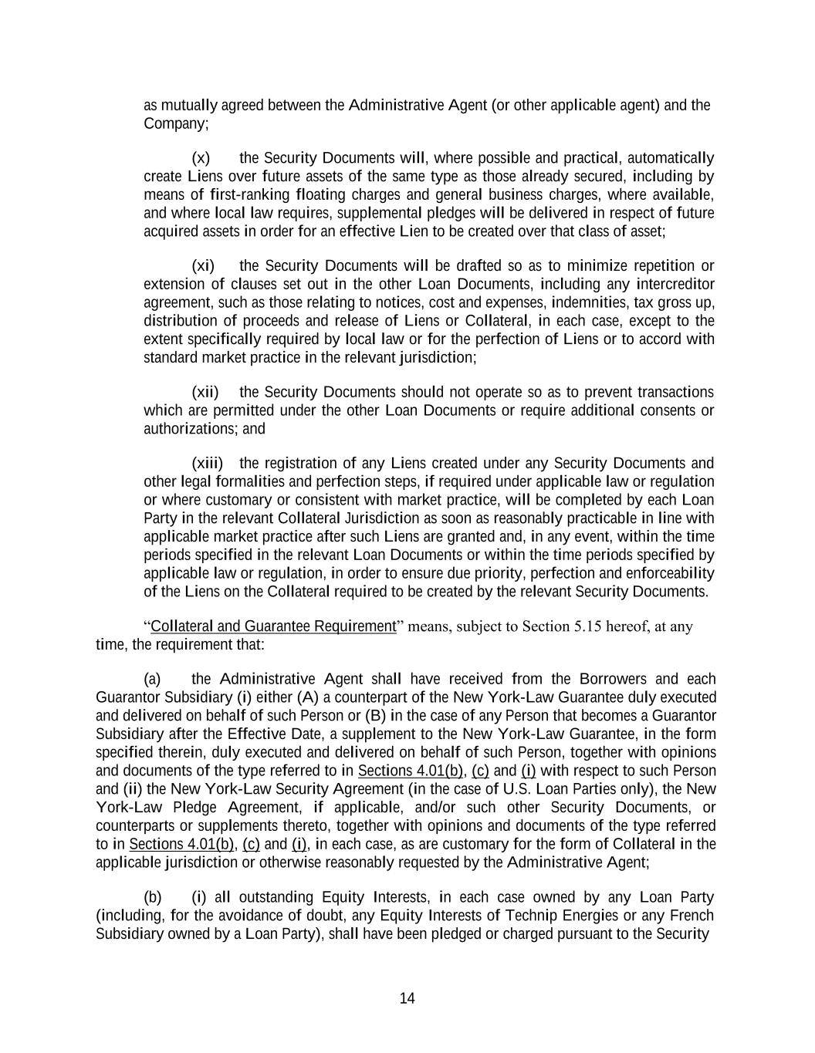
14 as mutually agreed between the Administrative Agent (or other applicable agent) and the Company; (x) the Security Documents will, where possible and practical, automatically create Liens over future assets of the same type as those already secured, including by means of first-ranking floating charges and general business charges, where available, and where local law requires, supplemental pledges will be delivered in respect of future acquired assets in order for an effective Lien to be created over that class of asset; (xi) the Security Documents will be drafted so as to minimize repetition or extension of clauses set out in the other Loan Documents, including any intercreditor agreement, such as those relating to notices, cost and expenses, indemnities, tax gross up, distribution of proceeds and release of Liens or Collateral, in each case, except to the extent specifically required by local law or for the perfection of Liens or to accord with standard market practice in the relevant jurisdiction; (xii) the Security Documents should not operate so as to prevent transactions which are permitted under the other Loan Documents or require additional consents or authorizations; and (xiii) the registration of any Liens created under any Security Documents and other legal formalities and perfection steps, if required under applicable law or regulation or where customary or consistent with market practice, will be completed by each Loan Party in the relevant Collateral Jurisdiction as soon as reasonably practicable in line with applicable market practice after such Liens are granted and, in any event, within the time periods specified in the relevant Loan Documents or within the time periods specified by applicable law or regulation, in order to ensure due priority, perfection and enforceability of the Liens on the Collateral required to be created by the relevant Security Documents. “Collateral and Guarantee Requirement” means, subject to Section 5.15 hereof, at any time, the requirement that: (a) the Administrative Agent shall have received from the Borrowers and each Guarantor Subsidiary (i) either (A) a counterpart of the New York-Law Guarantee duly executed and delivered on behalf of such Person or (B) in the case of any Person that becomes a Guarantor Subsidiary after the Effective Date, a supplement to the New York-Law Guarantee, in the form specified therein, duly executed and delivered on behalf of such Person, together with opinions and documents of the type referred to in Sections 4.01(b), (c) and (i) with respect to such Person and (ii) the New York-Law Security Agreement (in the case of U.S. Loan Parties only), the New York-Law Pledge Agreement, if applicable, and/or such other Security Documents, or counterparts or supplements thereto, together with opinions and documents of the type referred to in Sections 4.01(b), (c) and (i), in each case, as are customary for the form of Collateral in the applicable jurisdiction or otherwise reasonably requested by the Administrative Agent; (b) (i) all outstanding Equity Interests, in each case owned by any Loan Party (including, for the avoidance of doubt, any Equity Interests of Technip Energies or any French Subsidiary owned by a Loan Party), shall have been pledged or charged pursuant to the Security

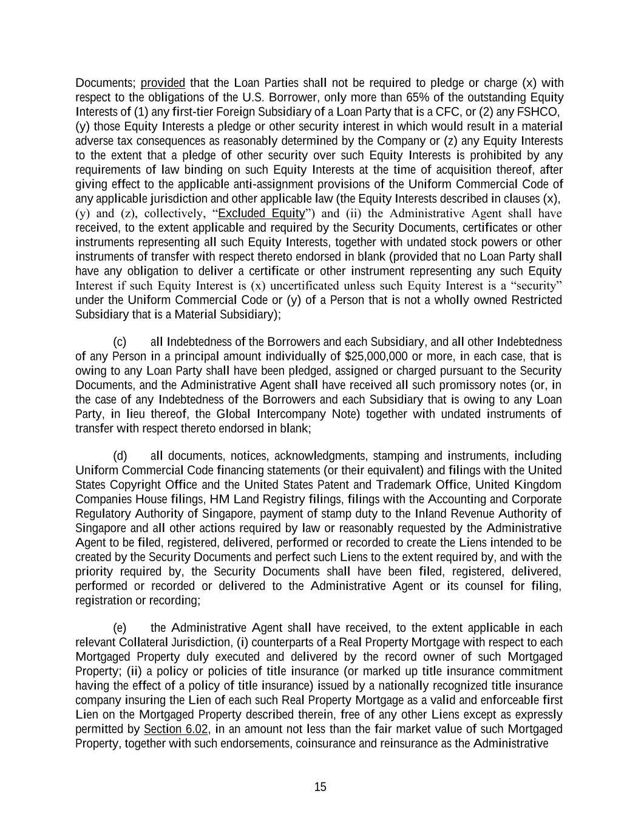
15 Documents; provided that the Loan Parties shall not be required to pledge or charge (x) with respect to the obligations of the U.S. Borrower, only more than 65% of the outstanding Equity Interests of (1) any first-tier Foreign Subsidiary of a Loan Party that is a CFC, or (2) any FSHCO, (y) those Equity Interests a pledge or other security interest in which would result in a material adverse tax consequences as reasonably determined by the Company or (z) any Equity Interests to the extent that a pledge of other security over such Equity Interests is prohibited by any requirements of law binding on such Equity Interests at the time of acquisition thereof, after giving effect to the applicable anti-assignment provisions of the Uniform Commercial Code of any applicable jurisdiction and other applicable law (the Equity Interests described in clauses (x), (y) and (z), collectively, “Excluded Equity”) and (ii) the Administrative Agent shall have received, to the extent applicable and required by the Security Documents, certificates or other instruments representing all such Equity Interests, together with undated stock powers or other instruments of transfer with respect thereto endorsed in blank (provided that no Loan Party shall have any obligation to deliver a certificate or other instrument representing any such Equity Interest if such Equity Interest is (x) uncertificated unless such Equity Interest is a “security” under the Uniform Commercial Code or (y) of a Person that is not a wholly owned Restricted Subsidiary that is a Material Subsidiary); (c) all Indebtedness of the Borrowers and each Subsidiary, and all other Indebtedness of any Person in a principal amount individually of $25,000,000 or more, in each case, that is owing to any Loan Party shall have been pledged, assigned or charged pursuant to the Security Documents, and the Administrative Agent shall have received all such promissory notes (or, in the case of any Indebtedness of the Borrowers and each Subsidiary that is owing to any Loan Party, in lieu thereof, the Global Intercompany Note) together with undated instruments of transfer with respect thereto endorsed in blank; (d) all documents, notices, acknowledgments, stamping and instruments, including Uniform Commercial Code financing statements (or their equivalent) and filings with the United States Copyright Office and the United States Patent and Trademark Office, United Kingdom Companies House filings, HM Land Registry filings, filings with the Accounting and Corporate Regulatory Authority of Singapore, payment of stamp duty to the Inland Revenue Authority of Singapore and all other actions required by law or reasonably requested by the Administrative Agent to be filed, registered, delivered, performed or recorded to create the Liens intended to be created by the Security Documents and perfect such Liens to the extent required by, and with the priority required by, the Security Documents shall have been filed, registered, delivered, performed or recorded or delivered to the Administrative Agent or its counsel for filing, registration or recording; (e) the Administrative Agent shall have received, to the extent applicable in each relevant Collateral Jurisdiction, (i) counterparts of a Real Property Mortgage with respect to each Mortgaged Property duly executed and delivered by the record owner of such Mortgaged Property; (ii) a policy or policies of title insurance (or marked up title insurance commitment having the effect of a policy of title insurance) issued by a nationally recognized title insurance company insuring the Lien of each such Real Property Mortgage as a valid and enforceable first Lien on the Mortgaged Property described therein, free of any other Liens except as expressly permitted by Section 6.02, in an amount not less than the fair market value of such Mortgaged Property, together with such endorsements, coinsurance and reinsurance as the Administrative

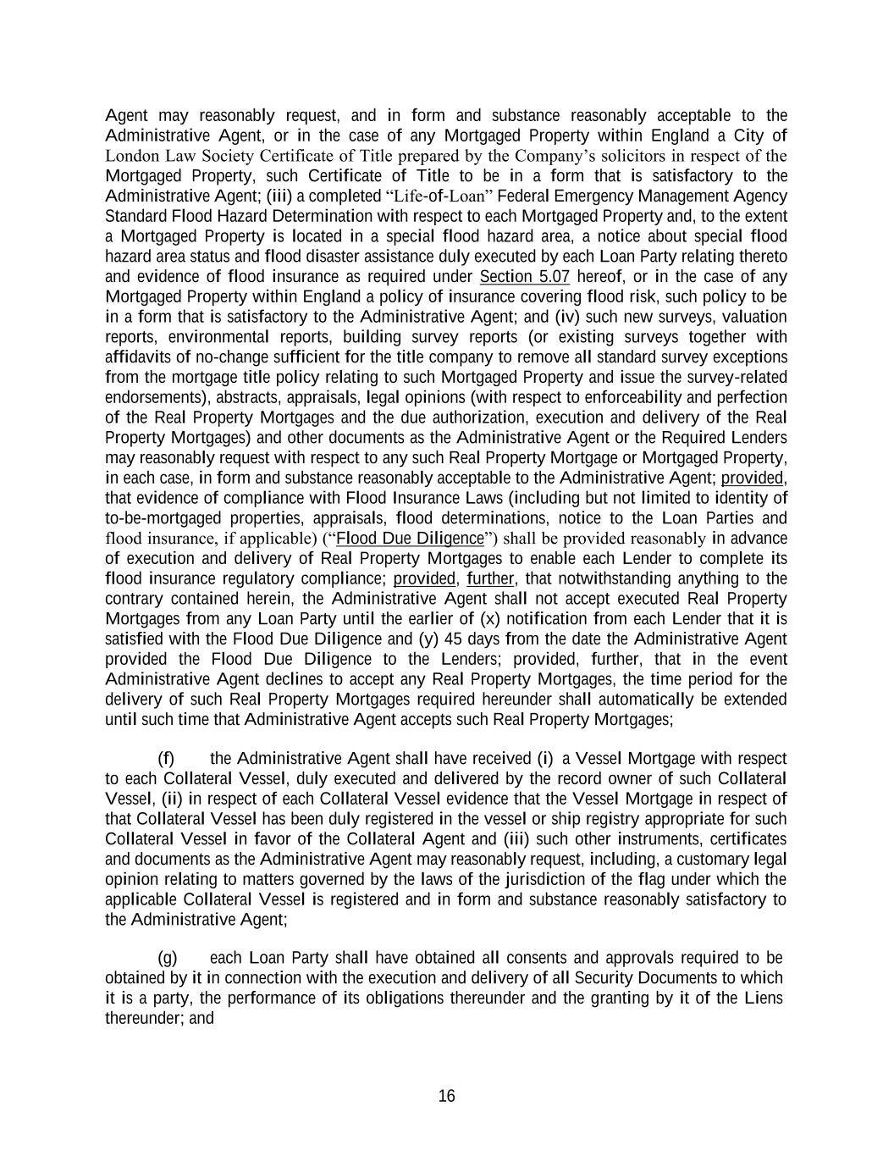
16 Agent may reasonably request, and in form and substance reasonably acceptable to the Administrative Agent, or in the case of any Mortgaged Property within England a City of London Law Society Certificate of Title prepared by the Company’s solicitors in respect of the Mortgaged Property, such Certificate of Title to be in a form that is satisfactory to the Administrative Agent; (iii) a completed “Life-of-Loan” Federal Emergency Management Agency Standard Flood Hazard Determination with respect to each Mortgaged Property and, to the extent a Mortgaged Property is located in a special flood hazard area, a notice about special flood hazard area status and flood disaster assistance duly executed by each Loan Party relating thereto and evidence of flood insurance as required under Section 5.07 hereof, or in the case of any Mortgaged Property within England a policy of insurance covering flood risk, such policy to be in a form that is satisfactory to the Administrative Agent; and (iv) such new surveys, valuation reports, environmental reports, building survey reports (or existing surveys together with affidavits of no-change sufficient for the title company to remove all standard survey exceptions from the mortgage title policy relating to such Mortgaged Property and issue the survey-related endorsements), abstracts, appraisals, legal opinions (with respect to enforceability and perfection of the Real Property Mortgages and the due authorization, execution and delivery of the Real Property Mortgages) and other documents as the Administrative Agent or the Required Lenders may reasonably request with respect to any such Real Property Mortgage or Mortgaged Property, in each case, in form and substance reasonably acceptable to the Administrative Agent; provided, that evidence of compliance with Flood Insurance Laws (including but not limited to identity of to-be-mortgaged properties, appraisals, flood determinations, notice to the Loan Parties and flood insurance, if applicable) (“Flood Due Diligence”) shall be provided reasonably in advance of execution and delivery of Real Property Mortgages to enable each Lender to complete its flood insurance regulatory compliance; provided, further, that notwithstanding anything to the contrary contained herein, the Administrative Agent shall not accept executed Real Property Mortgages from any Loan Party until the earlier of (x) notification from each Lender that it is satisfied with the Flood Due Diligence and (y) 45 days from the date the Administrative Agent provided the Flood Due Diligence to the Lenders; provided, further, that in the event Administrative Agent declines to accept any Real Property Mortgages, the time period for the delivery of such Real Property Mortgages required hereunder shall automatically be extended until such time that Administrative Agent accepts such Real Property Mortgages; (f) the Administrative Agent shall have received (i) a Vessel Mortgage with respect to each Collateral Vessel, duly executed and delivered by the record owner of such Collateral Vessel, (ii) in respect of each Collateral Vessel evidence that the Vessel Mortgage in respect of that Collateral Vessel has been duly registered in the vessel or ship registry appropriate for such Collateral Vessel in favor of the Collateral Agent and (iii) such other instruments, certificates and documents as the Administrative Agent may reasonably request, including, a customary legal opinion relating to matters governed by the laws of the jurisdiction of the flag under which the applicable Collateral Vessel is registered and in form and substance reasonably satisfactory to the Administrative Agent; (g) each Loan Party shall have obtained all consents and approvals required to be obtained by it in connection with the execution and delivery of all Security Documents to which it is a party, the performance of its obligations thereunder and the granting by it of the Liens thereunder; and

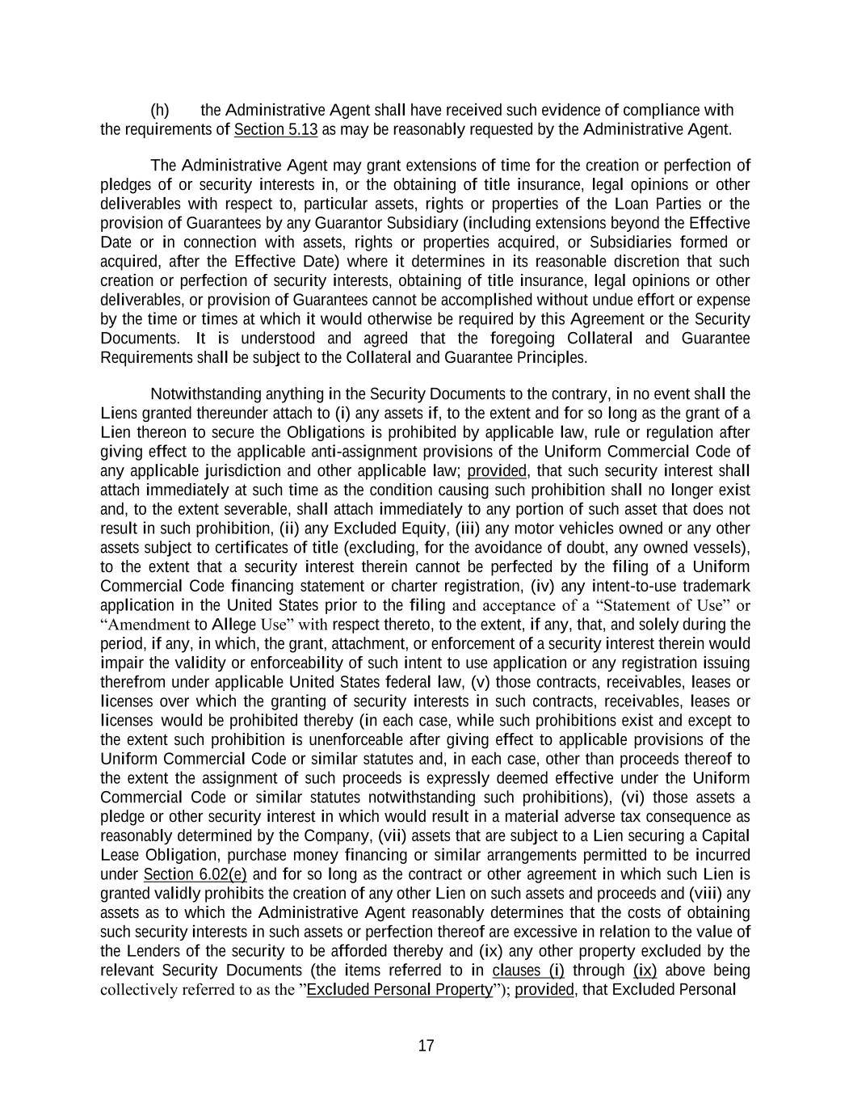
17 (h) the Administrative Agent shall have received such evidence of compliance with the requirements of Section 5.13 as may be reasonably requested by the Administrative Agent. The Administrative Agent may grant extensions of time for the creation or perfection of pledges of or security interests in, or the obtaining of title insurance, legal opinions or other deliverables with respect to, particular assets, rights or properties of the Loan Parties or the provision of Guarantees by any Guarantor Subsidiary (including extensions beyond the Effective Date or in connection with assets, rights or properties acquired, or Subsidiaries formed or acquired, after the Effective Date) where it determines in its reasonable discretion that such creation or perfection of security interests, obtaining of title insurance, legal opinions or other deliverables, or provision of Guarantees cannot be accomplished without undue effort or expense by the time or times at which it would otherwise be required by this Agreement or the Security Documents. It is understood and agreed that the foregoing Collateral and Guarantee Requirements shall be subject to the Collateral and Guarantee Principles. Notwithstanding anything in the Security Documents to the contrary, in no event shall the Liens granted thereunder attach to (i) any assets if, to the extent and for so long as the grant of a Lien thereon to secure the Obligations is prohibited by applicable law, rule or regulation after giving effect to the applicable anti-assignment provisions of the Uniform Commercial Code of any applicable jurisdiction and other applicable law; provided, that such security interest shall attach immediately at such time as the condition causing such prohibition shall no longer exist and, to the extent severable, shall attach immediately to any portion of such asset that does not result in such prohibition, (ii) any Excluded Equity, (iii) any motor vehicles owned or any other assets subject to certificates of title (excluding, for the avoidance of doubt, any owned vessels), to the extent that a security interest therein cannot be perfected by the filing of a Uniform Commercial Code financing statement or charter registration, (iv) any intent-to-use trademark application in the United States prior to the filing and acceptance of a “Statement of Use” or “Amendment to Allege Use” with respect thereto, to the extent, if any, that, and solely during the period, if any, in which, the grant, attachment, or enforcement of a security interest therein would impair the validity or enforceability of such intent to use application or any registration issuing therefrom under applicable United States federal law, (v) those contracts, receivables, leases or licenses over which the granting of security interests in such contracts, receivables, leases or licenses would be prohibited thereby (in each case, while such prohibitions exist and except to the extent such prohibition is unenforceable after giving effect to applicable provisions of the Uniform Commercial Code or similar statutes and, in each case, other than proceeds thereof to the extent the assignment of such proceeds is expressly deemed effective under the Uniform Commercial Code or similar statutes notwithstanding such prohibitions), (vi) those assets a pledge or other security interest in which would result in a material adverse tax consequence as reasonably determined by the Company, (vii) assets that are subject to a Lien securing a Capital Lease Obligation, purchase money financing or similar arrangements permitted to be incurred under Section 6.02(e) and for so long as the contract or other agreement in which such Lien is granted validly prohibits the creation of any other Lien on such assets and proceeds and (viii) any assets as to which the Administrative Agent reasonably determines that the costs of obtaining such security interests in such assets or perfection thereof are excessive in relation to the value of the Lenders of the security to be afforded thereby and (ix) any other property excluded by the relevant Security Documents (the items referred to in clauses (i) through (ix) above being collectively referred to as the ”Excluded Personal Property”); provided, that Excluded Personal

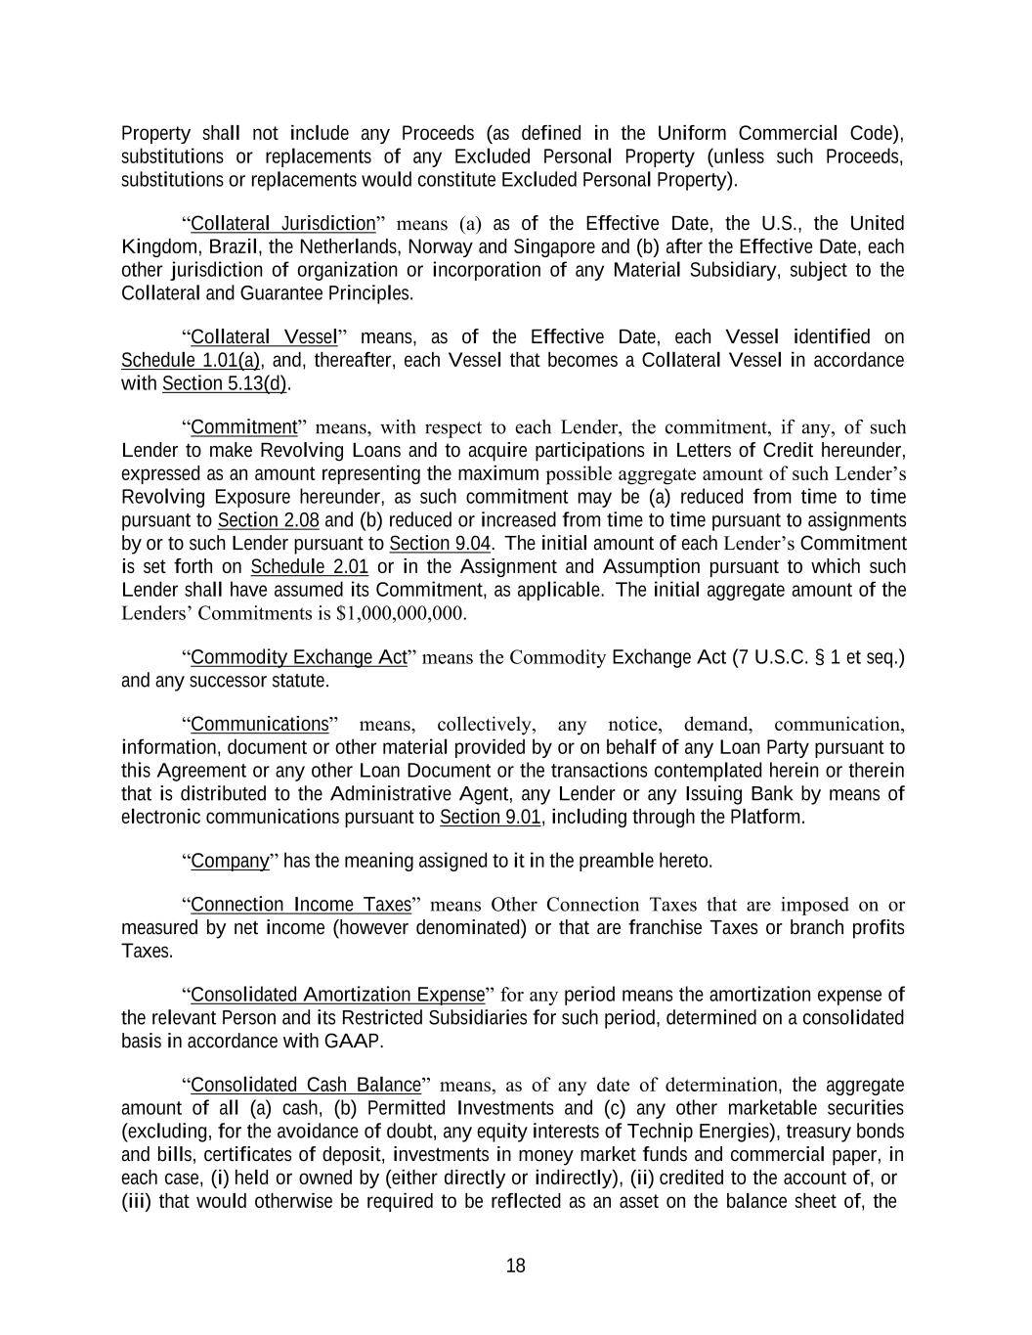
18 Property shall not include any Proceeds (as defined in the Uniform Commercial Code), substitutions or replacements of any Excluded Personal Property (unless such Proceeds, substitutions or replacements would constitute Excluded Personal Property). “Collateral Jurisdiction” means (a) as of the Effective Date, the U.S., the United Kingdom, Brazil, the Netherlands, Norway and Singapore and (b) after the Effective Date, each other jurisdiction of organization or incorporation of any Material Subsidiary, subject to the Collateral and Guarantee Principles. “Collateral Vessel” means, as of the Effective Date, each Vessel identified on Schedule 1.01(a), and, thereafter, each Vessel that becomes a Collateral Vessel in accordance with Section 5.13(d). “Commitment” means, with respect to each Lender, the commitment, if any, of such Lender to make Revolving Loans and to acquire participations in Letters of Credit hereunder, expressed as an amount representing the maximum possible aggregate amount of such Lender’s Revolving Exposure hereunder, as such commitment may be (a) reduced from time to time pursuant to Section 2.08 and (b) reduced or increased from time to time pursuant to assignments by or to such Lender pursuant to Section 9.04. The initial amount of each Lender’s Commitment is set forth on Schedule 2.01 or in the Assignment and Assumption pursuant to which such Lender shall have assumed its Commitment, as applicable. The initial aggregate amount of the Lenders’ Commitments is $1,000,000,000. “Commodity Exchange Act” means the Commodity Exchange Act (7 U.S.C. § 1 et seq.) and any successor statute. “Communications” means, collectively, any notice, demand, communication, information, document or other material provided by or on behalf of any Loan Party pursuant to this Agreement or any other Loan Document or the transactions contemplated herein or therein that is distributed to the Administrative Agent, any Lender or any Issuing Bank by means of electronic communications pursuant to Section 9.01, including through the Platform. “Company” has the meaning assigned to it in the preamble hereto. “Connection Income Taxes” means Other Connection Taxes that are imposed on or measured by net income (however denominated) or that are franchise Taxes or branch profits Taxes. “Consolidated Amortization Expense” for any period means the amortization expense of the relevant Person and its Restricted Subsidiaries for such period, determined on a consolidated basis in accordance with GAAP. “Consolidated Cash Balance” means, as of any date of determination, the aggregate amount of all (a) cash, (b) Permitted Investments and (c) any other marketable securities (excluding, for the avoidance of doubt, any equity interests of Technip Energies), treasury bonds and bills, certificates of deposit, investments in money market funds and commercial paper, in each case, (i) held or owned by (either directly or indirectly), (ii) credited to the account of, or (iii) that would otherwise be required to be reflected as an asset on the balance sheet of, the

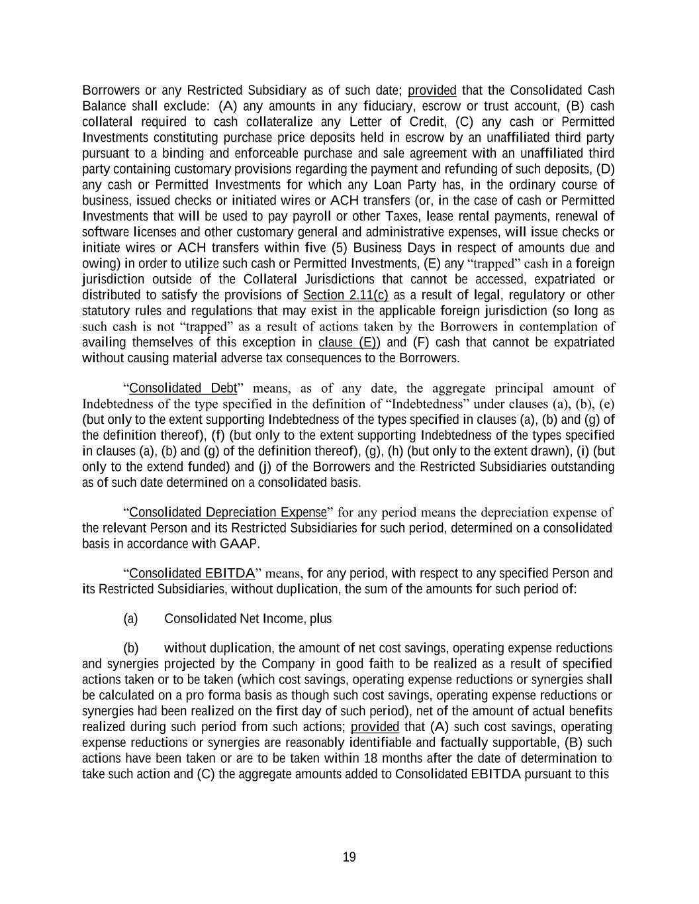
19 Borrowers or any Restricted Subsidiary as of such date; provided that the Consolidated Cash Balance shall exclude: (A) any amounts in any fiduciary, escrow or trust account, (B) cash collateral required to cash collateralize any Letter of Credit, (C) any cash or Permitted Investments constituting purchase price deposits held in escrow by an unaffiliated third party pursuant to a binding and enforceable purchase and sale agreement with an unaffiliated third party containing customary provisions regarding the payment and refunding of such deposits, (D) any cash or Permitted Investments for which any Loan Party has, in the ordinary course of business, issued checks or initiated wires or ACH transfers (or, in the case of cash or Permitted Investments that will be used to pay payroll or other Taxes, lease rental payments, renewal of software licenses and other customary general and administrative expenses, will issue checks or initiate wires or ACH transfers within five (5) Business Days in respect of amounts due and owing) in order to utilize such cash or Permitted Investments, (E) any “trapped” cash in a foreign jurisdiction outside of the Collateral Jurisdictions that cannot be accessed, expatriated or distributed to satisfy the provisions of Section 2.11(c) as a result of legal, regulatory or other statutory rules and regulations that may exist in the applicable foreign jurisdiction (so long as such cash is not “trapped” as a result of actions taken by the Borrowers in contemplation of availing themselves of this exception in clause (E)) and (F) cash that cannot be expatriated without causing material adverse tax consequences to the Borrowers. “Consolidated Debt” means, as of any date, the aggregate principal amount of Indebtedness of the type specified in the definition of “Indebtedness” under clauses (a), (b), (e) (but only to the extent supporting Indebtedness of the types specified in clauses (a), (b) and (g) of the definition thereof), (f) (but only to the extent supporting Indebtedness of the types specified in clauses (a), (b) and (g) of the definition thereof), (g), (h) (but only to the extent drawn), (i) (but only to the extend funded) and (j) of the Borrowers and the Restricted Subsidiaries outstanding as of such date determined on a consolidated basis. “Consolidated Depreciation Expense” for any period means the depreciation expense of the relevant Person and its Restricted Subsidiaries for such period, determined on a consolidated basis in accordance with GAAP. “Consolidated EBITDA” means, for any period, with respect to any specified Person and its Restricted Subsidiaries, without duplication, the sum of the amounts for such period of: (a) Consolidated Net Income, plus (b) without duplication, the amount of net cost savings, operating expense reductions and synergies projected by the Company in good faith to be realized as a result of specified actions taken or to be taken (which cost savings, operating expense reductions or synergies shall be calculated on a pro forma basis as though such cost savings, operating expense reductions or synergies had been realized on the first day of such period), net of the amount of actual benefits realized during such period from such actions; provided that (A) such cost savings, operating expense reductions or synergies are reasonably identifiable and factually supportable, (B) such actions have been taken or are to be taken within 18 months after the date of determination to take such action and (C) the aggregate amounts added to Consolidated EBITDA pursuant to this

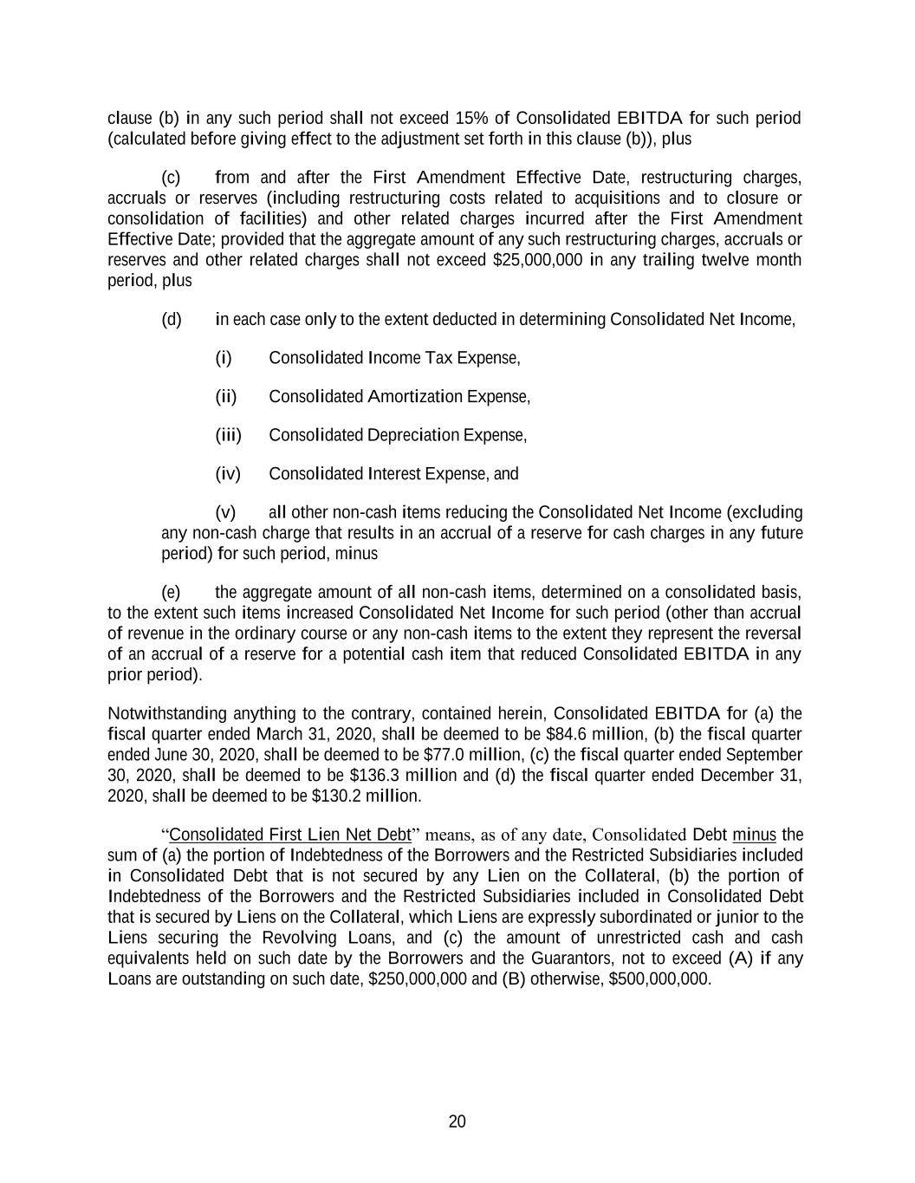
20 clause (b) in any such period shall not exceed 15% of Consolidated EBITDA for such period (calculated before giving effect to the adjustment set forth in this clause (b)), plus (c) from and after the First Amendment Effective Date, restructuring charges, accruals or reserves (including restructuring costs related to acquisitions and to closure or consolidation of facilities) and other related charges incurred after the First Amendment Effective Date; provided that the aggregate amount of any such restructuring charges, accruals or reserves and other related charges shall not exceed $25,000,000 in any trailing twelve month period, plus (d) in each case only to the extent deducted in determining Consolidated Net Income, (i) Consolidated Income Tax Expense, (ii) Consolidated Amortization Expense, (iii) Consolidated Depreciation Expense, (iv) Consolidated Interest Expense, and (v) all other non-cash items reducing the Consolidated Net Income (excluding any non-cash charge that results in an accrual of a reserve for cash charges in any future period) for such period, minus (e) the aggregate amount of all non-cash items, determined on a consolidated basis, to the extent such items increased Consolidated Net Income for such period (other than accrual of revenue in the ordinary course or any non-cash items to the extent they represent the reversal of an accrual of a reserve for a potential cash item that reduced Consolidated EBITDA in any prior period). Notwithstanding anything to the contrary, contained herein, Consolidated EBITDA for (a) the fiscal quarter ended March 31, 2020, shall be deemed to be $84.6 million, (b) the fiscal quarter ended June 30, 2020, shall be deemed to be $77.0 million, (c) the fiscal quarter ended September 30, 2020, shall be deemed to be $136.3 million and (d) the fiscal quarter ended December 31, 2020, shall be deemed to be $130.2 million. “Consolidated First Lien Net Debt” means, as of any date, Consolidated Debt minus the sum of (a) the portion of Indebtedness of the Borrowers and the Restricted Subsidiaries included in Consolidated Debt that is not secured by any Lien on the Collateral, (b) the portion of Indebtedness of the Borrowers and the Restricted Subsidiaries included in Consolidated Debt that is secured by Liens on the Collateral, which Liens are expressly subordinated or junior to the Liens securing the Revolving Loans, and (c) the amount of unrestricted cash and cash equivalents held on such date by the Borrowers and the Guarantors, not to exceed (A) if any Loans are outstanding on such date, $250,000,000 and (B) otherwise, $500,000,000.

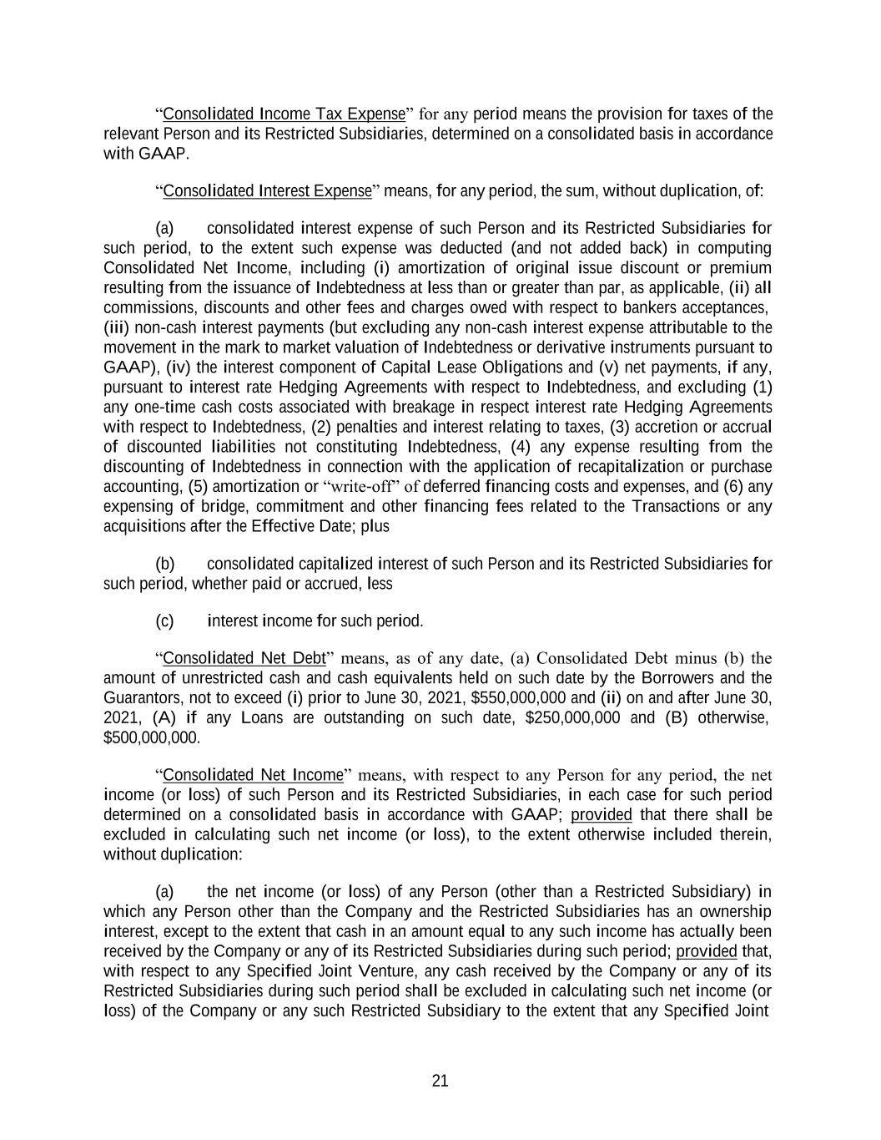
21 “Consolidated Income Tax Expense” for any period means the provision for taxes of the relevant Person and its Restricted Subsidiaries, determined on a consolidated basis in accordance with GAAP. “Consolidated Interest Expense” means, for any period, the sum, without duplication, of: (a) consolidated interest expense of such Person and its Restricted Subsidiaries for such period, to the extent such expense was deducted (and not added back) in computing Consolidated Net Income, including (i) amortization of original issue discount or premium resulting from the issuance of Indebtedness at less than or greater than par, as applicable, (ii) all commissions, discounts and other fees and charges owed with respect to bankers acceptances, (iii) non-cash interest payments (but excluding any non-cash interest expense attributable to the movement in the mark to market valuation of Indebtedness or derivative instruments pursuant to GAAP), (iv) the interest component of Capital Lease Obligations and (v) net payments, if any, pursuant to interest rate Hedging Agreements with respect to Indebtedness, and excluding (1) any one-time cash costs associated with breakage in respect interest rate Hedging Agreements with respect to Indebtedness, (2) penalties and interest relating to taxes, (3) accretion or accrual of discounted liabilities not constituting Indebtedness, (4) any expense resulting from the discounting of Indebtedness in connection with the application of recapitalization or purchase accounting, (5) amortization or “write-off” of deferred financing costs and expenses, and (6) any expensing of bridge, commitment and other financing fees related to the Transactions or any acquisitions after the Effective Date; plus (b) consolidated capitalized interest of such Person and its Restricted Subsidiaries for such period, whether paid or accrued, less (c) interest income for such period. “Consolidated Net Debt” means, as of any date, (a) Consolidated Debt minus (b) the amount of unrestricted cash and cash equivalents held on such date by the Borrowers and the Guarantors, not to exceed (i) prior to June 30, 2021, $550,000,000 and (ii) on and after June 30, 2021, (A) if any Loans are outstanding on such date, $250,000,000 and (B) otherwise, $500,000,000. “Consolidated Net Income” means, with respect to any Person for any period, the net income (or loss) of such Person and its Restricted Subsidiaries, in each case for such period determined on a consolidated basis in accordance with GAAP; provided that there shall be excluded in calculating such net income (or loss), to the extent otherwise included therein, without duplication: (a) the net income (or loss) of any Person (other than a Restricted Subsidiary) in which any Person other than the Company and the Restricted Subsidiaries has an ownership interest, except to the extent that cash in an amount equal to any such income has actually been received by the Company or any of its Restricted Subsidiaries during such period; provided that, with respect to any Specified Joint Venture, any cash received by the Company or any of its Restricted Subsidiaries during such period shall be excluded in calculating such net income (or loss) of the Company or any such Restricted Subsidiary to the extent that any Specified Joint

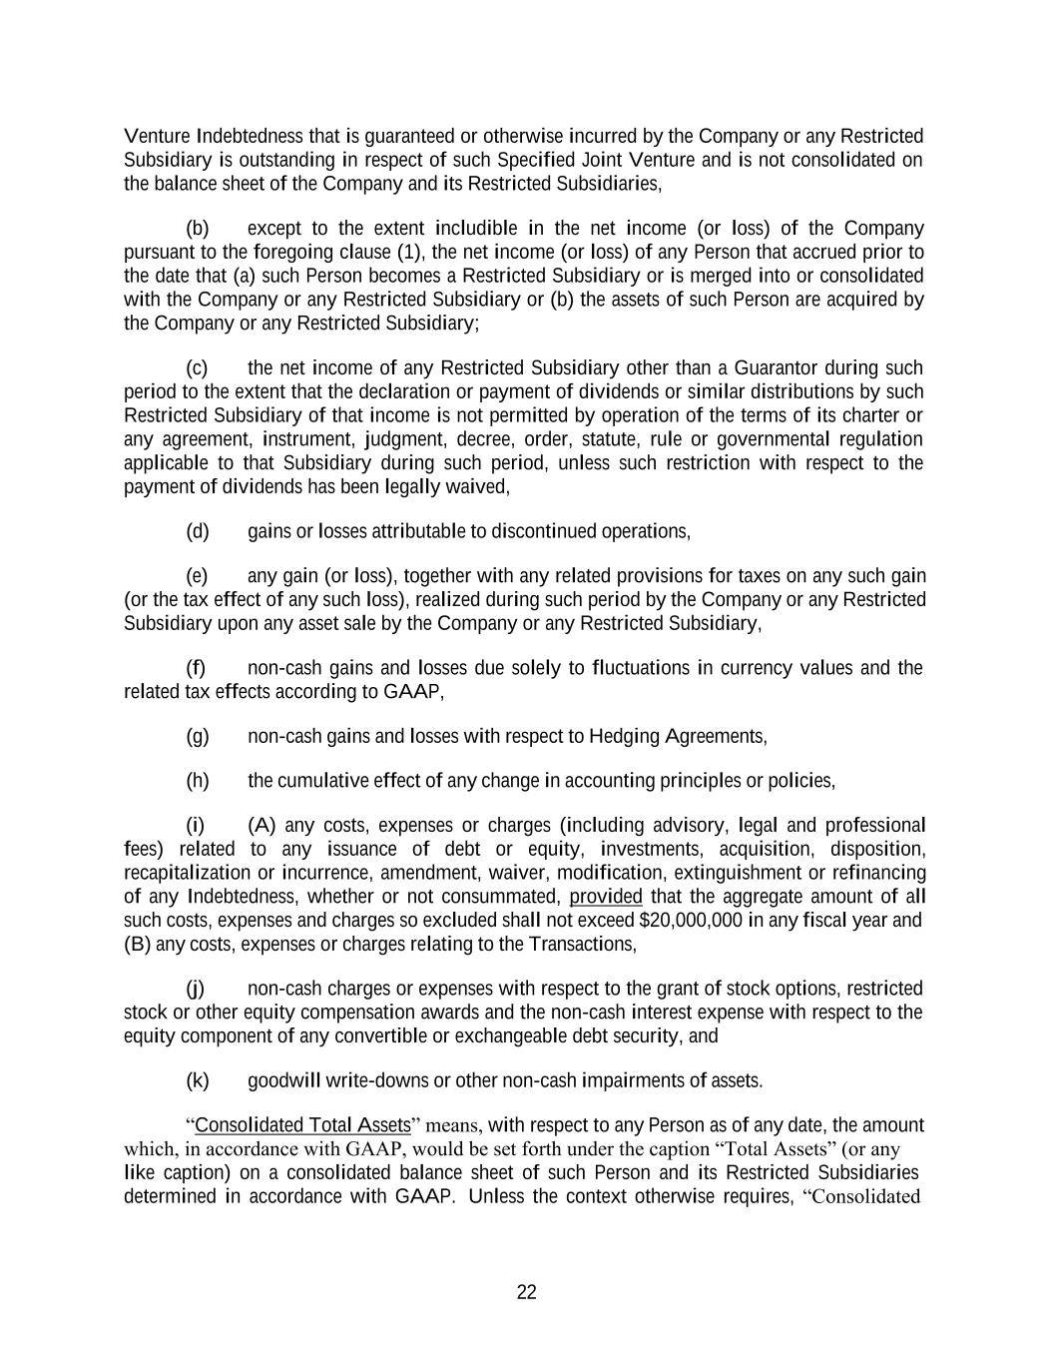
22 Venture Indebtedness that is guaranteed or otherwise incurred by the Company or any Restricted Subsidiary is outstanding in respect of such Specified Joint Venture and is not consolidated on the balance sheet of the Company and its Restricted Subsidiaries, (b) except to the extent includible in the net income (or loss) of the Company pursuant to the foregoing clause (1), the net income (or loss) of any Person that accrued prior to the date that (a) such Person becomes a Restricted Subsidiary or is merged into or consolidated with the Company or any Restricted Subsidiary or (b) the assets of such Person are acquired by the Company or any Restricted Subsidiary; (c) the net income of any Restricted Subsidiary other than a Guarantor during such period to the extent that the declaration or payment of dividends or similar distributions by such Restricted Subsidiary of that income is not permitted by operation of the terms of its charter or any agreement, instrument, judgment, decree, order, statute, rule or governmental regulation applicable to that Subsidiary during such period, unless such restriction with respect to the payment of dividends has been legally waived, (d) gains or losses attributable to discontinued operations, (e) any gain (or loss), together with any related provisions for taxes on any such gain (or the tax effect of any such loss), realized during such period by the Company or any Restricted Subsidiary upon any asset sale by the Company or any Restricted Subsidiary, (f) non-cash gains and losses due solely to fluctuations in currency values and the related tax effects according to GAAP, (g) non-cash gains and losses with respect to Hedging Agreements, (h) the cumulative effect of any change in accounting principles or policies, (i) (A) any costs, expenses or charges (including advisory, legal and professional fees) related to any issuance of debt or equity, investments, acquisition, disposition, recapitalization or incurrence, amendment, waiver, modification, extinguishment or refinancing of any Indebtedness, whether or not consummated, provided that the aggregate amount of all such costs, expenses and charges so excluded shall not exceed $20,000,000 in any fiscal year and (B) any costs, expenses or charges relating to the Transactions, (j) non-cash charges or expenses with respect to the grant of stock options, restricted stock or other equity compensation awards and the non-cash interest expense with respect to the equity component of any convertible or exchangeable debt security, and (k) goodwill write-downs or other non-cash impairments of assets. “Consolidated Total Assets” means, with respect to any Person as of any date, the amount which, in accordance with GAAP, would be set forth under the caption “Total Assets” (or any like caption) on a consolidated balance sheet of such Person and its Restricted Subsidiaries determined in accordance with GAAP. Unless the context otherwise requires, “Consolidated

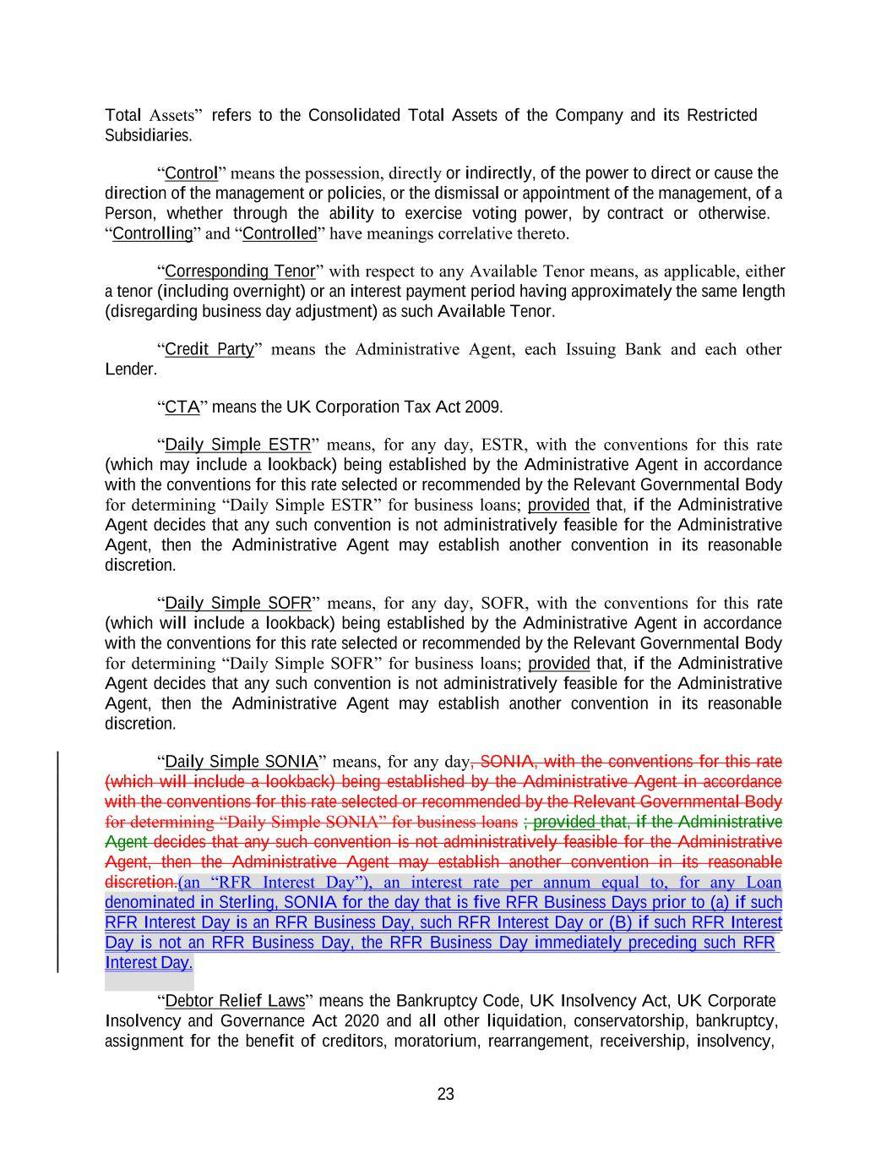
23 Interest Day. Total Assets” refers to the Consolidated Total Assets of the Company and its Restricted Subsidiaries. “Control” means the possession, directly or indirectly, of the power to direct or cause the direction of the management or policies, or the dismissal or appointment of the management, of a Person, whether through the ability to exercise voting power, by contract or otherwise. “Controlling” and “Controlled” have meanings correlative thereto. “Corresponding Tenor” with respect to any Available Tenor means, as applicable, either a tenor (including overnight) or an interest payment period having approximately the same length (disregarding business day adjustment) as such Available Tenor. “Credit Party” means the Administrative Agent, each Issuing Bank and each other Lender. “CTA” means the UK Corporation Tax Act 2009. “Daily Simple ESTR” means, for any day, ESTR, with the conventions for this rate (which may include a lookback) being established by the Administrative Agent in accordance with the conventions for this rate selected or recommended by the Relevant Governmental Body for determining “Daily Simple ESTR” for business loans; provided that, if the Administrative Agent decides that any such convention is not administratively feasible for the Administrative Agent, then the Administrative Agent may establish another convention in its reasonable discretion. “Daily Simple SOFR” means, for any day, SOFR, with the conventions for this rate (which will include a lookback) being established by the Administrative Agent in accordance with the conventions for this rate selected or recommended by the Relevant Governmental Body for determining “Daily Simple SOFR” for business loans; provided that, if the Administrative Agent decides that any such convention is not administratively feasible for the Administrative Agent, then the Administrative Agent may establish another convention in its reasonable discretion. “Daily Simple SONIA” means, for any day, SONIA, with the conventions for this rate (which will include a lookback) being established by the Administrative Agent in accordance with the conventions for this rate selected or recommended by the Relevant Governmental Body for determining “Daily Simple SONIA” for business loans ; provided that, if the Administrative Agent decides that any such convention is not administratively feasible for the Administrative Agent, then the Administrative Agent may establish another convention in its reasonable discretion.(an “RFR Interest Day”), an interest rate per annum equal to, for any Loan denominated in Sterling, SONIA for the day that is five RFR Business Days prior to (a) if such RFR Interest Day is an RFR Business Day, such RFR Interest Day or (B) if such RFR Interest Day is not an RFR Business Day, the RFR Business Day immediately preceding such RFR “Debtor Relief Laws” means the Bankruptcy Code, UK Insolvency Act, UK Corporate Insolvency and Governance Act 2020 and all other liquidation, conservatorship, bankruptcy, assignment for the benefit of creditors, moratorium, rearrangement, receivership, insolvency,

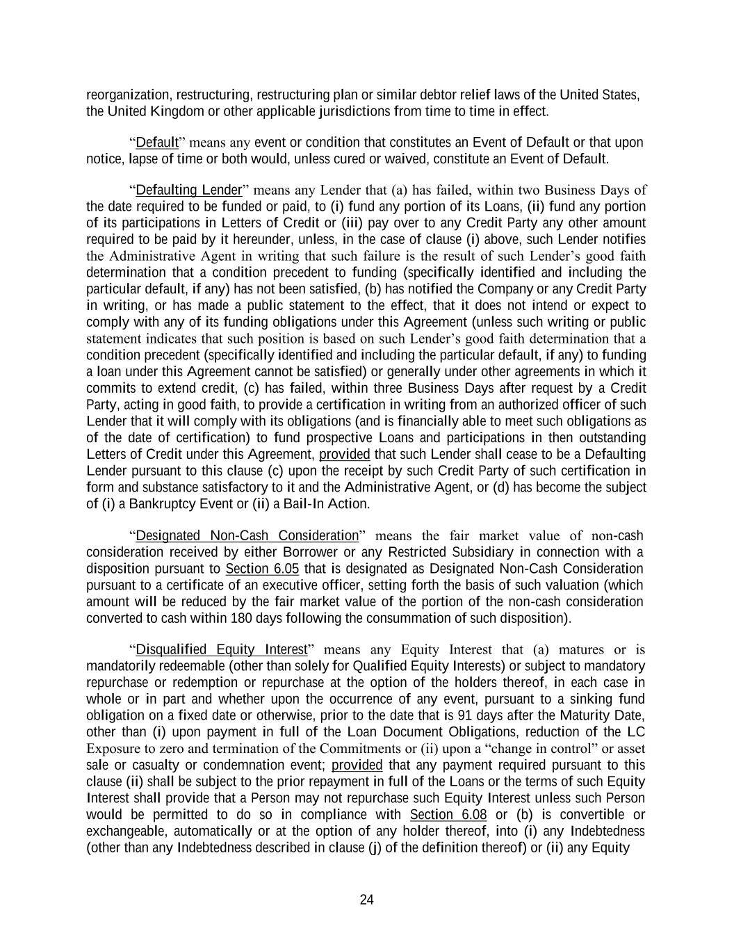
24 reorganization, restructuring, restructuring plan or similar debtor relief laws of the United States, the United Kingdom or other applicable jurisdictions from time to time in effect. “Default” means any event or condition that constitutes an Event of Default or that upon notice, lapse of time or both would, unless cured or waived, constitute an Event of Default. “Defaulting Lender” means any Lender that (a) has failed, within two Business Days of the date required to be funded or paid, to (i) fund any portion of its Loans, (ii) fund any portion of its participations in Letters of Credit or (iii) pay over to any Credit Party any other amount required to be paid by it hereunder, unless, in the case of clause (i) above, such Lender notifies the Administrative Agent in writing that such failure is the result of such Lender’s good faith determination that a condition precedent to funding (specifically identified and including the particular default, if any) has not been satisfied, (b) has notified the Company or any Credit Party in writing, or has made a public statement to the effect, that it does not intend or expect to comply with any of its funding obligations under this Agreement (unless such writing or public statement indicates that such position is based on such Lender’s good faith determination that a condition precedent (specifically identified and including the particular default, if any) to funding a loan under this Agreement cannot be satisfied) or generally under other agreements in which it commits to extend credit, (c) has failed, within three Business Days after request by a Credit Party, acting in good faith, to provide a certification in writing from an authorized officer of such Lender that it will comply with its obligations (and is financially able to meet such obligations as of the date of certification) to fund prospective Loans and participations in then outstanding Letters of Credit under this Agreement, provided that such Lender shall cease to be a Defaulting Lender pursuant to this clause (c) upon the receipt by such Credit Party of such certification in form and substance satisfactory to it and the Administrative Agent, or (d) has become the subject of (i) a Bankruptcy Event or (ii) a Bail-In Action. “Designated Non-Cash Consideration” means the fair market value of non-cash consideration received by either Borrower or any Restricted Subsidiary in connection with a disposition pursuant to Section 6.05 that is designated as Designated Non-Cash Consideration pursuant to a certificate of an executive officer, setting forth the basis of such valuation (which amount will be reduced by the fair market value of the portion of the non-cash consideration converted to cash within 180 days following the consummation of such disposition). “Disqualified Equity Interest” means any Equity Interest that (a) matures or is mandatorily redeemable (other than solely for Qualified Equity Interests) or subject to mandatory repurchase or redemption or repurchase at the option of the holders thereof, in each case in whole or in part and whether upon the occurrence of any event, pursuant to a sinking fund obligation on a fixed date or otherwise, prior to the date that is 91 days after the Maturity Date, other than (i) upon payment in full of the Loan Document Obligations, reduction of the LC Exposure to zero and termination of the Commitments or (ii) upon a “change in control” or asset sale or casualty or condemnation event; provided that any payment required pursuant to this clause (ii) shall be subject to the prior repayment in full of the Loans or the terms of such Equity Interest shall provide that a Person may not repurchase such Equity Interest unless such Person would be permitted to do so in compliance with Section 6.08 or (b) is convertible or exchangeable, automatically or at the option of any holder thereof, into (i) any Indebtedness (other than any Indebtedness described in clause (j) of the definition thereof) or (ii) any Equity

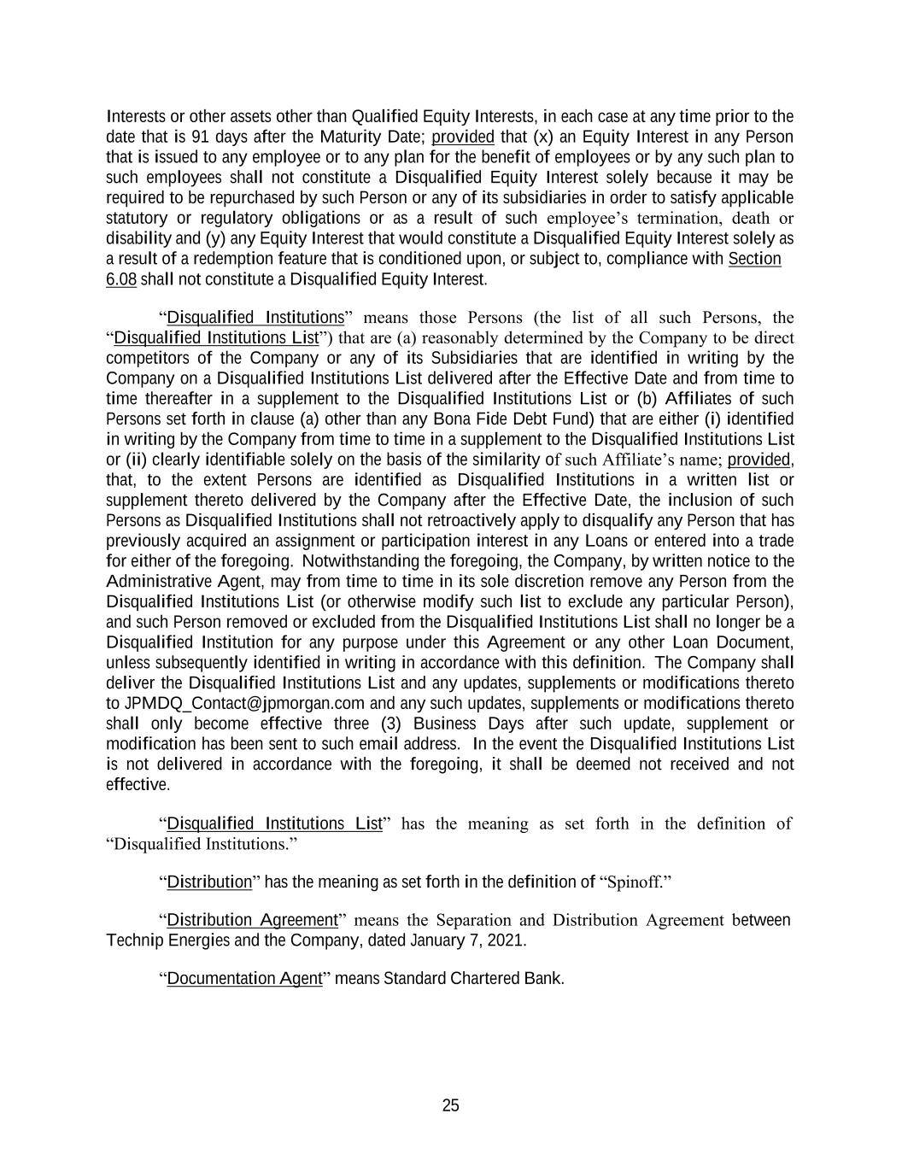
25 Interests or other assets other than Qualified Equity Interests, in each case at any time prior to the date that is 91 days after the Maturity Date; provided that (x) an Equity Interest in any Person that is issued to any employee or to any plan for the benefit of employees or by any such plan to such employees shall not constitute a Disqualified Equity Interest solely because it may be required to be repurchased by such Person or any of its subsidiaries in order to satisfy applicable statutory or regulatory obligations or as a result of such employee’s termination, death or disability and (y) any Equity Interest that would constitute a Disqualified Equity Interest solely as a result of a redemption feature that is conditioned upon, or subject to, compliance with Section 6.08 shall not constitute a Disqualified Equity Interest. “Disqualified Institutions” means those Persons (the list of all such Persons, the “Disqualified Institutions List”) that are (a) reasonably determined by the Company to be direct competitors of the Company or any of its Subsidiaries that are identified in writing by the Company on a Disqualified Institutions List delivered after the Effective Date and from time to time thereafter in a supplement to the Disqualified Institutions List or (b) Affiliates of such Persons set forth in clause (a) other than any Bona Fide Debt Fund) that are either (i) identified in writing by the Company from time to time in a supplement to the Disqualified Institutions List or (ii) clearly identifiable solely on the basis of the similarity of such Affiliate’s name; provided, that, to the extent Persons are identified as Disqualified Institutions in a written list or supplement thereto delivered by the Company after the Effective Date, the inclusion of such Persons as Disqualified Institutions shall not retroactively apply to disqualify any Person that has previously acquired an assignment or participation interest in any Loans or entered into a trade for either of the foregoing. Notwithstanding the foregoing, the Company, by written notice to the Administrative Agent, may from time to time in its sole discretion remove any Person from the Disqualified Institutions List (or otherwise modify such list to exclude any particular Person), and such Person removed or excluded from the Disqualified Institutions List shall no longer be a Disqualified Institution for any purpose under this Agreement or any other Loan Document, unless subsequently identified in writing in accordance with this definition. The Company shall deliver the Disqualified Institutions List and any updates, supplements or modifications thereto to JPMDQ_Contact@jpmorgan.com and any such updates, supplements or modifications thereto shall only become effective three (3) Business Days after such update, supplement or modification has been sent to such email address. In the event the Disqualified Institutions List is not delivered in accordance with the foregoing, it shall be deemed not received and not effective. “Disqualified Institutions List” has the meaning as set forth in the definition of “Disqualified Institutions.” “Distribution” has the meaning as set forth in the definition of “Spinoff.” “Distribution Agreement” means the Separation and Distribution Agreement between Technip Energies and the Company, dated January 7, 2021. “Documentation Agent” means Standard Chartered Bank.

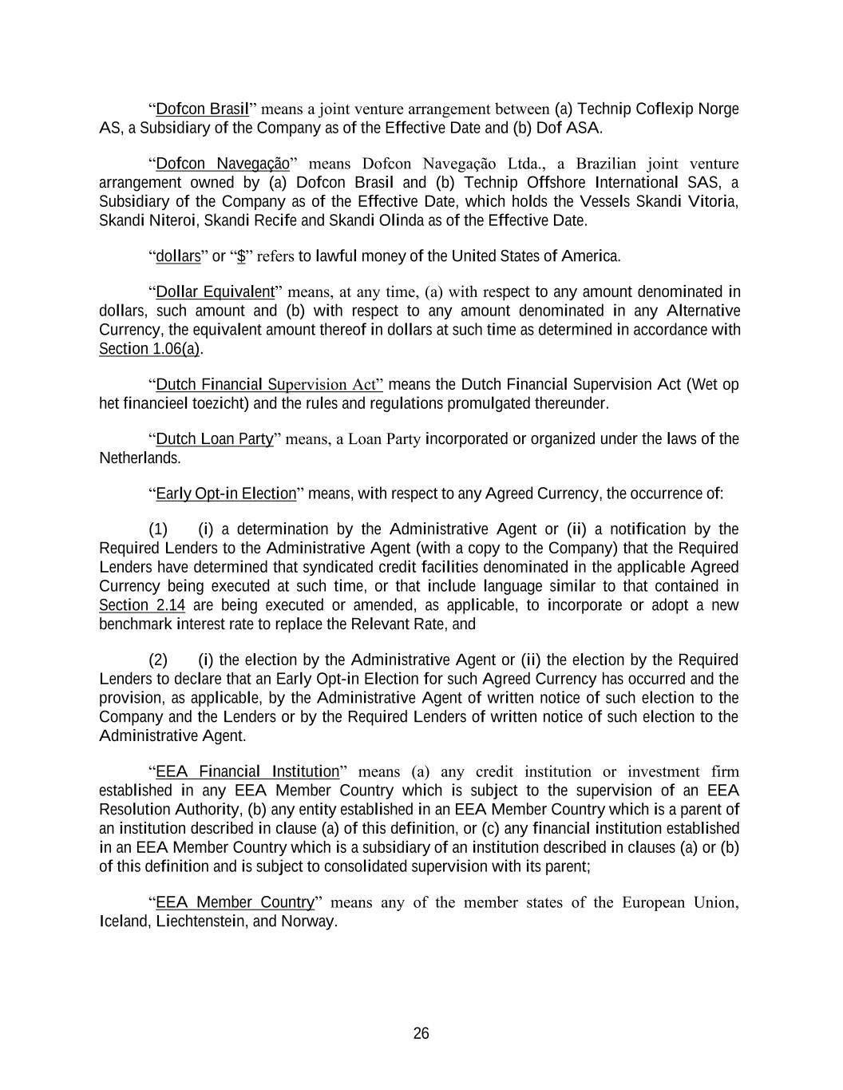
26 “Dofcon Brasil” means a joint venture arrangement between (a) Technip Coflexip Norge AS, a Subsidiary of the Company as of the Effective Date and (b) Dof ASA. “Dofcon Navegação” means Dofcon Navegação Ltda., a Brazilian joint venture arrangement owned by (a) Dofcon Brasil and (b) Technip Offshore International SAS, a Subsidiary of the Company as of the Effective Date, which holds the Vessels Skandi Vitoria, Skandi Niteroi, Skandi Recife and Skandi Olinda as of the Effective Date. “dollars” or “$” refers to lawful money of the United States of America. “Dollar Equivalent” means, at any time, (a) with respect to any amount denominated in dollars, such amount and (b) with respect to any amount denominated in any Alternative Currency, the equivalent amount thereof in dollars at such time as determined in accordance with Section 1.06(a). “Dutch Financial Supervision Act” means the Dutch Financial Supervision Act (Wet op het financieel toezicht) and the rules and regulations promulgated thereunder. “Dutch Loan Party” means, a Loan Party incorporated or organized under the laws of the Netherlands. “Early Opt-in Election” means, with respect to any Agreed Currency, the occurrence of: (1) (i) a determination by the Administrative Agent or (ii) a notification by the Required Lenders to the Administrative Agent (with a copy to the Company) that the Required Lenders have determined that syndicated credit facilities denominated in the applicable Agreed Currency being executed at such time, or that include language similar to that contained in Section 2.14 are being executed or amended, as applicable, to incorporate or adopt a new benchmark interest rate to replace the Relevant Rate, and (2) (i) the election by the Administrative Agent or (ii) the election by the Required Lenders to declare that an Early Opt-in Election for such Agreed Currency has occurred and the provision, as applicable, by the Administrative Agent of written notice of such election to the Company and the Lenders or by the Required Lenders of written notice of such election to the Administrative Agent. “EEA Financial Institution” means (a) any credit institution or investment firm established in any EEA Member Country which is subject to the supervision of an EEA Resolution Authority, (b) any entity established in an EEA Member Country which is a parent of an institution described in clause (a) of this definition, or (c) any financial institution established in an EEA Member Country which is a subsidiary of an institution described in clauses (a) or (b) of this definition and is subject to consolidated supervision with its parent; “EEA Member Country” means any of the member states of the European Union, Iceland, Liechtenstein, and Norway.

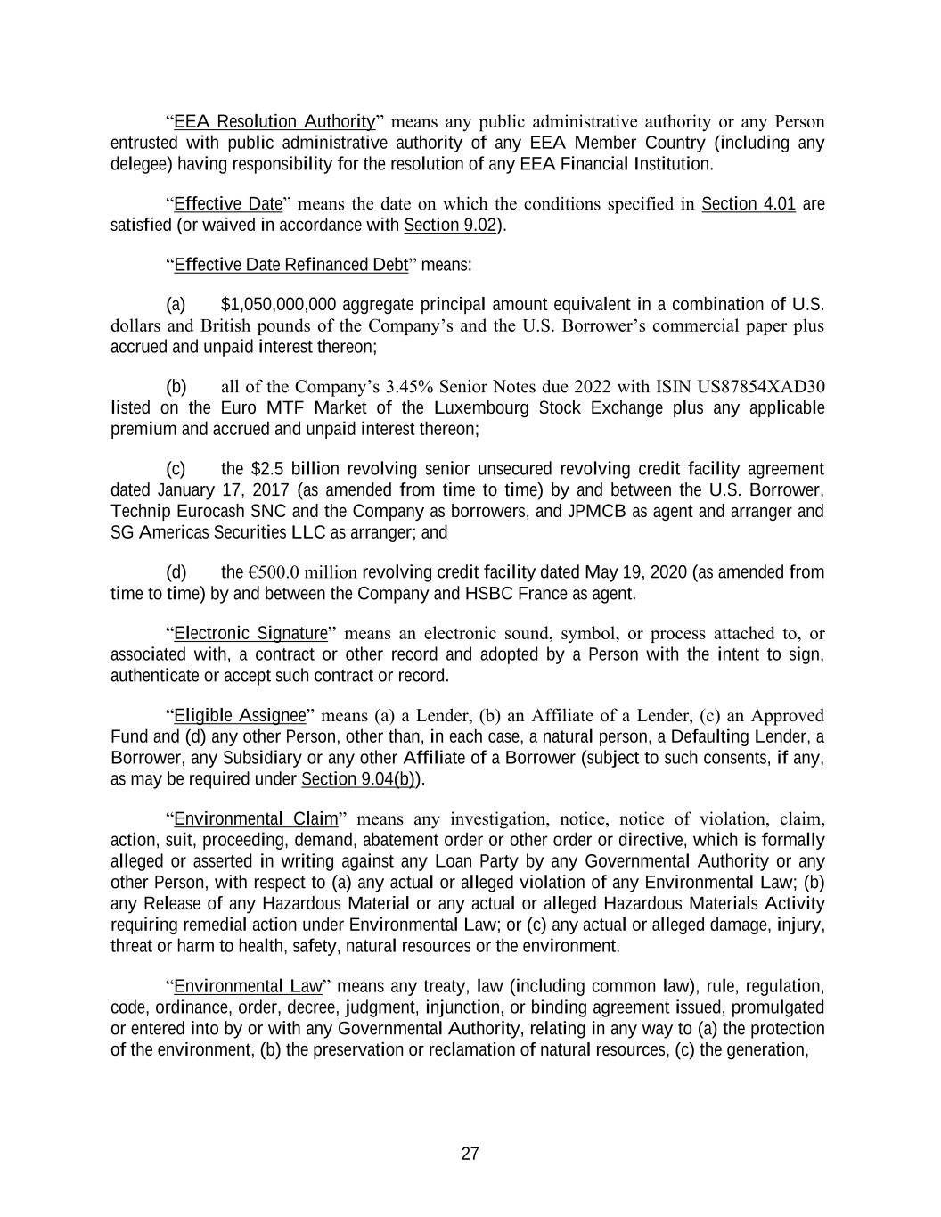
27 “EEA Resolution Authority” means any public administrative authority or any Person entrusted with public administrative authority of any EEA Member Country (including any delegee) having responsibility for the resolution of any EEA Financial Institution. “Effective Date” means the date on which the conditions specified in Section 4.01 are satisfied (or waived in accordance with Section 9.02). “Effective Date Refinanced Debt” means: (a) $1,050,000,000 aggregate principal amount equivalent in a combination of U.S. dollars and British pounds of the Company’s and the U.S. Borrower’s commercial paper plus accrued and unpaid interest thereon; (b) all of the Company’s 3.45% Senior Notes due 2022 with ISIN US87854XAD30 listed on the Euro MTF Market of the Luxembourg Stock Exchange plus any applicable premium and accrued and unpaid interest thereon; (c) the $2.5 billion revolving senior unsecured revolving credit facility agreement dated January 17, 2017 (as amended from time to time) by and between the U.S. Borrower, Technip Eurocash SNC and the Company as borrowers, and JPMCB as agent and arranger and SG Americas Securities LLC as arranger; and (d) the €500.0 million revolving credit facility dated May 19, 2020 (as amended from time to time) by and between the Company and HSBC France as agent. “Electronic Signature” means an electronic sound, symbol, or process attached to, or associated with, a contract or other record and adopted by a Person with the intent to sign, authenticate or accept such contract or record. “Eligible Assignee” means (a) a Lender, (b) an Affiliate of a Lender, (c) an Approved Fund and (d) any other Person, other than, in each case, a natural person, a Defaulting Lender, a Borrower, any Subsidiary or any other Affiliate of a Borrower (subject to such consents, if any, as may be required under Section 9.04(b)). “Environmental Claim” means any investigation, notice, notice of violation, claim, action, suit, proceeding, demand, abatement order or other order or directive, which is formally alleged or asserted in writing against any Loan Party by any Governmental Authority or any other Person, with respect to (a) any actual or alleged violation of any Environmental Law; (b) any Release of any Hazardous Material or any actual or alleged Hazardous Materials Activity requiring remedial action under Environmental Law; or (c) any actual or alleged damage, injury, threat or harm to health, safety, natural resources or the environment. “Environmental Law” means any treaty, law (including common law), rule, regulation, code, ordinance, order, decree, judgment, injunction, or binding agreement issued, promulgated or entered into by or with any Governmental Authority, relating in any way to (a) the protection of the environment, (b) the preservation or reclamation of natural resources, (c) the generation,

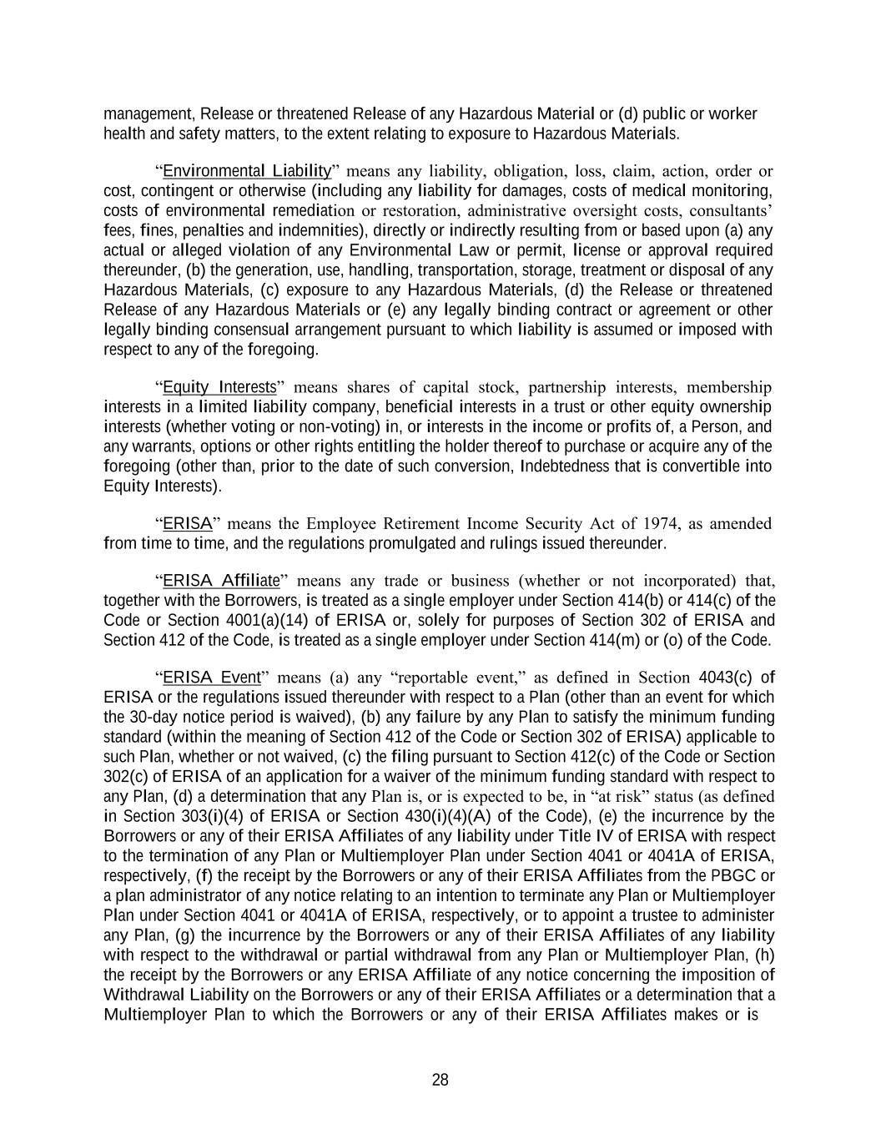
28 management, Release or threatened Release of any Hazardous Material or (d) public or worker health and safety matters, to the extent relating to exposure to Hazardous Materials. “Environmental Liability” means any liability, obligation, loss, claim, action, order or cost, contingent or otherwise (including any liability for damages, costs of medical monitoring, costs of environmental remediation or restoration, administrative oversight costs, consultants’ fees, fines, penalties and indemnities), directly or indirectly resulting from or based upon (a) any actual or alleged violation of any Environmental Law or permit, license or approval required thereunder, (b) the generation, use, handling, transportation, storage, treatment or disposal of any Hazardous Materials, (c) exposure to any Hazardous Materials, (d) the Release or threatened Release of any Hazardous Materials or (e) any legally binding contract or agreement or other legally binding consensual arrangement pursuant to which liability is assumed or imposed with respect to any of the foregoing. “Equity Interests” means shares of capital stock, partnership interests, membership interests in a limited liability company, beneficial interests in a trust or other equity ownership interests (whether voting or non-voting) in, or interests in the income or profits of, a Person, and any warrants, options or other rights entitling the holder thereof to purchase or acquire any of the foregoing (other than, prior to the date of such conversion, Indebtedness that is convertible into Equity Interests). “ERISA” means the Employee Retirement Income Security Act of 1974, as amended from time to time, and the regulations promulgated and rulings issued thereunder. “ERISA Affiliate” means any trade or business (whether or not incorporated) that, together with the Borrowers, is treated as a single employer under Section 414(b) or 414(c) of the Code or Section 4001(a)(14) of ERISA or, solely for purposes of Section 302 of ERISA and Section 412 of the Code, is treated as a single employer under Section 414(m) or (o) of the Code. “ERISA Event” means (a) any “reportable event,” as defined in Section 4043(c) of ERISA or the regulations issued thereunder with respect to a Plan (other than an event for which the 30-day notice period is waived), (b) any failure by any Plan to satisfy the minimum funding standard (within the meaning of Section 412 of the Code or Section 302 of ERISA) applicable to such Plan, whether or not waived, (c) the filing pursuant to Section 412(c) of the Code or Section 302(c) of ERISA of an application for a waiver of the minimum funding standard with respect to any Plan, (d) a determination that any Plan is, or is expected to be, in “at risk” status (as defined in Section 303(i)(4) of ERISA or Section 430(i)(4)(A) of the Code), (e) the incurrence by the Borrowers or any of their ERISA Affiliates of any liability under Title IV of ERISA with respect to the termination of any Plan or Multiemployer Plan under Section 4041 or 4041A of ERISA, respectively, (f) the receipt by the Borrowers or any of their ERISA Affiliates from the PBGC or a plan administrator of any notice relating to an intention to terminate any Plan or Multiemployer Plan under Section 4041 or 4041A of ERISA, respectively, or to appoint a trustee to administer any Plan, (g) the incurrence by the Borrowers or any of their ERISA Affiliates of any liability with respect to the withdrawal or partial withdrawal from any Plan or Multiemployer Plan, (h) the receipt by the Borrowers or any ERISA Affiliate of any notice concerning the imposition of Withdrawal Liability on the Borrowers or any of their ERISA Affiliates or a determination that a Multiemployer Plan to which the Borrowers or any of their ERISA Affiliates makes or is

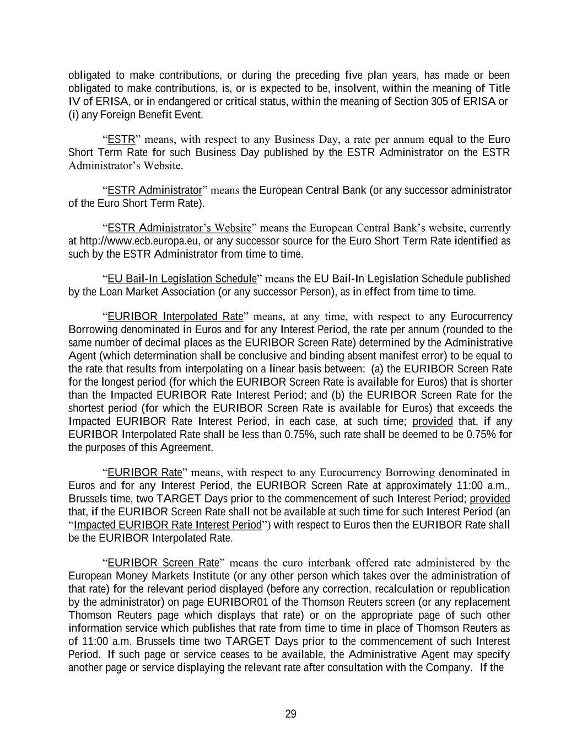
29 obligated to make contributions, or during the preceding five plan years, has made or been obligated to make contributions, is, or is expected to be, insolvent, within the meaning of Title IV of ERISA, or in endangered or critical status, within the meaning of Section 305 of ERISA or (i) any Foreign Benefit Event. “ESTR” means, with respect to any Business Day, a rate per annum equal to the Euro Short Term Rate for such Business Day published by the ESTR Administrator on the ESTR Administrator’s Website. “ESTR Administrator” means the European Central Bank (or any successor administrator of the Euro Short Term Rate). “ESTR Administrator’s Website” means the European Central Bank’s website, currently at http://www.ecb.europa.eu, or any successor source for the Euro Short Term Rate identified as such by the ESTR Administrator from time to time. “EU Bail-In Legislation Schedule” means the EU Bail-In Legislation Schedule published by the Loan Market Association (or any successor Person), as in effect from time to time. “EURIBOR Interpolated Rate” means, at any time, with respect to any Eurocurrency Borrowing denominated in Euros and for any Interest Period, the rate per annum (rounded to the same number of decimal places as the EURIBOR Screen Rate) determined by the Administrative Agent (which determination shall be conclusive and binding absent manifest error) to be equal to the rate that results from interpolating on a linear basis between: (a) the EURIBOR Screen Rate for the longest period (for which the EURIBOR Screen Rate is available for Euros) that is shorter than the Impacted EURIBOR Rate Interest Period; and (b) the EURIBOR Screen Rate for the shortest period (for which the EURIBOR Screen Rate is available for Euros) that exceeds the Impacted EURIBOR Rate Interest Period, in each case, at such time; provided that, if any EURIBOR Interpolated Rate shall be less than 0.75%, such rate shall be deemed to be 0.75% for the purposes of this Agreement. “EURIBOR Rate” means, with respect to any Eurocurrency Borrowing denominated in Euros and for any Interest Period, the EURIBOR Screen Rate at approximately 11:00 a.m., Brussels time, two TARGET Days prior to the commencement of such Interest Period; provided that, if the EURIBOR Screen Rate shall not be available at such time for such Interest Period (an “Impacted EURIBOR Rate Interest Period”) with respect to Euros then the EURIBOR Rate shall be the EURIBOR Interpolated Rate. “EURIBOR Screen Rate” means the euro interbank offered rate administered by the European Money Markets Institute (or any other person which takes over the administration of that rate) for the relevant period displayed (before any correction, recalculation or republication by the administrator) on page EURIBOR01 of the Thomson Reuters screen (or any replacement Thomson Reuters page which displays that rate) or on the appropriate page of such other information service which publishes that rate from time to time in place of Thomson Reuters as of 11:00 a.m. Brussels time two TARGET Days prior to the commencement of such Interest Period. If such page or service ceases to be available, the Administrative Agent may specify another page or service displaying the relevant rate after consultation with the Company. If the

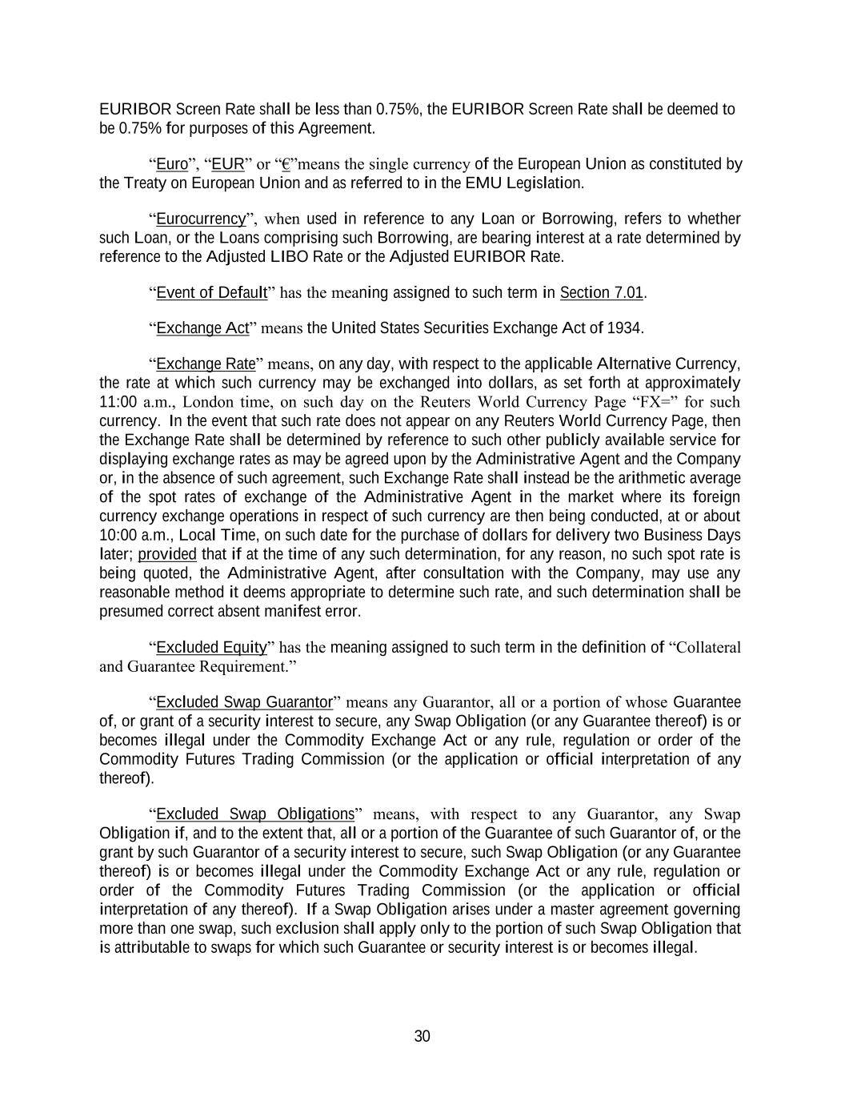
30 EURIBOR Screen Rate shall be less than 0.75%, the EURIBOR Screen Rate shall be deemed to be 0.75% for purposes of this Agreement. “Euro”, “EUR” or “€”means the single currency of the European Union as constituted by the Treaty on European Union and as referred to in the EMU Legislation. “Eurocurrency”, when used in reference to any Loan or Borrowing, refers to whether such Loan, or the Loans comprising such Borrowing, are bearing interest at a rate determined by reference to the Adjusted LIBO Rate or the Adjusted EURIBOR Rate. “Event of Default” has the meaning assigned to such term in Section 7.01. “Exchange Act” means the United States Securities Exchange Act of 1934. “Exchange Rate” means, on any day, with respect to the applicable Alternative Currency, the rate at which such currency may be exchanged into dollars, as set forth at approximately 11:00 a.m., London time, on such day on the Reuters World Currency Page “FX=” for such currency. In the event that such rate does not appear on any Reuters World Currency Page, then the Exchange Rate shall be determined by reference to such other publicly available service for displaying exchange rates as may be agreed upon by the Administrative Agent and the Company or, in the absence of such agreement, such Exchange Rate shall instead be the arithmetic average of the spot rates of exchange of the Administrative Agent in the market where its foreign currency exchange operations in respect of such currency are then being conducted, at or about 10:00 a.m., Local Time, on such date for the purchase of dollars for delivery two Business Days later; provided that if at the time of any such determination, for any reason, no such spot rate is being quoted, the Administrative Agent, after consultation with the Company, may use any reasonable method it deems appropriate to determine such rate, and such determination shall be presumed correct absent manifest error. “Excluded Equity” has the meaning assigned to such term in the definition of “Collateral and Guarantee Requirement.” “Excluded Swap Guarantor” means any Guarantor, all or a portion of whose Guarantee of, or grant of a security interest to secure, any Swap Obligation (or any Guarantee thereof) is or becomes illegal under the Commodity Exchange Act or any rule, regulation or order of the Commodity Futures Trading Commission (or the application or official interpretation of any thereof). “Excluded Swap Obligations” means, with respect to any Guarantor, any Swap Obligation if, and to the extent that, all or a portion of the Guarantee of such Guarantor of, or the grant by such Guarantor of a security interest to secure, such Swap Obligation (or any Guarantee thereof) is or becomes illegal under the Commodity Exchange Act or any rule, regulation or order of the Commodity Futures Trading Commission (or the application or official interpretation of any thereof). If a Swap Obligation arises under a master agreement governing more than one swap, such exclusion shall apply only to the portion of such Swap Obligation that is attributable to swaps for which such Guarantee or security interest is or becomes illegal.

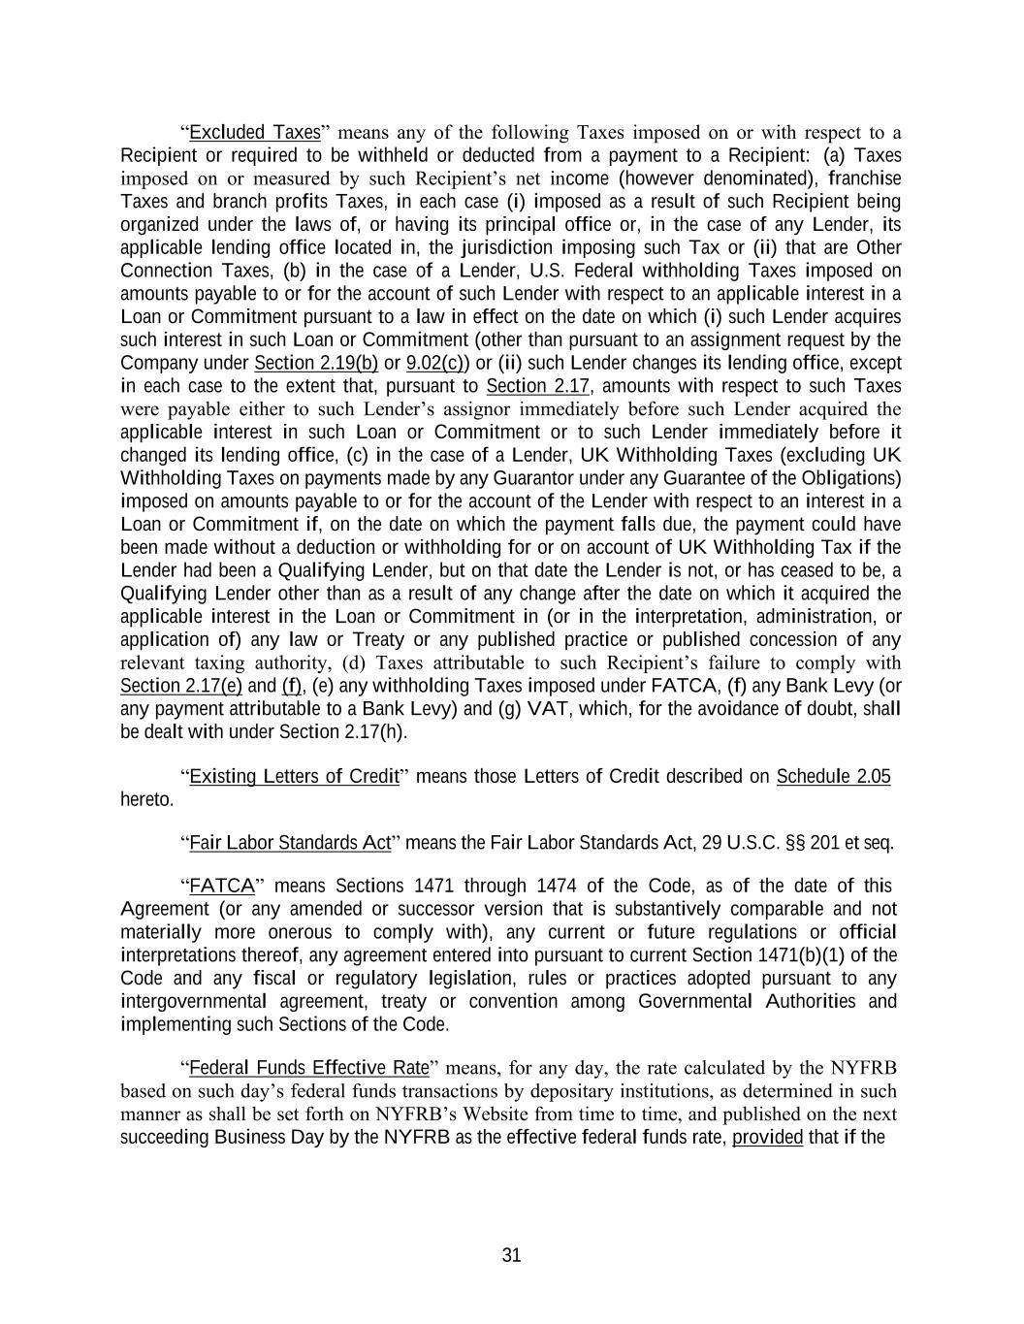
31 “Excluded Taxes” means any of the following Taxes imposed on or with respect to a Recipient or required to be withheld or deducted from a payment to a Recipient: (a) Taxes imposed on or measured by such Recipient’s net income (however denominated), franchise Taxes and branch profits Taxes, in each case (i) imposed as a result of such Recipient being organized under the laws of, or having its principal office or, in the case of any Lender, its applicable lending office located in, the jurisdiction imposing such Tax or (ii) that are Other Connection Taxes, (b) in the case of a Lender, U.S. Federal withholding Taxes imposed on amounts payable to or for the account of such Lender with respect to an applicable interest in a Loan or Commitment pursuant to a law in effect on the date on which (i) such Lender acquires such interest in such Loan or Commitment (other than pursuant to an assignment request by the Company under Section 2.19(b) or 9.02(c)) or (ii) such Lender changes its lending office, except in each case to the extent that, pursuant to Section 2.17, amounts with respect to such Taxes were payable either to such Lender’s assignor immediately before such Lender acquired the applicable interest in such Loan or Commitment or to such Lender immediately before it changed its lending office, (c) in the case of a Lender, UK Withholding Taxes (excluding UK Withholding Taxes on payments made by any Guarantor under any Guarantee of the Obligations) imposed on amounts payable to or for the account of the Lender with respect to an interest in a Loan or Commitment if, on the date on which the payment falls due, the payment could have been made without a deduction or withholding for or on account of UK Withholding Tax if the Lender had been a Qualifying Lender, but on that date the Lender is not, or has ceased to be, a Qualifying Lender other than as a result of any change after the date on which it acquired the applicable interest in the Loan or Commitment in (or in the interpretation, administration, or application of) any law or Treaty or any published practice or published concession of any relevant taxing authority, (d) Taxes attributable to such Recipient’s failure to comply with Section 2.17(e) and (f), (e) any withholding Taxes imposed under FATCA, (f) any Bank Levy (or any payment attributable to a Bank Levy) and (g) VAT, which, for the avoidance of doubt, shall be dealt with under Section 2.17(h). “Existing Letters of Credit” means those Letters of Credit described on Schedule 2.05 hereto. “Fair Labor Standards Act” means the Fair Labor Standards Act, 29 U.S.C. §§ 201 et seq. “FATCA” means Sections 1471 through 1474 of the Code, as of the date of this Agreement (or any amended or successor version that is substantively comparable and not materially more onerous to comply with), any current or future regulations or official interpretations thereof, any agreement entered into pursuant to current Section 1471(b)(1) of the Code and any fiscal or regulatory legislation, rules or practices adopted pursuant to any intergovernmental agreement, treaty or convention among Governmental Authorities and implementing such Sections of the Code. “Federal Funds Effective Rate” means, for any day, the rate calculated by the NYFRB based on such day’s federal funds transactions by depositary institutions, as determined in such manner as shall be set forth on NYFRB’s Website from time to time, and published on the next succeeding Business Day by the NYFRB as the effective federal funds rate, provided that if the

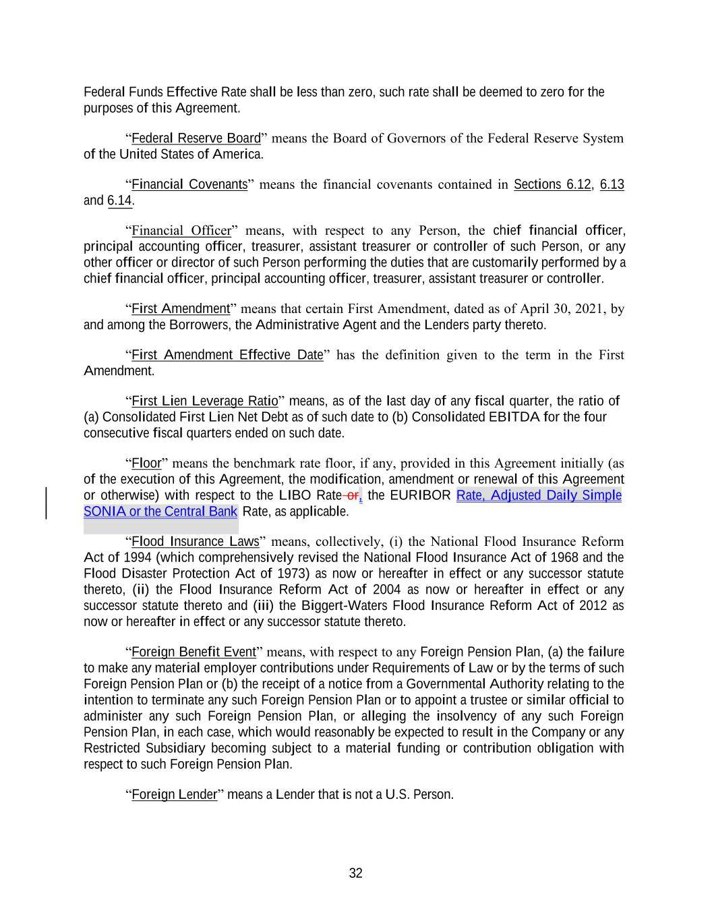
32 Federal Funds Effective Rate shall be less than zero, such rate shall be deemed to zero for the purposes of this Agreement. “Federal Reserve Board” means the Board of Governors of the Federal Reserve System of the United States of America. “Financial Covenants” means the financial covenants contained in Sections 6.12, 6.13 and 6.14. “Financial Officer” means, with respect to any Person, the chief financial officer, principal accounting officer, treasurer, assistant treasurer or controller of such Person, or any other officer or director of such Person performing the duties that are customarily performed by a chief financial officer, principal accounting officer, treasurer, assistant treasurer or controller. “First Amendment” means that certain First Amendment, dated as of April 30, 2021, by and among the Borrowers, the Administrative Agent and the Lenders party thereto. “First Amendment Effective Date” has the definition given to the term in the First Amendment. “First Lien Leverage Ratio” means, as of the last day of any fiscal quarter, the ratio of (a) Consolidated First Lien Net Debt as of such date to (b) Consolidated EBITDA for the four consecutive fiscal quarters ended on such date. “Floor” means the benchmark rate floor, if any, provided in this Agreement initially (as of the execution of this Agreement, the modification, amendment or renewal of this Agreement or otherwise) with respect to the LIBO Rate or, the EURIBOR Rate, Adjusted Daily Simple Rate, as applicable. “Flood Insurance Laws” means, collectively, (i) the National Flood Insurance Reform Act of 1994 (which comprehensively revised the National Flood Insurance Act of 1968 and the Flood Disaster Protection Act of 1973) as now or hereafter in effect or any successor statute thereto, (ii) the Flood Insurance Reform Act of 2004 as now or hereafter in effect or any successor statute thereto and (iii) the Biggert-Waters Flood Insurance Reform Act of 2012 as now or hereafter in effect or any successor statute thereto. “Foreign Benefit Event” means, with respect to any Foreign Pension Plan, (a) the failure to make any material employer contributions under Requirements of Law or by the terms of such Foreign Pension Plan or (b) the receipt of a notice from a Governmental Authority relating to the intention to terminate any such Foreign Pension Plan or to appoint a trustee or similar official to administer any such Foreign Pension Plan, or alleging the insolvency of any such Foreign Pension Plan, in each case, which would reasonably be expected to result in the Company or any Restricted Subsidiary becoming subject to a material funding or contribution obligation with respect to such Foreign Pension Plan. “Foreign Lender” means a Lender that is not a U.S. Person. SONIA or the Central Bank

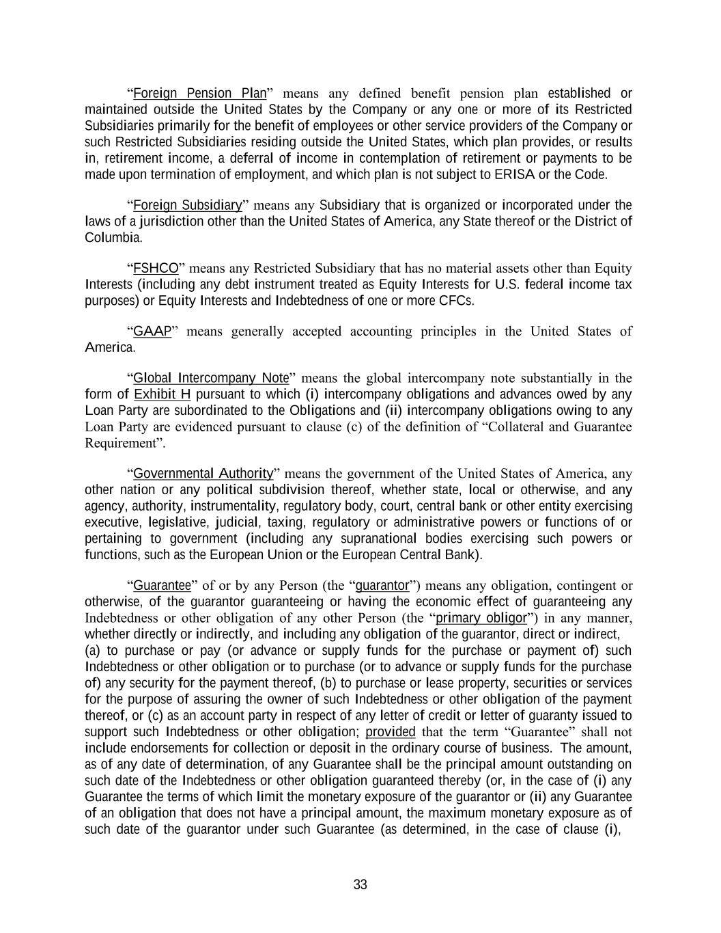
33 “Foreign Pension Plan” means any defined benefit pension plan established or maintained outside the United States by the Company or any one or more of its Restricted Subsidiaries primarily for the benefit of employees or other service providers of the Company or such Restricted Subsidiaries residing outside the United States, which plan provides, or results in, retirement income, a deferral of income in contemplation of retirement or payments to be made upon termination of employment, and which plan is not subject to ERISA or the Code. “Foreign Subsidiary” means any Subsidiary that is organized or incorporated under the laws of a jurisdiction other than the United States of America, any State thereof or the District of Columbia. “FSHCO” means any Restricted Subsidiary that has no material assets other than Equity Interests (including any debt instrument treated as Equity Interests for U.S. federal income tax purposes) or Equity Interests and Indebtedness of one or more CFCs. “GAAP” means generally accepted accounting principles in the United States of America. “Global Intercompany Note” means the global intercompany note substantially in the form of Exhibit H pursuant to which (i) intercompany obligations and advances owed by any Loan Party are subordinated to the Obligations and (ii) intercompany obligations owing to any Loan Party are evidenced pursuant to clause (c) of the definition of “Collateral and Guarantee Requirement”. “Governmental Authority” means the government of the United States of America, any other nation or any political subdivision thereof, whether state, local or otherwise, and any agency, authority, instrumentality, regulatory body, court, central bank or other entity exercising executive, legislative, judicial, taxing, regulatory or administrative powers or functions of or pertaining to government (including any supranational bodies exercising such powers or functions, such as the European Union or the European Central Bank). “Guarantee” of or by any Person (the “guarantor”) means any obligation, contingent or otherwise, of the guarantor guaranteeing or having the economic effect of guaranteeing any Indebtedness or other obligation of any other Person (the “primary obligor”) in any manner, whether directly or indirectly, and including any obligation of the guarantor, direct or indirect, (a) to purchase or pay (or advance or supply funds for the purchase or payment of) such Indebtedness or other obligation or to purchase (or to advance or supply funds for the purchase of) any security for the payment thereof, (b) to purchase or lease property, securities or services for the purpose of assuring the owner of such Indebtedness or other obligation of the payment thereof, or (c) as an account party in respect of any letter of credit or letter of guaranty issued to support such Indebtedness or other obligation; provided that the term “Guarantee” shall not include endorsements for collection or deposit in the ordinary course of business. The amount, as of any date of determination, of any Guarantee shall be the principal amount outstanding on such date of the Indebtedness or other obligation guaranteed thereby (or, in the case of (i) any Guarantee the terms of which limit the monetary exposure of the guarantor or (ii) any Guarantee of an obligation that does not have a principal amount, the maximum monetary exposure as of such date of the guarantor under such Guarantee (as determined, in the case of clause (i),

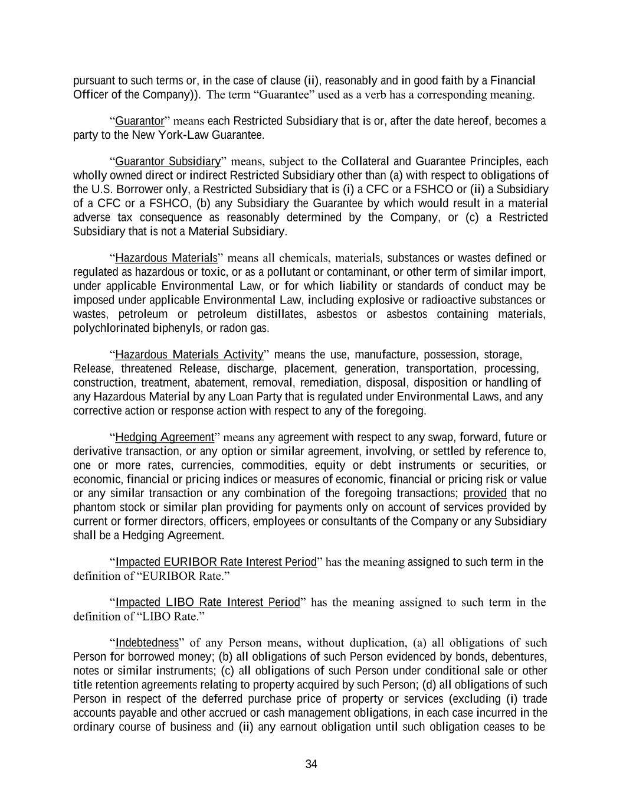
34 pursuant to such terms or, in the case of clause (ii), reasonably and in good faith by a Financial Officer of the Company)). The term “Guarantee” used as a verb has a corresponding meaning. “Guarantor” means each Restricted Subsidiary that is or, after the date hereof, becomes a party to the New York-Law Guarantee. “Guarantor Subsidiary” means, subject to the Collateral and Guarantee Principles, each wholly owned direct or indirect Restricted Subsidiary other than (a) with respect to obligations of the U.S. Borrower only, a Restricted Subsidiary that is (i) a CFC or a FSHCO or (ii) a Subsidiary of a CFC or a FSHCO, (b) any Subsidiary the Guarantee by which would result in a material adverse tax consequence as reasonably determined by the Company, or (c) a Restricted Subsidiary that is not a Material Subsidiary. “Hazardous Materials” means all chemicals, materials, substances or wastes defined or regulated as hazardous or toxic, or as a pollutant or contaminant, or other term of similar import, under applicable Environmental Law, or for which liability or standards of conduct may be imposed under applicable Environmental Law, including explosive or radioactive substances or wastes, petroleum or petroleum distillates, asbestos or asbestos containing materials, polychlorinated biphenyls, or radon gas. “Hazardous Materials Activity” means the use, manufacture, possession, storage, Release, threatened Release, discharge, placement, generation, transportation, processing, construction, treatment, abatement, removal, remediation, disposal, disposition or handling of any Hazardous Material by any Loan Party that is regulated under Environmental Laws, and any corrective action or response action with respect to any of the foregoing. “Hedging Agreement” means any agreement with respect to any swap, forward, future or derivative transaction, or any option or similar agreement, involving, or settled by reference to, one or more rates, currencies, commodities, equity or debt instruments or securities, or economic, financial or pricing indices or measures of economic, financial or pricing risk or value or any similar transaction or any combination of the foregoing transactions; provided that no phantom stock or similar plan providing for payments only on account of services provided by current or former directors, officers, employees or consultants of the Company or any Subsidiary shall be a Hedging Agreement. “Impacted EURIBOR Rate Interest Period” has the meaning assigned to such term in the definition of “EURIBOR Rate.” “Impacted LIBO Rate Interest Period” has the meaning assigned to such term in the definition of “LIBO Rate.” “Indebtedness” of any Person means, without duplication, (a) all obligations of such Person for borrowed money; (b) all obligations of such Person evidenced by bonds, debentures, notes or similar instruments; (c) all obligations of such Person under conditional sale or other title retention agreements relating to property acquired by such Person; (d) all obligations of such Person in respect of the deferred purchase price of property or services (excluding (i) trade accounts payable and other accrued or cash management obligations, in each case incurred in the ordinary course of business and (ii) any earnout obligation until such obligation ceases to be

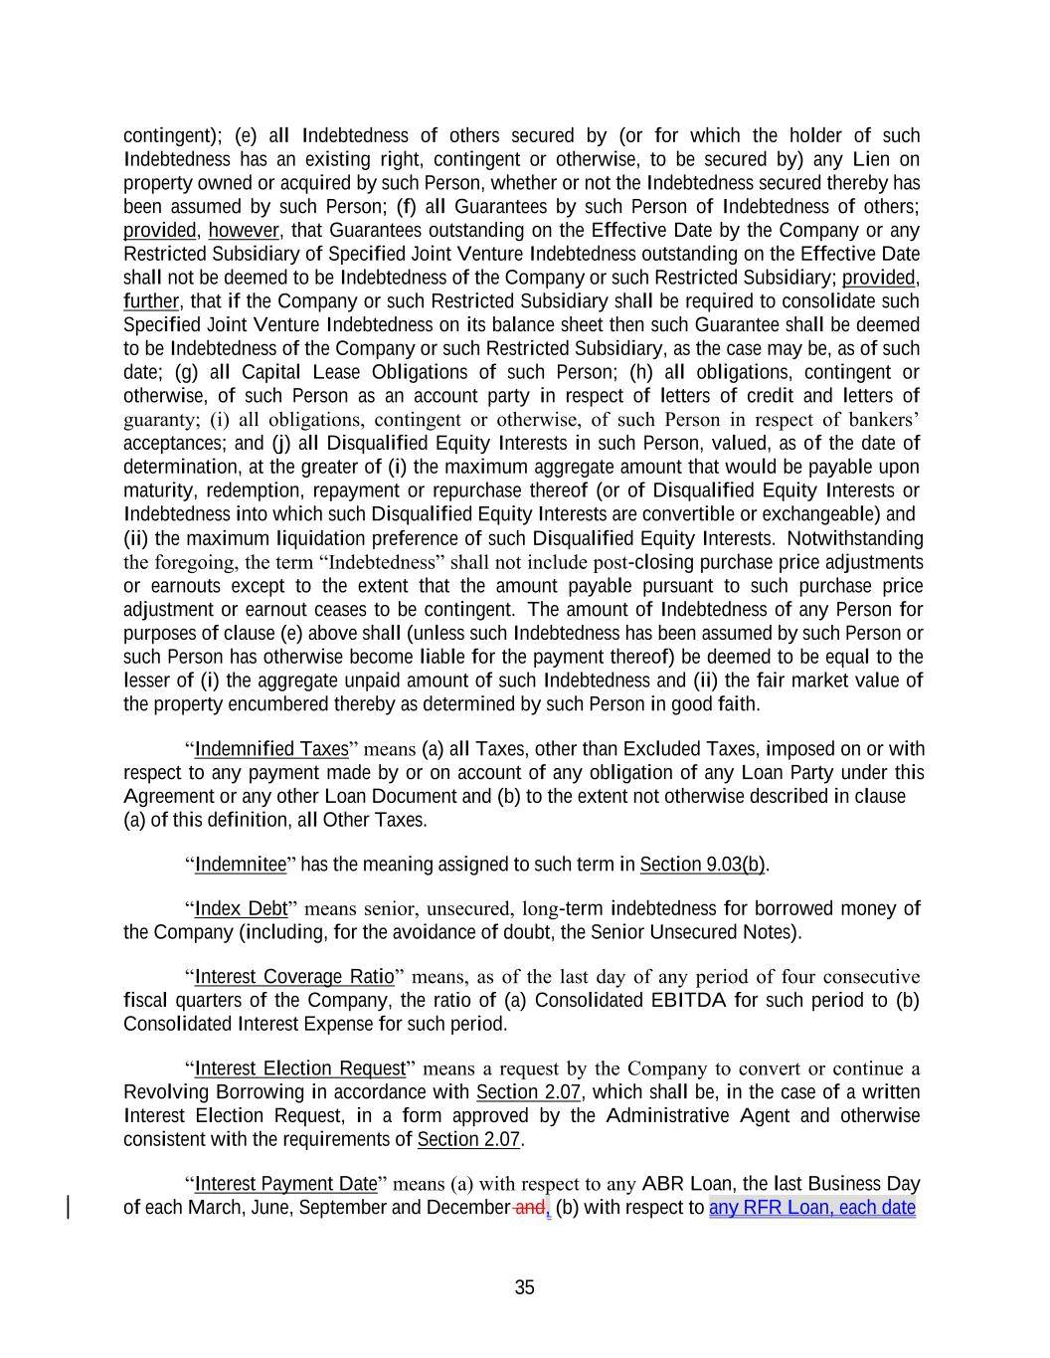
35 contingent); (e) all Indebtedness of others secured by (or for which the holder of such Indebtedness has an existing right, contingent or otherwise, to be secured by) any Lien on property owned or acquired by such Person, whether or not the Indebtedness secured thereby has been assumed by such Person; (f) all Guarantees by such Person of Indebtedness of others; provided, however, that Guarantees outstanding on the Effective Date by the Company or any Restricted Subsidiary of Specified Joint Venture Indebtedness outstanding on the Effective Date shall not be deemed to be Indebtedness of the Company or such Restricted Subsidiary; provided, further, that if the Company or such Restricted Subsidiary shall be required to consolidate such Specified Joint Venture Indebtedness on its balance sheet then such Guarantee shall be deemed to be Indebtedness of the Company or such Restricted Subsidiary, as the case may be, as of such date; (g) all Capital Lease Obligations of such Person; (h) all obligations, contingent or otherwise, of such Person as an account party in respect of letters of credit and letters of guaranty; (i) all obligations, contingent or otherwise, of such Person in respect of bankers’ acceptances; and (j) all Disqualified Equity Interests in such Person, valued, as of the date of determination, at the greater of (i) the maximum aggregate amount that would be payable upon maturity, redemption, repayment or repurchase thereof (or of Disqualified Equity Interests or Indebtedness into which such Disqualified Equity Interests are convertible or exchangeable) and (ii) the maximum liquidation preference of such Disqualified Equity Interests. Notwithstanding the foregoing, the term “Indebtedness” shall not include post-closing purchase price adjustments or earnouts except to the extent that the amount payable pursuant to such purchase price adjustment or earnout ceases to be contingent. The amount of Indebtedness of any Person for purposes of clause (e) above shall (unless such Indebtedness has been assumed by such Person or such Person has otherwise become liable for the payment thereof) be deemed to be equal to the lesser of (i) the aggregate unpaid amount of such Indebtedness and (ii) the fair market value of the property encumbered thereby as determined by such Person in good faith. “Indemnified Taxes” means (a) all Taxes, other than Excluded Taxes, imposed on or with respect to any payment made by or on account of any obligation of any Loan Party under this Agreement or any other Loan Document and (b) to the extent not otherwise described in clause (a) of this definition, all Other Taxes. “Indemnitee” has the meaning assigned to such term in Section 9.03(b). “Index Debt” means senior, unsecured, long-term indebtedness for borrowed money of the Company (including, for the avoidance of doubt, the Senior Unsecured Notes). “Interest Coverage Ratio” means, as of the last day of any period of four consecutive fiscal quarters of the Company, the ratio of (a) Consolidated EBITDA for such period to (b) Consolidated Interest Expense for such period. “Interest Election Request” means a request by the Company to convert or continue a Revolving Borrowing in accordance with Section 2.07, which shall be, in the case of a written Interest Election Request, in a form approved by the Administrative Agent and otherwise consistent with the requirements of Section 2.07. “Interest Payment Date” means (a) with respect to any ABR Loan, the last Business Day of each March, June, September and December and, (b) with respect to any RFR Loan, each date

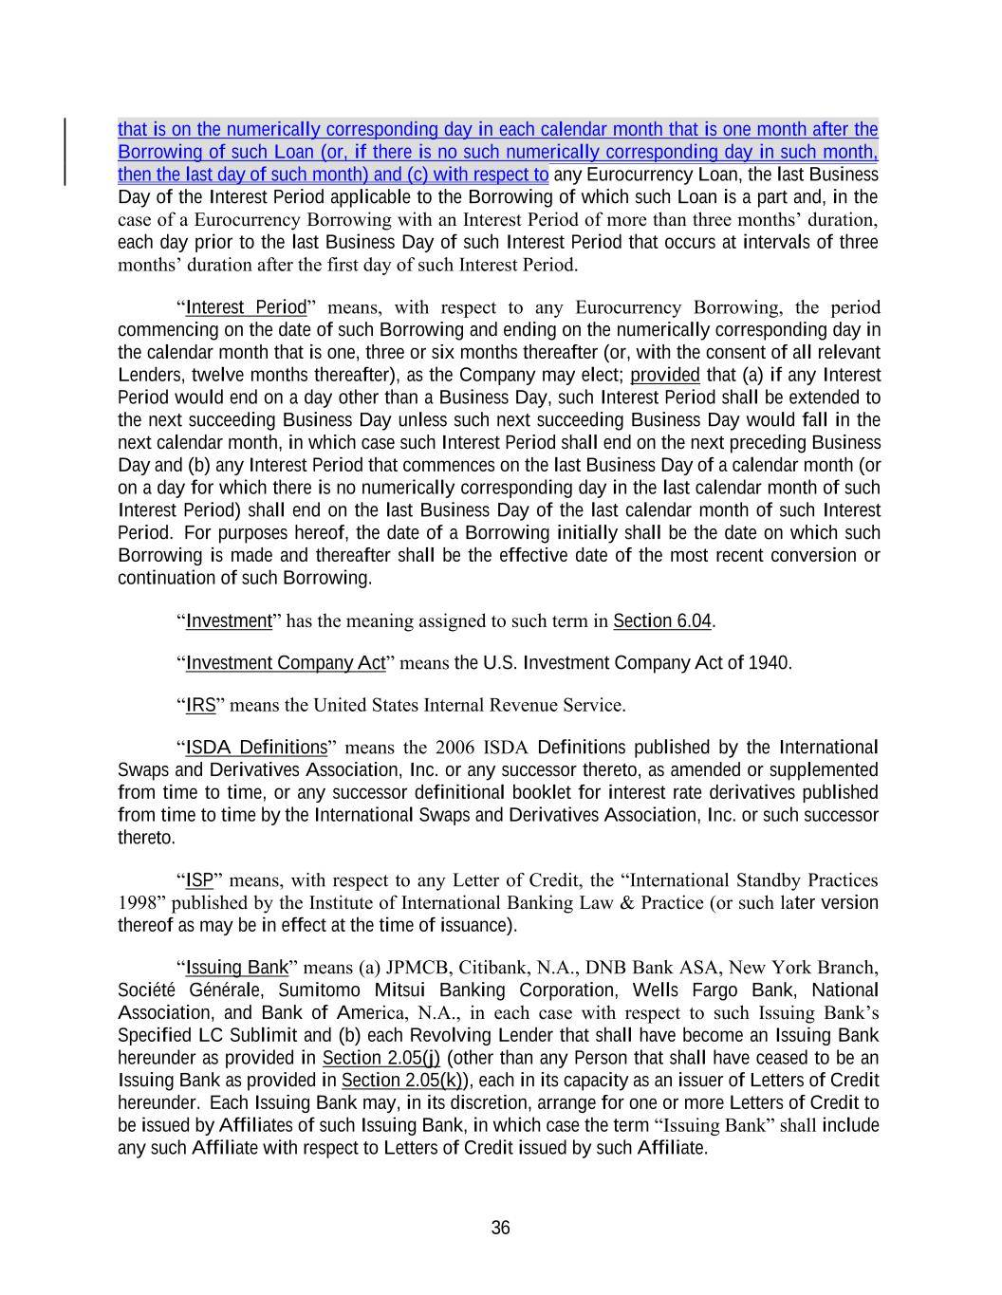
36 that is on the numerically corresponding day in each calendar month that is one month after the Borrowing of such Loan (or, if there is no such numerically corresponding day in such month, then the last day of such month) and (c) with respect to any Eurocurrency Loan, the last Business Day of the Interest Period applicable to the Borrowing of which such Loan is a part and, in the case of a Eurocurrency Borrowing with an Interest Period of more than three months’ duration, each day prior to the last Business Day of such Interest Period that occurs at intervals of three months’ duration after the first day of such Interest Period. “Interest Period” means, with respect to any Eurocurrency Borrowing, the period commencing on the date of such Borrowing and ending on the numerically corresponding day in the calendar month that is one, three or six months thereafter (or, with the consent of all relevant Lenders, twelve months thereafter), as the Company may elect; provided that (a) if any Interest Period would end on a day other than a Business Day, such Interest Period shall be extended to the next succeeding Business Day unless such next succeeding Business Day would fall in the next calendar month, in which case such Interest Period shall end on the next preceding Business Day and (b) any Interest Period that commences on the last Business Day of a calendar month (or on a day for which there is no numerically corresponding day in the last calendar month of such Interest Period) shall end on the last Business Day of the last calendar month of such Interest Period. For purposes hereof, the date of a Borrowing initially shall be the date on which such Borrowing is made and thereafter shall be the effective date of the most recent conversion or continuation of such Borrowing. “Investment” has the meaning assigned to such term in Section 6.04. “Investment Company Act” means the U.S. Investment Company Act of 1940. “IRS” means the United States Internal Revenue Service. “ISDA Definitions” means the 2006 ISDA Definitions published by the International Swaps and Derivatives Association, Inc. or any successor thereto, as amended or supplemented from time to time, or any successor definitional booklet for interest rate derivatives published from time to time by the International Swaps and Derivatives Association, Inc. or such successor thereto. “ISP” means, with respect to any Letter of Credit, the “International Standby Practices 1998” published by the Institute of International Banking Law & Practice (or such later version thereof as may be in effect at the time of issuance). “Issuing Bank” means (a) JPMCB, Citibank, N.A., DNB Bank ASA, New York Branch, Société Générale, Sumitomo Mitsui Banking Corporation, Wells Fargo Bank, National Association, and Bank of America, N.A., in each case with respect to such Issuing Bank’s Specified LC Sublimit and (b) each Revolving Lender that shall have become an Issuing Bank hereunder as provided in Section 2.05(j) (other than any Person that shall have ceased to be an Issuing Bank as provided in Section 2.05(k)), each in its capacity as an issuer of Letters of Credit hereunder. Each Issuing Bank may, in its discretion, arrange for one or more Letters of Credit to be issued by Affiliates of such Issuing Bank, in which case the term “Issuing Bank” shall include any such Affiliate with respect to Letters of Credit issued by such Affiliate.

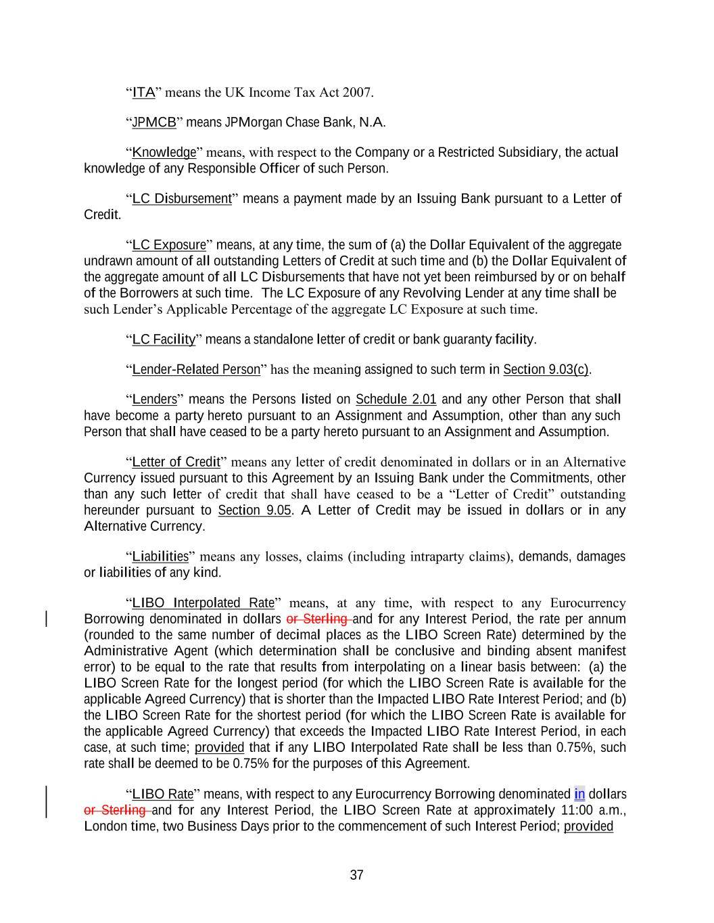
37 “ITA” means the UK Income Tax Act 2007. “JPMCB” means JPMorgan Chase Bank, N.A. “Knowledge” means, with respect to the Company or a Restricted Subsidiary, the actual knowledge of any Responsible Officer of such Person. “LC Disbursement” means a payment made by an Issuing Bank pursuant to a Letter of Credit. “LC Exposure” means, at any time, the sum of (a) the Dollar Equivalent of the aggregate undrawn amount of all outstanding Letters of Credit at such time and (b) the Dollar Equivalent of the aggregate amount of all LC Disbursements that have not yet been reimbursed by or on behalf of the Borrowers at such time. The LC Exposure of any Revolving Lender at any time shall be such Lender’s Applicable Percentage of the aggregate LC Exposure at such time. “LC Facility” means a standalone letter of credit or bank guaranty facility. “Lender-Related Person” has the meaning assigned to such term in Section 9.03(c). “Lenders” means the Persons listed on Schedule 2.01 and any other Person that shall have become a party hereto pursuant to an Assignment and Assumption, other than any such Person that shall have ceased to be a party hereto pursuant to an Assignment and Assumption. “Letter of Credit” means any letter of credit denominated in dollars or in an Alternative Currency issued pursuant to this Agreement by an Issuing Bank under the Commitments, other than any such letter of credit that shall have ceased to be a “Letter of Credit” outstanding hereunder pursuant to Section 9.05. A Letter of Credit may be issued in dollars or in any Alternative Currency. “Liabilities” means any losses, claims (including intraparty claims), demands, damages or liabilities of any kind. “LIBO Interpolated Rate” means, at any time, with respect to any Eurocurrency Borrowing denominated in dollars or Sterling and for any Interest Period, the rate per annum (rounded to the same number of decimal places as the LIBO Screen Rate) determined by the Administrative Agent (which determination shall be conclusive and binding absent manifest error) to be equal to the rate that results from interpolating on a linear basis between: (a) the LIBO Screen Rate for the longest period (for which the LIBO Screen Rate is available for the applicable Agreed Currency) that is shorter than the Impacted LIBO Rate Interest Period; and (b) the LIBO Screen Rate for the shortest period (for which the LIBO Screen Rate is available for the applicable Agreed Currency) that exceeds the Impacted LIBO Rate Interest Period, in each case, at such time; provided that if any LIBO Interpolated Rate shall be less than 0.75%, such rate shall be deemed to be 0.75% for the purposes of this Agreement. “LIBO Rate” means, with respect to any Eurocurrency Borrowing denominated in dollars or Sterling and for any Interest Period, the LIBO Screen Rate at approximately 11:00 a.m., London time, two Business Days prior to the commencement of such Interest Period; provided

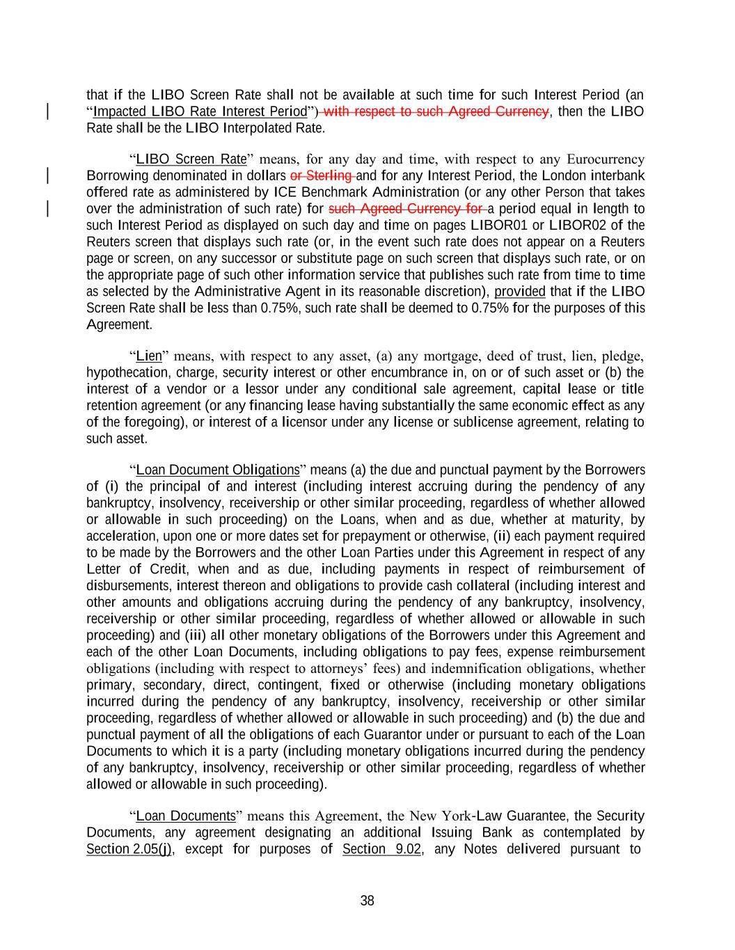
38 that if the LIBO Screen Rate shall not be available at such time for such Interest Period (an “Impacted LIBO Rate Interest Period”) with respect to such Agreed Currency, then the LIBO Rate shall be the LIBO Interpolated Rate. “LIBO Screen Rate” means, for any day and time, with respect to any Eurocurrency Borrowing denominated in dollars or Sterling and for any Interest Period, the London interbank offered rate as administered by ICE Benchmark Administration (or any other Person that takes over the administration of such rate) for such Agreed Currency for a period equal in length to such Interest Period as displayed on such day and time on pages LIBOR01 or LIBOR02 of the Reuters screen that displays such rate (or, in the event such rate does not appear on a Reuters page or screen, on any successor or substitute page on such screen that displays such rate, or on the appropriate page of such other information service that publishes such rate from time to time as selected by the Administrative Agent in its reasonable discretion), provided that if the LIBO Screen Rate shall be less than 0.75%, such rate shall be deemed to 0.75% for the purposes of this Agreement. “Lien” means, with respect to any asset, (a) any mortgage, deed of trust, lien, pledge, hypothecation, charge, security interest or other encumbrance in, on or of such asset or (b) the interest of a vendor or a lessor under any conditional sale agreement, capital lease or title retention agreement (or any financing lease having substantially the same economic effect as any of the foregoing), or interest of a licensor under any license or sublicense agreement, relating to such asset. “Loan Document Obligations” means (a) the due and punctual payment by the Borrowers of (i) the principal of and interest (including interest accruing during the pendency of any bankruptcy, insolvency, receivership or other similar proceeding, regardless of whether allowed or allowable in such proceeding) on the Loans, when and as due, whether at maturity, by acceleration, upon one or more dates set for prepayment or otherwise, (ii) each payment required to be made by the Borrowers and the other Loan Parties under this Agreement in respect of any Letter of Credit, when and as due, including payments in respect of reimbursement of disbursements, interest thereon and obligations to provide cash collateral (including interest and other amounts and obligations accruing during the pendency of any bankruptcy, insolvency, receivership or other similar proceeding, regardless of whether allowed or allowable in such proceeding) and (iii) all other monetary obligations of the Borrowers under this Agreement and each of the other Loan Documents, including obligations to pay fees, expense reimbursement obligations (including with respect to attorneys’ fees) and indemnification obligations, whether primary, secondary, direct, contingent, fixed or otherwise (including monetary obligations incurred during the pendency of any bankruptcy, insolvency, receivership or other similar proceeding, regardless of whether allowed or allowable in such proceeding) and (b) the due and punctual payment of all the obligations of each Guarantor under or pursuant to each of the Loan Documents to which it is a party (including monetary obligations incurred during the pendency of any bankruptcy, insolvency, receivership or other similar proceeding, regardless of whether allowed or allowable in such proceeding). “Loan Documents” means this Agreement, the New York-Law Guarantee, the Security Documents, any agreement designating an additional Issuing Bank as contemplated by Section 2.05(j), except for purposes of Section 9.02, any Notes delivered pursuant to

39 Section 2.09(c), any SCF Intercreditor Agreement and all other agreements, instruments, documents and certificates now or hereafter executed and delivered by a Loan Party to, or in favor of, the Administrative Agent or Collateral Agent or any Lender in connection with this Agreement to the extent designated as a “Loan Document” therein (and, in each case, any amendment, restatement, waiver, supplement or other modification to any of the foregoing). “Loan Parties” means, collectively, the Borrowers and the Guarantors. “Loans” means the loans made by the Lenders to the Borrowers pursuant to this Agreement. “Local Time” means (a) with respect to any Loan or Borrowing denominated in dollars or any Letter of Credit denominated in dollars, New York City time and (b) with respect to any Loan or Borrowing denominated in an Alternative Currency or any Letter of Credit denominated in an Alternative Currency, London time. “London Business Day” means any day on which banks are generally open for dealings in dollar deposits in the London interbank market. “Material Adverse Effect” means a material adverse effect on (a) the business, assets, liabilities, operations or financial condition of the Borrowers and the Restricted Subsidiaries, taken as a whole, (b) the ability of the Loan Parties (taken as a whole) to perform their obligations to the Lenders or the Administrative Agent under this Agreement or any other Loan Document or (c) the rights of, or remedies available to, the Administrative Agent or the Lenders under this Agreement or any other Loan Document. “Material Indebtedness” means Indebtedness (other than the Loans, the Letters of Credit and the Guarantees under the Loan Documents), or obligations in respect of one or more Hedging Agreements, of any one or more of the Borrowers and the Restricted Subsidiaries in an aggregate principal amount exceeding $100,000,000. For purposes of determining Material Indebtedness, the “principal amount” of the obligations of a Borrower or any Restricted Subsidiary in respect of any Hedging Agreement at any time shall be the maximum aggregate amount (giving effect to any netting agreements) that such Borrower or such Restricted Subsidiary would be required to pay if such Hedging Agreement were terminated at such time. “Material Real Property” means any fee-owned real property in any Collateral Jurisdiction with a book value of at least $5,000,000 as reasonably determined by the Company in good faith. “Material Subsidiary” means each Restricted Subsidiary (a) the Consolidated Total Assets of which equal 5.0% or more of the Consolidated Total Assets of the Company and the Restricted Subsidiaries or (b) the consolidated revenues of which equal 5.0% or more of the consolidated revenues of the Company and the Restricted Subsidiaries, in each case as of the end of or for the most recent period of four consecutive fiscal quarters for which financial statements have been delivered pursuant to Section 5.01(a) or 5.01(b) (or, prior to the first delivery of any such financial statements, as of the end of or for the period of four consecutive fiscal quarters most recently ended prior to the Effective Date); provided that if, at the end of or for any such most recent period of four consecutive fiscal quarters, the combined Consolidated Total Assets

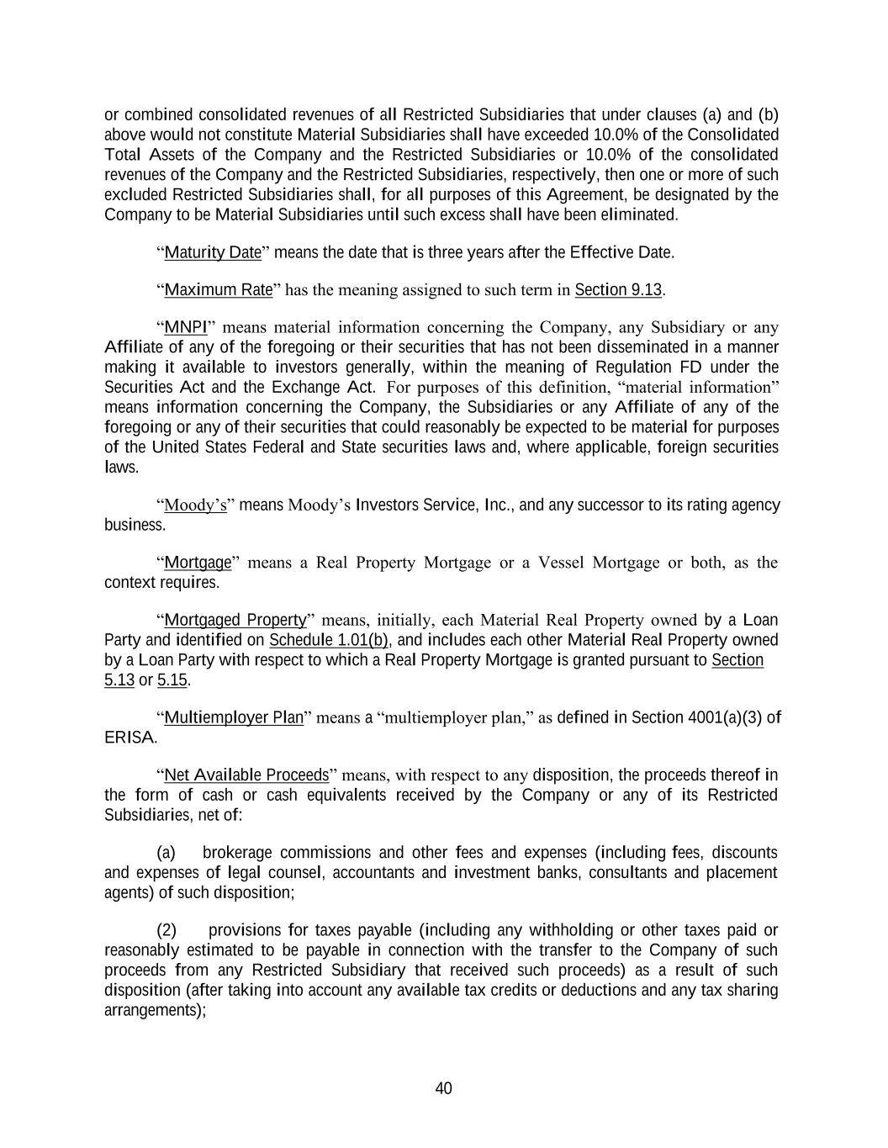
40 or combined consolidated revenues of all Restricted Subsidiaries that under clauses (a) and (b) above would not constitute Material Subsidiaries shall have exceeded 10.0% of the Consolidated Total Assets of the Company and the Restricted Subsidiaries or 10.0% of the consolidated revenues of the Company and the Restricted Subsidiaries, respectively, then one or more of such excluded Restricted Subsidiaries shall, for all purposes of this Agreement, be designated by the Company to be Material Subsidiaries until such excess shall have been eliminated. “Maturity Date” means the date that is three years after the Effective Date. “Maximum Rate” has the meaning assigned to such term in Section 9.13. “MNPI” means material information concerning the Company, any Subsidiary or any Affiliate of any of the foregoing or their securities that has not been disseminated in a manner making it available to investors generally, within the meaning of Regulation FD under the Securities Act and the Exchange Act. For purposes of this definition, “material information” means information concerning the Company, the Subsidiaries or any Affiliate of any of the foregoing or any of their securities that could reasonably be expected to be material for purposes of the United States Federal and State securities laws and, where applicable, foreign securities laws. “Moody’s” means Moody’s Investors Service, Inc., and any successor to its rating agency business. “Mortgage” means a Real Property Mortgage or a Vessel Mortgage or both, as the context requires. “Mortgaged Property” means, initially, each Material Real Property owned by a Loan Party and identified on Schedule 1.01(b), and includes each other Material Real Property owned by a Loan Party with respect to which a Real Property Mortgage is granted pursuant to Section 5.13 or 5.15. “Multiemployer Plan” means a “multiemployer plan,” as defined in Section 4001(a)(3) of ERISA. “Net Available Proceeds” means, with respect to any disposition, the proceeds thereof in the form of cash or cash equivalents received by the Company or any of its Restricted Subsidiaries, net of: (a) brokerage commissions and other fees and expenses (including fees, discounts and expenses of legal counsel, accountants and investment banks, consultants and placement agents) of such disposition; (2) provisions for taxes payable (including any withholding or other taxes paid or reasonably estimated to be payable in connection with the transfer to the Company of such proceeds from any Restricted Subsidiary that received such proceeds) as a result of such disposition (after taking into account any available tax credits or deductions and any tax sharing arrangements);

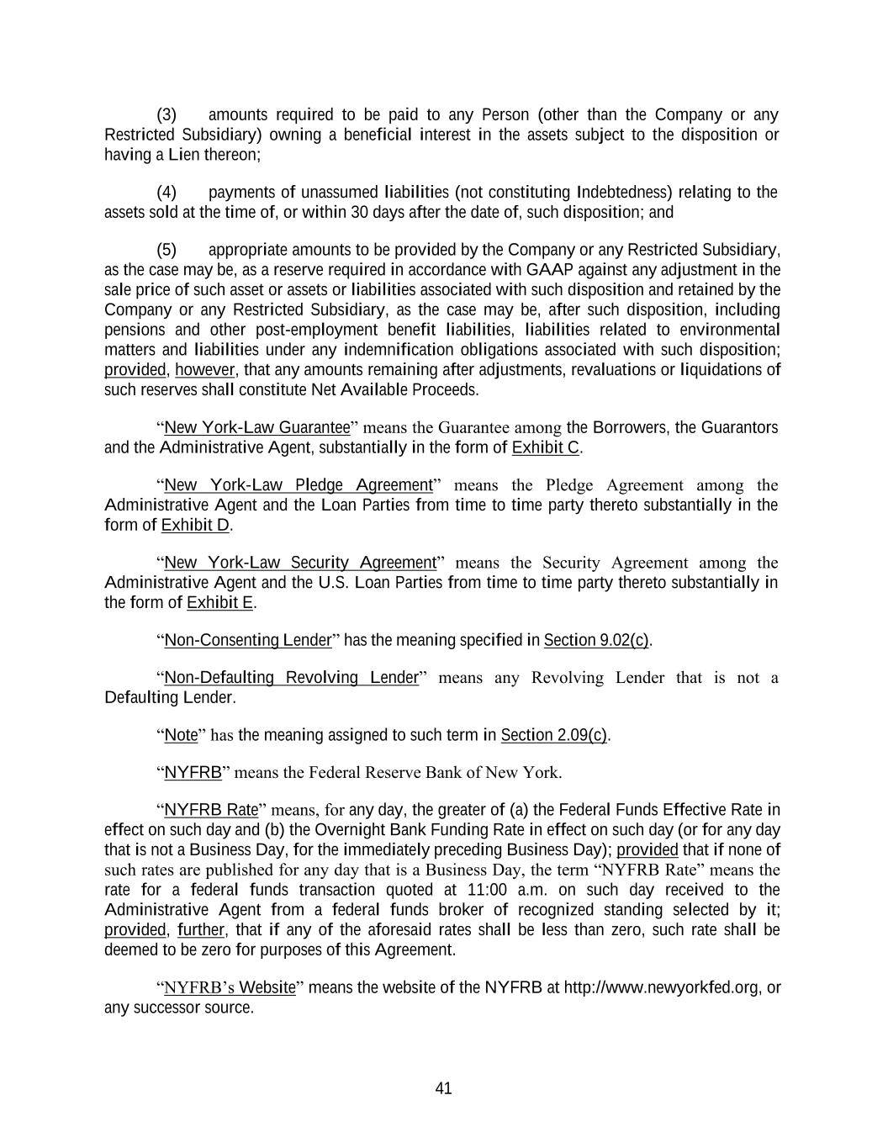
41 (3) amounts required to be paid to any Person (other than the Company or any Restricted Subsidiary) owning a beneficial interest in the assets subject to the disposition or having a Lien thereon; (4) payments of unassumed liabilities (not constituting Indebtedness) relating to the assets sold at the time of, or within 30 days after the date of, such disposition; and (5) appropriate amounts to be provided by the Company or any Restricted Subsidiary, as the case may be, as a reserve required in accordance with GAAP against any adjustment in the sale price of such asset or assets or liabilities associated with such disposition and retained by the Company or any Restricted Subsidiary, as the case may be, after such disposition, including pensions and other post-employment benefit liabilities, liabilities related to environmental matters and liabilities under any indemnification obligations associated with such disposition; provided, however, that any amounts remaining after adjustments, revaluations or liquidations of such reserves shall constitute Net Available Proceeds. “New York-Law Guarantee” means the Guarantee among the Borrowers, the Guarantors and the Administrative Agent, substantially in the form of Exhibit C. “New York-Law Pledge Agreement” means the Pledge Agreement among the Administrative Agent and the Loan Parties from time to time party thereto substantially in the form of Exhibit D. “New York-Law Security Agreement” means the Security Agreement among the Administrative Agent and the U.S. Loan Parties from time to time party thereto substantially in the form of Exhibit E. “Non-Consenting Lender” has the meaning specified in Section 9.02(c). “Non-Defaulting Revolving Lender” means any Revolving Lender that is not a Defaulting Lender. “Note” has the meaning assigned to such term in Section 2.09(c). “NYFRB” means the Federal Reserve Bank of New York. “NYFRB Rate” means, for any day, the greater of (a) the Federal Funds Effective Rate in effect on such day and (b) the Overnight Bank Funding Rate in effect on such day (or for any day that is not a Business Day, for the immediately preceding Business Day); provided that if none of such rates are published for any day that is a Business Day, the term “NYFRB Rate” means the rate for a federal funds transaction quoted at 11:00 a.m. on such day received to the Administrative Agent from a federal funds broker of recognized standing selected by it; provided, further, that if any of the aforesaid rates shall be less than zero, such rate shall be deemed to be zero for purposes of this Agreement. “NYFRB’s Website” means the website of the NYFRB at http://www.newyorkfed.org, or any successor source.

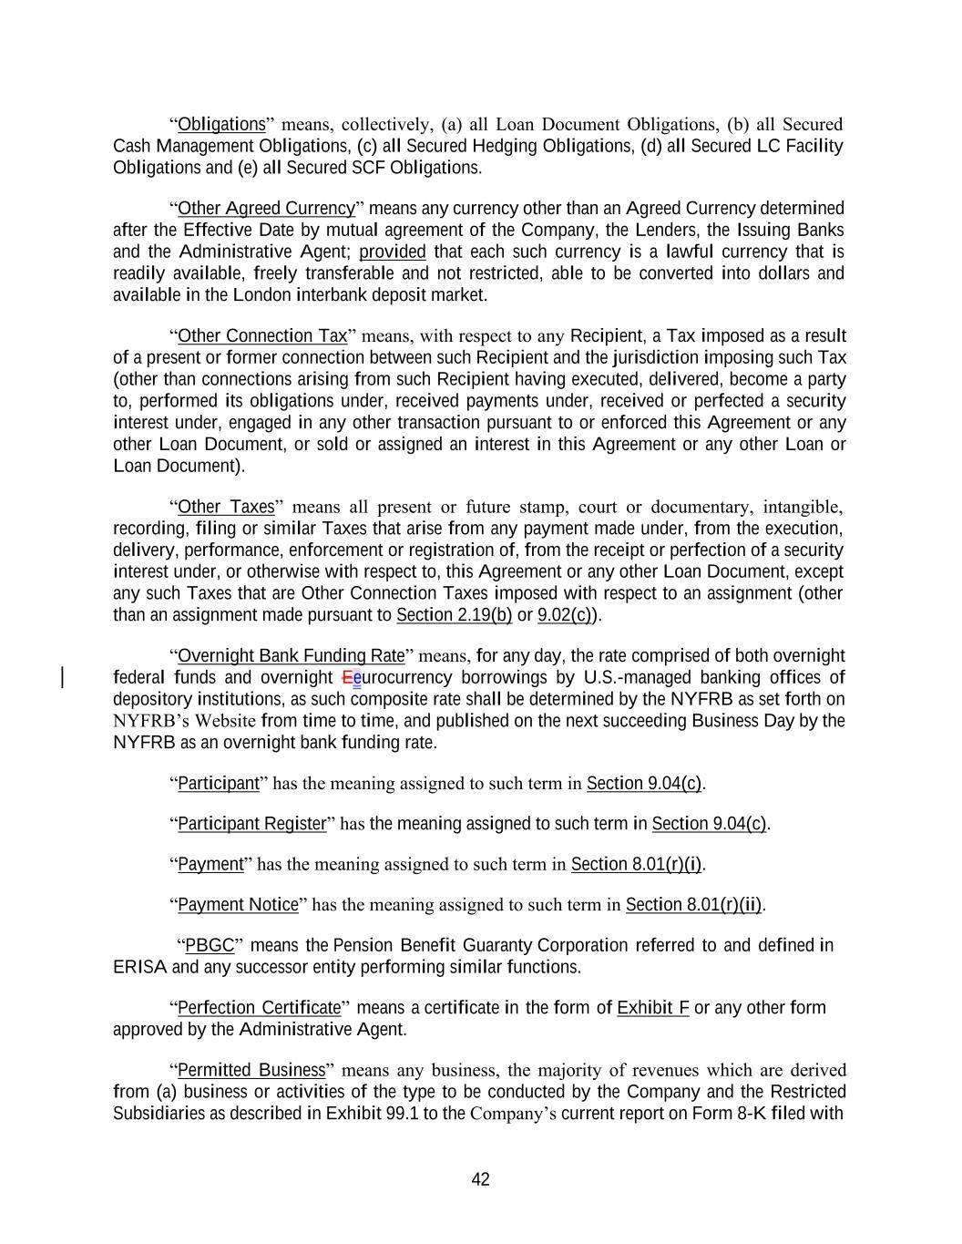
42 “Obligations” means, collectively, (a) all Loan Document Obligations, (b) all Secured Cash Management Obligations, (c) all Secured Hedging Obligations, (d) all Secured LC Facility Obligations and (e) all Secured SCF Obligations. “Other Agreed Currency” means any currency other than an Agreed Currency determined after the Effective Date by mutual agreement of the Company, the Lenders, the Issuing Banks and the Administrative Agent; provided that each such currency is a lawful currency that is readily available, freely transferable and not restricted, able to be converted into dollars and available in the London interbank deposit market. “Other Connection Tax” means, with respect to any Recipient, a Tax imposed as a result of a present or former connection between such Recipient and the jurisdiction imposing such Tax (other than connections arising from such Recipient having executed, delivered, become a party to, performed its obligations under, received payments under, received or perfected a security interest under, engaged in any other transaction pursuant to or enforced this Agreement or any other Loan Document, or sold or assigned an interest in this Agreement or any other Loan or Loan Document). “Other Taxes” means all present or future stamp, court or documentary, intangible, recording, filing or similar Taxes that arise from any payment made under, from the execution, delivery, performance, enforcement or registration of, from the receipt or perfection of a security interest under, or otherwise with respect to, this Agreement or any other Loan Document, except any such Taxes that are Other Connection Taxes imposed with respect to an assignment (other than an assignment made pursuant to Section 2.19(b) or 9.02(c)). “Overnight Bank Funding Rate” means, for any day, the rate comprised of both overnight federal funds and overnight Eeurocurrency borrowings by U.S.-managed banking offices of depository institutions, as such composite rate shall be determined by the NYFRB as set forth on NYFRB’s Website from time to time, and published on the next succeeding Business Day by the NYFRB as an overnight bank funding rate. “Participant” has the meaning assigned to such term in Section 9.04(c). “Participant Register” has the meaning assigned to such term in Section 9.04(c). “Payment” has the meaning assigned to such term in Section 8.01(r)(i). “Payment Notice” has the meaning assigned to such term in Section 8.01(r)(ii). “PBGC” means the Pension Benefit Guaranty Corporation referred to and defined in ERISA and any successor entity performing similar functions. “Perfection Certificate” means a certificate in the form of Exhibit F or any other form approved by the Administrative Agent. “Permitted Business” means any business, the majority of revenues which are derived from (a) business or activities of the type to be conducted by the Company and the Restricted Subsidiaries as described in Exhibit 99.1 to the Company’s current report on Form 8-K filed with

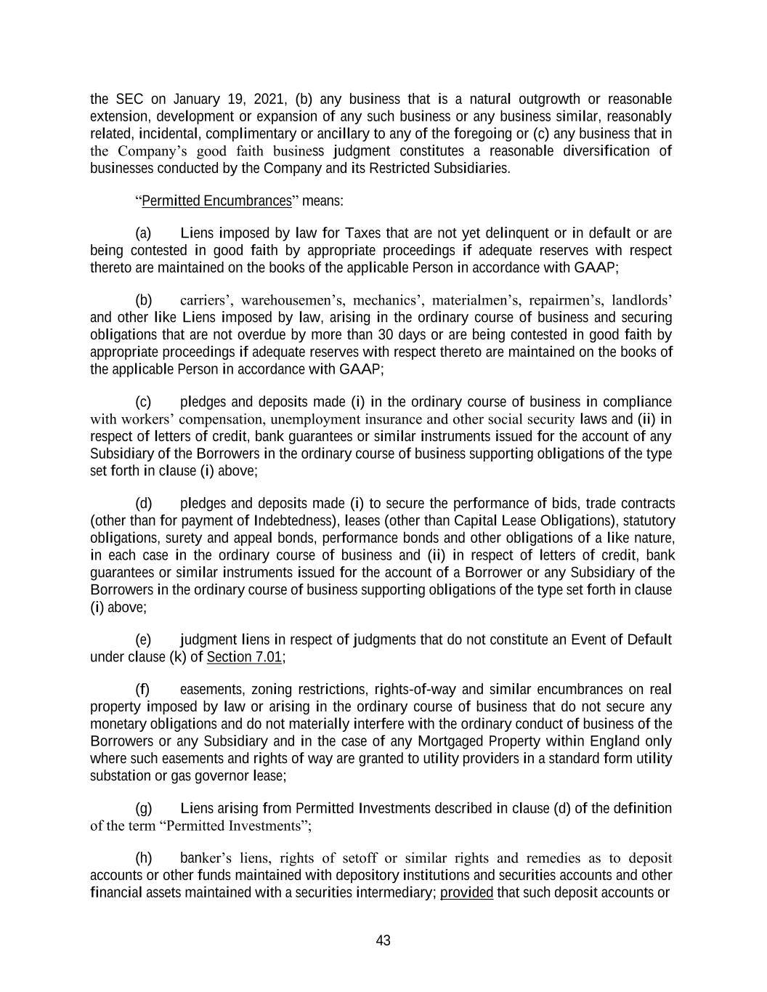
43 the SEC on January 19, 2021, (b) any business that is a natural outgrowth or reasonable extension, development or expansion of any such business or any business similar, reasonably related, incidental, complimentary or ancillary to any of the foregoing or (c) any business that in the Company’s good faith business judgment constitutes a reasonable diversification of businesses conducted by the Company and its Restricted Subsidiaries. “Permitted Encumbrances” means: (a) Liens imposed by law for Taxes that are not yet delinquent or in default or are being contested in good faith by appropriate proceedings if adequate reserves with respect thereto are maintained on the books of the applicable Person in accordance with GAAP; (b) carriers’, warehousemen’s, mechanics’, materialmen’s, repairmen’s, landlords’ and other like Liens imposed by law, arising in the ordinary course of business and securing obligations that are not overdue by more than 30 days or are being contested in good faith by appropriate proceedings if adequate reserves with respect thereto are maintained on the books of the applicable Person in accordance with GAAP; (c) pledges and deposits made (i) in the ordinary course of business in compliance with workers’ compensation, unemployment insurance and other social security laws and (ii) in respect of letters of credit, bank guarantees or similar instruments issued for the account of any Subsidiary of the Borrowers in the ordinary course of business supporting obligations of the type set forth in clause (i) above; (d) pledges and deposits made (i) to secure the performance of bids, trade contracts (other than for payment of Indebtedness), leases (other than Capital Lease Obligations), statutory obligations, surety and appeal bonds, performance bonds and other obligations of a like nature, in each case in the ordinary course of business and (ii) in respect of letters of credit, bank guarantees or similar instruments issued for the account of a Borrower or any Subsidiary of the Borrowers in the ordinary course of business supporting obligations of the type set forth in clause (i) above; (e) judgment liens in respect of judgments that do not constitute an Event of Default under clause (k) of Section 7.01; (f) easements, zoning restrictions, rights-of-way and similar encumbrances on real property imposed by law or arising in the ordinary course of business that do not secure any monetary obligations and do not materially interfere with the ordinary conduct of business of the Borrowers or any Subsidiary and in the case of any Mortgaged Property within England only where such easements and rights of way are granted to utility providers in a standard form utility substation or gas governor lease; (g) Liens arising from Permitted Investments described in clause (d) of the definition of the term “Permitted Investments”; (h) banker’s liens, rights of setoff or similar rights and remedies as to deposit accounts or other funds maintained with depository institutions and securities accounts and other financial assets maintained with a securities intermediary; provided that such deposit accounts or

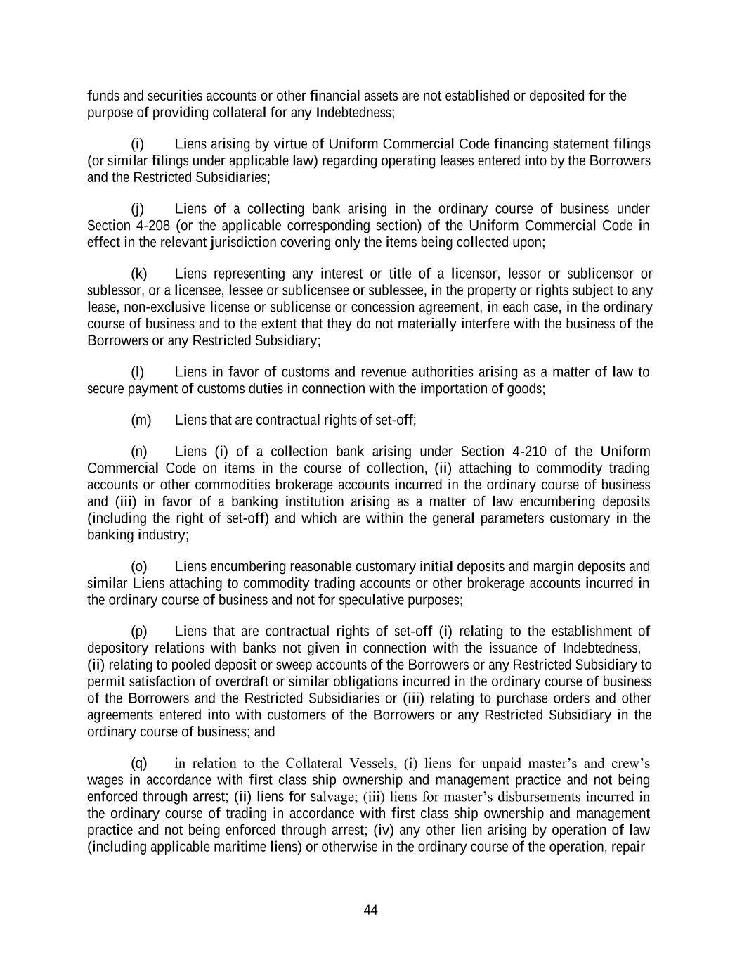
44 funds and securities accounts or other financial assets are not established or deposited for the purpose of providing collateral for any Indebtedness; (i) Liens arising by virtue of Uniform Commercial Code financing statement filings (or similar filings under applicable law) regarding operating leases entered into by the Borrowers and the Restricted Subsidiaries; (j) Liens of a collecting bank arising in the ordinary course of business under Section 4-208 (or the applicable corresponding section) of the Uniform Commercial Code in effect in the relevant jurisdiction covering only the items being collected upon; (k) Liens representing any interest or title of a licensor, lessor or sublicensor or sublessor, or a licensee, lessee or sublicensee or sublessee, in the property or rights subject to any lease, non-exclusive license or sublicense or concession agreement, in each case, in the ordinary course of business and to the extent that they do not materially interfere with the business of the Borrowers or any Restricted Subsidiary; (l) Liens in favor of customs and revenue authorities arising as a matter of law to secure payment of customs duties in connection with the importation of goods; (m) Liens that are contractual rights of set-off; (n) Liens (i) of a collection bank arising under Section 4-210 of the Uniform Commercial Code on items in the course of collection, (ii) attaching to commodity trading accounts or other commodities brokerage accounts incurred in the ordinary course of business and (iii) in favor of a banking institution arising as a matter of law encumbering deposits (including the right of set-off) and which are within the general parameters customary in the banking industry; (o) Liens encumbering reasonable customary initial deposits and margin deposits and similar Liens attaching to commodity trading accounts or other brokerage accounts incurred in the ordinary course of business and not for speculative purposes; (p) Liens that are contractual rights of set-off (i) relating to the establishment of depository relations with banks not given in connection with the issuance of Indebtedness, (ii) relating to pooled deposit or sweep accounts of the Borrowers or any Restricted Subsidiary to permit satisfaction of overdraft or similar obligations incurred in the ordinary course of business of the Borrowers and the Restricted Subsidiaries or (iii) relating to purchase orders and other agreements entered into with customers of the Borrowers or any Restricted Subsidiary in the ordinary course of business; and (q) in relation to the Collateral Vessels, (i) liens for unpaid master’s and crew’s wages in accordance with first class ship ownership and management practice and not being enforced through arrest; (ii) liens for salvage; (iii) liens for master’s disbursements incurred in the ordinary course of trading in accordance with first class ship ownership and management practice and not being enforced through arrest; (iv) any other lien arising by operation of law (including applicable maritime liens) or otherwise in the ordinary course of the operation, repair

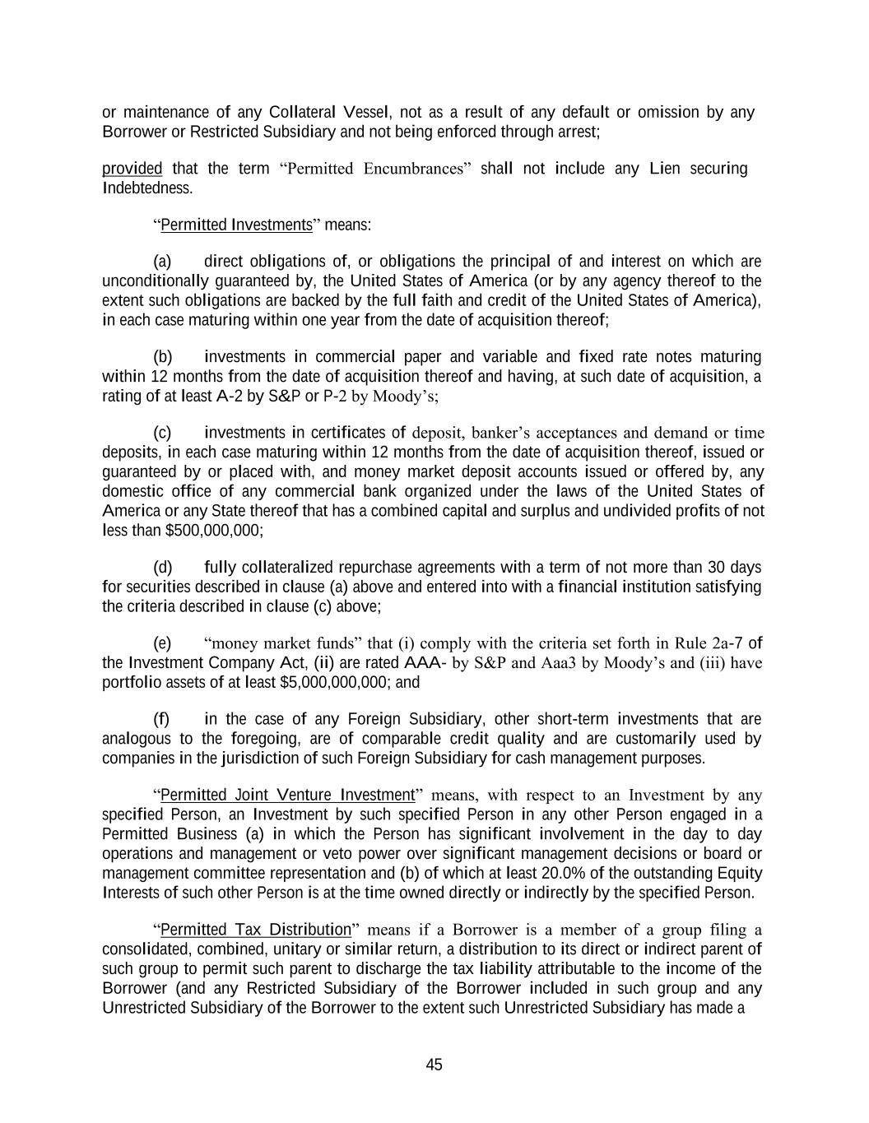
45 or maintenance of any Collateral Vessel, not as a result of any default or omission by any Borrower or Restricted Subsidiary and not being enforced through arrest; provided that the term “Permitted Encumbrances” shall not include any Lien securing Indebtedness. “Permitted Investments” means: (a) direct obligations of, or obligations the principal of and interest on which are unconditionally guaranteed by, the United States of America (or by any agency thereof to the extent such obligations are backed by the full faith and credit of the United States of America), in each case maturing within one year from the date of acquisition thereof; (b) investments in commercial paper and variable and fixed rate notes maturing within 12 months from the date of acquisition thereof and having, at such date of acquisition, a rating of at least A-2 by S&P or P-2 by Moody’s; (c) investments in certificates of deposit, banker’s acceptances and demand or time deposits, in each case maturing within 12 months from the date of acquisition thereof, issued or guaranteed by or placed with, and money market deposit accounts issued or offered by, any domestic office of any commercial bank organized under the laws of the United States of America or any State thereof that has a combined capital and surplus and undivided profits of not less than $500,000,000; (d) fully collateralized repurchase agreements with a term of not more than 30 days for securities described in clause (a) above and entered into with a financial institution satisfying the criteria described in clause (c) above; (e) “money market funds” that (i) comply with the criteria set forth in Rule 2a-7 of the Investment Company Act, (ii) are rated AAA- by S&P and Aaa3 by Moody’s and (iii) have portfolio assets of at least $5,000,000,000; and (f) in the case of any Foreign Subsidiary, other short-term investments that are analogous to the foregoing, are of comparable credit quality and are customarily used by companies in the jurisdiction of such Foreign Subsidiary for cash management purposes. “Permitted Joint Venture Investment” means, with respect to an Investment by any specified Person, an Investment by such specified Person in any other Person engaged in a Permitted Business (a) in which the Person has significant involvement in the day to day operations and management or veto power over significant management decisions or board or management committee representation and (b) of which at least 20.0% of the outstanding Equity Interests of such other Person is at the time owned directly or indirectly by the specified Person. “Permitted Tax Distribution” means if a Borrower is a member of a group filing a consolidated, combined, unitary or similar return, a distribution to its direct or indirect parent of such group to permit such parent to discharge the tax liability attributable to the income of the Borrower (and any Restricted Subsidiary of the Borrower included in such group and any Unrestricted Subsidiary of the Borrower to the extent such Unrestricted Subsidiary has made a

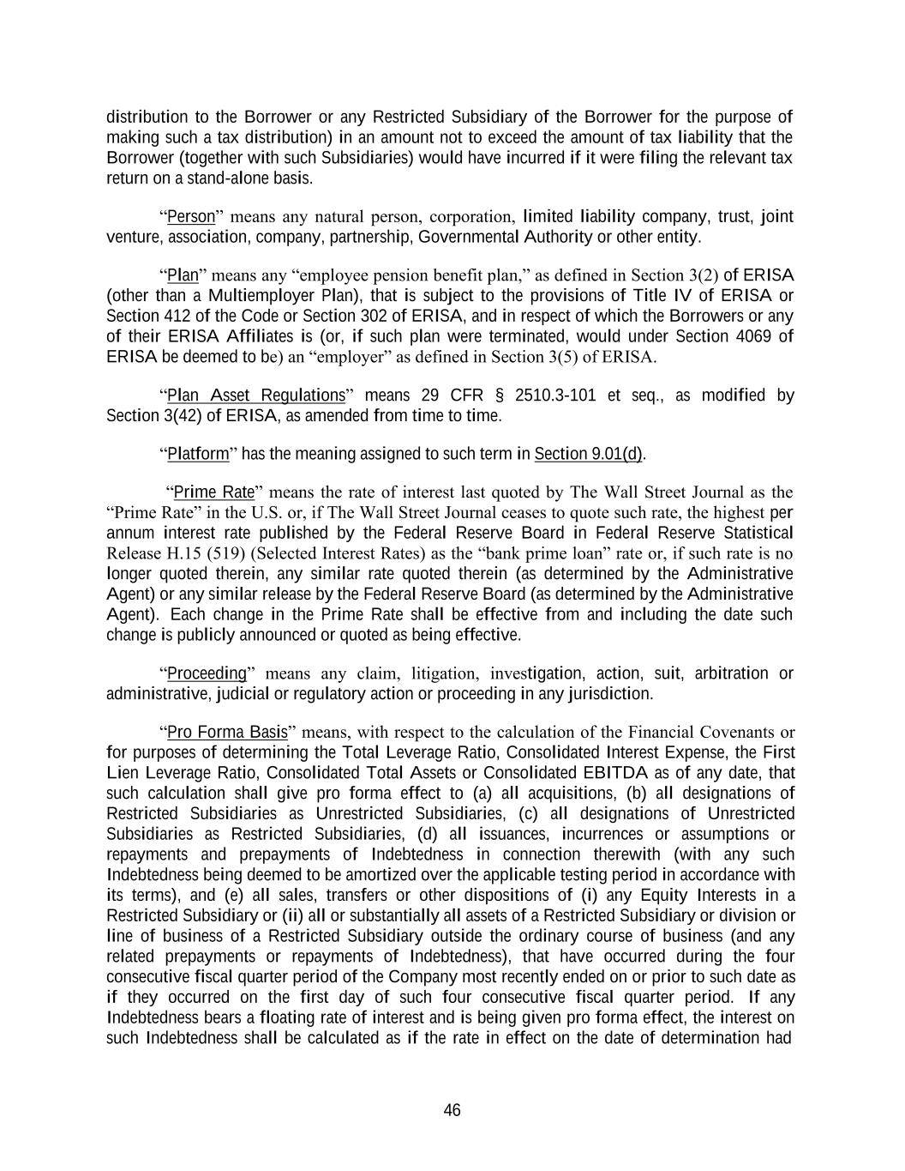
46 distribution to the Borrower or any Restricted Subsidiary of the Borrower for the purpose of making such a tax distribution) in an amount not to exceed the amount of tax liability that the Borrower (together with such Subsidiaries) would have incurred if it were filing the relevant tax return on a stand-alone basis. “Person” means any natural person, corporation, limited liability company, trust, joint venture, association, company, partnership, Governmental Authority or other entity. “Plan” means any “employee pension benefit plan,” as defined in Section 3(2) of ERISA (other than a Multiemployer Plan), that is subject to the provisions of Title IV of ERISA or Section 412 of the Code or Section 302 of ERISA, and in respect of which the Borrowers or any of their ERISA Affiliates is (or, if such plan were terminated, would under Section 4069 of ERISA be deemed to be) an “employer” as defined in Section 3(5) of ERISA. “Plan Asset Regulations” means 29 CFR § 2510.3-101 et seq., as modified by Section 3(42) of ERISA, as amended from time to time. “Platform” has the meaning assigned to such term in Section 9.01(d). “Prime Rate” means the rate of interest last quoted by The Wall Street Journal as the “Prime Rate” in the U.S. or, if The Wall Street Journal ceases to quote such rate, the highest per annum interest rate published by the Federal Reserve Board in Federal Reserve Statistical Release H.15 (519) (Selected Interest Rates) as the “bank prime loan” rate or, if such rate is no longer quoted therein, any similar rate quoted therein (as determined by the Administrative Agent) or any similar release by the Federal Reserve Board (as determined by the Administrative Agent). Each change in the Prime Rate shall be effective from and including the date such change is publicly announced or quoted as being effective. “Proceeding” means any claim, litigation, investigation, action, suit, arbitration or administrative, judicial or regulatory action or proceeding in any jurisdiction. “Pro Forma Basis” means, with respect to the calculation of the Financial Covenants or for purposes of determining the Total Leverage Ratio, Consolidated Interest Expense, the First Lien Leverage Ratio, Consolidated Total Assets or Consolidated EBITDA as of any date, that such calculation shall give pro forma effect to (a) all acquisitions, (b) all designations of Restricted Subsidiaries as Unrestricted Subsidiaries, (c) all designations of Unrestricted Subsidiaries as Restricted Subsidiaries, (d) all issuances, incurrences or assumptions or repayments and prepayments of Indebtedness in connection therewith (with any such Indebtedness being deemed to be amortized over the applicable testing period in accordance with its terms), and (e) all sales, transfers or other dispositions of (i) any Equity Interests in a Restricted Subsidiary or (ii) all or substantially all assets of a Restricted Subsidiary or division or line of business of a Restricted Subsidiary outside the ordinary course of business (and any related prepayments or repayments of Indebtedness), that have occurred during the four consecutive fiscal quarter period of the Company most recently ended on or prior to such date as if they occurred on the first day of such four consecutive fiscal quarter period. If any Indebtedness bears a floating rate of interest and is being given pro forma effect, the interest on such Indebtedness shall be calculated as if the rate in effect on the date of determination had

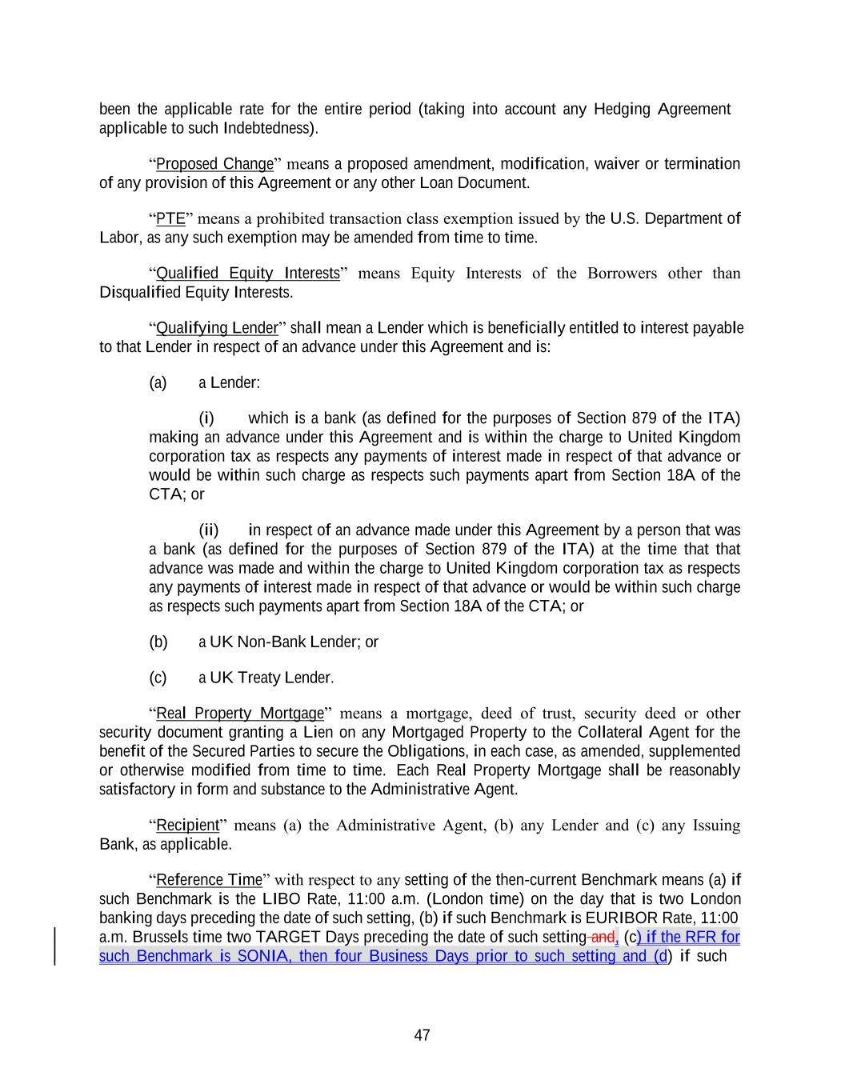
47 been the applicable rate for the entire period (taking into account any Hedging Agreement applicable to such Indebtedness). “Proposed Change” means a proposed amendment, modification, waiver or termination of any provision of this Agreement or any other Loan Document. “PTE” means a prohibited transaction class exemption issued by the U.S. Department of Labor, as any such exemption may be amended from time to time. “Qualified Equity Interests” means Equity Interests of the Borrowers other than Disqualified Equity Interests. “Qualifying Lender” shall mean a Lender which is beneficially entitled to interest payable to that Lender in respect of an advance under this Agreement and is: (a) a Lender: (i) which is a bank (as defined for the purposes of Section 879 of the ITA) making an advance under this Agreement and is within the charge to United Kingdom corporation tax as respects any payments of interest made in respect of that advance or would be within such charge as respects such payments apart from Section 18A of the CTA; or (ii) in respect of an advance made under this Agreement by a person that was a bank (as defined for the purposes of Section 879 of the ITA) at the time that that advance was made and within the charge to United Kingdom corporation tax as respects any payments of interest made in respect of that advance or would be within such charge as respects such payments apart from Section 18A of the CTA; or (b) a UK Non-Bank Lender; or (c) a UK Treaty Lender. “Real Property Mortgage” means a mortgage, deed of trust, security deed or other security document granting a Lien on any Mortgaged Property to the Collateral Agent for the benefit of the Secured Parties to secure the Obligations, in each case, as amended, supplemented or otherwise modified from time to time. Each Real Property Mortgage shall be reasonably satisfactory in form and substance to the Administrative Agent. “Recipient” means (a) the Administrative Agent, (b) any Lender and (c) any Issuing Bank, as applicable. “Reference Time” with respect to any setting of the then-current Benchmark means (a) if such Benchmark is the LIBO Rate, 11:00 a.m. (London time) on the day that is two London banking days preceding the date of such setting, (b) if such Benchmark is EURIBOR Rate, 11:00 a.m. Brussels time two TARGET Days preceding the date of such setting and, (c) if the RFR for such Benchmark is SONIA, then four Business Days prior to such setting and (d) if such

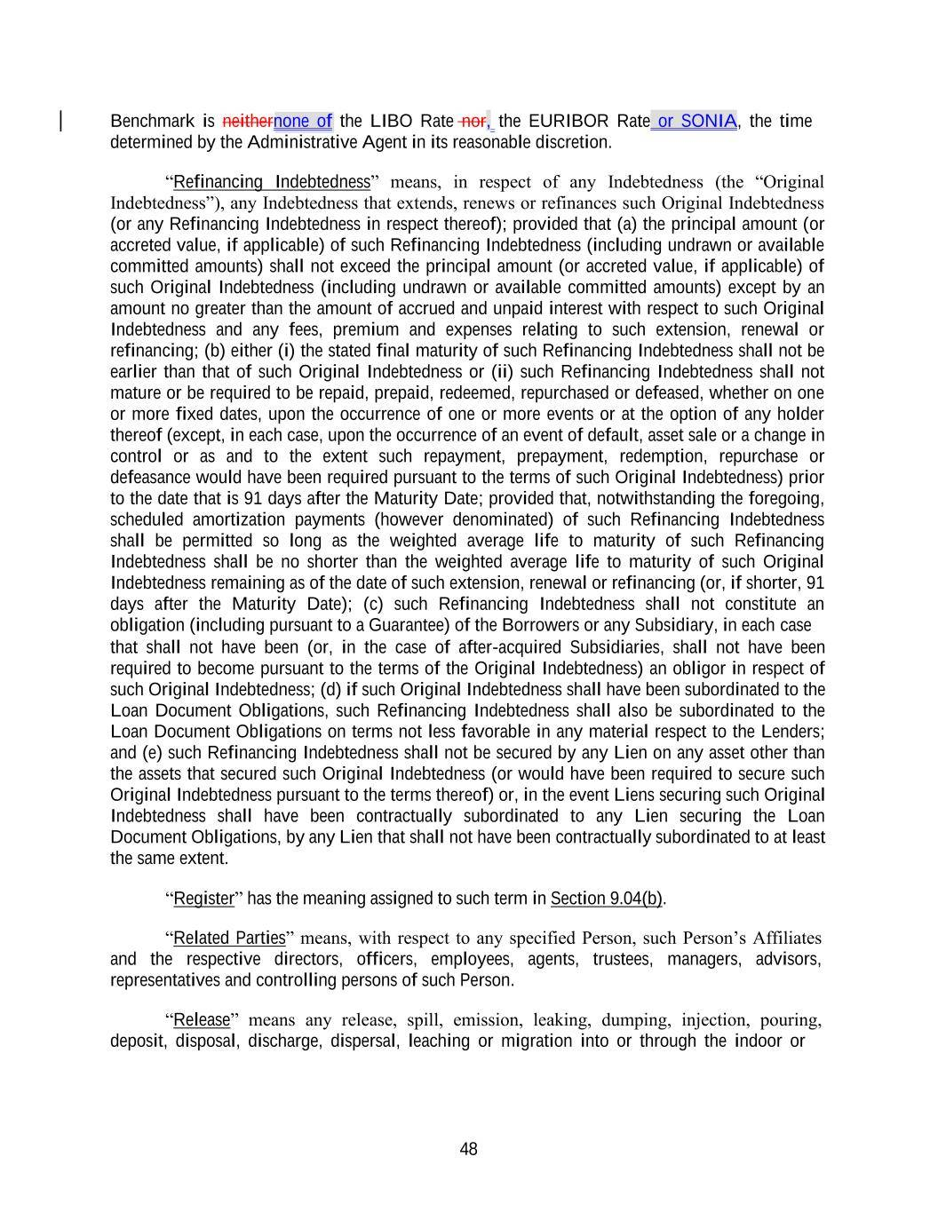
48 Benchmark is neithernone of the LIBO Rate nor, the EURIBOR Rate or SONIA, the time determined by the Administrative Agent in its reasonable discretion. “Refinancing Indebtedness” means, in respect of any Indebtedness (the “Original Indebtedness”), any Indebtedness that extends, renews or refinances such Original Indebtedness (or any Refinancing Indebtedness in respect thereof); provided that (a) the principal amount (or accreted value, if applicable) of such Refinancing Indebtedness (including undrawn or available committed amounts) shall not exceed the principal amount (or accreted value, if applicable) of such Original Indebtedness (including undrawn or available committed amounts) except by an amount no greater than the amount of accrued and unpaid interest with respect to such Original Indebtedness and any fees, premium and expenses relating to such extension, renewal or refinancing; (b) either (i) the stated final maturity of such Refinancing Indebtedness shall not be earlier than that of such Original Indebtedness or (ii) such Refinancing Indebtedness shall not mature or be required to be repaid, prepaid, redeemed, repurchased or defeased, whether on one or more fixed dates, upon the occurrence of one or more events or at the option of any holder thereof (except, in each case, upon the occurrence of an event of default, asset sale or a change in control or as and to the extent such repayment, prepayment, redemption, repurchase or defeasance would have been required pursuant to the terms of such Original Indebtedness) prior to the date that is 91 days after the Maturity Date; provided that, notwithstanding the foregoing, scheduled amortization payments (however denominated) of such Refinancing Indebtedness shall be permitted so long as the weighted average life to maturity of such Refinancing Indebtedness shall be no shorter than the weighted average life to maturity of such Original Indebtedness remaining as of the date of such extension, renewal or refinancing (or, if shorter, 91 days after the Maturity Date); (c) such Refinancing Indebtedness shall not constitute an obligation (including pursuant to a Guarantee) of the Borrowers or any Subsidiary, in each case that shall not have been (or, in the case of after-acquired Subsidiaries, shall not have been required to become pursuant to the terms of the Original Indebtedness) an obligor in respect of such Original Indebtedness; (d) if such Original Indebtedness shall have been subordinated to the Loan Document Obligations, such Refinancing Indebtedness shall also be subordinated to the Loan Document Obligations on terms not less favorable in any material respect to the Lenders; and (e) such Refinancing Indebtedness shall not be secured by any Lien on any asset other than the assets that secured such Original Indebtedness (or would have been required to secure such Original Indebtedness pursuant to the terms thereof) or, in the event Liens securing such Original Indebtedness shall have been contractually subordinated to any Lien securing the Loan Document Obligations, by any Lien that shall not have been contractually subordinated to at least the same extent. “Register” has the meaning assigned to such term in Section 9.04(b). “Related Parties” means, with respect to any specified Person, such Person’s Affiliates and the respective directors, officers, employees, agents, trustees, managers, advisors, representatives and controlling persons of such Person. “Release” means any release, spill, emission, leaking, dumping, injection, pouring, deposit, disposal, discharge, dispersal, leaching or migration into or through the indoor or

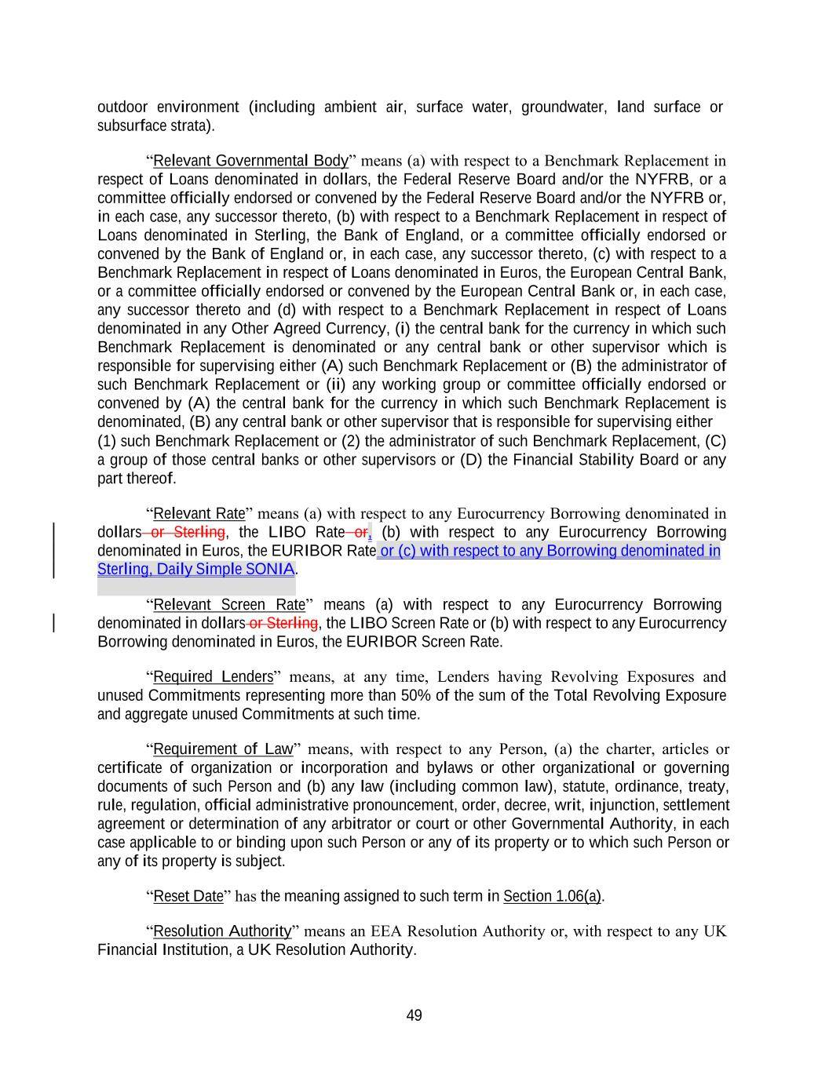
49 Sterling, Daily Simple SONIA. outdoor environment (including ambient air, surface water, groundwater, land surface or subsurface strata). “Relevant Governmental Body” means (a) with respect to a Benchmark Replacement in respect of Loans denominated in dollars, the Federal Reserve Board and/or the NYFRB, or a committee officially endorsed or convened by the Federal Reserve Board and/or the NYFRB or, in each case, any successor thereto, (b) with respect to a Benchmark Replacement in respect of Loans denominated in Sterling, the Bank of England, or a committee officially endorsed or convened by the Bank of England or, in each case, any successor thereto, (c) with respect to a Benchmark Replacement in respect of Loans denominated in Euros, the European Central Bank, or a committee officially endorsed or convened by the European Central Bank or, in each case, any successor thereto and (d) with respect to a Benchmark Replacement in respect of Loans denominated in any Other Agreed Currency, (i) the central bank for the currency in which such Benchmark Replacement is denominated or any central bank or other supervisor which is responsible for supervising either (A) such Benchmark Replacement or (B) the administrator of such Benchmark Replacement or (ii) any working group or committee officially endorsed or convened by (A) the central bank for the currency in which such Benchmark Replacement is denominated, (B) any central bank or other supervisor that is responsible for supervising either (1) such Benchmark Replacement or (2) the administrator of such Benchmark Replacement, (C) a group of those central banks or other supervisors or (D) the Financial Stability Board or any part thereof. “Relevant Rate” means (a) with respect to any Eurocurrency Borrowing denominated in dollars or Sterling, the LIBO Rate or, (b) with respect to any Eurocurrency Borrowing denominated in Euros, the EURIBOR Rate or (c) with respect to any Borrowing denominated in “Relevant Screen Rate” means (a) with respect to any Eurocurrency Borrowing denominated in dollars or Sterling, the LIBO Screen Rate or (b) with respect to any Eurocurrency Borrowing denominated in Euros, the EURIBOR Screen Rate. “Required Lenders” means, at any time, Lenders having Revolving Exposures and unused Commitments representing more than 50% of the sum of the Total Revolving Exposure and aggregate unused Commitments at such time. “Requirement of Law” means, with respect to any Person, (a) the charter, articles or certificate of organization or incorporation and bylaws or other organizational or governing documents of such Person and (b) any law (including common law), statute, ordinance, treaty, rule, regulation, official administrative pronouncement, order, decree, writ, injunction, settlement agreement or determination of any arbitrator or court or other Governmental Authority, in each case applicable to or binding upon such Person or any of its property or to which such Person or any of its property is subject. “Reset Date” has the meaning assigned to such term in Section 1.06(a). “Resolution Authority” means an EEA Resolution Authority or, with respect to any UK Financial Institution, a UK Resolution Authority.

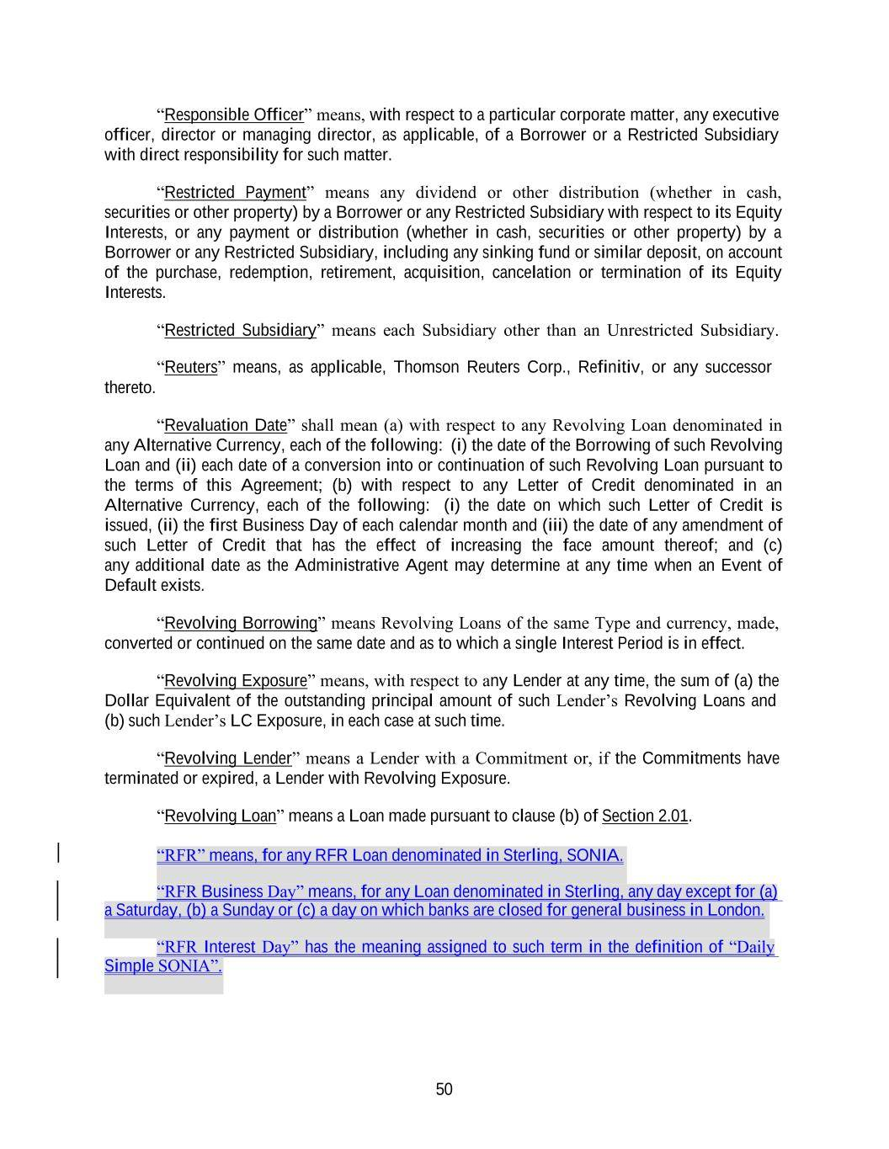
50 “Responsible Officer” means, with respect to a particular corporate matter, any executive officer, director or managing director, as applicable, of a Borrower or a Restricted Subsidiary with direct responsibility for such matter. “Restricted Payment” means any dividend or other distribution (whether in cash, securities or other property) by a Borrower or any Restricted Subsidiary with respect to its Equity Interests, or any payment or distribution (whether in cash, securities or other property) by a Borrower or any Restricted Subsidiary, including any sinking fund or similar deposit, on account of the purchase, redemption, retirement, acquisition, cancelation or termination of its Equity Interests. “Restricted Subsidiary” means each Subsidiary other than an Unrestricted Subsidiary. “Reuters” means, as applicable, Thomson Reuters Corp., Refinitiv, or any successor thereto. “Revaluation Date” shall mean (a) with respect to any Revolving Loan denominated in any Alternative Currency, each of the following: (i) the date of the Borrowing of such Revolving Loan and (ii) each date of a conversion into or continuation of such Revolving Loan pursuant to the terms of this Agreement; (b) with respect to any Letter of Credit denominated in an Alternative Currency, each of the following: (i) the date on which such Letter of Credit is issued, (ii) the first Business Day of each calendar month and (iii) the date of any amendment of such Letter of Credit that has the effect of increasing the face amount thereof; and (c) any additional date as the Administrative Agent may determine at any time when an Event of Default exists. “Revolving Borrowing” means Revolving Loans of the same Type and currency, made, converted or continued on the same date and as to which a single Interest Period is in effect. “Revolving Exposure” means, with respect to any Lender at any time, the sum of (a) the Dollar Equivalent of the outstanding principal amount of such Lender’s Revolving Loans and (b) such Lender’s LC Exposure, in each case at such time. “Revolving Lender” means a Lender with a Commitment or, if the Commitments have terminated or expired, a Lender with Revolving Exposure. “Revolving Loan” means a Loan made pursuant to clause (b) of Section 2.01. “RFR Business Day” means, for any Loan denominated in Sterling, any day except for (a) “RFR Interest Day” has the meaning assigned to such term in the definition of “Daily “RFR” means, for any RFR Loan denominated in Sterling, SONIA. a Saturday, (b) a Sunday or (c) a day on which banks are closed for general business in London. Simple SONIA”.

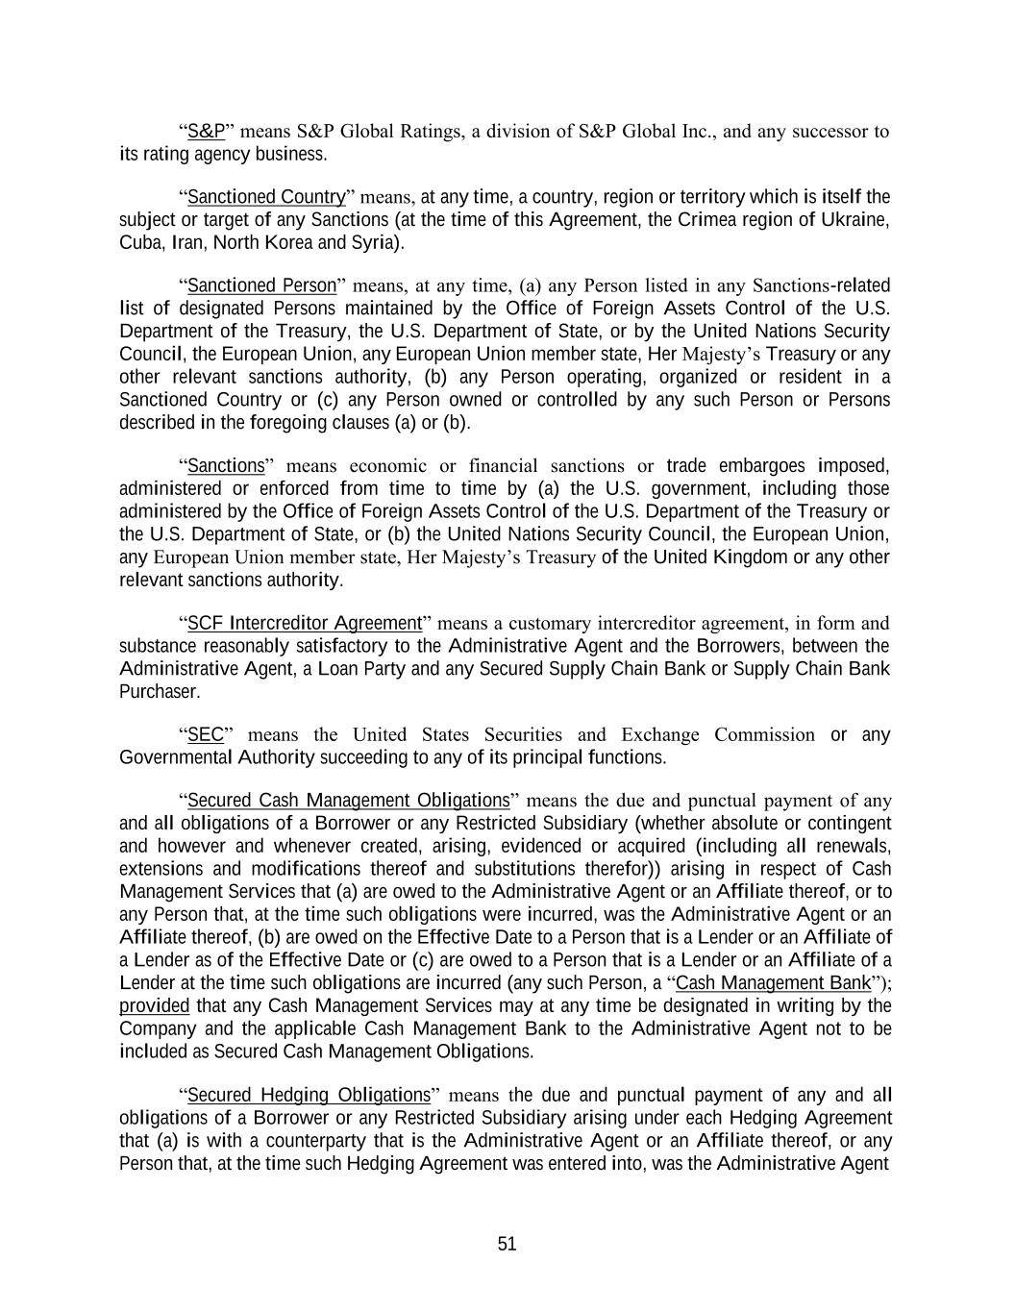
51 “S&P” means S&P Global Ratings, a division of S&P Global Inc., and any successor to its rating agency business. “Sanctioned Country” means, at any time, a country, region or territory which is itself the subject or target of any Sanctions (at the time of this Agreement, the Crimea region of Ukraine, Cuba, Iran, North Korea and Syria). “Sanctioned Person” means, at any time, (a) any Person listed in any Sanctions-related list of designated Persons maintained by the Office of Foreign Assets Control of the U.S. Department of the Treasury, the U.S. Department of State, or by the United Nations Security Council, the European Union, any European Union member state, Her Majesty’s Treasury or any other relevant sanctions authority, (b) any Person operating, organized or resident in a Sanctioned Country or (c) any Person owned or controlled by any such Person or Persons described in the foregoing clauses (a) or (b). “Sanctions” means economic or financial sanctions or trade embargoes imposed, administered or enforced from time to time by (a) the U.S. government, including those administered by the Office of Foreign Assets Control of the U.S. Department of the Treasury or the U.S. Department of State, or (b) the United Nations Security Council, the European Union, any European Union member state, Her Majesty’s Treasury of the United Kingdom or any other relevant sanctions authority. “SCF Intercreditor Agreement” means a customary intercreditor agreement, in form and substance reasonably satisfactory to the Administrative Agent and the Borrowers, between the Administrative Agent, a Loan Party and any Secured Supply Chain Bank or Supply Chain Bank Purchaser. “SEC” means the United States Securities and Exchange Commission or any Governmental Authority succeeding to any of its principal functions. “Secured Cash Management Obligations” means the due and punctual payment of any and all obligations of a Borrower or any Restricted Subsidiary (whether absolute or contingent and however and whenever created, arising, evidenced or acquired (including all renewals, extensions and modifications thereof and substitutions therefor)) arising in respect of Cash Management Services that (a) are owed to the Administrative Agent or an Affiliate thereof, or to any Person that, at the time such obligations were incurred, was the Administrative Agent or an Affiliate thereof, (b) are owed on the Effective Date to a Person that is a Lender or an Affiliate of a Lender as of the Effective Date or (c) are owed to a Person that is a Lender or an Affiliate of a Lender at the time such obligations are incurred (any such Person, a “Cash Management Bank”); provided that any Cash Management Services may at any time be designated in writing by the Company and the applicable Cash Management Bank to the Administrative Agent not to be included as Secured Cash Management Obligations. “Secured Hedging Obligations” means the due and punctual payment of any and all obligations of a Borrower or any Restricted Subsidiary arising under each Hedging Agreement that (a) is with a counterparty that is the Administrative Agent or an Affiliate thereof, or any Person that, at the time such Hedging Agreement was entered into, was the Administrative Agent

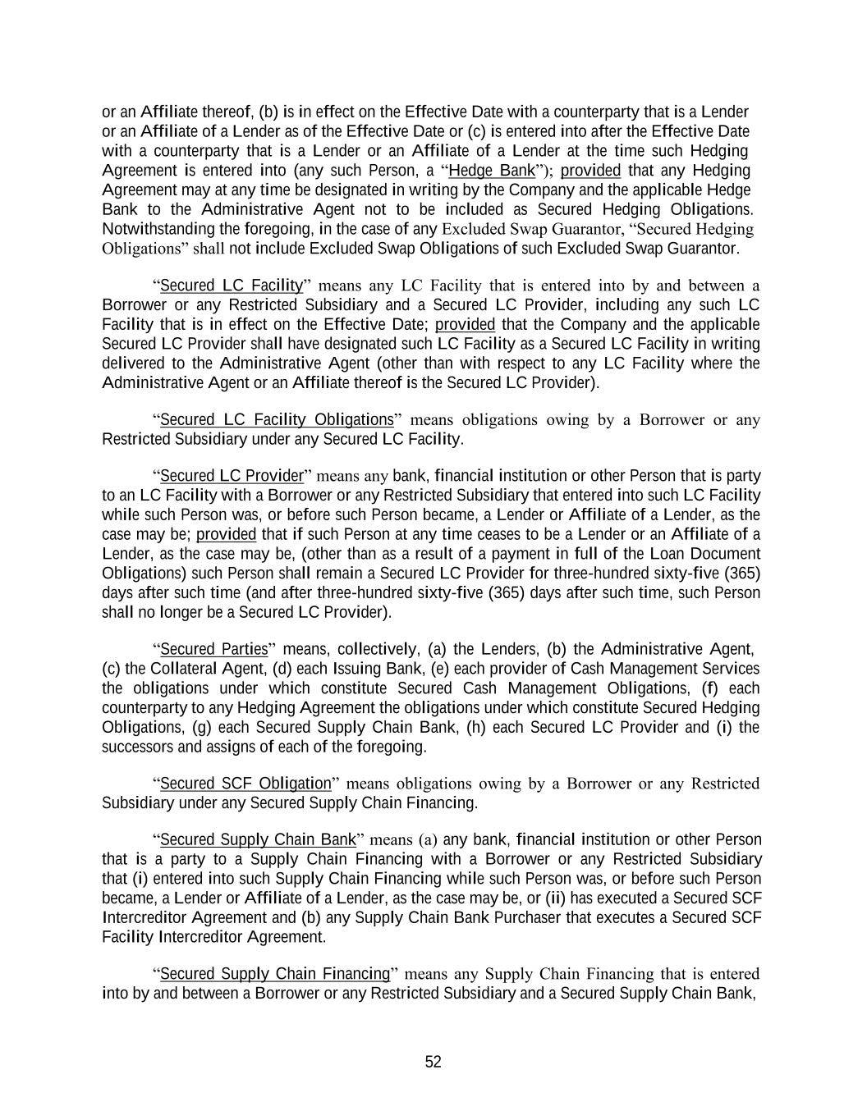
52 or an Affiliate thereof, (b) is in effect on the Effective Date with a counterparty that is a Lender or an Affiliate of a Lender as of the Effective Date or (c) is entered into after the Effective Date with a counterparty that is a Lender or an Affiliate of a Lender at the time such Hedging Agreement is entered into (any such Person, a “Hedge Bank”); provided that any Hedging Agreement may at any time be designated in writing by the Company and the applicable Hedge Bank to the Administrative Agent not to be included as Secured Hedging Obligations. Notwithstanding the foregoing, in the case of any Excluded Swap Guarantor, “Secured Hedging Obligations” shall not include Excluded Swap Obligations of such Excluded Swap Guarantor. “Secured LC Facility” means any LC Facility that is entered into by and between a Borrower or any Restricted Subsidiary and a Secured LC Provider, including any such LC Facility that is in effect on the Effective Date; provided that the Company and the applicable Secured LC Provider shall have designated such LC Facility as a Secured LC Facility in writing delivered to the Administrative Agent (other than with respect to any LC Facility where the Administrative Agent or an Affiliate thereof is the Secured LC Provider). “Secured LC Facility Obligations” means obligations owing by a Borrower or any Restricted Subsidiary under any Secured LC Facility. “Secured LC Provider” means any bank, financial institution or other Person that is party to an LC Facility with a Borrower or any Restricted Subsidiary that entered into such LC Facility while such Person was, or before such Person became, a Lender or Affiliate of a Lender, as the case may be; provided that if such Person at any time ceases to be a Lender or an Affiliate of a Lender, as the case may be, (other than as a result of a payment in full of the Loan Document Obligations) such Person shall remain a Secured LC Provider for three-hundred sixty-five (365) days after such time (and after three-hundred sixty-five (365) days after such time, such Person shall no longer be a Secured LC Provider). “Secured Parties” means, collectively, (a) the Lenders, (b) the Administrative Agent, (c) the Collateral Agent, (d) each Issuing Bank, (e) each provider of Cash Management Services the obligations under which constitute Secured Cash Management Obligations, (f) each counterparty to any Hedging Agreement the obligations under which constitute Secured Hedging Obligations, (g) each Secured Supply Chain Bank, (h) each Secured LC Provider and (i) the successors and assigns of each of the foregoing. “Secured SCF Obligation” means obligations owing by a Borrower or any Restricted Subsidiary under any Secured Supply Chain Financing. “Secured Supply Chain Bank” means (a) any bank, financial institution or other Person that is a party to a Supply Chain Financing with a Borrower or any Restricted Subsidiary that (i) entered into such Supply Chain Financing while such Person was, or before such Person became, a Lender or Affiliate of a Lender, as the case may be, or (ii) has executed a Secured SCF Intercreditor Agreement and (b) any Supply Chain Bank Purchaser that executes a Secured SCF Facility Intercreditor Agreement. “Secured Supply Chain Financing” means any Supply Chain Financing that is entered into by and between a Borrower or any Restricted Subsidiary and a Secured Supply Chain Bank,

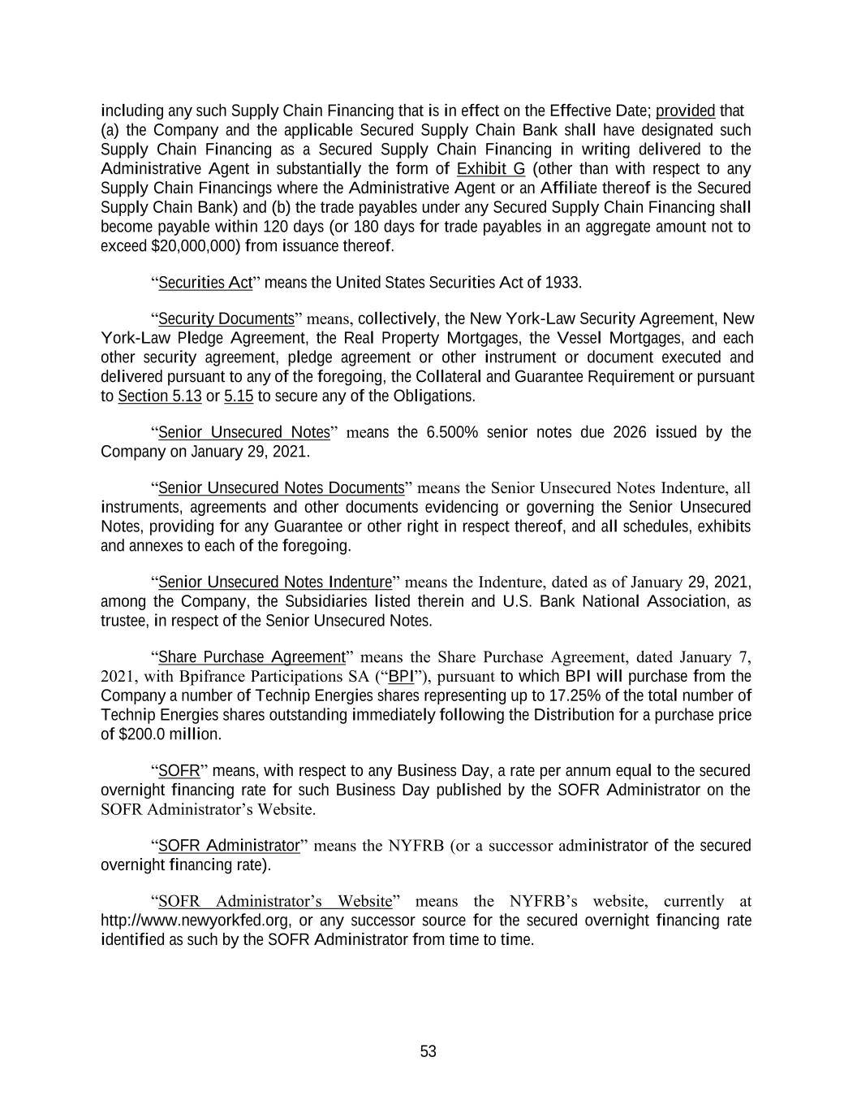
53 including any such Supply Chain Financing that is in effect on the Effective Date; provided that (a) the Company and the applicable Secured Supply Chain Bank shall have designated such Supply Chain Financing as a Secured Supply Chain Financing in writing delivered to the Administrative Agent in substantially the form of Exhibit G (other than with respect to any Supply Chain Financings where the Administrative Agent or an Affiliate thereof is the Secured Supply Chain Bank) and (b) the trade payables under any Secured Supply Chain Financing shall become payable within 120 days (or 180 days for trade payables in an aggregate amount not to exceed $20,000,000) from issuance thereof. “Securities Act” means the United States Securities Act of 1933. “Security Documents” means, collectively, the New York-Law Security Agreement, New York-Law Pledge Agreement, the Real Property Mortgages, the Vessel Mortgages, and each other security agreement, pledge agreement or other instrument or document executed and delivered pursuant to any of the foregoing, the Collateral and Guarantee Requirement or pursuant to Section 5.13 or 5.15 to secure any of the Obligations. “Senior Unsecured Notes” means the 6.500% senior notes due 2026 issued by the Company on January 29, 2021. “Senior Unsecured Notes Documents” means the Senior Unsecured Notes Indenture, all instruments, agreements and other documents evidencing or governing the Senior Unsecured Notes, providing for any Guarantee or other right in respect thereof, and all schedules, exhibits and annexes to each of the foregoing. “Senior Unsecured Notes Indenture” means the Indenture, dated as of January 29, 2021, among the Company, the Subsidiaries listed therein and U.S. Bank National Association, as trustee, in respect of the Senior Unsecured Notes. “Share Purchase Agreement” means the Share Purchase Agreement, dated January 7, 2021, with Bpifrance Participations SA (“BPI”), pursuant to which BPI will purchase from the Company a number of Technip Energies shares representing up to 17.25% of the total number of Technip Energies shares outstanding immediately following the Distribution for a purchase price of $200.0 million. “SOFR” means, with respect to any Business Day, a rate per annum equal to the secured overnight financing rate for such Business Day published by the SOFR Administrator on the SOFR Administrator’s Website. “SOFR Administrator” means the NYFRB (or a successor administrator of the secured overnight financing rate). “SOFR Administrator’s Website” means the NYFRB’s website, currently at http://www.newyorkfed.org, or any successor source for the secured overnight financing rate identified as such by the SOFR Administrator from time to time.

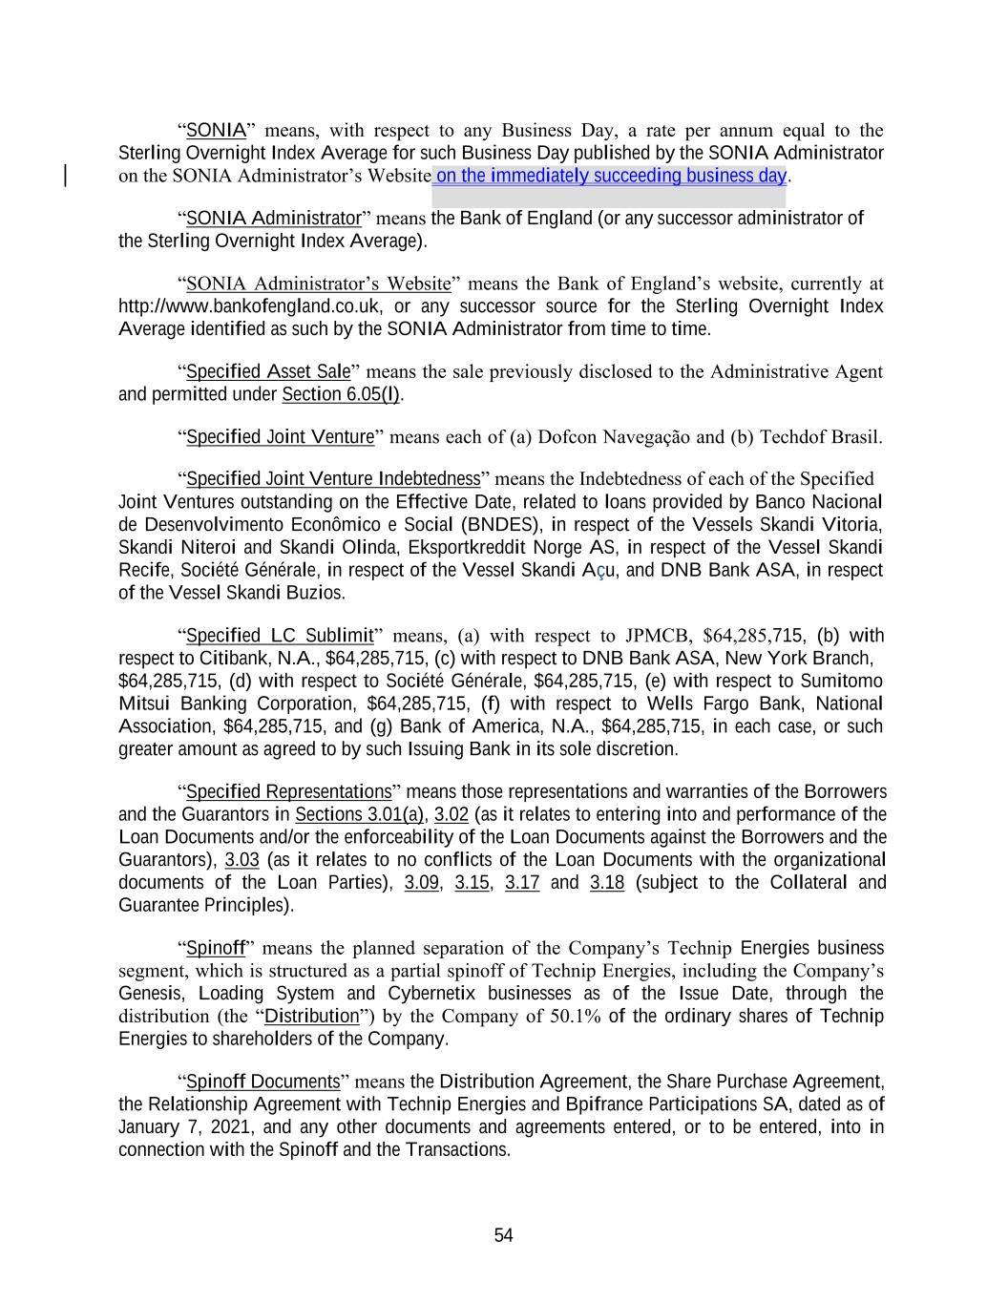
54 “SONIA” means, with respect to any Business Day, a rate per annum equal to the Sterling Overnight Index Average for such Business Day published by the SONIA Administrator on the SONIA Administrator’s Website on the immediately succeeding business day. “SONIA Administrator” means the Bank of England (or any successor administrator of the Sterling Overnight Index Average). “SONIA Administrator’s Website” means the Bank of England’s website, currently at http://www.bankofengland.co.uk, or any successor source for the Sterling Overnight Index Average identified as such by the SONIA Administrator from time to time. “Specified Asset Sale” means the sale previously disclosed to the Administrative Agent and permitted under Section 6.05(l). “Specified Joint Venture” means each of (a) Dofcon Navegação and (b) Techdof Brasil. “Specified Joint Venture Indebtedness” means the Indebtedness of each of the Specified Joint Ventures outstanding on the Effective Date, related to loans provided by Banco Nacional de Desenvolvimento Econômico e Social (BNDES), in respect of the Vessels Skandi Vitoria, Skandi Niteroi and Skandi Olinda, Eksportkreddit Norge AS, in respect of the Vessel Skandi Recife, Société Générale, in respect of the Vessel Skandi Açu, and DNB Bank ASA, in respect of the Vessel Skandi Buzios. “Specified LC Sublimit” means, (a) with respect to JPMCB, $64,285,715, (b) with respect to Citibank, N.A., $64,285,715, (c) with respect to DNB Bank ASA, New York Branch, $64,285,715, (d) with respect to Société Générale, $64,285,715, (e) with respect to Sumitomo Mitsui Banking Corporation, $64,285,715, (f) with respect to Wells Fargo Bank, National Association, $64,285,715, and (g) Bank of America, N.A., $64,285,715, in each case, or such greater amount as agreed to by such Issuing Bank in its sole discretion. “Specified Representations” means those representations and warranties of the Borrowers and the Guarantors in Sections 3.01(a), 3.02 (as it relates to entering into and performance of the Loan Documents and/or the enforceability of the Loan Documents against the Borrowers and the Guarantors), 3.03 (as it relates to no conflicts of the Loan Documents with the organizational documents of the Loan Parties), 3.09, 3.15, 3.17 and 3.18 (subject to the Collateral and Guarantee Principles). “Spinoff” means the planned separation of the Company’s Technip Energies business segment, which is structured as a partial spinoff of Technip Energies, including the Company’s Genesis, Loading System and Cybernetix businesses as of the Issue Date, through the distribution (the “Distribution”) by the Company of 50.1% of the ordinary shares of Technip Energies to shareholders of the Company. “Spinoff Documents” means the Distribution Agreement, the Share Purchase Agreement, the Relationship Agreement with Technip Energies and Bpifrance Participations SA, dated as of January 7, 2021, and any other documents and agreements entered, or to be entered, into in connection with the Spinoff and the Transactions.

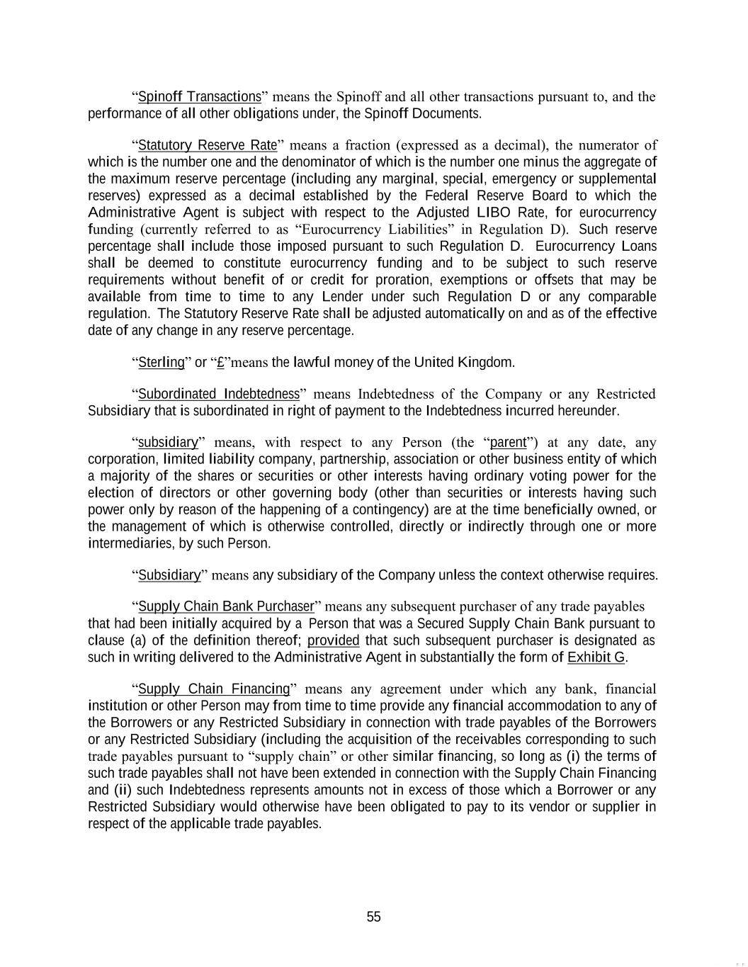
55 “Spinoff Transactions” means the Spinoff and all other transactions pursuant to, and the performance of all other obligations under, the Spinoff Documents. “Statutory Reserve Rate” means a fraction (expressed as a decimal), the numerator of which is the number one and the denominator of which is the number one minus the aggregate of the maximum reserve percentage (including any marginal, special, emergency or supplemental reserves) expressed as a decimal established by the Federal Reserve Board to which the Administrative Agent is subject with respect to the Adjusted LIBO Rate, for eurocurrency funding (currently referred to as “Eurocurrency Liabilities” in Regulation D). Such reserve percentage shall include those imposed pursuant to such Regulation D. Eurocurrency Loans shall be deemed to constitute eurocurrency funding and to be subject to such reserve requirements without benefit of or credit for proration, exemptions or offsets that may be available from time to time to any Lender under such Regulation D or any comparable regulation. The Statutory Reserve Rate shall be adjusted automatically on and as of the effective date of any change in any reserve percentage. “Sterling” or “£”means the lawful money of the United Kingdom. “Subordinated Indebtedness” means Indebtedness of the Company or any Restricted Subsidiary that is subordinated in right of payment to the Indebtedness incurred hereunder. “subsidiary” means, with respect to any Person (the “parent”) at any date, any corporation, limited liability company, partnership, association or other business entity of which a majority of the shares or securities or other interests having ordinary voting power for the election of directors or other governing body (other than securities or interests having such power only by reason of the happening of a contingency) are at the time beneficially owned, or the management of which is otherwise controlled, directly or indirectly through one or more intermediaries, by such Person. “Subsidiary” means any subsidiary of the Company unless the context otherwise requires. “Supply Chain Bank Purchaser” means any subsequent purchaser of any trade payables that had been initially acquired by a Person that was a Secured Supply Chain Bank pursuant to clause (a) of the definition thereof; provided that such subsequent purchaser is designated as such in writing delivered to the Administrative Agent in substantially the form of Exhibit G. “Supply Chain Financing” means any agreement under which any bank, financial institution or other Person may from time to time provide any financial accommodation to any of the Borrowers or any Restricted Subsidiary in connection with trade payables of the Borrowers or any Restricted Subsidiary (including the acquisition of the receivables corresponding to such trade payables pursuant to “supply chain” or other similar financing, so long as (i) the terms of such trade payables shall not have been extended in connection with the Supply Chain Financing and (ii) such Indebtedness represents amounts not in excess of those which a Borrower or any Restricted Subsidiary would otherwise have been obligated to pay to its vendor or supplier in respect of the applicable trade payables.

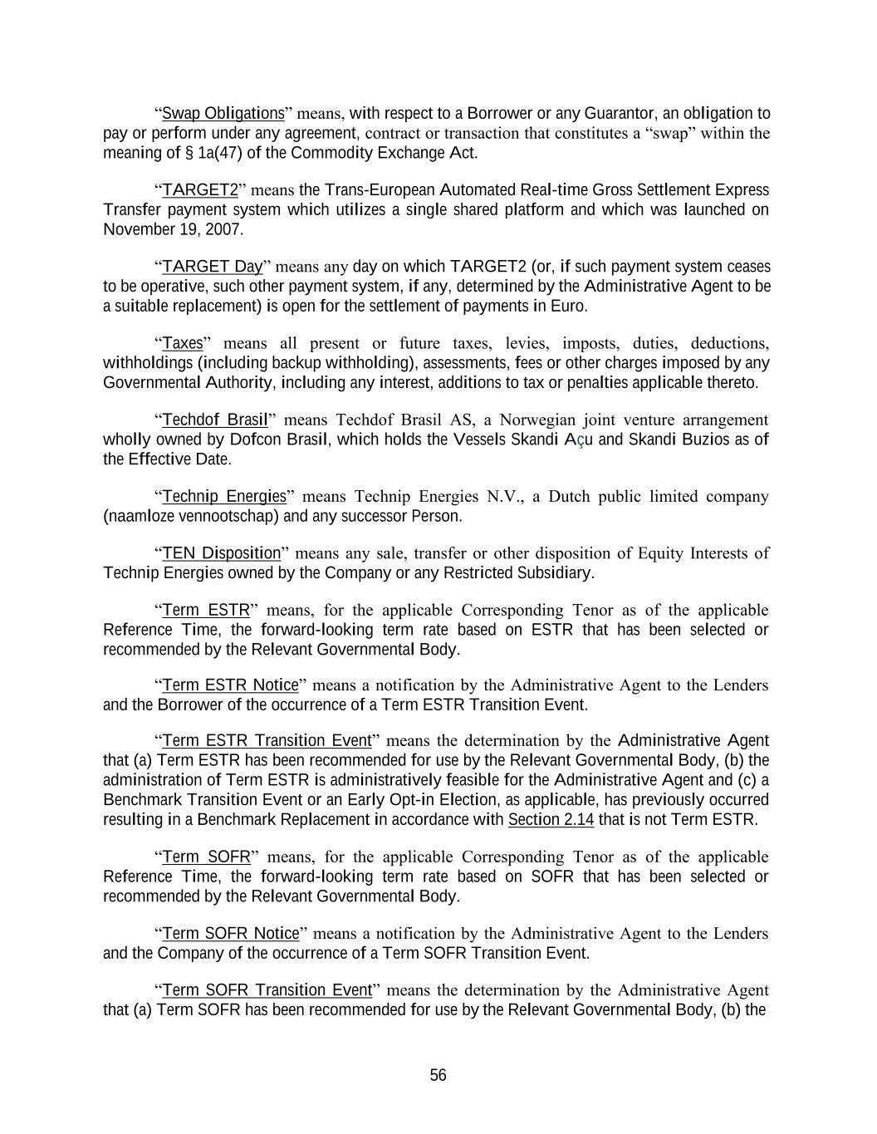
56 “Swap Obligations” means, with respect to a Borrower or any Guarantor, an obligation to pay or perform under any agreement, contract or transaction that constitutes a “swap” within the meaning of § 1a(47) of the Commodity Exchange Act. “TARGET2” means the Trans-European Automated Real-time Gross Settlement Express Transfer payment system which utilizes a single shared platform and which was launched on November 19, 2007. “TARGET Day” means any day on which TARGET2 (or, if such payment system ceases to be operative, such other payment system, if any, determined by the Administrative Agent to be a suitable replacement) is open for the settlement of payments in Euro. “Taxes” means all present or future taxes, levies, imposts, duties, deductions, withholdings (including backup withholding), assessments, fees or other charges imposed by any Governmental Authority, including any interest, additions to tax or penalties applicable thereto. “Techdof Brasil” means Techdof Brasil AS, a Norwegian joint venture arrangement wholly owned by Dofcon Brasil, which holds the Vessels Skandi Açu and Skandi Buzios as of the Effective Date. “Technip Energies” means Technip Energies N.V., a Dutch public limited company (naamloze vennootschap) and any successor Person. “TEN Disposition” means any sale, transfer or other disposition of Equity Interests of Technip Energies owned by the Company or any Restricted Subsidiary. “Term ESTR” means, for the applicable Corresponding Tenor as of the applicable Reference Time, the forward-looking term rate based on ESTR that has been selected or recommended by the Relevant Governmental Body. “Term ESTR Notice” means a notification by the Administrative Agent to the Lenders and the Borrower of the occurrence of a Term ESTR Transition Event. “Term ESTR Transition Event” means the determination by the Administrative Agent that (a) Term ESTR has been recommended for use by the Relevant Governmental Body, (b) the administration of Term ESTR is administratively feasible for the Administrative Agent and (c) a Benchmark Transition Event or an Early Opt-in Election, as applicable, has previously occurred resulting in a Benchmark Replacement in accordance with Section 2.14 that is not Term ESTR. “Term SOFR” means, for the applicable Corresponding Tenor as of the applicable Reference Time, the forward-looking term rate based on SOFR that has been selected or recommended by the Relevant Governmental Body. “Term SOFR Notice” means a notification by the Administrative Agent to the Lenders and the Company of the occurrence of a Term SOFR Transition Event. “Term SOFR Transition Event” means the determination by the Administrative Agent that (a) Term SOFR has been recommended for use by the Relevant Governmental Body, (b) the

57 Daily Simple SONIA. administration of Term SOFR is administratively feasible for the Administrative Agent and (c) a Benchmark Transition Event or an Early Opt-in Election, as applicable, has previously occurred resulting in a Benchmark Replacement in accordance with Section 2.14 that is not Term SOFR. “Total Commitments” means, at any time, the sum of the Commitments of all the Revolving Lenders at such time. “Total Leverage Ratio” means, as of the last day of any fiscal quarter, the ratio of (a) Consolidated Net Debt as of such date to (b) Consolidated EBITDA for the four consecutive fiscal quarters of the Company ended on such date. “Total Revolving Exposure” means, at any time, the sum of the Revolving Exposures of all the Revolving Lenders at such time. “Transaction Costs” means all fees, costs and expenses incurred or payable by the Company or any Subsidiary in connection with the Transactions. “Transactions” means, collectively, (a) the execution, delivery and performance by each Loan Party of the Loan Documents (including this Agreement) to which it is to be a party, the borrowing of Loans, the use of the proceeds thereof and the issuance of Letters of Credit hereunder, (b) the execution, delivery and performance by each Loan Party of the Senior Unsecured Notes Documents to which it is to be a party, the issuance of the Senior Unsecured Notes and the use of the proceeds thereof (including, together with cash on hand, to satisfy and discharge, refinance, repay, redeem and/or cancel the Effective Date Refinanced Debt), (c) the payment of the Transaction Costs and (d) the Spinoff Transactions. “Type,” when used in reference to any Loan or Borrowing, refers to whether the rate of interest on such Loan, or on the Loans comprising such Borrowing, is determined by reference to the Adjusted LIBO Rate, the Adjusted EURIBOR Rate or, the Alternate Base Rate or Adjusted “UCP” means the Uniform Customs and Practice for Documentary Credits, International Chamber of Commerce (“ICC”) Publication No. 600 (or such later version thereof as may be in effect at the time of issuance). “UK” or “United Kingdom” means the United Kingdom of Great Britain and Northern Ireland. “UK Borrower” means any Borrower (i) that is incorporated or existing under the laws of England and Wales or (ii) payments from which under this Agreement or any other Loan Document are subject to UK Withholding Tax. “UK Financial Institution” means any BRRD Undertaking (as such term is defined under the PRA Rulebook (as amended form time to time) promulgated by the United Kingdom Prudential Regulation Authority) or any person falling within IFPRU 11.6 of the FCA Handbook (as amended from time to time) promulgated by the United Kingdom Financial Conduct

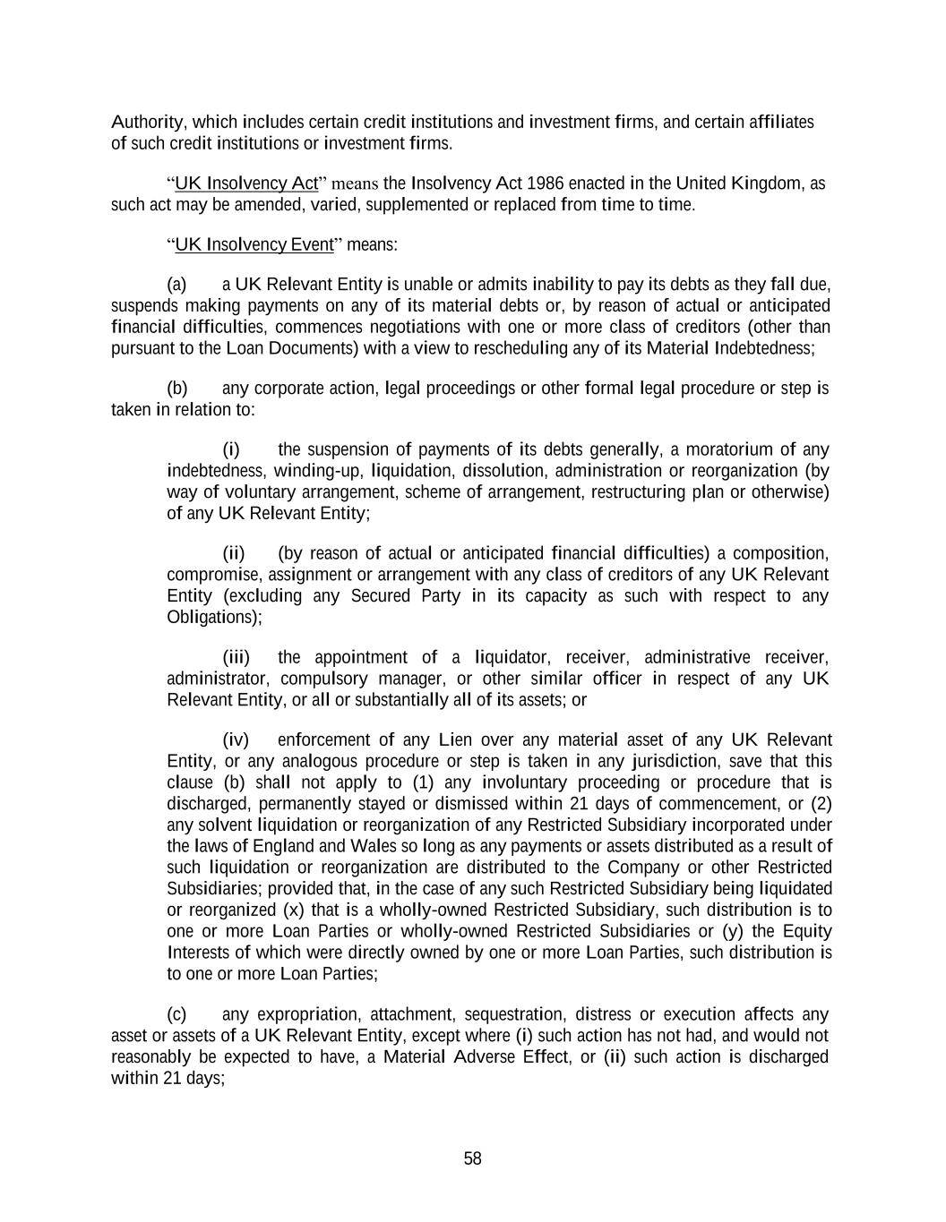
58 Authority, which includes certain credit institutions and investment firms, and certain affiliates of such credit institutions or investment firms. “UK Insolvency Act” means the Insolvency Act 1986 enacted in the United Kingdom, as such act may be amended, varied, supplemented or replaced from time to time. “UK Insolvency Event” means: (a) a UK Relevant Entity is unable or admits inability to pay its debts as they fall due, suspends making payments on any of its material debts or, by reason of actual or anticipated financial difficulties, commences negotiations with one or more class of creditors (other than pursuant to the Loan Documents) with a view to rescheduling any of its Material Indebtedness; (b) any corporate action, legal proceedings or other formal legal procedure or step is taken in relation to: (i) the suspension of payments of its debts generally, a moratorium of any indebtedness, winding-up, liquidation, dissolution, administration or reorganization (by way of voluntary arrangement, scheme of arrangement, restructuring plan or otherwise) of any UK Relevant Entity; (ii) (by reason of actual or anticipated financial difficulties) a composition, compromise, assignment or arrangement with any class of creditors of any UK Relevant Entity (excluding any Secured Party in its capacity as such with respect to any Obligations); (iii) the appointment of a liquidator, receiver, administrative receiver, administrator, compulsory manager, or other similar officer in respect of any UK Relevant Entity, or all or substantially all of its assets; or (iv) enforcement of any Lien over any material asset of any UK Relevant Entity, or any analogous procedure or step is taken in any jurisdiction, save that this clause (b) shall not apply to (1) any involuntary proceeding or procedure that is discharged, permanently stayed or dismissed within 21 days of commencement, or (2) any solvent liquidation or reorganization of any Restricted Subsidiary incorporated under the laws of England and Wales so long as any payments or assets distributed as a result of such liquidation or reorganization are distributed to the Company or other Restricted Subsidiaries; provided that, in the case of any such Restricted Subsidiary being liquidated or reorganized (x) that is a wholly-owned Restricted Subsidiary, such distribution is to one or more Loan Parties or wholly-owned Restricted Subsidiaries or (y) the Equity Interests of which were directly owned by one or more Loan Parties, such distribution is to one or more Loan Parties; (c) any expropriation, attachment, sequestration, distress or execution affects any asset or assets of a UK Relevant Entity, except where (i) such action has not had, and would not reasonably be expected to have, a Material Adverse Effect, or (ii) such action is discharged within 21 days;

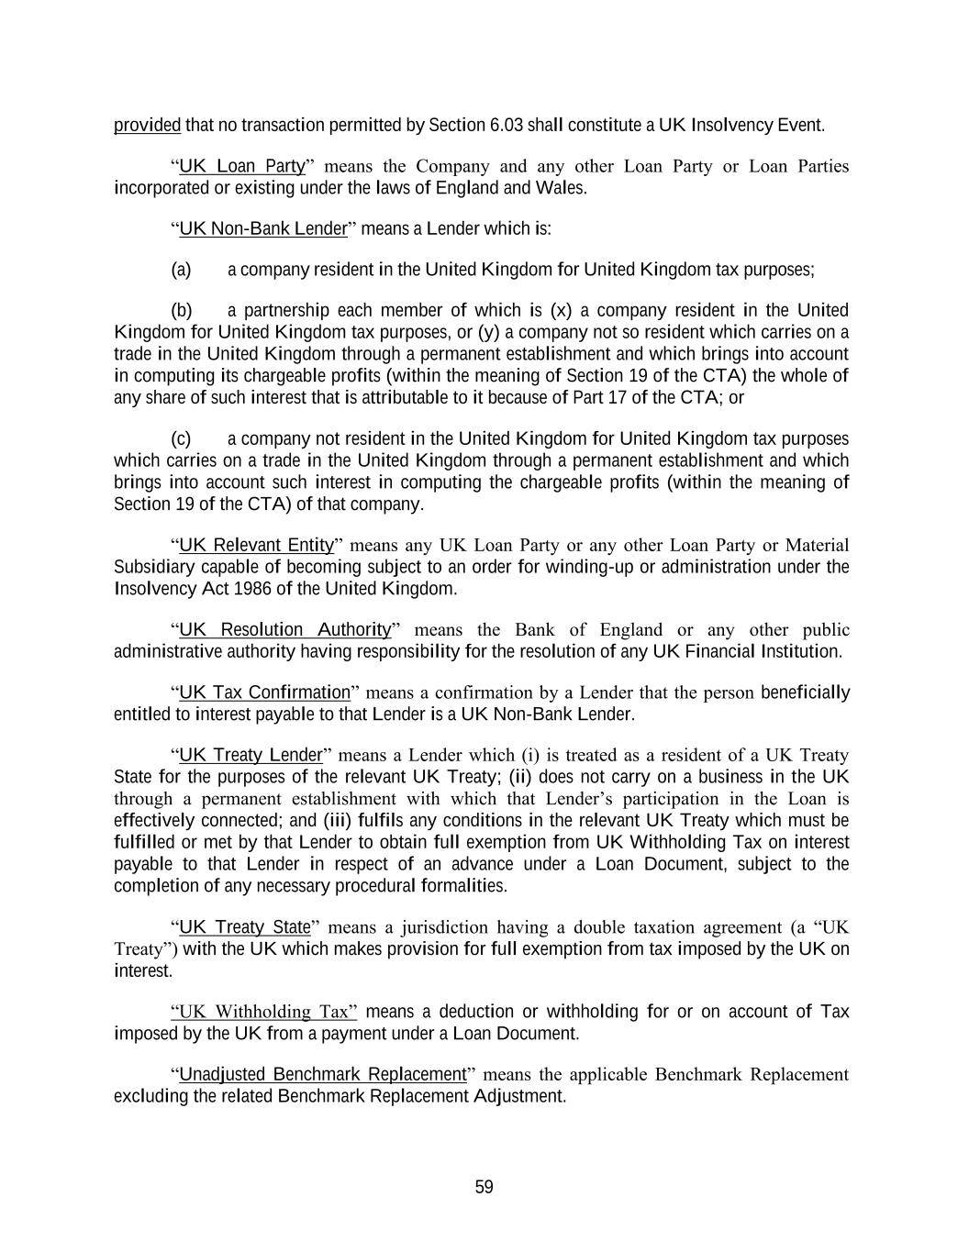
59 provided that no transaction permitted by Section 6.03 shall constitute a UK Insolvency Event. “UK Loan Party” means the Company and any other Loan Party or Loan Parties incorporated or existing under the laws of England and Wales. “UK Non-Bank Lender” means a Lender which is: (a) a company resident in the United Kingdom for United Kingdom tax purposes; (b) a partnership each member of which is (x) a company resident in the United Kingdom for United Kingdom tax purposes, or (y) a company not so resident which carries on a trade in the United Kingdom through a permanent establishment and which brings into account in computing its chargeable profits (within the meaning of Section 19 of the CTA) the whole of any share of such interest that is attributable to it because of Part 17 of the CTA; or (c) a company not resident in the United Kingdom for United Kingdom tax purposes which carries on a trade in the United Kingdom through a permanent establishment and which brings into account such interest in computing the chargeable profits (within the meaning of Section 19 of the CTA) of that company. “UK Relevant Entity” means any UK Loan Party or any other Loan Party or Material Subsidiary capable of becoming subject to an order for winding-up or administration under the Insolvency Act 1986 of the United Kingdom. “UK Resolution Authority” means the Bank of England or any other public administrative authority having responsibility for the resolution of any UK Financial Institution. “UK Tax Confirmation” means a confirmation by a Lender that the person beneficially entitled to interest payable to that Lender is a UK Non-Bank Lender. “UK Treaty Lender” means a Lender which (i) is treated as a resident of a UK Treaty State for the purposes of the relevant UK Treaty; (ii) does not carry on a business in the UK through a permanent establishment with which that Lender’s participation in the Loan is effectively connected; and (iii) fulfils any conditions in the relevant UK Treaty which must be fulfilled or met by that Lender to obtain full exemption from UK Withholding Tax on interest payable to that Lender in respect of an advance under a Loan Document, subject to the completion of any necessary procedural formalities. “UK Treaty State” means a jurisdiction having a double taxation agreement (a “UK Treaty”) with the UK which makes provision for full exemption from tax imposed by the UK on interest. “UK Withholding Tax” means a deduction or withholding for or on account of Tax imposed by the UK from a payment under a Loan Document. “Unadjusted Benchmark Replacement” means the applicable Benchmark Replacement excluding the related Benchmark Replacement Adjustment.

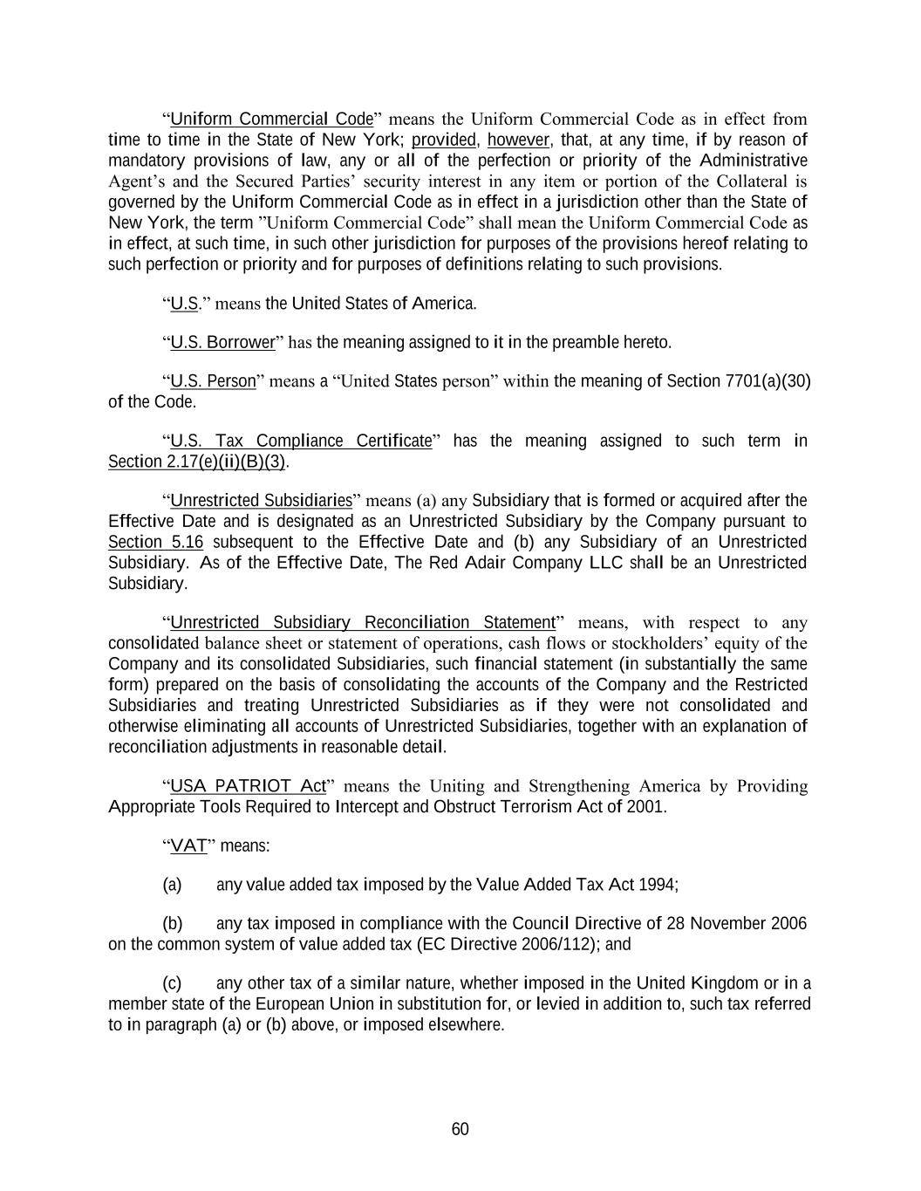
60 “Uniform Commercial Code” means the Uniform Commercial Code as in effect from time to time in the State of New York; provided, however, that, at any time, if by reason of mandatory provisions of law, any or all of the perfection or priority of the Administrative Agent’s and the Secured Parties’ security interest in any item or portion of the Collateral is governed by the Uniform Commercial Code as in effect in a jurisdiction other than the State of New York, the term ”Uniform Commercial Code” shall mean the Uniform Commercial Code as in effect, at such time, in such other jurisdiction for purposes of the provisions hereof relating to such perfection or priority and for purposes of definitions relating to such provisions. “U.S.” means the United States of America. “U.S. Borrower” has the meaning assigned to it in the preamble hereto. “U.S. Person” means a “United States person” within the meaning of Section 7701(a)(30) of the Code. “U.S. Tax Compliance Certificate” has the meaning assigned to such term in Section 2.17(e)(ii)(B)(3). “Unrestricted Subsidiaries” means (a) any Subsidiary that is formed or acquired after the Effective Date and is designated as an Unrestricted Subsidiary by the Company pursuant to Section 5.16 subsequent to the Effective Date and (b) any Subsidiary of an Unrestricted Subsidiary. As of the Effective Date, The Red Adair Company LLC shall be an Unrestricted Subsidiary. “Unrestricted Subsidiary Reconciliation Statement” means, with respect to any consolidated balance sheet or statement of operations, cash flows or stockholders’ equity of the Company and its consolidated Subsidiaries, such financial statement (in substantially the same form) prepared on the basis of consolidating the accounts of the Company and the Restricted Subsidiaries and treating Unrestricted Subsidiaries as if they were not consolidated and otherwise eliminating all accounts of Unrestricted Subsidiaries, together with an explanation of reconciliation adjustments in reasonable detail. “USA PATRIOT Act” means the Uniting and Strengthening America by Providing Appropriate Tools Required to Intercept and Obstruct Terrorism Act of 2001. “VAT” means: (a) any value added tax imposed by the Value Added Tax Act 1994; (b) any tax imposed in compliance with the Council Directive of 28 November 2006 on the common system of value added tax (EC Directive 2006/112); and (c) any other tax of a similar nature, whether imposed in the United Kingdom or in a member state of the European Union in substitution for, or levied in addition to, such tax referred to in paragraph (a) or (b) above, or imposed elsewhere.

61 “RFR Loan” or “Vessel” means any vessel whether now owned or later acquired by the owner and also any and all additions, improvements and replacements made in or to such vessel or any part of it or in or to its equipment and appurtenances. “Vessel Deed of Covenants” means, as applicable, a deed of covenants collateral to a Vessel Mortgage executed or, as the context may require, to be executed by the relevant owner of a Collateral Vessel in favor of the Collateral Agent in such form as may be agreed between the Administrative Agent and the Company and creating security over that Collateral Vessel. “Vessel Mortgage” means, as applicable, a first priority or preferred ship mortgage on each Collateral Vessel, each duly registered in the vessel or ship registry appropriate for such Collateral Vessel in favor of the Collateral Agent and in such form as may be agreed between the Administrative Agent and the Company, together with, if relevant, the Vessel Deed of Covenants. “Voting Equity Interests” of any Person means the Equity Interests of such Person ordinarily having the power to vote for the election of the directors of such Person. “wholly owned Subsidiary” means, with respect to any Person at any date, a Subsidiary of such Person of which securities or other ownership interests representing 100% of the Equity Interests (other than directors’ qualifying shares) are, as of such date, owned, controlled or held by such Person or one or more wholly owned Subsidiaries of such Person or by such Person and one or more wholly owned Subsidiaries of such Person. “Withdrawal Liability” means liability to a Multiemployer Plan as a result of a complete or partial withdrawal from such Multiemployer Plan, as such terms are defined in Part I of Subtitle E of Title IV of ERISA. “Withholding Agent” means any Loan Party, the Administrative Agent and any other applicable withholding agent. “Write-Down and Conversion Powers” means, (a) with respect to any EEA Resolution Authority, the write-down and conversion powers of such EEA Resolution Authority from time to time under the Bail-In Legislation for the applicable EEA Member Country, which write-down and conversion powers are described in the EU Bail-In Legislation Schedule, and (b) with respect to the United Kingdom, any powers of the applicable Resolution Authority under the Bail-In Legislation to cancel, reduce, modify or change the form of a liability of any UK Financial Institution or any contract or instrument under which that liability arises, to convert all or part of that liability into shares, securities or obligations of that person or any other person, to provide that any such contract or instrument is to have effect as if a right had been exercised under it or to suspend any obligation in respect of that liability or any of the powers under that Bail-In Legislation that are related to or ancillary to any of those powers. SECTION 1.02. Classification of Loans and Borrowings. For purposes of this Agreement, Loans and Borrowings, respectively, may be classified and referred to by Type (e.g., a “Eurocurrency Loan” or a “Eurocurrency Borrowing” or “RFR Borrowing”).

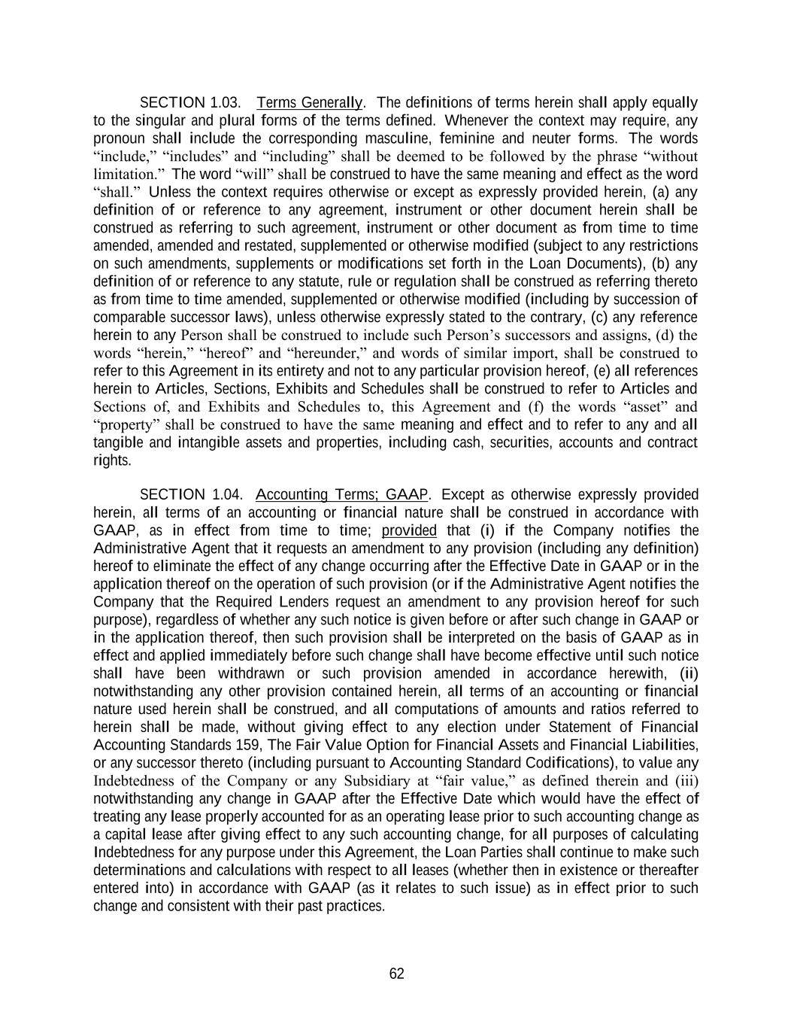
62 SECTION 1.03. Terms Generally. The definitions of terms herein shall apply equally to the singular and plural forms of the terms defined. Whenever the context may require, any pronoun shall include the corresponding masculine, feminine and neuter forms. The words “include,” “includes” and “including” shall be deemed to be followed by the phrase “without limitation.” The word “will” shall be construed to have the same meaning and effect as the word “shall.” Unless the context requires otherwise or except as expressly provided herein, (a) any definition of or reference to any agreement, instrument or other document herein shall be construed as referring to such agreement, instrument or other document as from time to time amended, amended and restated, supplemented or otherwise modified (subject to any restrictions on such amendments, supplements or modifications set forth in the Loan Documents), (b) any definition of or reference to any statute, rule or regulation shall be construed as referring thereto as from time to time amended, supplemented or otherwise modified (including by succession of comparable successor laws), unless otherwise expressly stated to the contrary, (c) any reference herein to any Person shall be construed to include such Person’s successors and assigns, (d) the words “herein,” “hereof” and “hereunder,” and words of similar import, shall be construed to refer to this Agreement in its entirety and not to any particular provision hereof, (e) all references herein to Articles, Sections, Exhibits and Schedules shall be construed to refer to Articles and Sections of, and Exhibits and Schedules to, this Agreement and (f) the words “asset” and “property” shall be construed to have the same meaning and effect and to refer to any and all tangible and intangible assets and properties, including cash, securities, accounts and contract rights. SECTION 1.04. Accounting Terms; GAAP. Except as otherwise expressly provided herein, all terms of an accounting or financial nature shall be construed in accordance with GAAP, as in effect from time to time; provided that (i) if the Company notifies the Administrative Agent that it requests an amendment to any provision (including any definition) hereof to eliminate the effect of any change occurring after the Effective Date in GAAP or in the application thereof on the operation of such provision (or if the Administrative Agent notifies the Company that the Required Lenders request an amendment to any provision hereof for such purpose), regardless of whether any such notice is given before or after such change in GAAP or in the application thereof, then such provision shall be interpreted on the basis of GAAP as in effect and applied immediately before such change shall have become effective until such notice shall have been withdrawn or such provision amended in accordance herewith, (ii) notwithstanding any other provision contained herein, all terms of an accounting or financial nature used herein shall be construed, and all computations of amounts and ratios referred to herein shall be made, without giving effect to any election under Statement of Financial Accounting Standards 159, The Fair Value Option for Financial Assets and Financial Liabilities, or any successor thereto (including pursuant to Accounting Standard Codifications), to value any Indebtedness of the Company or any Subsidiary at “fair value,” as defined therein and (iii) notwithstanding any change in GAAP after the Effective Date which would have the effect of treating any lease properly accounted for as an operating lease prior to such accounting change as a capital lease after giving effect to any such accounting change, for all purposes of calculating Indebtedness for any purpose under this Agreement, the Loan Parties shall continue to make such determinations and calculations with respect to all leases (whether then in existence or thereafter entered into) in accordance with GAAP (as it relates to such issue) as in effect prior to such change and consistent with their past practices.

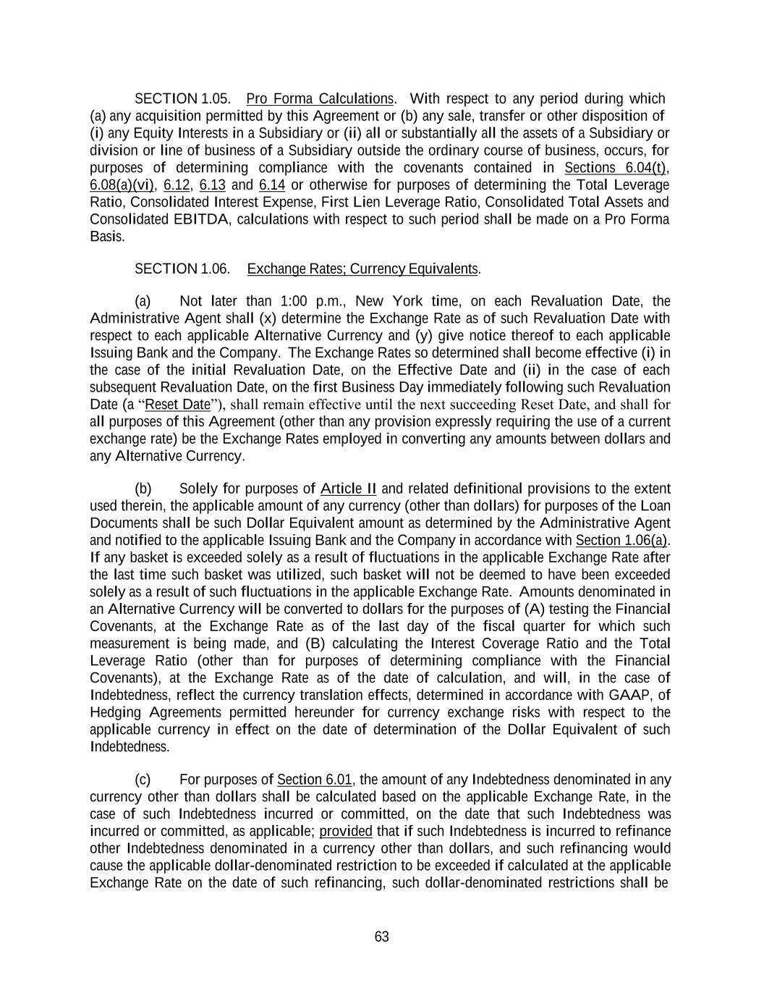
63 SECTION 1.05. Pro Forma Calculations. With respect to any period during which (a) any acquisition permitted by this Agreement or (b) any sale, transfer or other disposition of (i) any Equity Interests in a Subsidiary or (ii) all or substantially all the assets of a Subsidiary or division or line of business of a Subsidiary outside the ordinary course of business, occurs, for purposes of determining compliance with the covenants contained in Sections 6.04(t), 6.08(a)(vi), 6.12, 6.13 and 6.14 or otherwise for purposes of determining the Total Leverage Ratio, Consolidated Interest Expense, First Lien Leverage Ratio, Consolidated Total Assets and Consolidated EBITDA, calculations with respect to such period shall be made on a Pro Forma Basis. SECTION 1.06. Exchange Rates; Currency Equivalents. (a) Not later than 1:00 p.m., New York time, on each Revaluation Date, the Administrative Agent shall (x) determine the Exchange Rate as of such Revaluation Date with respect to each applicable Alternative Currency and (y) give notice thereof to each applicable Issuing Bank and the Company. The Exchange Rates so determined shall become effective (i) in the case of the initial Revaluation Date, on the Effective Date and (ii) in the case of each subsequent Revaluation Date, on the first Business Day immediately following such Revaluation Date (a “Reset Date”), shall remain effective until the next succeeding Reset Date, and shall for all purposes of this Agreement (other than any provision expressly requiring the use of a current exchange rate) be the Exchange Rates employed in converting any amounts between dollars and any Alternative Currency. (b) Solely for purposes of Article II and related definitional provisions to the extent used therein, the applicable amount of any currency (other than dollars) for purposes of the Loan Documents shall be such Dollar Equivalent amount as determined by the Administrative Agent and notified to the applicable Issuing Bank and the Company in accordance with Section 1.06(a). If any basket is exceeded solely as a result of fluctuations in the applicable Exchange Rate after the last time such basket was utilized, such basket will not be deemed to have been exceeded solely as a result of such fluctuations in the applicable Exchange Rate. Amounts denominated in an Alternative Currency will be converted to dollars for the purposes of (A) testing the Financial Covenants, at the Exchange Rate as of the last day of the fiscal quarter for which such measurement is being made, and (B) calculating the Interest Coverage Ratio and the Total Leverage Ratio (other than for purposes of determining compliance with the Financial Covenants), at the Exchange Rate as of the date of calculation, and will, in the case of Indebtedness, reflect the currency translation effects, determined in accordance with GAAP, of Hedging Agreements permitted hereunder for currency exchange risks with respect to the applicable currency in effect on the date of determination of the Dollar Equivalent of such Indebtedness. (c) For purposes of Section 6.01, the amount of any Indebtedness denominated in any currency other than dollars shall be calculated based on the applicable Exchange Rate, in the case of such Indebtedness incurred or committed, on the date that such Indebtedness was incurred or committed, as applicable; provided that if such Indebtedness is incurred to refinance other Indebtedness denominated in a currency other than dollars, and such refinancing would cause the applicable dollar-denominated restriction to be exceeded if calculated at the applicable Exchange Rate on the date of such refinancing, such dollar-denominated restrictions shall be

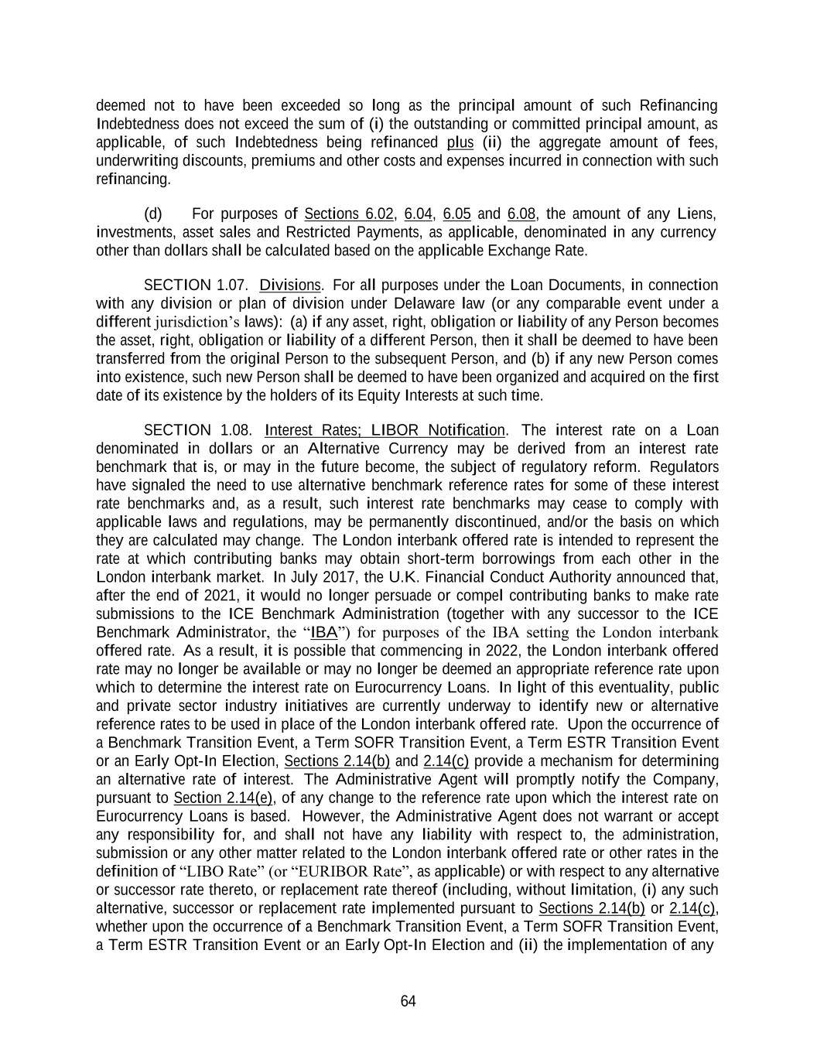
64 deemed not to have been exceeded so long as the principal amount of such Refinancing Indebtedness does not exceed the sum of (i) the outstanding or committed principal amount, as applicable, of such Indebtedness being refinanced plus (ii) the aggregate amount of fees, underwriting discounts, premiums and other costs and expenses incurred in connection with such refinancing. (d) For purposes of Sections 6.02, 6.04, 6.05 and 6.08, the amount of any Liens, investments, asset sales and Restricted Payments, as applicable, denominated in any currency other than dollars shall be calculated based on the applicable Exchange Rate. SECTION 1.07. Divisions. For all purposes under the Loan Documents, in connection with any division or plan of division under Delaware law (or any comparable event under a different jurisdiction’s laws): (a) if any asset, right, obligation or liability of any Person becomes the asset, right, obligation or liability of a different Person, then it shall be deemed to have been transferred from the original Person to the subsequent Person, and (b) if any new Person comes into existence, such new Person shall be deemed to have been organized and acquired on the first date of its existence by the holders of its Equity Interests at such time. SECTION 1.08. Interest Rates; LIBOR Notification. The interest rate on a Loan denominated in dollars or an Alternative Currency may be derived from an interest rate benchmark that is, or may in the future become, the subject of regulatory reform. Regulators have signaled the need to use alternative benchmark reference rates for some of these interest rate benchmarks and, as a result, such interest rate benchmarks may cease to comply with applicable laws and regulations, may be permanently discontinued, and/or the basis on which they are calculated may change. The London interbank offered rate is intended to represent the rate at which contributing banks may obtain short-term borrowings from each other in the London interbank market. In July 2017, the U.K. Financial Conduct Authority announced that, after the end of 2021, it would no longer persuade or compel contributing banks to make rate submissions to the ICE Benchmark Administration (together with any successor to the ICE Benchmark Administrator, the “IBA”) for purposes of the IBA setting the London interbank offered rate. As a result, it is possible that commencing in 2022, the London interbank offered rate may no longer be available or may no longer be deemed an appropriate reference rate upon which to determine the interest rate on Eurocurrency Loans. In light of this eventuality, public and private sector industry initiatives are currently underway to identify new or alternative reference rates to be used in place of the London interbank offered rate. Upon the occurrence of a Benchmark Transition Event, a Term SOFR Transition Event, a Term ESTR Transition Event or an Early Opt-In Election, Sections 2.14(b) and 2.14(c) provide a mechanism for determining an alternative rate of interest. The Administrative Agent will promptly notify the Company, pursuant to Section 2.14(e), of any change to the reference rate upon which the interest rate on Eurocurrency Loans is based. However, the Administrative Agent does not warrant or accept any responsibility for, and shall not have any liability with respect to, the administration, submission or any other matter related to the London interbank offered rate or other rates in the definition of “LIBO Rate” (or “EURIBOR Rate”, as applicable) or with respect to any alternative or successor rate thereto, or replacement rate thereof (including, without limitation, (i) any such alternative, successor or replacement rate implemented pursuant to Sections 2.14(b) or 2.14(c), whether upon the occurrence of a Benchmark Transition Event, a Term SOFR Transition Event, a Term ESTR Transition Event or an Early Opt-In Election and (ii) the implementation of any

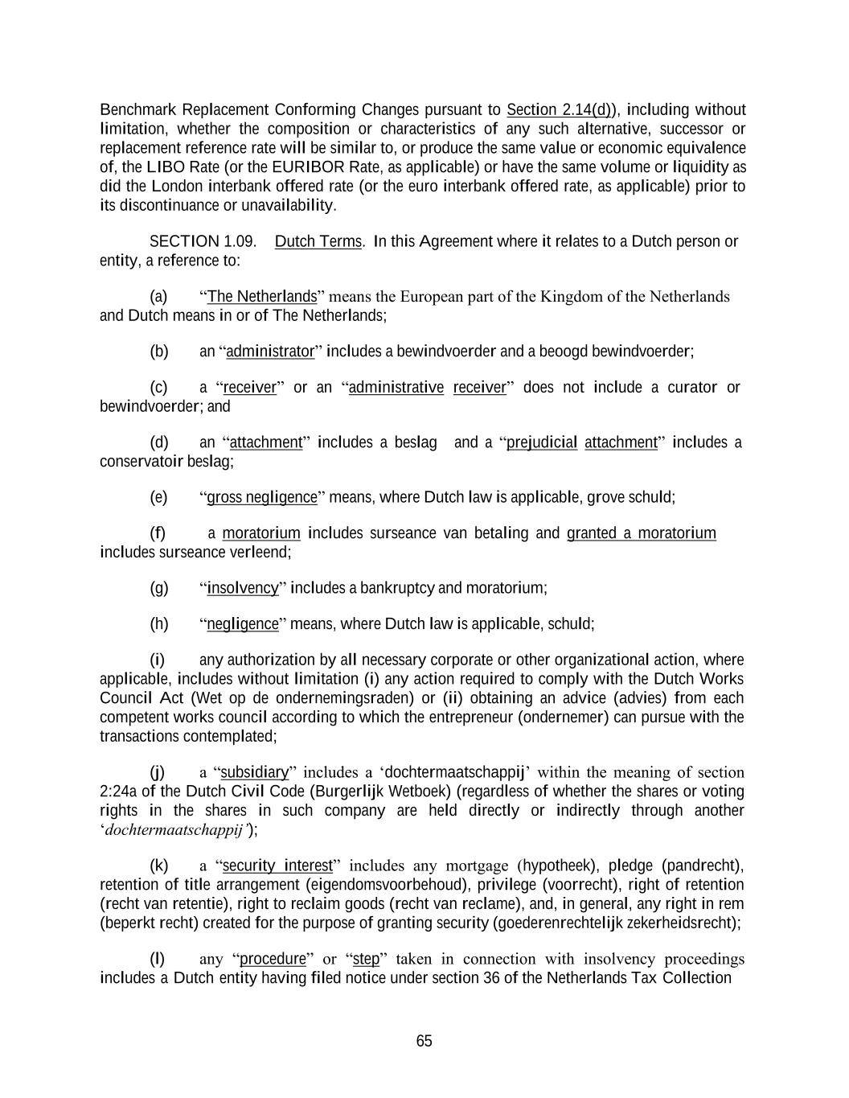
65 Benchmark Replacement Conforming Changes pursuant to Section 2.14(d)), including without limitation, whether the composition or characteristics of any such alternative, successor or replacement reference rate will be similar to, or produce the same value or economic equivalence of, the LIBO Rate (or the EURIBOR Rate, as applicable) or have the same volume or liquidity as did the London interbank offered rate (or the euro interbank offered rate, as applicable) prior to its discontinuance or unavailability. SECTION 1.09. Dutch Terms. In this Agreement where it relates to a Dutch person or entity, a reference to: (a) “The Netherlands” means the European part of the Kingdom of the Netherlands and Dutch means in or of The Netherlands; (b) an “administrator” includes a bewindvoerder and a beoogd bewindvoerder; (c) a “receiver” or an “administrative receiver” does not include a curator or bewindvoerder; and (d) an “attachment” includes a beslag and a “prejudicial attachment” includes a conservatoir beslag; (e) “gross negligence” means, where Dutch law is applicable, grove schuld; (f) a moratorium includes surseance van betaling and granted a moratorium includes surseance verleend; (g) “insolvency” includes a bankruptcy and moratorium; (h) “negligence” means, where Dutch law is applicable, schuld; (i) any authorization by all necessary corporate or other organizational action, where applicable, includes without limitation (i) any action required to comply with the Dutch Works Council Act (Wet op de ondernemingsraden) or (ii) obtaining an advice (advies) from each competent works council according to which the entrepreneur (ondernemer) can pursue with the transactions contemplated; (j) a “subsidiary” includes a ‘dochtermaatschappij’ within the meaning of section 2:24a of the Dutch Civil Code (Burgerlijk Wetboek) (regardless of whether the shares or voting rights in the shares in such company are held directly or indirectly through another ‘dochtermaatschappij’); (k) a “security interest” includes any mortgage (hypotheek), pledge (pandrecht), retention of title arrangement (eigendomsvoorbehoud), privilege (voorrecht), right of retention (recht van retentie), right to reclaim goods (recht van reclame), and, in general, any right in rem (beperkt recht) created for the purpose of granting security (goederenrechtelijk zekerheidsrecht); (l) any “procedure” or “step” taken in connection with insolvency proceedings includes a Dutch entity having filed notice under section 36 of the Netherlands Tax Collection

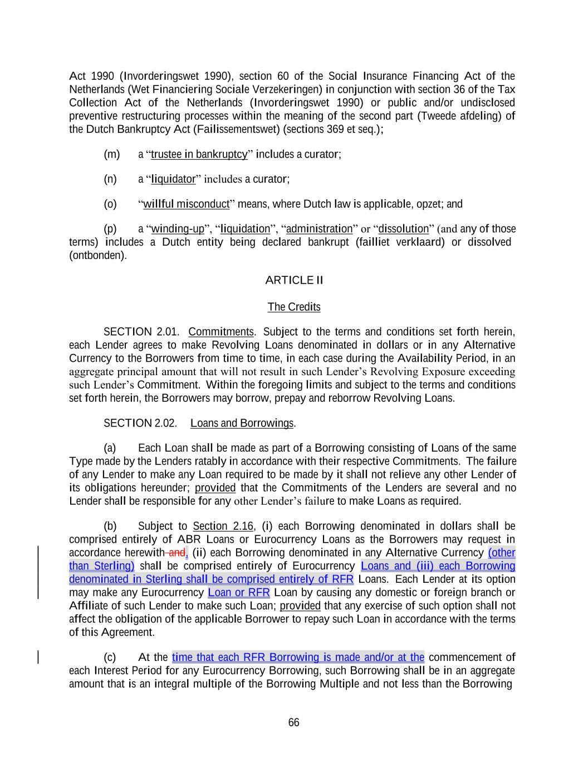
66 Act 1990 (Invorderingswet 1990), section 60 of the Social Insurance Financing Act of the Netherlands (Wet Financiering Sociale Verzekeringen) in conjunction with section 36 of the Tax Collection Act of the Netherlands (Invorderingswet 1990) or public and/or undisclosed preventive restructuring processes within the meaning of the second part (Tweede afdeling) of the Dutch Bankruptcy Act (Failissementswet) (sections 369 et seq.); (m) a “trustee in bankruptcy” includes a curator; (n) a “liquidator” includes a curator; (o) “willful misconduct” means, where Dutch law is applicable, opzet; and (p) a “winding-up”, “liquidation”, “administration” or “dissolution” (and any of those terms) includes a Dutch entity being declared bankrupt (failliet verklaard) or dissolved (ontbonden). ARTICLE II The Credits SECTION 2.01. Commitments. Subject to the terms and conditions set forth herein, each Lender agrees to make Revolving Loans denominated in dollars or in any Alternative Currency to the Borrowers from time to time, in each case during the Availability Period, in an aggregate principal amount that will not result in such Lender’s Revolving Exposure exceeding such Lender’s Commitment. Within the foregoing limits and subject to the terms and conditions set forth herein, the Borrowers may borrow, prepay and reborrow Revolving Loans. SECTION 2.02. Loans and Borrowings. (a) Each Loan shall be made as part of a Borrowing consisting of Loans of the same Type made by the Lenders ratably in accordance with their respective Commitments. The failure of any Lender to make any Loan required to be made by it shall not relieve any other Lender of its obligations hereunder; provided that the Commitments of the Lenders are several and no Lender shall be responsible for any other Lender’s failure to make Loans as required. (b) Subject to Section 2.16, (i) each Borrowing denominated in dollars shall be comprised entirely of ABR Loans or Eurocurrency Loans as the Borrowers may request in accordance herewith and, (ii) each Borrowing denominated in any Alternative Currency (other than Sterling) shall be comprised entirely of Eurocurrency Loans and (iii) each Borrowing denominated in Sterling shall be comprised entirely of RFR Loans. Each Lender at its option may make any Eurocurrency Loan or RFR Loan by causing any domestic or foreign branch or Affiliate of such Lender to make such Loan; provided that any exercise of such option shall not affect the obligation of the applicable Borrower to repay such Loan in accordance with the terms of this Agreement. (c) At the time that each RFR Borrowing is made and/or at the commencement of each Interest Period for any Eurocurrency Borrowing, such Borrowing shall be in an aggregate amount that is an integral multiple of the Borrowing Multiple and not less than the Borrowing

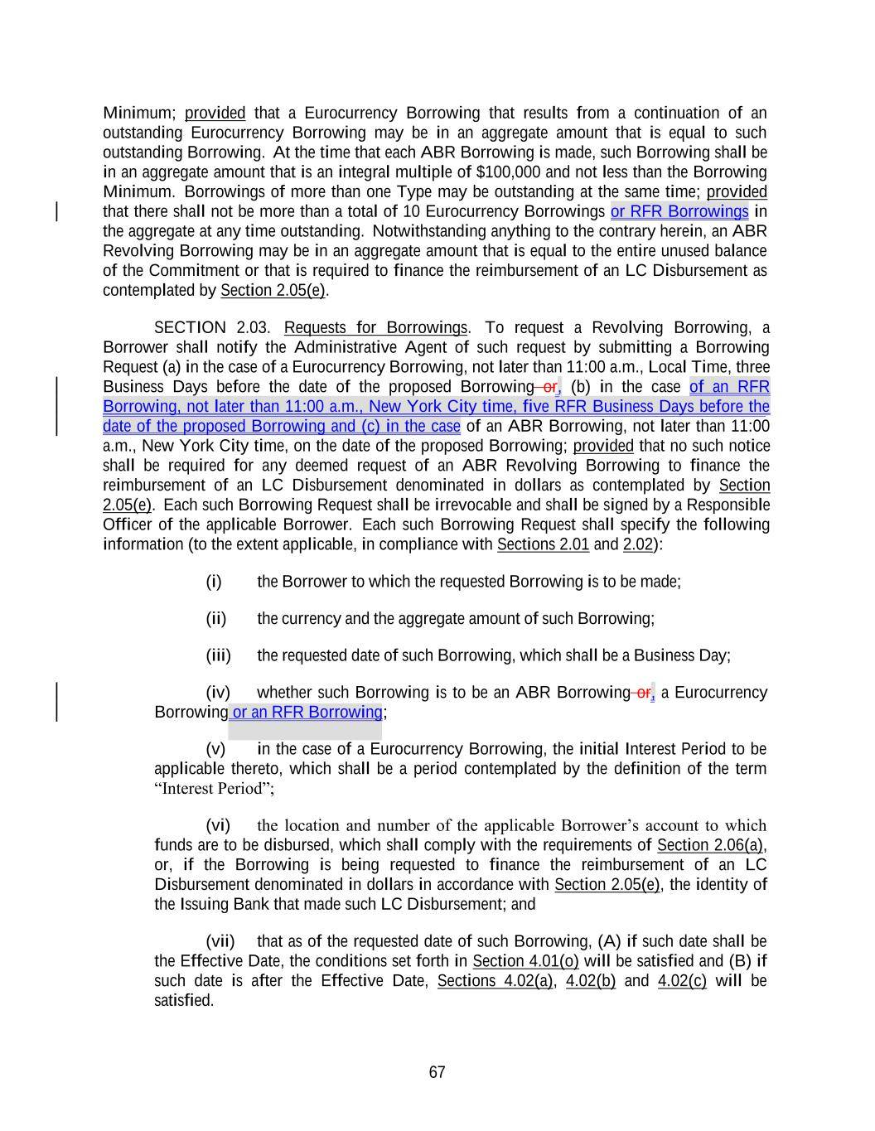
67 Minimum; provided that a Eurocurrency Borrowing that results from a continuation of an outstanding Eurocurrency Borrowing may be in an aggregate amount that is equal to such outstanding Borrowing. At the time that each ABR Borrowing is made, such Borrowing shall be in an aggregate amount that is an integral multiple of $100,000 and not less than the Borrowing Minimum. Borrowings of more than one Type may be outstanding at the same time; provided that there shall not be more than a total of 10 Eurocurrency Borrowings or RFR Borrowings in the aggregate at any time outstanding. Notwithstanding anything to the contrary herein, an ABR Revolving Borrowing may be in an aggregate amount that is equal to the entire unused balance of the Commitment or that is required to finance the reimbursement of an LC Disbursement as contemplated by Section 2.05(e). SECTION 2.03. Requests for Borrowings. To request a Revolving Borrowing, a Borrower shall notify the Administrative Agent of such request by submitting a Borrowing Request (a) in the case of a Eurocurrency Borrowing, not later than 11:00 a.m., Local Time, three Business Days before the date of the proposed Borrowing or, (b) in the case of an RFR Borrowing, not later than 11:00 a.m., New York City time, five RFR Business Days before the date of the proposed Borrowing and (c) in the case of an ABR Borrowing, not later than 11:00 a.m., New York City time, on the date of the proposed Borrowing; provided that no such notice shall be required for any deemed request of an ABR Revolving Borrowing to finance the reimbursement of an LC Disbursement denominated in dollars as contemplated by Section 2.05(e). Each such Borrowing Request shall be irrevocable and shall be signed by a Responsible Officer of the applicable Borrower. Each such Borrowing Request shall specify the following information (to the extent applicable, in compliance with Sections 2.01 and 2.02): (i) the Borrower to which the requested Borrowing is to be made; (ii) the currency and the aggregate amount of such Borrowing; (iii) the requested date of such Borrowing, which shall be a Business Day; (iv) whether such Borrowing is to be an ABR Borrowing or, a Eurocurrency Borrowing or an RFR Borrowing; (v) in the case of a Eurocurrency Borrowing, the initial Interest Period to be applicable thereto, which shall be a period contemplated by the definition of the term “Interest Period”; (vi) the location and number of the applicable Borrower’s account to which funds are to be disbursed, which shall comply with the requirements of Section 2.06(a), or, if the Borrowing is being requested to finance the reimbursement of an LC Disbursement denominated in dollars in accordance with Section 2.05(e), the identity of the Issuing Bank that made such LC Disbursement; and (vii) that as of the requested date of such Borrowing, (A) if such date shall be the Effective Date, the conditions set forth in Section 4.01(o) will be satisfied and (B) if such date is after the Effective Date, Sections 4.02(a), 4.02(b) and 4.02(c) will be satisfied.

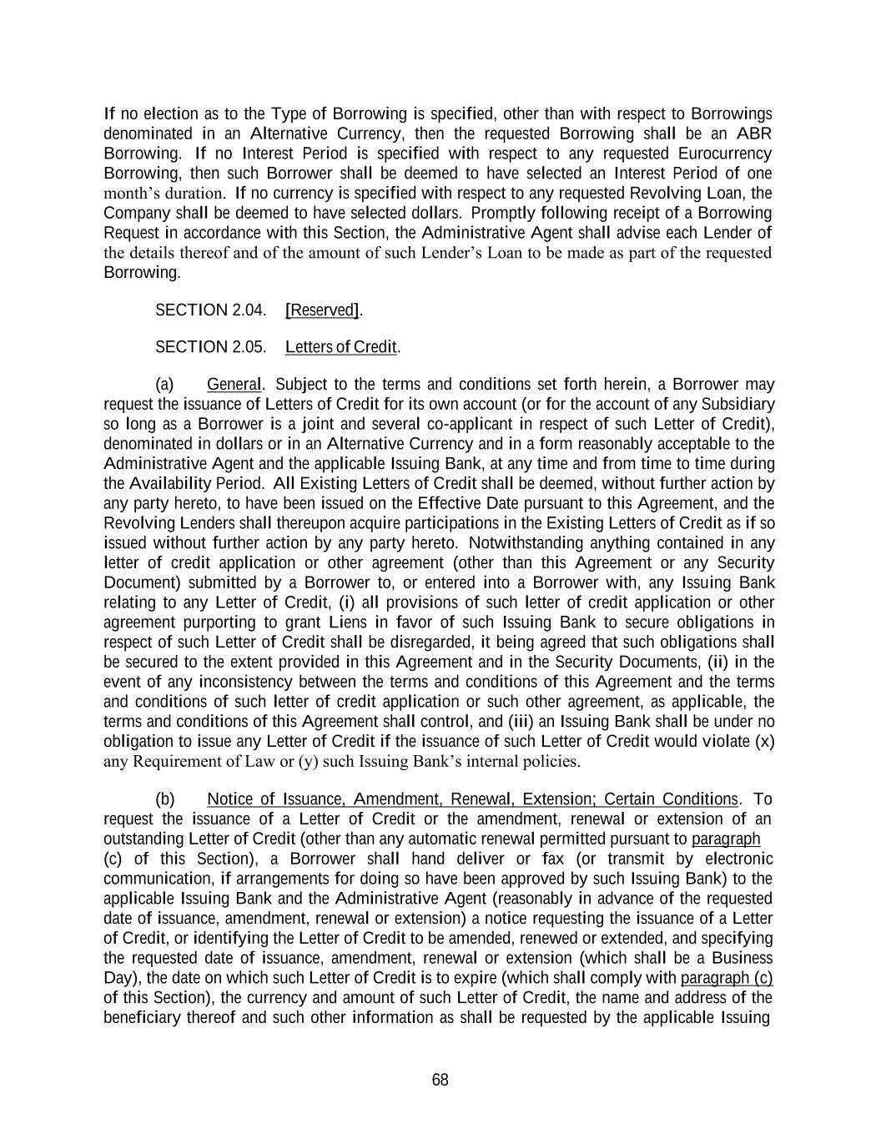
68 If no election as to the Type of Borrowing is specified, other than with respect to Borrowings denominated in an Alternative Currency, then the requested Borrowing shall be an ABR Borrowing. If no Interest Period is specified with respect to any requested Eurocurrency Borrowing, then such Borrower shall be deemed to have selected an Interest Period of one month’s duration. If no currency is specified with respect to any requested Revolving Loan, the Company shall be deemed to have selected dollars. Promptly following receipt of a Borrowing Request in accordance with this Section, the Administrative Agent shall advise each Lender of the details thereof and of the amount of such Lender’s Loan to be made as part of the requested Borrowing. SECTION 2.04. [Reserved]. SECTION 2.05. Letters of Credit. (a) General. Subject to the terms and conditions set forth herein, a Borrower may request the issuance of Letters of Credit for its own account (or for the account of any Subsidiary so long as a Borrower is a joint and several co-applicant in respect of such Letter of Credit), denominated in dollars or in an Alternative Currency and in a form reasonably acceptable to the Administrative Agent and the applicable Issuing Bank, at any time and from time to time during the Availability Period. All Existing Letters of Credit shall be deemed, without further action by any party hereto, to have been issued on the Effective Date pursuant to this Agreement, and the Revolving Lenders shall thereupon acquire participations in the Existing Letters of Credit as if so issued without further action by any party hereto. Notwithstanding anything contained in any letter of credit application or other agreement (other than this Agreement or any Security Document) submitted by a Borrower to, or entered into a Borrower with, any Issuing Bank relating to any Letter of Credit, (i) all provisions of such letter of credit application or other agreement purporting to grant Liens in favor of such Issuing Bank to secure obligations in respect of such Letter of Credit shall be disregarded, it being agreed that such obligations shall be secured to the extent provided in this Agreement and in the Security Documents, (ii) in the event of any inconsistency between the terms and conditions of this Agreement and the terms and conditions of such letter of credit application or such other agreement, as applicable, the terms and conditions of this Agreement shall control, and (iii) an Issuing Bank shall be under no obligation to issue any Letter of Credit if the issuance of such Letter of Credit would violate (x) any Requirement of Law or (y) such Issuing Bank’s internal policies. (b) Notice of Issuance, Amendment, Renewal, Extension; Certain Conditions. To request the issuance of a Letter of Credit or the amendment, renewal or extension of an outstanding Letter of Credit (other than any automatic renewal permitted pursuant to paragraph (c) of this Section), a Borrower shall hand deliver or fax (or transmit by electronic communication, if arrangements for doing so have been approved by such Issuing Bank) to the applicable Issuing Bank and the Administrative Agent (reasonably in advance of the requested date of issuance, amendment, renewal or extension) a notice requesting the issuance of a Letter of Credit, or identifying the Letter of Credit to be amended, renewed or extended, and specifying the requested date of issuance, amendment, renewal or extension (which shall be a Business Day), the date on which such Letter of Credit is to expire (which shall comply with paragraph (c) of this Section), the currency and amount of such Letter of Credit, the name and address of the beneficiary thereof and such other information as shall be requested by the applicable Issuing

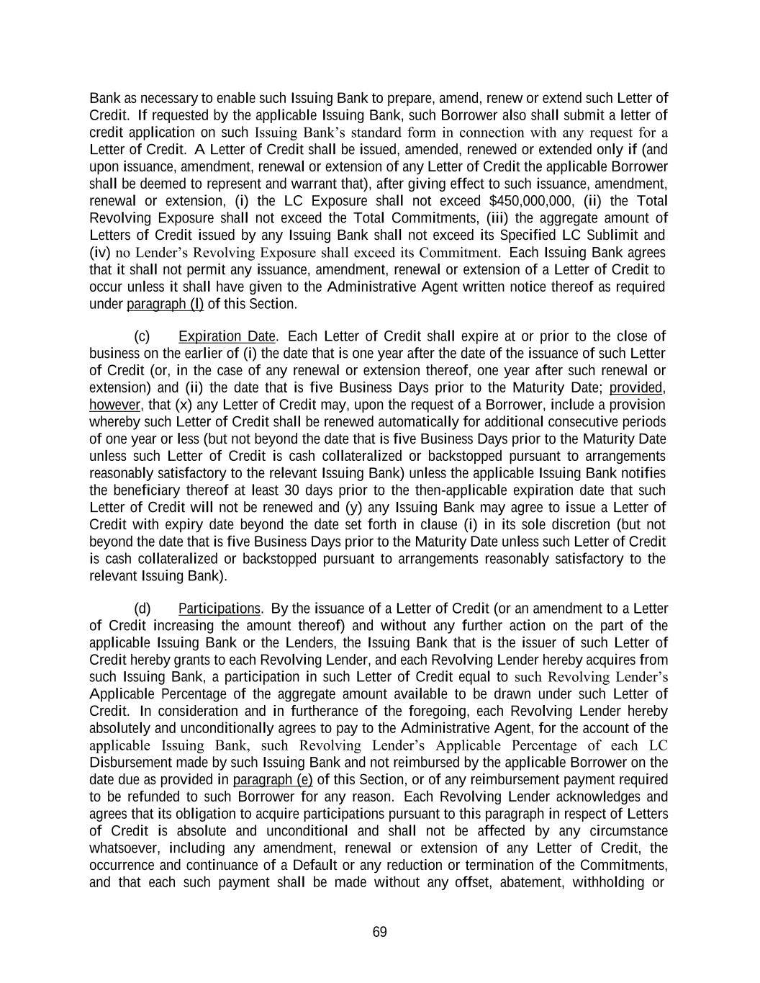
69 Bank as necessary to enable such Issuing Bank to prepare, amend, renew or extend such Letter of Credit. If requested by the applicable Issuing Bank, such Borrower also shall submit a letter of credit application on such Issuing Bank’s standard form in connection with any request for a Letter of Credit. A Letter of Credit shall be issued, amended, renewed or extended only if (and upon issuance, amendment, renewal or extension of any Letter of Credit the applicable Borrower shall be deemed to represent and warrant that), after giving effect to such issuance, amendment, renewal or extension, (i) the LC Exposure shall not exceed $450,000,000, (ii) the Total Revolving Exposure shall not exceed the Total Commitments, (iii) the aggregate amount of Letters of Credit issued by any Issuing Bank shall not exceed its Specified LC Sublimit and (iv) no Lender’s Revolving Exposure shall exceed its Commitment. Each Issuing Bank agrees that it shall not permit any issuance, amendment, renewal or extension of a Letter of Credit to occur unless it shall have given to the Administrative Agent written notice thereof as required under paragraph (l) of this Section. (c) Expiration Date. Each Letter of Credit shall expire at or prior to the close of business on the earlier of (i) the date that is one year after the date of the issuance of such Letter of Credit (or, in the case of any renewal or extension thereof, one year after such renewal or extension) and (ii) the date that is five Business Days prior to the Maturity Date; provided, however, that (x) any Letter of Credit may, upon the request of a Borrower, include a provision whereby such Letter of Credit shall be renewed automatically for additional consecutive periods of one year or less (but not beyond the date that is five Business Days prior to the Maturity Date unless such Letter of Credit is cash collateralized or backstopped pursuant to arrangements reasonably satisfactory to the relevant Issuing Bank) unless the applicable Issuing Bank notifies the beneficiary thereof at least 30 days prior to the then-applicable expiration date that such Letter of Credit will not be renewed and (y) any Issuing Bank may agree to issue a Letter of Credit with expiry date beyond the date set forth in clause (i) in its sole discretion (but not beyond the date that is five Business Days prior to the Maturity Date unless such Letter of Credit is cash collateralized or backstopped pursuant to arrangements reasonably satisfactory to the relevant Issuing Bank). (d) Participations. By the issuance of a Letter of Credit (or an amendment to a Letter of Credit increasing the amount thereof) and without any further action on the part of the applicable Issuing Bank or the Lenders, the Issuing Bank that is the issuer of such Letter of Credit hereby grants to each Revolving Lender, and each Revolving Lender hereby acquires from such Issuing Bank, a participation in such Letter of Credit equal to such Revolving Lender’s Applicable Percentage of the aggregate amount available to be drawn under such Letter of Credit. In consideration and in furtherance of the foregoing, each Revolving Lender hereby absolutely and unconditionally agrees to pay to the Administrative Agent, for the account of the applicable Issuing Bank, such Revolving Lender’s Applicable Percentage of each LC Disbursement made by such Issuing Bank and not reimbursed by the applicable Borrower on the date due as provided in paragraph (e) of this Section, or of any reimbursement payment required to be refunded to such Borrower for any reason. Each Revolving Lender acknowledges and agrees that its obligation to acquire participations pursuant to this paragraph in respect of Letters of Credit is absolute and unconditional and shall not be affected by any circumstance whatsoever, including any amendment, renewal or extension of any Letter of Credit, the occurrence and continuance of a Default or any reduction or termination of the Commitments, and that each such payment shall be made without any offset, abatement, withholding or

70 reduction whatsoever. Each Revolving Lender further acknowledges and agrees that, in issuing, amending, renewing or extending any Letter of Credit, the applicable Issuing Bank shall be entitled to rely, and shall not incur any liability for relying, upon the representation and warranty of a Borrower deemed made pursuant to Section 4.02 unless, at least one Business Day prior to the time such Letter of Credit is issued, amended, renewed or extended (or, in the case of an automatic renewal permitted pursuant to paragraph (c) of this Section, at least one Business Day prior to the time by which the election not to extend must be made by the applicable Issuing Bank), the Required Lenders shall have notified the applicable Issuing Bank (with a copy to the Administrative Agent) in writing that, as a result of one or more events or circumstances described in such notice, one or more of the conditions precedent set forth in Section 4.02(a) or 4.02(b) would not be satisfied if such Letter of Credit were then issued, amended, renewed or extended (it being understood and agreed that, in the event any Issuing Bank shall have received any such notice, no Issuing Bank shall have any obligation to issue, amend, renew or extend any Letter of Credit until and unless it shall be satisfied that the events and circumstances described in such notice shall have been cured or otherwise shall have ceased to exist). (e) Reimbursement. If an Issuing Bank shall make any LC Disbursement in respect of a Letter of Credit, then the applicable Borrower shall reimburse such LC Disbursement by paying to the Administrative Agent an amount equal to such LC Disbursement not later than (i) if such Borrower shall have received notice of such LC Disbursement prior to 12:00 noon, Local Time, on any Business Day, then 5:00 p.m., Local Time, on such Business Day, or (ii) otherwise, 10:00 a.m., Local Time, on the Business Day immediately following the day that such Borrower receives such notice; provided that, unless such Borrower has notified the applicable Issuing Bank that it will reimburse such LC Disbursement by the required date and time, such Borrower shall, subject to the conditions to borrowing set forth herein, be deemed to have requested, and such Borrower does hereby request in such event that such payment be financed with an ABR Revolving Borrowing in an equivalent amount and, to the extent so financed, such Borrower’s obligation to make such payment shall be discharged and replaced by the resulting ABR Revolving Borrowing. In the case of any such reimbursement in dollars with respect to a Letter of Credit denominated in an Alternative Currency, the applicable Issuing Bank shall notify such Borrower of the Dollar Equivalent of the amount of the draft so paid promptly following the determination thereof. If such Borrower fails to reimburse any LC Disbursement by the time specified above in this paragraph, then the Administrative Agent shall notify each Revolving Lender, as the case may be, of the applicable LC Disbursement, the currency and amount of the payment then due from such Borrower in respect thereof and such Revolving Lender’s Applicable Percentage thereof, as applicable. Promptly following receipt of such notice, each Revolving Lender shall pay to the Administrative Agent its Applicable Percentage of the amount then due from such Borrower in the currency of the applicable LC Disbursement, in the same manner as provided in Section 2.06 with respect to Loans made by such Lender (and Section 2.06 shall apply, mutatis mutandis, to the payment obligations of the Revolving Lenders under this paragraph), and the Administrative Agent shall promptly remit to the applicable Issuing Bank the amounts so received by it from the applicable Revolving Lenders. Promptly following receipt by the Administrative Agent of any payment from a Borrower pursuant to this paragraph, the Administrative Agent shall distribute such payment to the applicable Issuing Bank or, to the extent that Revolving Lenders have made payments pursuant to this paragraph to reimburse such Issuing Bank, then to such Revolving Lenders and such Issuing Bank as their interests may appear. Any payment made by a Revolving Lender pursuant to this paragraph to reimburse an

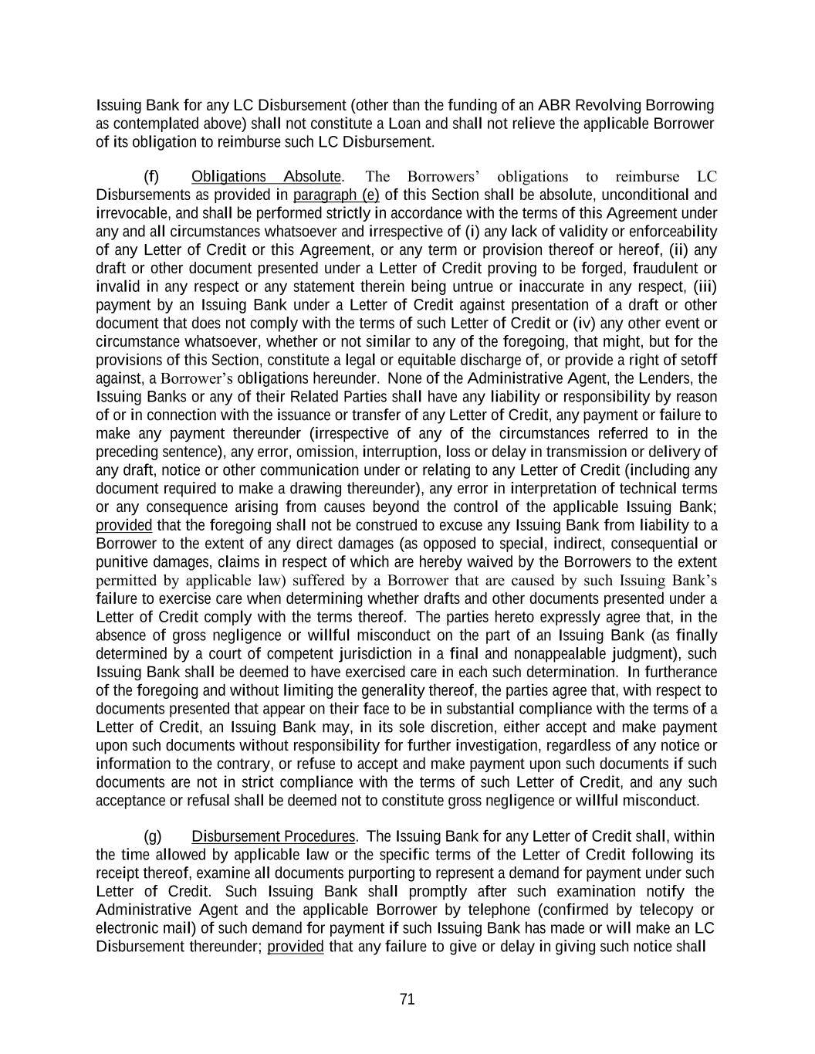
71 Issuing Bank for any LC Disbursement (other than the funding of an ABR Revolving Borrowing as contemplated above) shall not constitute a Loan and shall not relieve the applicable Borrower of its obligation to reimburse such LC Disbursement. (f) Obligations Absolute. The Borrowers’ obligations to reimburse LC Disbursements as provided in paragraph (e) of this Section shall be absolute, unconditional and irrevocable, and shall be performed strictly in accordance with the terms of this Agreement under any and all circumstances whatsoever and irrespective of (i) any lack of validity or enforceability of any Letter of Credit or this Agreement, or any term or provision thereof or hereof, (ii) any draft or other document presented under a Letter of Credit proving to be forged, fraudulent or invalid in any respect or any statement therein being untrue or inaccurate in any respect, (iii) payment by an Issuing Bank under a Letter of Credit against presentation of a draft or other document that does not comply with the terms of such Letter of Credit or (iv) any other event or circumstance whatsoever, whether or not similar to any of the foregoing, that might, but for the provisions of this Section, constitute a legal or equitable discharge of, or provide a right of setoff against, a Borrower’s obligations hereunder. None of the Administrative Agent, the Lenders, the Issuing Banks or any of their Related Parties shall have any liability or responsibility by reason of or in connection with the issuance or transfer of any Letter of Credit, any payment or failure to make any payment thereunder (irrespective of any of the circumstances referred to in the preceding sentence), any error, omission, interruption, loss or delay in transmission or delivery of any draft, notice or other communication under or relating to any Letter of Credit (including any document required to make a drawing thereunder), any error in interpretation of technical terms or any consequence arising from causes beyond the control of the applicable Issuing Bank; provided that the foregoing shall not be construed to excuse any Issuing Bank from liability to a Borrower to the extent of any direct damages (as opposed to special, indirect, consequential or punitive damages, claims in respect of which are hereby waived by the Borrowers to the extent permitted by applicable law) suffered by a Borrower that are caused by such Issuing Bank’s failure to exercise care when determining whether drafts and other documents presented under a Letter of Credit comply with the terms thereof. The parties hereto expressly agree that, in the absence of gross negligence or willful misconduct on the part of an Issuing Bank (as finally determined by a court of competent jurisdiction in a final and nonappealable judgment), such Issuing Bank shall be deemed to have exercised care in each such determination. In furtherance of the foregoing and without limiting the generality thereof, the parties agree that, with respect to documents presented that appear on their face to be in substantial compliance with the terms of a Letter of Credit, an Issuing Bank may, in its sole discretion, either accept and make payment upon such documents without responsibility for further investigation, regardless of any notice or information to the contrary, or refuse to accept and make payment upon such documents if such documents are not in strict compliance with the terms of such Letter of Credit, and any such acceptance or refusal shall be deemed not to constitute gross negligence or willful misconduct. (g) Disbursement Procedures. The Issuing Bank for any Letter of Credit shall, within the time allowed by applicable law or the specific terms of the Letter of Credit following its receipt thereof, examine all documents purporting to represent a demand for payment under such Letter of Credit. Such Issuing Bank shall promptly after such examination notify the Administrative Agent and the applicable Borrower by telephone (confirmed by telecopy or electronic mail) of such demand for payment if such Issuing Bank has made or will make an LC Disbursement thereunder; provided that any failure to give or delay in giving such notice shall

72 not relieve the applicable Borrower of its obligation to reimburse such Issuing Bank and the Revolving Lenders with respect to any such LC Disbursement in accordance with paragraph (e) of this Section. (h) Interim Interest. If an Issuing Bank shall make any LC Disbursement, then, unless the applicable Borrower shall reimburse such LC Disbursement in full on the date such LC Disbursement is made, the unpaid amount thereof shall bear interest, for each day from and including the date such LC Disbursement is made to but excluding the date that the such Borrower reimburses such LC Disbursement in full, at (i) in the case of any LC Disbursement denominated in dollars, the rate per annum then applicable to ABR Revolving Loans and (ii) in the case of an LC Disbursement denominated in any Alternative Currency, a rate per annum determined by the applicable Issuing Bank (which determination will be conclusive absent manifest error) to represent its cost of funds plus the Applicable Rate used to determine interest applicable to Eurocurrency Revolving Loans; provided that, if the applicable Borrower fails to reimburse such LC Disbursement in full when due pursuant to paragraph (e) of this Section, then Section 2.13(cd) shall apply. Interest accrued pursuant to this paragraph shall be paid to the Administrative Agent, for the account of the applicable Issuing Bank, except that interest accrued on and after the date of payment by any Revolving Lender pursuant to paragraph (e) of this Section to reimburse such Issuing Bank shall be for the account of such Lender to the extent of such payment, and shall be payable on demand or, if no demand has been made, on the date on which the applicable Borrower reimburses the applicable LC Disbursement in full. (i) Cash Collateralization. If any Event of Default shall occur and be continuing, on the Business Day on which the Company receives notice from the Administrative Agent or the Required Lenders, the Borrowers shall deposit in an account with the Administrative Agent, in the name of the Administrative Agent and for the benefit of the Revolving Lenders, an amount in cash and in the currency of each applicable Letter of Credit equal to the LC Exposure as of such date plus any accrued and unpaid interest thereon; provided that the obligation to deposit such cash collateral shall become effective immediately, and such deposit shall become immediately due and payable, without demand or other notice of any kind, upon the occurrence of any Event of Default with respect to any Borrower described in clause (h) or (i) of Section 7.01. The Borrowers also shall deposit cash collateral in accordance with this paragraph as and to the extent required by Section 2.11(b) or 2.20(c). Each such deposit shall be held by the Administrative Agent as collateral for the payment and performance of the obligations of the Borrowers under this Agreement. The Administrative Agent shall have exclusive dominion and control, including the exclusive right of withdrawal, over such account. Other than any interest earned on the investment of such deposits, which investments shall be made at the option and sole discretion of the Administrative Agent and at the Borrowers’ risk and expense, such deposits shall not bear interest. Interest or profits, if any, on such investments shall accumulate in such account. Notwithstanding the terms of any Security Document, moneys in such account shall be applied by the Administrative Agent to reimburse the Issuing Banks for LC Disbursements for which they have not been reimbursed and, to the extent not so applied, shall be held for the satisfaction of the reimbursement obligations of the Borrowers for the LC Exposure at such time or, if the maturity of the Loans has been accelerated (but subject to (i) the consent of the Required Lenders and (ii) in the case of any such application at a time when any Revolving Lender is a Defaulting Lender (but only if, after giving effect thereto, the remaining cash collateral shall be less than the aggregate LC Exposure of all the Defaulting Lenders), the

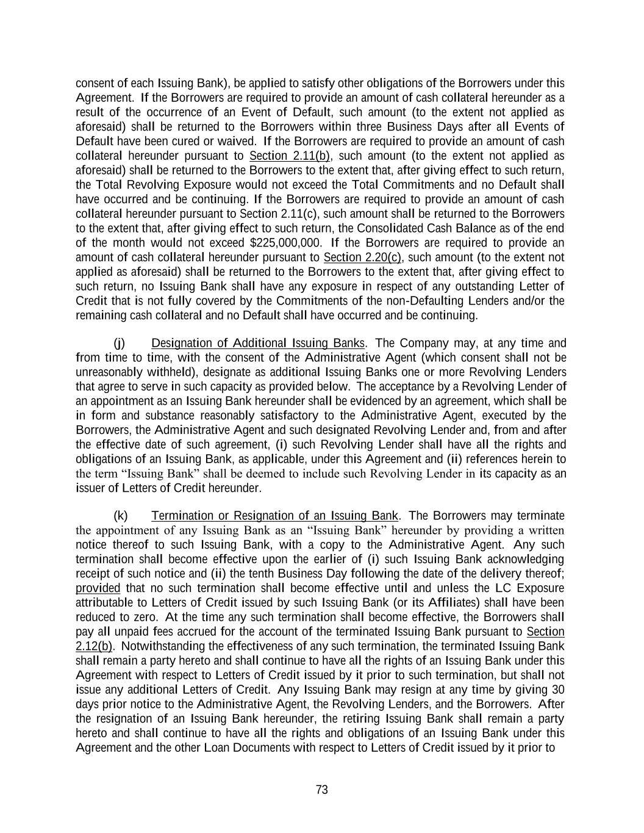
73 consent of each Issuing Bank), be applied to satisfy other obligations of the Borrowers under this Agreement. If the Borrowers are required to provide an amount of cash collateral hereunder as a result of the occurrence of an Event of Default, such amount (to the extent not applied as aforesaid) shall be returned to the Borrowers within three Business Days after all Events of Default have been cured or waived. If the Borrowers are required to provide an amount of cash collateral hereunder pursuant to Section 2.11(b), such amount (to the extent not applied as aforesaid) shall be returned to the Borrowers to the extent that, after giving effect to such return, the Total Revolving Exposure would not exceed the Total Commitments and no Default shall have occurred and be continuing. If the Borrowers are required to provide an amount of cash collateral hereunder pursuant to Section 2.11(c), such amount shall be returned to the Borrowers to the extent that, after giving effect to such return, the Consolidated Cash Balance as of the end of the month would not exceed $225,000,000. If the Borrowers are required to provide an amount of cash collateral hereunder pursuant to Section 2.20(c), such amount (to the extent not applied as aforesaid) shall be returned to the Borrowers to the extent that, after giving effect to such return, no Issuing Bank shall have any exposure in respect of any outstanding Letter of Credit that is not fully covered by the Commitments of the non-Defaulting Lenders and/or the remaining cash collateral and no Default shall have occurred and be continuing. (j) Designation of Additional Issuing Banks. The Company may, at any time and from time to time, with the consent of the Administrative Agent (which consent shall not be unreasonably withheld), designate as additional Issuing Banks one or more Revolving Lenders that agree to serve in such capacity as provided below. The acceptance by a Revolving Lender of an appointment as an Issuing Bank hereunder shall be evidenced by an agreement, which shall be in form and substance reasonably satisfactory to the Administrative Agent, executed by the Borrowers, the Administrative Agent and such designated Revolving Lender and, from and after the effective date of such agreement, (i) such Revolving Lender shall have all the rights and obligations of an Issuing Bank, as applicable, under this Agreement and (ii) references herein to the term “Issuing Bank” shall be deemed to include such Revolving Lender in its capacity as an issuer of Letters of Credit hereunder. (k) Termination or Resignation of an Issuing Bank. The Borrowers may terminate the appointment of any Issuing Bank as an “Issuing Bank” hereunder by providing a written notice thereof to such Issuing Bank, with a copy to the Administrative Agent. Any such termination shall become effective upon the earlier of (i) such Issuing Bank acknowledging receipt of such notice and (ii) the tenth Business Day following the date of the delivery thereof; provided that no such termination shall become effective until and unless the LC Exposure attributable to Letters of Credit issued by such Issuing Bank (or its Affiliates) shall have been reduced to zero. At the time any such termination shall become effective, the Borrowers shall pay all unpaid fees accrued for the account of the terminated Issuing Bank pursuant to Section 2.12(b). Notwithstanding the effectiveness of any such termination, the terminated Issuing Bank shall remain a party hereto and shall continue to have all the rights of an Issuing Bank under this Agreement with respect to Letters of Credit issued by it prior to such termination, but shall not issue any additional Letters of Credit. Any Issuing Bank may resign at any time by giving 30 days prior notice to the Administrative Agent, the Revolving Lenders, and the Borrowers. After the resignation of an Issuing Bank hereunder, the retiring Issuing Bank shall remain a party hereto and shall continue to have all the rights and obligations of an Issuing Bank under this Agreement and the other Loan Documents with respect to Letters of Credit issued by it prior to

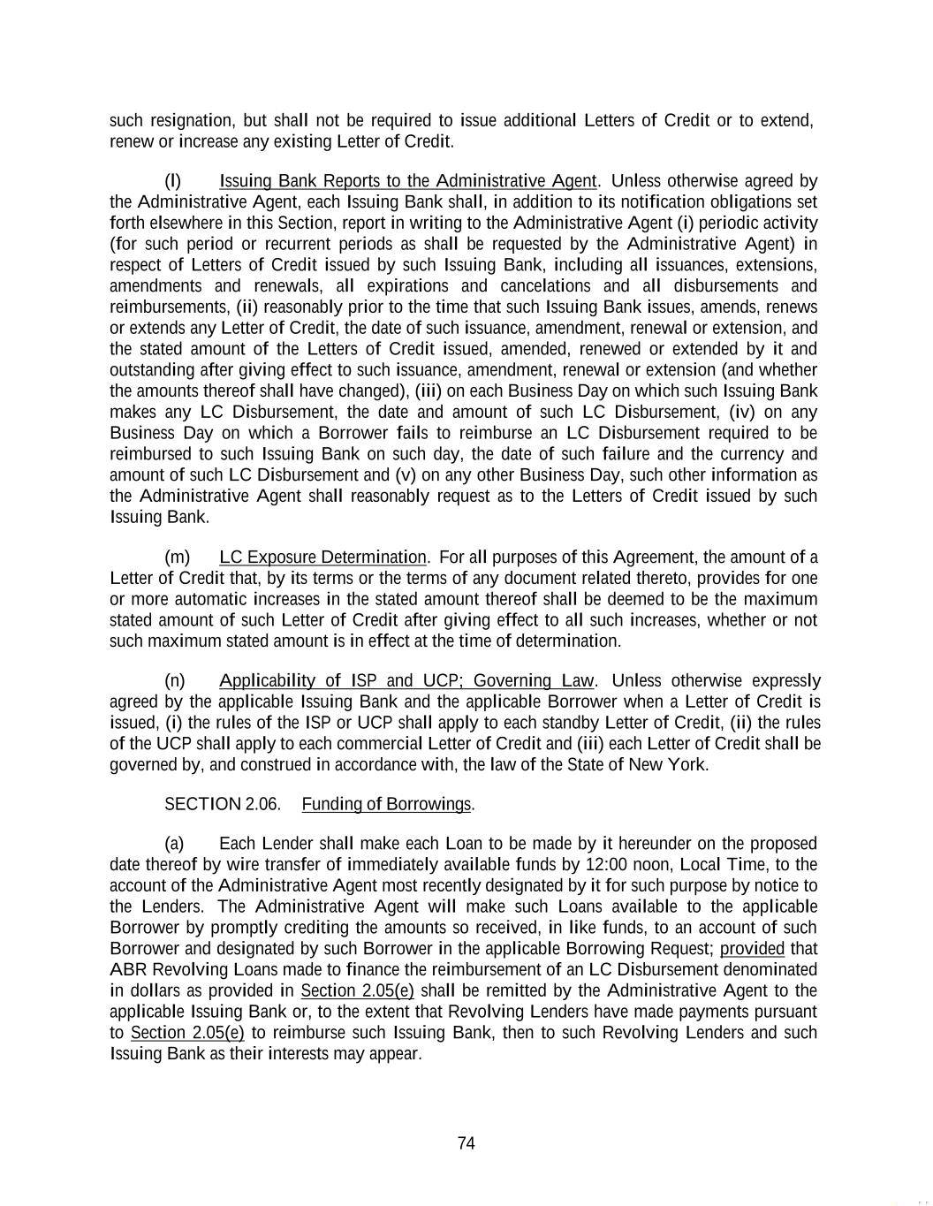
74 such resignation, but shall not be required to issue additional Letters of Credit or to extend, renew or increase any existing Letter of Credit. (l) Issuing Bank Reports to the Administrative Agent. Unless otherwise agreed by the Administrative Agent, each Issuing Bank shall, in addition to its notification obligations set forth elsewhere in this Section, report in writing to the Administrative Agent (i) periodic activity (for such period or recurrent periods as shall be requested by the Administrative Agent) in respect of Letters of Credit issued by such Issuing Bank, including all issuances, extensions, amendments and renewals, all expirations and cancelations and all disbursements and reimbursements, (ii) reasonably prior to the time that such Issuing Bank issues, amends, renews or extends any Letter of Credit, the date of such issuance, amendment, renewal or extension, and the stated amount of the Letters of Credit issued, amended, renewed or extended by it and outstanding after giving effect to such issuance, amendment, renewal or extension (and whether the amounts thereof shall have changed), (iii) on each Business Day on which such Issuing Bank makes any LC Disbursement, the date and amount of such LC Disbursement, (iv) on any Business Day on which a Borrower fails to reimburse an LC Disbursement required to be reimbursed to such Issuing Bank on such day, the date of such failure and the currency and amount of such LC Disbursement and (v) on any other Business Day, such other information as the Administrative Agent shall reasonably request as to the Letters of Credit issued by such Issuing Bank. (m) LC Exposure Determination. For all purposes of this Agreement, the amount of a Letter of Credit that, by its terms or the terms of any document related thereto, provides for one or more automatic increases in the stated amount thereof shall be deemed to be the maximum stated amount of such Letter of Credit after giving effect to all such increases, whether or not such maximum stated amount is in effect at the time of determination. (n) Applicability of ISP and UCP; Governing Law. Unless otherwise expressly agreed by the applicable Issuing Bank and the applicable Borrower when a Letter of Credit is issued, (i) the rules of the ISP or UCP shall apply to each standby Letter of Credit, (ii) the rules of the UCP shall apply to each commercial Letter of Credit and (iii) each Letter of Credit shall be governed by, and construed in accordance with, the law of the State of New York. SECTION 2.06. Funding of Borrowings. (a) Each Lender shall make each Loan to be made by it hereunder on the proposed date thereof by wire transfer of immediately available funds by 12:00 noon, Local Time, to the account of the Administrative Agent most recently designated by it for such purpose by notice to the Lenders. The Administrative Agent will make such Loans available to the applicable Borrower by promptly crediting the amounts so received, in like funds, to an account of such Borrower and designated by such Borrower in the applicable Borrowing Request; provided that ABR Revolving Loans made to finance the reimbursement of an LC Disbursement denominated in dollars as provided in Section 2.05(e) shall be remitted by the Administrative Agent to the applicable Issuing Bank or, to the extent that Revolving Lenders have made payments pursuant to Section 2.05(e) to reimburse such Issuing Bank, then to such Revolving Lenders and such Issuing Bank as their interests may appear.

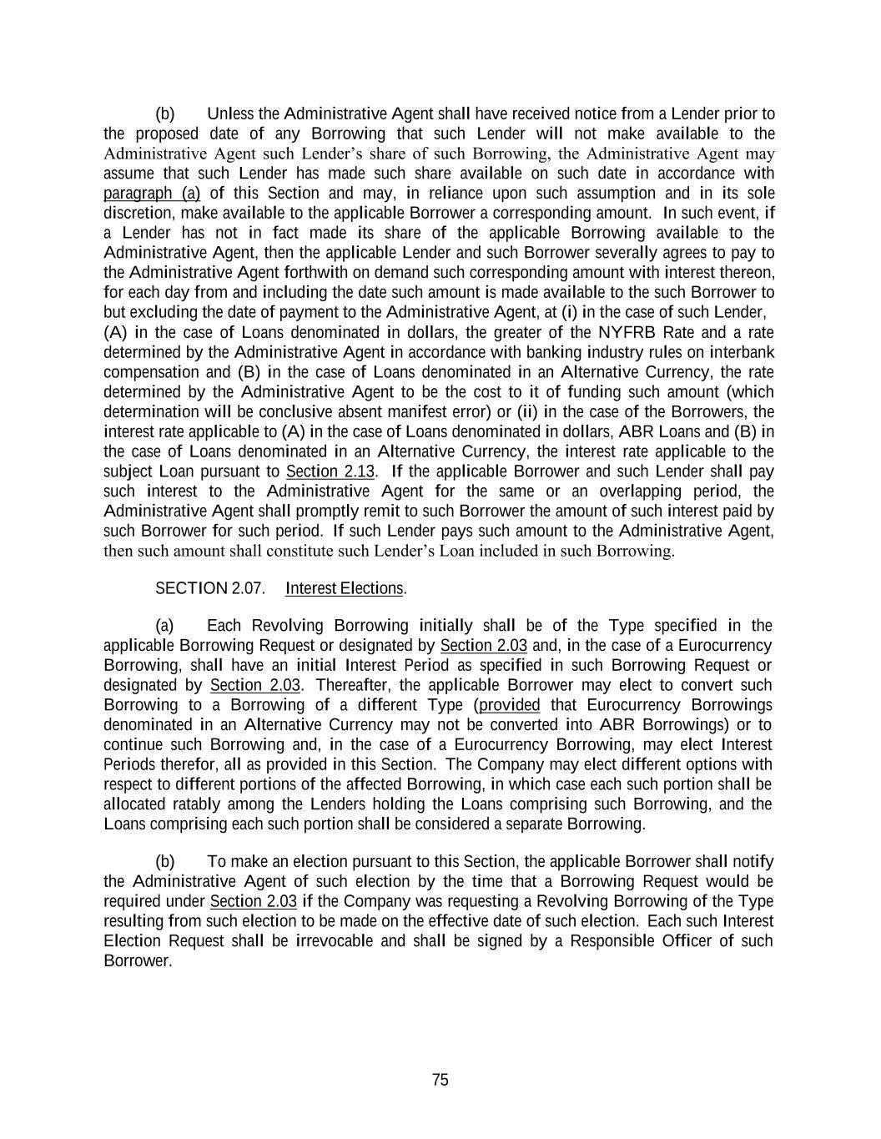
75 (b) Unless the Administrative Agent shall have received notice from a Lender prior to the proposed date of any Borrowing that such Lender will not make available to the Administrative Agent such Lender’s share of such Borrowing, the Administrative Agent may assume that such Lender has made such share available on such date in accordance with paragraph (a) of this Section and may, in reliance upon such assumption and in its sole discretion, make available to the applicable Borrower a corresponding amount. In such event, if a Lender has not in fact made its share of the applicable Borrowing available to the Administrative Agent, then the applicable Lender and such Borrower severally agrees to pay to the Administrative Agent forthwith on demand such corresponding amount with interest thereon, for each day from and including the date such amount is made available to the such Borrower to but excluding the date of payment to the Administrative Agent, at (i) in the case of such Lender, (A) in the case of Loans denominated in dollars, the greater of the NYFRB Rate and a rate determined by the Administrative Agent in accordance with banking industry rules on interbank compensation and (B) in the case of Loans denominated in an Alternative Currency, the rate determined by the Administrative Agent to be the cost to it of funding such amount (which determination will be conclusive absent manifest error) or (ii) in the case of the Borrowers, the interest rate applicable to (A) in the case of Loans denominated in dollars, ABR Loans and (B) in the case of Loans denominated in an Alternative Currency, the interest rate applicable to the subject Loan pursuant to Section 2.13. If the applicable Borrower and such Lender shall pay such interest to the Administrative Agent for the same or an overlapping period, the Administrative Agent shall promptly remit to such Borrower the amount of such interest paid by such Borrower for such period. If such Lender pays such amount to the Administrative Agent, then such amount shall constitute such Lender’s Loan included in such Borrowing. SECTION 2.07. Interest Elections. (a) Each Revolving Borrowing initially shall be of the Type specified in the applicable Borrowing Request or designated by Section 2.03 and, in the case of a Eurocurrency Borrowing, shall have an initial Interest Period as specified in such Borrowing Request or designated by Section 2.03. Thereafter, the applicable Borrower may elect to convert such Borrowing to a Borrowing of a different Type (provided that Eurocurrency Borrowings denominated in an Alternative Currency may not be converted into ABR Borrowings) or to continue such Borrowing and, in the case of a Eurocurrency Borrowing, may elect Interest Periods therefor, all as provided in this Section. The Company may elect different options with respect to different portions of the affected Borrowing, in which case each such portion shall be allocated ratably among the Lenders holding the Loans comprising such Borrowing, and the Loans comprising each such portion shall be considered a separate Borrowing. (b) To make an election pursuant to this Section, the applicable Borrower shall notify the Administrative Agent of such election by the time that a Borrowing Request would be required under Section 2.03 if the Company was requesting a Revolving Borrowing of the Type resulting from such election to be made on the effective date of such election. Each such Interest Election Request shall be irrevocable and shall be signed by a Responsible Officer of such Borrower.

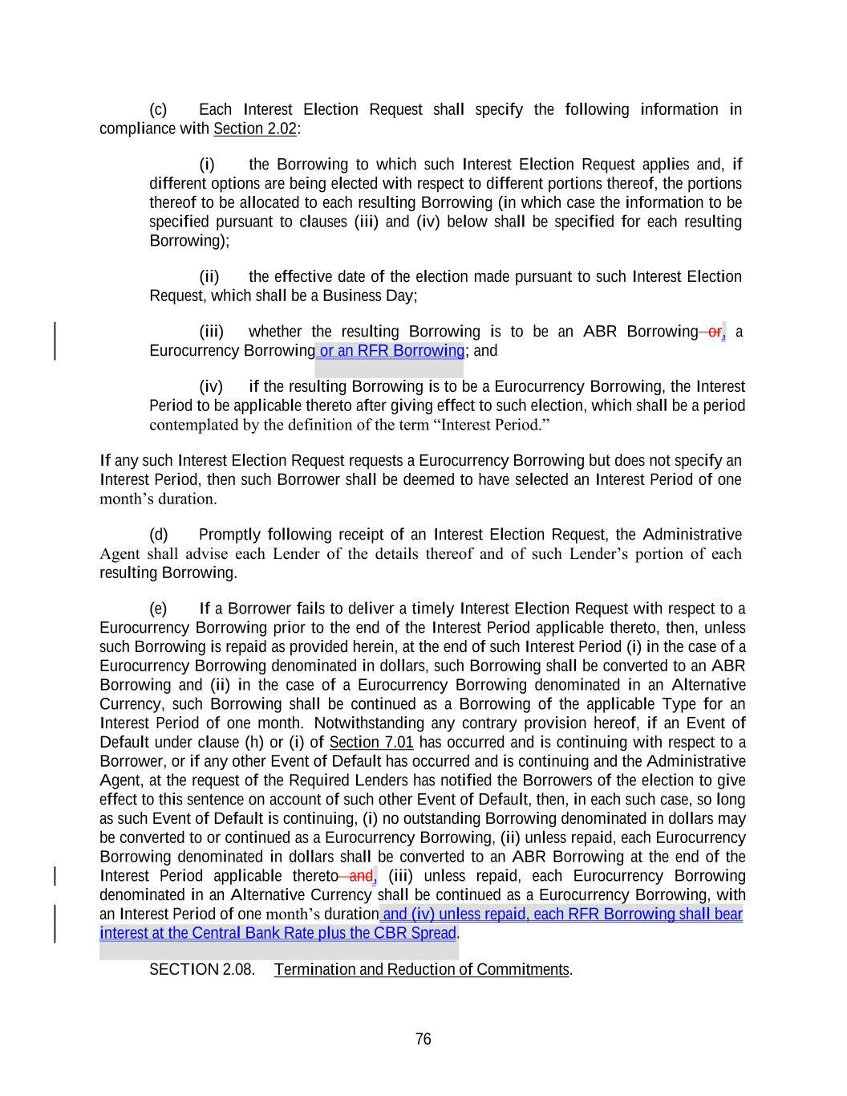
76 interest at the Central Bank Rate plus the CBR Spread. (c) Each Interest Election Request shall specify the following information in compliance with Section 2.02: (i) the Borrowing to which such Interest Election Request applies and, if different options are being elected with respect to different portions thereof, the portions thereof to be allocated to each resulting Borrowing (in which case the information to be specified pursuant to clauses (iii) and (iv) below shall be specified for each resulting Borrowing); (ii) the effective date of the election made pursuant to such Interest Election Request, which shall be a Business Day; (iii) whether the resulting Borrowing is to be an ABR Borrowing or, a Eurocurrency Borrowing or an RFR Borrowing; and (iv) if the resulting Borrowing is to be a Eurocurrency Borrowing, the Interest Period to be applicable thereto after giving effect to such election, which shall be a period contemplated by the definition of the term “Interest Period.” If any such Interest Election Request requests a Eurocurrency Borrowing but does not specify an Interest Period, then such Borrower shall be deemed to have selected an Interest Period of one month’s duration. (d) Promptly following receipt of an Interest Election Request, the Administrative Agent shall advise each Lender of the details thereof and of such Lender’s portion of each resulting Borrowing. (e) If a Borrower fails to deliver a timely Interest Election Request with respect to a Eurocurrency Borrowing prior to the end of the Interest Period applicable thereto, then, unless such Borrowing is repaid as provided herein, at the end of such Interest Period (i) in the case of a Eurocurrency Borrowing denominated in dollars, such Borrowing shall be converted to an ABR Borrowing and (ii) in the case of a Eurocurrency Borrowing denominated in an Alternative Currency, such Borrowing shall be continued as a Borrowing of the applicable Type for an Interest Period of one month. Notwithstanding any contrary provision hereof, if an Event of Default under clause (h) or (i) of Section 7.01 has occurred and is continuing with respect to a Borrower, or if any other Event of Default has occurred and is continuing and the Administrative Agent, at the request of the Required Lenders has notified the Borrowers of the election to give effect to this sentence on account of such other Event of Default, then, in each such case, so long as such Event of Default is continuing, (i) no outstanding Borrowing denominated in dollars may be converted to or continued as a Eurocurrency Borrowing, (ii) unless repaid, each Eurocurrency Borrowing denominated in dollars shall be converted to an ABR Borrowing at the end of the Interest Period applicable thereto and, (iii) unless repaid, each Eurocurrency Borrowing denominated in an Alternative Currency shall be continued as a Eurocurrency Borrowing, with an Interest Period of one month’s duration and (iv) unless repaid, each RFR Borrowing shall bear SECTION 2.08. Termination and Reduction of Commitments.

77 (a) Unless previously terminated, the Commitments shall automatically terminate on the Maturity Date. (b) The Company may at any time terminate, or from time to time permanently reduce, the Commitments; provided that (i) each partial reduction of the Commitments shall be in an amount that is an integral multiple of $1,000,000 and not less than $10,000,000 and (ii) the Company shall not terminate or reduce the Commitments if, after giving effect to any concurrent prepayment of the Revolving Loans in accordance with Section 2.11, the Total Revolving Exposure would exceed the Total Commitments. (c) The Company shall notify the Administrative Agent of any election to terminate or reduce the Commitments under paragraph (b) of this Section at least three Business Days prior to the effective date of such termination or reduction, specifying such election and the effective date thereof. Promptly following receipt of any such notice, the Administrative Agent shall advise the Lenders of the contents thereof. Each notice delivered by the Company pursuant to this Section shall be irrevocable; provided that a notice of termination or reduction of the Commitments delivered under this paragraph may state that such notice is conditioned upon the occurrence of one or more events specified therein, in which case such notice may be revoked by the Company (by notice to the Administrative Agent on or prior to the specified effective date) if such condition is not satisfied. Any termination or reduction of the Commitments shall be permanent. Each reduction of the Commitments shall be made ratably among the Lenders in accordance with their respective Commitments. SECTION 2.09. Repayment of Loans; Evidence of Debt. (a) Each Borrower hereby unconditionally promise to pay to the Administrative Agent for the account of each Revolving Lender the then unpaid principal amount of each Revolving Loan of such Revolving Lender on the Maturity Date. (b) The records maintained by the Administrative Agent and the Lenders shall be prima facie evidence of the existence and amounts of the obligations of each Borrower in respect of Loans, LC Disbursements, interest and fees due or accrued hereunder; provided that the failure of the Administrative Agent or any Lender to maintain such records or any error therein shall not in any manner affect the obligation of the Borrowers to pay any amounts due hereunder in accordance with the terms of this Agreement. (c) Any Lender may request that Loans made by it be evidenced by a Note. In such event, the applicable Borrower shall prepare, execute and deliver to such Lender a promissory note payable to such Lender in substantially the form of Exhibit J attached hereto (each, a “Note”). Thereafter, the Loans evidenced by such Note and interest thereon shall at all times (including after assignment pursuant to Section 9.04) be represented by a Note in such form payable to such payee and its registered assigns. SECTION 2.10. [Reserved]. SECTION 2.11. Prepayment of Loans.

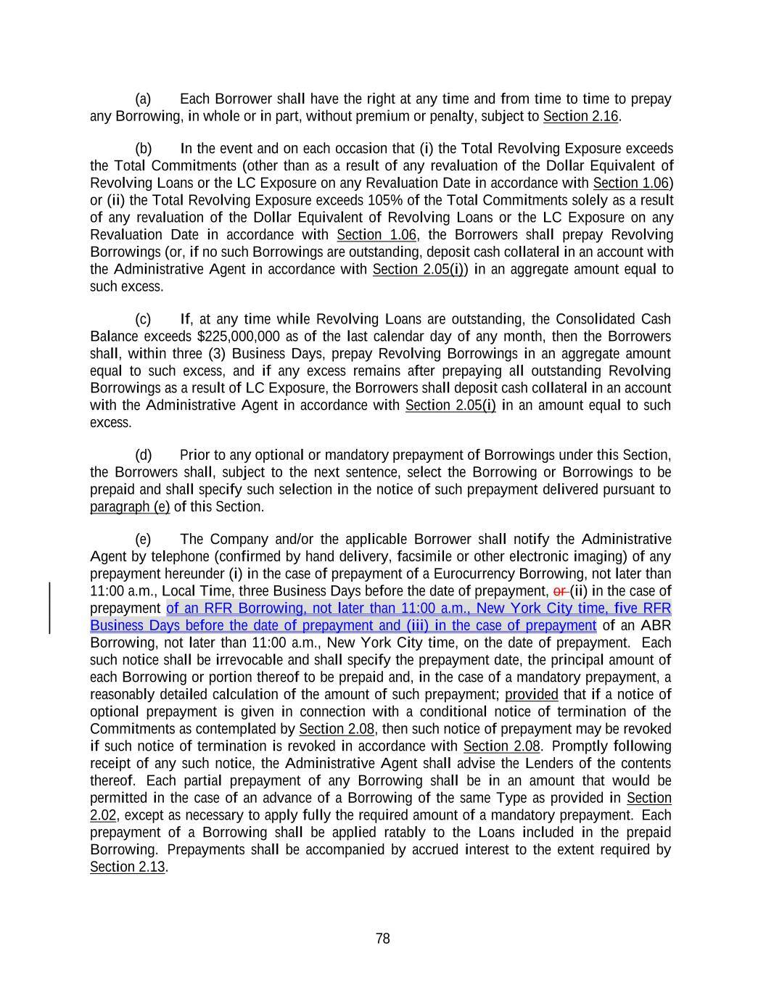
78 (a) Each Borrower shall have the right at any time and from time to time to prepay any Borrowing, in whole or in part, without premium or penalty, subject to Section 2.16. (b) In the event and on each occasion that (i) the Total Revolving Exposure exceeds the Total Commitments (other than as a result of any revaluation of the Dollar Equivalent of Revolving Loans or the LC Exposure on any Revaluation Date in accordance with Section 1.06) or (ii) the Total Revolving Exposure exceeds 105% of the Total Commitments solely as a result of any revaluation of the Dollar Equivalent of Revolving Loans or the LC Exposure on any Revaluation Date in accordance with Section 1.06, the Borrowers shall prepay Revolving Borrowings (or, if no such Borrowings are outstanding, deposit cash collateral in an account with the Administrative Agent in accordance with Section 2.05(i)) in an aggregate amount equal to such excess. (c) If, at any time while Revolving Loans are outstanding, the Consolidated Cash Balance exceeds $225,000,000 as of the last calendar day of any month, then the Borrowers shall, within three (3) Business Days, prepay Revolving Borrowings in an aggregate amount equal to such excess, and if any excess remains after prepaying all outstanding Revolving Borrowings as a result of LC Exposure, the Borrowers shall deposit cash collateral in an account with the Administrative Agent in accordance with Section 2.05(i) in an amount equal to such excess. (d) Prior to any optional or mandatory prepayment of Borrowings under this Section, the Borrowers shall, subject to the next sentence, select the Borrowing or Borrowings to be prepaid and shall specify such selection in the notice of such prepayment delivered pursuant to paragraph (e) of this Section. (e) The Company and/or the applicable Borrower shall notify the Administrative Agent by telephone (confirmed by hand delivery, facsimile or other electronic imaging) of any prepayment hereunder (i) in the case of prepayment of a Eurocurrency Borrowing, not later than 11:00 a.m., Local Time, three Business Days before the date of prepayment, or (ii) in the case of prepayment of an RFR Borrowing, not later than 11:00 a.m., New York City time, five RFR Business Days before the date of prepayment and (iii) in the case of prepayment of an ABR Borrowing, not later than 11:00 a.m., New York City time, on the date of prepayment. Each such notice shall be irrevocable and shall specify the prepayment date, the principal amount of each Borrowing or portion thereof to be prepaid and, in the case of a mandatory prepayment, a reasonably detailed calculation of the amount of such prepayment; provided that if a notice of optional prepayment is given in connection with a conditional notice of termination of the Commitments as contemplated by Section 2.08, then such notice of prepayment may be revoked if such notice of termination is revoked in accordance with Section 2.08. Promptly following receipt of any such notice, the Administrative Agent shall advise the Lenders of the contents thereof. Each partial prepayment of any Borrowing shall be in an amount that would be permitted in the case of an advance of a Borrowing of the same Type as provided in Section 2.02, except as necessary to apply fully the required amount of a mandatory prepayment. Each prepayment of a Borrowing shall be applied ratably to the Loans included in the prepaid Borrowing. Prepayments shall be accompanied by accrued interest to the extent required by Section 2.13.

79 SECTION 2.12. Fees. (a) The Borrowers agree to pay to the Administrative Agent for the account of each Revolving Lender for the period from and including the Effective Date to but excluding the date on which the Commitments terminate (or are otherwise reduced to zero), a commitment fee which shall accrue at the Applicable Rate on the average daily unused amount of the Commitment of such Revolving Lender. Such accrued commitment fees shall be payable in arrears on the last Business Day of March, June, September and December of each year and on the date on which all the Commitments terminate, commencing on the first such date to occur after the Effective Date. For purposes of computing commitment fees, a Commitment shall be deemed to be used to the extent of the outstanding Revolving Loans and LC Exposure of such Lender. (b) The Borrowers agree to pay (i) to the Administrative Agent for the account of each Revolving Lender a participation fee with respect to its participations in Letters of Credit, which shall accrue at the same Applicable Rate then used to determine the interest rate applicable to Eurocurrency Revolving Loans on the average daily amount of such Lender’s LC Exposure (excluding any portion thereof attributable to unreimbursed LC Disbursements) during the period from and including the Effective Date to but excluding the later of the date on which such Lender’s Commitment terminates and the date on which such Lender ceases to have any LC Exposure and (ii) to each Issuing Bank a fronting fee, which shall accrue at a rate per annum equal to 0.20% on the average daily amount of the LC Exposure attributable to Letters of Credit issued by such Issuing Bank (excluding any portion thereof attributable to unreimbursed LC Disbursements) during the period from and including the Effective Date to but excluding the later of the date of termination of all the Commitments and the date on which there ceases to be any such LC Exposure, as well as such Issuing Bank’s standard fees with respect to the issuance, amendment, renewal or extension of any Letter of Credit or processing of drawings thereunder. Participation fees and fronting fees accrued through and including the last day of March, June, September and December of each year shall be payable on the third Business Day following such last day, commencing on the first such date to occur after the Effective Date; provided that all such fees shall be payable on the date on which all the Commitments terminate and any such fees accruing after the date on which all the Commitments terminate shall be payable on demand. Any other fees payable to an Issuing Bank pursuant to this paragraph shall be payable within the time periods separately agreed by the applicable Borrower and such Issuing Bank. (c) The Borrowers agree to pay to the Administrative Agent, for its own account, fees payable in the amounts and at the times separately agreed upon between the Borrowers and the Administrative Agent. (d) All fees payable hereunder shall be paid on the dates due, in immediately available funds, to the Administrative Agent (or to the applicable Issuing Bank, in the case of fees payable to it) for distribution, in the case of commitment fees and participation fees, to the Revolving Lenders entitled thereto. Fees paid hereunder shall not be refundable under any circumstances.

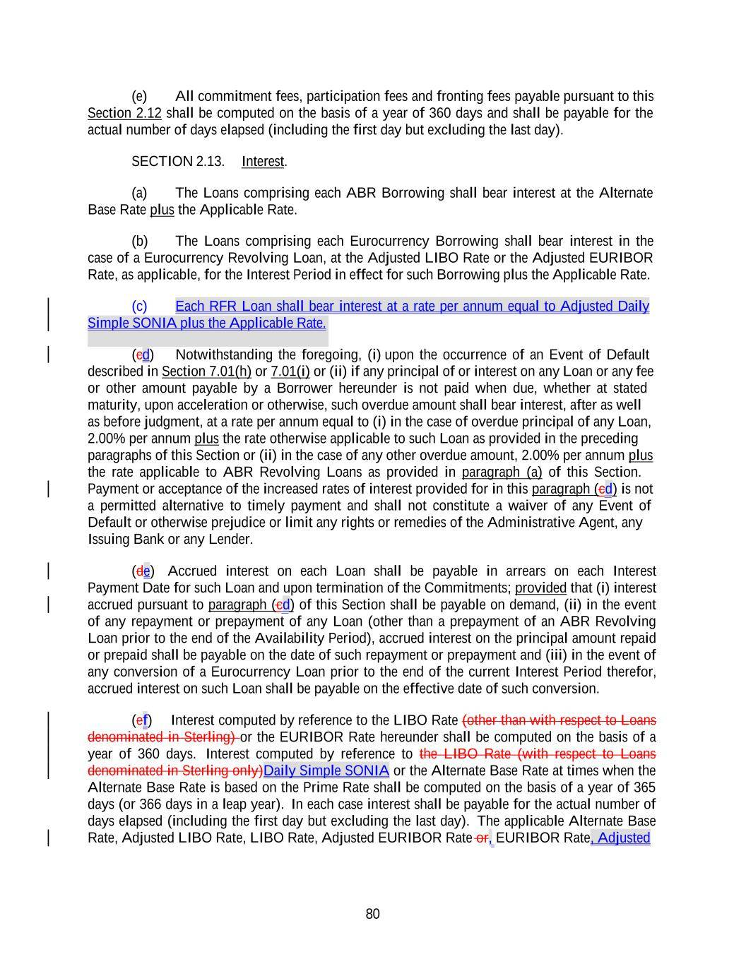
80 Simple SONIA plus the Applicable Rate. (e) All commitment fees, participation fees and fronting fees payable pursuant to this Section 2.12 shall be computed on the basis of a year of 360 days and shall be payable for the actual number of days elapsed (including the first day but excluding the last day). SECTION 2.13. Interest. (a) The Loans comprising each ABR Borrowing shall bear interest at the Alternate Base Rate plus the Applicable Rate. (b) The Loans comprising each Eurocurrency Borrowing shall bear interest in the case of a Eurocurrency Revolving Loan, at the Adjusted LIBO Rate or the Adjusted EURIBOR Rate, as applicable, for the Interest Period in effect for such Borrowing plus the Applicable Rate. (c) Each RFR Loan shall bear interest at a rate per annum equal to Adjusted Daily (cd) Notwithstanding the foregoing, (i) upon the occurrence of an Event of Default described in Section 7.01(h) or 7.01(i) or (ii) if any principal of or interest on any Loan or any fee or other amount payable by a Borrower hereunder is not paid when due, whether at stated maturity, upon acceleration or otherwise, such overdue amount shall bear interest, after as well as before judgment, at a rate per annum equal to (i) in the case of overdue principal of any Loan, 2.00% per annum plus the rate otherwise applicable to such Loan as provided in the preceding paragraphs of this Section or (ii) in the case of any other overdue amount, 2.00% per annum plus the rate applicable to ABR Revolving Loans as provided in paragraph (a) of this Section. Payment or acceptance of the increased rates of interest provided for in this paragraph (cd) is not a permitted alternative to timely payment and shall not constitute a waiver of any Event of Default or otherwise prejudice or limit any rights or remedies of the Administrative Agent, any Issuing Bank or any Lender. (de) Accrued interest on each Loan shall be payable in arrears on each Interest Payment Date for such Loan and upon termination of the Commitments; provided that (i) interest accrued pursuant to paragraph (cd) of this Section shall be payable on demand, (ii) in the event of any repayment or prepayment of any Loan (other than a prepayment of an ABR Revolving Loan prior to the end of the Availability Period), accrued interest on the principal amount repaid or prepaid shall be payable on the date of such repayment or prepayment and (iii) in the event of any conversion of a Eurocurrency Loan prior to the end of the current Interest Period therefor, accrued interest on such Loan shall be payable on the effective date of such conversion. (ef) Interest computed by reference to the LIBO Rate (other than with respect to Loans denominated in Sterling) or the EURIBOR Rate hereunder shall be computed on the basis of a year of 360 days. Interest computed by reference to the LIBO Rate (with respect to Loans denominated in Sterling only)Daily Simple SONIA or the Alternate Base Rate at times when the Alternate Base Rate is based on the Prime Rate shall be computed on the basis of a year of 365 days (or 366 days in a leap year). In each case interest shall be payable for the actual number of days elapsed (including the first day but excluding the last day). The applicable Alternate Base Rate, Adjusted LIBO Rate, LIBO Rate, Adjusted EURIBOR Rate or, EURIBOR Rate, Adjusted

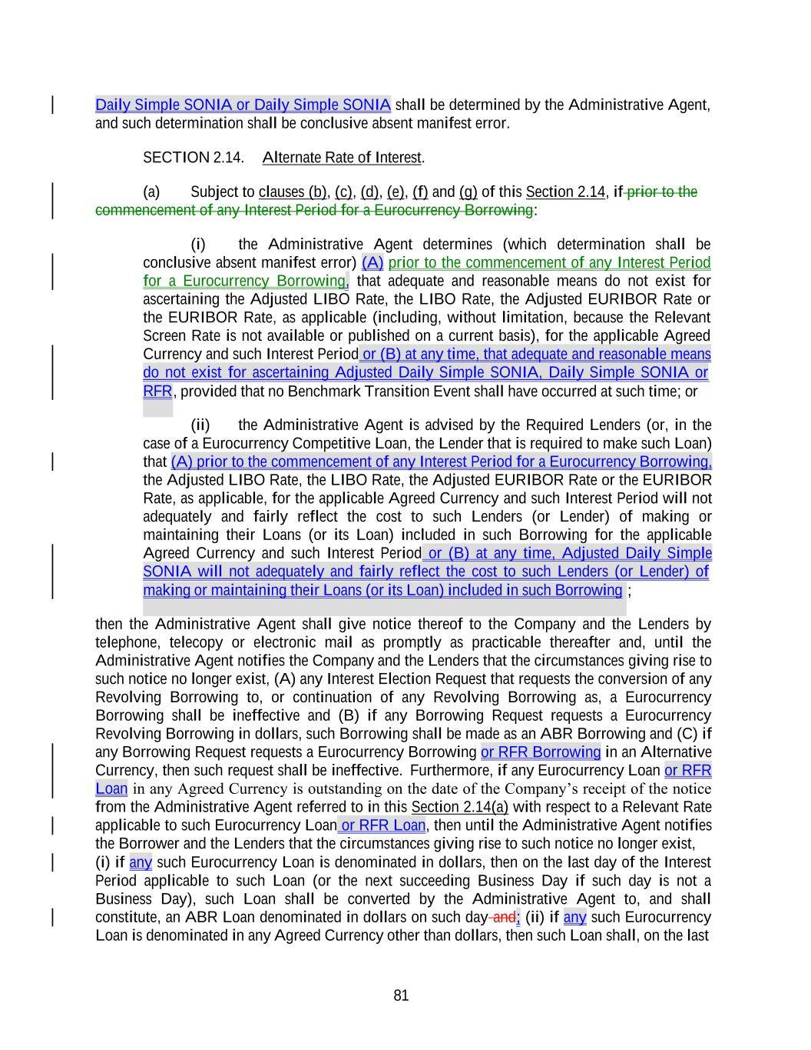
81 Daily Simple SONIA or Daily Simple SONIA shall be determined by the Administrative Agent, and such determination shall be conclusive absent manifest error. SECTION 2.14. Alternate Rate of Interest. (a) Subject to clauses (b), (c), (d), (e), (f) and (g) of this Section 2.14, if prior to the commencement of any Interest Period for a Eurocurrency Borrowing: (i) the Administrative Agent determines (which determination shall be conclusive absent manifest error) (A) prior to the commencement of any Interest Period for a Eurocurrency Borrowing, that adequate and reasonable means do not exist for ascertaining the Adjusted LIBO Rate, the LIBO Rate, the Adjusted EURIBOR Rate or the EURIBOR Rate, as applicable (including, without limitation, because the Relevant Screen Rate is not available or published on a current basis), for the applicable Agreed Currency and such Interest Period or (B) at any time, that adequate and reasonable means do not exist for ascertaining Adjusted Daily Simple SONIA, Daily Simple SONIA or , provided that no Benchmark Transition Event shall have occurred at such time; or (ii) the Administrative Agent is advised by the Required Lenders (or, in the case of a Eurocurrency Competitive Loan, the Lender that is required to make such Loan) that (A) prior to the commencement of any Interest Period for a Eurocurrency Borrowing, the Adjusted LIBO Rate, the LIBO Rate, the Adjusted EURIBOR Rate or the EURIBOR Rate, as applicable, for the applicable Agreed Currency and such Interest Period will not adequately and fairly reflect the cost to such Lenders (or Lender) of making or maintaining their Loans (or its Loan) included in such Borrowing for the applicable Agreed Currency and such Interest Period or (B) at any time, Adjusted Daily Simple SONIA will not adequately and fairly reflect the cost to such Lenders (or Lender) of ; then the Administrative Agent shall give notice thereof to the Company and the Lenders by telephone, telecopy or electronic mail as promptly as practicable thereafter and, until the Administrative Agent notifies the Company and the Lenders that the circumstances giving rise to such notice no longer exist, (A) any Interest Election Request that requests the conversion of any Revolving Borrowing to, or continuation of any Revolving Borrowing as, a Eurocurrency Borrowing shall be ineffective and (B) if any Borrowing Request requests a Eurocurrency Revolving Borrowing in dollars, such Borrowing shall be made as an ABR Borrowing and (C) if any Borrowing Request requests a Eurocurrency Borrowing or RFR Borrowing in an Alternative Currency, then such request shall be ineffective. Furthermore, if any Eurocurrency Loan or RFR Loan in any Agreed Currency is outstanding on the date of the Company’s receipt of the notice from the Administrative Agent referred to in this Section 2.14(a) with respect to a Relevant Rate applicable to such Eurocurrency Loan or RFR Loan, then until the Administrative Agent notifies the Borrower and the Lenders that the circumstances giving rise to such notice no longer exist, (i) if any such Eurocurrency Loan is denominated in dollars, then on the last day of the Interest Period applicable to such Loan (or the next succeeding Business Day if such day is not a Business Day), such Loan shall be converted by the Administrative Agent to, and shall constitute, an ABR Loan denominated in dollars on such day and; (ii) if any such Eurocurrency Loan is denominated in any Agreed Currency other than dollars, then such Loan shall, on the last making or maintaining their Loans (or its Loan) included in such Borrowing RFR

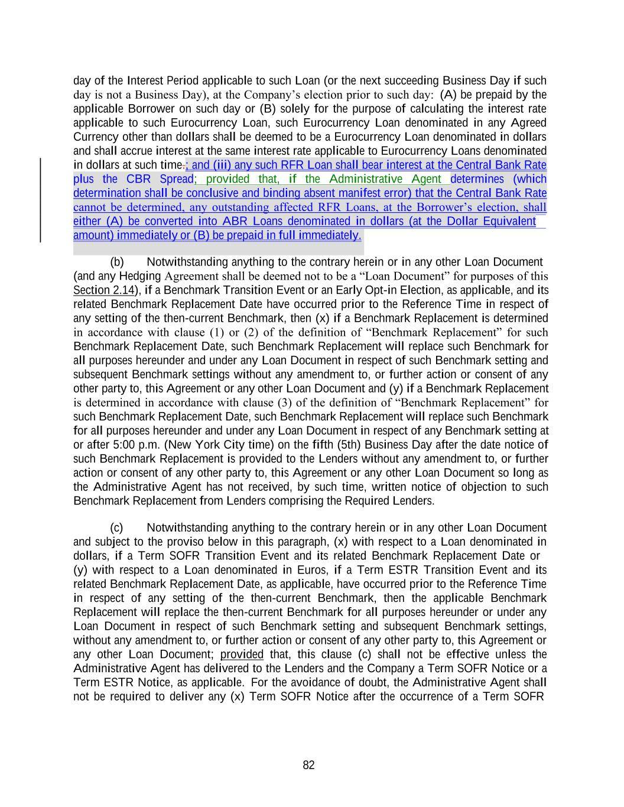
82 amount) immediately or (B) be prepaid in full immediately. day of the Interest Period applicable to such Loan (or the next succeeding Business Day if such day is not a Business Day), at the Company’s election prior to such day: (A) be prepaid by the applicable Borrower on such day or (B) solely for the purpose of calculating the interest rate applicable to such Eurocurrency Loan, such Eurocurrency Loan denominated in any Agreed Currency other than dollars shall be deemed to be a Eurocurrency Loan denominated in dollars and shall accrue interest at the same interest rate applicable to Eurocurrency Loans denominated in dollars at such time.; and (iii) any such RFR Loan shall bear interest at the Central Bank Rate plus the CBR Spread; provided that, if the Administrative Agent determines (which determination shall be conclusive and binding absent manifest error) that the Central Bank Rate cannot be determined, any outstanding affected RFR Loans, at the Borrower’s election, shall either (A) be converted into ABR Loans denominated in dollars (at the Dollar Equivalent (b) Notwithstanding anything to the contrary herein or in any other Loan Document (and any Hedging Agreement shall be deemed not to be a “Loan Document” for purposes of this Section 2.14), if a Benchmark Transition Event or an Early Opt-in Election, as applicable, and its related Benchmark Replacement Date have occurred prior to the Reference Time in respect of any setting of the then-current Benchmark, then (x) if a Benchmark Replacement is determined in accordance with clause (1) or (2) of the definition of “Benchmark Replacement” for such Benchmark Replacement Date, such Benchmark Replacement will replace such Benchmark for all purposes hereunder and under any Loan Document in respect of such Benchmark setting and subsequent Benchmark settings without any amendment to, or further action or consent of any other party to, this Agreement or any other Loan Document and (y) if a Benchmark Replacement is determined in accordance with clause (3) of the definition of “Benchmark Replacement” for such Benchmark Replacement Date, such Benchmark Replacement will replace such Benchmark for all purposes hereunder and under any Loan Document in respect of any Benchmark setting at or after 5:00 p.m. (New York City time) on the fifth (5th) Business Day after the date notice of such Benchmark Replacement is provided to the Lenders without any amendment to, or further action or consent of any other party to, this Agreement or any other Loan Document so long as the Administrative Agent has not received, by such time, written notice of objection to such Benchmark Replacement from Lenders comprising the Required Lenders. (c) Notwithstanding anything to the contrary herein or in any other Loan Document and subject to the proviso below in this paragraph, (x) with respect to a Loan denominated in dollars, if a Term SOFR Transition Event and its related Benchmark Replacement Date or (y) with respect to a Loan denominated in Euros, if a Term ESTR Transition Event and its related Benchmark Replacement Date, as applicable, have occurred prior to the Reference Time in respect of any setting of the then-current Benchmark, then the applicable Benchmark Replacement will replace the then-current Benchmark for all purposes hereunder or under any Loan Document in respect of such Benchmark setting and subsequent Benchmark settings, without any amendment to, or further action or consent of any other party to, this Agreement or any other Loan Document; provided that, this clause (c) shall not be effective unless the Administrative Agent has delivered to the Lenders and the Company a Term SOFR Notice or a Term ESTR Notice, as applicable. For the avoidance of doubt, the Administrative Agent shall not be required to deliver any (x) Term SOFR Notice after the occurrence of a Term SOFR

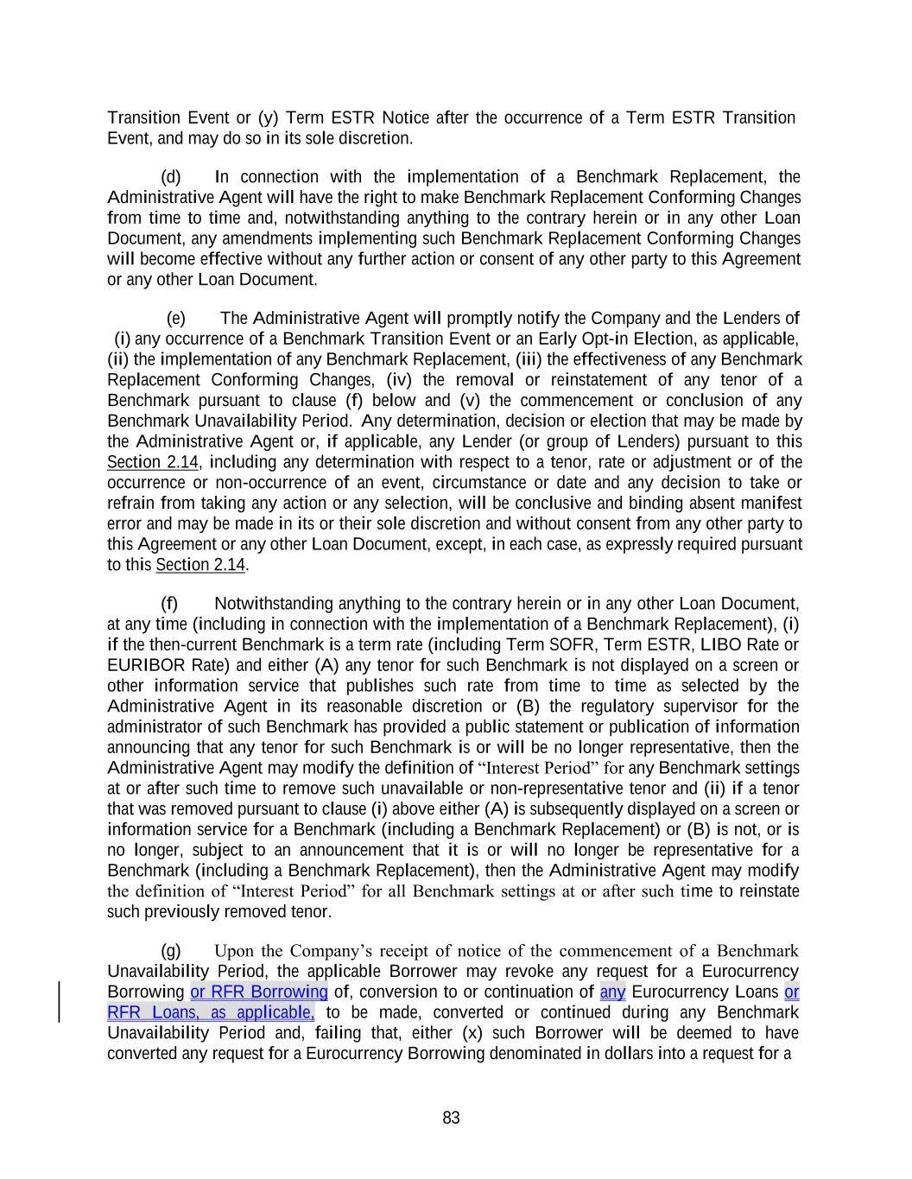
83 Transition Event or (y) Term ESTR Notice after the occurrence of a Term ESTR Transition Event, and may do so in its sole discretion. (d) In connection with the implementation of a Benchmark Replacement, the Administrative Agent will have the right to make Benchmark Replacement Conforming Changes from time to time and, notwithstanding anything to the contrary herein or in any other Loan Document, any amendments implementing such Benchmark Replacement Conforming Changes will become effective without any further action or consent of any other party to this Agreement or any other Loan Document. (e) The Administrative Agent will promptly notify the Company and the Lenders of (i) any occurrence of a Benchmark Transition Event or an Early Opt-in Election, as applicable, (ii) the implementation of any Benchmark Replacement, (iii) the effectiveness of any Benchmark Replacement Conforming Changes, (iv) the removal or reinstatement of any tenor of a Benchmark pursuant to clause (f) below and (v) the commencement or conclusion of any Benchmark Unavailability Period. Any determination, decision or election that may be made by the Administrative Agent or, if applicable, any Lender (or group of Lenders) pursuant to this Section 2.14, including any determination with respect to a tenor, rate or adjustment or of the occurrence or non-occurrence of an event, circumstance or date and any decision to take or refrain from taking any action or any selection, will be conclusive and binding absent manifest error and may be made in its or their sole discretion and without consent from any other party to this Agreement or any other Loan Document, except, in each case, as expressly required pursuant to this Section 2.14. (f) Notwithstanding anything to the contrary herein or in any other Loan Document, at any time (including in connection with the implementation of a Benchmark Replacement), (i) if the then-current Benchmark is a term rate (including Term SOFR, Term ESTR, LIBO Rate or EURIBOR Rate) and either (A) any tenor for such Benchmark is not displayed on a screen or other information service that publishes such rate from time to time as selected by the Administrative Agent in its reasonable discretion or (B) the regulatory supervisor for the administrator of such Benchmark has provided a public statement or publication of information announcing that any tenor for such Benchmark is or will be no longer representative, then the Administrative Agent may modify the definition of “Interest Period” for any Benchmark settings at or after such time to remove such unavailable or non-representative tenor and (ii) if a tenor that was removed pursuant to clause (i) above either (A) is subsequently displayed on a screen or information service for a Benchmark (including a Benchmark Replacement) or (B) is not, or is no longer, subject to an announcement that it is or will no longer be representative for a Benchmark (including a Benchmark Replacement), then the Administrative Agent may modify the definition of “Interest Period” for all Benchmark settings at or after such time to reinstate such previously removed tenor. (g) Upon the Company’s receipt of notice of the commencement of a Benchmark Unavailability Period, the applicable Borrower may revoke any request for a Eurocurrency Borrowing or RFR Borrowing of, conversion to or continuation of any Eurocurrency Loans or RFR Loans, as applicable, to be made, converted or continued during any Benchmark Unavailability Period and, failing that, either (x) such Borrower will be deemed to have converted any request for a Eurocurrency Borrowing denominated in dollars into a request for a

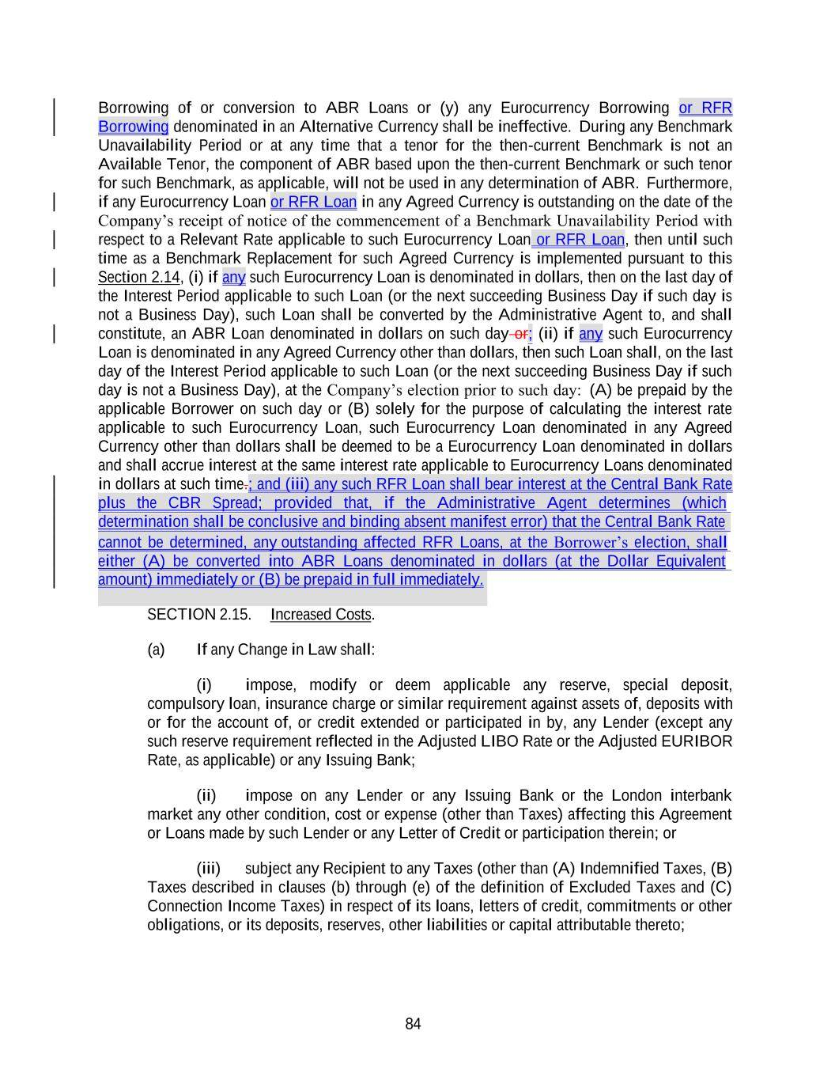
84 determination shall be conclusive and binding absent manifest error) that the Central Bank Rate Borrowing of or conversion to ABR Loans or (y) any Eurocurrency Borrowing or RFR Borrowing denominated in an Alternative Currency shall be ineffective. During any Benchmark Unavailability Period or at any time that a tenor for the then-current Benchmark is not an Available Tenor, the component of ABR based upon the then-current Benchmark or such tenor for such Benchmark, as applicable, will not be used in any determination of ABR. Furthermore, if any Eurocurrency Loan or RFR Loan in any Agreed Currency is outstanding on the date of the Company’s receipt of notice of the commencement of a Benchmark Unavailability Period with respect to a Relevant Rate applicable to such Eurocurrency Loan or RFR Loan, then until such time as a Benchmark Replacement for such Agreed Currency is implemented pursuant to this Section 2.14, (i) if any such Eurocurrency Loan is denominated in dollars, then on the last day of the Interest Period applicable to such Loan (or the next succeeding Business Day if such day is not a Business Day), such Loan shall be converted by the Administrative Agent to, and shall constitute, an ABR Loan denominated in dollars on such day or; (ii) if any such Eurocurrency Loan is denominated in any Agreed Currency other than dollars, then such Loan shall, on the last day of the Interest Period applicable to such Loan (or the next succeeding Business Day if such day is not a Business Day), at the Company’s election prior to such day: (A) be prepaid by the applicable Borrower on such day or (B) solely for the purpose of calculating the interest rate applicable to such Eurocurrency Loan, such Eurocurrency Loan denominated in any Agreed Currency other than dollars shall be deemed to be a Eurocurrency Loan denominated in dollars and shall accrue interest at the same interest rate applicable to Eurocurrency Loans denominated in dollars at such time.; and (iii) any such RFR Loan shall bear interest at the Central Bank Rate plus the CBR Spread; provided that, if the Administrative Agent determines (which cannot be determined, any outstanding affected RFR Loans, at the Borrower’s election, shall either (A) be converted into ABR Loans denominated in dollars (at the Dollar Equivalent SECTION 2.15. Increased Costs. (a) If any Change in Law shall: (i) impose, modify or deem applicable any reserve, special deposit, compulsory loan, insurance charge or similar requirement against assets of, deposits with or for the account of, or credit extended or participated in by, any Lender (except any such reserve requirement reflected in the Adjusted LIBO Rate or the Adjusted EURIBOR Rate, as applicable) or any Issuing Bank; (ii) impose on any Lender or any Issuing Bank or the London interbank market any other condition, cost or expense (other than Taxes) affecting this Agreement or Loans made by such Lender or any Letter of Credit or participation therein; or (iii) subject any Recipient to any Taxes (other than (A) Indemnified Taxes, (B) Taxes described in clauses (b) through (e) of the definition of Excluded Taxes and (C) Connection Income Taxes) in respect of its loans, letters of credit, commitments or other obligations, or its deposits, reserves, other liabilities or capital attributable thereto; amount) immediately or (B) be prepaid in full immediately.

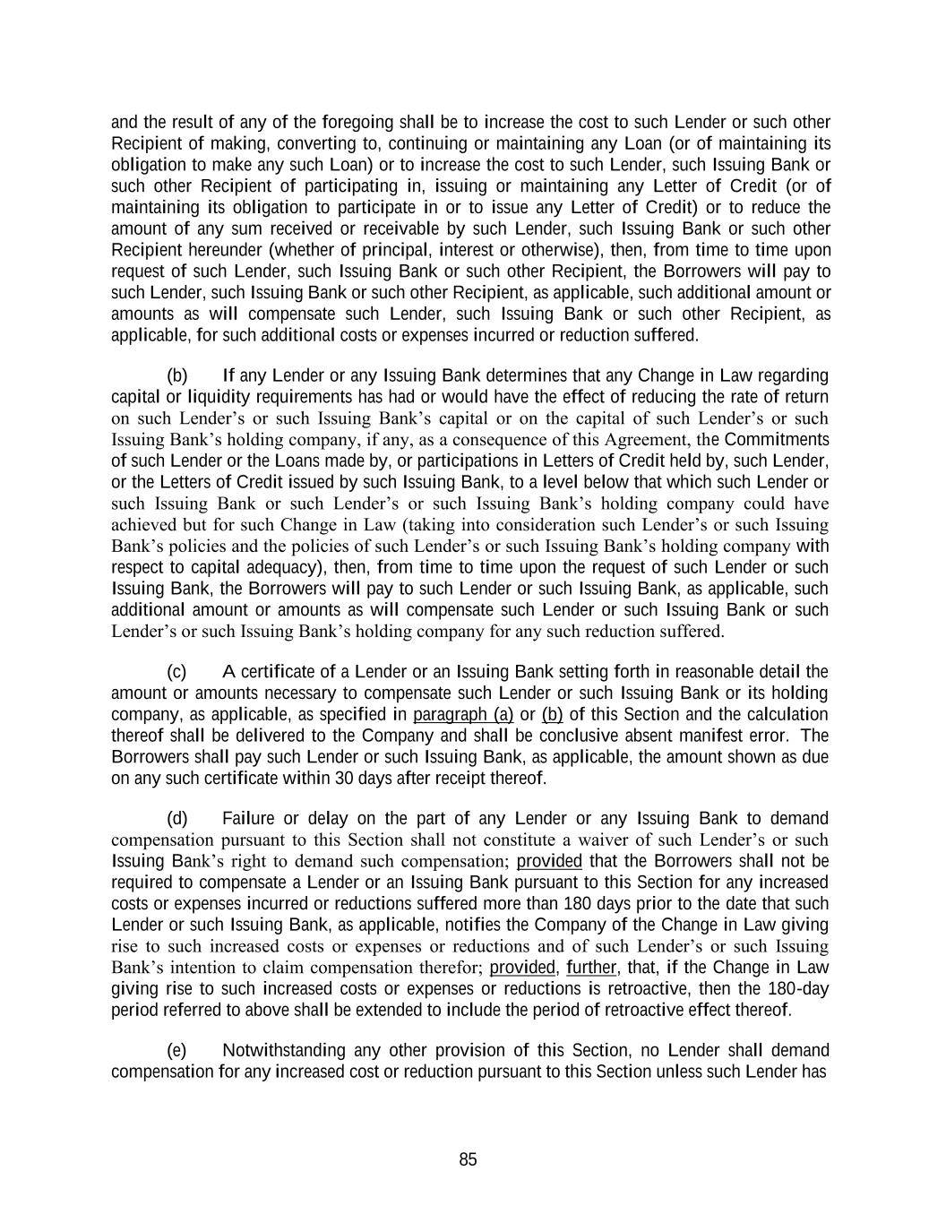
85 and the result of any of the foregoing shall be to increase the cost to such Lender or such other Recipient of making, converting to, continuing or maintaining any Loan (or of maintaining its obligation to make any such Loan) or to increase the cost to such Lender, such Issuing Bank or such other Recipient of participating in, issuing or maintaining any Letter of Credit (or of maintaining its obligation to participate in or to issue any Letter of Credit) or to reduce the amount of any sum received or receivable by such Lender, such Issuing Bank or such other Recipient hereunder (whether of principal, interest or otherwise), then, from time to time upon request of such Lender, such Issuing Bank or such other Recipient, the Borrowers will pay to such Lender, such Issuing Bank or such other Recipient, as applicable, such additional amount or amounts as will compensate such Lender, such Issuing Bank or such other Recipient, as applicable, for such additional costs or expenses incurred or reduction suffered. (b) If any Lender or any Issuing Bank determines that any Change in Law regarding capital or liquidity requirements has had or would have the effect of reducing the rate of return on such Lender’s or such Issuing Bank’s capital or on the capital of such Lender’s or such Issuing Bank’s holding company, if any, as a consequence of this Agreement, the Commitments of such Lender or the Loans made by, or participations in Letters of Credit held by, such Lender, or the Letters of Credit issued by such Issuing Bank, to a level below that which such Lender or such Issuing Bank or such Lender’s or such Issuing Bank’s holding company could have achieved but for such Change in Law (taking into consideration such Lender’s or such Issuing Bank’s policies and the policies of such Lender’s or such Issuing Bank’s holding company with respect to capital adequacy), then, from time to time upon the request of such Lender or such Issuing Bank, the Borrowers will pay to such Lender or such Issuing Bank, as applicable, such additional amount or amounts as will compensate such Lender or such Issuing Bank or such Lender’s or such Issuing Bank’s holding company for any such reduction suffered. (c) A certificate of a Lender or an Issuing Bank setting forth in reasonable detail the amount or amounts necessary to compensate such Lender or such Issuing Bank or its holding company, as applicable, as specified in paragraph (a) or (b) of this Section and the calculation thereof shall be delivered to the Company and shall be conclusive absent manifest error. The Borrowers shall pay such Lender or such Issuing Bank, as applicable, the amount shown as due on any such certificate within 30 days after receipt thereof. (d) Failure or delay on the part of any Lender or any Issuing Bank to demand compensation pursuant to this Section shall not constitute a waiver of such Lender’s or such Issuing Bank’s right to demand such compensation; provided that the Borrowers shall not be required to compensate a Lender or an Issuing Bank pursuant to this Section for any increased costs or expenses incurred or reductions suffered more than 180 days prior to the date that such Lender or such Issuing Bank, as applicable, notifies the Company of the Change in Law giving rise to such increased costs or expenses or reductions and of such Lender’s or such Issuing Bank’s intention to claim compensation therefor; provided, further, that, if the Change in Law giving rise to such increased costs or expenses or reductions is retroactive, then the 180-day period referred to above shall be extended to include the period of retroactive effect thereof. (e) Notwithstanding any other provision of this Section, no Lender shall demand compensation for any increased cost or reduction pursuant to this Section unless such Lender has

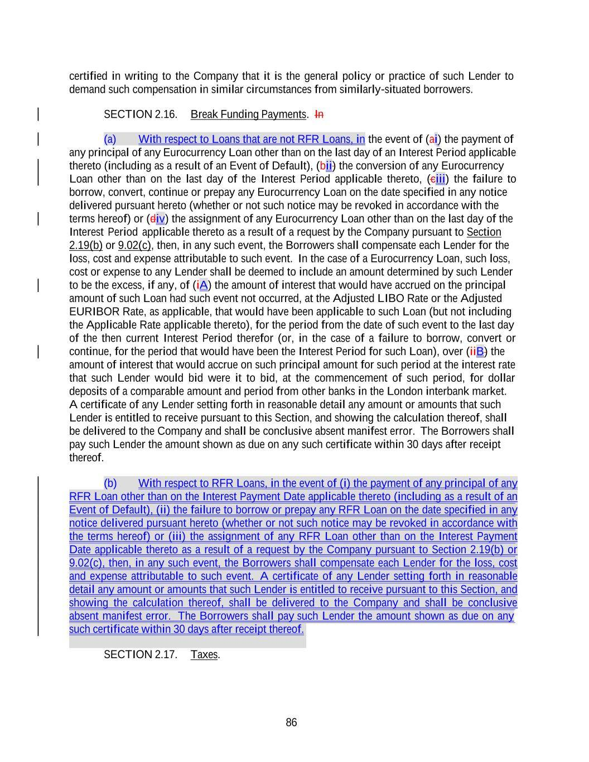
86 such certificate within 30 days after receipt thereof. certified in writing to the Company that it is the general policy or practice of such Lender to demand such compensation in similar circumstances from similarly-situated borrowers. SECTION 2.16. Break Funding Payments. In (a) With respect to Loans that are not RFR Loans, in the event of (ai) the payment of any principal of any Eurocurrency Loan other than on the last day of an Interest Period applicable thereto (including as a result of an Event of Default), (bii) the conversion of any Eurocurrency Loan other than on the last day of the Interest Period applicable thereto, (ciii) the failure to borrow, convert, continue or prepay any Eurocurrency Loan on the date specified in any notice delivered pursuant hereto (whether or not such notice may be revoked in accordance with the terms hereof) or (div) the assignment of any Eurocurrency Loan other than on the last day of the Interest Period applicable thereto as a result of a request by the Company pursuant to Section 2.19(b) or 9.02(c), then, in any such event, the Borrowers shall compensate each Lender for the loss, cost and expense attributable to such event. In the case of a Eurocurrency Loan, such loss, cost or expense to any Lender shall be deemed to include an amount determined by such Lender to be the excess, if any, of (iA) the amount of interest that would have accrued on the principal amount of such Loan had such event not occurred, at the Adjusted LIBO Rate or the Adjusted EURIBOR Rate, as applicable, that would have been applicable to such Loan (but not including the Applicable Rate applicable thereto), for the period from the date of such event to the last day of the then current Interest Period therefor (or, in the case of a failure to borrow, convert or continue, for the period that would have been the Interest Period for such Loan), over (iiB) the amount of interest that would accrue on such principal amount for such period at the interest rate that such Lender would bid were it to bid, at the commencement of such period, for dollar deposits of a comparable amount and period from other banks in the London interbank market. A certificate of any Lender setting forth in reasonable detail any amount or amounts that such Lender is entitled to receive pursuant to this Section, and showing the calculation thereof, shall be delivered to the Company and shall be conclusive absent manifest error. The Borrowers shall pay such Lender the amount shown as due on any such certificate within 30 days after receipt thereof. (b) With respect to RFR Loans, in the event of (i) the payment of any principal of any RFR Loan other than on the Interest Payment Date applicable thereto (including as a result of an Event of Default), (ii) the failure to borrow or prepay any RFR Loan on the date specified in any notice delivered pursuant hereto (whether or not such notice may be revoked in accordance with the terms hereof) or (iii) the assignment of any RFR Loan other than on the Interest Payment Date applicable thereto as a result of a request by the Company pursuant to Section 2.19(b) or 9.02(c), then, in any such event, the Borrowers shall compensate each Lender for the loss, cost and expense attributable to such event. A certificate of any Lender setting forth in reasonable detail any amount or amounts that such Lender is entitled to receive pursuant to this Section, and showing the calculation thereof, shall be delivered to the Company and shall be conclusive absent manifest error. The Borrowers shall pay such Lender the amount shown as due on any SECTION 2.17. Taxes.

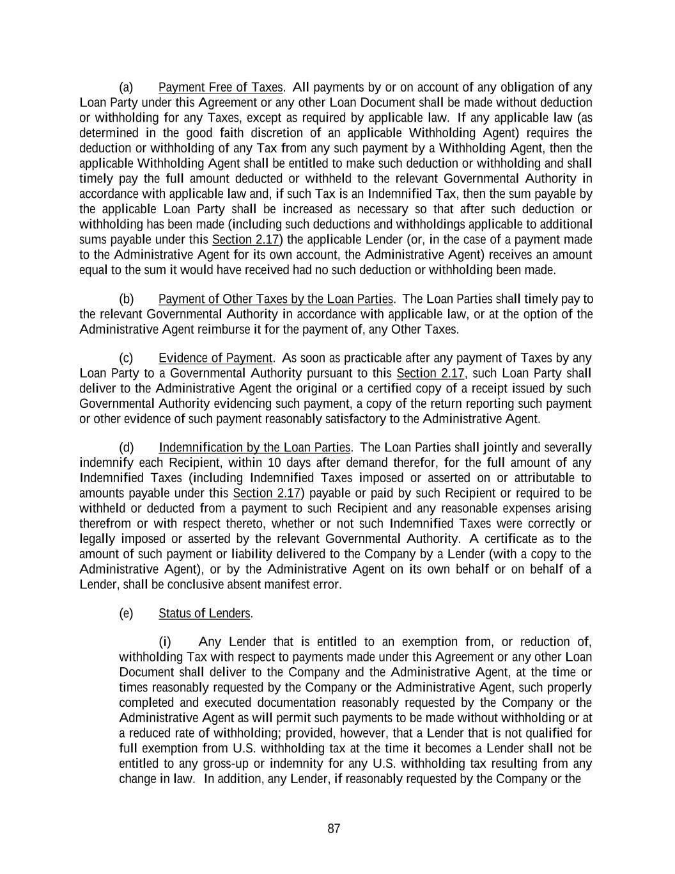
87 (a) Payment Free of Taxes. All payments by or on account of any obligation of any Loan Party under this Agreement or any other Loan Document shall be made without deduction or withholding for any Taxes, except as required by applicable law. If any applicable law (as determined in the good faith discretion of an applicable Withholding Agent) requires the deduction or withholding of any Tax from any such payment by a Withholding Agent, then the applicable Withholding Agent shall be entitled to make such deduction or withholding and shall timely pay the full amount deducted or withheld to the relevant Governmental Authority in accordance with applicable law and, if such Tax is an Indemnified Tax, then the sum payable by the applicable Loan Party shall be increased as necessary so that after such deduction or withholding has been made (including such deductions and withholdings applicable to additional sums payable under this Section 2.17) the applicable Lender (or, in the case of a payment made to the Administrative Agent for its own account, the Administrative Agent) receives an amount equal to the sum it would have received had no such deduction or withholding been made. (b) Payment of Other Taxes by the Loan Parties. The Loan Parties shall timely pay to the relevant Governmental Authority in accordance with applicable law, or at the option of the Administrative Agent reimburse it for the payment of, any Other Taxes. (c) Evidence of Payment. As soon as practicable after any payment of Taxes by any Loan Party to a Governmental Authority pursuant to this Section 2.17, such Loan Party shall deliver to the Administrative Agent the original or a certified copy of a receipt issued by such Governmental Authority evidencing such payment, a copy of the return reporting such payment or other evidence of such payment reasonably satisfactory to the Administrative Agent. (d) Indemnification by the Loan Parties. The Loan Parties shall jointly and severally indemnify each Recipient, within 10 days after demand therefor, for the full amount of any Indemnified Taxes (including Indemnified Taxes imposed or asserted on or attributable to amounts payable under this Section 2.17) payable or paid by such Recipient or required to be withheld or deducted from a payment to such Recipient and any reasonable expenses arising therefrom or with respect thereto, whether or not such Indemnified Taxes were correctly or legally imposed or asserted by the relevant Governmental Authority. A certificate as to the amount of such payment or liability delivered to the Company by a Lender (with a copy to the Administrative Agent), or by the Administrative Agent on its own behalf or on behalf of a Lender, shall be conclusive absent manifest error. (e) Status of Lenders. (i) Any Lender that is entitled to an exemption from, or reduction of, withholding Tax with respect to payments made under this Agreement or any other Loan Document shall deliver to the Company and the Administrative Agent, at the time or times reasonably requested by the Company or the Administrative Agent, such properly completed and executed documentation reasonably requested by the Company or the Administrative Agent as will permit such payments to be made without withholding or at a reduced rate of withholding; provided, however, that a Lender that is not qualified for full exemption from U.S. withholding tax at the time it becomes a Lender shall not be entitled to any gross-up or indemnity for any U.S. withholding tax resulting from any change in law. In addition, any Lender, if reasonably requested by the Company or the

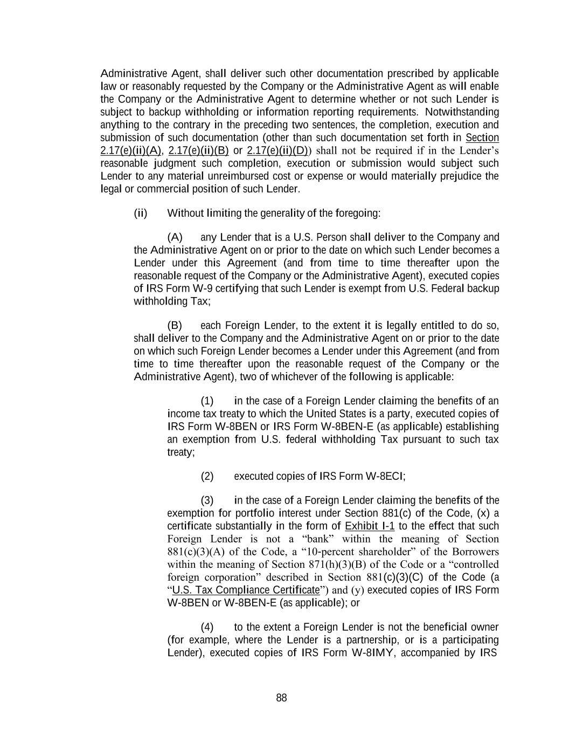
88 Administrative Agent, shall deliver such other documentation prescribed by applicable law or reasonably requested by the Company or the Administrative Agent as will enable the Company or the Administrative Agent to determine whether or not such Lender is subject to backup withholding or information reporting requirements. Notwithstanding anything to the contrary in the preceding two sentences, the completion, execution and submission of such documentation (other than such documentation set forth in Section 2.17(e)(ii)(A), 2.17(e)(ii)(B) or 2.17(e)(ii)(D)) shall not be required if in the Lender’s reasonable judgment such completion, execution or submission would subject such Lender to any material unreimbursed cost or expense or would materially prejudice the legal or commercial position of such Lender. (ii) Without limiting the generality of the foregoing: (A) any Lender that is a U.S. Person shall deliver to the Company and the Administrative Agent on or prior to the date on which such Lender becomes a Lender under this Agreement (and from time to time thereafter upon the reasonable request of the Company or the Administrative Agent), executed copies of IRS Form W-9 certifying that such Lender is exempt from U.S. Federal backup withholding Tax; (B) each Foreign Lender, to the extent it is legally entitled to do so, shall deliver to the Company and the Administrative Agent on or prior to the date on which such Foreign Lender becomes a Lender under this Agreement (and from time to time thereafter upon the reasonable request of the Company or the Administrative Agent), two of whichever of the following is applicable: (1) in the case of a Foreign Lender claiming the benefits of an income tax treaty to which the United States is a party, executed copies of IRS Form W-8BEN or IRS Form W-8BEN-E (as applicable) establishing an exemption from U.S. federal withholding Tax pursuant to such tax treaty; (2) executed copies of IRS Form W-8ECI; (3) in the case of a Foreign Lender claiming the benefits of the exemption for portfolio interest under Section 881(c) of the Code, (x) a certificate substantially in the form of Exhibit I-1 to the effect that such Foreign Lender is not a “bank” within the meaning of Section 881(c)(3)(A) of the Code, a “10-percent shareholder” of the Borrowers within the meaning of Section 871(h)(3)(B) of the Code or a “controlled foreign corporation” described in Section 881(c)(3)(C) of the Code (a “U.S. Tax Compliance Certificate”) and (y) executed copies of IRS Form W-8BEN or W-8BEN-E (as applicable); or (4) to the extent a Foreign Lender is not the beneficial owner (for example, where the Lender is a partnership, or is a participating Lender), executed copies of IRS Form W-8IMY, accompanied by IRS

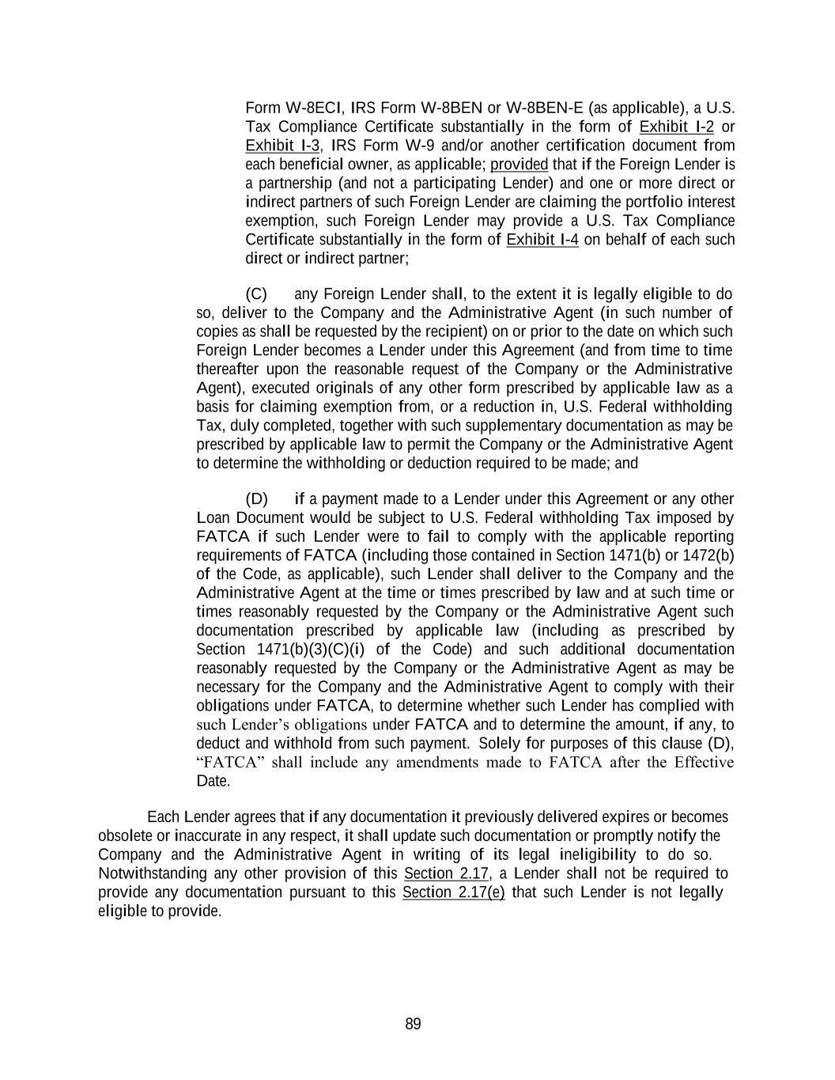
89 Form W-8ECI, IRS Form W-8BEN or W-8BEN-E (as applicable), a U.S. Tax Compliance Certificate substantially in the form of Exhibit I-2 or Exhibit I-3, IRS Form W-9 and/or another certification document from each beneficial owner, as applicable; provided that if the Foreign Lender is a partnership (and not a participating Lender) and one or more direct or indirect partners of such Foreign Lender are claiming the portfolio interest exemption, such Foreign Lender may provide a U.S. Tax Compliance Certificate substantially in the form of Exhibit I-4 on behalf of each such direct or indirect partner; (C) any Foreign Lender shall, to the extent it is legally eligible to do so, deliver to the Company and the Administrative Agent (in such number of copies as shall be requested by the recipient) on or prior to the date on which such Foreign Lender becomes a Lender under this Agreement (and from time to time thereafter upon the reasonable request of the Company or the Administrative Agent), executed originals of any other form prescribed by applicable law as a basis for claiming exemption from, or a reduction in, U.S. Federal withholding Tax, duly completed, together with such supplementary documentation as may be prescribed by applicable law to permit the Company or the Administrative Agent to determine the withholding or deduction required to be made; and (D) if a payment made to a Lender under this Agreement or any other Loan Document would be subject to U.S. Federal withholding Tax imposed by FATCA if such Lender were to fail to comply with the applicable reporting requirements of FATCA (including those contained in Section 1471(b) or 1472(b) of the Code, as applicable), such Lender shall deliver to the Company and the Administrative Agent at the time or times prescribed by law and at such time or times reasonably requested by the Company or the Administrative Agent such documentation prescribed by applicable law (including as prescribed by Section 1471(b)(3)(C)(i) of the Code) and such additional documentation reasonably requested by the Company or the Administrative Agent as may be necessary for the Company and the Administrative Agent to comply with their obligations under FATCA, to determine whether such Lender has complied with such Lender’s obligations under FATCA and to determine the amount, if any, to deduct and withhold from such payment. Solely for purposes of this clause (D), “FATCA” shall include any amendments made to FATCA after the Effective Date. Each Lender agrees that if any documentation it previously delivered expires or becomes obsolete or inaccurate in any respect, it shall update such documentation or promptly notify the Company and the Administrative Agent in writing of its legal ineligibility to do so. Notwithstanding any other provision of this Section 2.17, a Lender shall not be required to provide any documentation pursuant to this Section 2.17(e) that such Lender is not legally eligible to provide.

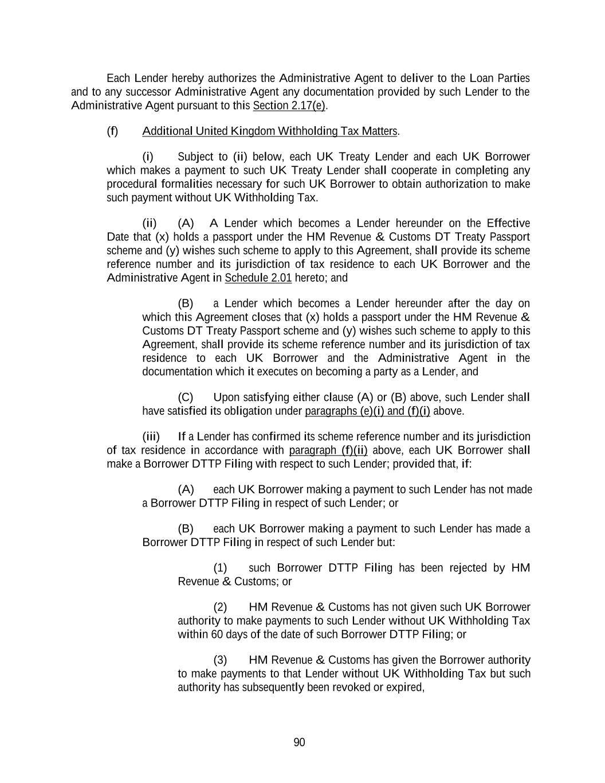
90 Each Lender hereby authorizes the Administrative Agent to deliver to the Loan Parties and to any successor Administrative Agent any documentation provided by such Lender to the Administrative Agent pursuant to this Section 2.17(e). (f) Additional United Kingdom Withholding Tax Matters. (i) Subject to (ii) below, each UK Treaty Lender and each UK Borrower which makes a payment to such UK Treaty Lender shall cooperate in completing any procedural formalities necessary for such UK Borrower to obtain authorization to make such payment without UK Withholding Tax. (ii) (A) A Lender which becomes a Lender hereunder on the Effective Date that (x) holds a passport under the HM Revenue & Customs DT Treaty Passport scheme and (y) wishes such scheme to apply to this Agreement, shall provide its scheme reference number and its jurisdiction of tax residence to each UK Borrower and the Administrative Agent in Schedule 2.01 hereto; and (B) a Lender which becomes a Lender hereunder after the day on which this Agreement closes that (x) holds a passport under the HM Revenue & Customs DT Treaty Passport scheme and (y) wishes such scheme to apply to this Agreement, shall provide its scheme reference number and its jurisdiction of tax residence to each UK Borrower and the Administrative Agent in the documentation which it executes on becoming a party as a Lender, and (C) Upon satisfying either clause (A) or (B) above, such Lender shall have satisfied its obligation under paragraphs (e)(i) and (f)(i) above. (iii) If a Lender has confirmed its scheme reference number and its jurisdiction of tax residence in accordance with paragraph (f)(ii) above, each UK Borrower shall make a Borrower DTTP Filing with respect to such Lender; provided that, if: (A) each UK Borrower making a payment to such Lender has not made a Borrower DTTP Filing in respect of such Lender; or (B) each UK Borrower making a payment to such Lender has made a Borrower DTTP Filing in respect of such Lender but: (1) such Borrower DTTP Filing has been rejected by HM Revenue & Customs; or (2) HM Revenue & Customs has not given such UK Borrower authority to make payments to such Lender without UK Withholding Tax within 60 days of the date of such Borrower DTTP Filing; or (3) HM Revenue & Customs has given the Borrower authority to make payments to that Lender without UK Withholding Tax but such authority has subsequently been revoked or expired,

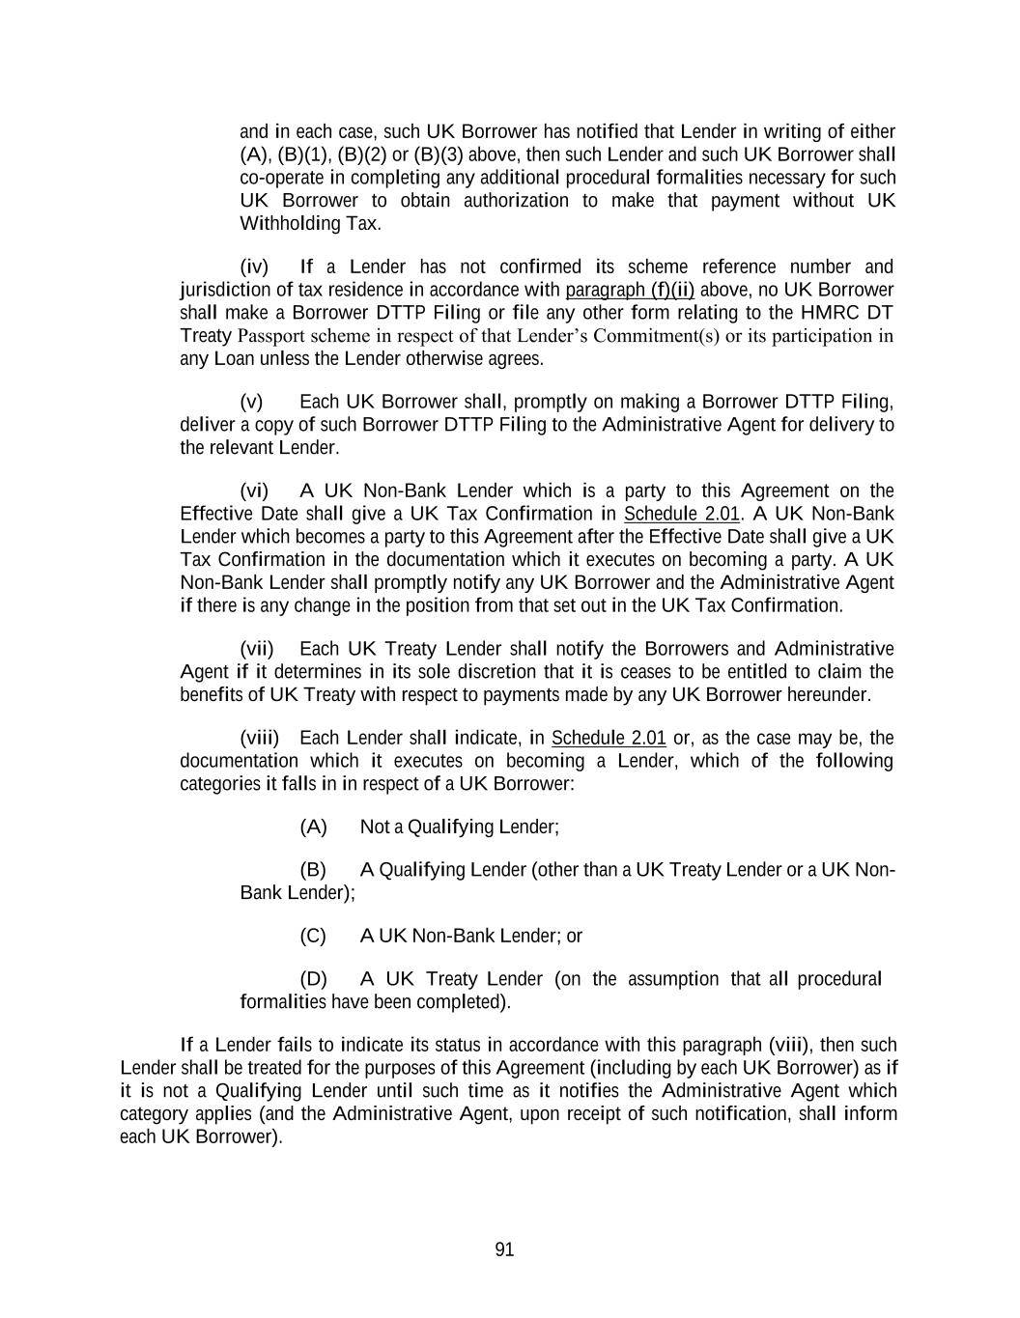
91 and in each case, such UK Borrower has notified that Lender in writing of either (A), (B)(1), (B)(2) or (B)(3) above, then such Lender and such UK Borrower shall co-operate in completing any additional procedural formalities necessary for such UK Borrower to obtain authorization to make that payment without UK Withholding Tax. (iv) If a Lender has not confirmed its scheme reference number and jurisdiction of tax residence in accordance with paragraph (f)(ii) above, no UK Borrower shall make a Borrower DTTP Filing or file any other form relating to the HMRC DT Treaty Passport scheme in respect of that Lender’s Commitment(s) or its participation in any Loan unless the Lender otherwise agrees. (v) Each UK Borrower shall, promptly on making a Borrower DTTP Filing, deliver a copy of such Borrower DTTP Filing to the Administrative Agent for delivery to the relevant Lender. (vi) A UK Non-Bank Lender which is a party to this Agreement on the Effective Date shall give a UK Tax Confirmation in Schedule 2.01. A UK Non-Bank Lender which becomes a party to this Agreement after the Effective Date shall give a UK Tax Confirmation in the documentation which it executes on becoming a party. A UK Non-Bank Lender shall promptly notify any UK Borrower and the Administrative Agent if there is any change in the position from that set out in the UK Tax Confirmation. (vii) Each UK Treaty Lender shall notify the Borrowers and Administrative Agent if it determines in its sole discretion that it is ceases to be entitled to claim the benefits of UK Treaty with respect to payments made by any UK Borrower hereunder. (viii) Each Lender shall indicate, in Schedule 2.01 or, as the case may be, the documentation which it executes on becoming a Lender, which of the following categories it falls in in respect of a UK Borrower: (A) Not a Qualifying Lender; (B) A Qualifying Lender (other than a UK Treaty Lender or a UK Non- Bank Lender); (C) A UK Non-Bank Lender; or (D) A UK Treaty Lender (on the assumption that all procedural formalities have been completed). If a Lender fails to indicate its status in accordance with this paragraph (viii), then such Lender shall be treated for the purposes of this Agreement (including by each UK Borrower) as if it is not a Qualifying Lender until such time as it notifies the Administrative Agent which category applies (and the Administrative Agent, upon receipt of such notification, shall inform each UK Borrower).

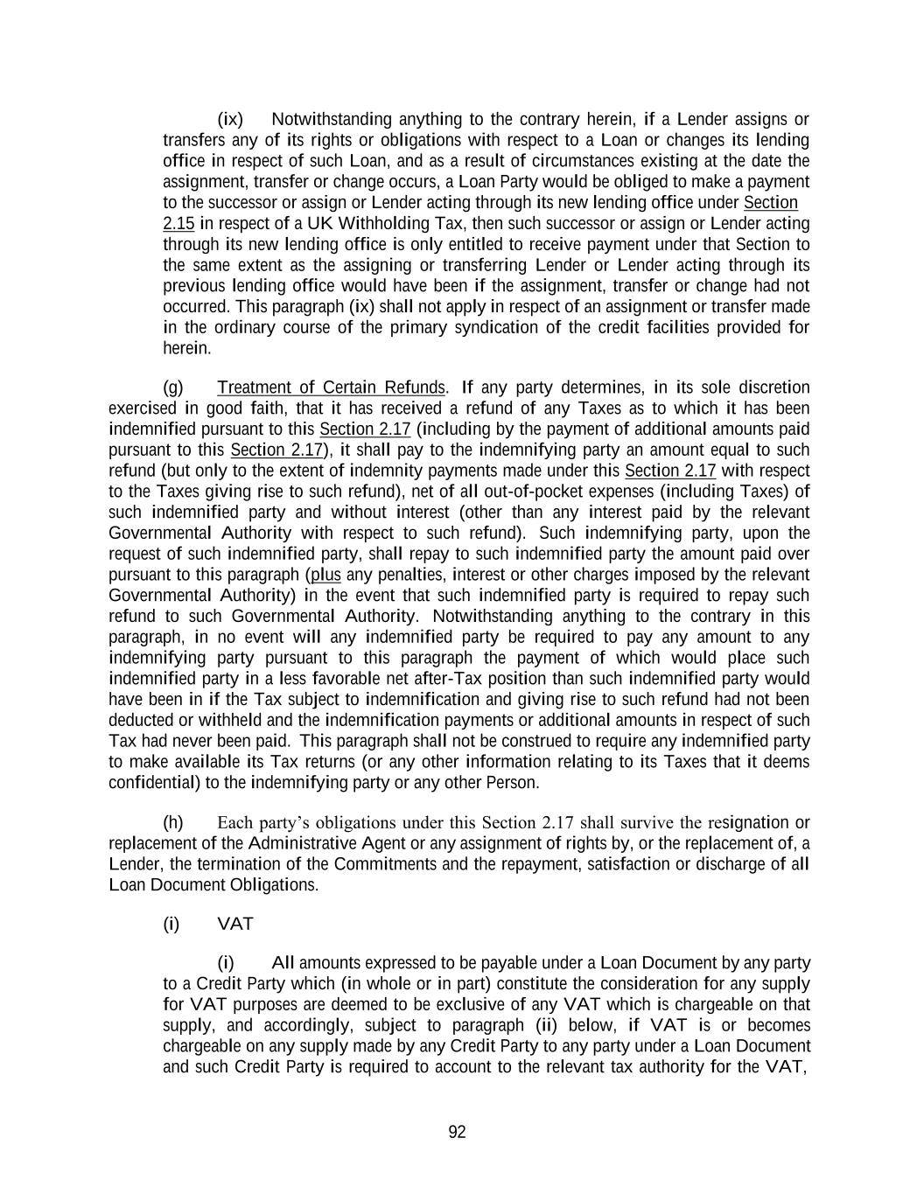
92 (ix) Notwithstanding anything to the contrary herein, if a Lender assigns or transfers any of its rights or obligations with respect to a Loan or changes its lending office in respect of such Loan, and as a result of circumstances existing at the date the assignment, transfer or change occurs, a Loan Party would be obliged to make a payment to the successor or assign or Lender acting through its new lending office under Section 2.15 in respect of a UK Withholding Tax, then such successor or assign or Lender acting through its new lending office is only entitled to receive payment under that Section to the same extent as the assigning or transferring Lender or Lender acting through its previous lending office would have been if the assignment, transfer or change had not occurred. This paragraph (ix) shall not apply in respect of an assignment or transfer made in the ordinary course of the primary syndication of the credit facilities provided for herein. (g) Treatment of Certain Refunds. If any party determines, in its sole discretion exercised in good faith, that it has received a refund of any Taxes as to which it has been indemnified pursuant to this Section 2.17 (including by the payment of additional amounts paid pursuant to this Section 2.17), it shall pay to the indemnifying party an amount equal to such refund (but only to the extent of indemnity payments made under this Section 2.17 with respect to the Taxes giving rise to such refund), net of all out-of-pocket expenses (including Taxes) of such indemnified party and without interest (other than any interest paid by the relevant Governmental Authority with respect to such refund). Such indemnifying party, upon the request of such indemnified party, shall repay to such indemnified party the amount paid over pursuant to this paragraph (plus any penalties, interest or other charges imposed by the relevant Governmental Authority) in the event that such indemnified party is required to repay such refund to such Governmental Authority. Notwithstanding anything to the contrary in this paragraph, in no event will any indemnified party be required to pay any amount to any indemnifying party pursuant to this paragraph the payment of which would place such indemnified party in a less favorable net after-Tax position than such indemnified party would have been in if the Tax subject to indemnification and giving rise to such refund had not been deducted or withheld and the indemnification payments or additional amounts in respect of such Tax had never been paid. This paragraph shall not be construed to require any indemnified party to make available its Tax returns (or any other information relating to its Taxes that it deems confidential) to the indemnifying party or any other Person. (h) Each party’s obligations under this Section 2.17 shall survive the resignation or replacement of the Administrative Agent or any assignment of rights by, or the replacement of, a Lender, the termination of the Commitments and the repayment, satisfaction or discharge of all Loan Document Obligations. (i) VAT (i) All amounts expressed to be payable under a Loan Document by any party to a Credit Party which (in whole or in part) constitute the consideration for any supply for VAT purposes are deemed to be exclusive of any VAT which is chargeable on that supply, and accordingly, subject to paragraph (ii) below, if VAT is or becomes chargeable on any supply made by any Credit Party to any party under a Loan Document and such Credit Party is required to account to the relevant tax authority for the VAT,

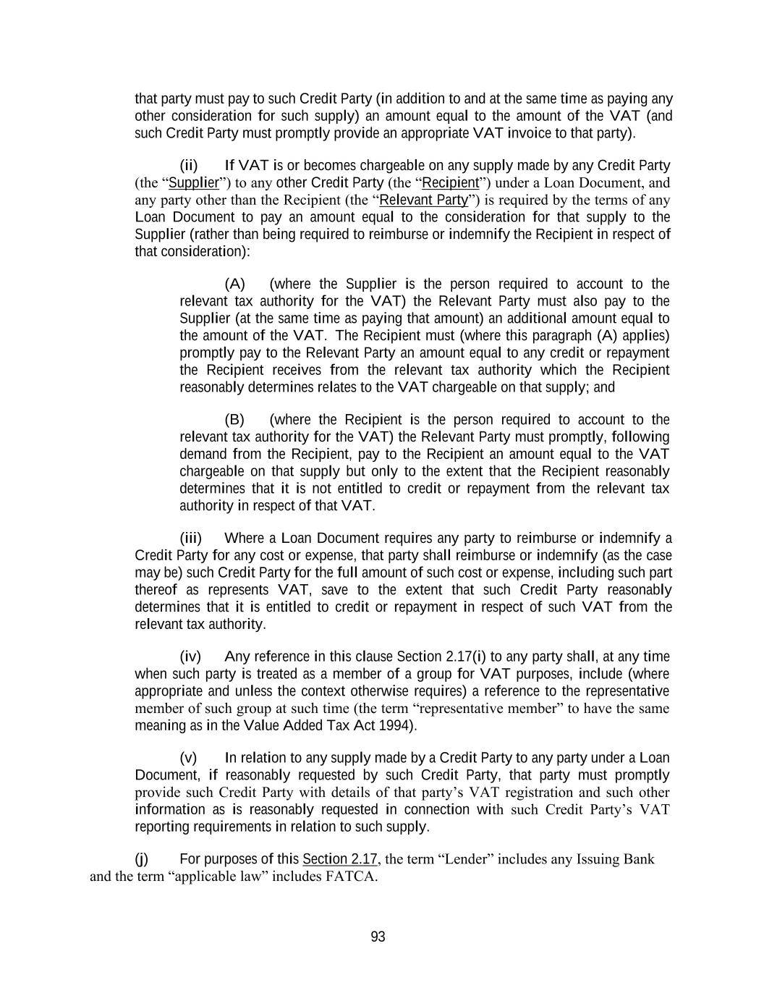
93 that party must pay to such Credit Party (in addition to and at the same time as paying any other consideration for such supply) an amount equal to the amount of the VAT (and such Credit Party must promptly provide an appropriate VAT invoice to that party). (ii) If VAT is or becomes chargeable on any supply made by any Credit Party (the “Supplier”) to any other Credit Party (the “Recipient”) under a Loan Document, and any party other than the Recipient (the “Relevant Party”) is required by the terms of any Loan Document to pay an amount equal to the consideration for that supply to the Supplier (rather than being required to reimburse or indemnify the Recipient in respect of that consideration): (A) (where the Supplier is the person required to account to the relevant tax authority for the VAT) the Relevant Party must also pay to the Supplier (at the same time as paying that amount) an additional amount equal to the amount of the VAT. The Recipient must (where this paragraph (A) applies) promptly pay to the Relevant Party an amount equal to any credit or repayment the Recipient receives from the relevant tax authority which the Recipient reasonably determines relates to the VAT chargeable on that supply; and (B) (where the Recipient is the person required to account to the relevant tax authority for the VAT) the Relevant Party must promptly, following demand from the Recipient, pay to the Recipient an amount equal to the VAT chargeable on that supply but only to the extent that the Recipient reasonably determines that it is not entitled to credit or repayment from the relevant tax authority in respect of that VAT. (iii) Where a Loan Document requires any party to reimburse or indemnify a Credit Party for any cost or expense, that party shall reimburse or indemnify (as the case may be) such Credit Party for the full amount of such cost or expense, including such part thereof as represents VAT, save to the extent that such Credit Party reasonably determines that it is entitled to credit or repayment in respect of such VAT from the relevant tax authority. (iv) Any reference in this clause Section 2.17(i) to any party shall, at any time when such party is treated as a member of a group for VAT purposes, include (where appropriate and unless the context otherwise requires) a reference to the representative member of such group at such time (the term “representative member” to have the same meaning as in the Value Added Tax Act 1994). (v) In relation to any supply made by a Credit Party to any party under a Loan Document, if reasonably requested by such Credit Party, that party must promptly provide such Credit Party with details of that party’s VAT registration and such other information as is reasonably requested in connection with such Credit Party’s VAT reporting requirements in relation to such supply. (j) For purposes of this Section 2.17, the term “Lender” includes any Issuing Bank and the term “applicable law” includes FATCA.

94 SECTION 2.18. Payments Generally; Pro Rata Treatment; Sharing of Setoffs; Application of Proceeds. (a) The Borrowers shall make each payment required to be made by it hereunder or under any other Loan Document (whether of principal, interest, fees or reimbursement of LC Disbursements, or of amounts payable under Section 2.15, 2.16 or 2.17, or otherwise) prior to the time expressly required hereunder or under such other Loan Document for such payment (or, if no such time is expressly required, prior to 1:00 p.m., New York City time), on the date when due, in immediately available funds, without any defense, setoff, recoupment or counterclaim. Any amounts received after such time on any date may, in the discretion of the Administrative Agent, be deemed to have been received on the next succeeding Business Day for purposes of calculating interest thereon. All such payments shall be made to such account or accounts as may be specified by the Administrative Agent, except that payments required to be made directly to any Issuing Bank shall be so made, payments pursuant to Sections 2.15, 2.16, 2.17 and 9.03 shall be made directly to the Persons entitled thereto and payments pursuant to other Loan Documents shall be made to the Persons specified therein. The Administrative Agent shall distribute any such payment received by it for the account of any other Person to the appropriate recipient promptly following receipt thereof. If any payment under this Agreement or any other Loan Document shall be due on a day that is not a Business Day, the date for payment shall be extended to the next succeeding Business Day and, in the case of any payment accruing interest, interest thereon shall be payable for the period of such extension. All payments hereunder of principal or interest in respect of any Loan or LC Disbursement shall, except as otherwise expressly provided herein, be made in the currency of such Loan or LC Disbursement; all other payments hereunder and under each other Loan Document shall be made in dollars. (b) If at any time insufficient funds are received by and available to the Administrative Agent to pay fully all amounts of principal, unreimbursed LC Disbursements, interest and fees then due hereunder, such funds shall be applied (i) first, towards payment of interest and fees then due to such parties, and (ii) second, towards payment of principal and unreimbursed LC Disbursements then due hereunder, ratably among the parties entitled thereto in accordance with the amounts of principal and unreimbursed LC Disbursements then due to such parties. (c) If any Lender shall, by exercising any right of setoff or counterclaim or otherwise, obtain payment in respect of any principal of or interest on any of its Revolving Loans or participations in LC Disbursements resulting in such Lender receiving payment of a greater proportion of the aggregate amount of its Revolving Loans and participations in LC Disbursements and accrued interest thereon than the proportion received by any other Lender, then the Lender receiving such greater proportion shall notify the Administrative Agent of such fact and shall purchase (for cash at face value) participations in the Revolving Loans and participations in LC Disbursements of other Lenders to the extent necessary so that the aggregate amount of all such payments shall be shared by the Lenders ratably in accordance with the aggregate amount of principal of and accrued interest on their respective Revolving Loans and participations in LC Disbursements; provided that (i) if any such participations are purchased and all or any portion of the payment giving rise thereto is recovered, such participations shall be rescinded and the purchase price restored to the extent of such recovery, without interest, and (ii) the provisions of this paragraph shall not be construed to apply to any payment made by a

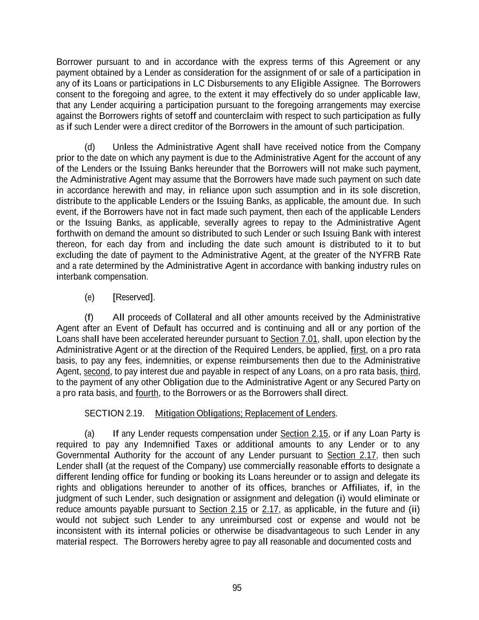
95 Borrower pursuant to and in accordance with the express terms of this Agreement or any payment obtained by a Lender as consideration for the assignment of or sale of a participation in any of its Loans or participations in LC Disbursements to any Eligible Assignee. The Borrowers consent to the foregoing and agree, to the extent it may effectively do so under applicable law, that any Lender acquiring a participation pursuant to the foregoing arrangements may exercise against the Borrowers rights of setoff and counterclaim with respect to such participation as fully as if such Lender were a direct creditor of the Borrowers in the amount of such participation. (d) Unless the Administrative Agent shall have received notice from the Company prior to the date on which any payment is due to the Administrative Agent for the account of any of the Lenders or the Issuing Banks hereunder that the Borrowers will not make such payment, the Administrative Agent may assume that the Borrowers have made such payment on such date in accordance herewith and may, in reliance upon such assumption and in its sole discretion, distribute to the applicable Lenders or the Issuing Banks, as applicable, the amount due. In such event, if the Borrowers have not in fact made such payment, then each of the applicable Lenders or the Issuing Banks, as applicable, severally agrees to repay to the Administrative Agent forthwith on demand the amount so distributed to such Lender or such Issuing Bank with interest thereon, for each day from and including the date such amount is distributed to it to but excluding the date of payment to the Administrative Agent, at the greater of the NYFRB Rate and a rate determined by the Administrative Agent in accordance with banking industry rules on interbank compensation. (e) [Reserved]. (f) All proceeds of Collateral and all other amounts received by the Administrative Agent after an Event of Default has occurred and is continuing and all or any portion of the Loans shall have been accelerated hereunder pursuant to Section 7.01, shall, upon election by the Administrative Agent or at the direction of the Required Lenders, be applied, first, on a pro rata basis, to pay any fees, indemnities, or expense reimbursements then due to the Administrative Agent, second, to pay interest due and payable in respect of any Loans, on a pro rata basis, third, to the payment of any other Obligation due to the Administrative Agent or any Secured Party on a pro rata basis, and fourth, to the Borrowers or as the Borrowers shall direct. SECTION 2.19. Mitigation Obligations; Replacement of Lenders. (a) If any Lender requests compensation under Section 2.15, or if any Loan Party is required to pay any Indemnified Taxes or additional amounts to any Lender or to any Governmental Authority for the account of any Lender pursuant to Section 2.17, then such Lender shall (at the request of the Company) use commercially reasonable efforts to designate a different lending office for funding or booking its Loans hereunder or to assign and delegate its rights and obligations hereunder to another of its offices, branches or Affiliates, if, in the judgment of such Lender, such designation or assignment and delegation (i) would eliminate or reduce amounts payable pursuant to Section 2.15 or 2.17, as applicable, in the future and (ii) would not subject such Lender to any unreimbursed cost or expense and would not be inconsistent with its internal policies or otherwise be disadvantageous to such Lender in any material respect. The Borrowers hereby agree to pay all reasonable and documented costs and

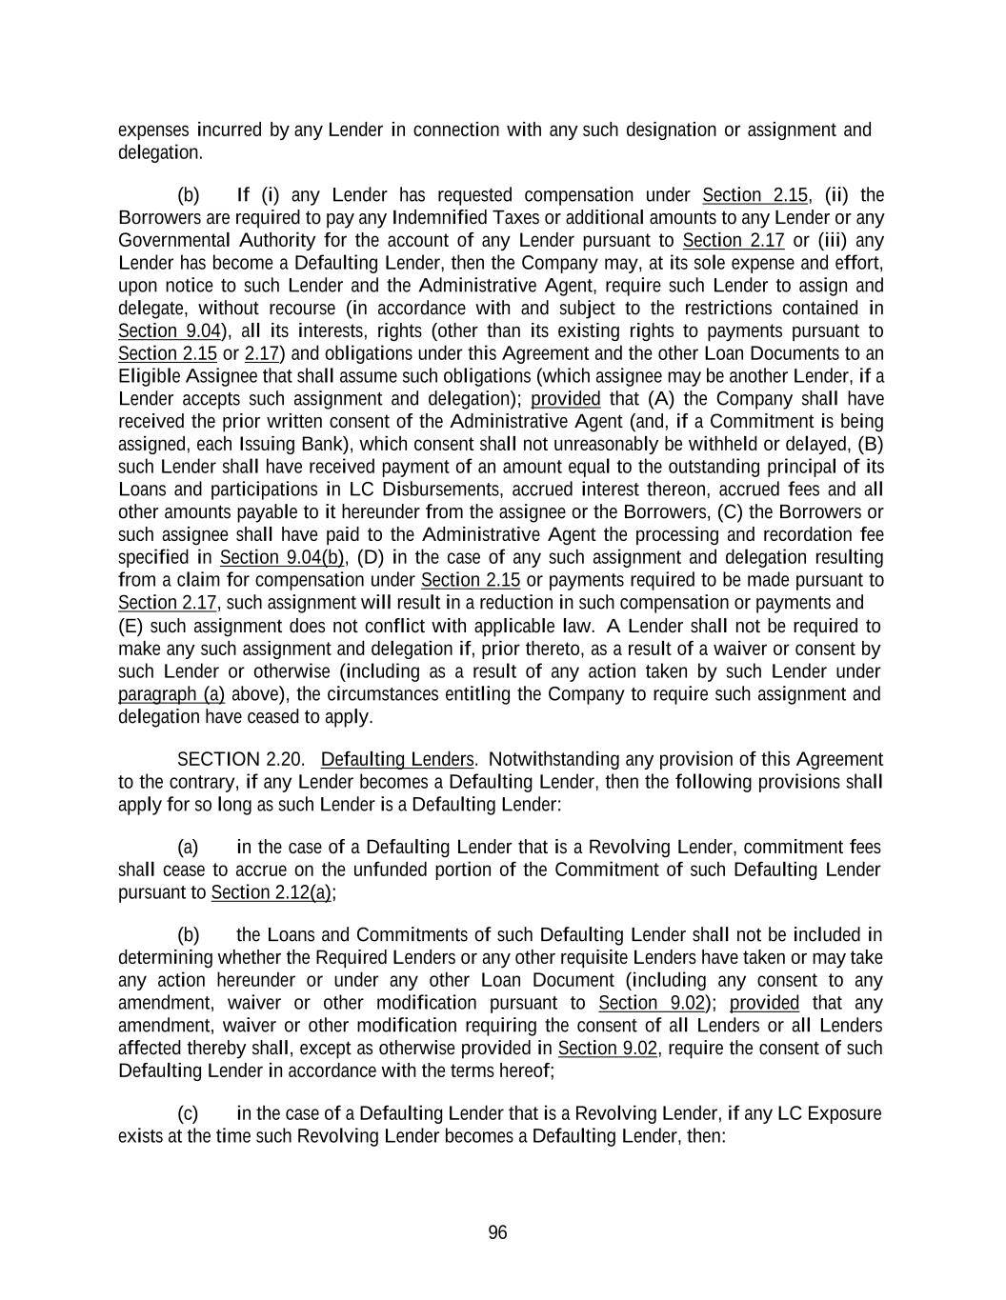
96 expenses incurred by any Lender in connection with any such designation or assignment and delegation. (b) If (i) any Lender has requested compensation under Section 2.15, (ii) the Borrowers are required to pay any Indemnified Taxes or additional amounts to any Lender or any Governmental Authority for the account of any Lender pursuant to Section 2.17 or (iii) any Lender has become a Defaulting Lender, then the Company may, at its sole expense and effort, upon notice to such Lender and the Administrative Agent, require such Lender to assign and delegate, without recourse (in accordance with and subject to the restrictions contained in Section 9.04), all its interests, rights (other than its existing rights to payments pursuant to Section 2.15 or 2.17) and obligations under this Agreement and the other Loan Documents to an Eligible Assignee that shall assume such obligations (which assignee may be another Lender, if a Lender accepts such assignment and delegation); provided that (A) the Company shall have received the prior written consent of the Administrative Agent (and, if a Commitment is being assigned, each Issuing Bank), which consent shall not unreasonably be withheld or delayed, (B) such Lender shall have received payment of an amount equal to the outstanding principal of its Loans and participations in LC Disbursements, accrued interest thereon, accrued fees and all other amounts payable to it hereunder from the assignee or the Borrowers, (C) the Borrowers or such assignee shall have paid to the Administrative Agent the processing and recordation fee specified in Section 9.04(b), (D) in the case of any such assignment and delegation resulting from a claim for compensation under Section 2.15 or payments required to be made pursuant to Section 2.17, such assignment will result in a reduction in such compensation or payments and (E) such assignment does not conflict with applicable law. A Lender shall not be required to make any such assignment and delegation if, prior thereto, as a result of a waiver or consent by such Lender or otherwise (including as a result of any action taken by such Lender under paragraph (a) above), the circumstances entitling the Company to require such assignment and delegation have ceased to apply. SECTION 2.20. Defaulting Lenders. Notwithstanding any provision of this Agreement to the contrary, if any Lender becomes a Defaulting Lender, then the following provisions shall apply for so long as such Lender is a Defaulting Lender: (a) in the case of a Defaulting Lender that is a Revolving Lender, commitment fees shall cease to accrue on the unfunded portion of the Commitment of such Defaulting Lender pursuant to Section 2.12(a); (b) the Loans and Commitments of such Defaulting Lender shall not be included in determining whether the Required Lenders or any other requisite Lenders have taken or may take any action hereunder or under any other Loan Document (including any consent to any amendment, waiver or other modification pursuant to Section 9.02); provided that any amendment, waiver or other modification requiring the consent of all Lenders or all Lenders affected thereby shall, except as otherwise provided in Section 9.02, require the consent of such Defaulting Lender in accordance with the terms hereof; (c) in the case of a Defaulting Lender that is a Revolving Lender, if any LC Exposure exists at the time such Revolving Lender becomes a Defaulting Lender, then:

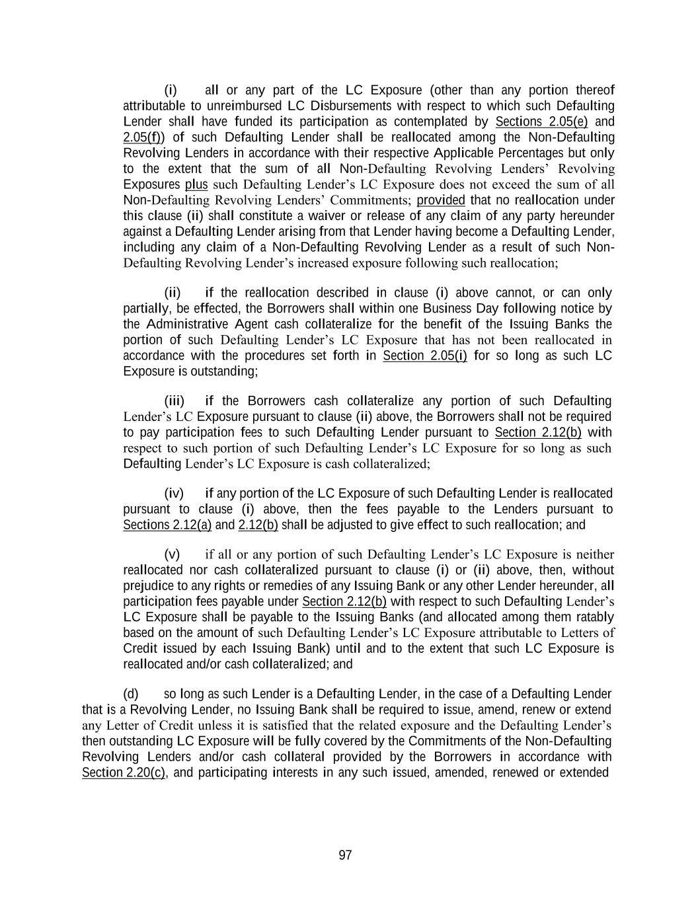
97 (i) all or any part of the LC Exposure (other than any portion thereof attributable to unreimbursed LC Disbursements with respect to which such Defaulting Lender shall have funded its participation as contemplated by Sections 2.05(e) and 2.05(f)) of such Defaulting Lender shall be reallocated among the Non-Defaulting Revolving Lenders in accordance with their respective Applicable Percentages but only to the extent that the sum of all Non-Defaulting Revolving Lenders’ Revolving Exposures plus such Defaulting Lender’s LC Exposure does not exceed the sum of all Non-Defaulting Revolving Lenders’ Commitments; provided that no reallocation under this clause (ii) shall constitute a waiver or release of any claim of any party hereunder against a Defaulting Lender arising from that Lender having become a Defaulting Lender, including any claim of a Non-Defaulting Revolving Lender as a result of such Non- Defaulting Revolving Lender’s increased exposure following such reallocation; (ii) if the reallocation described in clause (i) above cannot, or can only partially, be effected, the Borrowers shall within one Business Day following notice by the Administrative Agent cash collateralize for the benefit of the Issuing Banks the portion of such Defaulting Lender’s LC Exposure that has not been reallocated in accordance with the procedures set forth in Section 2.05(i) for so long as such LC Exposure is outstanding; (iii) if the Borrowers cash collateralize any portion of such Defaulting Lender’s LC Exposure pursuant to clause (ii) above, the Borrowers shall not be required to pay participation fees to such Defaulting Lender pursuant to Section 2.12(b) with respect to such portion of such Defaulting Lender’s LC Exposure for so long as such Defaulting Lender’s LC Exposure is cash collateralized; (iv) if any portion of the LC Exposure of such Defaulting Lender is reallocated pursuant to clause (i) above, then the fees payable to the Lenders pursuant to Sections 2.12(a) and 2.12(b) shall be adjusted to give effect to such reallocation; and (v) if all or any portion of such Defaulting Lender’s LC Exposure is neither reallocated nor cash collateralized pursuant to clause (i) or (ii) above, then, without prejudice to any rights or remedies of any Issuing Bank or any other Lender hereunder, all participation fees payable under Section 2.12(b) with respect to such Defaulting Lender’s LC Exposure shall be payable to the Issuing Banks (and allocated among them ratably based on the amount of such Defaulting Lender’s LC Exposure attributable to Letters of Credit issued by each Issuing Bank) until and to the extent that such LC Exposure is reallocated and/or cash collateralized; and (d) so long as such Lender is a Defaulting Lender, in the case of a Defaulting Lender that is a Revolving Lender, no Issuing Bank shall be required to issue, amend, renew or extend any Letter of Credit unless it is satisfied that the related exposure and the Defaulting Lender’s then outstanding LC Exposure will be fully covered by the Commitments of the Non-Defaulting Revolving Lenders and/or cash collateral provided by the Borrowers in accordance with Section 2.20(c), and participating interests in any such issued, amended, renewed or extended

98 Letter of Credit will be allocated among the Non-Defaulting Revolving Lenders in a manner consistent with Section 2.20(c)(i) (and such Defaulting Lender shall not participate therein). In the event that (i) a Bankruptcy Event or a Bail-In Action with respect to a direct or indirect parent company of a Lender shall occur following the Effective Date and for so long as such Bankruptcy Event or Bail-In Action shall continue or (ii) any applicable Issuing Bank has a good faith belief that any Lender has defaulted in fulfilling its obligations under one or more other agreements in which such Lender commits to extend credit, such Issuing Bank shall not be required to issue, amend, renew or extend any Letter of Credit, unless such Issuing Bank shall have entered into arrangements with the applicable Borrower or the applicable Revolving Lender, satisfactory to such Issuing Bank to defease any risk to it in respect of such Lender hereunder. In the event that the Administrative Agent, the Company and each applicable Issuing Bank each agrees that a Defaulting Lender has adequately remedied all matters that caused the applicable Lender to be a Defaulting Lender, then the LC Exposure of the Revolving Lenders shall be readjusted to reflect the inclusion of such Lender’s Commitment and on such date such Lender shall purchase at par such of the Revolving Loans of the other Revolving Lenders as the Administrative Agent shall determine may be necessary in order for such Lender to hold such Revolving Loans in accordance with its Applicable Percentage; provided that no adjustments will be made retroactively with respect to fees accrued or payments made by or on behalf of the Borrowers while such Lender was a Defaulting Lender; provided, further that, except as otherwise expressly agreed by the affected parties, no change hereunder from a Defaulting Lender to a non-Defaulting Lender will constitute a waiver or release of any claim of any party hereunder arising from such Lender’s having been a Defaulting Lender. ARTICLE III Representations and Warranties Each Borrower (with respect to itself and, where applicable, its respective Subsidiaries) represents and warrants to the Administrative Agent, each of the Issuing Banks and each of the Lenders that: SECTION 3.01. Organization; Powers. Each Borrower and each Restricted Subsidiary (a) is duly organized, incorporated or established, validly existing and, to the extent that such concept is applicable in the relevant jurisdiction, in good standing under the laws of the jurisdiction of its organization, incorporation or establishment except, in the case of any Restricted Subsidiary that is not a Loan Party, to the extent the failure of such Restricted Subsidiary to be in good standing would not reasonably be expected to have a Material Adverse Effect, (b) has all requisite power and authority, and the legal right, to carry on its business as now conducted and as proposed to be conducted, and (c) except where the failure to do so, individually or in the aggregate, could not reasonably be expected to result in a Material Adverse Effect, is qualified to do business in, and, to the extent that such concept is applicable in the relevant jurisdiction, is in good standing in, every jurisdiction where such qualification is required.

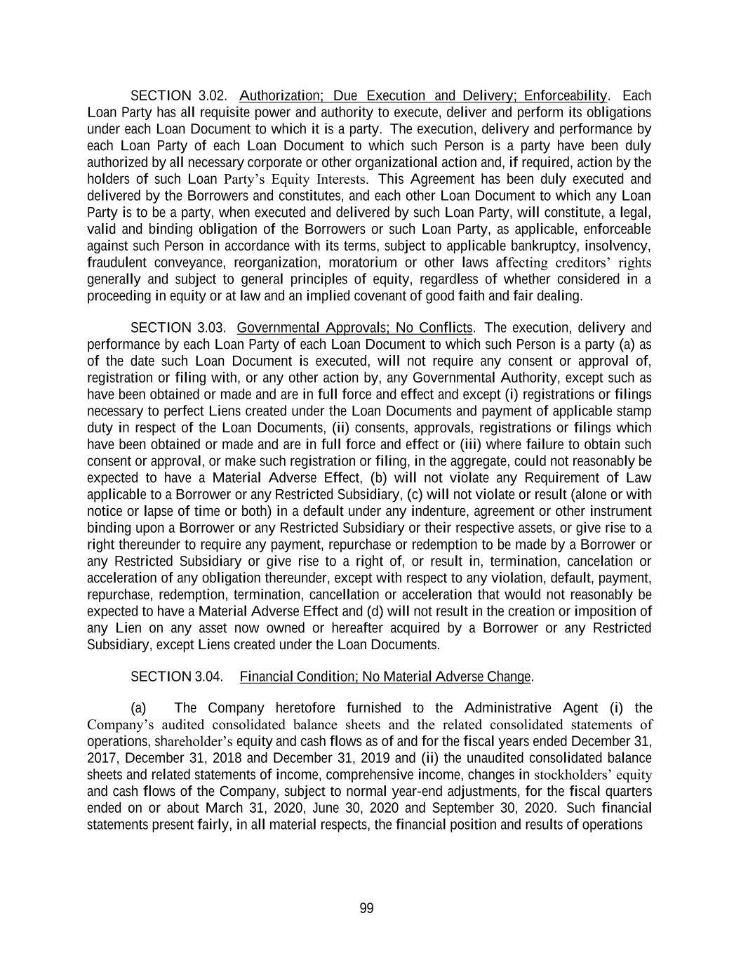
99 SECTION 3.02. Authorization; Due Execution and Delivery; Enforceability. Each Loan Party has all requisite power and authority to execute, deliver and perform its obligations under each Loan Document to which it is a party. The execution, delivery and performance by each Loan Party of each Loan Document to which such Person is a party have been duly authorized by all necessary corporate or other organizational action and, if required, action by the holders of such Loan Party’s Equity Interests. This Agreement has been duly executed and delivered by the Borrowers and constitutes, and each other Loan Document to which any Loan Party is to be a party, when executed and delivered by such Loan Party, will constitute, a legal, valid and binding obligation of the Borrowers or such Loan Party, as applicable, enforceable against such Person in accordance with its terms, subject to applicable bankruptcy, insolvency, fraudulent conveyance, reorganization, moratorium or other laws affecting creditors’ rights generally and subject to general principles of equity, regardless of whether considered in a proceeding in equity or at law and an implied covenant of good faith and fair dealing. SECTION 3.03. Governmental Approvals; No Conflicts. The execution, delivery and performance by each Loan Party of each Loan Document to which such Person is a party (a) as of the date such Loan Document is executed, will not require any consent or approval of, registration or filing with, or any other action by, any Governmental Authority, except such as have been obtained or made and are in full force and effect and except (i) registrations or filings necessary to perfect Liens created under the Loan Documents and payment of applicable stamp duty in respect of the Loan Documents, (ii) consents, approvals, registrations or filings which have been obtained or made and are in full force and effect or (iii) where failure to obtain such consent or approval, or make such registration or filing, in the aggregate, could not reasonably be expected to have a Material Adverse Effect, (b) will not violate any Requirement of Law applicable to a Borrower or any Restricted Subsidiary, (c) will not violate or result (alone or with notice or lapse of time or both) in a default under any indenture, agreement or other instrument binding upon a Borrower or any Restricted Subsidiary or their respective assets, or give rise to a right thereunder to require any payment, repurchase or redemption to be made by a Borrower or any Restricted Subsidiary or give rise to a right of, or result in, termination, cancelation or acceleration of any obligation thereunder, except with respect to any violation, default, payment, repurchase, redemption, termination, cancellation or acceleration that would not reasonably be expected to have a Material Adverse Effect and (d) will not result in the creation or imposition of any Lien on any asset now owned or hereafter acquired by a Borrower or any Restricted Subsidiary, except Liens created under the Loan Documents. SECTION 3.04. Financial Condition; No Material Adverse Change. (a) The Company heretofore furnished to the Administrative Agent (i) the Company’s audited consolidated balance sheets and the related consolidated statements of operations, shareholder’s equity and cash flows as of and for the fiscal years ended December 31, 2017, December 31, 2018 and December 31, 2019 and (ii) the unaudited consolidated balance sheets and related statements of income, comprehensive income, changes in stockholders’ equity and cash flows of the Company, subject to normal year-end adjustments, for the fiscal quarters ended on or about March 31, 2020, June 30, 2020 and September 30, 2020. Such financial statements present fairly, in all material respects, the financial position and results of operations

100 and cash flows of the Company and its Subsidiaries on a consolidated basis as of such dates and for such periods in accordance with GAAP consistently applied. (b) No event, change or condition has occurred that has had, or would reasonably be expected to have, a Material Adverse Effect since December 31, 2019. SECTION 3.05. Properties. (a) Each Borrower and each Restricted Subsidiary has good and marketable title to, all its property necessary for the conduct of its business (including the Mortgaged Properties), except for minor defects in title that do not interfere with its ability to conduct its business as currently conducted or as proposed to be conducted or to utilize such properties for their intended purposes. All such property is free and clear of Liens, other than Liens expressly permitted by Section 6.02. Each Borrower and each Restricted Subsidiary is the legal and beneficial owner of the property necessary for the conduct of its business (including the Mortgaged Properties). (b) Each Borrower and each Restricted Subsidiary owns, or has secured the rights to use, all trademarks, trade names, copyrights, patents and other intellectual property used in its business as currently conducted, and the operation of the respective businesses as currently operated by each Borrower and each Restricted Subsidiary does not infringe upon, misappropriate or otherwise violate the rights of any other Person, except, in each case, for any such failures to own or have rights to use, or any such infringements that, individually or in the aggregate, could not reasonably be expected to result in a Material Adverse Effect. No claim or litigation regarding any trademarks, trade names, copyrights, patents or other intellectual property (i) owned by a Borrower or any Restricted Subsidiary is pending; (ii) used by a Borrower or any Restricted Subsidiary, to the Knowledge of the Borrowers or any Restricted Subsidiary, is pending; or (iii) owned or used by a Borrower or any Restricted Subsidiary, to the Knowledge of the Borrowers or any Restricted Subsidiary, is threatened against a Borrower or any Restricted Subsidiary that, in each of (i), (ii) and (iii) individually or in the aggregate, could reasonably be expected to result in a Material Adverse Effect. Each Borrower and Restricted Subsidiary has taken commercially reasonable measures to protect and maintain the confidentiality of its material trade secrets. (c) As of the Effective Date, none of the Borrowers or any Restricted Subsidiary has received notice of, or has Knowledge of, any pending or contemplated condemnation proceeding affecting any Mortgaged Property or any sale or disposition thereof in lieu of condemnation, or any dispute in relation to the Mortgaged Property, any breach of any of the covenants affecting the title to the Mortgaged Property or, where such property is leasehold, any of the covenants within the relevant lease. Neither any Mortgaged Property nor any interest therein is subject to any right of first refusal, option or other contractual right to purchase such Mortgaged Property or interest therein. SECTION 3.06. Litigation and Environmental Matters. (a) There are no actions, suits, investigations or proceedings at law or in equity or by or before any arbitrator or Governmental Authority pending against or, to the Knowledge of the

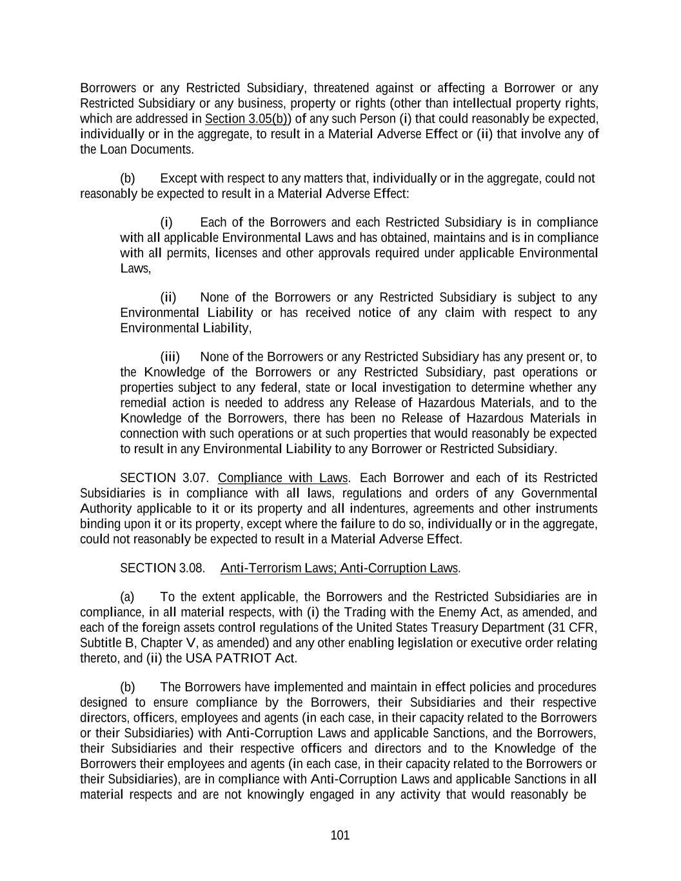
101 Borrowers or any Restricted Subsidiary, threatened against or affecting a Borrower or any Restricted Subsidiary or any business, property or rights (other than intellectual property rights, which are addressed in Section 3.05(b)) of any such Person (i) that could reasonably be expected, individually or in the aggregate, to result in a Material Adverse Effect or (ii) that involve any of the Loan Documents. (b) Except with respect to any matters that, individually or in the aggregate, could not reasonably be expected to result in a Material Adverse Effect: (i) Each of the Borrowers and each Restricted Subsidiary is in compliance with all applicable Environmental Laws and has obtained, maintains and is in compliance with all permits, licenses and other approvals required under applicable Environmental Laws, (ii) None of the Borrowers or any Restricted Subsidiary is subject to any Environmental Liability or has received notice of any claim with respect to any Environmental Liability, (iii) None of the Borrowers or any Restricted Subsidiary has any present or, to the Knowledge of the Borrowers or any Restricted Subsidiary, past operations or properties subject to any federal, state or local investigation to determine whether any remedial action is needed to address any Release of Hazardous Materials, and to the Knowledge of the Borrowers, there has been no Release of Hazardous Materials in connection with such operations or at such properties that would reasonably be expected to result in any Environmental Liability to any Borrower or Restricted Subsidiary. SECTION 3.07. Compliance with Laws. Each Borrower and each of its Restricted Subsidiaries is in compliance with all laws, regulations and orders of any Governmental Authority applicable to it or its property and all indentures, agreements and other instruments binding upon it or its property, except where the failure to do so, individually or in the aggregate, could not reasonably be expected to result in a Material Adverse Effect. SECTION 3.08. Anti-Terrorism Laws; Anti-Corruption Laws. (a) To the extent applicable, the Borrowers and the Restricted Subsidiaries are in compliance, in all material respects, with (i) the Trading with the Enemy Act, as amended, and each of the foreign assets control regulations of the United States Treasury Department (31 CFR, Subtitle B, Chapter V, as amended) and any other enabling legislation or executive order relating thereto, and (ii) the USA PATRIOT Act. (b) The Borrowers have implemented and maintain in effect policies and procedures designed to ensure compliance by the Borrowers, their Subsidiaries and their respective directors, officers, employees and agents (in each case, in their capacity related to the Borrowers or their Subsidiaries) with Anti-Corruption Laws and applicable Sanctions, and the Borrowers, their Subsidiaries and their respective officers and directors and to the Knowledge of the Borrowers their employees and agents (in each case, in their capacity related to the Borrowers or their Subsidiaries), are in compliance with Anti-Corruption Laws and applicable Sanctions in all material respects and are not knowingly engaged in any activity that would reasonably be

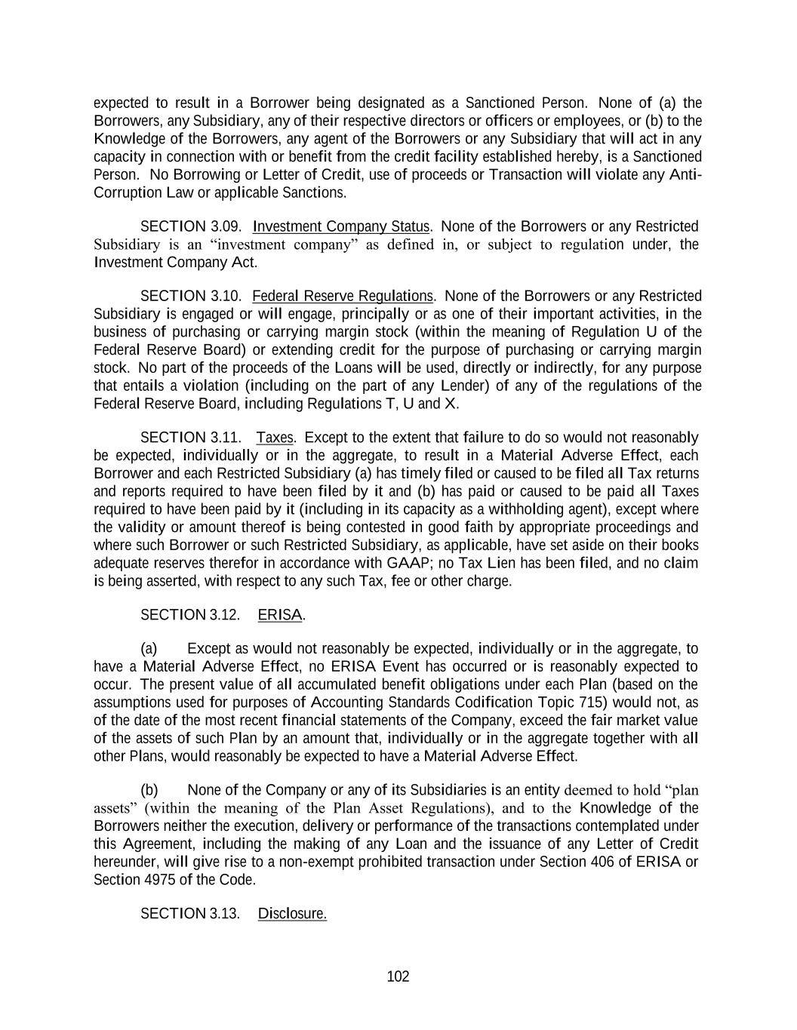
102 expected to result in a Borrower being designated as a Sanctioned Person. None of (a) the Borrowers, any Subsidiary, any of their respective directors or officers or employees, or (b) to the Knowledge of the Borrowers, any agent of the Borrowers or any Subsidiary that will act in any capacity in connection with or benefit from the credit facility established hereby, is a Sanctioned Person. No Borrowing or Letter of Credit, use of proceeds or Transaction will violate any Anti- Corruption Law or applicable Sanctions. SECTION 3.09. Investment Company Status. None of the Borrowers or any Restricted Subsidiary is an “investment company” as defined in, or subject to regulation under, the Investment Company Act. SECTION 3.10. Federal Reserve Regulations. None of the Borrowers or any Restricted Subsidiary is engaged or will engage, principally or as one of their important activities, in the business of purchasing or carrying margin stock (within the meaning of Regulation U of the Federal Reserve Board) or extending credit for the purpose of purchasing or carrying margin stock. No part of the proceeds of the Loans will be used, directly or indirectly, for any purpose that entails a violation (including on the part of any Lender) of any of the regulations of the Federal Reserve Board, including Regulations T, U and X. SECTION 3.11. Taxes. Except to the extent that failure to do so would not reasonably be expected, individually or in the aggregate, to result in a Material Adverse Effect, each Borrower and each Restricted Subsidiary (a) has timely filed or caused to be filed all Tax returns and reports required to have been filed by it and (b) has paid or caused to be paid all Taxes required to have been paid by it (including in its capacity as a withholding agent), except where the validity or amount thereof is being contested in good faith by appropriate proceedings and where such Borrower or such Restricted Subsidiary, as applicable, have set aside on their books adequate reserves therefor in accordance with GAAP; no Tax Lien has been filed, and no claim is being asserted, with respect to any such Tax, fee or other charge. SECTION 3.12. ERISA. (a) Except as would not reasonably be expected, individually or in the aggregate, to have a Material Adverse Effect, no ERISA Event has occurred or is reasonably expected to occur. The present value of all accumulated benefit obligations under each Plan (based on the assumptions used for purposes of Accounting Standards Codification Topic 715) would not, as of the date of the most recent financial statements of the Company, exceed the fair market value of the assets of such Plan by an amount that, individually or in the aggregate together with all other Plans, would reasonably be expected to have a Material Adverse Effect. (b) None of the Company or any of its Subsidiaries is an entity deemed to hold “plan assets” (within the meaning of the Plan Asset Regulations), and to the Knowledge of the Borrowers neither the execution, delivery or performance of the transactions contemplated under this Agreement, including the making of any Loan and the issuance of any Letter of Credit hereunder, will give rise to a non-exempt prohibited transaction under Section 406 of ERISA or Section 4975 of the Code. SECTION 3.13. Disclosure.

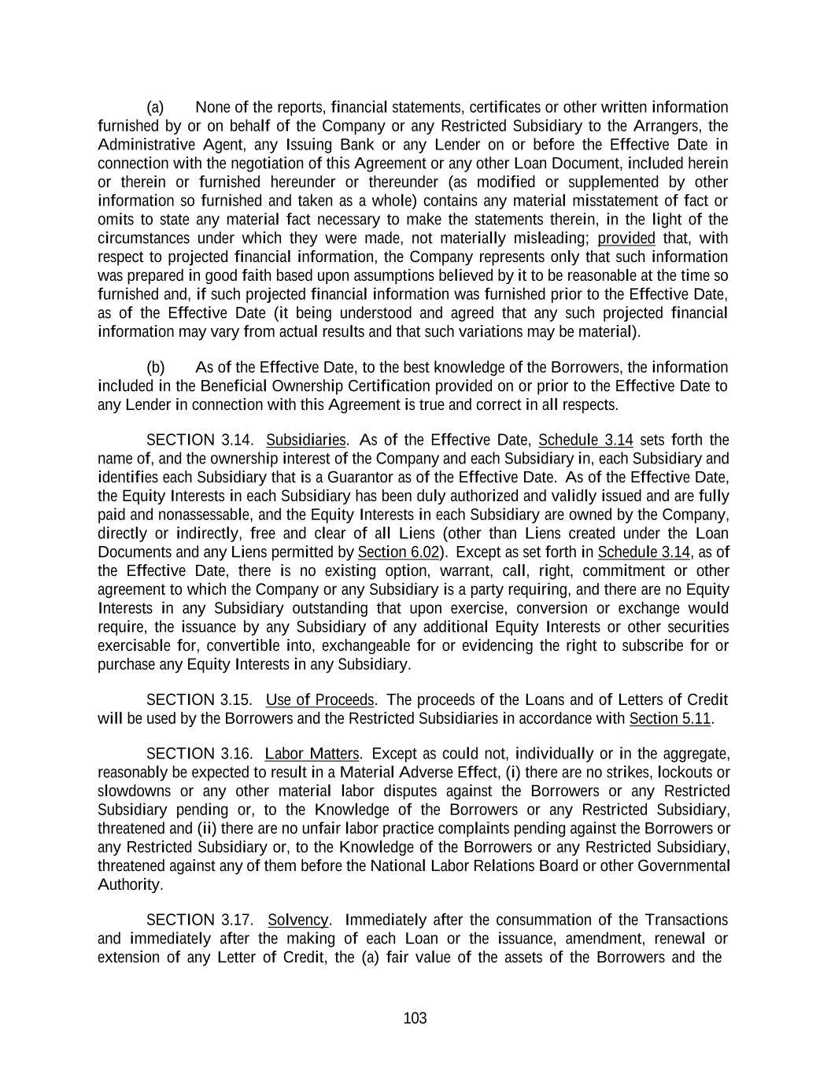
103 (a) None of the reports, financial statements, certificates or other written information furnished by or on behalf of the Company or any Restricted Subsidiary to the Arrangers, the Administrative Agent, any Issuing Bank or any Lender on or before the Effective Date in connection with the negotiation of this Agreement or any other Loan Document, included herein or therein or furnished hereunder or thereunder (as modified or supplemented by other information so furnished and taken as a whole) contains any material misstatement of fact or omits to state any material fact necessary to make the statements therein, in the light of the circumstances under which they were made, not materially misleading; provided that, with respect to projected financial information, the Company represents only that such information was prepared in good faith based upon assumptions believed by it to be reasonable at the time so furnished and, if such projected financial information was furnished prior to the Effective Date, as of the Effective Date (it being understood and agreed that any such projected financial information may vary from actual results and that such variations may be material). (b) As of the Effective Date, to the best knowledge of the Borrowers, the information included in the Beneficial Ownership Certification provided on or prior to the Effective Date to any Lender in connection with this Agreement is true and correct in all respects. SECTION 3.14. Subsidiaries. As of the Effective Date, Schedule 3.14 sets forth the name of, and the ownership interest of the Company and each Subsidiary in, each Subsidiary and identifies each Subsidiary that is a Guarantor as of the Effective Date. As of the Effective Date, the Equity Interests in each Subsidiary has been duly authorized and validly issued and are fully paid and nonassessable, and the Equity Interests in each Subsidiary are owned by the Company, directly or indirectly, free and clear of all Liens (other than Liens created under the Loan Documents and any Liens permitted by Section 6.02). Except as set forth in Schedule 3.14, as of the Effective Date, there is no existing option, warrant, call, right, commitment or other agreement to which the Company or any Subsidiary is a party requiring, and there are no Equity Interests in any Subsidiary outstanding that upon exercise, conversion or exchange would require, the issuance by any Subsidiary of any additional Equity Interests or other securities exercisable for, convertible into, exchangeable for or evidencing the right to subscribe for or purchase any Equity Interests in any Subsidiary. SECTION 3.15. Use of Proceeds. The proceeds of the Loans and of Letters of Credit will be used by the Borrowers and the Restricted Subsidiaries in accordance with Section 5.11. SECTION 3.16. Labor Matters. Except as could not, individually or in the aggregate, reasonably be expected to result in a Material Adverse Effect, (i) there are no strikes, lockouts or slowdowns or any other material labor disputes against the Borrowers or any Restricted Subsidiary pending or, to the Knowledge of the Borrowers or any Restricted Subsidiary, threatened and (ii) there are no unfair labor practice complaints pending against the Borrowers or any Restricted Subsidiary or, to the Knowledge of the Borrowers or any Restricted Subsidiary, threatened against any of them before the National Labor Relations Board or other Governmental Authority. SECTION 3.17. Solvency. Immediately after the consummation of the Transactions and immediately after the making of each Loan or the issuance, amendment, renewal or extension of any Letter of Credit, the (a) fair value of the assets of the Borrowers and the

104 Restricted Subsidiaries, taken as a whole, at a fair valuation, will exceed their debts and liabilities, subordinated, contingent or otherwise, (b) present fair saleable value of the property of the Borrowers and the Restricted Subsidiaries, taken as a whole, will be greater than the amount that will be required to pay the probable liability of their debts and other liabilities, subordinated, contingent or otherwise, as such debts and other liabilities become absolute and matured, (c) the Borrowers and the Restricted Subsidiaries, taken as a whole, will be able to pay their debts and liabilities, subordinated, contingent or otherwise, as such debts and liabilities become absolute and matured and (d) the Borrowers and the Restricted Subsidiaries, taken as a whole, will not have unreasonably small capital with which to conduct the business in which they are engaged as such business is now conducted and is proposed to be conducted following the Effective Date. For purposes of this Section, the amount of contingent liabilities at any time shall be computed as the amount that, in light of all the facts and circumstances existing at such time, represents the amount that can reasonably be expected to become an actual or matured liability. SECTION 3.18. Collateral Matters. (a) The Security Documents will create in favor of the Collateral Agent, for the benefit of the Secured Parties, a legal, valid and enforceable security interest in the Collateral (as defined therein) and (i) when such Collateral constituting certificated securities (as defined in the Uniform Commercial Code) is delivered to the Collateral Agent, together with instruments of transfer duly endorsed in blank, the security interest created under the Security Documents will constitute a fully perfected security interest in all right, title and interest of the pledgors thereunder in such Collateral, prior and superior in right to any other Person, and (ii) when financing statements (or their equivalent) in appropriate form are filed in the applicable filing offices, the security interest created under the Security Documents will constitute a fully perfected security interest in all right, title and interest of the Loan Parties in the remaining Collateral (as defined therein) (subject to subsections (b) and (c) of this Section 3.18) to the extent perfection can be obtained by filing Uniform Commercial Code financing statements (or their equivalent), prior and superior to the Lien of any other Person, except for Liens permitted under Section 6.02. (b) Each Mortgage and Vessel Deed of Covenants, upon execution and delivery thereof by the parties thereto, will create in favor of the Collateral Agent, for the benefit of the Secured Parties, a legal, valid and enforceable security interest in all the applicable mortgagor’s right, title and interest in and to the Collateral Vessels and Mortgaged Properties, as applicable, subject thereto and the proceeds thereof, and when the Mortgages have been filed or (as applicable) registered in the jurisdictions specified therein, the Mortgages will constitute a fully perfected security interest in all right, title and interest of the mortgagors in the Collateral Vessels and Mortgaged Properties, as applicable, and the proceeds thereof, prior and superior in right to any other Person, but subject to Liens permitted under Section 6.02. (c) Upon the recordation of the New York-Law Security Agreement (or a short-form security agreement in form and substance reasonably satisfactory to the Borrowers and the Administrative Agent) with the United States Patent and Trademark Office or the United States Copyright Office, as applicable, and the filing of the financing statements referred to in paragraph (a) of this Section, the security interest created under the New York-Law Security Agreement will constitute a fully perfected security interest in all right, title and interest of the

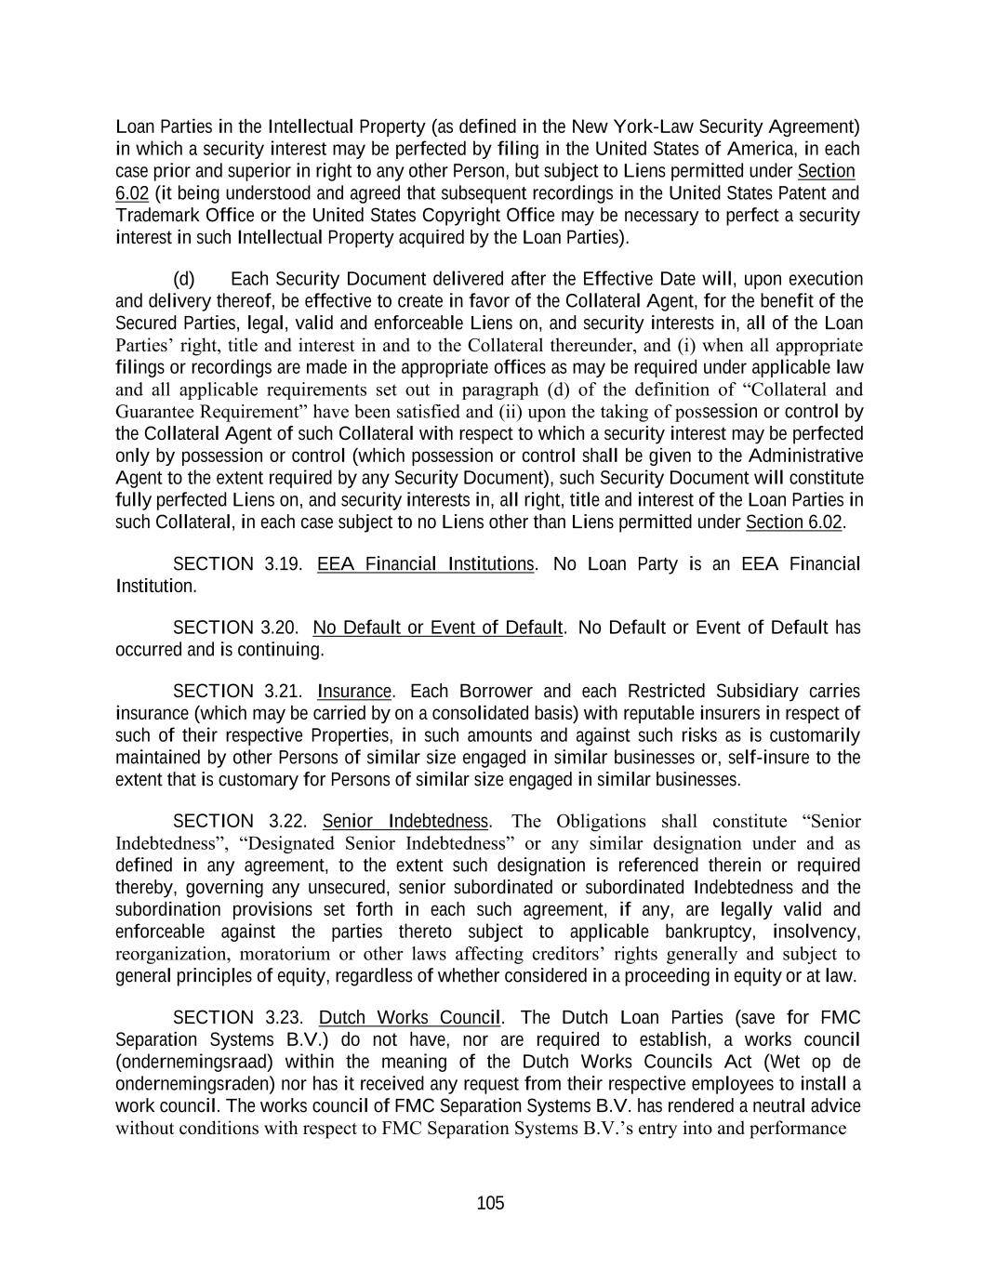
105 Loan Parties in the Intellectual Property (as defined in the New York-Law Security Agreement) in which a security interest may be perfected by filing in the United States of America, in each case prior and superior in right to any other Person, but subject to Liens permitted under Section 6.02 (it being understood and agreed that subsequent recordings in the United States Patent and Trademark Office or the United States Copyright Office may be necessary to perfect a security interest in such Intellectual Property acquired by the Loan Parties). (d) Each Security Document delivered after the Effective Date will, upon execution and delivery thereof, be effective to create in favor of the Collateral Agent, for the benefit of the Secured Parties, legal, valid and enforceable Liens on, and security interests in, all of the Loan Parties’ right, title and interest in and to the Collateral thereunder, and (i) when all appropriate filings or recordings are made in the appropriate offices as may be required under applicable law and all applicable requirements set out in paragraph (d) of the definition of “Collateral and Guarantee Requirement” have been satisfied and (ii) upon the taking of possession or control by the Collateral Agent of such Collateral with respect to which a security interest may be perfected only by possession or control (which possession or control shall be given to the Administrative Agent to the extent required by any Security Document), such Security Document will constitute fully perfected Liens on, and security interests in, all right, title and interest of the Loan Parties in such Collateral, in each case subject to no Liens other than Liens permitted under Section 6.02. SECTION 3.19. EEA Financial Institutions. No Loan Party is an EEA Financial Institution. SECTION 3.20. No Default or Event of Default. No Default or Event of Default has occurred and is continuing. SECTION 3.21. Insurance. Each Borrower and each Restricted Subsidiary carries insurance (which may be carried by on a consolidated basis) with reputable insurers in respect of such of their respective Properties, in such amounts and against such risks as is customarily maintained by other Persons of similar size engaged in similar businesses or, self-insure to the extent that is customary for Persons of similar size engaged in similar businesses. SECTION 3.22. Senior Indebtedness. The Obligations shall constitute “Senior Indebtedness”, “Designated Senior Indebtedness” or any similar designation under and as defined in any agreement, to the extent such designation is referenced therein or required thereby, governing any unsecured, senior subordinated or subordinated Indebtedness and the subordination provisions set forth in each such agreement, if any, are legally valid and enforceable against the parties thereto subject to applicable bankruptcy, insolvency, reorganization, moratorium or other laws affecting creditors’ rights generally and subject to general principles of equity, regardless of whether considered in a proceeding in equity or at law. SECTION 3.23. Dutch Works Council. The Dutch Loan Parties (save for FMC Separation Systems B.V.) do not have, nor are required to establish, a works council (ondernemingsraad) within the meaning of the Dutch Works Councils Act (Wet op de ondernemingsraden) nor has it received any request from their respective employees to install a work council. The works council of FMC Separation Systems B.V. has rendered a neutral advice without conditions with respect to FMC Separation Systems B.V.’s entry into and performance

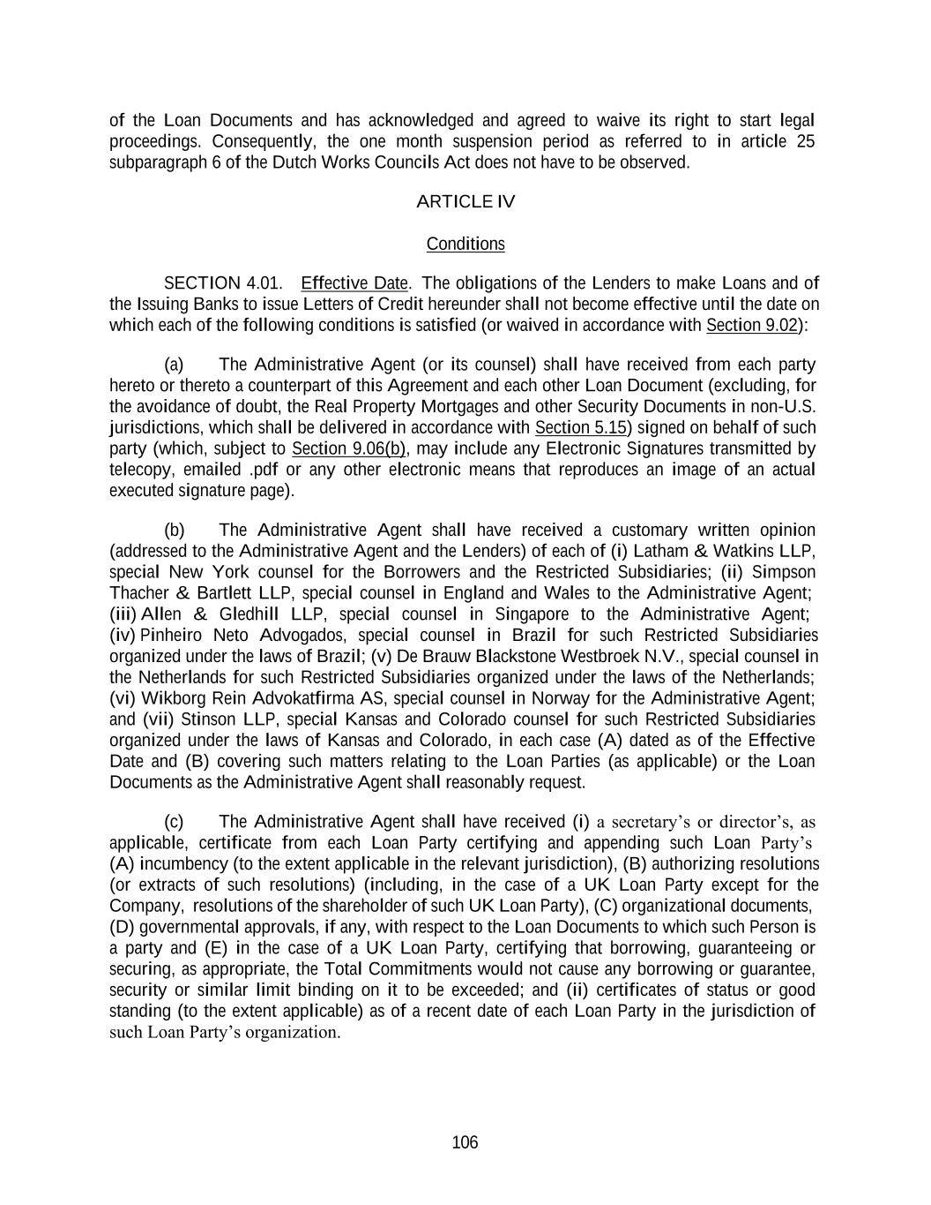
106 of the Loan Documents and has acknowledged and agreed to waive its right to start legal proceedings. Consequently, the one month suspension period as referred to in article 25 subparagraph 6 of the Dutch Works Councils Act does not have to be observed. ARTICLE IV Conditions SECTION 4.01. Effective Date. The obligations of the Lenders to make Loans and of the Issuing Banks to issue Letters of Credit hereunder shall not become effective until the date on which each of the following conditions is satisfied (or waived in accordance with Section 9.02): (a) The Administrative Agent (or its counsel) shall have received from each party hereto or thereto a counterpart of this Agreement and each other Loan Document (excluding, for the avoidance of doubt, the Real Property Mortgages and other Security Documents in non-U.S. jurisdictions, which shall be delivered in accordance with Section 5.15) signed on behalf of such party (which, subject to Section 9.06(b), may include any Electronic Signatures transmitted by telecopy, emailed .pdf or any other electronic means that reproduces an image of an actual executed signature page). (b) The Administrative Agent shall have received a customary written opinion (addressed to the Administrative Agent and the Lenders) of each of (i) Latham & Watkins LLP, special New York counsel for the Borrowers and the Restricted Subsidiaries; (ii) Simpson Thacher & Bartlett LLP, special counsel in England and Wales to the Administrative Agent; (iii) Allen & Gledhill LLP, special counsel in Singapore to the Administrative Agent; (iv) Pinheiro Neto Advogados, special counsel in Brazil for such Restricted Subsidiaries organized under the laws of Brazil; (v) De Brauw Blackstone Westbroek N.V., special counsel in the Netherlands for such Restricted Subsidiaries organized under the laws of the Netherlands; (vi) Wikborg Rein Advokatfirma AS, special counsel in Norway for the Administrative Agent; and (vii) Stinson LLP, special Kansas and Colorado counsel for such Restricted Subsidiaries organized under the laws of Kansas and Colorado, in each case (A) dated as of the Effective Date and (B) covering such matters relating to the Loan Parties (as applicable) or the Loan Documents as the Administrative Agent shall reasonably request. (c) The Administrative Agent shall have received (i) a secretary’s or director’s, as applicable, certificate from each Loan Party certifying and appending such Loan Party’s (A) incumbency (to the extent applicable in the relevant jurisdiction), (B) authorizing resolutions (or extracts of such resolutions) (including, in the case of a UK Loan Party except for the Company, resolutions of the shareholder of such UK Loan Party), (C) organizational documents, (D) governmental approvals, if any, with respect to the Loan Documents to which such Person is a party and (E) in the case of a UK Loan Party, certifying that borrowing, guaranteeing or securing, as appropriate, the Total Commitments would not cause any borrowing or guarantee, security or similar limit binding on it to be exceeded; and (ii) certificates of status or good standing (to the extent applicable) as of a recent date of each Loan Party in the jurisdiction of such Loan Party’s organization.

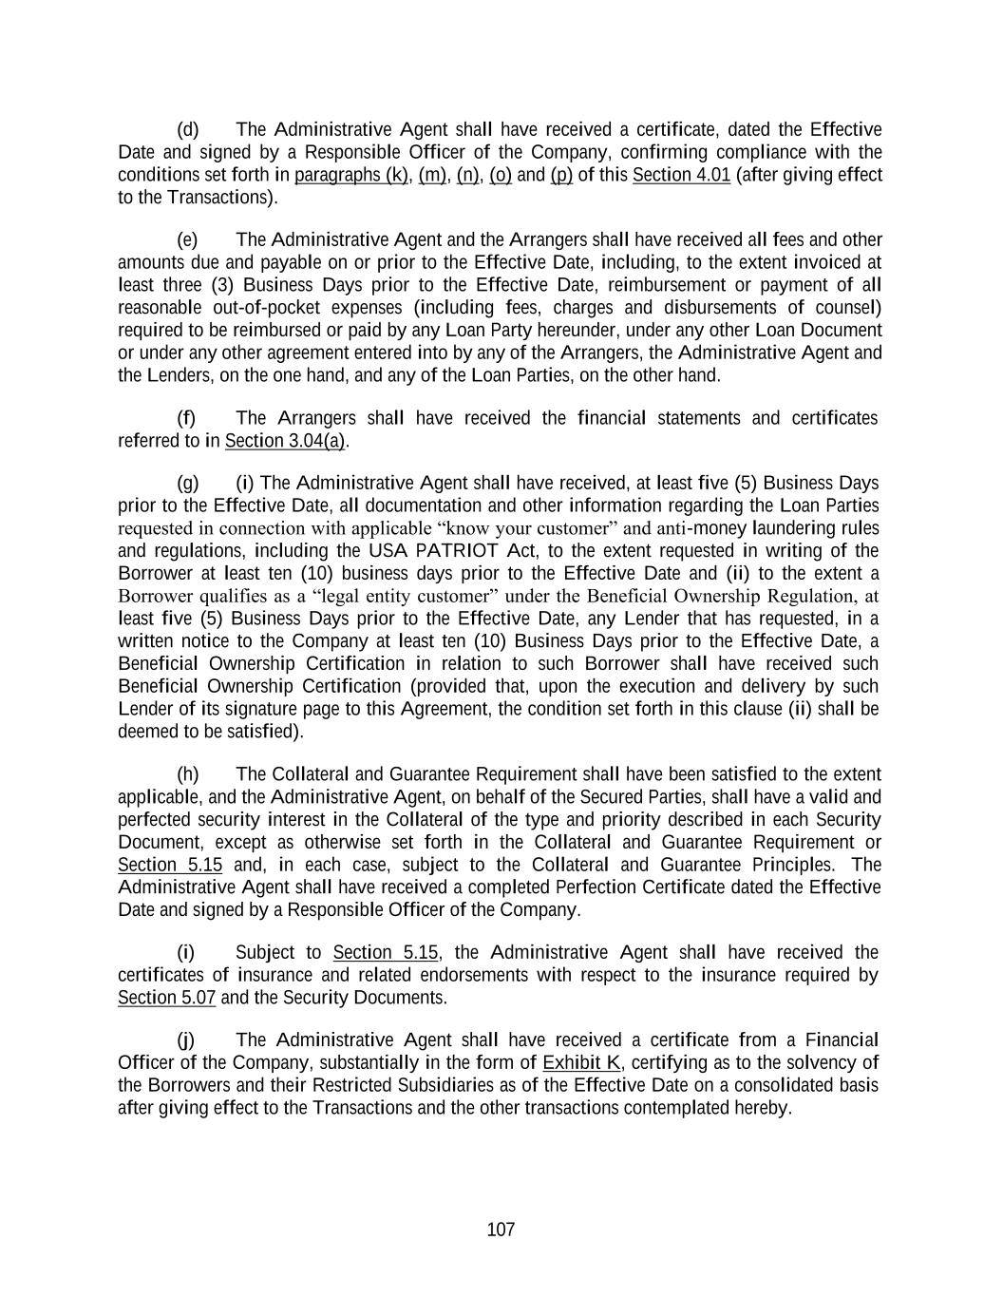
107 (d) The Administrative Agent shall have received a certificate, dated the Effective Date and signed by a Responsible Officer of the Company, confirming compliance with the conditions set forth in paragraphs (k), (m), (n), (o) and (p) of this Section 4.01 (after giving effect to the Transactions). (e) The Administrative Agent and the Arrangers shall have received all fees and other amounts due and payable on or prior to the Effective Date, including, to the extent invoiced at least three (3) Business Days prior to the Effective Date, reimbursement or payment of all reasonable out-of-pocket expenses (including fees, charges and disbursements of counsel) required to be reimbursed or paid by any Loan Party hereunder, under any other Loan Document or under any other agreement entered into by any of the Arrangers, the Administrative Agent and the Lenders, on the one hand, and any of the Loan Parties, on the other hand. (f) The Arrangers shall have received the financial statements and certificates referred to in Section 3.04(a). (g) (i) The Administrative Agent shall have received, at least five (5) Business Days prior to the Effective Date, all documentation and other information regarding the Loan Parties requested in connection with applicable “know your customer” and anti-money laundering rules and regulations, including the USA PATRIOT Act, to the extent requested in writing of the Borrower at least ten (10) business days prior to the Effective Date and (ii) to the extent a Borrower qualifies as a “legal entity customer” under the Beneficial Ownership Regulation, at least five (5) Business Days prior to the Effective Date, any Lender that has requested, in a written notice to the Company at least ten (10) Business Days prior to the Effective Date, a Beneficial Ownership Certification in relation to such Borrower shall have received such Beneficial Ownership Certification (provided that, upon the execution and delivery by such Lender of its signature page to this Agreement, the condition set forth in this clause (ii) shall be deemed to be satisfied). (h) The Collateral and Guarantee Requirement shall have been satisfied to the extent applicable, and the Administrative Agent, on behalf of the Secured Parties, shall have a valid and perfected security interest in the Collateral of the type and priority described in each Security Document, except as otherwise set forth in the Collateral and Guarantee Requirement or Section 5.15 and, in each case, subject to the Collateral and Guarantee Principles. The Administrative Agent shall have received a completed Perfection Certificate dated the Effective Date and signed by a Responsible Officer of the Company. (i) Subject to Section 5.15, the Administrative Agent shall have received the certificates of insurance and related endorsements with respect to the insurance required by Section 5.07 and the Security Documents. (j) The Administrative Agent shall have received a certificate from a Financial Officer of the Company, substantially in the form of Exhibit K, certifying as to the solvency of the Borrowers and their Restricted Subsidiaries as of the Effective Date on a consolidated basis after giving effect to the Transactions and the other transactions contemplated hereby.

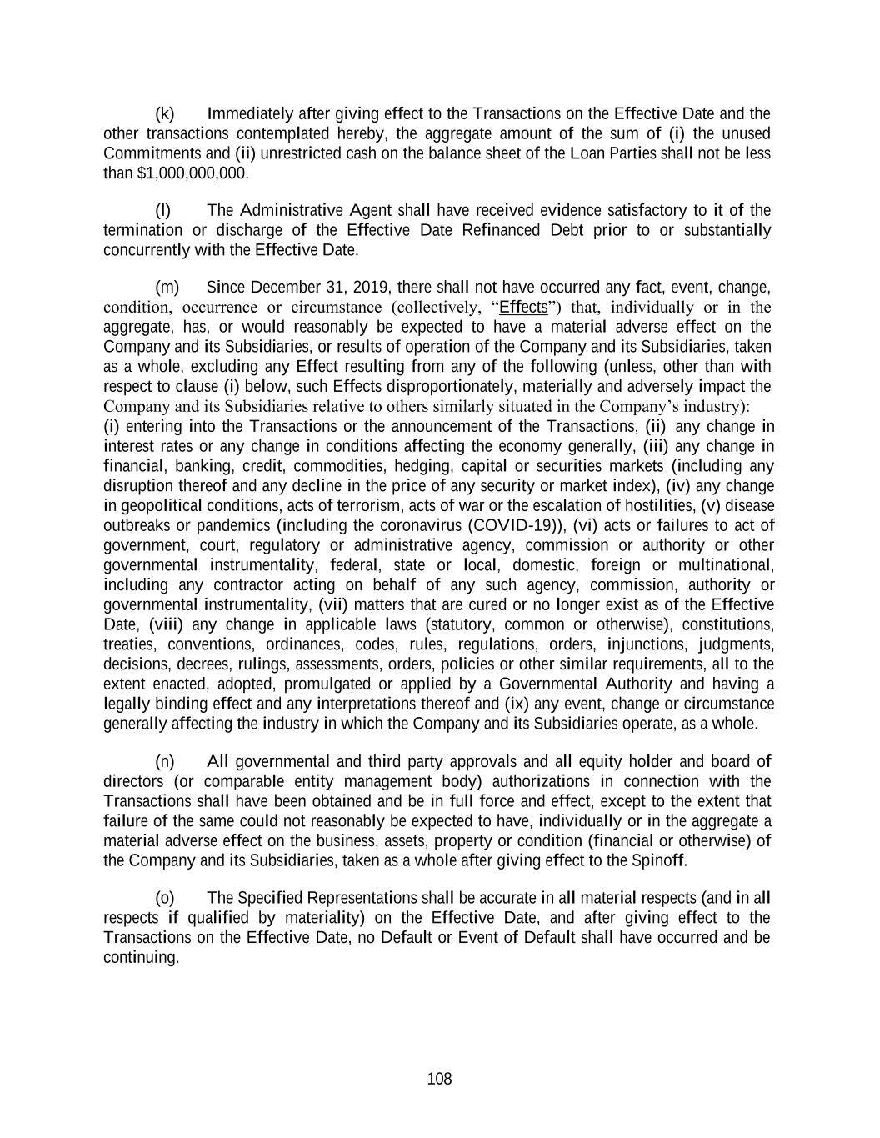
108 (k) Immediately after giving effect to the Transactions on the Effective Date and the other transactions contemplated hereby, the aggregate amount of the sum of (i) the unused Commitments and (ii) unrestricted cash on the balance sheet of the Loan Parties shall not be less than $1,000,000,000. (l) The Administrative Agent shall have received evidence satisfactory to it of the termination or discharge of the Effective Date Refinanced Debt prior to or substantially concurrently with the Effective Date. (m) Since December 31, 2019, there shall not have occurred any fact, event, change, condition, occurrence or circumstance (collectively, “Effects”) that, individually or in the aggregate, has, or would reasonably be expected to have a material adverse effect on the Company and its Subsidiaries, or results of operation of the Company and its Subsidiaries, taken as a whole, excluding any Effect resulting from any of the following (unless, other than with respect to clause (i) below, such Effects disproportionately, materially and adversely impact the Company and its Subsidiaries relative to others similarly situated in the Company’s industry): (i) entering into the Transactions or the announcement of the Transactions, (ii) any change in interest rates or any change in conditions affecting the economy generally, (iii) any change in financial, banking, credit, commodities, hedging, capital or securities markets (including any disruption thereof and any decline in the price of any security or market index), (iv) any change in geopolitical conditions, acts of terrorism, acts of war or the escalation of hostilities, (v) disease outbreaks or pandemics (including the coronavirus (COVID-19)), (vi) acts or failures to act of government, court, regulatory or administrative agency, commission or authority or other governmental instrumentality, federal, state or local, domestic, foreign or multinational, including any contractor acting on behalf of any such agency, commission, authority or governmental instrumentality, (vii) matters that are cured or no longer exist as of the Effective Date, (viii) any change in applicable laws (statutory, common or otherwise), constitutions, treaties, conventions, ordinances, codes, rules, regulations, orders, injunctions, judgments, decisions, decrees, rulings, assessments, orders, policies or other similar requirements, all to the extent enacted, adopted, promulgated or applied by a Governmental Authority and having a legally binding effect and any interpretations thereof and (ix) any event, change or circumstance generally affecting the industry in which the Company and its Subsidiaries operate, as a whole. (n) All governmental and third party approvals and all equity holder and board of directors (or comparable entity management body) authorizations in connection with the Transactions shall have been obtained and be in full force and effect, except to the extent that failure of the same could not reasonably be expected to have, individually or in the aggregate a material adverse effect on the business, assets, property or condition (financial or otherwise) of the Company and its Subsidiaries, taken as a whole after giving effect to the Spinoff. (o) The Specified Representations shall be accurate in all material respects (and in all respects if qualified by materiality) on the Effective Date, and after giving effect to the Transactions on the Effective Date, no Default or Event of Default shall have occurred and be continuing.

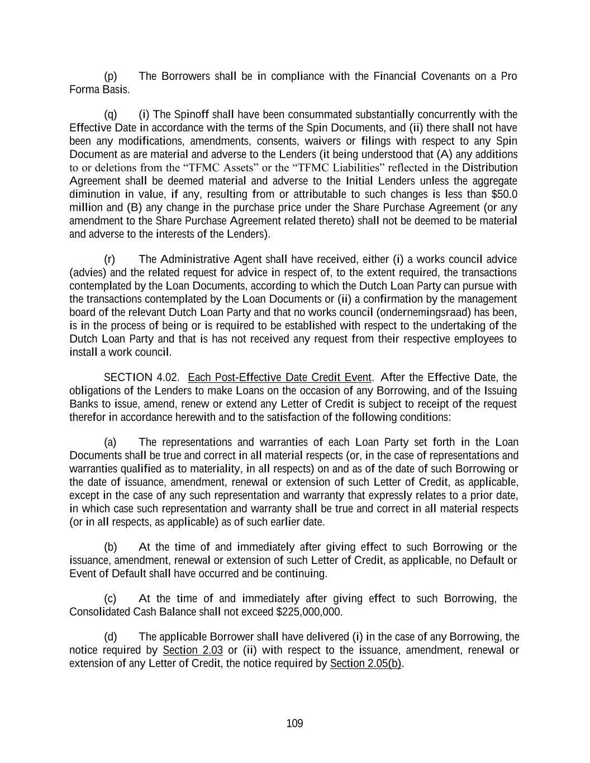
109 (p) The Borrowers shall be in compliance with the Financial Covenants on a Pro Forma Basis. (q) (i) The Spinoff shall have been consummated substantially concurrently with the Effective Date in accordance with the terms of the Spin Documents, and (ii) there shall not have been any modifications, amendments, consents, waivers or filings with respect to any Spin Document as are material and adverse to the Lenders (it being understood that (A) any additions to or deletions from the “TFMC Assets” or the “TFMC Liabilities” reflected in the Distribution Agreement shall be deemed material and adverse to the Initial Lenders unless the aggregate diminution in value, if any, resulting from or attributable to such changes is less than $50.0 million and (B) any change in the purchase price under the Share Purchase Agreement (or any amendment to the Share Purchase Agreement related thereto) shall not be deemed to be material and adverse to the interests of the Lenders). (r) The Administrative Agent shall have received, either (i) a works council advice (advies) and the related request for advice in respect of, to the extent required, the transactions contemplated by the Loan Documents, according to which the Dutch Loan Party can pursue with the transactions contemplated by the Loan Documents or (ii) a confirmation by the management board of the relevant Dutch Loan Party and that no works council (ondernemingsraad) has been, is in the process of being or is required to be established with respect to the undertaking of the Dutch Loan Party and that is has not received any request from their respective employees to install a work council. SECTION 4.02. Each Post-Effective Date Credit Event. After the Effective Date, the obligations of the Lenders to make Loans on the occasion of any Borrowing, and of the Issuing Banks to issue, amend, renew or extend any Letter of Credit is subject to receipt of the request therefor in accordance herewith and to the satisfaction of the following conditions: (a) The representations and warranties of each Loan Party set forth in the Loan Documents shall be true and correct in all material respects (or, in the case of representations and warranties qualified as to materiality, in all respects) on and as of the date of such Borrowing or the date of issuance, amendment, renewal or extension of such Letter of Credit, as applicable, except in the case of any such representation and warranty that expressly relates to a prior date, in which case such representation and warranty shall be true and correct in all material respects (or in all respects, as applicable) as of such earlier date. (b) At the time of and immediately after giving effect to such Borrowing or the issuance, amendment, renewal or extension of such Letter of Credit, as applicable, no Default or Event of Default shall have occurred and be continuing. (c) At the time of and immediately after giving effect to such Borrowing, the Consolidated Cash Balance shall not exceed $225,000,000. (d) The applicable Borrower shall have delivered (i) in the case of any Borrowing, the notice required by Section 2.03 or (ii) with respect to the issuance, amendment, renewal or extension of any Letter of Credit, the notice required by Section 2.05(b).

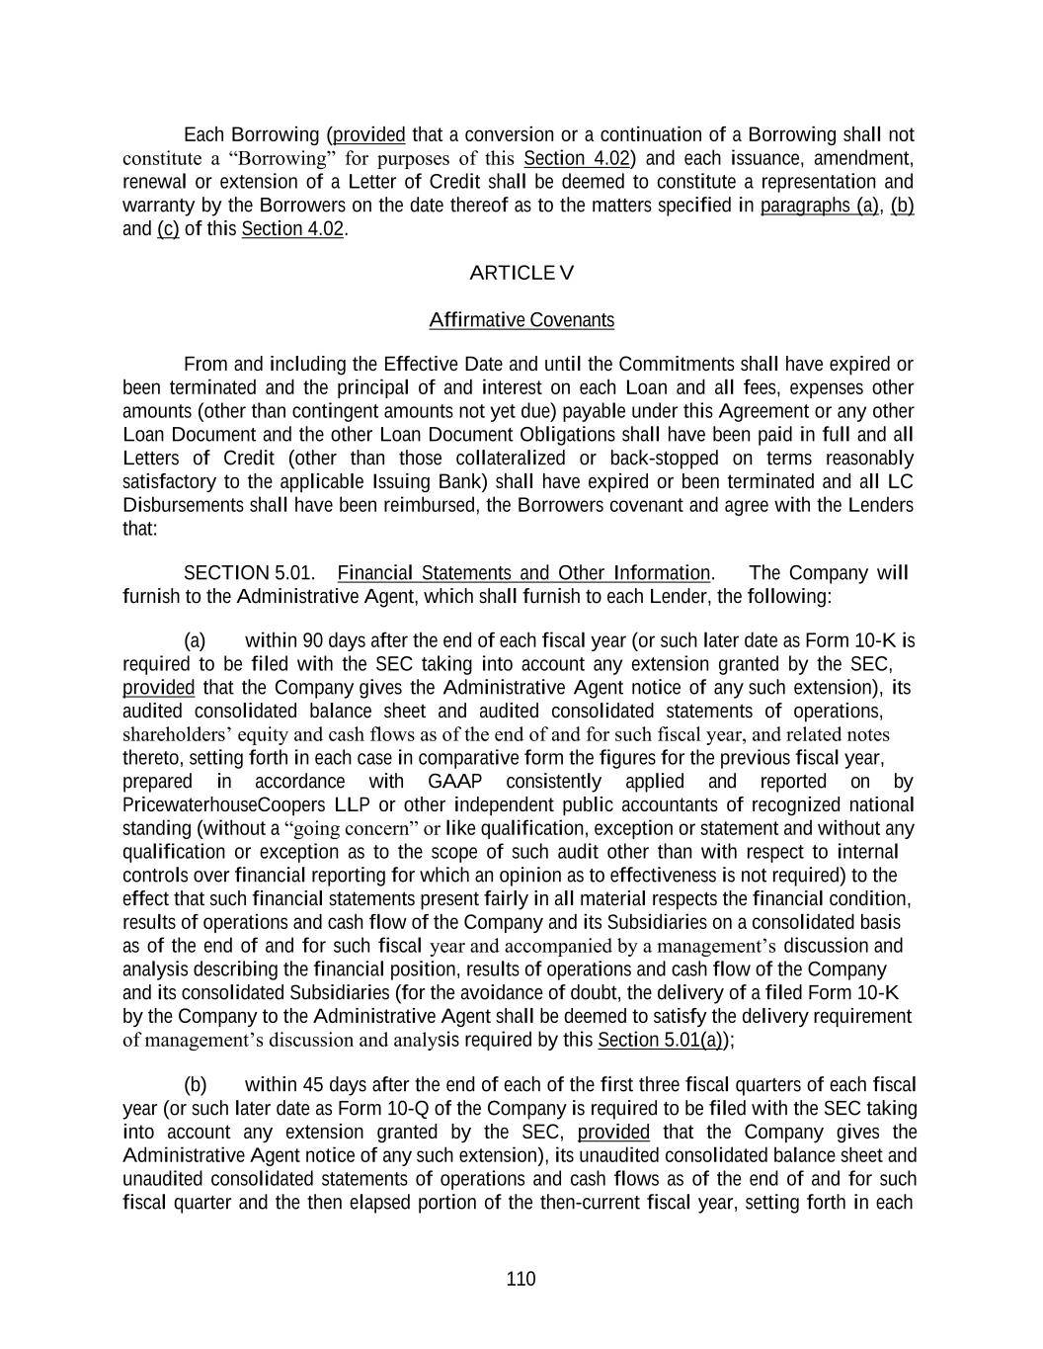
110 Each Borrowing (provided that a conversion or a continuation of a Borrowing shall not constitute a “Borrowing” for purposes of this Section 4.02) and each issuance, amendment, renewal or extension of a Letter of Credit shall be deemed to constitute a representation and warranty by the Borrowers on the date thereof as to the matters specified in paragraphs (a), (b) and (c) of this Section 4.02. ARTICLE V Affirmative Covenants From and including the Effective Date and until the Commitments shall have expired or been terminated and the principal of and interest on each Loan and all fees, expenses other amounts (other than contingent amounts not yet due) payable under this Agreement or any other Loan Document and the other Loan Document Obligations shall have been paid in full and all Letters of Credit (other than those collateralized or back-stopped on terms reasonably satisfactory to the applicable Issuing Bank) shall have expired or been terminated and all LC Disbursements shall have been reimbursed, the Borrowers covenant and agree with the Lenders that: SECTION 5.01. Financial Statements and Other Information. The Company will furnish to the Administrative Agent, which shall furnish to each Lender, the following: (a) within 90 days after the end of each fiscal year (or such later date as Form 10-K is required to be filed with the SEC taking into account any extension granted by the SEC, provided that the Company gives the Administrative Agent notice of any such extension), its audited consolidated balance sheet and audited consolidated statements of operations, shareholders’ equity and cash flows as of the end of and for such fiscal year, and related notes thereto, setting forth in each case in comparative form the figures for the previous fiscal year, prepared in accordance with GAAP consistently applied and reported on by PricewaterhouseCoopers LLP or other independent public accountants of recognized national standing (without a “going concern” or like qualification, exception or statement and without any qualification or exception as to the scope of such audit other than with respect to internal controls over financial reporting for which an opinion as to effectiveness is not required) to the effect that such financial statements present fairly in all material respects the financial condition, results of operations and cash flow of the Company and its Subsidiaries on a consolidated basis as of the end of and for such fiscal year and accompanied by a management’s discussion and analysis describing the financial position, results of operations and cash flow of the Company and its consolidated Subsidiaries (for the avoidance of doubt, the delivery of a filed Form 10-K by the Company to the Administrative Agent shall be deemed to satisfy the delivery requirement of management’s discussion and analysis required by this Section 5.01(a)); (b) within 45 days after the end of each of the first three fiscal quarters of each fiscal year (or such later date as Form 10-Q of the Company is required to be filed with the SEC taking into account any extension granted by the SEC, provided that the Company gives the Administrative Agent notice of any such extension), its unaudited consolidated balance sheet and unaudited consolidated statements of operations and cash flows as of the end of and for such fiscal quarter and the then elapsed portion of the then-current fiscal year, setting forth in each

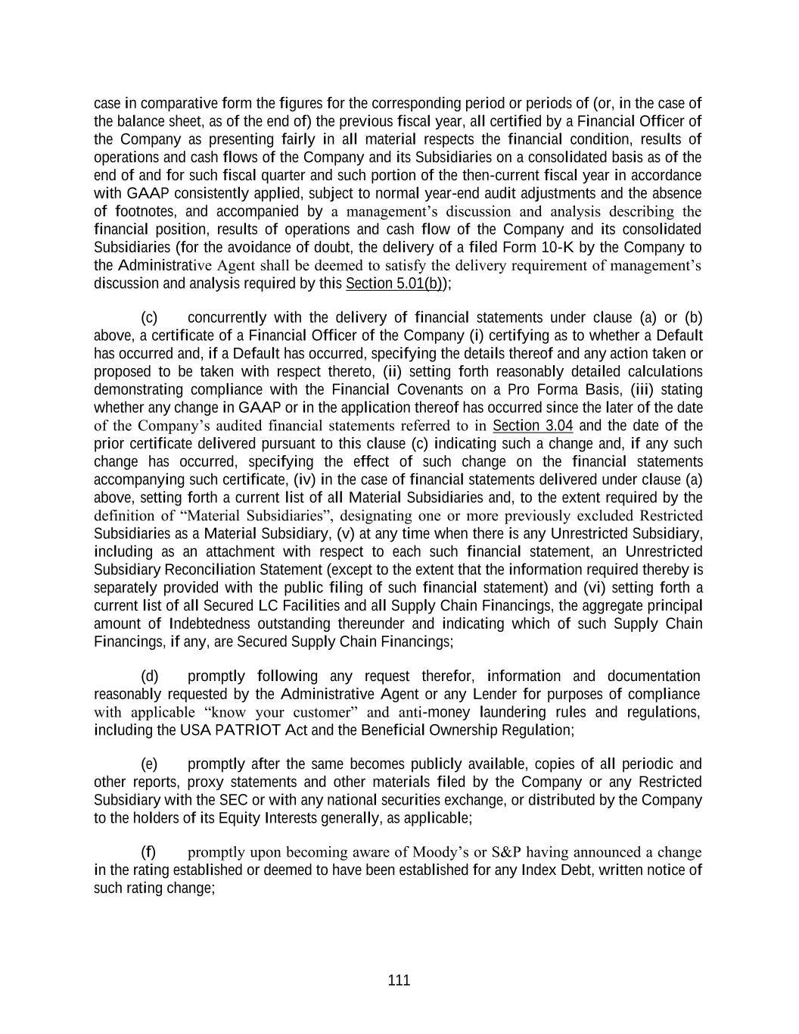
111 case in comparative form the figures for the corresponding period or periods of (or, in the case of the balance sheet, as of the end of) the previous fiscal year, all certified by a Financial Officer of the Company as presenting fairly in all material respects the financial condition, results of operations and cash flows of the Company and its Subsidiaries on a consolidated basis as of the end of and for such fiscal quarter and such portion of the then-current fiscal year in accordance with GAAP consistently applied, subject to normal year-end audit adjustments and the absence of footnotes, and accompanied by a management’s discussion and analysis describing the financial position, results of operations and cash flow of the Company and its consolidated Subsidiaries (for the avoidance of doubt, the delivery of a filed Form 10-K by the Company to the Administrative Agent shall be deemed to satisfy the delivery requirement of management’s discussion and analysis required by this Section 5.01(b)); (c) concurrently with the delivery of financial statements under clause (a) or (b) above, a certificate of a Financial Officer of the Company (i) certifying as to whether a Default has occurred and, if a Default has occurred, specifying the details thereof and any action taken or proposed to be taken with respect thereto, (ii) setting forth reasonably detailed calculations demonstrating compliance with the Financial Covenants on a Pro Forma Basis, (iii) stating whether any change in GAAP or in the application thereof has occurred since the later of the date of the Company’s audited financial statements referred to in Section 3.04 and the date of the prior certificate delivered pursuant to this clause (c) indicating such a change and, if any such change has occurred, specifying the effect of such change on the financial statements accompanying such certificate, (iv) in the case of financial statements delivered under clause (a) above, setting forth a current list of all Material Subsidiaries and, to the extent required by the definition of “Material Subsidiaries”, designating one or more previously excluded Restricted Subsidiaries as a Material Subsidiary, (v) at any time when there is any Unrestricted Subsidiary, including as an attachment with respect to each such financial statement, an Unrestricted Subsidiary Reconciliation Statement (except to the extent that the information required thereby is separately provided with the public filing of such financial statement) and (vi) setting forth a current list of all Secured LC Facilities and all Supply Chain Financings, the aggregate principal amount of Indebtedness outstanding thereunder and indicating which of such Supply Chain Financings, if any, are Secured Supply Chain Financings; (d) promptly following any request therefor, information and documentation reasonably requested by the Administrative Agent or any Lender for purposes of compliance with applicable “know your customer” and anti-money laundering rules and regulations, including the USA PATRIOT Act and the Beneficial Ownership Regulation; (e) promptly after the same becomes publicly available, copies of all periodic and other reports, proxy statements and other materials filed by the Company or any Restricted Subsidiary with the SEC or with any national securities exchange, or distributed by the Company to the holders of its Equity Interests generally, as applicable; (f) promptly upon becoming aware of Moody’s or S&P having announced a change in the rating established or deemed to have been established for any Index Debt, written notice of such rating change;

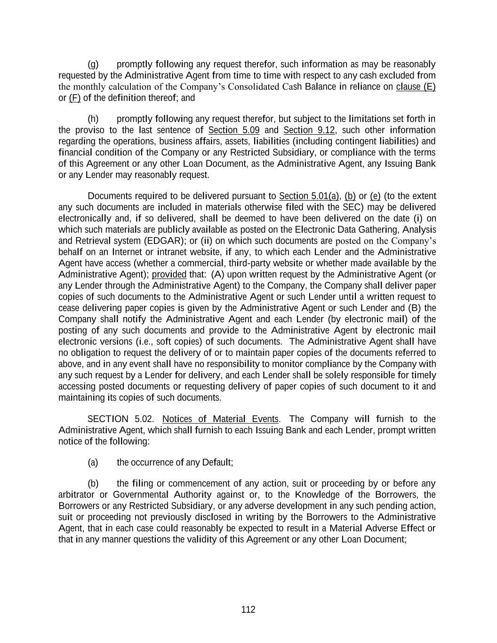
112 (g) promptly following any request therefor, such information as may be reasonably requested by the Administrative Agent from time to time with respect to any cash excluded from the monthly calculation of the Company’s Consolidated Cash Balance in reliance on clause (E) or (F) of the definition thereof; and (h) promptly following any request therefor, but subject to the limitations set forth in the proviso to the last sentence of Section 5.09 and Section 9.12, such other information regarding the operations, business affairs, assets, liabilities (including contingent liabilities) and financial condition of the Company or any Restricted Subsidiary, or compliance with the terms of this Agreement or any other Loan Document, as the Administrative Agent, any Issuing Bank or any Lender may reasonably request. Documents required to be delivered pursuant to Section 5.01(a), (b) or (e) (to the extent any such documents are included in materials otherwise filed with the SEC) may be delivered electronically and, if so delivered, shall be deemed to have been delivered on the date (i) on which such materials are publicly available as posted on the Electronic Data Gathering, Analysis and Retrieval system (EDGAR); or (ii) on which such documents are posted on the Company’s behalf on an Internet or intranet website, if any, to which each Lender and the Administrative Agent have access (whether a commercial, third-party website or whether made available by the Administrative Agent); provided that: (A) upon written request by the Administrative Agent (or any Lender through the Administrative Agent) to the Company, the Company shall deliver paper copies of such documents to the Administrative Agent or such Lender until a written request to cease delivering paper copies is given by the Administrative Agent or such Lender and (B) the Company shall notify the Administrative Agent and each Lender (by electronic mail) of the posting of any such documents and provide to the Administrative Agent by electronic mail electronic versions (i.e., soft copies) of such documents. The Administrative Agent shall have no obligation to request the delivery of or to maintain paper copies of the documents referred to above, and in any event shall have no responsibility to monitor compliance by the Company with any such request by a Lender for delivery, and each Lender shall be solely responsible for timely accessing posted documents or requesting delivery of paper copies of such document to it and maintaining its copies of such documents. SECTION 5.02. Notices of Material Events. The Company will furnish to the Administrative Agent, which shall furnish to each Issuing Bank and each Lender, prompt written notice of the following: (a) the occurrence of any Default; (b) the filing or commencement of any action, suit or proceeding by or before any arbitrator or Governmental Authority against or, to the Knowledge of the Borrowers, the Borrowers or any Restricted Subsidiary, or any adverse development in any such pending action, suit or proceeding not previously disclosed in writing by the Borrowers to the Administrative Agent, that in each case could reasonably be expected to result in a Material Adverse Effect or that in any manner questions the validity of this Agreement or any other Loan Document;

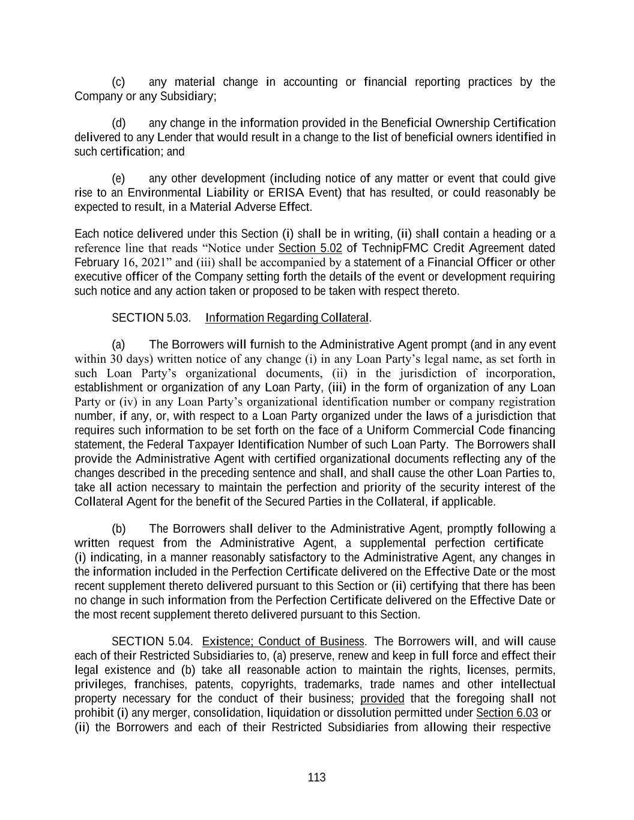
113 (c) any material change in accounting or financial reporting practices by the Company or any Subsidiary; (d) any change in the information provided in the Beneficial Ownership Certification delivered to any Lender that would result in a change to the list of beneficial owners identified in such certification; and (e) any other development (including notice of any matter or event that could give rise to an Environmental Liability or ERISA Event) that has resulted, or could reasonably be expected to result, in a Material Adverse Effect. Each notice delivered under this Section (i) shall be in writing, (ii) shall contain a heading or a reference line that reads “Notice under Section 5.02 of TechnipFMC Credit Agreement dated February 16, 2021” and (iii) shall be accompanied by a statement of a Financial Officer or other executive officer of the Company setting forth the details of the event or development requiring such notice and any action taken or proposed to be taken with respect thereto. SECTION 5.03. Information Regarding Collateral. (a) The Borrowers will furnish to the Administrative Agent prompt (and in any event within 30 days) written notice of any change (i) in any Loan Party’s legal name, as set forth in such Loan Party’s organizational documents, (ii) in the jurisdiction of incorporation, establishment or organization of any Loan Party, (iii) in the form of organization of any Loan Party or (iv) in any Loan Party’s organizational identification number or company registration number, if any, or, with respect to a Loan Party organized under the laws of a jurisdiction that requires such information to be set forth on the face of a Uniform Commercial Code financing statement, the Federal Taxpayer Identification Number of such Loan Party. The Borrowers shall provide the Administrative Agent with certified organizational documents reflecting any of the changes described in the preceding sentence and shall, and shall cause the other Loan Parties to, take all action necessary to maintain the perfection and priority of the security interest of the Collateral Agent for the benefit of the Secured Parties in the Collateral, if applicable. (b) The Borrowers shall deliver to the Administrative Agent, promptly following a written request from the Administrative Agent, a supplemental perfection certificate (i) indicating, in a manner reasonably satisfactory to the Administrative Agent, any changes in the information included in the Perfection Certificate delivered on the Effective Date or the most recent supplement thereto delivered pursuant to this Section or (ii) certifying that there has been no change in such information from the Perfection Certificate delivered on the Effective Date or the most recent supplement thereto delivered pursuant to this Section. SECTION 5.04. Existence; Conduct of Business. The Borrowers will, and will cause each of their Restricted Subsidiaries to, (a) preserve, renew and keep in full force and effect their legal existence and (b) take all reasonable action to maintain the rights, licenses, permits, privileges, franchises, patents, copyrights, trademarks, trade names and other intellectual property necessary for the conduct of their business; provided that the foregoing shall not prohibit (i) any merger, consolidation, liquidation or dissolution permitted under Section 6.03 or (ii) the Borrowers and each of their Restricted Subsidiaries from allowing their respective

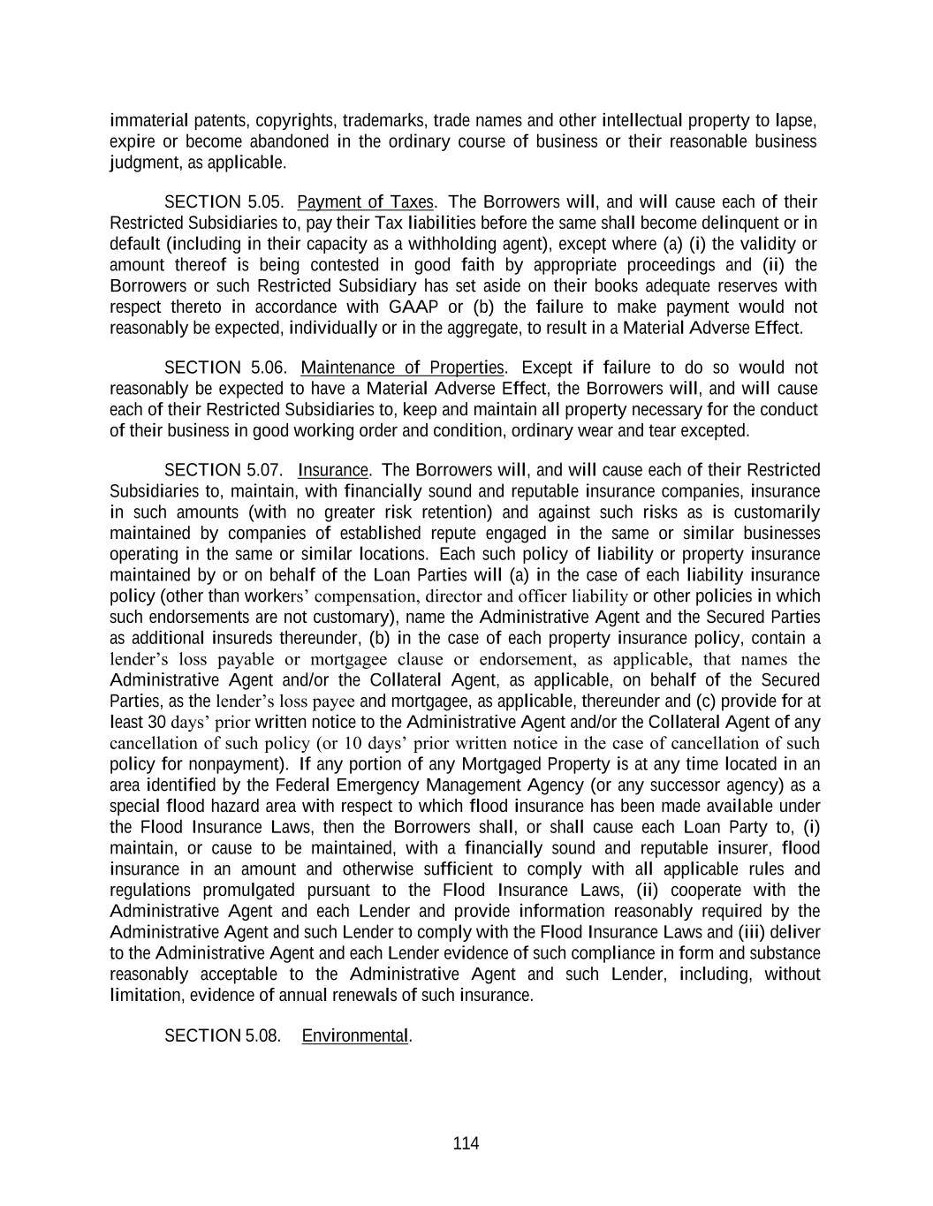
114 immaterial patents, copyrights, trademarks, trade names and other intellectual property to lapse, expire or become abandoned in the ordinary course of business or their reasonable business judgment, as applicable. SECTION 5.05. Payment of Taxes. The Borrowers will, and will cause each of their Restricted Subsidiaries to, pay their Tax liabilities before the same shall become delinquent or in default (including in their capacity as a withholding agent), except where (a) (i) the validity or amount thereof is being contested in good faith by appropriate proceedings and (ii) the Borrowers or such Restricted Subsidiary has set aside on their books adequate reserves with respect thereto in accordance with GAAP or (b) the failure to make payment would not reasonably be expected, individually or in the aggregate, to result in a Material Adverse Effect. SECTION 5.06. Maintenance of Properties. Except if failure to do so would not reasonably be expected to have a Material Adverse Effect, the Borrowers will, and will cause each of their Restricted Subsidiaries to, keep and maintain all property necessary for the conduct of their business in good working order and condition, ordinary wear and tear excepted. SECTION 5.07. Insurance. The Borrowers will, and will cause each of their Restricted Subsidiaries to, maintain, with financially sound and reputable insurance companies, insurance in such amounts (with no greater risk retention) and against such risks as is customarily maintained by companies of established repute engaged in the same or similar businesses operating in the same or similar locations. Each such policy of liability or property insurance maintained by or on behalf of the Loan Parties will (a) in the case of each liability insurance policy (other than workers’ compensation, director and officer liability or other policies in which such endorsements are not customary), name the Administrative Agent and the Secured Parties as additional insureds thereunder, (b) in the case of each property insurance policy, contain a lender’s loss payable or mortgagee clause or endorsement, as applicable, that names the Administrative Agent and/or the Collateral Agent, as applicable, on behalf of the Secured Parties, as the lender’s loss payee and mortgagee, as applicable, thereunder and (c) provide for at least 30 days’ prior written notice to the Administrative Agent and/or the Collateral Agent of any cancellation of such policy (or 10 days’ prior written notice in the case of cancellation of such policy for nonpayment). If any portion of any Mortgaged Property is at any time located in an area identified by the Federal Emergency Management Agency (or any successor agency) as a special flood hazard area with respect to which flood insurance has been made available under the Flood Insurance Laws, then the Borrowers shall, or shall cause each Loan Party to, (i) maintain, or cause to be maintained, with a financially sound and reputable insurer, flood insurance in an amount and otherwise sufficient to comply with all applicable rules and regulations promulgated pursuant to the Flood Insurance Laws, (ii) cooperate with the Administrative Agent and each Lender and provide information reasonably required by the Administrative Agent and such Lender to comply with the Flood Insurance Laws and (iii) deliver to the Administrative Agent and each Lender evidence of such compliance in form and substance reasonably acceptable to the Administrative Agent and such Lender, including, without limitation, evidence of annual renewals of such insurance. SECTION 5.08. Environmental.

115 Agent: (a) Environmental Disclosure. The Borrowers will deliver to the Administrative (i) as soon as reasonably practicable following the sending or receipt thereof by the Borrowers or any of their Restricted Subsidiaries, a copy of material written non- privileged communications with respect to (A) any Environmental Claims that, individually or in the aggregate, are reasonably expected to give rise to a Material Adverse Effect and (B) any Release required to be reported by the Borrowers or any of their Restricted Subsidiaries to any Governmental Authority that reasonably could be expected to have a Material Adverse Effect; (ii) with reasonable promptness, such other non-privileged documents and information as from time to time may be reasonably requested by the Administrative Agent in relation to any matters disclosed pursuant to this Section 5.08(a). (b) Hazardous Materials Activities, Etc. The Borrowers shall promptly take, and shall cause each of their Restricted Subsidiaries promptly to take, any and all actions necessary to (i) cure any violation of Environmental Laws that could reasonably be expected to have, individually or in the aggregate, a Material Adverse Effect and (ii) make an appropriate response to any Environmental Claim, in each case, where failure to do so could reasonably be expected to have, individually or in the aggregate, a Material Adverse Effect. SECTION 5.09. Books and Records; Inspection and Audit Rights. The Borrowers will, and will cause each of their Restricted Subsidiaries to, keep proper books of record and accounts in which full, true and correct entries in conformity with GAAP and all Requirements of Law are made of all dealings and transactions in relation to their business and activities. The Borrowers will, and will cause each of their Restricted Subsidiaries to, permit any representatives designated by the Administrative Agent or any Lender, upon reasonable prior notice, to visit and inspect their properties, to examine and make extracts from their books and records, and to discuss their affairs, finances and condition with their officers and independent accountants, all at such reasonable times during normal business hours upon reasonable prior notice to the Borrowers, but, unless an Event of Default has occurred and is continuing, no more often than two times during any calendar year; provided that none of the Borrowers or any Restricted Subsidiary will be required to disclose, permit the inspection, examination or making copies or abstracts of, or discussion of, any document, information or other matter (i) that constitutes non- financial trade secrets or non-financial proprietary information, (ii) in respect of which disclosure to the Administrative Agent or any Lender (or their respective representatives or contractors) is prohibited by Requirement of Law or any binding agreement or (iii) that is subject to attorney- client or similar privilege or constitutes attorney work product. SECTION 5.10. Compliance with Laws. The Borrowers will, and will cause each of their Restricted Subsidiaries to, comply with all Requirements of Law (including Environmental Laws) with respect to them or their property, except where the failure to do so, individually or in the aggregate, would not reasonably be expected to result in a Material Adverse Effect. The Borrowers will maintain in effect and enforce policies and procedures designed to ensure compliance by the Borrowers, their Subsidiaries and their respective directors, officers,

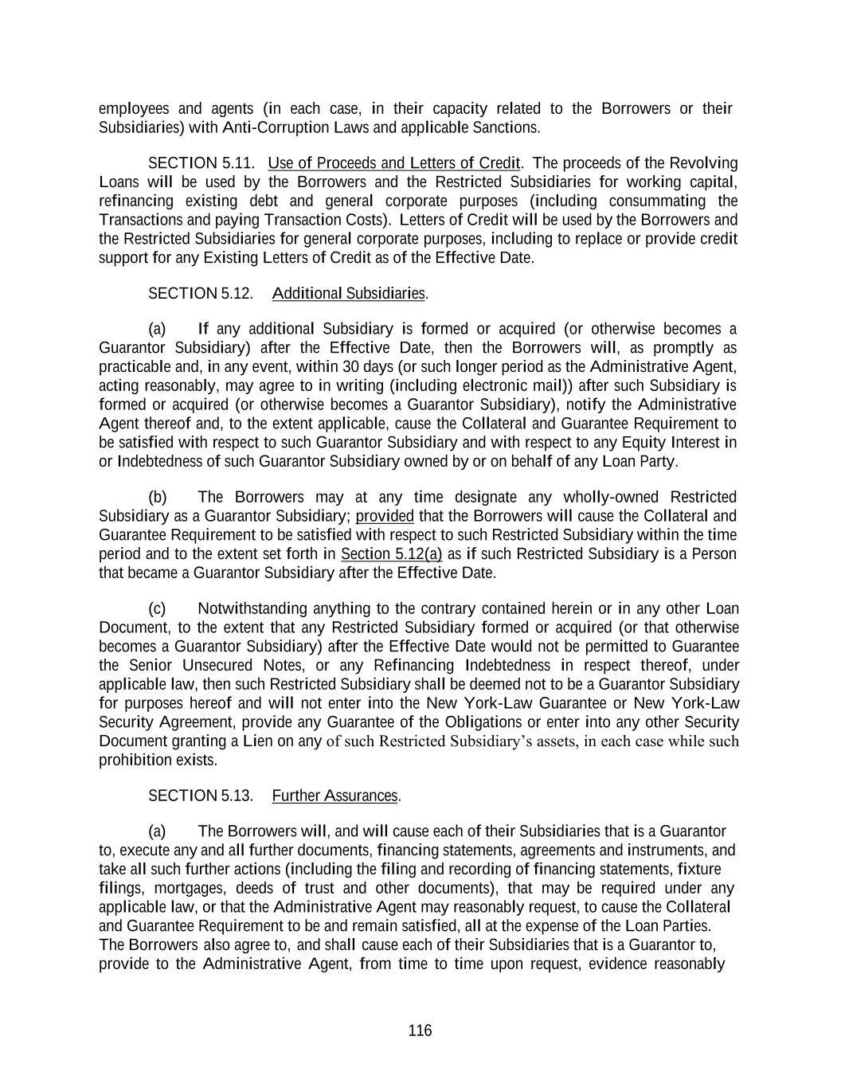
116 employees and agents (in each case, in their capacity related to the Borrowers or their Subsidiaries) with Anti-Corruption Laws and applicable Sanctions. SECTION 5.11. Use of Proceeds and Letters of Credit. The proceeds of the Revolving Loans will be used by the Borrowers and the Restricted Subsidiaries for working capital, refinancing existing debt and general corporate purposes (including consummating the Transactions and paying Transaction Costs). Letters of Credit will be used by the Borrowers and the Restricted Subsidiaries for general corporate purposes, including to replace or provide credit support for any Existing Letters of Credit as of the Effective Date. SECTION 5.12. Additional Subsidiaries. (a) If any additional Subsidiary is formed or acquired (or otherwise becomes a Guarantor Subsidiary) after the Effective Date, then the Borrowers will, as promptly as practicable and, in any event, within 30 days (or such longer period as the Administrative Agent, acting reasonably, may agree to in writing (including electronic mail)) after such Subsidiary is formed or acquired (or otherwise becomes a Guarantor Subsidiary), notify the Administrative Agent thereof and, to the extent applicable, cause the Collateral and Guarantee Requirement to be satisfied with respect to such Guarantor Subsidiary and with respect to any Equity Interest in or Indebtedness of such Guarantor Subsidiary owned by or on behalf of any Loan Party. (b) The Borrowers may at any time designate any wholly-owned Restricted Subsidiary as a Guarantor Subsidiary; provided that the Borrowers will cause the Collateral and Guarantee Requirement to be satisfied with respect to such Restricted Subsidiary within the time period and to the extent set forth in Section 5.12(a) as if such Restricted Subsidiary is a Person that became a Guarantor Subsidiary after the Effective Date. (c) Notwithstanding anything to the contrary contained herein or in any other Loan Document, to the extent that any Restricted Subsidiary formed or acquired (or that otherwise becomes a Guarantor Subsidiary) after the Effective Date would not be permitted to Guarantee the Senior Unsecured Notes, or any Refinancing Indebtedness in respect thereof, under applicable law, then such Restricted Subsidiary shall be deemed not to be a Guarantor Subsidiary for purposes hereof and will not enter into the New York-Law Guarantee or New York-Law Security Agreement, provide any Guarantee of the Obligations or enter into any other Security Document granting a Lien on any of such Restricted Subsidiary’s assets, in each case while such prohibition exists. SECTION 5.13. Further Assurances. (a) The Borrowers will, and will cause each of their Subsidiaries that is a Guarantor to, execute any and all further documents, financing statements, agreements and instruments, and take all such further actions (including the filing and recording of financing statements, fixture filings, mortgages, deeds of trust and other documents), that may be required under any applicable law, or that the Administrative Agent may reasonably request, to cause the Collateral and Guarantee Requirement to be and remain satisfied, all at the expense of the Loan Parties. The Borrowers also agree to, and shall cause each of their Subsidiaries that is a Guarantor to, provide to the Administrative Agent, from time to time upon request, evidence reasonably

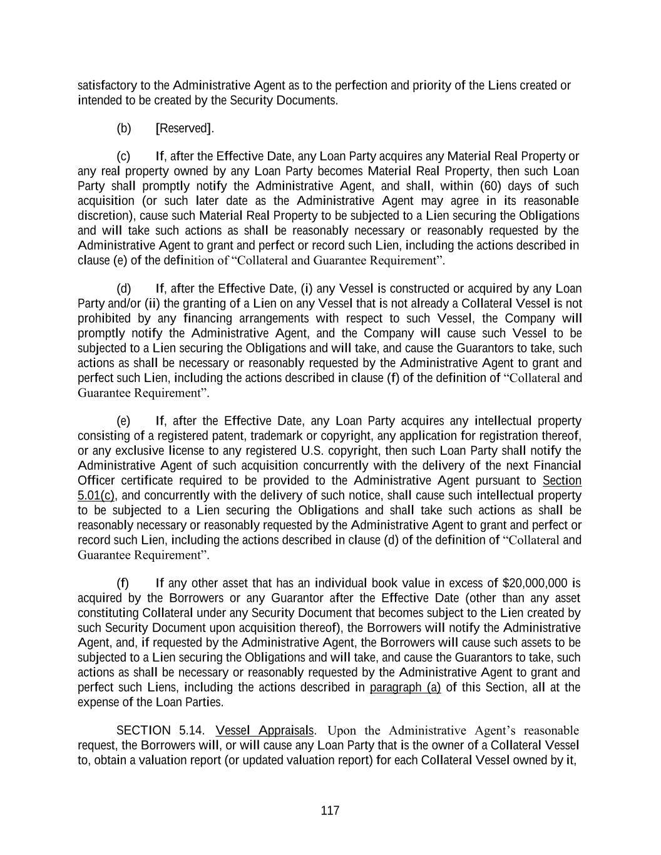
117 satisfactory to the Administrative Agent as to the perfection and priority of the Liens created or intended to be created by the Security Documents. (b) [Reserved]. (c) If, after the Effective Date, any Loan Party acquires any Material Real Property or any real property owned by any Loan Party becomes Material Real Property, then such Loan Party shall promptly notify the Administrative Agent, and shall, within (60) days of such acquisition (or such later date as the Administrative Agent may agree in its reasonable discretion), cause such Material Real Property to be subjected to a Lien securing the Obligations and will take such actions as shall be reasonably necessary or reasonably requested by the Administrative Agent to grant and perfect or record such Lien, including the actions described in clause (e) of the definition of “Collateral and Guarantee Requirement”. (d) If, after the Effective Date, (i) any Vessel is constructed or acquired by any Loan Party and/or (ii) the granting of a Lien on any Vessel that is not already a Collateral Vessel is not prohibited by any financing arrangements with respect to such Vessel, the Company will promptly notify the Administrative Agent, and the Company will cause such Vessel to be subjected to a Lien securing the Obligations and will take, and cause the Guarantors to take, such actions as shall be necessary or reasonably requested by the Administrative Agent to grant and perfect such Lien, including the actions described in clause (f) of the definition of “Collateral and Guarantee Requirement”. (e) If, after the Effective Date, any Loan Party acquires any intellectual property consisting of a registered patent, trademark or copyright, any application for registration thereof, or any exclusive license to any registered U.S. copyright, then such Loan Party shall notify the Administrative Agent of such acquisition concurrently with the delivery of the next Financial Officer certificate required to be provided to the Administrative Agent pursuant to Section 5.01(c), and concurrently with the delivery of such notice, shall cause such intellectual property to be subjected to a Lien securing the Obligations and shall take such actions as shall be reasonably necessary or reasonably requested by the Administrative Agent to grant and perfect or record such Lien, including the actions described in clause (d) of the definition of “Collateral and Guarantee Requirement”. (f) If any other asset that has an individual book value in excess of $20,000,000 is acquired by the Borrowers or any Guarantor after the Effective Date (other than any asset constituting Collateral under any Security Document that becomes subject to the Lien created by such Security Document upon acquisition thereof), the Borrowers will notify the Administrative Agent, and, if requested by the Administrative Agent, the Borrowers will cause such assets to be subjected to a Lien securing the Obligations and will take, and cause the Guarantors to take, such actions as shall be necessary or reasonably requested by the Administrative Agent to grant and perfect such Liens, including the actions described in paragraph (a) of this Section, all at the expense of the Loan Parties. SECTION 5.14. Vessel Appraisals. Upon the Administrative Agent’s reasonable request, the Borrowers will, or will cause any Loan Party that is the owner of a Collateral Vessel to, obtain a valuation report (or updated valuation report) for each Collateral Vessel owned by it,

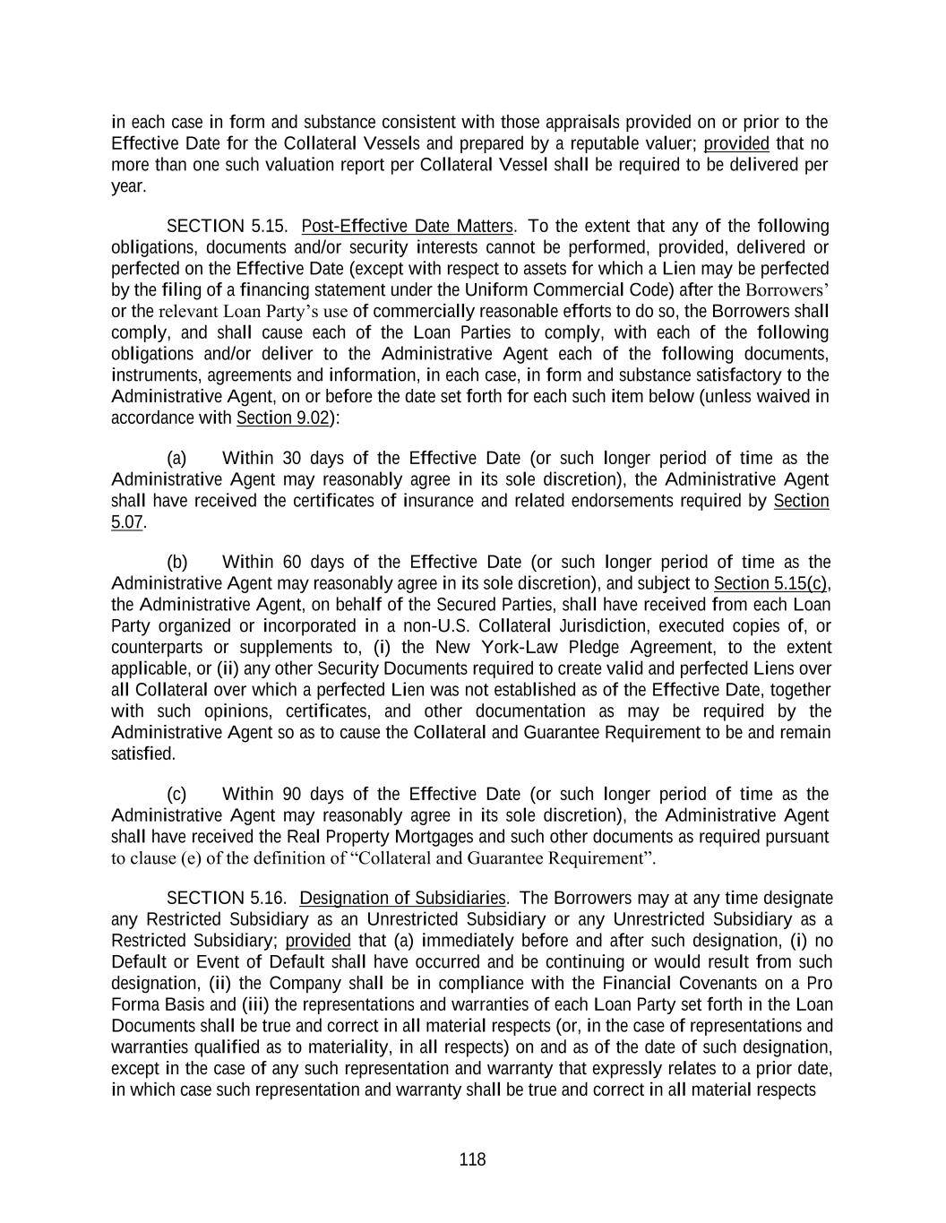
118 in each case in form and substance consistent with those appraisals provided on or prior to the Effective Date for the Collateral Vessels and prepared by a reputable valuer; provided that no more than one such valuation report per Collateral Vessel shall be required to be delivered per year. SECTION 5.15. Post-Effective Date Matters. To the extent that any of the following obligations, documents and/or security interests cannot be performed, provided, delivered or perfected on the Effective Date (except with respect to assets for which a Lien may be perfected by the filing of a financing statement under the Uniform Commercial Code) after the Borrowers’ or the relevant Loan Party’s use of commercially reasonable efforts to do so, the Borrowers shall comply, and shall cause each of the Loan Parties to comply, with each of the following obligations and/or deliver to the Administrative Agent each of the following documents, instruments, agreements and information, in each case, in form and substance satisfactory to the Administrative Agent, on or before the date set forth for each such item below (unless waived in accordance with Section 9.02): (a) Within 30 days of the Effective Date (or such longer period of time as the Administrative Agent may reasonably agree in its sole discretion), the Administrative Agent shall have received the certificates of insurance and related endorsements required by Section 5.07. (b) Within 60 days of the Effective Date (or such longer period of time as the Administrative Agent may reasonably agree in its sole discretion), and subject to Section 5.15(c), the Administrative Agent, on behalf of the Secured Parties, shall have received from each Loan Party organized or incorporated in a non-U.S. Collateral Jurisdiction, executed copies of, or counterparts or supplements to, (i) the New York-Law Pledge Agreement, to the extent applicable, or (ii) any other Security Documents required to create valid and perfected Liens over all Collateral over which a perfected Lien was not established as of the Effective Date, together with such opinions, certificates, and other documentation as may be required by the Administrative Agent so as to cause the Collateral and Guarantee Requirement to be and remain satisfied. (c) Within 90 days of the Effective Date (or such longer period of time as the Administrative Agent may reasonably agree in its sole discretion), the Administrative Agent shall have received the Real Property Mortgages and such other documents as required pursuant to clause (e) of the definition of “Collateral and Guarantee Requirement”. SECTION 5.16. Designation of Subsidiaries. The Borrowers may at any time designate any Restricted Subsidiary as an Unrestricted Subsidiary or any Unrestricted Subsidiary as a Restricted Subsidiary; provided that (a) immediately before and after such designation, (i) no Default or Event of Default shall have occurred and be continuing or would result from such designation, (ii) the Company shall be in compliance with the Financial Covenants on a Pro Forma Basis and (iii) the representations and warranties of each Loan Party set forth in the Loan Documents shall be true and correct in all material respects (or, in the case of representations and warranties qualified as to materiality, in all respects) on and as of the date of such designation, except in the case of any such representation and warranty that expressly relates to a prior date, in which case such representation and warranty shall be true and correct in all material respects

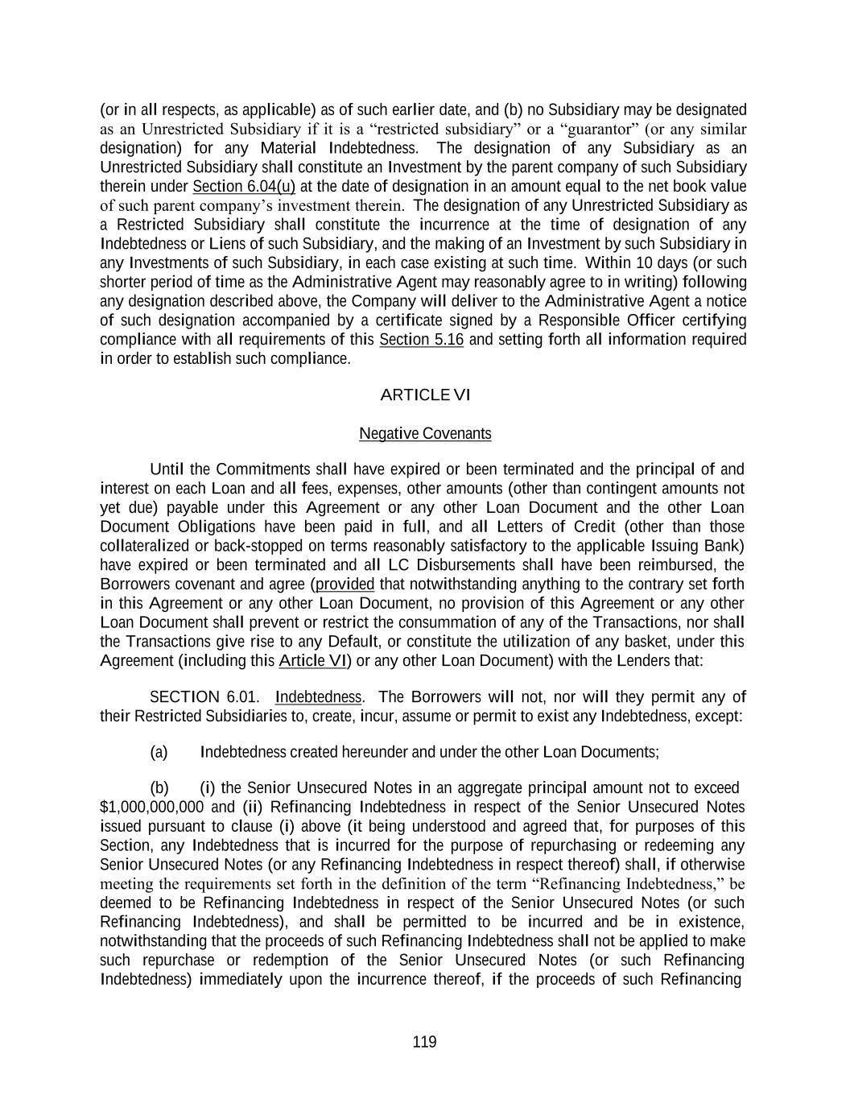
119 (or in all respects, as applicable) as of such earlier date, and (b) no Subsidiary may be designated as an Unrestricted Subsidiary if it is a “restricted subsidiary” or a “guarantor” (or any similar designation) for any Material Indebtedness. The designation of any Subsidiary as an Unrestricted Subsidiary shall constitute an Investment by the parent company of such Subsidiary therein under Section 6.04(u) at the date of designation in an amount equal to the net book value of such parent company’s investment therein. The designation of any Unrestricted Subsidiary as a Restricted Subsidiary shall constitute the incurrence at the time of designation of any Indebtedness or Liens of such Subsidiary, and the making of an Investment by such Subsidiary in any Investments of such Subsidiary, in each case existing at such time. Within 10 days (or such shorter period of time as the Administrative Agent may reasonably agree to in writing) following any designation described above, the Company will deliver to the Administrative Agent a notice of such designation accompanied by a certificate signed by a Responsible Officer certifying compliance with all requirements of this Section 5.16 and setting forth all information required in order to establish such compliance. ARTICLE VI Negative Covenants Until the Commitments shall have expired or been terminated and the principal of and interest on each Loan and all fees, expenses, other amounts (other than contingent amounts not yet due) payable under this Agreement or any other Loan Document and the other Loan Document Obligations have been paid in full, and all Letters of Credit (other than those collateralized or back-stopped on terms reasonably satisfactory to the applicable Issuing Bank) have expired or been terminated and all LC Disbursements shall have been reimbursed, the Borrowers covenant and agree (provided that notwithstanding anything to the contrary set forth in this Agreement or any other Loan Document, no provision of this Agreement or any other Loan Document shall prevent or restrict the consummation of any of the Transactions, nor shall the Transactions give rise to any Default, or constitute the utilization of any basket, under this Agreement (including this Article VI) or any other Loan Document) with the Lenders that: SECTION 6.01. Indebtedness. The Borrowers will not, nor will they permit any of their Restricted Subsidiaries to, create, incur, assume or permit to exist any Indebtedness, except: (a) Indebtedness created hereunder and under the other Loan Documents; (b) (i) the Senior Unsecured Notes in an aggregate principal amount not to exceed $1,000,000,000 and (ii) Refinancing Indebtedness in respect of the Senior Unsecured Notes issued pursuant to clause (i) above (it being understood and agreed that, for purposes of this Section, any Indebtedness that is incurred for the purpose of repurchasing or redeeming any Senior Unsecured Notes (or any Refinancing Indebtedness in respect thereof) shall, if otherwise meeting the requirements set forth in the definition of the term “Refinancing Indebtedness,” be deemed to be Refinancing Indebtedness in respect of the Senior Unsecured Notes (or such Refinancing Indebtedness), and shall be permitted to be incurred and be in existence, notwithstanding that the proceeds of such Refinancing Indebtedness shall not be applied to make such repurchase or redemption of the Senior Unsecured Notes (or such Refinancing Indebtedness) immediately upon the incurrence thereof, if the proceeds of such Refinancing

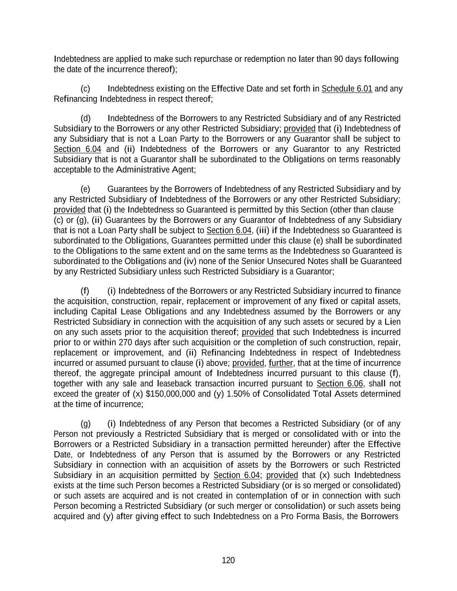
120 Indebtedness are applied to make such repurchase or redemption no later than 90 days following the date of the incurrence thereof); (c) Indebtedness existing on the Effective Date and set forth in Schedule 6.01 and any Refinancing Indebtedness in respect thereof; (d) Indebtedness of the Borrowers to any Restricted Subsidiary and of any Restricted Subsidiary to the Borrowers or any other Restricted Subsidiary; provided that (i) Indebtedness of any Subsidiary that is not a Loan Party to the Borrowers or any Guarantor shall be subject to Section 6.04 and (ii) Indebtedness of the Borrowers or any Guarantor to any Restricted Subsidiary that is not a Guarantor shall be subordinated to the Obligations on terms reasonably acceptable to the Administrative Agent; (e) Guarantees by the Borrowers of Indebtedness of any Restricted Subsidiary and by any Restricted Subsidiary of Indebtedness of the Borrowers or any other Restricted Subsidiary; provided that (i) the Indebtedness so Guaranteed is permitted by this Section (other than clause (c) or (g), (ii) Guarantees by the Borrowers or any Guarantor of Indebtedness of any Subsidiary that is not a Loan Party shall be subject to Section 6.04, (iii) if the Indebtedness so Guaranteed is subordinated to the Obligations, Guarantees permitted under this clause (e) shall be subordinated to the Obligations to the same extent and on the same terms as the Indebtedness so Guaranteed is subordinated to the Obligations and (iv) none of the Senior Unsecured Notes shall be Guaranteed by any Restricted Subsidiary unless such Restricted Subsidiary is a Guarantor; (f) (i) Indebtedness of the Borrowers or any Restricted Subsidiary incurred to finance the acquisition, construction, repair, replacement or improvement of any fixed or capital assets, including Capital Lease Obligations and any Indebtedness assumed by the Borrowers or any Restricted Subsidiary in connection with the acquisition of any such assets or secured by a Lien on any such assets prior to the acquisition thereof; provided that such Indebtedness is incurred prior to or within 270 days after such acquisition or the completion of such construction, repair, replacement or improvement, and (ii) Refinancing Indebtedness in respect of Indebtedness incurred or assumed pursuant to clause (i) above; provided, further, that at the time of incurrence thereof, the aggregate principal amount of Indebtedness incurred pursuant to this clause (f), together with any sale and leaseback transaction incurred pursuant to Section 6.06, shall not exceed the greater of (x) $150,000,000 and (y) 1.50% of Consolidated Total Assets determined at the time of incurrence; (g) (i) Indebtedness of any Person that becomes a Restricted Subsidiary (or of any Person not previously a Restricted Subsidiary that is merged or consolidated with or into the Borrowers or a Restricted Subsidiary in a transaction permitted hereunder) after the Effective Date, or Indebtedness of any Person that is assumed by the Borrowers or any Restricted Subsidiary in connection with an acquisition of assets by the Borrowers or such Restricted Subsidiary in an acquisition permitted by Section 6.04; provided that (x) such Indebtedness exists at the time such Person becomes a Restricted Subsidiary (or is so merged or consolidated) or such assets are acquired and is not created in contemplation of or in connection with such Person becoming a Restricted Subsidiary (or such merger or consolidation) or such assets being acquired and (y) after giving effect to such Indebtedness on a Pro Forma Basis, the Borrowers

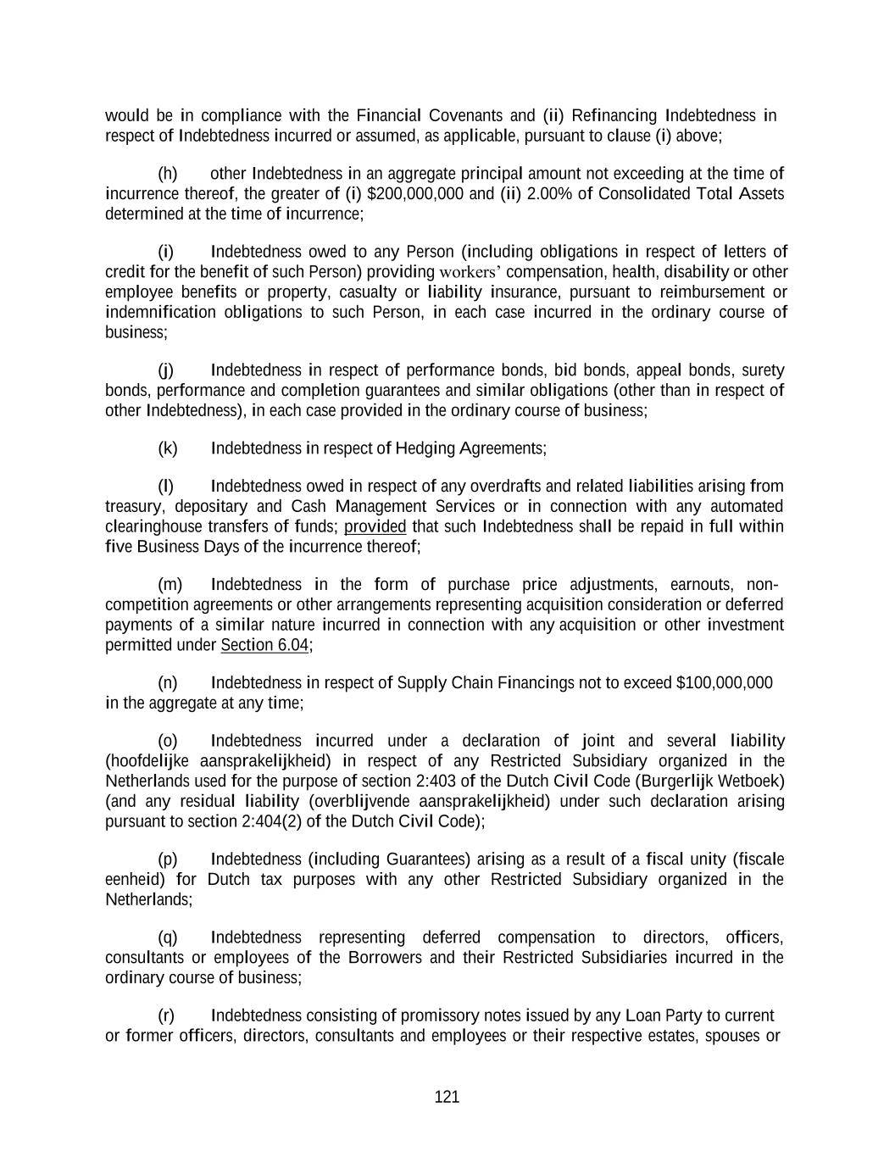
121 would be in compliance with the Financial Covenants and (ii) Refinancing Indebtedness in respect of Indebtedness incurred or assumed, as applicable, pursuant to clause (i) above; (h) other Indebtedness in an aggregate principal amount not exceeding at the time of incurrence thereof, the greater of (i) $200,000,000 and (ii) 2.00% of Consolidated Total Assets determined at the time of incurrence; (i) Indebtedness owed to any Person (including obligations in respect of letters of credit for the benefit of such Person) providing workers’ compensation, health, disability or other employee benefits or property, casualty or liability insurance, pursuant to reimbursement or indemnification obligations to such Person, in each case incurred in the ordinary course of business; (j) Indebtedness in respect of performance bonds, bid bonds, appeal bonds, surety bonds, performance and completion guarantees and similar obligations (other than in respect of other Indebtedness), in each case provided in the ordinary course of business; (k) Indebtedness in respect of Hedging Agreements; (l) Indebtedness owed in respect of any overdrafts and related liabilities arising from treasury, depositary and Cash Management Services or in connection with any automated clearinghouse transfers of funds; provided that such Indebtedness shall be repaid in full within five Business Days of the incurrence thereof; (m) Indebtedness in the form of purchase price adjustments, earnouts, non- competition agreements or other arrangements representing acquisition consideration or deferred payments of a similar nature incurred in connection with any acquisition or other investment permitted under Section 6.04; (n) Indebtedness in respect of Supply Chain Financings not to exceed $100,000,000 in the aggregate at any time; (o) Indebtedness incurred under a declaration of joint and several liability (hoofdelijke aansprakelijkheid) in respect of any Restricted Subsidiary organized in the Netherlands used for the purpose of section 2:403 of the Dutch Civil Code (Burgerlijk Wetboek) (and any residual liability (overblijvende aansprakelijkheid) under such declaration arising pursuant to section 2:404(2) of the Dutch Civil Code); (p) Indebtedness (including Guarantees) arising as a result of a fiscal unity (fiscale eenheid) for Dutch tax purposes with any other Restricted Subsidiary organized in the Netherlands; (q) Indebtedness representing deferred compensation to directors, officers, consultants or employees of the Borrowers and their Restricted Subsidiaries incurred in the ordinary course of business; (r) Indebtedness consisting of promissory notes issued by any Loan Party to current or former officers, directors, consultants and employees or their respective estates, spouses or

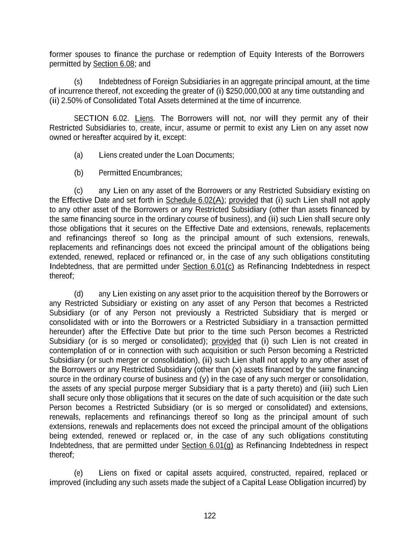
122 former spouses to finance the purchase or redemption of Equity Interests of the Borrowers permitted by Section 6.08; and (s) Indebtedness of Foreign Subsidiaries in an aggregate principal amount, at the time of incurrence thereof, not exceeding the greater of (i) $250,000,000 at any time outstanding and (ii) 2.50% of Consolidated Total Assets determined at the time of incurrence. SECTION 6.02. Liens. The Borrowers will not, nor will they permit any of their Restricted Subsidiaries to, create, incur, assume or permit to exist any Lien on any asset now owned or hereafter acquired by it, except: (a) Liens created under the Loan Documents; (b) Permitted Encumbrances; (c) any Lien on any asset of the Borrowers or any Restricted Subsidiary existing on the Effective Date and set forth in Schedule 6.02(A); provided that (i) such Lien shall not apply to any other asset of the Borrowers or any Restricted Subsidiary (other than assets financed by the same financing source in the ordinary course of business), and (ii) such Lien shall secure only those obligations that it secures on the Effective Date and extensions, renewals, replacements and refinancings thereof so long as the principal amount of such extensions, renewals, replacements and refinancings does not exceed the principal amount of the obligations being extended, renewed, replaced or refinanced or, in the case of any such obligations constituting Indebtedness, that are permitted under Section 6.01(c) as Refinancing Indebtedness in respect thereof; (d) any Lien existing on any asset prior to the acquisition thereof by the Borrowers or any Restricted Subsidiary or existing on any asset of any Person that becomes a Restricted Subsidiary (or of any Person not previously a Restricted Subsidiary that is merged or consolidated with or into the Borrowers or a Restricted Subsidiary in a transaction permitted hereunder) after the Effective Date but prior to the time such Person becomes a Restricted Subsidiary (or is so merged or consolidated); provided that (i) such Lien is not created in contemplation of or in connection with such acquisition or such Person becoming a Restricted Subsidiary (or such merger or consolidation), (ii) such Lien shall not apply to any other asset of the Borrowers or any Restricted Subsidiary (other than (x) assets financed by the same financing source in the ordinary course of business and (y) in the case of any such merger or consolidation, the assets of any special purpose merger Subsidiary that is a party thereto) and (iii) such Lien shall secure only those obligations that it secures on the date of such acquisition or the date such Person becomes a Restricted Subsidiary (or is so merged or consolidated) and extensions, renewals, replacements and refinancings thereof so long as the principal amount of such extensions, renewals and replacements does not exceed the principal amount of the obligations being extended, renewed or replaced or, in the case of any such obligations constituting Indebtedness, that are permitted under Section 6.01(g) as Refinancing Indebtedness in respect thereof; (e) Liens on fixed or capital assets acquired, constructed, repaired, replaced or improved (including any such assets made the subject of a Capital Lease Obligation incurred) by

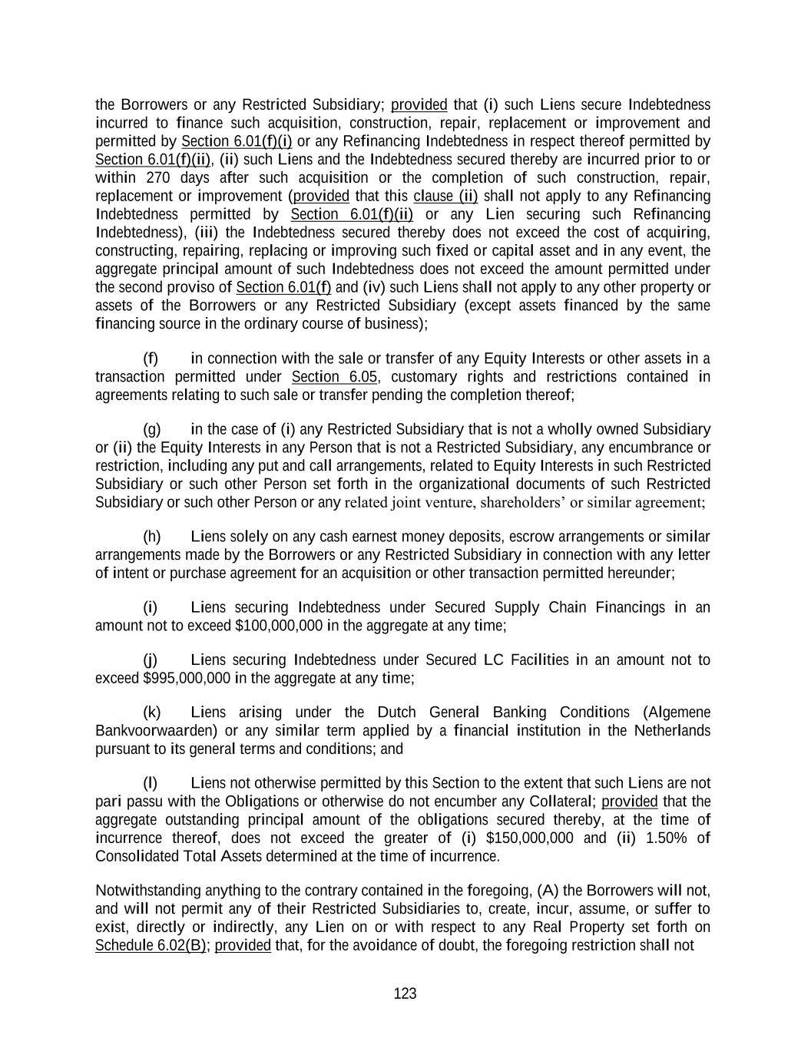
123 the Borrowers or any Restricted Subsidiary; provided that (i) such Liens secure Indebtedness incurred to finance such acquisition, construction, repair, replacement or improvement and permitted by Section 6.01(f)(i) or any Refinancing Indebtedness in respect thereof permitted by Section 6.01(f)(ii), (ii) such Liens and the Indebtedness secured thereby are incurred prior to or within 270 days after such acquisition or the completion of such construction, repair, replacement or improvement (provided that this clause (ii) shall not apply to any Refinancing Indebtedness permitted by Section 6.01(f)(ii) or any Lien securing such Refinancing Indebtedness), (iii) the Indebtedness secured thereby does not exceed the cost of acquiring, constructing, repairing, replacing or improving such fixed or capital asset and in any event, the aggregate principal amount of such Indebtedness does not exceed the amount permitted under the second proviso of Section 6.01(f) and (iv) such Liens shall not apply to any other property or assets of the Borrowers or any Restricted Subsidiary (except assets financed by the same financing source in the ordinary course of business); (f) in connection with the sale or transfer of any Equity Interests or other assets in a transaction permitted under Section 6.05, customary rights and restrictions contained in agreements relating to such sale or transfer pending the completion thereof; (g) in the case of (i) any Restricted Subsidiary that is not a wholly owned Subsidiary or (ii) the Equity Interests in any Person that is not a Restricted Subsidiary, any encumbrance or restriction, including any put and call arrangements, related to Equity Interests in such Restricted Subsidiary or such other Person set forth in the organizational documents of such Restricted Subsidiary or such other Person or any related joint venture, shareholders’ or similar agreement; (h) Liens solely on any cash earnest money deposits, escrow arrangements or similar arrangements made by the Borrowers or any Restricted Subsidiary in connection with any letter of intent or purchase agreement for an acquisition or other transaction permitted hereunder; (i) Liens securing Indebtedness under Secured Supply Chain Financings in an amount not to exceed $100,000,000 in the aggregate at any time; (j) Liens securing Indebtedness under Secured LC Facilities in an amount not to exceed $995,000,000 in the aggregate at any time; (k) Liens arising under the Dutch General Banking Conditions (Algemene Bankvoorwaarden) or any similar term applied by a financial institution in the Netherlands pursuant to its general terms and conditions; and (l) Liens not otherwise permitted by this Section to the extent that such Liens are not pari passu with the Obligations or otherwise do not encumber any Collateral; provided that the aggregate outstanding principal amount of the obligations secured thereby, at the time of incurrence thereof, does not exceed the greater of (i) $150,000,000 and (ii) 1.50% of Consolidated Total Assets determined at the time of incurrence. Notwithstanding anything to the contrary contained in the foregoing, (A) the Borrowers will not, and will not permit any of their Restricted Subsidiaries to, create, incur, assume, or suffer to exist, directly or indirectly, any Lien on or with respect to any Real Property set forth on Schedule 6.02(B); provided that, for the avoidance of doubt, the foregoing restriction shall not

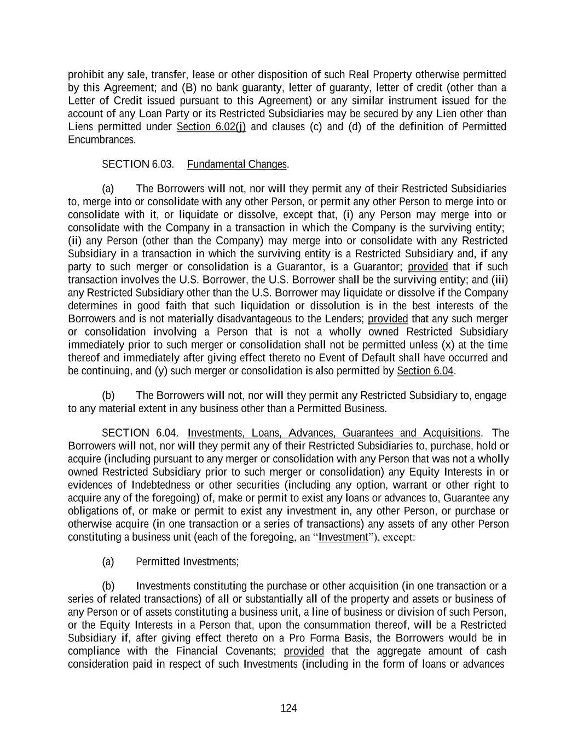
124 prohibit any sale, transfer, lease or other disposition of such Real Property otherwise permitted by this Agreement; and (B) no bank guaranty, letter of guaranty, letter of credit (other than a Letter of Credit issued pursuant to this Agreement) or any similar instrument issued for the account of any Loan Party or its Restricted Subsidiaries may be secured by any Lien other than Liens permitted under Section 6.02(j) and clauses (c) and (d) of the definition of Permitted Encumbrances. SECTION 6.03. Fundamental Changes. (a) The Borrowers will not, nor will they permit any of their Restricted Subsidiaries to, merge into or consolidate with any other Person, or permit any other Person to merge into or consolidate with it, or liquidate or dissolve, except that, (i) any Person may merge into or consolidate with the Company in a transaction in which the Company is the surviving entity; (ii) any Person (other than the Company) may merge into or consolidate with any Restricted Subsidiary in a transaction in which the surviving entity is a Restricted Subsidiary and, if any party to such merger or consolidation is a Guarantor, is a Guarantor; provided that if such transaction involves the U.S. Borrower, the U.S. Borrower shall be the surviving entity; and (iii) any Restricted Subsidiary other than the U.S. Borrower may liquidate or dissolve if the Company determines in good faith that such liquidation or dissolution is in the best interests of the Borrowers and is not materially disadvantageous to the Lenders; provided that any such merger or consolidation involving a Person that is not a wholly owned Restricted Subsidiary immediately prior to such merger or consolidation shall not be permitted unless (x) at the time thereof and immediately after giving effect thereto no Event of Default shall have occurred and be continuing, and (y) such merger or consolidation is also permitted by Section 6.04. (b) The Borrowers will not, nor will they permit any Restricted Subsidiary to, engage to any material extent in any business other than a Permitted Business. SECTION 6.04. Investments, Loans, Advances, Guarantees and Acquisitions. The Borrowers will not, nor will they permit any of their Restricted Subsidiaries to, purchase, hold or acquire (including pursuant to any merger or consolidation with any Person that was not a wholly owned Restricted Subsidiary prior to such merger or consolidation) any Equity Interests in or evidences of Indebtedness or other securities (including any option, warrant or other right to acquire any of the foregoing) of, make or permit to exist any loans or advances to, Guarantee any obligations of, or make or permit to exist any investment in, any other Person, or purchase or otherwise acquire (in one transaction or a series of transactions) any assets of any other Person constituting a business unit (each of the foregoing, an “Investment”), except: (a) Permitted Investments; (b) Investments constituting the purchase or other acquisition (in one transaction or a series of related transactions) of all or substantially all of the property and assets or business of any Person or of assets constituting a business unit, a line of business or division of such Person, or the Equity Interests in a Person that, upon the consummation thereof, will be a Restricted Subsidiary if, after giving effect thereto on a Pro Forma Basis, the Borrowers would be in compliance with the Financial Covenants; provided that the aggregate amount of cash consideration paid in respect of such Investments (including in the form of loans or advances

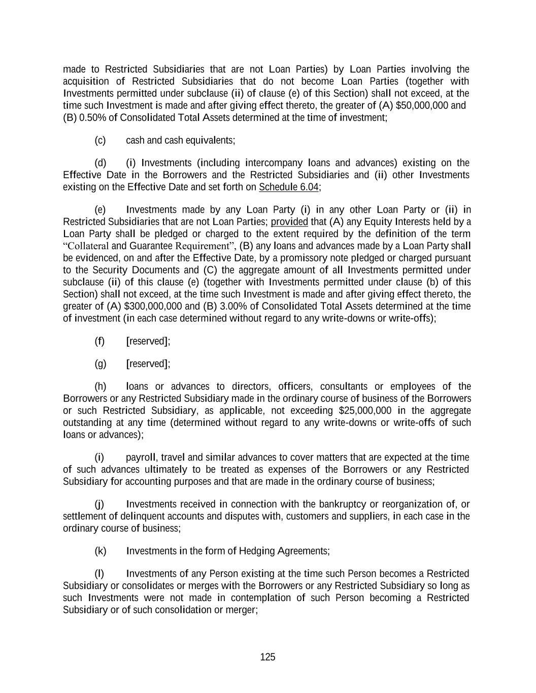
125 made to Restricted Subsidiaries that are not Loan Parties) by Loan Parties involving the acquisition of Restricted Subsidiaries that do not become Loan Parties (together with Investments permitted under subclause (ii) of clause (e) of this Section) shall not exceed, at the time such Investment is made and after giving effect thereto, the greater of (A) $50,000,000 and (B) 0.50% of Consolidated Total Assets determined at the time of investment; (c) cash and cash equivalents; (d) (i) Investments (including intercompany loans and advances) existing on the Effective Date in the Borrowers and the Restricted Subsidiaries and (ii) other Investments existing on the Effective Date and set forth on Schedule 6.04; (e) Investments made by any Loan Party (i) in any other Loan Party or (ii) in Restricted Subsidiaries that are not Loan Parties; provided that (A) any Equity Interests held by a Loan Party shall be pledged or charged to the extent required by the definition of the term “Collateral and Guarantee Requirement”, (B) any loans and advances made by a Loan Party shall be evidenced, on and after the Effective Date, by a promissory note pledged or charged pursuant to the Security Documents and (C) the aggregate amount of all Investments permitted under subclause (ii) of this clause (e) (together with Investments permitted under clause (b) of this Section) shall not exceed, at the time such Investment is made and after giving effect thereto, the greater of (A) $300,000,000 and (B) 3.00% of Consolidated Total Assets determined at the time of investment (in each case determined without regard to any write-downs or write-offs); (f) [reserved]; (g) [reserved]; (h) loans or advances to directors, officers, consultants or employees of the Borrowers or any Restricted Subsidiary made in the ordinary course of business of the Borrowers or such Restricted Subsidiary, as applicable, not exceeding $25,000,000 in the aggregate outstanding at any time (determined without regard to any write-downs or write-offs of such loans or advances); (i) payroll, travel and similar advances to cover matters that are expected at the time of such advances ultimately to be treated as expenses of the Borrowers or any Restricted Subsidiary for accounting purposes and that are made in the ordinary course of business; (j) Investments received in connection with the bankruptcy or reorganization of, or settlement of delinquent accounts and disputes with, customers and suppliers, in each case in the ordinary course of business; (k) Investments in the form of Hedging Agreements; (l) Investments of any Person existing at the time such Person becomes a Restricted Subsidiary or consolidates or merges with the Borrowers or any Restricted Subsidiary so long as such Investments were not made in contemplation of such Person becoming a Restricted Subsidiary or of such consolidation or merger;

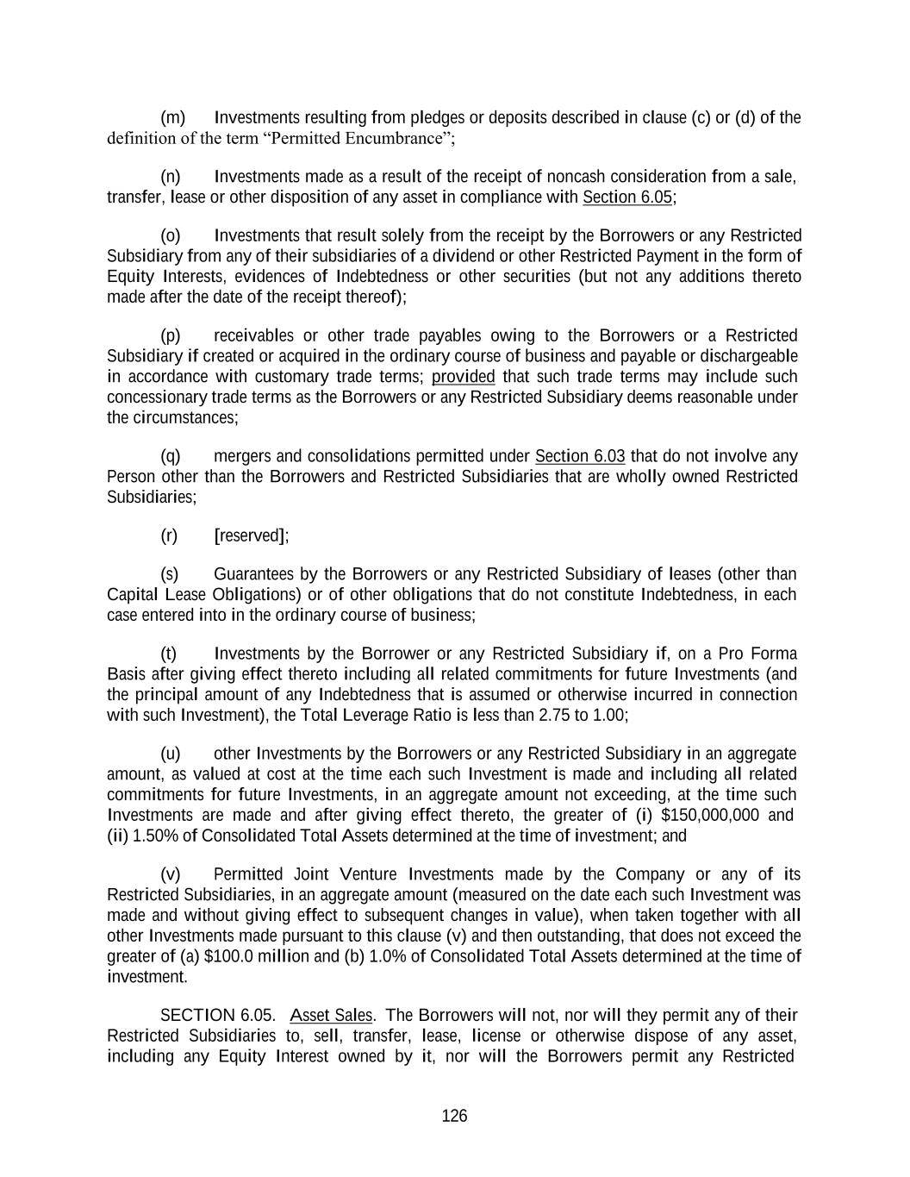
126 (m) Investments resulting from pledges or deposits described in clause (c) or (d) of the definition of the term “Permitted Encumbrance”; (n) Investments made as a result of the receipt of noncash consideration from a sale, transfer, lease or other disposition of any asset in compliance with Section 6.05; (o) Investments that result solely from the receipt by the Borrowers or any Restricted Subsidiary from any of their subsidiaries of a dividend or other Restricted Payment in the form of Equity Interests, evidences of Indebtedness or other securities (but not any additions thereto made after the date of the receipt thereof); (p) receivables or other trade payables owing to the Borrowers or a Restricted Subsidiary if created or acquired in the ordinary course of business and payable or dischargeable in accordance with customary trade terms; provided that such trade terms may include such concessionary trade terms as the Borrowers or any Restricted Subsidiary deems reasonable under the circumstances; (q) mergers and consolidations permitted under Section 6.03 that do not involve any Person other than the Borrowers and Restricted Subsidiaries that are wholly owned Restricted Subsidiaries; (r) [reserved]; (s) Guarantees by the Borrowers or any Restricted Subsidiary of leases (other than Capital Lease Obligations) or of other obligations that do not constitute Indebtedness, in each case entered into in the ordinary course of business; (t) Investments by the Borrower or any Restricted Subsidiary if, on a Pro Forma Basis after giving effect thereto including all related commitments for future Investments (and the principal amount of any Indebtedness that is assumed or otherwise incurred in connection with such Investment), the Total Leverage Ratio is less than 2.75 to 1.00; (u) other Investments by the Borrowers or any Restricted Subsidiary in an aggregate amount, as valued at cost at the time each such Investment is made and including all related commitments for future Investments, in an aggregate amount not exceeding, at the time such Investments are made and after giving effect thereto, the greater of (i) $150,000,000 and (ii) 1.50% of Consolidated Total Assets determined at the time of investment; and (v) Permitted Joint Venture Investments made by the Company or any of its Restricted Subsidiaries, in an aggregate amount (measured on the date each such Investment was made and without giving effect to subsequent changes in value), when taken together with all other Investments made pursuant to this clause (v) and then outstanding, that does not exceed the greater of (a) $100.0 million and (b) 1.0% of Consolidated Total Assets determined at the time of investment. SECTION 6.05. Asset Sales. The Borrowers will not, nor will they permit any of their Restricted Subsidiaries to, sell, transfer, lease, license or otherwise dispose of any asset, including any Equity Interest owned by it, nor will the Borrowers permit any Restricted

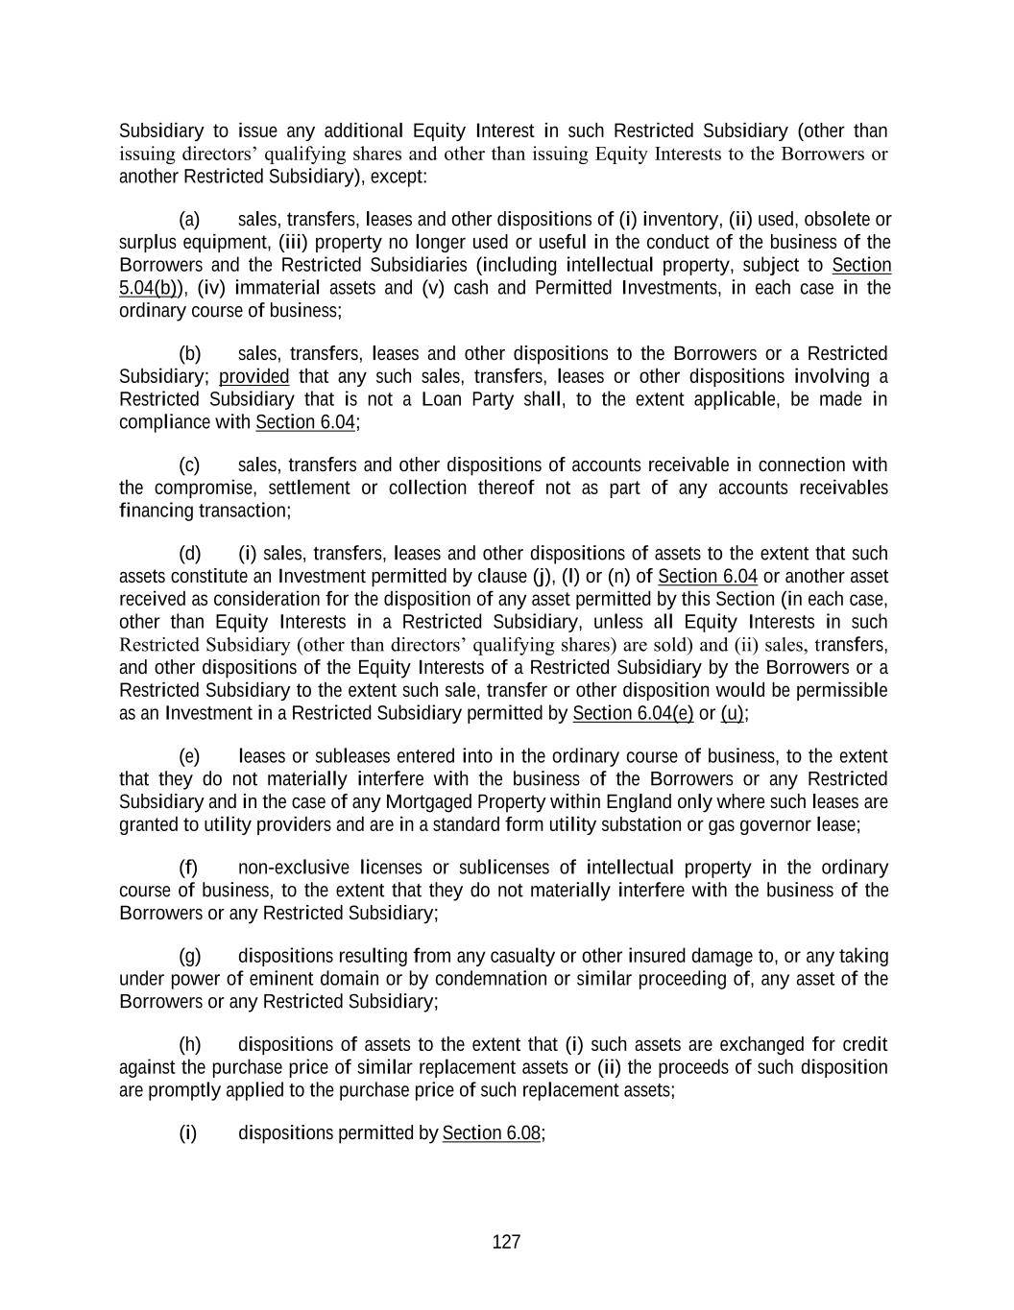
127 Subsidiary to issue any additional Equity Interest in such Restricted Subsidiary (other than issuing directors’ qualifying shares and other than issuing Equity Interests to the Borrowers or another Restricted Subsidiary), except: (a) sales, transfers, leases and other dispositions of (i) inventory, (ii) used, obsolete or surplus equipment, (iii) property no longer used or useful in the conduct of the business of the Borrowers and the Restricted Subsidiaries (including intellectual property, subject to Section 5.04(b)), (iv) immaterial assets and (v) cash and Permitted Investments, in each case in the ordinary course of business; (b) sales, transfers, leases and other dispositions to the Borrowers or a Restricted Subsidiary; provided that any such sales, transfers, leases or other dispositions involving a Restricted Subsidiary that is not a Loan Party shall, to the extent applicable, be made in compliance with Section 6.04; (c) sales, transfers and other dispositions of accounts receivable in connection with the compromise, settlement or collection thereof not as part of any accounts receivables financing transaction; (d) (i) sales, transfers, leases and other dispositions of assets to the extent that such assets constitute an Investment permitted by clause (j), (l) or (n) of Section 6.04 or another asset received as consideration for the disposition of any asset permitted by this Section (in each case, other than Equity Interests in a Restricted Subsidiary, unless all Equity Interests in such Restricted Subsidiary (other than directors’ qualifying shares) are sold) and (ii) sales, transfers, and other dispositions of the Equity Interests of a Restricted Subsidiary by the Borrowers or a Restricted Subsidiary to the extent such sale, transfer or other disposition would be permissible as an Investment in a Restricted Subsidiary permitted by Section 6.04(e) or (u); (e) leases or subleases entered into in the ordinary course of business, to the extent that they do not materially interfere with the business of the Borrowers or any Restricted Subsidiary and in the case of any Mortgaged Property within England only where such leases are granted to utility providers and are in a standard form utility substation or gas governor lease; (f) non-exclusive licenses or sublicenses of intellectual property in the ordinary course of business, to the extent that they do not materially interfere with the business of the Borrowers or any Restricted Subsidiary; (g) dispositions resulting from any casualty or other insured damage to, or any taking under power of eminent domain or by condemnation or similar proceeding of, any asset of the Borrowers or any Restricted Subsidiary; (h) dispositions of assets to the extent that (i) such assets are exchanged for credit against the purchase price of similar replacement assets or (ii) the proceeds of such disposition are promptly applied to the purchase price of such replacement assets; (i) dispositions permitted by Section 6.08;

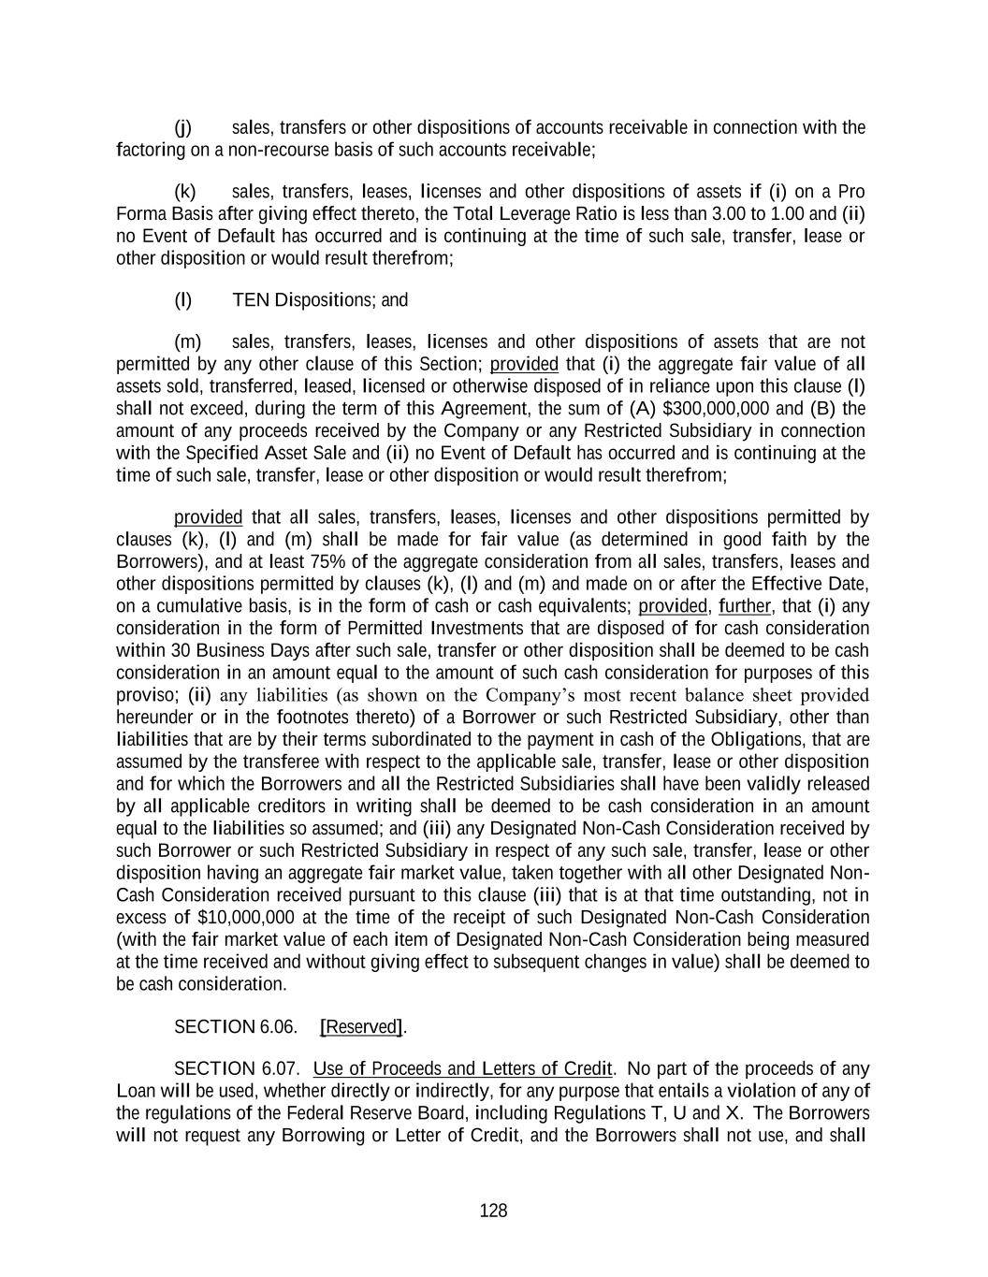
128 (j) sales, transfers or other dispositions of accounts receivable in connection with the factoring on a non-recourse basis of such accounts receivable; (k) sales, transfers, leases, licenses and other dispositions of assets if (i) on a Pro Forma Basis after giving effect thereto, the Total Leverage Ratio is less than 3.00 to 1.00 and (ii) no Event of Default has occurred and is continuing at the time of such sale, transfer, lease or other disposition or would result therefrom; (l) TEN Dispositions; and (m) sales, transfers, leases, licenses and other dispositions of assets that are not permitted by any other clause of this Section; provided that (i) the aggregate fair value of all assets sold, transferred, leased, licensed or otherwise disposed of in reliance upon this clause (l) shall not exceed, during the term of this Agreement, the sum of (A) $300,000,000 and (B) the amount of any proceeds received by the Company or any Restricted Subsidiary in connection with the Specified Asset Sale and (ii) no Event of Default has occurred and is continuing at the time of such sale, transfer, lease or other disposition or would result therefrom; provided that all sales, transfers, leases, licenses and other dispositions permitted by clauses (k), (l) and (m) shall be made for fair value (as determined in good faith by the Borrowers), and at least 75% of the aggregate consideration from all sales, transfers, leases and other dispositions permitted by clauses (k), (l) and (m) and made on or after the Effective Date, on a cumulative basis, is in the form of cash or cash equivalents; provided, further, that (i) any consideration in the form of Permitted Investments that are disposed of for cash consideration within 30 Business Days after such sale, transfer or other disposition shall be deemed to be cash consideration in an amount equal to the amount of such cash consideration for purposes of this proviso; (ii) any liabilities (as shown on the Company’s most recent balance sheet provided hereunder or in the footnotes thereto) of a Borrower or such Restricted Subsidiary, other than liabilities that are by their terms subordinated to the payment in cash of the Obligations, that are assumed by the transferee with respect to the applicable sale, transfer, lease or other disposition and for which the Borrowers and all the Restricted Subsidiaries shall have been validly released by all applicable creditors in writing shall be deemed to be cash consideration in an amount equal to the liabilities so assumed; and (iii) any Designated Non-Cash Consideration received by such Borrower or such Restricted Subsidiary in respect of any such sale, transfer, lease or other disposition having an aggregate fair market value, taken together with all other Designated Non- Cash Consideration received pursuant to this clause (iii) that is at that time outstanding, not in excess of $10,000,000 at the time of the receipt of such Designated Non-Cash Consideration (with the fair market value of each item of Designated Non-Cash Consideration being measured at the time received and without giving effect to subsequent changes in value) shall be deemed to be cash consideration. SECTION 6.06. [Reserved]. SECTION 6.07. Use of Proceeds and Letters of Credit. No part of the proceeds of any Loan will be used, whether directly or indirectly, for any purpose that entails a violation of any of the regulations of the Federal Reserve Board, including Regulations T, U and X. The Borrowers will not request any Borrowing or Letter of Credit, and the Borrowers shall not use, and shall

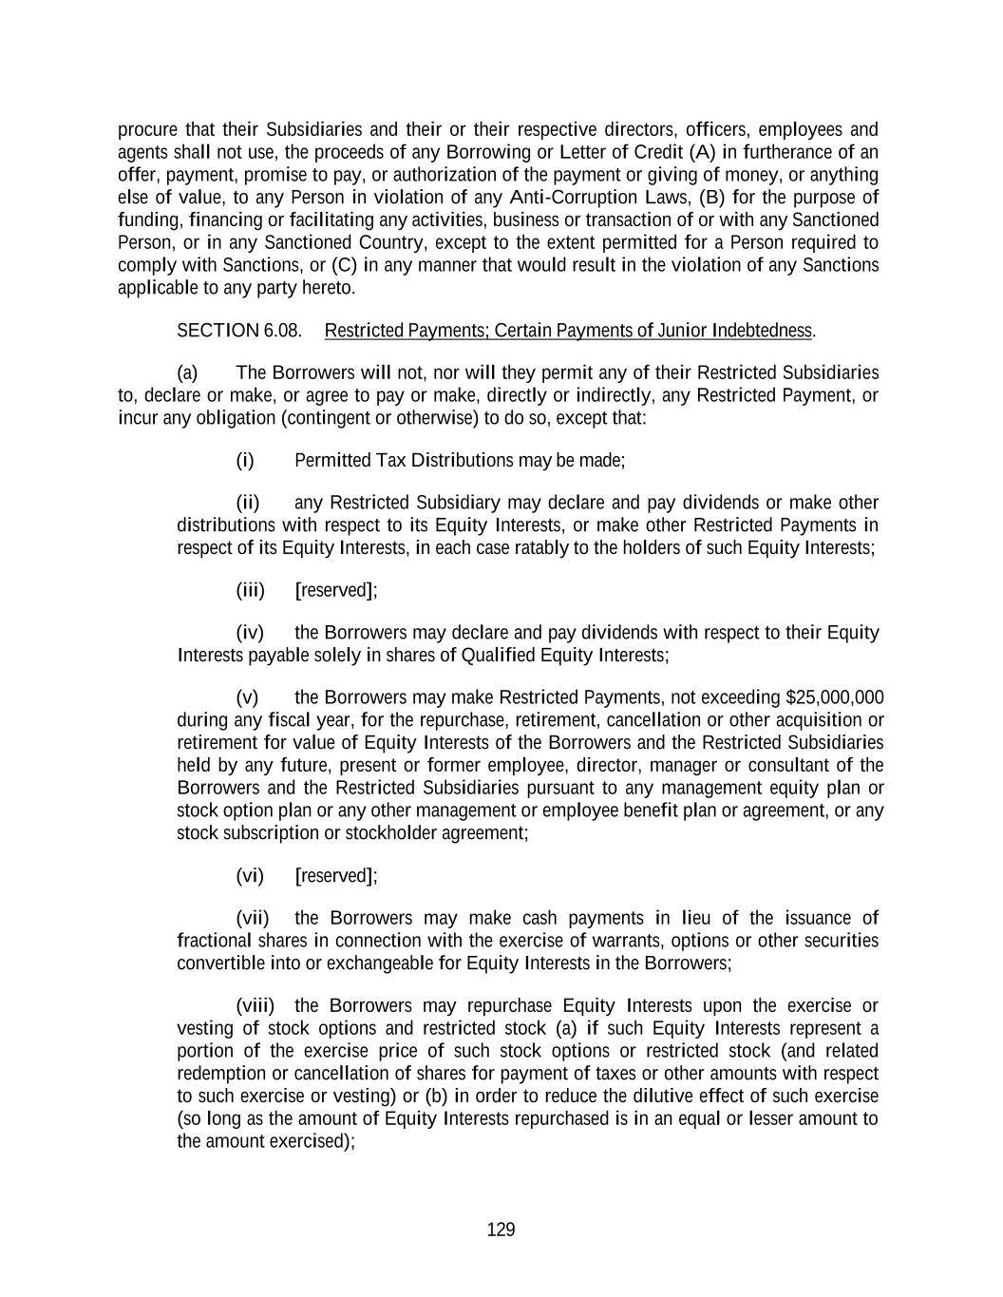
129 procure that their Subsidiaries and their or their respective directors, officers, employees and agents shall not use, the proceeds of any Borrowing or Letter of Credit (A) in furtherance of an offer, payment, promise to pay, or authorization of the payment or giving of money, or anything else of value, to any Person in violation of any Anti-Corruption Laws, (B) for the purpose of funding, financing or facilitating any activities, business or transaction of or with any Sanctioned Person, or in any Sanctioned Country, except to the extent permitted for a Person required to comply with Sanctions, or (C) in any manner that would result in the violation of any Sanctions applicable to any party hereto. SECTION 6.08. Restricted Payments; Certain Payments of Junior Indebtedness. (a) The Borrowers will not, nor will they permit any of their Restricted Subsidiaries to, declare or make, or agree to pay or make, directly or indirectly, any Restricted Payment, or incur any obligation (contingent or otherwise) to do so, except that: (i) Permitted Tax Distributions may be made; (ii) any Restricted Subsidiary may declare and pay dividends or make other distributions with respect to its Equity Interests, or make other Restricted Payments in respect of its Equity Interests, in each case ratably to the holders of such Equity Interests; (iii) [reserved]; (iv) the Borrowers may declare and pay dividends with respect to their Equity Interests payable solely in shares of Qualified Equity Interests; (v) the Borrowers may make Restricted Payments, not exceeding $25,000,000 during any fiscal year, for the repurchase, retirement, cancellation or other acquisition or retirement for value of Equity Interests of the Borrowers and the Restricted Subsidiaries held by any future, present or former employee, director, manager or consultant of the Borrowers and the Restricted Subsidiaries pursuant to any management equity plan or stock option plan or any other management or employee benefit plan or agreement, or any stock subscription or stockholder agreement; (vi) [reserved]; (vii) the Borrowers may make cash payments in lieu of the issuance of fractional shares in connection with the exercise of warrants, options or other securities convertible into or exchangeable for Equity Interests in the Borrowers; (viii) the Borrowers may repurchase Equity Interests upon the exercise or vesting of stock options and restricted stock (a) if such Equity Interests represent a portion of the exercise price of such stock options or restricted stock (and related redemption or cancellation of shares for payment of taxes or other amounts with respect to such exercise or vesting) or (b) in order to reduce the dilutive effect of such exercise (so long as the amount of Equity Interests repurchased is in an equal or lesser amount to the amount exercised);

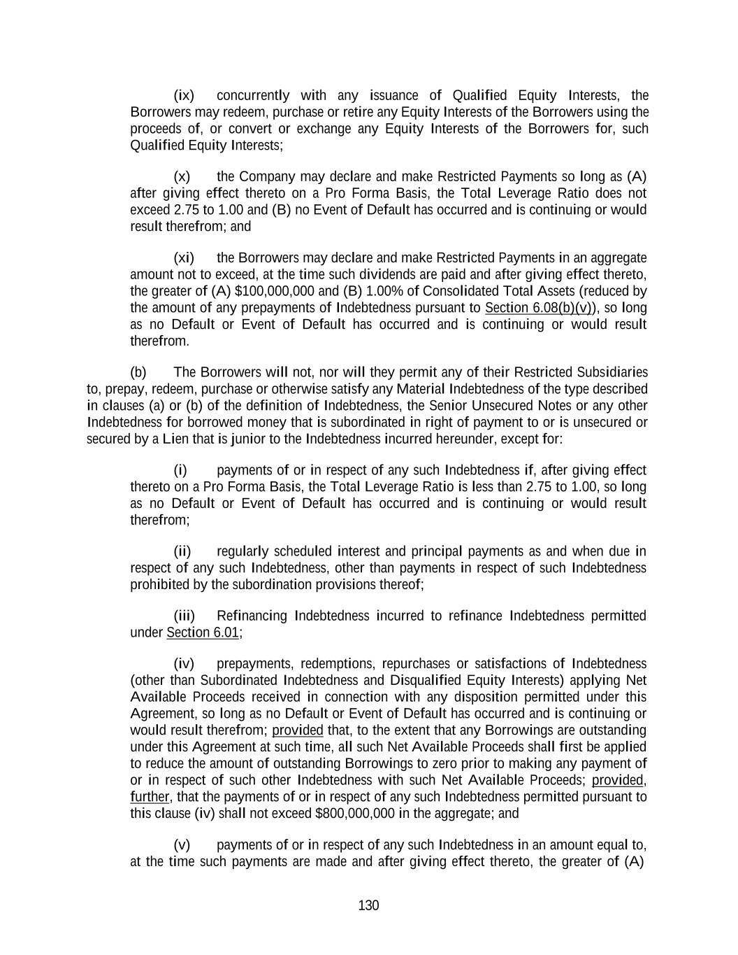
130 (ix) concurrently with any issuance of Qualified Equity Interests, the Borrowers may redeem, purchase or retire any Equity Interests of the Borrowers using the proceeds of, or convert or exchange any Equity Interests of the Borrowers for, such Qualified Equity Interests; (x) the Company may declare and make Restricted Payments so long as (A) after giving effect thereto on a Pro Forma Basis, the Total Leverage Ratio does not exceed 2.75 to 1.00 and (B) no Event of Default has occurred and is continuing or would result therefrom; and (xi) the Borrowers may declare and make Restricted Payments in an aggregate amount not to exceed, at the time such dividends are paid and after giving effect thereto, the greater of (A) $100,000,000 and (B) 1.00% of Consolidated Total Assets (reduced by the amount of any prepayments of Indebtedness pursuant to Section 6.08(b)(v)), so long as no Default or Event of Default has occurred and is continuing or would result therefrom. (b) The Borrowers will not, nor will they permit any of their Restricted Subsidiaries to, prepay, redeem, purchase or otherwise satisfy any Material Indebtedness of the type described in clauses (a) or (b) of the definition of Indebtedness, the Senior Unsecured Notes or any other Indebtedness for borrowed money that is subordinated in right of payment to or is unsecured or secured by a Lien that is junior to the Indebtedness incurred hereunder, except for: (i) payments of or in respect of any such Indebtedness if, after giving effect thereto on a Pro Forma Basis, the Total Leverage Ratio is less than 2.75 to 1.00, so long as no Default or Event of Default has occurred and is continuing or would result therefrom; (ii) regularly scheduled interest and principal payments as and when due in respect of any such Indebtedness, other than payments in respect of such Indebtedness prohibited by the subordination provisions thereof; (iii) Refinancing Indebtedness incurred to refinance Indebtedness permitted under Section 6.01; (iv) prepayments, redemptions, repurchases or satisfactions of Indebtedness (other than Subordinated Indebtedness and Disqualified Equity Interests) applying Net Available Proceeds received in connection with any disposition permitted under this Agreement, so long as no Default or Event of Default has occurred and is continuing or would result therefrom; provided that, to the extent that any Borrowings are outstanding under this Agreement at such time, all such Net Available Proceeds shall first be applied to reduce the amount of outstanding Borrowings to zero prior to making any payment of or in respect of such other Indebtedness with such Net Available Proceeds; provided, further, that the payments of or in respect of any such Indebtedness permitted pursuant to this clause (iv) shall not exceed $800,000,000 in the aggregate; and (v) payments of or in respect of any such Indebtedness in an amount equal to, at the time such payments are made and after giving effect thereto, the greater of (A)

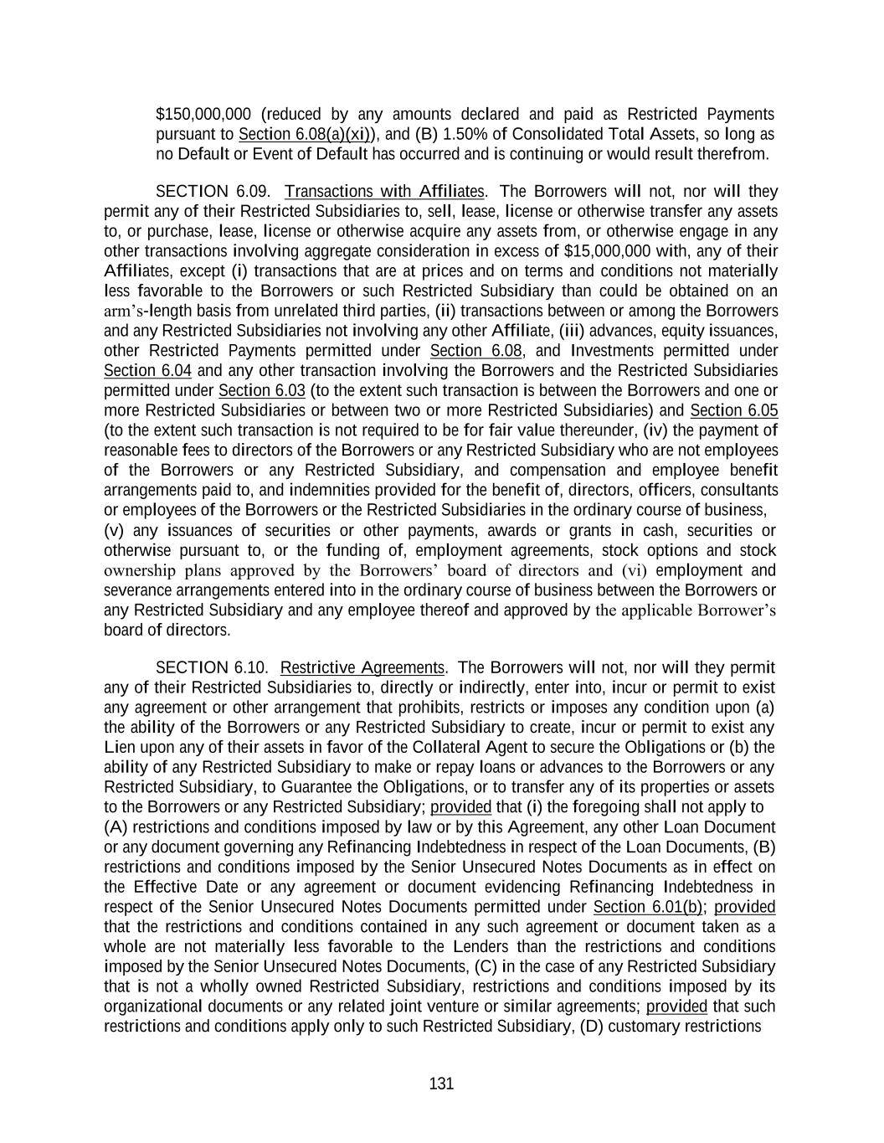
131 $150,000,000 (reduced by any amounts declared and paid as Restricted Payments pursuant to Section 6.08(a)(xi)), and (B) 1.50% of Consolidated Total Assets, so long as no Default or Event of Default has occurred and is continuing or would result therefrom. SECTION 6.09. Transactions with Affiliates. The Borrowers will not, nor will they permit any of their Restricted Subsidiaries to, sell, lease, license or otherwise transfer any assets to, or purchase, lease, license or otherwise acquire any assets from, or otherwise engage in any other transactions involving aggregate consideration in excess of $15,000,000 with, any of their Affiliates, except (i) transactions that are at prices and on terms and conditions not materially less favorable to the Borrowers or such Restricted Subsidiary than could be obtained on an arm’s-length basis from unrelated third parties, (ii) transactions between or among the Borrowers and any Restricted Subsidiaries not involving any other Affiliate, (iii) advances, equity issuances, other Restricted Payments permitted under Section 6.08, and Investments permitted under Section 6.04 and any other transaction involving the Borrowers and the Restricted Subsidiaries permitted under Section 6.03 (to the extent such transaction is between the Borrowers and one or more Restricted Subsidiaries or between two or more Restricted Subsidiaries) and Section 6.05 (to the extent such transaction is not required to be for fair value thereunder, (iv) the payment of reasonable fees to directors of the Borrowers or any Restricted Subsidiary who are not employees of the Borrowers or any Restricted Subsidiary, and compensation and employee benefit arrangements paid to, and indemnities provided for the benefit of, directors, officers, consultants or employees of the Borrowers or the Restricted Subsidiaries in the ordinary course of business, (v) any issuances of securities or other payments, awards or grants in cash, securities or otherwise pursuant to, or the funding of, employment agreements, stock options and stock ownership plans approved by the Borrowers’ board of directors and (vi) employment and severance arrangements entered into in the ordinary course of business between the Borrowers or any Restricted Subsidiary and any employee thereof and approved by the applicable Borrower’s board of directors. SECTION 6.10. Restrictive Agreements. The Borrowers will not, nor will they permit any of their Restricted Subsidiaries to, directly or indirectly, enter into, incur or permit to exist any agreement or other arrangement that prohibits, restricts or imposes any condition upon (a) the ability of the Borrowers or any Restricted Subsidiary to create, incur or permit to exist any Lien upon any of their assets in favor of the Collateral Agent to secure the Obligations or (b) the ability of any Restricted Subsidiary to make or repay loans or advances to the Borrowers or any Restricted Subsidiary, to Guarantee the Obligations, or to transfer any of its properties or assets to the Borrowers or any Restricted Subsidiary; provided that (i) the foregoing shall not apply to (A) restrictions and conditions imposed by law or by this Agreement, any other Loan Document or any document governing any Refinancing Indebtedness in respect of the Loan Documents, (B) restrictions and conditions imposed by the Senior Unsecured Notes Documents as in effect on the Effective Date or any agreement or document evidencing Refinancing Indebtedness in respect of the Senior Unsecured Notes Documents permitted under Section 6.01(b); provided that the restrictions and conditions contained in any such agreement or document taken as a whole are not materially less favorable to the Lenders than the restrictions and conditions imposed by the Senior Unsecured Notes Documents, (C) in the case of any Restricted Subsidiary that is not a wholly owned Restricted Subsidiary, restrictions and conditions imposed by its organizational documents or any related joint venture or similar agreements; provided that such restrictions and conditions apply only to such Restricted Subsidiary, (D) customary restrictions

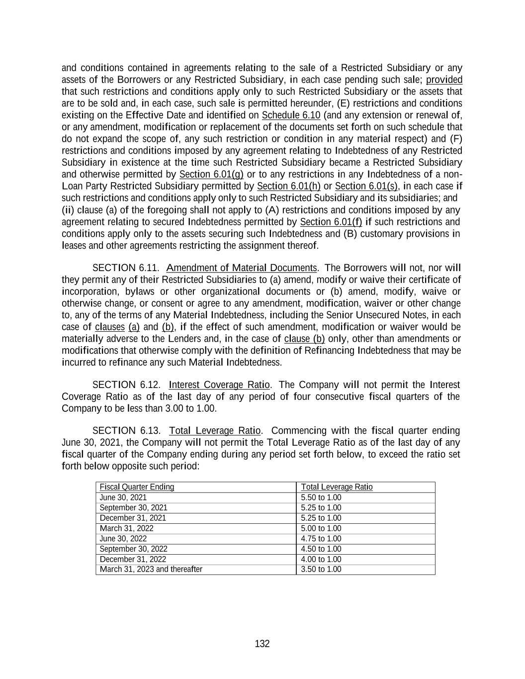
132 and conditions contained in agreements relating to the sale of a Restricted Subsidiary or any assets of the Borrowers or any Restricted Subsidiary, in each case pending such sale; provided that such restrictions and conditions apply only to such Restricted Subsidiary or the assets that are to be sold and, in each case, such sale is permitted hereunder, (E) restrictions and conditions existing on the Effective Date and identified on Schedule 6.10 (and any extension or renewal of, or any amendment, modification or replacement of the documents set forth on such schedule that do not expand the scope of, any such restriction or condition in any material respect) and (F) restrictions and conditions imposed by any agreement relating to Indebtedness of any Restricted Subsidiary in existence at the time such Restricted Subsidiary became a Restricted Subsidiary and otherwise permitted by Section 6.01(g) or to any restrictions in any Indebtedness of a non- Loan Party Restricted Subsidiary permitted by Section 6.01(h) or Section 6.01(s), in each case if such restrictions and conditions apply only to such Restricted Subsidiary and its subsidiaries; and (ii) clause (a) of the foregoing shall not apply to (A) restrictions and conditions imposed by any agreement relating to secured Indebtedness permitted by Section 6.01(f) if such restrictions and conditions apply only to the assets securing such Indebtedness and (B) customary provisions in leases and other agreements restricting the assignment thereof. SECTION 6.11. Amendment of Material Documents. The Borrowers will not, nor will they permit any of their Restricted Subsidiaries to (a) amend, modify or waive their certificate of incorporation, bylaws or other organizational documents or (b) amend, modify, waive or otherwise change, or consent or agree to any amendment, modification, waiver or other change to, any of the terms of any Material Indebtedness, including the Senior Unsecured Notes, in each case of clauses (a) and (b), if the effect of such amendment, modification or waiver would be materially adverse to the Lenders and, in the case of clause (b) only, other than amendments or modifications that otherwise comply with the definition of Refinancing Indebtedness that may be incurred to refinance any such Material Indebtedness. SECTION 6.12. Interest Coverage Ratio. The Company will not permit the Interest Coverage Ratio as of the last day of any period of four consecutive fiscal quarters of the Company to be less than 3.00 to 1.00. SECTION 6.13. Total Leverage Ratio. Commencing with the fiscal quarter ending June 30, 2021, the Company will not permit the Total Leverage Ratio as of the last day of any fiscal quarter of the Company ending during any period set forth below, to exceed the ratio set forth below opposite such period: Fiscal Quarter Ending Total Leverage Ratio June 30, 2021 5.50 to 1.00 September 30, 2021 5.25 to 1.00 December 31, 2021 5.25 to 1.00 March 31, 2022 5.00 to 1.00 June 30, 2022 4.75 to 1.00 September 30, 2022 4.50 to 1.00 December 31, 2022 4.00 to 1.00 March 31, 2023 and thereafter 3.50 to 1.00

133 SECTION 6.14. First Lien Leverage Ratio. The Company will not permit the First Lien Leverage Ratio as of the last day of any fiscal quarter of the Company, commencing with the fiscal quarter ending June 30, 2021, to exceed 2.50 to 1.00. SECTION 6.15. Changes in Fiscal Periods. The Borrowers will neither (a) permit their fiscal year or the fiscal year of any Restricted Subsidiary to end on a day other than December 31, nor (b) change their method of determining fiscal quarters. ARTICLE VII Events of Default SECTION 7.01. Events of Default. If any of the following events (each such event, an “Event of Default”) shall occur: (a) the Borrowers shall fail to pay any principal of any Loan or any reimbursement obligation in respect of any LC Disbursement when and as the same shall become due and payable, whether at the due date thereof or at a date fixed for prepayment thereof or otherwise; (b) the Borrowers shall fail to pay any interest on any Loan or any fee or any other amount (other than an amount referred to in clause (a) of this Section) payable under this Agreement or any other Loan Document, when and as the same shall become due and payable, and such failure shall continue unremedied for a period of three (3) Business Days; (c) on and after the Effective Date, any representation or warranty made or deemed made by or on behalf of the Borrowers or any Restricted Subsidiary in this Agreement or any other Loan Document, or in any report, certificate or financial statement furnished pursuant to or in connection with this Agreement or any other Loan Document, shall prove to have been incorrect in any material respect when made or deemed made; (d) on and after the Effective Date, the Borrowers shall fail to observe or perform any covenant, condition or agreement contained in Section 5.02(a), 5.04 (with respect to the existence of the Borrowers), 5.16 or in Article VI; (e) on and after the Effective Date, any Loan Party shall fail to observe or perform any covenant, condition or agreement contained in this Agreement or any other Loan Document (other than those specified in clause (a), (b) or (d) of this Section), and such failure shall continue unremedied for a period of 30 days after notice thereof from the Administrative Agent or any Lender to the Borrowers; (f) the Borrowers or any Restricted Subsidiary shall fail to make any payment (whether of principal, interest, premium or otherwise and regardless of amount) in respect of any Material Indebtedness when and as the same shall become due and payable (after giving effect to any applicable grace period in respect of such failure under the documentation governing such Material Indebtedness); (g) any event or condition occurs that results in any Material Indebtedness becoming due or being terminated or required to be prepaid, repurchased, redeemed or defeased prior to its

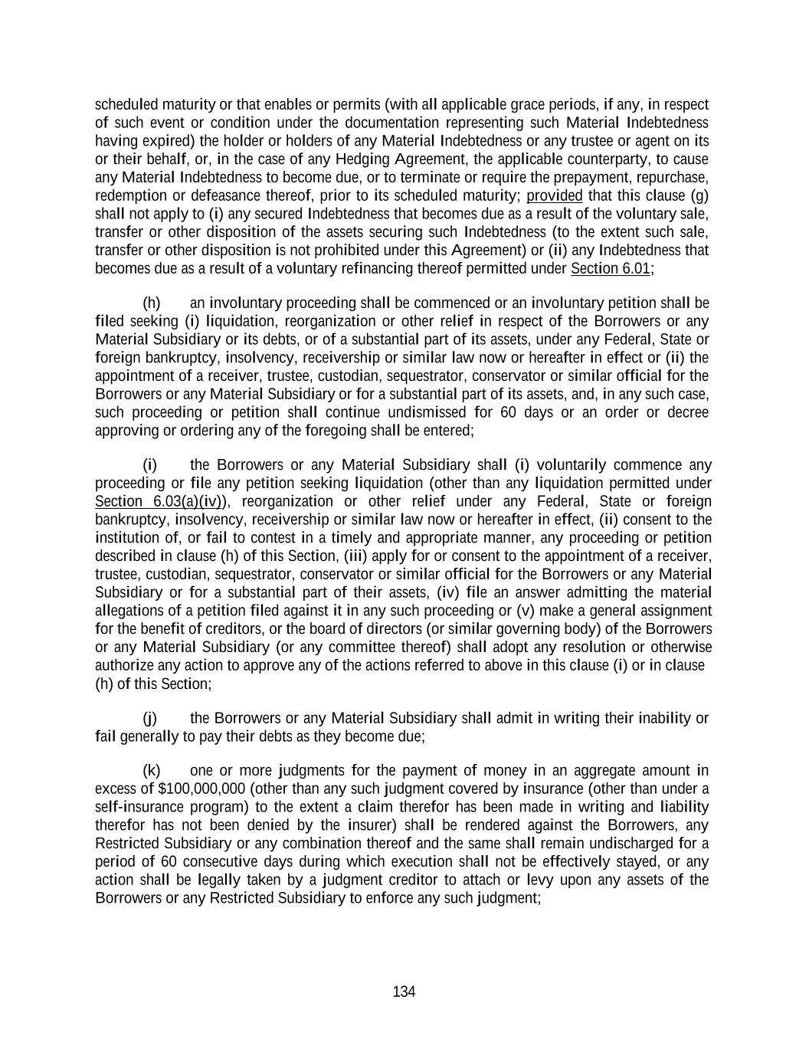
134 scheduled maturity or that enables or permits (with all applicable grace periods, if any, in respect of such event or condition under the documentation representing such Material Indebtedness having expired) the holder or holders of any Material Indebtedness or any trustee or agent on its or their behalf, or, in the case of any Hedging Agreement, the applicable counterparty, to cause any Material Indebtedness to become due, or to terminate or require the prepayment, repurchase, redemption or defeasance thereof, prior to its scheduled maturity; provided that this clause (g) shall not apply to (i) any secured Indebtedness that becomes due as a result of the voluntary sale, transfer or other disposition of the assets securing such Indebtedness (to the extent such sale, transfer or other disposition is not prohibited under this Agreement) or (ii) any Indebtedness that becomes due as a result of a voluntary refinancing thereof permitted under Section 6.01; (h) an involuntary proceeding shall be commenced or an involuntary petition shall be filed seeking (i) liquidation, reorganization or other relief in respect of the Borrowers or any Material Subsidiary or its debts, or of a substantial part of its assets, under any Federal, State or foreign bankruptcy, insolvency, receivership or similar law now or hereafter in effect or (ii) the appointment of a receiver, trustee, custodian, sequestrator, conservator or similar official for the Borrowers or any Material Subsidiary or for a substantial part of its assets, and, in any such case, such proceeding or petition shall continue undismissed for 60 days or an order or decree approving or ordering any of the foregoing shall be entered; (i) the Borrowers or any Material Subsidiary shall (i) voluntarily commence any proceeding or file any petition seeking liquidation (other than any liquidation permitted under Section 6.03(a)(iv)), reorganization or other relief under any Federal, State or foreign bankruptcy, insolvency, receivership or similar law now or hereafter in effect, (ii) consent to the institution of, or fail to contest in a timely and appropriate manner, any proceeding or petition described in clause (h) of this Section, (iii) apply for or consent to the appointment of a receiver, trustee, custodian, sequestrator, conservator or similar official for the Borrowers or any Material Subsidiary or for a substantial part of their assets, (iv) file an answer admitting the material allegations of a petition filed against it in any such proceeding or (v) make a general assignment for the benefit of creditors, or the board of directors (or similar governing body) of the Borrowers or any Material Subsidiary (or any committee thereof) shall adopt any resolution or otherwise authorize any action to approve any of the actions referred to above in this clause (i) or in clause (h) of this Section; (j) the Borrowers or any Material Subsidiary shall admit in writing their inability or fail generally to pay their debts as they become due; (k) one or more judgments for the payment of money in an aggregate amount in excess of $100,000,000 (other than any such judgment covered by insurance (other than under a self-insurance program) to the extent a claim therefor has been made in writing and liability therefor has not been denied by the insurer) shall be rendered against the Borrowers, any Restricted Subsidiary or any combination thereof and the same shall remain undischarged for a period of 60 consecutive days during which execution shall not be effectively stayed, or any action shall be legally taken by a judgment creditor to attach or levy upon any assets of the Borrowers or any Restricted Subsidiary to enforce any such judgment;

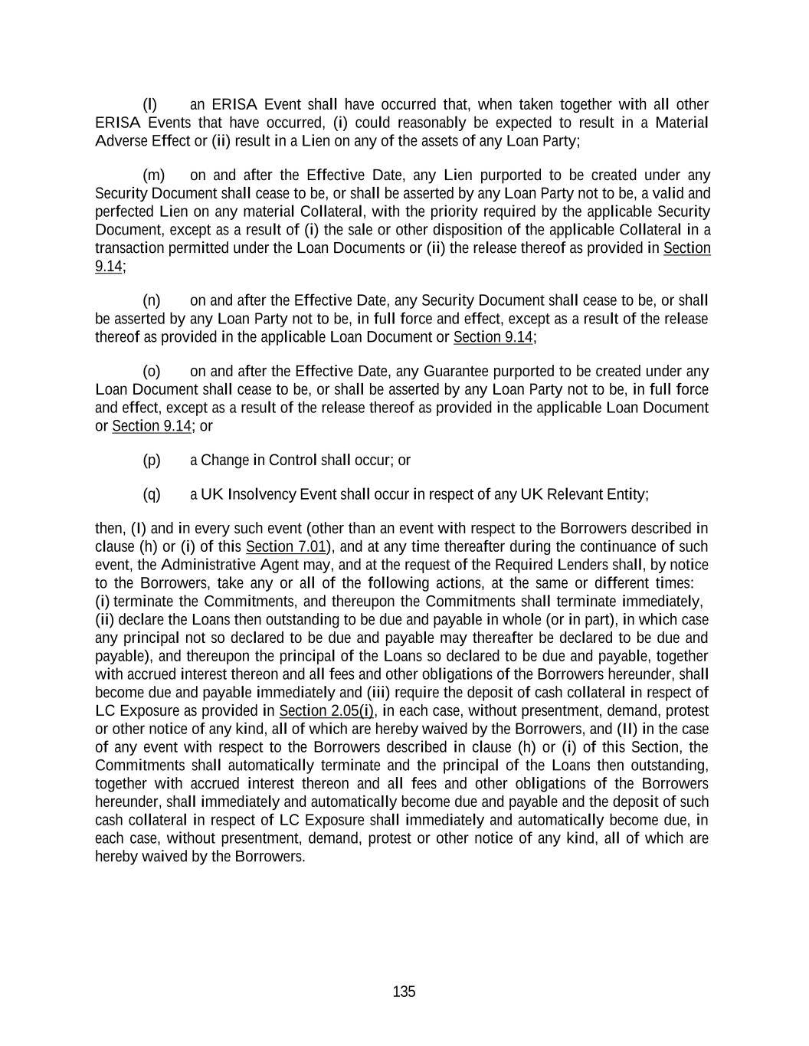
135 (l) an ERISA Event shall have occurred that, when taken together with all other ERISA Events that have occurred, (i) could reasonably be expected to result in a Material Adverse Effect or (ii) result in a Lien on any of the assets of any Loan Party; (m) on and after the Effective Date, any Lien purported to be created under any Security Document shall cease to be, or shall be asserted by any Loan Party not to be, a valid and perfected Lien on any material Collateral, with the priority required by the applicable Security Document, except as a result of (i) the sale or other disposition of the applicable Collateral in a transaction permitted under the Loan Documents or (ii) the release thereof as provided in Section 9.14; (n) on and after the Effective Date, any Security Document shall cease to be, or shall be asserted by any Loan Party not to be, in full force and effect, except as a result of the release thereof as provided in the applicable Loan Document or Section 9.14; (o) on and after the Effective Date, any Guarantee purported to be created under any Loan Document shall cease to be, or shall be asserted by any Loan Party not to be, in full force and effect, except as a result of the release thereof as provided in the applicable Loan Document or Section 9.14; or (p) a Change in Control shall occur; or (q) a UK Insolvency Event shall occur in respect of any UK Relevant Entity; then, (I) and in every such event (other than an event with respect to the Borrowers described in clause (h) or (i) of this Section 7.01), and at any time thereafter during the continuance of such event, the Administrative Agent may, and at the request of the Required Lenders shall, by notice to the Borrowers, take any or all of the following actions, at the same or different times: (i) terminate the Commitments, and thereupon the Commitments shall terminate immediately, (ii) declare the Loans then outstanding to be due and payable in whole (or in part), in which case any principal not so declared to be due and payable may thereafter be declared to be due and payable), and thereupon the principal of the Loans so declared to be due and payable, together with accrued interest thereon and all fees and other obligations of the Borrowers hereunder, shall become due and payable immediately and (iii) require the deposit of cash collateral in respect of LC Exposure as provided in Section 2.05(i), in each case, without presentment, demand, protest or other notice of any kind, all of which are hereby waived by the Borrowers, and (II) in the case of any event with respect to the Borrowers described in clause (h) or (i) of this Section, the Commitments shall automatically terminate and the principal of the Loans then outstanding, together with accrued interest thereon and all fees and other obligations of the Borrowers hereunder, shall immediately and automatically become due and payable and the deposit of such cash collateral in respect of LC Exposure shall immediately and automatically become due, in each case, without presentment, demand, protest or other notice of any kind, all of which are hereby waived by the Borrowers.

136 ARTICLE VIII The Administrative Agent SECTION 8.01. Administrative Agent Matters. (a) Each of the Lenders and the Issuing Banks hereby irrevocably appoints the entity named as Administrative Agent in the heading of this Agreement and its successors to serve as administrative agent and collateral agent (without prejudice to the right of the Administrative Agent to designate any sub-agent, co-agent or trustee to serve as collateral agent or security trustee) under the Loan Documents and authorizes the Administrative Agent to take such actions and to exercise such powers as are delegated to the Administrative Agent by the terms of the Loan Documents, together with such actions and powers as are reasonably incidental thereto. In addition, to the extent required under the laws of any jurisdiction other than the United States of America, each of the Lenders and the Issuing Banks hereby grants to the Administrative Agent (including any sub-agent, co-agent or trustee designated by the Administrative Agent) any required powers of attorney to execute any Security Document governed by the laws of such jurisdiction on such Lender’s or such Issuing Bank’s behalf. It is understood and agreed that the use of the term “agent” (or any similar term) herein or in any other Loan Document with reference to the Administrative Agent is not intended to connote any fiduciary duty or other implied (or express) obligations arising under agency doctrine of any applicable law. Instead, such term is used as a matter of market custom and is intended to create or reflect only an administrative relationship between contracting parties. (b) The Person serving as the Administrative Agent hereunder shall have the same rights and powers in its capacity as a Lender or an Issuing Bank as any other Lender or Issuing Bank and may exercise the same as though it were not the Administrative Agent, and such Person and its Affiliates may accept deposits from, lend money to, own securities of, act as the financial advisor or in any other advisory capacity for and generally engage in any kind of business with the Borrowers or any Subsidiary or other Affiliate thereof as if such Person were not the Administrative Agent hereunder and without any duty to account therefor to the Lenders or the Issuing Banks. (c) The Administrative Agent shall not have any duties or obligations except those expressly set forth in the Loan Documents, and its duties hereunder shall be administrative in nature. Without limiting the generality of the foregoing, (i) the Administrative Agent shall not be subject to any fiduciary or other implied duties, regardless of whether a Default has occurred and is continuing, (ii) the Administrative Agent shall not have any duty to take any discretionary action or to exercise any discretionary power, except discretionary rights and powers expressly contemplated by the Loan Documents that the Administrative Agent is required to exercise as directed in writing by the Required Lenders (or such other number or percentage of the Lenders as shall be necessary, or as the Administrative Agent shall believe in good faith to be necessary, under the circumstances as provided in the Loan Documents); provided that the Administrative Agent shall not be required to take any action that, in its opinion, could expose the Administrative Agent to liability or be contrary to this Agreement or any other Loan Document or applicable law, and (iii) except as expressly set forth in the Loan Documents, the Administrative Agent shall not have any duty to disclose, and shall not be liable for the failure to

137 disclose, any information relating to the Borrowers, any Subsidiary or any other Affiliate of any of the foregoing that is communicated to or obtained by the Person serving as Administrative Agent or any of its Affiliates in any capacity. The Administrative Agent shall not be liable for any action taken or not taken by it with the consent or at the request of the Required Lenders (or such other number or percentage of the Lenders as shall be necessary, or as the Administrative Agent shall believe in good faith to be necessary, under the circumstances as provided in the Loan Documents) or in the absence of its own gross negligence or willful misconduct (such absence to be presumed unless otherwise determined by a court of competent jurisdiction by a final and nonappealable judgment). The Administrative Agent shall be deemed not to have knowledge of any Default unless and until written notice thereof (stating that it is a “notice of default”) is given to the Administrative Agent by the Borrowers, a Lender or an Issuing Bank, and the Administrative Agent shall not be responsible for or have any duty to ascertain or inquire into (A) any statement, warranty or representation made in or in connection with this Agreement or any other Loan Document, (B) the contents of any certificate, report or other document delivered hereunder or thereunder or in connection herewith or therewith, (C) the performance or observance of any of the covenants, agreements or other terms or conditions set forth in this Agreement or any other Loan Document or the occurrence of any Default, (D) the sufficiency, validity, enforceability, effectiveness or genuineness of this Agreement or any other Loan Document or any other agreement, instrument or document or (E) the satisfaction of any condition set forth in Article IV or elsewhere in this Agreement or any other Loan Document, other than to confirm receipt of items expressly required to be delivered to the Administrative Agent or satisfaction of any condition that expressly refers to the matters described therein being acceptable or satisfactory to the Administrative Agent. Notwithstanding anything herein to the contrary, the Administrative Agent shall not be liable for, or be responsible for any loss, cost or expense suffered by the Borrowers or any Lender as a result of, any determination of the Revolving Exposure or the component amounts thereof. (d) The Administrative Agent shall be entitled to rely, and shall not incur any liability for relying, upon any notice, request, certificate, consent, statement, instrument, document or other writing (including any electronic message, Internet or intranet website posting or other distribution) believed by it to be genuine and to have been signed or sent or otherwise authenticated by the proper Person (whether or not such Person in fact meets the requirements set forth in the Loan Documents for being the signatory, sender or authenticator thereof). The Administrative Agent also shall be entitled to rely, and shall not incur any liability for relying, upon any statement made to it orally or by telephone and believed by it to be made by the proper Person (whether or not such Person in fact meets the requirements set forth in the Loan Documents for being the signatory, sender or authenticator thereof), and may act upon any such statement prior to receipt of written confirmation thereof. In determining compliance with any condition hereunder to the making of a Loan, or the issuance, extension, renewal or increase of a Letter of Credit, that by its terms must be fulfilled to the satisfaction of a Lender or an Issuing Bank, the Administrative Agent may presume that such condition is satisfactory to such Lender or such Issuing Bank unless the Administrative Agent shall have received notice to the contrary from such Lender or such Issuing Bank prior to the making of such Loan or the issuance of such Letter of Credit. The Administrative Agent may consult with legal counsel (who may be counsel for the Borrowers), independent accountants and other experts selected by it, and shall not be

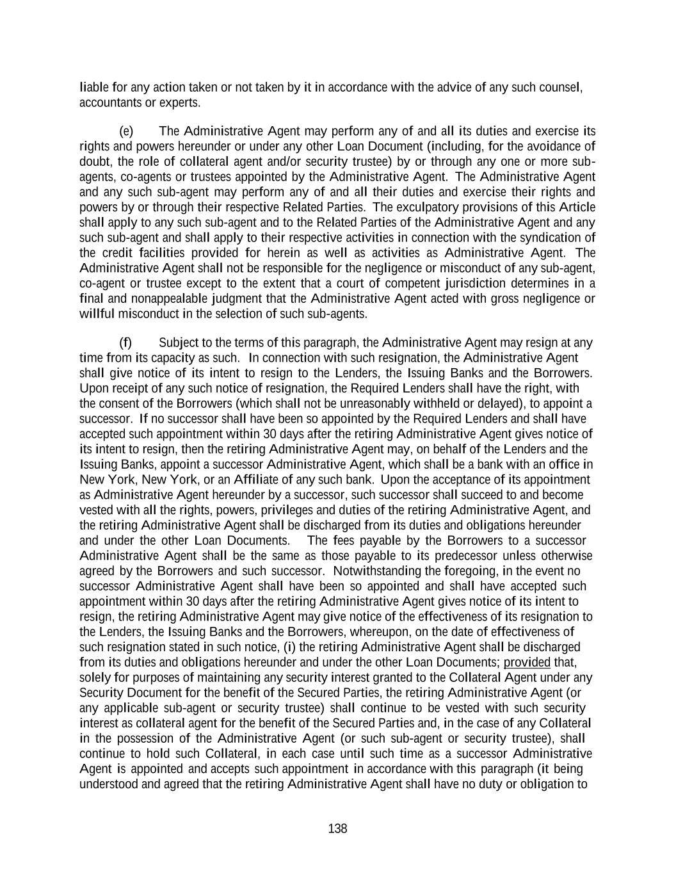
138 liable for any action taken or not taken by it in accordance with the advice of any such counsel, accountants or experts. (e) The Administrative Agent may perform any of and all its duties and exercise its rights and powers hereunder or under any other Loan Document (including, for the avoidance of doubt, the role of collateral agent and/or security trustee) by or through any one or more sub- agents, co-agents or trustees appointed by the Administrative Agent. The Administrative Agent and any such sub-agent may perform any of and all their duties and exercise their rights and powers by or through their respective Related Parties. The exculpatory provisions of this Article shall apply to any such sub-agent and to the Related Parties of the Administrative Agent and any such sub-agent and shall apply to their respective activities in connection with the syndication of the credit facilities provided for herein as well as activities as Administrative Agent. The Administrative Agent shall not be responsible for the negligence or misconduct of any sub-agent, co-agent or trustee except to the extent that a court of competent jurisdiction determines in a final and nonappealable judgment that the Administrative Agent acted with gross negligence or willful misconduct in the selection of such sub-agents. (f) Subject to the terms of this paragraph, the Administrative Agent may resign at any time from its capacity as such. In connection with such resignation, the Administrative Agent shall give notice of its intent to resign to the Lenders, the Issuing Banks and the Borrowers. Upon receipt of any such notice of resignation, the Required Lenders shall have the right, with the consent of the Borrowers (which shall not be unreasonably withheld or delayed), to appoint a successor. If no successor shall have been so appointed by the Required Lenders and shall have accepted such appointment within 30 days after the retiring Administrative Agent gives notice of its intent to resign, then the retiring Administrative Agent may, on behalf of the Lenders and the Issuing Banks, appoint a successor Administrative Agent, which shall be a bank with an office in New York, New York, or an Affiliate of any such bank. Upon the acceptance of its appointment as Administrative Agent hereunder by a successor, such successor shall succeed to and become vested with all the rights, powers, privileges and duties of the retiring Administrative Agent, and the retiring Administrative Agent shall be discharged from its duties and obligations hereunder and under the other Loan Documents. The fees payable by the Borrowers to a successor Administrative Agent shall be the same as those payable to its predecessor unless otherwise agreed by the Borrowers and such successor. Notwithstanding the foregoing, in the event no successor Administrative Agent shall have been so appointed and shall have accepted such appointment within 30 days after the retiring Administrative Agent gives notice of its intent to resign, the retiring Administrative Agent may give notice of the effectiveness of its resignation to the Lenders, the Issuing Banks and the Borrowers, whereupon, on the date of effectiveness of such resignation stated in such notice, (i) the retiring Administrative Agent shall be discharged from its duties and obligations hereunder and under the other Loan Documents; provided that, solely for purposes of maintaining any security interest granted to the Collateral Agent under any Security Document for the benefit of the Secured Parties, the retiring Administrative Agent (or any applicable sub-agent or security trustee) shall continue to be vested with such security interest as collateral agent for the benefit of the Secured Parties and, in the case of any Collateral in the possession of the Administrative Agent (or such sub-agent or security trustee), shall continue to hold such Collateral, in each case until such time as a successor Administrative Agent is appointed and accepts such appointment in accordance with this paragraph (it being understood and agreed that the retiring Administrative Agent shall have no duty or obligation to

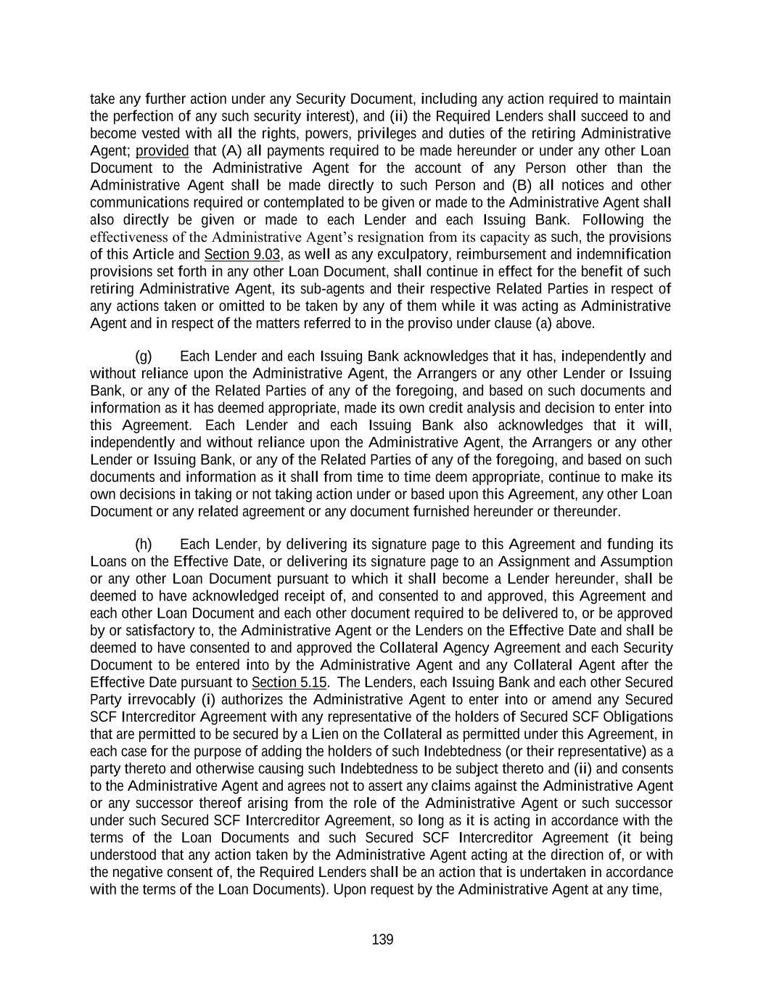
139 take any further action under any Security Document, including any action required to maintain the perfection of any such security interest), and (ii) the Required Lenders shall succeed to and become vested with all the rights, powers, privileges and duties of the retiring Administrative Agent; provided that (A) all payments required to be made hereunder or under any other Loan Document to the Administrative Agent for the account of any Person other than the Administrative Agent shall be made directly to such Person and (B) all notices and other communications required or contemplated to be given or made to the Administrative Agent shall also directly be given or made to each Lender and each Issuing Bank. Following the effectiveness of the Administrative Agent’s resignation from its capacity as such, the provisions of this Article and Section 9.03, as well as any exculpatory, reimbursement and indemnification provisions set forth in any other Loan Document, shall continue in effect for the benefit of such retiring Administrative Agent, its sub-agents and their respective Related Parties in respect of any actions taken or omitted to be taken by any of them while it was acting as Administrative Agent and in respect of the matters referred to in the proviso under clause (a) above. (g) Each Lender and each Issuing Bank acknowledges that it has, independently and without reliance upon the Administrative Agent, the Arrangers or any other Lender or Issuing Bank, or any of the Related Parties of any of the foregoing, and based on such documents and information as it has deemed appropriate, made its own credit analysis and decision to enter into this Agreement. Each Lender and each Issuing Bank also acknowledges that it will, independently and without reliance upon the Administrative Agent, the Arrangers or any other Lender or Issuing Bank, or any of the Related Parties of any of the foregoing, and based on such documents and information as it shall from time to time deem appropriate, continue to make its own decisions in taking or not taking action under or based upon this Agreement, any other Loan Document or any related agreement or any document furnished hereunder or thereunder. (h) Each Lender, by delivering its signature page to this Agreement and funding its Loans on the Effective Date, or delivering its signature page to an Assignment and Assumption or any other Loan Document pursuant to which it shall become a Lender hereunder, shall be deemed to have acknowledged receipt of, and consented to and approved, this Agreement and each other Loan Document and each other document required to be delivered to, or be approved by or satisfactory to, the Administrative Agent or the Lenders on the Effective Date and shall be deemed to have consented to and approved the Collateral Agency Agreement and each Security Document to be entered into by the Administrative Agent and any Collateral Agent after the Effective Date pursuant to Section 5.15. The Lenders, each Issuing Bank and each other Secured Party irrevocably (i) authorizes the Administrative Agent to enter into or amend any Secured SCF Intercreditor Agreement with any representative of the holders of Secured SCF Obligations that are permitted to be secured by a Lien on the Collateral as permitted under this Agreement, in each case for the purpose of adding the holders of such Indebtedness (or their representative) as a party thereto and otherwise causing such Indebtedness to be subject thereto and (ii) and consents to the Administrative Agent and agrees not to assert any claims against the Administrative Agent or any successor thereof arising from the role of the Administrative Agent or such successor under such Secured SCF Intercreditor Agreement, so long as it is acting in accordance with the terms of the Loan Documents and such Secured SCF Intercreditor Agreement (it being understood that any action taken by the Administrative Agent acting at the direction of, or with the negative consent of, the Required Lenders shall be an action that is undertaken in accordance with the terms of the Loan Documents). Upon request by the Administrative Agent at any time,

140 the Required Lenders will confirm in writing the Administrative Agent’s authority to enter into or amend such Secured SCF Intercreditor Agreement pursuant to this Section 8.01(h). (i) Except with respect to the exercise of setoff rights of any Lender in accordance with Section 9.08 or with respect to a Lender’s right to file a proof of claim in an insolvency proceeding, no Secured Party shall have any right individually to realize upon any of the Collateral or to enforce any Guarantee of the Obligations, it being understood and agreed that all powers, rights and remedies under the Loan Documents may be exercised solely by the Administrative Agent (or any sub-agent, co-agent or trustee designated by it as collateral agent or security trustee) on behalf of the Secured Parties in accordance with the terms thereof. In the event of a foreclosure by the Administrative Agent (or any sub-agent(s) designated by it as collateral agent or security trustee) on any of the Collateral pursuant to a public or private sale or other disposition, the Administrative Agent or any Lender may be the purchaser or licensor of any or all of such Collateral at any such sale or other disposition, and the Administrative Agent (or any sub-agent, co-agent or trustee designated by it as collateral agent or security trustee), as agent for and representative of the Secured Parties (but not any Lender or Lenders in its or their respective individual capacities unless the Required Lenders shall otherwise agree in writing) shall be entitled, for the purpose of bidding and making settlement or payment of the purchase price for all or any portion of the Collateral sold at any such public sale, to use and apply any of the Loan Document Obligations as a credit on account of the purchase price for any collateral payable by the Administrative Agent (or any sub-agent, co-agent or trustee designated by it as collateral agent or security trustee) on behalf of the Secured Parties at such sale or other disposition. (j) The Secured Cash Management Obligations, the Secured Hedging Obligations, the Secured LC Facility Obligations and the Secured SCF Obligations, shall be secured and guaranteed pursuant to the Loan Documents only to the extent that, and for so long as, the other Obligations are so secured and guaranteed. No person shall have any voting rights under any Loan Document solely as a result of the existence of Secured Cash Management Obligations, Secured Hedging Obligations, Secured LC Facility Obligations or Secured SCF Obligations owed to it. For the avoidance of doubt, no release of Collateral or Guarantors effected in the manner permitted by this Agreement shall require the consent of any holder of Secured Cash Management Obligations, Secured Hedging Obligations, Secured LC Facility Obligations or Secured SCF Obligations. By accepting the benefits of the Collateral, each Secured Party that is a provider of Cash Management Services or a party to any Hedging Agreement, Secured LC Facility or Secured Supply Chain Financing shall be deemed to have appointed the Administrative Agent to serve as administrative agent and collateral agent (without prejudice to the Administrative Agent’s right to designate any sub-agent, co-agent or trustee as collateral agent or security trustee) under the Loan Documents and agreed to be bound by the Loan Documents as a Secured Party thereunder, subject to the limitations set forth in this paragraph. (k) The Secured Parties irrevocably authorize the Administrative Agent (or any sub- agent, co-agent or trustee designated by it as collateral agent or security trustee), at its option and in its discretion, to subordinate any Lien on any property granted to or held by the Administrative Agent under any Loan Document to the holder of any Lien on such property that is permitted by Section 6.02(b). The Administrative Agent (or any sub-agent, co-agent or trustee designated by it as collateral agent or security trustee) shall not be responsible for or have a duty to ascertain or

141 inquire into any representation or warranty regarding the existence, value or collectability of the Collateral, the existence, priority or perfection of the Administrative Agent’s (or any designated collateral agent’s or security trustee’s) Lien thereon or any certificate prepared by any Loan Party in connection therewith, nor shall the Administrative Agent (or any sub-agent, co-agent or trustee designated by it as collateral agent or security trustee) be responsible or liable to the Lenders for any failure to monitor or maintain any portion of the Collateral. (l) The Secured Parties hereby irrevocably authorize the Administrative Agent, at the direction of the Required Lenders, to credit bid all or any portion of the Obligations (including by accepting some or all of the Collateral in satisfaction of some or all of the Obligations pursuant to a deed in lieu of foreclosure or otherwise) and in such manner purchase (either directly or through one or more acquisition vehicles) all or any portion of the Collateral (i) at any sale thereof conducted under the provisions of the Bankruptcy Code, including under Sections 363, 1123 or 1129 of the Bankruptcy Code, or any similar laws in any other jurisdictions to which a Loan Party is subject, or (ii) at any other sale, foreclosure or acceptance of collateral in lieu of debt conducted by (or with the consent or at the direction of) the Administrative Agent (whether by judicial action or otherwise) in accordance with any applicable law. In connection with any such credit bid and purchase, the Obligations owed to the Secured Parties shall be entitled to be, and shall be, credit bid by the Administrative Agent at the direction of the Required Lenders on a ratable basis (with Obligations with respect to contingent or unliquidated claims receiving contingent interests in the acquired assets on a ratable basis that shall vest upon the liquidation of such claims in an amount proportional to the liquidated portion of the contingent claim amount used in allocating the contingent interests) for the asset or assets so purchased (or for the equity interests or debt instruments of the acquisition vehicle or vehicles that are issued in connection with such purchase). In connection with any such bid (A) the Administrative Agent shall be authorized to form one or more acquisition vehicles and to assign any successful credit bid to such acquisition vehicle or vehicles (B) each of the Secured Parties’ ratable interests in the Obligations which were credit bid shall be deemed without any further action under this Agreement to be assigned to such vehicle or vehicles for the purpose of closing such sale, (C) the Administrative Agent shall be authorized to adopt documents providing for the governance of the acquisition vehicle or vehicles (provided that any actions by the Administrative Agent with respect to such acquisition vehicle or vehicles, including any disposition of the assets or equity interests thereof, shall be governed, directly or indirectly, by, and the governing documents shall provide for, control by the vote of the Required Lenders or their permitted assignees under the terms of this Agreement or the governing documents of the applicable acquisition vehicle or vehicles, as the case may be, irrespective of the termination of this Agreement and without giving effect to the limitations on actions by the Required Lenders contained in Section 9.02 of this Agreement), (D) the Administrative Agent on behalf of such acquisition vehicle or vehicles shall be authorized to issue to each of the Secured Parties, ratably on account of the relevant Obligations which were credit bid, interests, whether as equity, partnership interests, limited partnership interests or membership interests, in any such acquisition vehicle and/or debt instruments issued by such acquisition vehicle, all without the need for any Secured Party or acquisition vehicle to take any further action and (E) to the extent that Obligations that are assigned to an acquisition vehicle are not used to acquire Collateral for any reason (as a result of another bid being higher or better, because the amount of Obligations assigned to the acquisition vehicle exceeds the amount of Obligations credit bid by the acquisition vehicle or otherwise), such Obligations shall automatically be reassigned to the

142 Secured Parties pro rata with their original interest in such Obligations and the equity interests and/or debt instruments issued by any acquisition vehicle on account of such Obligations shall automatically be cancelled, without the need for any Secured Party or any acquisition vehicle to take any further action. Notwithstanding that the ratable portion of the Obligations of each Secured Party are deemed assigned to the acquisition vehicle or vehicles as set forth in clause (B) above, each Secured Party shall execute such documents and provide such information regarding the Secured Party (and/or any designee of the Secured Party which will receive interests in or debt instruments issued by such acquisition vehicle) as the Administrative Agent may reasonably request in connection with the formation of any acquisition vehicle, the formulation or submission of any credit bid or the consummation of the transactions contemplated by such credit bid. (m) In case of the pendency of any proceeding with respect to any Loan Party under any Federal, State or foreign bankruptcy, insolvency, receivership or similar law now or hereafter in effect, the Administrative Agent (irrespective of whether the principal of any Loan or any LC Disbursement shall then be due and payable as herein expressed or by declaration or otherwise and irrespective of whether the Administrative Agent shall have made any demand on the Borrowers) shall be entitled and empowered (but not obligated) by intervention in such proceeding or otherwise: (i) to file and prove a claim for the whole amount of the principal and interest owing and unpaid in respect of the Loans, LC Exposure and all other Obligations that are owing and unpaid and to file such other documents as may be necessary or advisable in order to have the claims of the Lenders, the Issuing Banks and the Administrative Agent (including any claim under Sections 2.12, 2.13, 2.15, 2.16, 2.17 and 9.03) allowed in such judicial proceeding; and (ii) to collect and receive any monies or other property payable or deliverable on any such claims and to distribute the same; and any custodian, receiver, assignee, trustee, liquidator, sequestrator or other similar official in any such proceeding is hereby authorized by each Lender, each Issuing Bank and each other Secured Party to make such payments to the Administrative Agent and, in the event that the Administrative Agent shall consent to the making of such payments directly to the Lenders, the Issuing Banks or the other Secured Parties, to pay to the Administrative Agent any amount due to it, in its capacity as the Administrative Agent, under the Loan Documents (including under Section 9.03). (n) Notwithstanding anything herein to the contrary, neither the Arrangers nor any Person named on the cover page of this Agreement as a Documentation Agent shall have any duties or obligations under this Agreement or any other Loan Document (except in its capacity, as applicable, as a Lender or an Issuing Bank), but all such Persons shall have the benefit of the indemnities provided for hereunder. (o) The provisions of this Article are solely for the benefit of the Administrative Agent, the Collateral Agent, the Lenders and the Issuing Banks, and, except solely to the extent of the Borrowers’ rights to consent pursuant to and subject to the conditions set forth in this

143 Article, none of the Borrowers or any Subsidiary shall have any rights as a third party beneficiary of any such provisions. Each Secured Party, whether or not a party hereto, will be deemed, by its acceptance of the benefits of the Collateral and the Guarantees of the Obligations provided under the Loan Documents, to have agreed to the provisions of this Article. (p) To the extent required by any applicable Requirement of Law, the Administrative Agent may withhold from any payment to any Lender under any Loan Document an amount equal to any applicable withholding Tax. If the IRS or any Governmental Authority asserts a claim that the Administrative Agent did not properly withhold Tax from any amount paid to or for the account of any Lender for any reason (including because the appropriate form was not delivered or was not properly executed, or because such Lender failed to notify the Administrative Agent of a change in circumstances that rendered the exemption from, or reduction of, withholding Tax ineffective), such Lender shall indemnify and hold harmless the Administrative Agent (to the extent that the Administrative Agent has not already been reimbursed by the Loan Parties and without limiting or expanding the obligation of the Loan Parties to do so) for all amounts paid, directly or indirectly, by the Administrative Agent as Tax or otherwise, together with all expenses incurred, including legal expenses and any out-of-pocket expenses, whether or not such Tax was correctly or legally imposed or asserted by the relevant Governmental Authority. A certificate as to the amount of such payment or liability delivered to any Lender by the Administrative Agent shall be conclusive absent manifest error. Each Lender hereby authorizes the Administrative Agent to set off and apply any and all amounts at any time owing to such Lender under this Agreement or any other Loan Document against any amount due to the Administrative Agent under this paragraph. The agreements in this paragraph shall survive the resignation and/or replacement of the Administrative Agent, any assignment of rights by, or the replacement of, a Lender, the termination of the Loans and the repayment, satisfaction or discharge of all obligations under this Agreement. (q) Unless required by applicable Requirement of Law, at no time shall the Administrative Agent have any obligation to file for or otherwise pursue on behalf of a Lender any refund of Taxes withheld or deducted from funds paid for the account of such Lender. For purposes of this paragraph, the term “Lender” includes any Issuing Bank. (r) (i) Each Lender and each Issuing Bank hereby agrees that (x) if the Administrative Agent notifies such Lender and/or Issuing Bank that the Administrative Agent has determined in its sole discretion that any funds received by such Lender or Issuing Bank from the Administrative Agent or any of its Affiliates (whether as a payment, prepayment or repayment of principal, interest, fees or otherwise; individually and collectively, a “Payment”) were erroneously transmitted to such Lender or Issuing Bank (whether or not known to such Lender or Issuing Bank), and demands the return of such Payment (or a portion thereof), such Lender and/or Issuing Bank shall promptly, but in no event later than one Business Day thereafter, return to the Administrative Agent the amount of any such Payment (or portion thereof) as to which such a demand was made in same day funds, together with interest thereon in respect of each day from and including the date such Payment (or portion thereof) was received by such Lender or Issuing Bank to the date such amount is repaid to the Administrative Agent at the greater of the NYFRB Rate and a rate determined by the Administrative Agent in accordance with banking industry rules on interbank compensation from time to time in effect, and (y) to the extent permitted by applicable law, such Lender or Issuing Bank, as applicable,

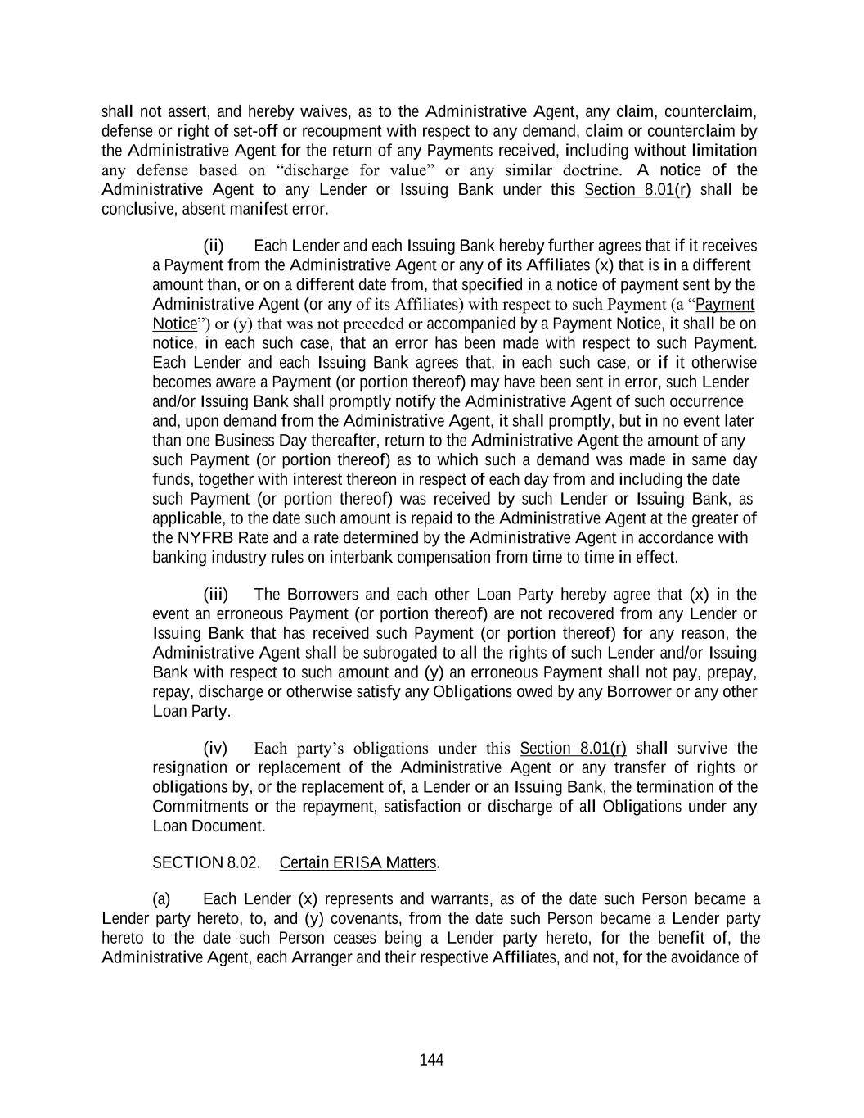
144 shall not assert, and hereby waives, as to the Administrative Agent, any claim, counterclaim, defense or right of set-off or recoupment with respect to any demand, claim or counterclaim by the Administrative Agent for the return of any Payments received, including without limitation any defense based on “discharge for value” or any similar doctrine. A notice of the Administrative Agent to any Lender or Issuing Bank under this Section 8.01(r) shall be conclusive, absent manifest error. (ii) Each Lender and each Issuing Bank hereby further agrees that if it receives a Payment from the Administrative Agent or any of its Affiliates (x) that is in a different amount than, or on a different date from, that specified in a notice of payment sent by the Administrative Agent (or any of its Affiliates) with respect to such Payment (a “Payment Notice”) or (y) that was not preceded or accompanied by a Payment Notice, it shall be on notice, in each such case, that an error has been made with respect to such Payment. Each Lender and each Issuing Bank agrees that, in each such case, or if it otherwise becomes aware a Payment (or portion thereof) may have been sent in error, such Lender and/or Issuing Bank shall promptly notify the Administrative Agent of such occurrence and, upon demand from the Administrative Agent, it shall promptly, but in no event later than one Business Day thereafter, return to the Administrative Agent the amount of any such Payment (or portion thereof) as to which such a demand was made in same day funds, together with interest thereon in respect of each day from and including the date such Payment (or portion thereof) was received by such Lender or Issuing Bank, as applicable, to the date such amount is repaid to the Administrative Agent at the greater of the NYFRB Rate and a rate determined by the Administrative Agent in accordance with banking industry rules on interbank compensation from time to time in effect. (iii) The Borrowers and each other Loan Party hereby agree that (x) in the event an erroneous Payment (or portion thereof) are not recovered from any Lender or Issuing Bank that has received such Payment (or portion thereof) for any reason, the Administrative Agent shall be subrogated to all the rights of such Lender and/or Issuing Bank with respect to such amount and (y) an erroneous Payment shall not pay, prepay, repay, discharge or otherwise satisfy any Obligations owed by any Borrower or any other Loan Party. (iv) Each party’s obligations under this Section 8.01(r) shall survive the resignation or replacement of the Administrative Agent or any transfer of rights or obligations by, or the replacement of, a Lender or an Issuing Bank, the termination of the Commitments or the repayment, satisfaction or discharge of all Obligations under any Loan Document. SECTION 8.02. Certain ERISA Matters. (a) Each Lender (x) represents and warrants, as of the date such Person became a Lender party hereto, to, and (y) covenants, from the date such Person became a Lender party hereto to the date such Person ceases being a Lender party hereto, for the benefit of, the Administrative Agent, each Arranger and their respective Affiliates, and not, for the avoidance of

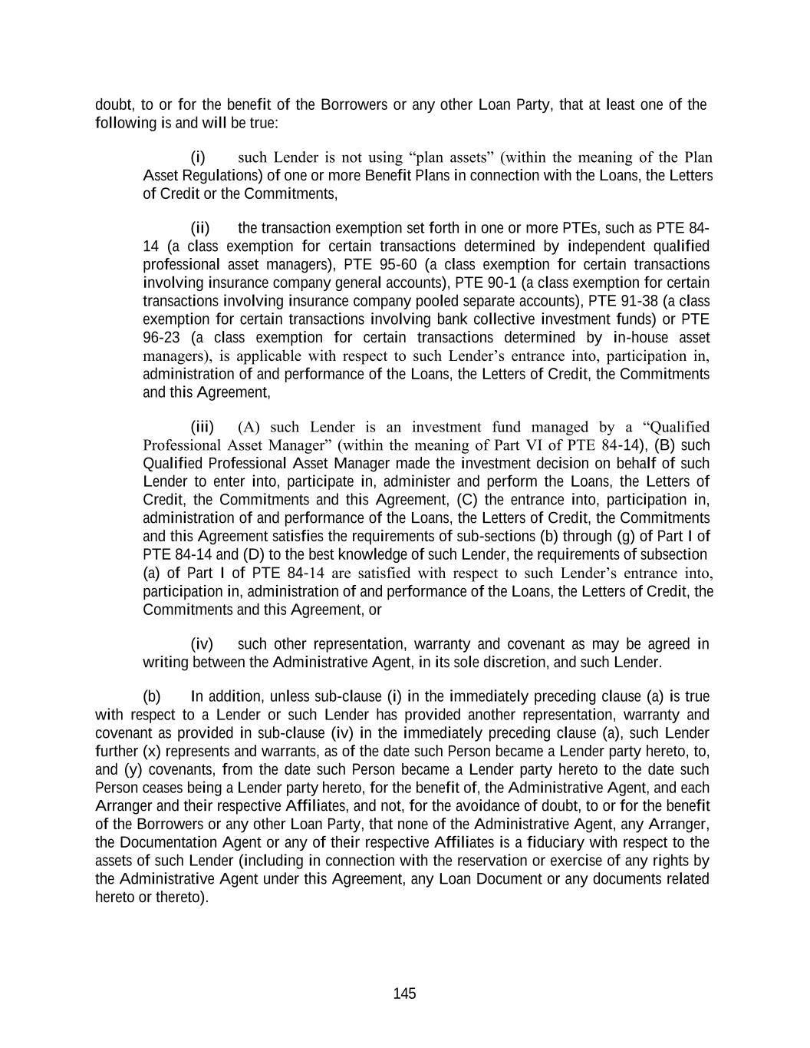
145 doubt, to or for the benefit of the Borrowers or any other Loan Party, that at least one of the following is and will be true: (i) such Lender is not using “plan assets” (within the meaning of the Plan Asset Regulations) of one or more Benefit Plans in connection with the Loans, the Letters of Credit or the Commitments, (ii) the transaction exemption set forth in one or more PTEs, such as PTE 84- 14 (a class exemption for certain transactions determined by independent qualified professional asset managers), PTE 95-60 (a class exemption for certain transactions involving insurance company general accounts), PTE 90-1 (a class exemption for certain transactions involving insurance company pooled separate accounts), PTE 91-38 (a class exemption for certain transactions involving bank collective investment funds) or PTE 96-23 (a class exemption for certain transactions determined by in-house asset managers), is applicable with respect to such Lender’s entrance into, participation in, administration of and performance of the Loans, the Letters of Credit, the Commitments and this Agreement, (iii) (A) such Lender is an investment fund managed by a “Qualified Professional Asset Manager” (within the meaning of Part VI of PTE 84-14), (B) such Qualified Professional Asset Manager made the investment decision on behalf of such Lender to enter into, participate in, administer and perform the Loans, the Letters of Credit, the Commitments and this Agreement, (C) the entrance into, participation in, administration of and performance of the Loans, the Letters of Credit, the Commitments and this Agreement satisfies the requirements of sub-sections (b) through (g) of Part I of PTE 84-14 and (D) to the best knowledge of such Lender, the requirements of subsection (a) of Part I of PTE 84-14 are satisfied with respect to such Lender’s entrance into, participation in, administration of and performance of the Loans, the Letters of Credit, the Commitments and this Agreement, or (iv) such other representation, warranty and covenant as may be agreed in writing between the Administrative Agent, in its sole discretion, and such Lender. (b) In addition, unless sub-clause (i) in the immediately preceding clause (a) is true with respect to a Lender or such Lender has provided another representation, warranty and covenant as provided in sub-clause (iv) in the immediately preceding clause (a), such Lender further (x) represents and warrants, as of the date such Person became a Lender party hereto, to, and (y) covenants, from the date such Person became a Lender party hereto to the date such Person ceases being a Lender party hereto, for the benefit of, the Administrative Agent, and each Arranger and their respective Affiliates, and not, for the avoidance of doubt, to or for the benefit of the Borrowers or any other Loan Party, that none of the Administrative Agent, any Arranger, the Documentation Agent or any of their respective Affiliates is a fiduciary with respect to the assets of such Lender (including in connection with the reservation or exercise of any rights by the Administrative Agent under this Agreement, any Loan Document or any documents related hereto or thereto).

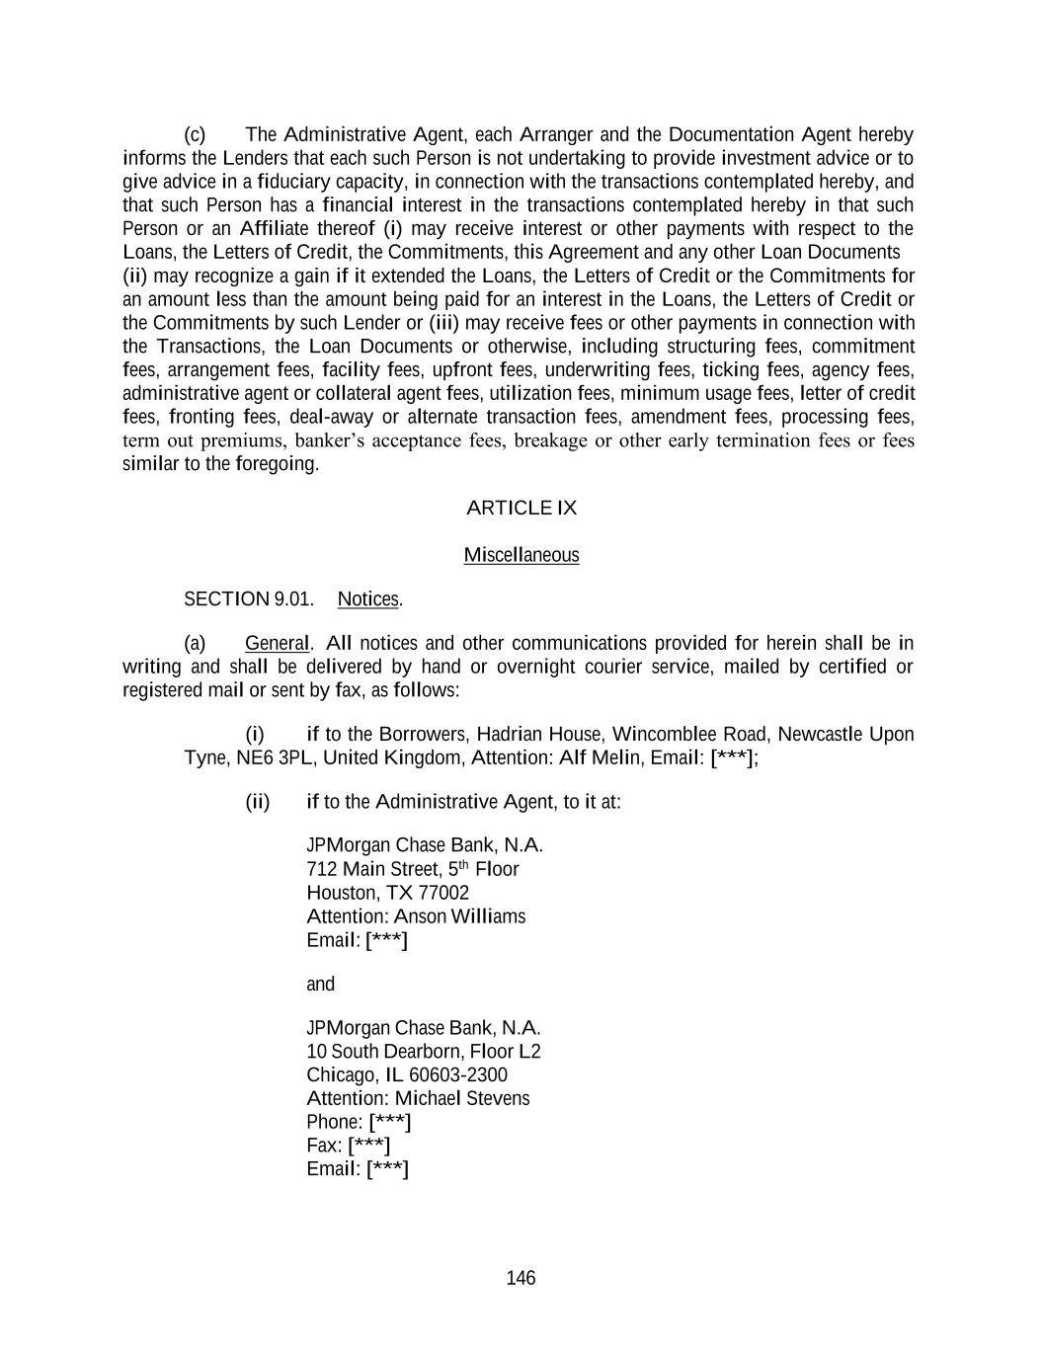
146 (c) The Administrative Agent, each Arranger and the Documentation Agent hereby informs the Lenders that each such Person is not undertaking to provide investment advice or to give advice in a fiduciary capacity, in connection with the transactions contemplated hereby, and that such Person has a financial interest in the transactions contemplated hereby in that such Person or an Affiliate thereof (i) may receive interest or other payments with respect to the Loans, the Letters of Credit, the Commitments, this Agreement and any other Loan Documents (ii) may recognize a gain if it extended the Loans, the Letters of Credit or the Commitments for an amount less than the amount being paid for an interest in the Loans, the Letters of Credit or the Commitments by such Lender or (iii) may receive fees or other payments in connection with the Transactions, the Loan Documents or otherwise, including structuring fees, commitment fees, arrangement fees, facility fees, upfront fees, underwriting fees, ticking fees, agency fees, administrative agent or collateral agent fees, utilization fees, minimum usage fees, letter of credit fees, fronting fees, deal-away or alternate transaction fees, amendment fees, processing fees, term out premiums, banker’s acceptance fees, breakage or other early termination fees or fees similar to the foregoing. ARTICLE IX Miscellaneous SECTION 9.01. Notices. (a) General. All notices and other communications provided for herein shall be in writing and shall be delivered by hand or overnight courier service, mailed by certified or registered mail or sent by fax, as follows: (i) if to the Borrowers, Hadrian House, Wincomblee Road, Newcastle Upon Tyne, NE6 3PL, United Kingdom, Attention: Alf Melin, Email: [***]; (ii) if to the Administrative Agent, to it at: JPMorgan Chase Bank, N.A. 712 Main Street, 5th Floor Houston, TX 77002 Attention: Anson Williams Email: [***] and JPMorgan Chase Bank, N.A. 10 South Dearborn, Floor L2 Chicago, IL 60603-2300 Attention: Michael Stevens Phone: [***] Fax: [***] Email: [***]

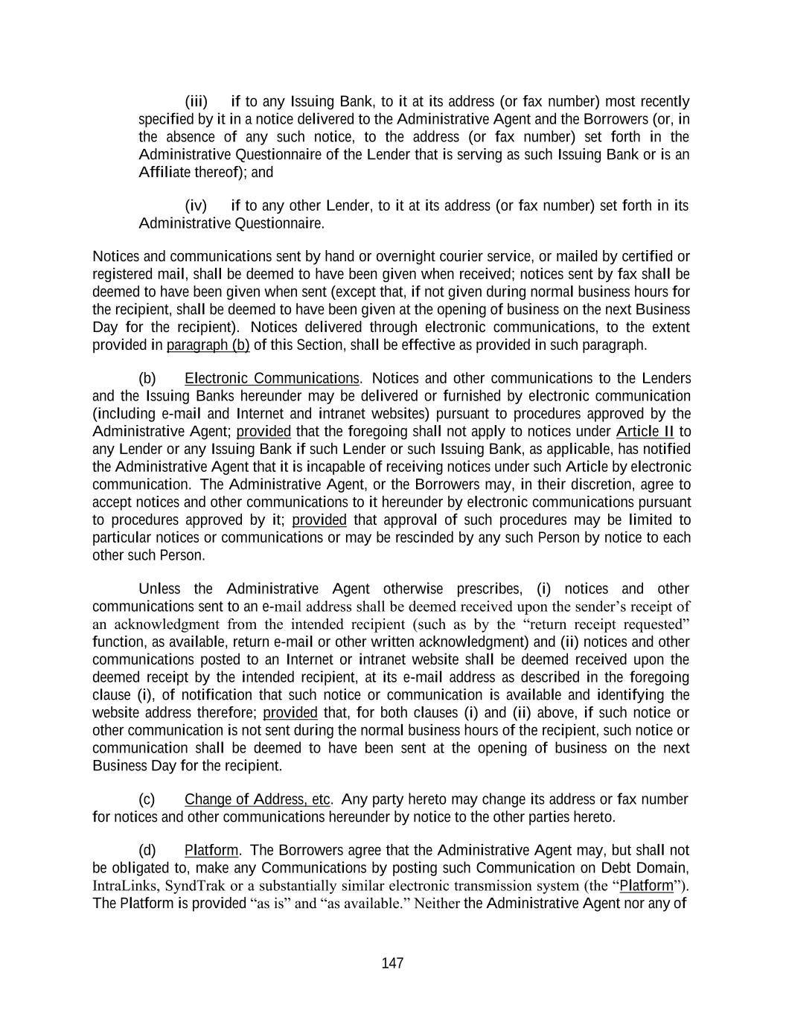
147 (iii) if to any Issuing Bank, to it at its address (or fax number) most recently specified by it in a notice delivered to the Administrative Agent and the Borrowers (or, in the absence of any such notice, to the address (or fax number) set forth in the Administrative Questionnaire of the Lender that is serving as such Issuing Bank or is an Affiliate thereof); and (iv) if to any other Lender, to it at its address (or fax number) set forth in its Administrative Questionnaire. Notices and communications sent by hand or overnight courier service, or mailed by certified or registered mail, shall be deemed to have been given when received; notices sent by fax shall be deemed to have been given when sent (except that, if not given during normal business hours for the recipient, shall be deemed to have been given at the opening of business on the next Business Day for the recipient). Notices delivered through electronic communications, to the extent provided in paragraph (b) of this Section, shall be effective as provided in such paragraph. (b) Electronic Communications. Notices and other communications to the Lenders and the Issuing Banks hereunder may be delivered or furnished by electronic communication (including e-mail and Internet and intranet websites) pursuant to procedures approved by the Administrative Agent; provided that the foregoing shall not apply to notices under Article II to any Lender or any Issuing Bank if such Lender or such Issuing Bank, as applicable, has notified the Administrative Agent that it is incapable of receiving notices under such Article by electronic communication. The Administrative Agent, or the Borrowers may, in their discretion, agree to accept notices and other communications to it hereunder by electronic communications pursuant to procedures approved by it; provided that approval of such procedures may be limited to particular notices or communications or may be rescinded by any such Person by notice to each other such Person. Unless the Administrative Agent otherwise prescribes, (i) notices and other communications sent to an e-mail address shall be deemed received upon the sender’s receipt of an acknowledgment from the intended recipient (such as by the “return receipt requested” function, as available, return e-mail or other written acknowledgment) and (ii) notices and other communications posted to an Internet or intranet website shall be deemed received upon the deemed receipt by the intended recipient, at its e-mail address as described in the foregoing clause (i), of notification that such notice or communication is available and identifying the website address therefore; provided that, for both clauses (i) and (ii) above, if such notice or other communication is not sent during the normal business hours of the recipient, such notice or communication shall be deemed to have been sent at the opening of business on the next Business Day for the recipient. (c) Change of Address, etc. Any party hereto may change its address or fax number for notices and other communications hereunder by notice to the other parties hereto. (d) Platform. The Borrowers agree that the Administrative Agent may, but shall not be obligated to, make any Communications by posting such Communication on Debt Domain, IntraLinks, SyndTrak or a substantially similar electronic transmission system (the “Platform”). The Platform is provided “as is” and “as available.” Neither the Administrative Agent nor any of

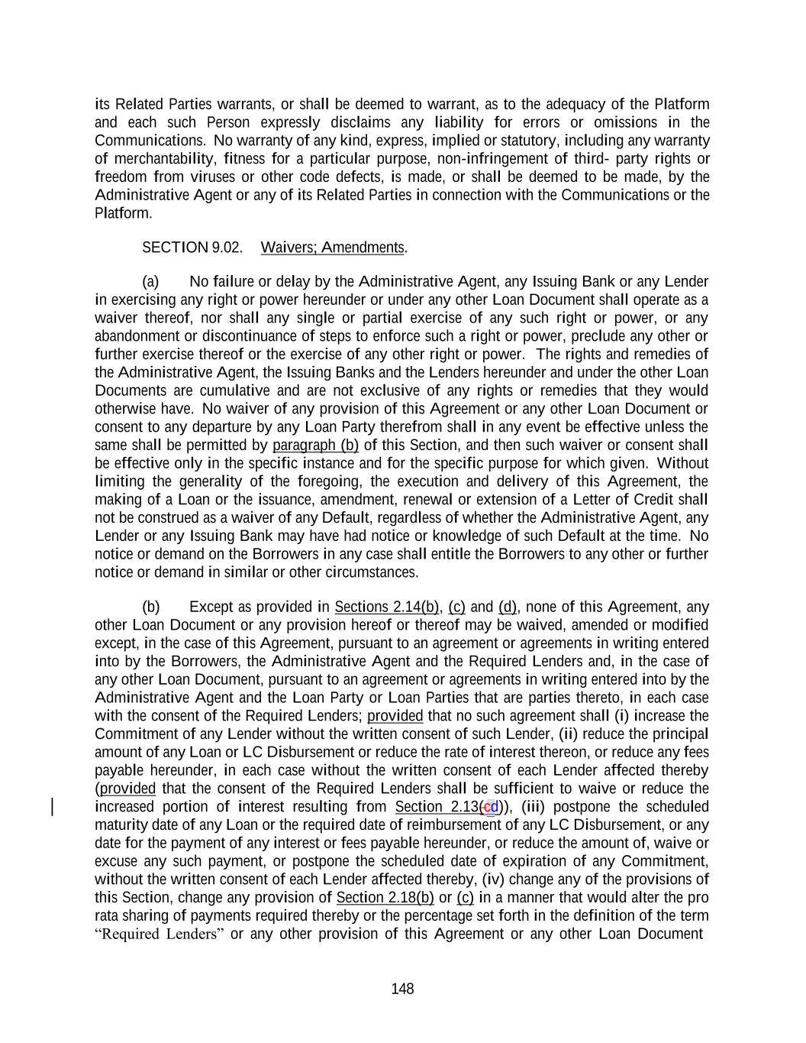
148 its Related Parties warrants, or shall be deemed to warrant, as to the adequacy of the Platform and each such Person expressly disclaims any liability for errors or omissions in the Communications. No warranty of any kind, express, implied or statutory, including any warranty of merchantability, fitness for a particular purpose, non-infringement of third- party rights or freedom from viruses or other code defects, is made, or shall be deemed to be made, by the Administrative Agent or any of its Related Parties in connection with the Communications or the Platform. SECTION 9.02. Waivers; Amendments. (a) No failure or delay by the Administrative Agent, any Issuing Bank or any Lender in exercising any right or power hereunder or under any other Loan Document shall operate as a waiver thereof, nor shall any single or partial exercise of any such right or power, or any abandonment or discontinuance of steps to enforce such a right or power, preclude any other or further exercise thereof or the exercise of any other right or power. The rights and remedies of the Administrative Agent, the Issuing Banks and the Lenders hereunder and under the other Loan Documents are cumulative and are not exclusive of any rights or remedies that they would otherwise have. No waiver of any provision of this Agreement or any other Loan Document or consent to any departure by any Loan Party therefrom shall in any event be effective unless the same shall be permitted by paragraph (b) of this Section, and then such waiver or consent shall be effective only in the specific instance and for the specific purpose for which given. Without limiting the generality of the foregoing, the execution and delivery of this Agreement, the making of a Loan or the issuance, amendment, renewal or extension of a Letter of Credit shall not be construed as a waiver of any Default, regardless of whether the Administrative Agent, any Lender or any Issuing Bank may have had notice or knowledge of such Default at the time. No notice or demand on the Borrowers in any case shall entitle the Borrowers to any other or further notice or demand in similar or other circumstances. (b) Except as provided in Sections 2.14(b), (c) and (d), none of this Agreement, any other Loan Document or any provision hereof or thereof may be waived, amended or modified except, in the case of this Agreement, pursuant to an agreement or agreements in writing entered into by the Borrowers, the Administrative Agent and the Required Lenders and, in the case of any other Loan Document, pursuant to an agreement or agreements in writing entered into by the Administrative Agent and the Loan Party or Loan Parties that are parties thereto, in each case with the consent of the Required Lenders; provided that no such agreement shall (i) increase the Commitment of any Lender without the written consent of such Lender, (ii) reduce the principal amount of any Loan or LC Disbursement or reduce the rate of interest thereon, or reduce any fees payable hereunder, in each case without the written consent of each Lender affected thereby (provided that the consent of the Required Lenders shall be sufficient to waive or reduce the increased portion of interest resulting from Section 2.13(cd)), (iii) postpone the scheduled maturity date of any Loan or the required date of reimbursement of any LC Disbursement, or any date for the payment of any interest or fees payable hereunder, or reduce the amount of, waive or excuse any such payment, or postpone the scheduled date of expiration of any Commitment, without the written consent of each Lender affected thereby, (iv) change any of the provisions of this Section, change any provision of Section 2.18(b) or (c) in a manner that would alter the pro rata sharing of payments required thereby or the percentage set forth in the definition of the term “Required Lenders” or any other provision of this Agreement or any other Loan Document

149 specifying the number or percentage of Lenders required to waive, amend or otherwise modify any rights thereunder or make any determination or grant any consent thereunder, without the written consent of each Lender, (v) release all or substantially all of the value of the Guarantees provided by the Loan Parties under the New York-Law Guarantee, in each case without the written consent of each Lender (except as expressly provided in Section 9.14 or the New York- Law Guarantee (including any such release by the Administrative Agent in connection with any sale or other disposition of any Subsidiary upon the exercise of remedies under the Security Documents), it being understood and agreed that an amendment or other modification of the type of obligations guaranteed under the New York-Law Guarantee shall not be deemed to be a release of any Guarantee), (vi) release all or substantially all the Collateral from the Liens of the Security Documents without the written consent of each Lender (except as expressly provided in Section 9.14 or the applicable Security Document (including any such release by the Administrative Agent in connection with any sale or other disposition of the Collateral upon the exercise of remedies under the Security Documents), it being understood and agreed that an amendment or other modification of the type of obligations secured by the Security Documents shall not be deemed to be a release of the Collateral from the Liens of the Security Documents), (vii) [reserved], (viii) [reserved] or (ix) amend Section 2.18(f) without the written consent of each Lender; provided, further, that no such agreement shall amend, modify, extend or otherwise affect the rights or obligations of the Administrative Agent or any Issuing Bank without the prior written consent of the Administrative Agent or such Issuing Bank, as applicable. Notwithstanding any of the foregoing, (1) no consent with respect to any waiver, amendment or other modification of this Agreement or any other Loan Document shall be required of any Defaulting Lender, except with respect to any waiver, amendment or other modification referred to in clause (i), (ii) or (iii) of the first proviso of this paragraph and then only in the event such Defaulting Lender shall be affected by such waiver, amendment or other modification and (2) any provision of this Agreement or any other Loan Document may be amended by an agreement in writing entered into by the Borrowers and the Administrative Agent to cure any ambiguity, omission, mistake, defect or inconsistency so long as, in each case, the Lenders shall have received at least five Business Days prior written notice thereof and the Administrative Agent shall not have received, within five Business Days of the date of such notice to the Lenders, a written notice from (x) the Required Lenders stating that the Required Lenders object to such amendment or (y) if affected by such amendment, any Issuing Bank stating that it objects to such amendment. (c) In connection with any Proposed Change requiring the consent of all Lenders or all affected Lenders, if the consent of the Required Lenders to such Proposed Change is obtained, but the consent to such Proposed Change of other Lenders whose consent is required is not obtained (any such Lender whose consent is not obtained as described in paragraph (b) of this Section being referred to as a “Non-Consenting Lender” for purposes of this clause (c)), then the Borrowers may, at their sole expense and effort, upon notice to such Non-Consenting Lender and the Administrative Agent, require such Non-Consenting Lender to assign and delegate, without recourse (in accordance with and subject to the restrictions contained in Section 9.04), all its interests, rights and obligations under this Agreement to an assignee that shall assume such obligations (which assignee may be another Lender, if a Lender accepts such assignment); provided that (i) if the Administrative Agent is not such Non-Consenting Lender, the Borrowers shall have received the prior written consent of the Administrative Agent (and, if a Commitment is being assigned, each Issuing Bank), which consent shall not unreasonably be withheld or

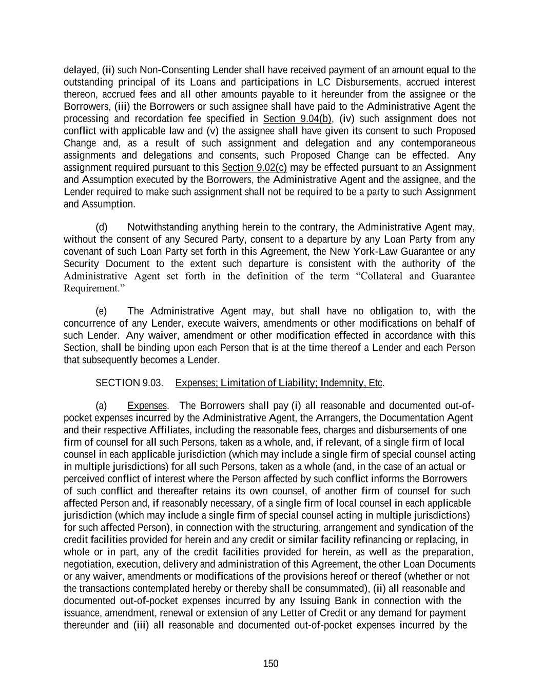
150 delayed, (ii) such Non-Consenting Lender shall have received payment of an amount equal to the outstanding principal of its Loans and participations in LC Disbursements, accrued interest thereon, accrued fees and all other amounts payable to it hereunder from the assignee or the Borrowers, (iii) the Borrowers or such assignee shall have paid to the Administrative Agent the processing and recordation fee specified in Section 9.04(b), (iv) such assignment does not conflict with applicable law and (v) the assignee shall have given its consent to such Proposed Change and, as a result of such assignment and delegation and any contemporaneous assignments and delegations and consents, such Proposed Change can be effected. Any assignment required pursuant to this Section 9.02(c) may be effected pursuant to an Assignment and Assumption executed by the Borrowers, the Administrative Agent and the assignee, and the Lender required to make such assignment shall not be required to be a party to such Assignment and Assumption. (d) Notwithstanding anything herein to the contrary, the Administrative Agent may, without the consent of any Secured Party, consent to a departure by any Loan Party from any covenant of such Loan Party set forth in this Agreement, the New York-Law Guarantee or any Security Document to the extent such departure is consistent with the authority of the Administrative Agent set forth in the definition of the term “Collateral and Guarantee Requirement.” (e) The Administrative Agent may, but shall have no obligation to, with the concurrence of any Lender, execute waivers, amendments or other modifications on behalf of such Lender. Any waiver, amendment or other modification effected in accordance with this Section, shall be binding upon each Person that is at the time thereof a Lender and each Person that subsequently becomes a Lender. SECTION 9.03. Expenses; Limitation of Liability; Indemnity, Etc. (a) Expenses. The Borrowers shall pay (i) all reasonable and documented out-of- pocket expenses incurred by the Administrative Agent, the Arrangers, the Documentation Agent and their respective Affiliates, including the reasonable fees, charges and disbursements of one firm of counsel for all such Persons, taken as a whole, and, if relevant, of a single firm of local counsel in each applicable jurisdiction (which may include a single firm of special counsel acting in multiple jurisdictions) for all such Persons, taken as a whole (and, in the case of an actual or perceived conflict of interest where the Person affected by such conflict informs the Borrowers of such conflict and thereafter retains its own counsel, of another firm of counsel for such affected Person and, if reasonably necessary, of a single firm of local counsel in each applicable jurisdiction (which may include a single firm of special counsel acting in multiple jurisdictions) for such affected Person), in connection with the structuring, arrangement and syndication of the credit facilities provided for herein and any credit or similar facility refinancing or replacing, in whole or in part, any of the credit facilities provided for herein, as well as the preparation, negotiation, execution, delivery and administration of this Agreement, the other Loan Documents or any waiver, amendments or modifications of the provisions hereof or thereof (whether or not the transactions contemplated hereby or thereby shall be consummated), (ii) all reasonable and documented out-of-pocket expenses incurred by any Issuing Bank in connection with the issuance, amendment, renewal or extension of any Letter of Credit or any demand for payment thereunder and (iii) all reasonable and documented out-of-pocket expenses incurred by the

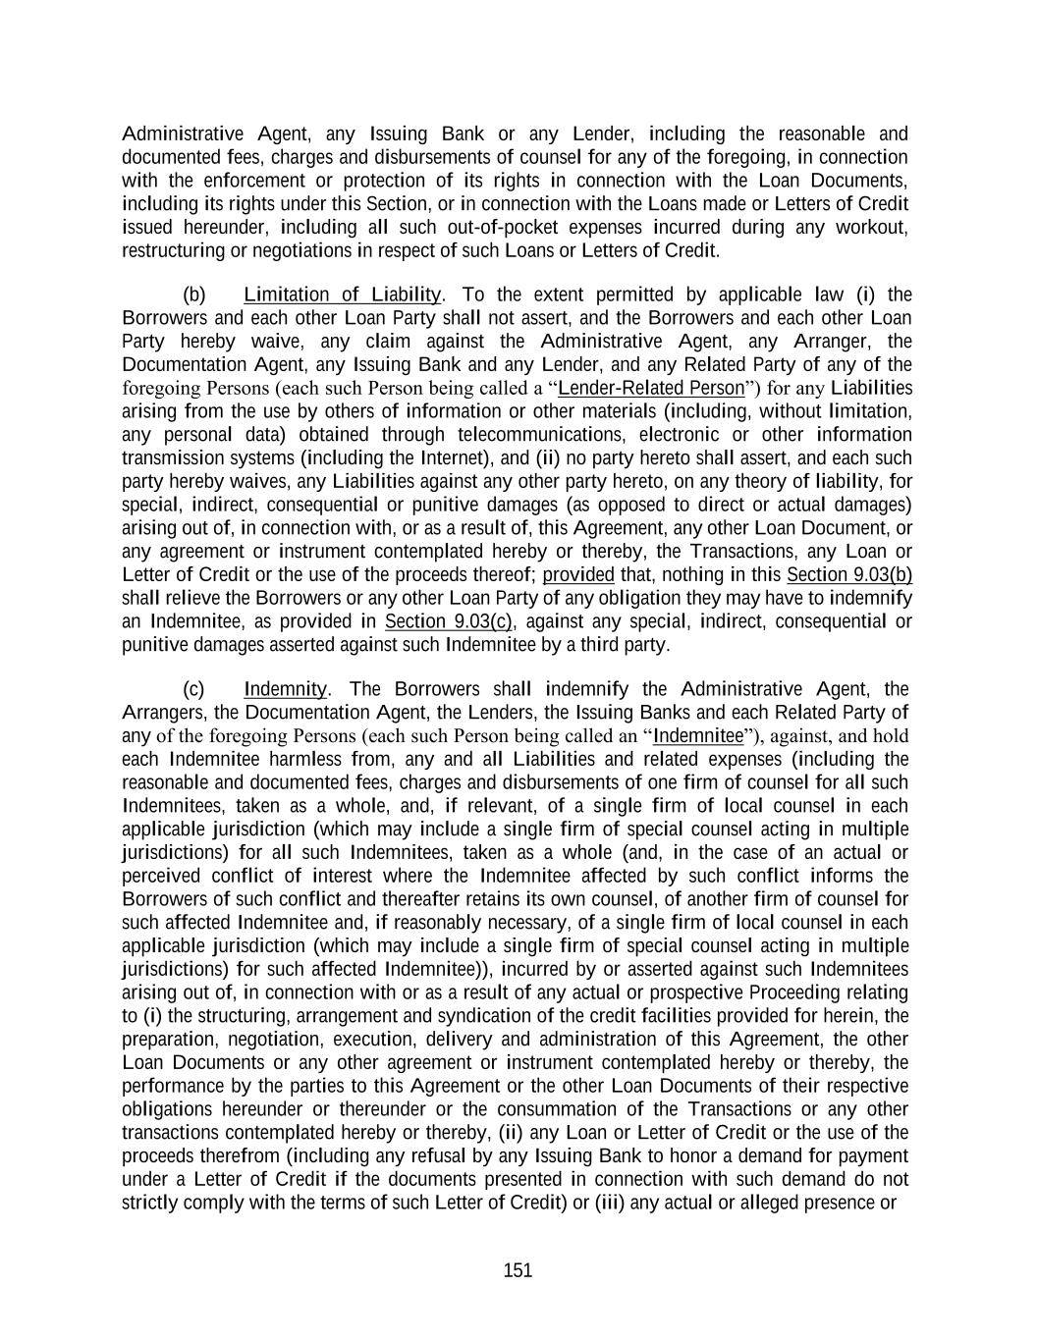
151 Administrative Agent, any Issuing Bank or any Lender, including the reasonable and documented fees, charges and disbursements of counsel for any of the foregoing, in connection with the enforcement or protection of its rights in connection with the Loan Documents, including its rights under this Section, or in connection with the Loans made or Letters of Credit issued hereunder, including all such out-of-pocket expenses incurred during any workout, restructuring or negotiations in respect of such Loans or Letters of Credit. (b) Limitation of Liability. To the extent permitted by applicable law (i) the Borrowers and each other Loan Party shall not assert, and the Borrowers and each other Loan Party hereby waive, any claim against the Administrative Agent, any Arranger, the Documentation Agent, any Issuing Bank and any Lender, and any Related Party of any of the foregoing Persons (each such Person being called a “Lender-Related Person”) for any Liabilities arising from the use by others of information or other materials (including, without limitation, any personal data) obtained through telecommunications, electronic or other information transmission systems (including the Internet), and (ii) no party hereto shall assert, and each such party hereby waives, any Liabilities against any other party hereto, on any theory of liability, for special, indirect, consequential or punitive damages (as opposed to direct or actual damages) arising out of, in connection with, or as a result of, this Agreement, any other Loan Document, or any agreement or instrument contemplated hereby or thereby, the Transactions, any Loan or Letter of Credit or the use of the proceeds thereof; provided that, nothing in this Section 9.03(b) shall relieve the Borrowers or any other Loan Party of any obligation they may have to indemnify an Indemnitee, as provided in Section 9.03(c), against any special, indirect, consequential or punitive damages asserted against such Indemnitee by a third party. (c) Indemnity. The Borrowers shall indemnify the Administrative Agent, the Arrangers, the Documentation Agent, the Lenders, the Issuing Banks and each Related Party of any of the foregoing Persons (each such Person being called an “Indemnitee”), against, and hold each Indemnitee harmless from, any and all Liabilities and related expenses (including the reasonable and documented fees, charges and disbursements of one firm of counsel for all such Indemnitees, taken as a whole, and, if relevant, of a single firm of local counsel in each applicable jurisdiction (which may include a single firm of special counsel acting in multiple jurisdictions) for all such Indemnitees, taken as a whole (and, in the case of an actual or perceived conflict of interest where the Indemnitee affected by such conflict informs the Borrowers of such conflict and thereafter retains its own counsel, of another firm of counsel for such affected Indemnitee and, if reasonably necessary, of a single firm of local counsel in each applicable jurisdiction (which may include a single firm of special counsel acting in multiple jurisdictions) for such affected Indemnitee)), incurred by or asserted against such Indemnitees arising out of, in connection with or as a result of any actual or prospective Proceeding relating to (i) the structuring, arrangement and syndication of the credit facilities provided for herein, the preparation, negotiation, execution, delivery and administration of this Agreement, the other Loan Documents or any other agreement or instrument contemplated hereby or thereby, the performance by the parties to this Agreement or the other Loan Documents of their respective obligations hereunder or thereunder or the consummation of the Transactions or any other transactions contemplated hereby or thereby, (ii) any Loan or Letter of Credit or the use of the proceeds therefrom (including any refusal by any Issuing Bank to honor a demand for payment under a Letter of Credit if the documents presented in connection with such demand do not strictly comply with the terms of such Letter of Credit) or (iii) any actual or alleged presence or

152 Release of Hazardous Materials on, at, to or from any Mortgaged Property or any other property currently or formerly owned or operated by the Borrowers or any Subsidiary, or any other Environmental Liability related in any way to the Borrowers or any Subsidiary, in each case, whether based on contract, tort or any other theory and whether initiated against or by any party to this Agreement or any other Loan Document, any Affiliate of any of the foregoing or any third party (and regardless of whether any Indemnitee is a party thereto); provided that the foregoing indemnity shall not, as to any Indemnitee, apply to any Liabilities or related expenses to the extent (A) they are found in a final and non-appealable judgment of a court of competent jurisdiction to have primarily resulted from the willful misconduct, bad faith or gross negligence of such Indemnitee or (B) a proceeding that does not involve an act or omission by the Borrowers or any of their respective Affiliates and that is brought by an Indemnitee against any other Indemnitee (other than a proceeding that is brought against the Administrative Agent, any Issuing Bank or any other agent or any Arranger in its capacity or in fulfilling its roles as an agent, issuing bank or arranger hereunder or any similar role with respect to the Indebtedness incurred or to be incurred hereunder). This Section 9.03(c) shall not apply with respect to Taxes other than any Taxes that represent losses, claims or damages arising from any non-Tax claim. (d) Lender Reimbursement. Each Lender severally agrees to pay any amount required to be paid by the Borrowers under paragraphs (a), (b) or (c) of this Section 9.03 or the Collateral Agency Agreement to the Administrative Agent, the Collateral Agent, any Issuing Bank, or any Related Party of any of the foregoing Persons (each, an “Agent-Related Person”) (to the extent not reimbursed by the Borrowers and without limiting their obligation to do so), ratably according to their respective Applicable Percentage in effect on the date on which such payment is sought under this Section (or, if such payment is sought after the date upon which the Commitments shall have terminated and the Loans shall have been paid in full, ratably in accordance with such Applicable Percentage immediately prior to such date), and agrees to indemnify and hold each Agent-Related Person harmless from and against any and all Liabilities and related expenses, including the fees, charges and disbursements of any kind whatsoever that may at any time (whether before or after the payment of the Loans) be imposed on, incurred by or asserted against such Agent-Related Person in any way relating to or arising out of the Commitments, this Agreement, any of the other Loan Documents or any documents contemplated by or referred to herein or therein or the transactions contemplated hereby or thereby or any action taken or omitted by such Agent-Related Person under or in connection with any of the foregoing; provided that the unreimbursed expense or Liability or related expense, as the case may be, was incurred by or asserted against such Agent-Related Person in its capacity as such; provided further that no Lender shall be liable for the payment of any portion of such Liabilities, costs, expenses or disbursements that are found by a final and nonappealable decision of a court of competent jurisdiction to have resulted primarily from such Agent-Related Party’s gross negligence or willful misconduct. The agreements in this Section shall survive the termination of this Agreement and the payment of the Loans and all other amounts payable hereunder. (e) All amounts due under this Section shall be payable promptly after written demand therefor. SECTION 9.04. Successors and Assigns.

153 (a) General. The provisions of this Agreement shall be binding upon and inure to the benefit of the parties hereto and their respective successors and assigns permitted hereby (including any Affiliate of any Issuing Bank that issues any Letter of Credit), except that (i) neither of the Borrowers may assign, delegate or otherwise transfer any of their rights or obligations hereunder without the prior written consent of the Administrative Agent and each Lender (and any attempted assignment, delegation or transfer by a Borrower without such consent shall be null and void) and (ii) no Lender may assign, delegate or otherwise transfer its rights or obligations hereunder except in accordance with this Section. Nothing in this Agreement, expressed or implied, shall be construed to confer upon any Person (other than the parties hereto, their respective successors and assigns permitted hereby (including any Affiliate of any Issuing Bank that issues any Letter of Credit), Participants (to the extent provided in paragraph (c) of this Section), the Arrangers, the Documentation Agent and, to the extent expressly contemplated hereby, the Related Parties of any of the Administrative Agent, any Arranger, the Documentation Agent, any Issuing Bank and any Lender) any legal or equitable right, remedy or claim under or by reason of this Agreement. (b) Assignments by Lenders. (i) Subject to the conditions set forth in paragraph (b)(ii) below, any Lender may assign and delegate to one or more Eligible Assignees all or a portion of its rights and obligations under this Agreement (including all or a portion of its Commitment and the Loans at the time owing to it) with the prior written consent (such consent not to be unreasonably withheld or delayed, except in connection with a proposed assignment to any Disqualified Institution) of (A) the Borrowers; provided that no consent of the Borrowers shall be required (1) for an assignment and delegation to a Revolving Lender, an affiliate of a Revolving Lender or an Approved Fund in respect of a Revolving Lender and (2) if an Event of Default of the type set forth in Section 7.01(a), (b), (d) (with respect to any Financial Covenant), (h) or (i) has occurred and is continuing, for any other assignment and delegation; provided, further, that the Borrowers shall be deemed to have consented to any such assignment and delegation unless they shall object thereto by written notice to the Administrative Agent within ten (10) Business Days after having received notice thereof, (B) the Administrative Agent; provided that no consent of the Administrative Agent shall be required for an assignment and delegation of all or any portion of a Commitment or Revolving Loan to a Revolving Lender, an affiliate of a Revolving Lender or an Approved Fund in respect of a Revolving Lender and (C) each Issuing Bank, in the case of any assignment and delegation of all or a portion of a Commitment or any Lender’s obligations in respect of its LC Exposure. (ii) Assignments shall be subject to the following additional conditions: (A) except in the case of an assignment to a Lender, an Affiliate of a Lender or an Approved Fund or an assignment of the entire remaining amount of the assigning Lender’s Commitment or Loans, the amount of the Commitment or Loans of the assigning Lender subject to each such assignment (determined as of the date the Assignment and Assumption with respect to such assignment and delegation is delivered to the Administrative Agent) shall not be less than $5,000,000, unless each Borrower and the Administrative Agent otherwise consents; provided that no such consent of the Borrowers shall be required if an Event of Default has occurred and is continuing, (B) each partial assignment shall be made as an assignment of a proportionate part of all the assigning Lender’s rights and obligations under this Agreement, (C) the parties to each assignment shall execute and deliver to the Administrative Agent (x) an Assignment and

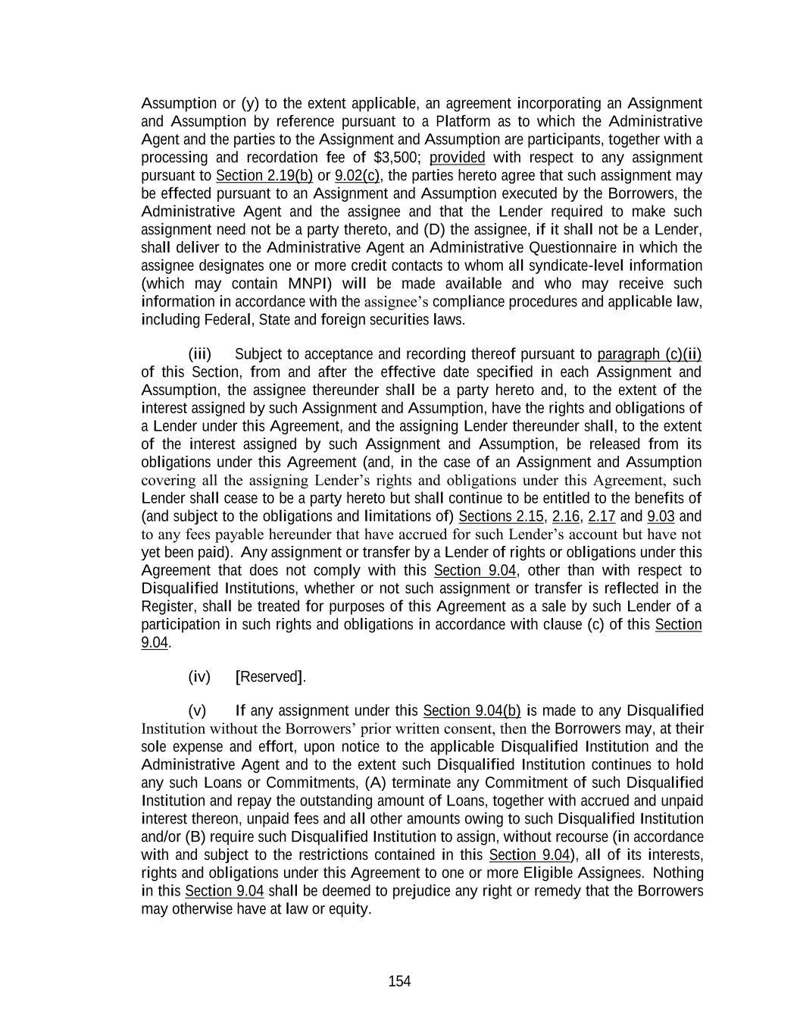
154 Assumption or (y) to the extent applicable, an agreement incorporating an Assignment and Assumption by reference pursuant to a Platform as to which the Administrative Agent and the parties to the Assignment and Assumption are participants, together with a processing and recordation fee of $3,500; provided with respect to any assignment pursuant to Section 2.19(b) or 9.02(c), the parties hereto agree that such assignment may be effected pursuant to an Assignment and Assumption executed by the Borrowers, the Administrative Agent and the assignee and that the Lender required to make such assignment need not be a party thereto, and (D) the assignee, if it shall not be a Lender, shall deliver to the Administrative Agent an Administrative Questionnaire in which the assignee designates one or more credit contacts to whom all syndicate-level information (which may contain MNPI) will be made available and who may receive such information in accordance with the assignee’s compliance procedures and applicable law, including Federal, State and foreign securities laws. (iii) Subject to acceptance and recording thereof pursuant to paragraph (c)(ii) of this Section, from and after the effective date specified in each Assignment and Assumption, the assignee thereunder shall be a party hereto and, to the extent of the interest assigned by such Assignment and Assumption, have the rights and obligations of a Lender under this Agreement, and the assigning Lender thereunder shall, to the extent of the interest assigned by such Assignment and Assumption, be released from its obligations under this Agreement (and, in the case of an Assignment and Assumption covering all the assigning Lender’s rights and obligations under this Agreement, such Lender shall cease to be a party hereto but shall continue to be entitled to the benefits of (and subject to the obligations and limitations of) Sections 2.15, 2.16, 2.17 and 9.03 and to any fees payable hereunder that have accrued for such Lender’s account but have not yet been paid). Any assignment or transfer by a Lender of rights or obligations under this Agreement that does not comply with this Section 9.04, other than with respect to Disqualified Institutions, whether or not such assignment or transfer is reflected in the Register, shall be treated for purposes of this Agreement as a sale by such Lender of a participation in such rights and obligations in accordance with clause (c) of this Section 9.04. (iv) [Reserved]. (v) If any assignment under this Section 9.04(b) is made to any Disqualified Institution without the Borrowers’ prior written consent, then the Borrowers may, at their sole expense and effort, upon notice to the applicable Disqualified Institution and the Administrative Agent and to the extent such Disqualified Institution continues to hold any such Loans or Commitments, (A) terminate any Commitment of such Disqualified Institution and repay the outstanding amount of Loans, together with accrued and unpaid interest thereon, unpaid fees and all other amounts owing to such Disqualified Institution and/or (B) require such Disqualified Institution to assign, without recourse (in accordance with and subject to the restrictions contained in this Section 9.04), all of its interests, rights and obligations under this Agreement to one or more Eligible Assignees. Nothing in this Section 9.04 shall be deemed to prejudice any right or remedy that the Borrowers may otherwise have at law or equity.

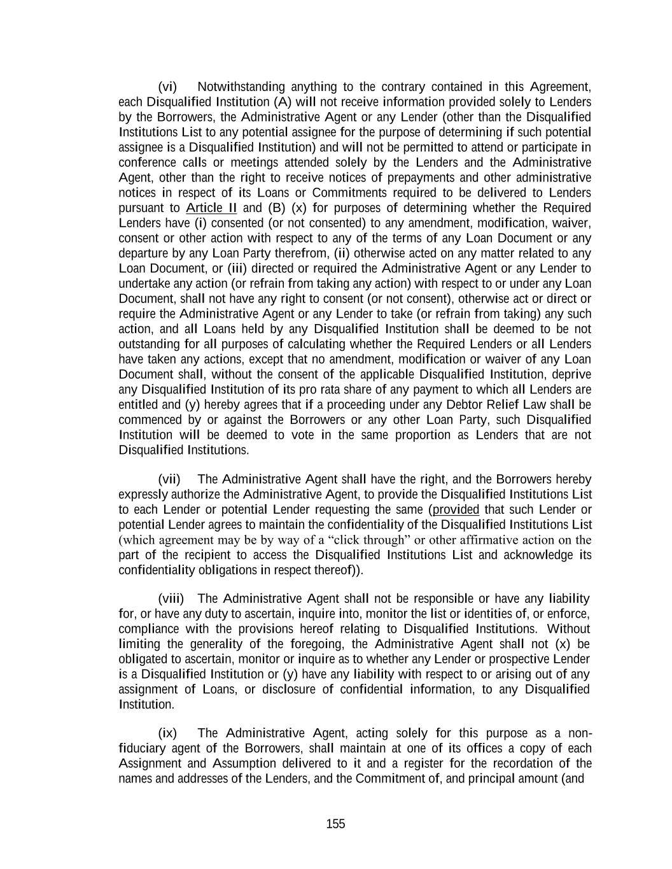
155 (vi) Notwithstanding anything to the contrary contained in this Agreement, each Disqualified Institution (A) will not receive information provided solely to Lenders by the Borrowers, the Administrative Agent or any Lender (other than the Disqualified Institutions List to any potential assignee for the purpose of determining if such potential assignee is a Disqualified Institution) and will not be permitted to attend or participate in conference calls or meetings attended solely by the Lenders and the Administrative Agent, other than the right to receive notices of prepayments and other administrative notices in respect of its Loans or Commitments required to be delivered to Lenders pursuant to Article II and (B) (x) for purposes of determining whether the Required Lenders have (i) consented (or not consented) to any amendment, modification, waiver, consent or other action with respect to any of the terms of any Loan Document or any departure by any Loan Party therefrom, (ii) otherwise acted on any matter related to any Loan Document, or (iii) directed or required the Administrative Agent or any Lender to undertake any action (or refrain from taking any action) with respect to or under any Loan Document, shall not have any right to consent (or not consent), otherwise act or direct or require the Administrative Agent or any Lender to take (or refrain from taking) any such action, and all Loans held by any Disqualified Institution shall be deemed to be not outstanding for all purposes of calculating whether the Required Lenders or all Lenders have taken any actions, except that no amendment, modification or waiver of any Loan Document shall, without the consent of the applicable Disqualified Institution, deprive any Disqualified Institution of its pro rata share of any payment to which all Lenders are entitled and (y) hereby agrees that if a proceeding under any Debtor Relief Law shall be commenced by or against the Borrowers or any other Loan Party, such Disqualified Institution will be deemed to vote in the same proportion as Lenders that are not Disqualified Institutions. (vii) The Administrative Agent shall have the right, and the Borrowers hereby expressly authorize the Administrative Agent, to provide the Disqualified Institutions List to each Lender or potential Lender requesting the same (provided that such Lender or potential Lender agrees to maintain the confidentiality of the Disqualified Institutions List (which agreement may be by way of a “click through” or other affirmative action on the part of the recipient to access the Disqualified Institutions List and acknowledge its confidentiality obligations in respect thereof)). (viii) The Administrative Agent shall not be responsible or have any liability for, or have any duty to ascertain, inquire into, monitor the list or identities of, or enforce, compliance with the provisions hereof relating to Disqualified Institutions. Without limiting the generality of the foregoing, the Administrative Agent shall not (x) be obligated to ascertain, monitor or inquire as to whether any Lender or prospective Lender is a Disqualified Institution or (y) have any liability with respect to or arising out of any assignment of Loans, or disclosure of confidential information, to any Disqualified Institution. (ix) The Administrative Agent, acting solely for this purpose as a non- fiduciary agent of the Borrowers, shall maintain at one of its offices a copy of each Assignment and Assumption delivered to it and a register for the recordation of the names and addresses of the Lenders, and the Commitment of, and principal amount (and

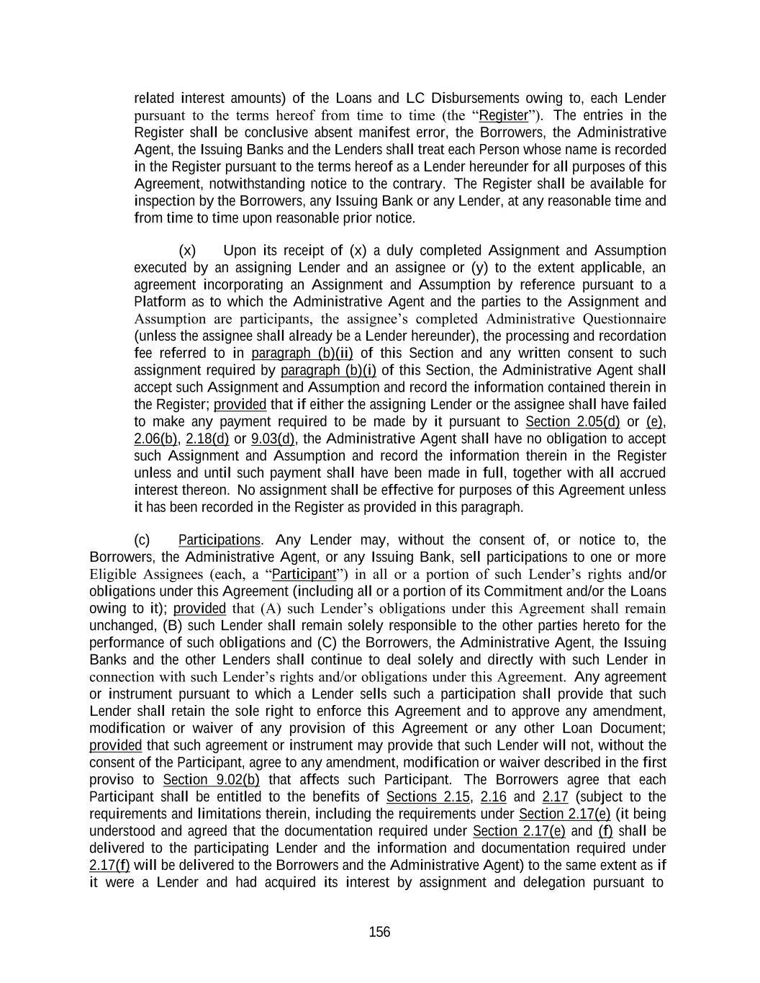
156 related interest amounts) of the Loans and LC Disbursements owing to, each Lender pursuant to the terms hereof from time to time (the “Register”). The entries in the Register shall be conclusive absent manifest error, the Borrowers, the Administrative Agent, the Issuing Banks and the Lenders shall treat each Person whose name is recorded in the Register pursuant to the terms hereof as a Lender hereunder for all purposes of this Agreement, notwithstanding notice to the contrary. The Register shall be available for inspection by the Borrowers, any Issuing Bank or any Lender, at any reasonable time and from time to time upon reasonable prior notice. (x) Upon its receipt of (x) a duly completed Assignment and Assumption executed by an assigning Lender and an assignee or (y) to the extent applicable, an agreement incorporating an Assignment and Assumption by reference pursuant to a Platform as to which the Administrative Agent and the parties to the Assignment and Assumption are participants, the assignee’s completed Administrative Questionnaire (unless the assignee shall already be a Lender hereunder), the processing and recordation fee referred to in paragraph (b)(ii) of this Section and any written consent to such assignment required by paragraph (b)(i) of this Section, the Administrative Agent shall accept such Assignment and Assumption and record the information contained therein in the Register; provided that if either the assigning Lender or the assignee shall have failed to make any payment required to be made by it pursuant to Section 2.05(d) or (e), 2.06(b), 2.18(d) or 9.03(d), the Administrative Agent shall have no obligation to accept such Assignment and Assumption and record the information therein in the Register unless and until such payment shall have been made in full, together with all accrued interest thereon. No assignment shall be effective for purposes of this Agreement unless it has been recorded in the Register as provided in this paragraph. (c) Participations. Any Lender may, without the consent of, or notice to, the Borrowers, the Administrative Agent, or any Issuing Bank, sell participations to one or more Eligible Assignees (each, a “Participant”) in all or a portion of such Lender’s rights and/or obligations under this Agreement (including all or a portion of its Commitment and/or the Loans owing to it); provided that (A) such Lender’s obligations under this Agreement shall remain unchanged, (B) such Lender shall remain solely responsible to the other parties hereto for the performance of such obligations and (C) the Borrowers, the Administrative Agent, the Issuing Banks and the other Lenders shall continue to deal solely and directly with such Lender in connection with such Lender’s rights and/or obligations under this Agreement. Any agreement or instrument pursuant to which a Lender sells such a participation shall provide that such Lender shall retain the sole right to enforce this Agreement and to approve any amendment, modification or waiver of any provision of this Agreement or any other Loan Document; provided that such agreement or instrument may provide that such Lender will not, without the consent of the Participant, agree to any amendment, modification or waiver described in the first proviso to Section 9.02(b) that affects such Participant. The Borrowers agree that each Participant shall be entitled to the benefits of Sections 2.15, 2.16 and 2.17 (subject to the requirements and limitations therein, including the requirements under Section 2.17(e) (it being understood and agreed that the documentation required under Section 2.17(e) and (f) shall be delivered to the participating Lender and the information and documentation required under 2.17(f) will be delivered to the Borrowers and the Administrative Agent) to the same extent as if it were a Lender and had acquired its interest by assignment and delegation pursuant to

157 paragraph (b) of this Section; provided that such Participant (A) agrees to be subject to the provisions of Sections 2.18 and 2.19 as if it were an assignee under paragraph (b) of this Section and (B) shall not be entitled to receive any greater payment under Section 2.15 or 2.17, with respect to any participation, than its participating Lender would have been entitled to receive, except to the extent such entitlement to receive a greater payment results from a Change in Law that occurs after the Participant acquired the applicable participation. Each Lender that sells a participation agrees, at the Borrowers’ request and expense, to use reasonable efforts to cooperate with the Borrowers to effectuate the provisions of Section 2.19(b) with respect to any Participant. To the extent permitted by law, each Participant also shall be entitled to the benefits of Section 9.08 as though it were a Lender; provided that such Participant agrees to be subject to Section 2.18(c) as though it were a Lender. Each Lender that sells a participation shall, acting solely for this purpose as a non-fiduciary agent of the Borrowers, maintain a register on which it enters the name and address of each Participant and the principal amounts (and stated interest) of each Participant’s interest in the Loans or other obligations under this Agreement or any other Loan Document (the “Participant Register”); provided that no Lender shall have any obligation to disclose all or any portion of the Participant Register (including the identity of any Participant or any information relating to a Participant’s interest in any Commitments, Loans, Letters of Credit or its other obligations under this Agreement or any other Loan Document) to any Person except to the extent that such disclosure is necessary to establish that such Commitment, Loan, Letter of Credit or other obligation is in registered form under Section 5f.103-1(c) or Proposed Section 1.163-5(b) of the United States Treasury Regulations (or, in each case, any amended or successor version). The entries in the Participant Register shall be conclusive absent manifest error, and such Lender shall treat each Person whose name is recorded in the Participant Register as the owner of such participation for all purposes of this Agreement notwithstanding any notice to the contrary. For the avoidance of doubt, the Administrative Agent (in its capacity as Administrative Agent) shall have no responsibility for maintaining a Participant Register. (d) Certain Pledges. Any Lender may, without the consent of the Borrowers, the Administrative Agent or any Issuing Bank, at any time pledge or assign a security interest in all or any portion of its rights under this Agreement to secure obligations of such Lender, including any pledge or assignment to secure obligations to a Federal Reserve Bank, and this Section shall not apply to any such pledge or assignment of a security interest; provided that no such pledge or assignment of a security interest shall release a Lender from any of its obligations hereunder or substitute any such pledgee or assignee for such Lender as a party hereto. SECTION 9.05. Survival. All covenants, agreements, representations and warranties made by the Loan Parties in this Agreement and the other Loan Documents and in the certificates or other instruments delivered in connection with or pursuant to this Agreement or any other Loan Document shall be considered to have been relied upon by the other parties hereto and shall survive the execution and delivery of this Agreement and the other Loan Documents and the making of any Loans and issuance of any Letters of Credit, regardless of any investigation made by any such other party or on its behalf and notwithstanding that the Administrative Agent, the Arrangers, the Documentation Agent, any Issuing Bank, any Lender or any Affiliate of any of the foregoing may have had notice or knowledge of any Default or incorrect representation or warranty at the time this Agreement or any other Loan Document is executed and delivered or any credit is extended hereunder, and shall continue in full force and effect as long as the principal of or any accrued interest on any Loan or any fee or any other amount payable under

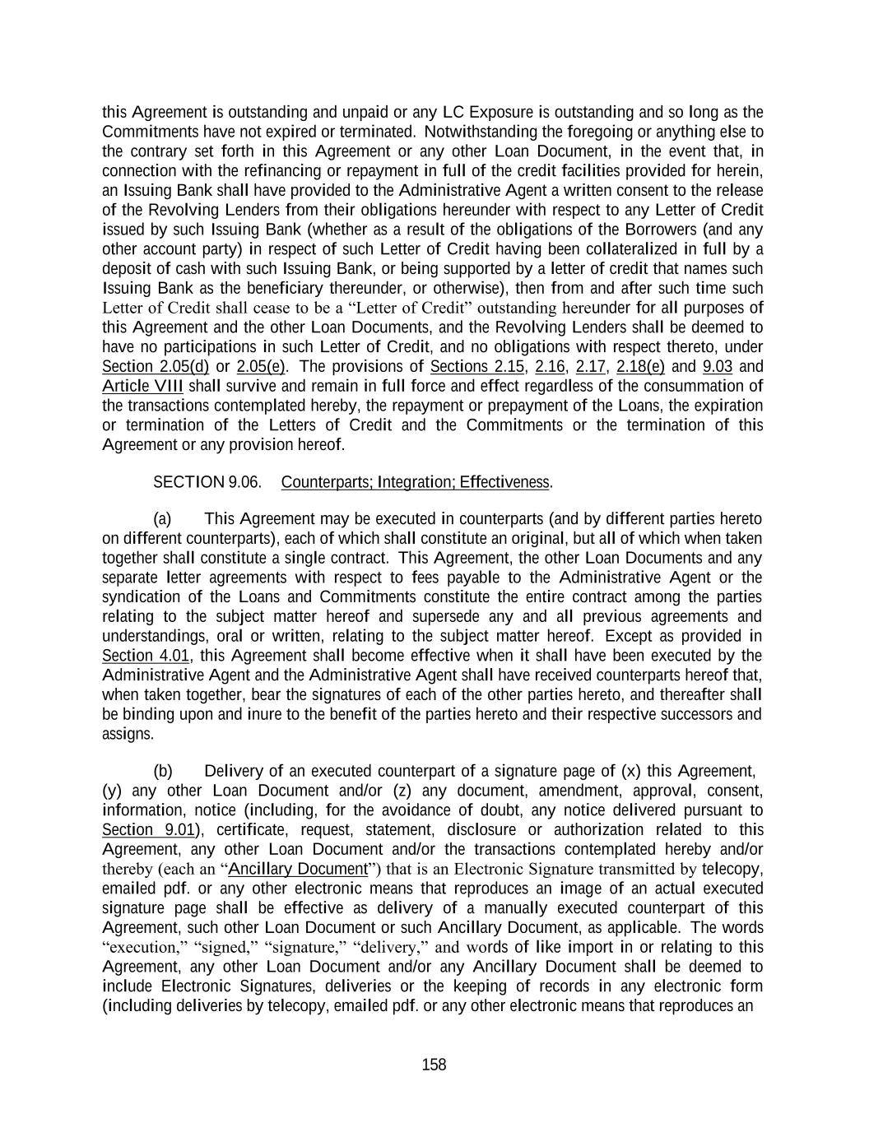
158 this Agreement is outstanding and unpaid or any LC Exposure is outstanding and so long as the Commitments have not expired or terminated. Notwithstanding the foregoing or anything else to the contrary set forth in this Agreement or any other Loan Document, in the event that, in connection with the refinancing or repayment in full of the credit facilities provided for herein, an Issuing Bank shall have provided to the Administrative Agent a written consent to the release of the Revolving Lenders from their obligations hereunder with respect to any Letter of Credit issued by such Issuing Bank (whether as a result of the obligations of the Borrowers (and any other account party) in respect of such Letter of Credit having been collateralized in full by a deposit of cash with such Issuing Bank, or being supported by a letter of credit that names such Issuing Bank as the beneficiary thereunder, or otherwise), then from and after such time such Letter of Credit shall cease to be a “Letter of Credit” outstanding hereunder for all purposes of this Agreement and the other Loan Documents, and the Revolving Lenders shall be deemed to have no participations in such Letter of Credit, and no obligations with respect thereto, under Section 2.05(d) or 2.05(e). The provisions of Sections 2.15, 2.16, 2.17, 2.18(e) and 9.03 and Article VIII shall survive and remain in full force and effect regardless of the consummation of the transactions contemplated hereby, the repayment or prepayment of the Loans, the expiration or termination of the Letters of Credit and the Commitments or the termination of this Agreement or any provision hereof. SECTION 9.06. Counterparts; Integration; Effectiveness. (a) This Agreement may be executed in counterparts (and by different parties hereto on different counterparts), each of which shall constitute an original, but all of which when taken together shall constitute a single contract. This Agreement, the other Loan Documents and any separate letter agreements with respect to fees payable to the Administrative Agent or the syndication of the Loans and Commitments constitute the entire contract among the parties relating to the subject matter hereof and supersede any and all previous agreements and understandings, oral or written, relating to the subject matter hereof. Except as provided in Section 4.01, this Agreement shall become effective when it shall have been executed by the Administrative Agent and the Administrative Agent shall have received counterparts hereof that, when taken together, bear the signatures of each of the other parties hereto, and thereafter shall be binding upon and inure to the benefit of the parties hereto and their respective successors and assigns. (b) Delivery of an executed counterpart of a signature page of (x) this Agreement, (y) any other Loan Document and/or (z) any document, amendment, approval, consent, information, notice (including, for the avoidance of doubt, any notice delivered pursuant to Section 9.01), certificate, request, statement, disclosure or authorization related to this Agreement, any other Loan Document and/or the transactions contemplated hereby and/or thereby (each an “Ancillary Document”) that is an Electronic Signature transmitted by telecopy, emailed pdf. or any other electronic means that reproduces an image of an actual executed signature page shall be effective as delivery of a manually executed counterpart of this Agreement, such other Loan Document or such Ancillary Document, as applicable. The words “execution,” “signed,” “signature,” “delivery,” and words of like import in or relating to this Agreement, any other Loan Document and/or any Ancillary Document shall be deemed to include Electronic Signatures, deliveries or the keeping of records in any electronic form (including deliveries by telecopy, emailed pdf. or any other electronic means that reproduces an

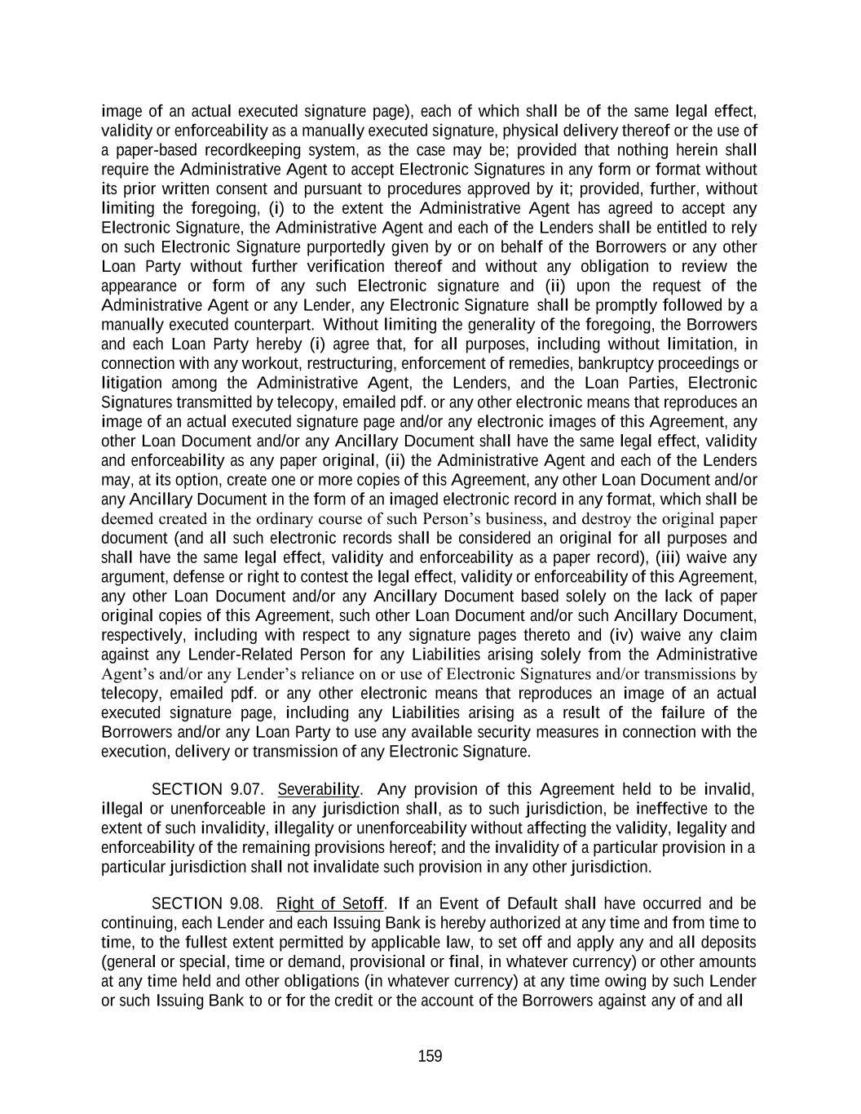
159 image of an actual executed signature page), each of which shall be of the same legal effect, validity or enforceability as a manually executed signature, physical delivery thereof or the use of a paper-based recordkeeping system, as the case may be; provided that nothing herein shall require the Administrative Agent to accept Electronic Signatures in any form or format without its prior written consent and pursuant to procedures approved by it; provided, further, without limiting the foregoing, (i) to the extent the Administrative Agent has agreed to accept any Electronic Signature, the Administrative Agent and each of the Lenders shall be entitled to rely on such Electronic Signature purportedly given by or on behalf of the Borrowers or any other Loan Party without further verification thereof and without any obligation to review the appearance or form of any such Electronic signature and (ii) upon the request of the Administrative Agent or any Lender, any Electronic Signature shall be promptly followed by a manually executed counterpart. Without limiting the generality of the foregoing, the Borrowers and each Loan Party hereby (i) agree that, for all purposes, including without limitation, in connection with any workout, restructuring, enforcement of remedies, bankruptcy proceedings or litigation among the Administrative Agent, the Lenders, and the Loan Parties, Electronic Signatures transmitted by telecopy, emailed pdf. or any other electronic means that reproduces an image of an actual executed signature page and/or any electronic images of this Agreement, any other Loan Document and/or any Ancillary Document shall have the same legal effect, validity and enforceability as any paper original, (ii) the Administrative Agent and each of the Lenders may, at its option, create one or more copies of this Agreement, any other Loan Document and/or any Ancillary Document in the form of an imaged electronic record in any format, which shall be deemed created in the ordinary course of such Person’s business, and destroy the original paper document (and all such electronic records shall be considered an original for all purposes and shall have the same legal effect, validity and enforceability as a paper record), (iii) waive any argument, defense or right to contest the legal effect, validity or enforceability of this Agreement, any other Loan Document and/or any Ancillary Document based solely on the lack of paper original copies of this Agreement, such other Loan Document and/or such Ancillary Document, respectively, including with respect to any signature pages thereto and (iv) waive any claim against any Lender-Related Person for any Liabilities arising solely from the Administrative Agent’s and/or any Lender’s reliance on or use of Electronic Signatures and/or transmissions by telecopy, emailed pdf. or any other electronic means that reproduces an image of an actual executed signature page, including any Liabilities arising as a result of the failure of the Borrowers and/or any Loan Party to use any available security measures in connection with the execution, delivery or transmission of any Electronic Signature. SECTION 9.07. Severability. Any provision of this Agreement held to be invalid, illegal or unenforceable in any jurisdiction shall, as to such jurisdiction, be ineffective to the extent of such invalidity, illegality or unenforceability without affecting the validity, legality and enforceability of the remaining provisions hereof; and the invalidity of a particular provision in a particular jurisdiction shall not invalidate such provision in any other jurisdiction. SECTION 9.08. Right of Setoff. If an Event of Default shall have occurred and be continuing, each Lender and each Issuing Bank is hereby authorized at any time and from time to time, to the fullest extent permitted by applicable law, to set off and apply any and all deposits (general or special, time or demand, provisional or final, in whatever currency) or other amounts at any time held and other obligations (in whatever currency) at any time owing by such Lender or such Issuing Bank to or for the credit or the account of the Borrowers against any of and all

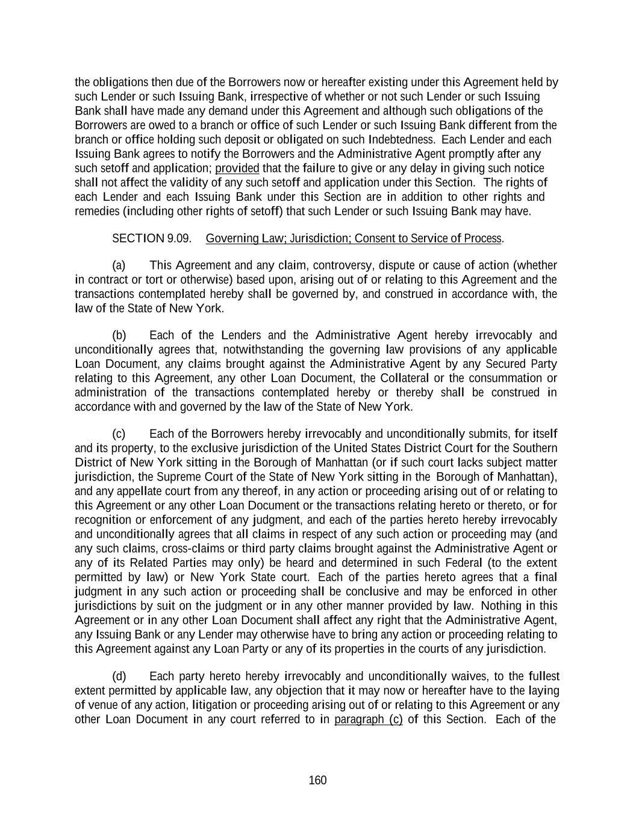
160 the obligations then due of the Borrowers now or hereafter existing under this Agreement held by such Lender or such Issuing Bank, irrespective of whether or not such Lender or such Issuing Bank shall have made any demand under this Agreement and although such obligations of the Borrowers are owed to a branch or office of such Lender or such Issuing Bank different from the branch or office holding such deposit or obligated on such Indebtedness. Each Lender and each Issuing Bank agrees to notify the Borrowers and the Administrative Agent promptly after any such setoff and application; provided that the failure to give or any delay in giving such notice shall not affect the validity of any such setoff and application under this Section. The rights of each Lender and each Issuing Bank under this Section are in addition to other rights and remedies (including other rights of setoff) that such Lender or such Issuing Bank may have. SECTION 9.09. Governing Law; Jurisdiction; Consent to Service of Process. (a) This Agreement and any claim, controversy, dispute or cause of action (whether in contract or tort or otherwise) based upon, arising out of or relating to this Agreement and the transactions contemplated hereby shall be governed by, and construed in accordance with, the law of the State of New York. (b) Each of the Lenders and the Administrative Agent hereby irrevocably and unconditionally agrees that, notwithstanding the governing law provisions of any applicable Loan Document, any claims brought against the Administrative Agent by any Secured Party relating to this Agreement, any other Loan Document, the Collateral or the consummation or administration of the transactions contemplated hereby or thereby shall be construed in accordance with and governed by the law of the State of New York. (c) Each of the Borrowers hereby irrevocably and unconditionally submits, for itself and its property, to the exclusive jurisdiction of the United States District Court for the Southern District of New York sitting in the Borough of Manhattan (or if such court lacks subject matter jurisdiction, the Supreme Court of the State of New York sitting in the Borough of Manhattan), and any appellate court from any thereof, in any action or proceeding arising out of or relating to this Agreement or any other Loan Document or the transactions relating hereto or thereto, or for recognition or enforcement of any judgment, and each of the parties hereto hereby irrevocably and unconditionally agrees that all claims in respect of any such action or proceeding may (and any such claims, cross-claims or third party claims brought against the Administrative Agent or any of its Related Parties may only) be heard and determined in such Federal (to the extent permitted by law) or New York State court. Each of the parties hereto agrees that a final judgment in any such action or proceeding shall be conclusive and may be enforced in other jurisdictions by suit on the judgment or in any other manner provided by law. Nothing in this Agreement or in any other Loan Document shall affect any right that the Administrative Agent, any Issuing Bank or any Lender may otherwise have to bring any action or proceeding relating to this Agreement against any Loan Party or any of its properties in the courts of any jurisdiction. (d) Each party hereto hereby irrevocably and unconditionally waives, to the fullest extent permitted by applicable law, any objection that it may now or hereafter have to the laying of venue of any action, litigation or proceeding arising out of or relating to this Agreement or any other Loan Document in any court referred to in paragraph (c) of this Section. Each of the

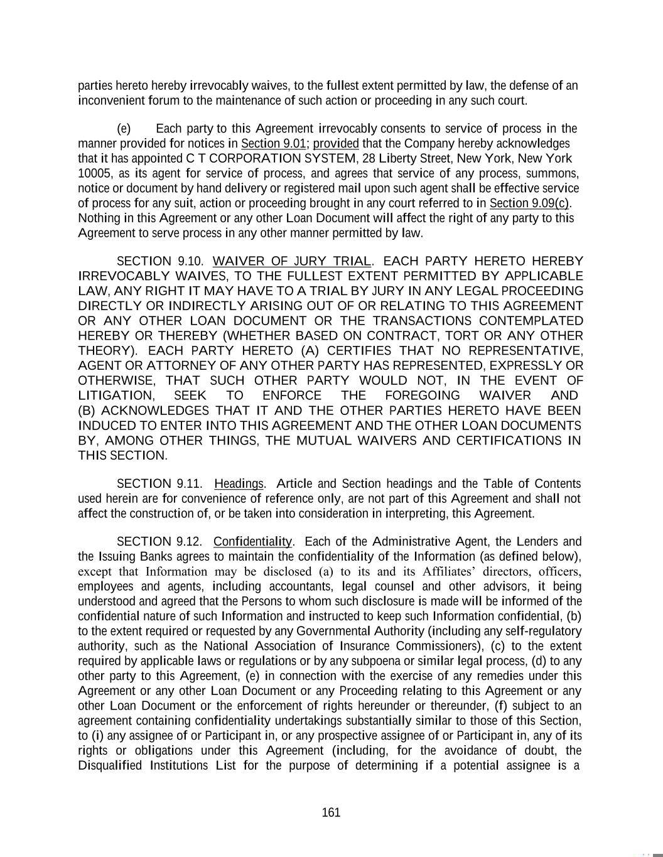
161 parties hereto hereby irrevocably waives, to the fullest extent permitted by law, the defense of an inconvenient forum to the maintenance of such action or proceeding in any such court. (e) Each party to this Agreement irrevocably consents to service of process in the manner provided for notices in Section 9.01; provided that the Company hereby acknowledges that it has appointed C T CORPORATION SYSTEM, 28 Liberty Street, New York, New York 10005, as its agent for service of process, and agrees that service of any process, summons, notice or document by hand delivery or registered mail upon such agent shall be effective service of process for any suit, action or proceeding brought in any court referred to in Section 9.09(c). Nothing in this Agreement or any other Loan Document will affect the right of any party to this Agreement to serve process in any other manner permitted by law. SECTION 9.10. WAIVER OF JURY TRIAL. EACH PARTY HERETO HEREBY IRREVOCABLY WAIVES, TO THE FULLEST EXTENT PERMITTED BY APPLICABLE LAW, ANY RIGHT IT MAY HAVE TO A TRIAL BY JURY IN ANY LEGAL PROCEEDING DIRECTLY OR INDIRECTLY ARISING OUT OF OR RELATING TO THIS AGREEMENT OR ANY OTHER LOAN DOCUMENT OR THE TRANSACTIONS CONTEMPLATED HEREBY OR THEREBY (WHETHER BASED ON CONTRACT, TORT OR ANY OTHER THEORY). EACH PARTY HERETO (A) CERTIFIES THAT NO REPRESENTATIVE, AGENT OR ATTORNEY OF ANY OTHER PARTY HAS REPRESENTED, EXPRESSLY OR OTHERWISE, THAT SUCH OTHER PARTY WOULD NOT, IN THE EVENT OF LITIGATION, SEEK TO ENFORCE THE FOREGOING WAIVER AND (B) ACKNOWLEDGES THAT IT AND THE OTHER PARTIES HERETO HAVE BEEN INDUCED TO ENTER INTO THIS AGREEMENT AND THE OTHER LOAN DOCUMENTS BY, AMONG OTHER THINGS, THE MUTUAL WAIVERS AND CERTIFICATIONS IN THIS SECTION. SECTION 9.11. Headings. Article and Section headings and the Table of Contents used herein are for convenience of reference only, are not part of this Agreement and shall not affect the construction of, or be taken into consideration in interpreting, this Agreement. SECTION 9.12. Confidentiality. Each of the Administrative Agent, the Lenders and the Issuing Banks agrees to maintain the confidentiality of the Information (as defined below), except that Information may be disclosed (a) to its and its Affiliates’ directors, officers, employees and agents, including accountants, legal counsel and other advisors, it being understood and agreed that the Persons to whom such disclosure is made will be informed of the confidential nature of such Information and instructed to keep such Information confidential, (b) to the extent required or requested by any Governmental Authority (including any self-regulatory authority, such as the National Association of Insurance Commissioners), (c) to the extent required by applicable laws or regulations or by any subpoena or similar legal process, (d) to any other party to this Agreement, (e) in connection with the exercise of any remedies under this Agreement or any other Loan Document or any Proceeding relating to this Agreement or any other Loan Document or the enforcement of rights hereunder or thereunder, (f) subject to an agreement containing confidentiality undertakings substantially similar to those of this Section, to (i) any assignee of or Participant in, or any prospective assignee of or Participant in, any of its rights or obligations under this Agreement (including, for the avoidance of doubt, the Disqualified Institutions List for the purpose of determining if a potential assignee is a

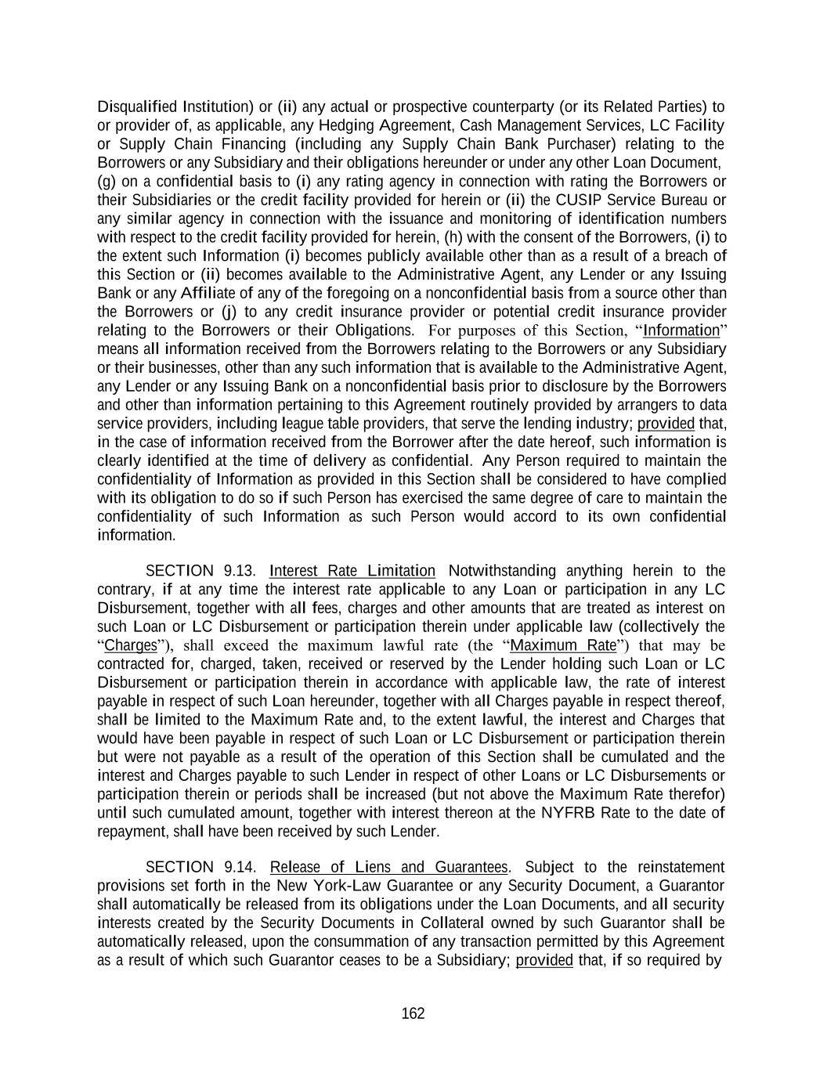
162 Disqualified Institution) or (ii) any actual or prospective counterparty (or its Related Parties) to or provider of, as applicable, any Hedging Agreement, Cash Management Services, LC Facility or Supply Chain Financing (including any Supply Chain Bank Purchaser) relating to the Borrowers or any Subsidiary and their obligations hereunder or under any other Loan Document, (g) on a confidential basis to (i) any rating agency in connection with rating the Borrowers or their Subsidiaries or the credit facility provided for herein or (ii) the CUSIP Service Bureau or any similar agency in connection with the issuance and monitoring of identification numbers with respect to the credit facility provided for herein, (h) with the consent of the Borrowers, (i) to the extent such Information (i) becomes publicly available other than as a result of a breach of this Section or (ii) becomes available to the Administrative Agent, any Lender or any Issuing Bank or any Affiliate of any of the foregoing on a nonconfidential basis from a source other than the Borrowers or (j) to any credit insurance provider or potential credit insurance provider relating to the Borrowers or their Obligations. For purposes of this Section, “Information” means all information received from the Borrowers relating to the Borrowers or any Subsidiary or their businesses, other than any such information that is available to the Administrative Agent, any Lender or any Issuing Bank on a nonconfidential basis prior to disclosure by the Borrowers and other than information pertaining to this Agreement routinely provided by arrangers to data service providers, including league table providers, that serve the lending industry; provided that, in the case of information received from the Borrower after the date hereof, such information is clearly identified at the time of delivery as confidential. Any Person required to maintain the confidentiality of Information as provided in this Section shall be considered to have complied with its obligation to do so if such Person has exercised the same degree of care to maintain the confidentiality of such Information as such Person would accord to its own confidential information. SECTION 9.13. Interest Rate Limitation Notwithstanding anything herein to the contrary, if at any time the interest rate applicable to any Loan or participation in any LC Disbursement, together with all fees, charges and other amounts that are treated as interest on such Loan or LC Disbursement or participation therein under applicable law (collectively the “Charges”), shall exceed the maximum lawful rate (the “Maximum Rate”) that may be contracted for, charged, taken, received or reserved by the Lender holding such Loan or LC Disbursement or participation therein in accordance with applicable law, the rate of interest payable in respect of such Loan hereunder, together with all Charges payable in respect thereof, shall be limited to the Maximum Rate and, to the extent lawful, the interest and Charges that would have been payable in respect of such Loan or LC Disbursement or participation therein but were not payable as a result of the operation of this Section shall be cumulated and the interest and Charges payable to such Lender in respect of other Loans or LC Disbursements or participation therein or periods shall be increased (but not above the Maximum Rate therefor) until such cumulated amount, together with interest thereon at the NYFRB Rate to the date of repayment, shall have been received by such Lender. SECTION 9.14. Release of Liens and Guarantees. Subject to the reinstatement provisions set forth in the New York-Law Guarantee or any Security Document, a Guarantor shall automatically be released from its obligations under the Loan Documents, and all security interests created by the Security Documents in Collateral owned by such Guarantor shall be automatically released, upon the consummation of any transaction permitted by this Agreement as a result of which such Guarantor ceases to be a Subsidiary; provided that, if so required by

163 this Agreement, the Required Lenders shall have consented to such transaction and the terms of such consent shall not have provided otherwise. Upon any sale or other transfer by any Loan Party (other than to the Borrowers or any other Loan Party) of any Collateral in a transaction permitted under this Agreement, or upon the effectiveness of any written consent to the release of the security interest created under any Security Document in any Collateral pursuant to Section 9.02, the security interests in such Collateral created by the Security Documents shall be automatically released. Upon payment in full of the Loan Document Obligations (other than contingent amounts not yet due), expiration or termination of all Commitments and the expiration or termination of all Letters of Credit (other than those collateralized or back-stopped on terms reasonably satisfactory to the applicable Issuing Bank) and reimbursement of all LC Disbursements, the security interests granted to the Administrative Agent pursuant to the Security Documents shall terminate. In connection with any termination or release pursuant to this Section, the Administrative Agent shall execute and deliver to any Loan Party, at such Loan Party’s expense, all documents that such Loan Party shall reasonably request to evidence such termination or release. Any execution and delivery of documents pursuant to this Section shall be without recourse to or warranty by the Administrative Agent. Each of the Secured Parties irrevocably authorizes the Administrative Agent, at its option and in its discretion, to effect the releases set forth in this Section, the Borrowers shall deliver to the Administrative Agent such officer’s certificates as the Administrative Agent may reasonably request to evidence compliance with the applicable provisions of the Loan Documents (including the Administrative Agent’s authority hereunder) and the Secured Parties acknowledge and agree that the Administrative Agent may rely, without independent investigation on such certificates. SECTION 9.15. USA PATRIOT Act Notice. Each Lender, each Issuing Bank and the Administrative Agent (for itself and not on behalf of any Lender) hereby notifies each Loan Party that, pursuant to the requirements of the USA PATRIOT Act, it is required to obtain, verify and record information that identifies such Loan Party, which information includes the name and address of such Loan Party and other information that will allow such Lender, such Issuing Bank or the Administrative Agent, as applicable, to identify such Loan Party in accordance with the USA PATRIOT Act, and each Loan Party agrees to provide such information from time to time to such Lender, such Issuing Bank and the Administrative Agent, as applicable. SECTION 9.16. No Fiduciary Relationship. The Borrowers acknowledge and agree, and acknowledge their Subsidiaries’ understanding, that no Credit Party will have any obligations except those obligations expressly set forth herein and in the other Loan Documents and each Credit Party is acting solely in the capacity of an arm’s length contractual counterparty to the Borrowers with respect to the Loan Documents and the transaction contemplated therein and not as a financial advisor or a fiduciary to, or an agent of, the Borrowers or any other person. The Borrowers agree that they will not assert any claim against any Credit Party based on an alleged breach of fiduciary duty by such Credit Party in connection with this Agreement and the transactions contemplated hereby. Additionally, the Borrowers acknowledge and agree that no Credit Party is advising the Borrowers as to any legal, tax, investment, accounting, regulatory or any other matters in any jurisdiction. The Borrowers shall consult with their own advisors concerning such matters and shall be responsible for making their own independent investigation and appraisal of the transactions contemplated hereby, and the Credit Parties shall have no responsibility or liability to the Borrowers with respect thereto.

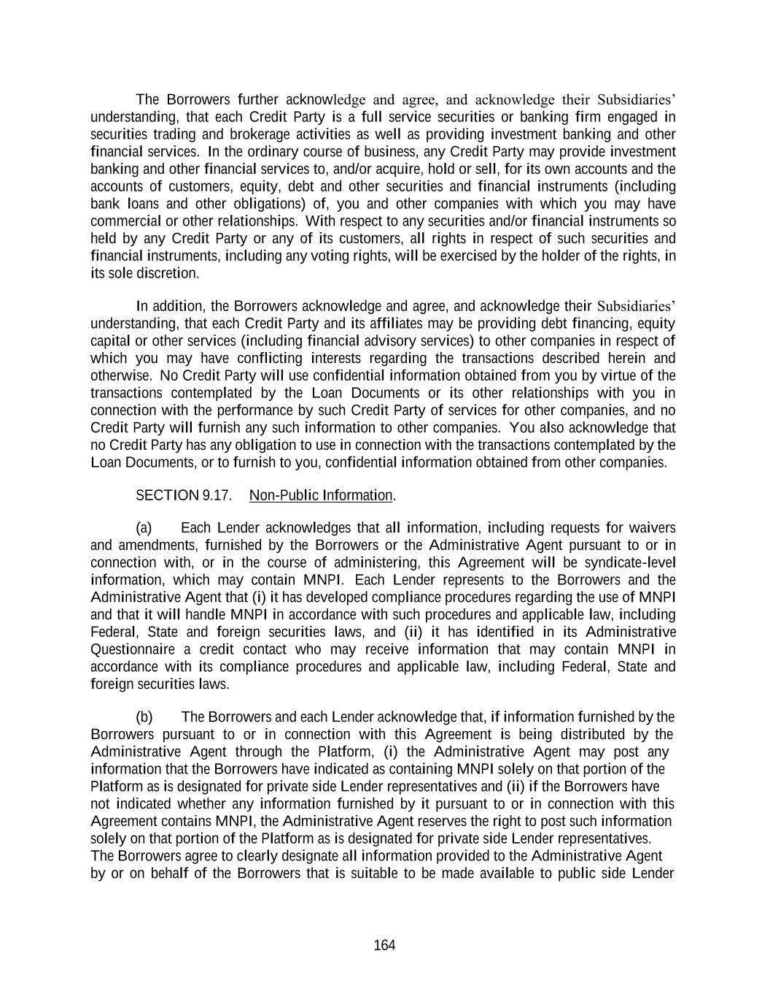
164 The Borrowers further acknowledge and agree, and acknowledge their Subsidiaries’ understanding, that each Credit Party is a full service securities or banking firm engaged in securities trading and brokerage activities as well as providing investment banking and other financial services. In the ordinary course of business, any Credit Party may provide investment banking and other financial services to, and/or acquire, hold or sell, for its own accounts and the accounts of customers, equity, debt and other securities and financial instruments (including bank loans and other obligations) of, you and other companies with which you may have commercial or other relationships. With respect to any securities and/or financial instruments so held by any Credit Party or any of its customers, all rights in respect of such securities and financial instruments, including any voting rights, will be exercised by the holder of the rights, in its sole discretion. In addition, the Borrowers acknowledge and agree, and acknowledge their Subsidiaries’ understanding, that each Credit Party and its affiliates may be providing debt financing, equity capital or other services (including financial advisory services) to other companies in respect of which you may have conflicting interests regarding the transactions described herein and otherwise. No Credit Party will use confidential information obtained from you by virtue of the transactions contemplated by the Loan Documents or its other relationships with you in connection with the performance by such Credit Party of services for other companies, and no Credit Party will furnish any such information to other companies. You also acknowledge that no Credit Party has any obligation to use in connection with the transactions contemplated by the Loan Documents, or to furnish to you, confidential information obtained from other companies. SECTION 9.17. Non-Public Information. (a) Each Lender acknowledges that all information, including requests for waivers and amendments, furnished by the Borrowers or the Administrative Agent pursuant to or in connection with, or in the course of administering, this Agreement will be syndicate-level information, which may contain MNPI. Each Lender represents to the Borrowers and the Administrative Agent that (i) it has developed compliance procedures regarding the use of MNPI and that it will handle MNPI in accordance with such procedures and applicable law, including Federal, State and foreign securities laws, and (ii) it has identified in its Administrative Questionnaire a credit contact who may receive information that may contain MNPI in accordance with its compliance procedures and applicable law, including Federal, State and foreign securities laws. (b) The Borrowers and each Lender acknowledge that, if information furnished by the Borrowers pursuant to or in connection with this Agreement is being distributed by the Administrative Agent through the Platform, (i) the Administrative Agent may post any information that the Borrowers have indicated as containing MNPI solely on that portion of the Platform as is designated for private side Lender representatives and (ii) if the Borrowers have not indicated whether any information furnished by it pursuant to or in connection with this Agreement contains MNPI, the Administrative Agent reserves the right to post such information solely on that portion of the Platform as is designated for private side Lender representatives. The Borrowers agree to clearly designate all information provided to the Administrative Agent by or on behalf of the Borrowers that is suitable to be made available to public side Lender

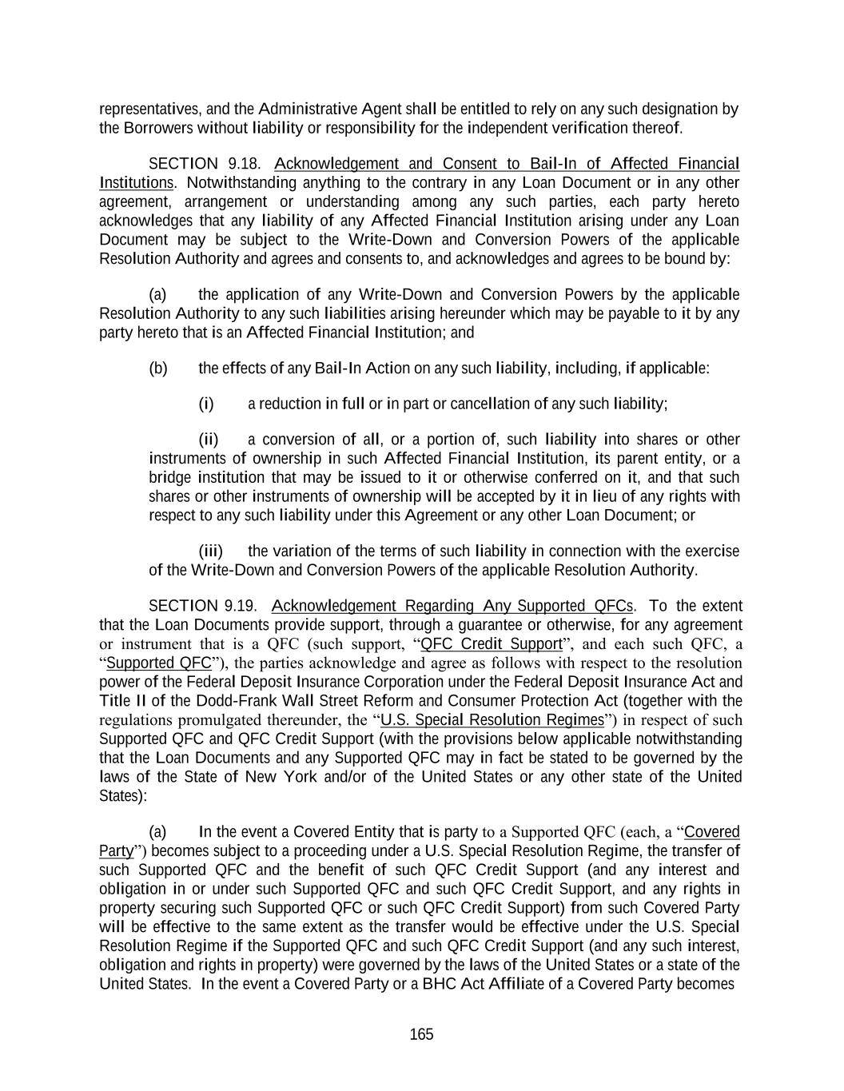
165 representatives, and the Administrative Agent shall be entitled to rely on any such designation by the Borrowers without liability or responsibility for the independent verification thereof. SECTION 9.18. Acknowledgement and Consent to Bail-In of Affected Financial Institutions. Notwithstanding anything to the contrary in any Loan Document or in any other agreement, arrangement or understanding among any such parties, each party hereto acknowledges that any liability of any Affected Financial Institution arising under any Loan Document may be subject to the Write-Down and Conversion Powers of the applicable Resolution Authority and agrees and consents to, and acknowledges and agrees to be bound by: (a) the application of any Write-Down and Conversion Powers by the applicable Resolution Authority to any such liabilities arising hereunder which may be payable to it by any party hereto that is an Affected Financial Institution; and (b) the effects of any Bail-In Action on any such liability, including, if applicable: (i) a reduction in full or in part or cancellation of any such liability; (ii) a conversion of all, or a portion of, such liability into shares or other instruments of ownership in such Affected Financial Institution, its parent entity, or a bridge institution that may be issued to it or otherwise conferred on it, and that such shares or other instruments of ownership will be accepted by it in lieu of any rights with respect to any such liability under this Agreement or any other Loan Document; or (iii) the variation of the terms of such liability in connection with the exercise of the Write-Down and Conversion Powers of the applicable Resolution Authority. SECTION 9.19. Acknowledgement Regarding Any Supported QFCs. To the extent that the Loan Documents provide support, through a guarantee or otherwise, for any agreement or instrument that is a QFC (such support, “QFC Credit Support”, and each such QFC, a “Supported QFC”), the parties acknowledge and agree as follows with respect to the resolution power of the Federal Deposit Insurance Corporation under the Federal Deposit Insurance Act and Title II of the Dodd-Frank Wall Street Reform and Consumer Protection Act (together with the regulations promulgated thereunder, the “U.S. Special Resolution Regimes”) in respect of such Supported QFC and QFC Credit Support (with the provisions below applicable notwithstanding that the Loan Documents and any Supported QFC may in fact be stated to be governed by the laws of the State of New York and/or of the United States or any other state of the United States): (a) In the event a Covered Entity that is party to a Supported QFC (each, a “Covered Party”) becomes subject to a proceeding under a U.S. Special Resolution Regime, the transfer of such Supported QFC and the benefit of such QFC Credit Support (and any interest and obligation in or under such Supported QFC and such QFC Credit Support, and any rights in property securing such Supported QFC or such QFC Credit Support) from such Covered Party will be effective to the same extent as the transfer would be effective under the U.S. Special Resolution Regime if the Supported QFC and such QFC Credit Support (and any such interest, obligation and rights in property) were governed by the laws of the United States or a state of the United States. In the event a Covered Party or a BHC Act Affiliate of a Covered Party becomes

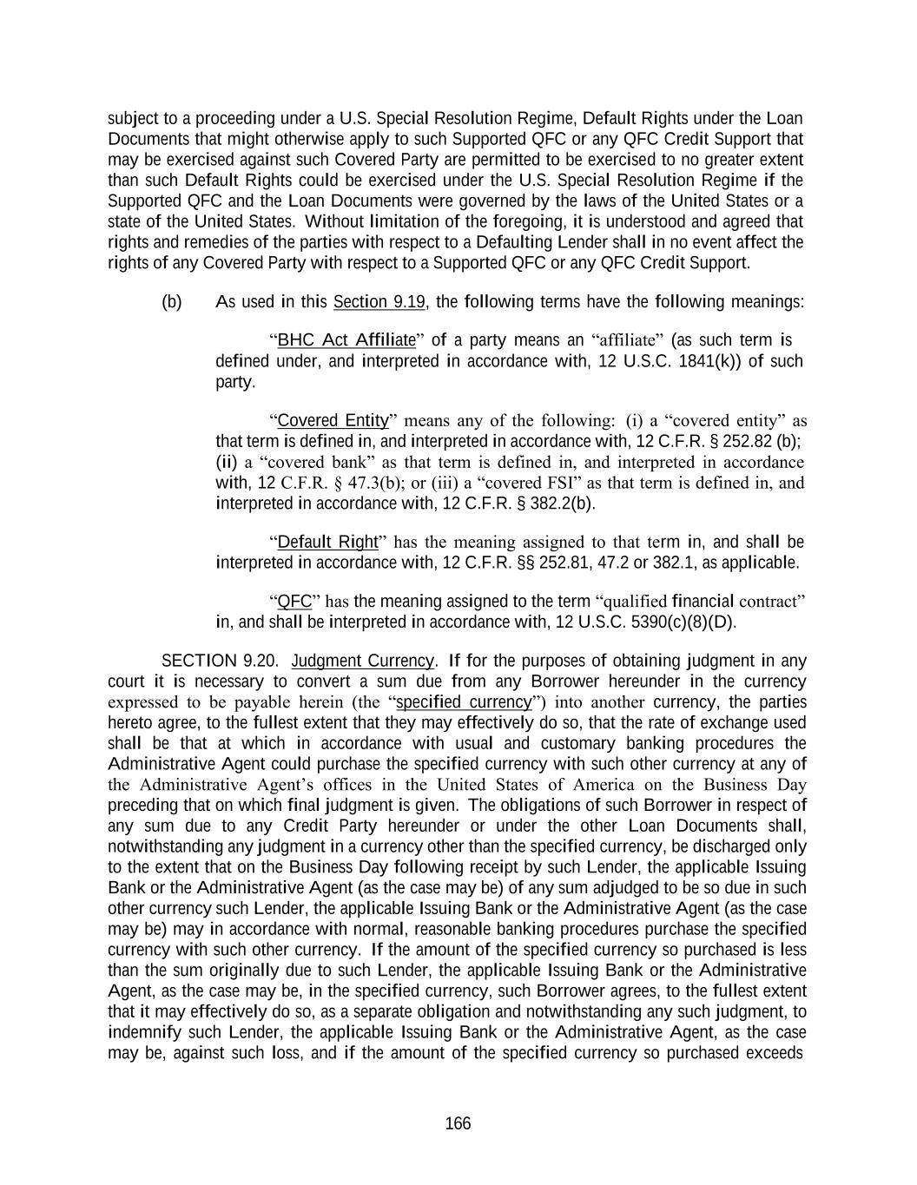
166 subject to a proceeding under a U.S. Special Resolution Regime, Default Rights under the Loan Documents that might otherwise apply to such Supported QFC or any QFC Credit Support that may be exercised against such Covered Party are permitted to be exercised to no greater extent than such Default Rights could be exercised under the U.S. Special Resolution Regime if the Supported QFC and the Loan Documents were governed by the laws of the United States or a state of the United States. Without limitation of the foregoing, it is understood and agreed that rights and remedies of the parties with respect to a Defaulting Lender shall in no event affect the rights of any Covered Party with respect to a Supported QFC or any QFC Credit Support. (b) As used in this Section 9.19, the following terms have the following meanings: “BHC Act Affiliate” of a party means an “affiliate” (as such term is defined under, and interpreted in accordance with, 12 U.S.C. 1841(k)) of such party. “Covered Entity” means any of the following: (i) a “covered entity” as that term is defined in, and interpreted in accordance with, 12 C.F.R. § 252.82 (b); (ii) a “covered bank” as that term is defined in, and interpreted in accordance with, 12 C.F.R. § 47.3(b); or (iii) a “covered FSI” as that term is defined in, and interpreted in accordance with, 12 C.F.R. § 382.2(b). “Default Right” has the meaning assigned to that term in, and shall be interpreted in accordance with, 12 C.F.R. §§ 252.81, 47.2 or 382.1, as applicable. “QFC” has the meaning assigned to the term “qualified financial contract” in, and shall be interpreted in accordance with, 12 U.S.C. 5390(c)(8)(D). SECTION 9.20. Judgment Currency. If for the purposes of obtaining judgment in any court it is necessary to convert a sum due from any Borrower hereunder in the currency expressed to be payable herein (the “specified currency”) into another currency, the parties hereto agree, to the fullest extent that they may effectively do so, that the rate of exchange used shall be that at which in accordance with usual and customary banking procedures the Administrative Agent could purchase the specified currency with such other currency at any of the Administrative Agent’s offices in the United States of America on the Business Day preceding that on which final judgment is given. The obligations of such Borrower in respect of any sum due to any Credit Party hereunder or under the other Loan Documents shall, notwithstanding any judgment in a currency other than the specified currency, be discharged only to the extent that on the Business Day following receipt by such Lender, the applicable Issuing Bank or the Administrative Agent (as the case may be) of any sum adjudged to be so due in such other currency such Lender, the applicable Issuing Bank or the Administrative Agent (as the case may be) may in accordance with normal, reasonable banking procedures purchase the specified currency with such other currency. If the amount of the specified currency so purchased is less than the sum originally due to such Lender, the applicable Issuing Bank or the Administrative Agent, as the case may be, in the specified currency, such Borrower agrees, to the fullest extent that it may effectively do so, as a separate obligation and notwithstanding any such judgment, to indemnify such Lender, the applicable Issuing Bank or the Administrative Agent, as the case may be, against such loss, and if the amount of the specified currency so purchased exceeds

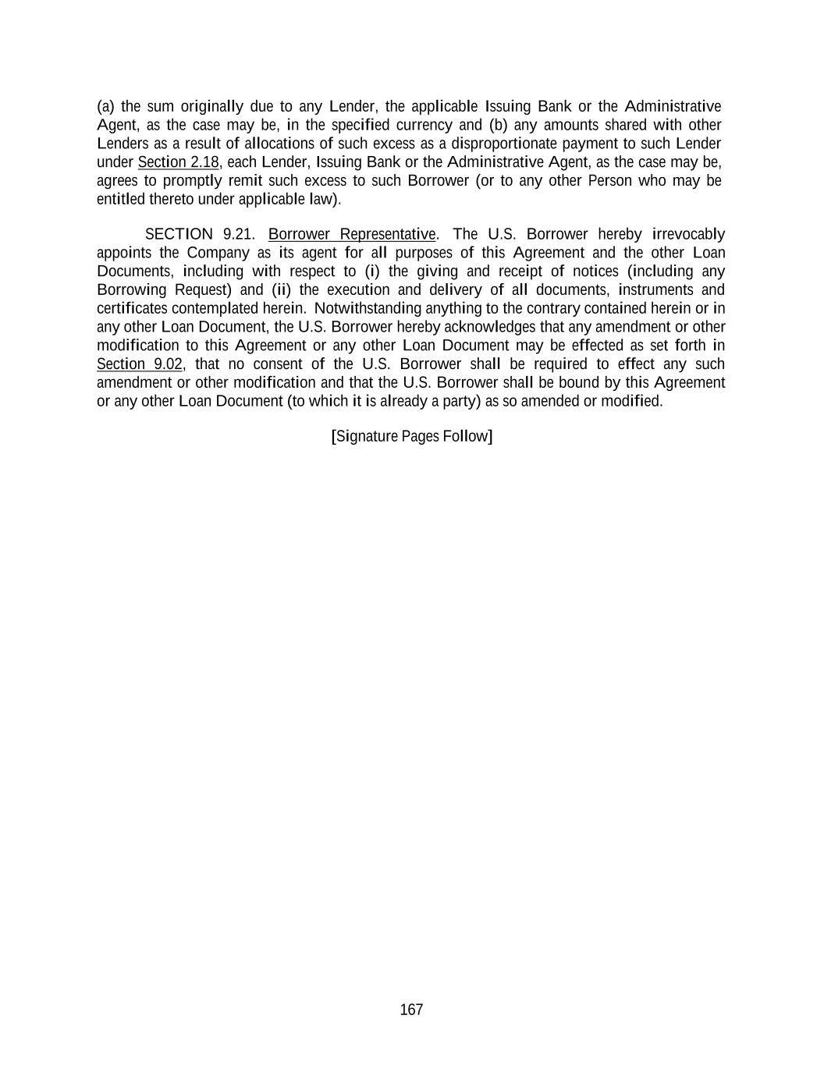
167 (a) the sum originally due to any Lender, the applicable Issuing Bank or the Administrative Agent, as the case may be, in the specified currency and (b) any amounts shared with other Lenders as a result of allocations of such excess as a disproportionate payment to such Lender under Section 2.18, each Lender, Issuing Bank or the Administrative Agent, as the case may be, agrees to promptly remit such excess to such Borrower (or to any other Person who may be entitled thereto under applicable law). SECTION 9.21. Borrower Representative. The U.S. Borrower hereby irrevocably appoints the Company as its agent for all purposes of this Agreement and the other Loan Documents, including with respect to (i) the giving and receipt of notices (including any Borrowing Request) and (ii) the execution and delivery of all documents, instruments and certificates contemplated herein. Notwithstanding anything to the contrary contained herein or in any other Loan Document, the U.S. Borrower hereby acknowledges that any amendment or other modification to this Agreement or any other Loan Document may be effected as set forth in Section 9.02, that no consent of the U.S. Borrower shall be required to effect any such amendment or other modification and that the U.S. Borrower shall be bound by this Agreement or any other Loan Document (to which it is already a party) as so amended or modified. [Signature Pages Follow]

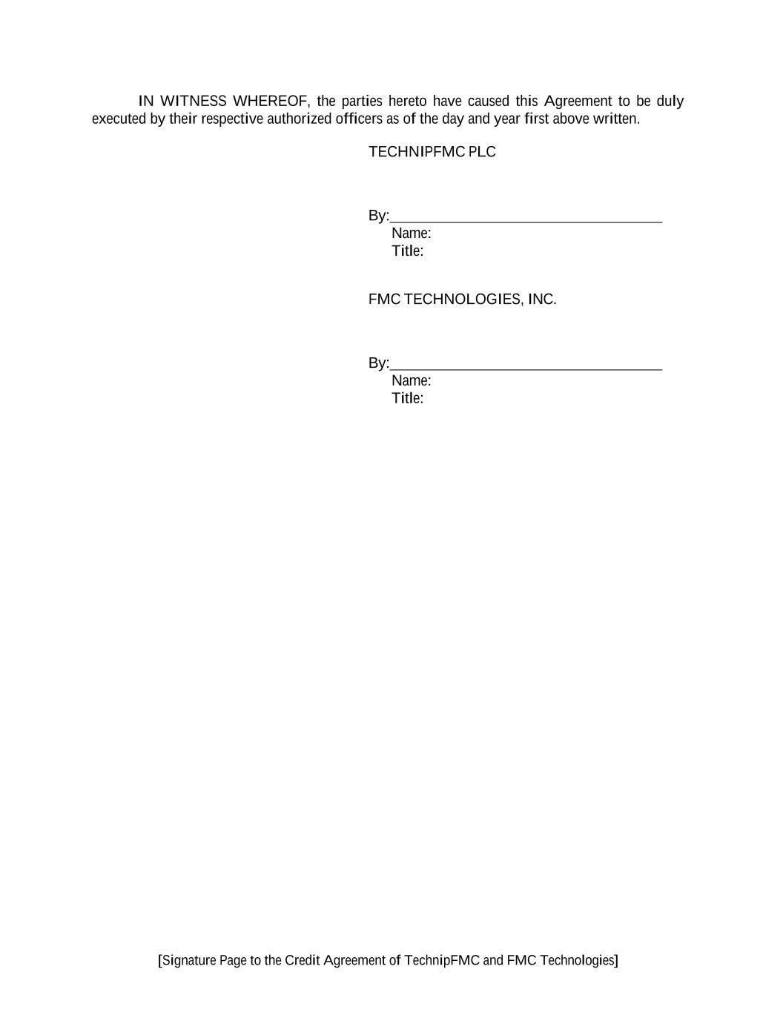
[Signature Page to the Credit Agreement of TechnipFMC and FMC Technologies] IN WITNESS WHEREOF, the parties hereto have caused this Agreement to be duly executed by their respective authorized officers as of the day and year first above written. TECHNIPFMC PLC By: Name: Title: FMC TECHNOLOGIES, INC. By: Name: Title:

[Signature Page to the Credit Agreement of TechnipFMC and FMC Technologies] JPMORGAN CHASE BANK, N.A., as Administrative Agent, individually as a Lender and as an Issuing Bank By: Name: Title:

[Signature Page to the Credit Agreement of TechnipFMC and FMC Technologies] [ ], as a Lender and as an Issuing Bank By: Name: Title:

[ ], as a Lender By: Name: Title

FOURTH AMENDMENT AND WAIVER TO CREDIT AGREEMENT
FOURTH AMENDMENT AND WAIVER TO CREDIT AGREEMENT, dated as of April 19, 2022 (this “ Amendment and Waiver ”), by and among TECHNIPFMC PLC, a public limited company incorporated under the laws of England and Wales (the “ Company ”), FMC TECHNOLOGIES, INC., a Delaware corporation (the “ U.S. Borrower ” and, together with the Company, the “ Borrowers ”), the Lenders party hereto and JPMORGAN CHASE BANK, N.A., as Administrative Agent (in such capacity, the “ Administrative Agent ”).
RECITALS
WHEREAS, the Borrowers are parties to that certain Credit Agreement, dated as of February 16, 2021 (as amended, restated, amended and restated, supplemented or otherwise modified prior to the date hereof, the “ Existing Credit Agreement ”, and as amended or otherwise modified by this Amendment and Waiver, the “ Credit Agreement ”), among the Borrowers, the Lenders from time to time party thereto, the Issuing Banks from time to time party thereto and the Administrative Agent;
WHEREAS, the Borrowers have requested that the Administrative Agent and the Lenders agree to amend the Existing Credit Agreement to, among other things, permit up to $1,000,000,000 of prepayments, redemptions, repurchases and/or satisfactions of Indebtedness;
WHEREAS, the Borrowers have requested that the Administrative Agent and the Lenders agree to waive any breaches, defaults and/or Events of Default resulting solely from the failure of the Borrowers to join (and any requirement to deliver notice thereof) (a) Tios AS, which was acquired on August 5, 2021, and (b) Magma Global Limited, which was acquired on October 13, 2021, pursuant to Section 5.12 of the Credit Agreement (each, a “ Specified Default ” and collectively, the “ Specified Defaults ”); and
WHEREAS, subject to the terms and conditions set forth herein, the Administrative Agent and the Lenders party hereto are willing to agree to such amendment to the Existing Credit Agreement.
NOW, THEREFORE, in consideration of the agreements contained herein, as well as other good and valuable consideration, the receipt and sufficiency of which are hereby acknowledged, the parties hereto agree as follows:
ARTICLE I
DEFINITIONS
SECTION 1.1. Certain Definitions . Capitalized terms used (including in the preamble and recitals hereto) but not defined herein shall have the meanings assigned to such terms in the Credit Agreement.
ARTICLE II
AMENDMENTS TO CREDIT AGREEMENT
SECTION 2.1. As of the Fourth Amendment Effective Date, the Existing Credit Agreement is hereby amended as follows:
(a) The definition of “Sanctioned Country” in Section 1.01 of the Existing Credit Agreement is hereby amended and restated in its entirety to read as follows:

“ Sanctioned Country ” means, at any time, a country, region or territory which is itself the subject or target of any Sanctions (at the time of this Agreement, the so-called Donetsk People’s Republic, the so-called Luhansk People’s Republic, the Crimea Region of Ukraine, Cuba, Iran, North Korea and Syria).
(b) Section 6.08(b)(iv) of the Existing Credit Agreement is hereby amended and restated in its entirety to read as follows:
(iv) prepayments, redemptions, repurchases or satisfactions of Indebtedness (other than Subordinated Indebtedness and Disqualified Equity Interests), so long as (A) no Default or Event of Default has occurred and is continuing or would result therefrom and (B) immediately after giving effect to such prepayment, redemption, repurchase or satisfaction of Indebtedness, the amount of Consolidated First Lien Net Debt of the Borrowers and the Restricted Subsidiaries shall not exceed $400,000,000; provided , that the payments of or in respect of any such Indebtedness permitted pursuant to this clause (iv) shall not exceed $1,000,000,000 in the aggregate.
ARTICLE III
WAIVER AND AGREEMENT
SECTION 3.1. Each of the undersigned Lenders hereby waives the Specified Defaults and any breach, default, and/or Event of Default that has occurred and is continuing on the date hereof arising solely from the Specified Defaults. For the avoidance of doubt, (a) each waiver contained herein is a one-time waiver and is limited to any breach, default or Event of Default that has occurred and is continuing on the date hereof which constitutes a Specified Default or arises solely from a Specified Default; and (b) all other provisions contained in the Credit Agreement and otherwise in the Loan Documents shall continue in full force and effect.
SECTION 3.2. The Borrowers hereby agree to cause Tios AS and Magma Global Limited to become Guarantors and otherwise comply with Section 5.12 of the Credit Agreement and the Collateral and Guarantee Requirement within 30 days of the date hereof (or such later date as the Administrative Agent, acting reasonably, may agree to in writing (including electronic mail)).
ARTICLE IV
CONDITIONS TO EFFECTIVENESS
SECTION 4.1. The effectiveness of this Amendment and Waiver (the date of such effectiveness, the “ Fourth Amendment Effective Date ”) is subject to (a) the due execution of this Amendment and Waiver by the Borrowers and Lenders constituting at least the Required Lenders, (b) receipt by the Administrative Agent of all fees and other amounts due and payable on or prior to the Fourth Amendment Effective Date, including to the extent invoiced at least one Business Day prior to the Fourth Amendment Effective Date, reimbursement or payment of all reasonable out-of-pocket expenses (including fees, charges and disbursements of counsel) required to be reimbursed or paid under the Existing Credit Agreement and (c) receipt by the Administrative Agent of a certificate of a Responsible Officer of the Company certifying as to the matters set forth in Section 5.1 .

2

ARTICLE V
REPRESENTATIONS AND WARRANTIES
SECTION 5.1. To induce the other parties hereto to enter into this Amendment and Waiver, the Borrowers represent and warrant to each of the Lenders that, as of the Fourth Amendment Effective Date:
(a) each Loan Party hereto (i) is a Person duly organized, incorporated or established, validly existing and, to the extent that such concept is applicable in the relevant jurisdiction, in good standing under the laws of the jurisdiction of its organization, incorporation or establishment and (ii) has all requisite power and authority to execute, deliver and perform its obligations under each Loan Document to which it is a party;
(b) (i) the execution, delivery and performance by the Borrowers of this Amendment and Waiver has been duly authorized by all necessary corporate or other organizational action, and (ii) the execution, delivery and performance by any Loan Party hereto of this Amendment and Waiver will not (x) result in any creation or imposition of any Lien upon any asset now owned or hereafter acquired by the Borrowers or any Loan Party (other than as permitted by the Loan Documents), (y) violate any Requirement of Law applicable to the Borrowers or any Loan Party and (z) violate or result (alone or with notice or lapse of time or both) in a default under any indenture, agreement or other instrument binding upon any Borrower or any Loan Party or their respective assets, or give rise to a right thereunder to require any payment, repurchase or redemption to be made by any Borrower or any Loan Party or give rise to a right of, or result in, termination, cancelation or acceleration of any obligation thereunder, except with respect to any violation, default, payment, repurchase, redemption, termination, cancellation or acceleration that would not reasonably be expected to have a Material Adverse Effect;
(c) the execution, delivery and performance by the Borrowers of this Amendment and Waiver, will not require any consent or approval of, registration or filing with, or any other action by, any Governmental Authority, except such as have been obtained or made and are in full force and effect and except (i) registrations or filings necessary to perfect Liens created under the Loan Documents and payment of applicable stamp duty in respect of the Loan Documents, (ii) consents, approvals, registrations or filings which have been obtained or made and are in full force and effect or (iii) where failure to obtain such consent or approval, or make such registration or filing, in the aggregate, could not reasonably be expected to have a Material Adverse Effect;
(d) this Amendment and Waiver has been duly executed and delivered by each Borrower and constitutes a legal, valid and binding obligation of each Borrower, enforceable against each Borrower in accordance with its terms, subject to general principles of equity, regardless of whether considered in a proceeding in equity or at law and an implied covenant of good faith and fair dealing;
(e) after giving effect to this Amendment and Waiver, the representations and warranties of each Loan Party set forth in the Loan Documents are true and correct in all material respects (or, in the case of representations and warranties qualified as to materiality, in all respects) on and as of the Fourth Amendment Effective Date, except in the case of any such representation and warranty that expressly relates to a prior date, in which case such representation and warranty
3

shall be true and correct in all material respects (or in all respects, as applicable) as of such earlier date; and
(f) after giving effect to this Amendment and Waiver, no Default or Event of Default has occurred and is continuing.

ARTICLE VI
EFFECTS ON LOAN DOCUMENTS
SECTION 6.1. On and after the Fourth Amendment Effective Date, each reference in the Credit Agreement to “this Agreement”, “hereunder”, “hereof”, “herein” or words of like import referring to the Credit Agreement, and each reference in the other Loan Documents to “the Credit Agreement”, “thereunder”, “thereof” or words of like import referring to the Credit Agreement shall, in each case, mean and be a reference to the Credit Agreement.
SECTION 6.2. Except as specifically amended or otherwise modified herein or contemplated hereby, the Credit Agreement and each of the other Loan Documents, as specifically amended by this Amendment and Waiver, are and shall continue to be in full force and effect in all respects. Without limiting the generality of the foregoing, all of the Collateral described in the Security Documents shall continue to secure the payment of all Obligations. This Amendment and Waiver shall not constitute a novation of any Obligations existing prior to the date hereof and shall merely amend or otherwise modify such Obligations to the extent set forth herein.
SECTION 6.3. On and after the Fourth Amendment Effective Date, this Amendment and Waiver shall constitute a Loan Document. This Amendment and Waiver and the Credit Agreement shall not constitute a novation of the Existing Credit Agreement or any other Loan Document.
ARTICLE VII
MISCELLANEOUS
SECTION 7.1. Waivers; Amendments; Severability . (a) This Amendment and Waiver may not be amended nor may any provision hereof be waived except in accordance with the provisions of Section 9.02 of the Credit Agreement. This Amendment and Waiver, except as expressly provided in Section 3.1 , shall not operate as a consent to or a waiver of any right, power or remedy of the Administrative Agent or any Lender under the Credit Agreement or any Loan Document, or constitute consent to or a waiver of any future failure of any Loan Party to comply with any of its obligations under the Credit Agreement or any other Loan Document
(b) Any provision of this Amendment and Waiver held to be invalid, illegal or unenforceable in any jurisdiction shall, as to such jurisdiction, be ineffective to the extent of such invalidity, illegality or unenforceability without affecting the validity, legality and enforceability of the remaining provisions hereof; and the invalidity of a particular provision in a particular jurisdiction shall not invalidate such provision in any other jurisdiction.
SECTION 7.2. Governing Law; Jurisdiction; Consent to Service of Process; Waiver of Jury Trial . This Amendment and Waiver shall be construed in accordance with and governed by the laws of the State of New York. The provisions of Sections 9.09 and 9.10 of the Credit Agreement are incorporated herein by reference, mutatis mutandis .
4

SECTION 7.3. Headings . Article and Section headings used herein are for convenience of reference only, are not part of this Amendment and Waiver and shall not affect the construction of, or be taken into consideration in interpreting, this Amendment and Waiver.
SECTION 7.4. Counterparts . This Amendment and Waiver may be executed in counterparts (and by different parties hereto on different counterparts), each of which shall constitute an original, but all of which when taken together shall constitute a single contract. The words “execution,” “signed,” “signature,” “delivery,” and words of like import in or relating to this Amendment and Waiver and/or any document to be signed in connection with this Amendment and Waiver and the transactions contemplated hereby shall be deemed to include Electronic Signatures, deliveries or the keeping of records in electronic form, each of which shall be of the same legal effect, validity or enforceability as a manually executed signature, physical delivery thereof or the use of a paper-based recordkeeping system, as the case may be.
SECTION 7.5. Reaffirmation . The Borrowers, on behalf of themselves and the Guarantors, hereby (a) consent to the amendment of the Credit Agreement effected hereby, (b) acknowledge and agree that all of their respective obligations under the Credit Agreement, the Guarantee, the Security Documents and the other Loan Documents, in each case as amended, supplemented or otherwise modified from time to time, are reaffirmed and remain in full force and effect on a continuous basis and are hereby ratified and confirmed in all respects, in each case as amended by this Amendment and Waiver, (c) reaffirm (i) each Lien granted by them to the Administrative Agent for the benefit of the Secured Parties and (ii) any guarantees made by them pursuant to the Guarantee, and (d) acknowledge and agree that the grants of security interests by them contained in, and all Liens created under, each Security Document shall remain in full force and effect and continue to secure the Obligations.
[ Remainder of page intentionally left blank .]
5

IN WITNESS WHEREOF, the parties hereto have caused this Amendment and Waiver to be duly executed and delivered by their respective duly authorized officers as of the day and year first above written.
TECHNIPFMC PLC , as Borrower
By: /s/ Alf Melin
Name: Alf Melin
Title: Executive Vice President and Chief Financial Officer
FMC TECHNOLOGIES, INC. , as Borrower
By: /s/ Alf Melin
Name: Alf Melin
Title: Executive Vice President and Chief Financial Officer

[ Signature Page to Fourth Amendment and Waiver ]

JPMORGAN CHASE BANK, N.A. , as Administrative Agent and individually as a Lender
By: /s/ Stephanie Balette
Name: Stephanie Balette
Title: Authorized Officer

[ Signature Page to Fourth Amendment and Waiver ]

CITIBANK, N.A. ,
as a Lender and as an Issuing Bank
By: /s/ Cathy Shepherd
Name: Cathy Shepherd
Title: Vice President

[ Signature Page to Fourth Amendment and Waiver ]

DNB CAPITAL LLC ,
as a Lender
By: /s/ Sybille Andaur
Name: Sybille Andaur
Title: Senior Vice President

By: /s/ Scott L. Joyce
Name: Scott L. Joyce
Title: Senior Vice President

[ Signature Page to Fourth Amendment and Waiver ]

SOCIÉTÉ GÉNÉRALE ,
as a Lender
By: /s/ Richard Bernal
Name: Richard Bernal
Title: Managing Director

[ Signature Page to Fourth Amendment and Waiver ]

SUMITOMO MITSUI BANKING CORPORATION ,
as a Lender
By: /s/ Jeffrey Cobb
Name: Jeffrey Cobb
Title: Director

[ Signature Page to Fourth Amendment and Waiver ]

WELLS FARGO BANK, NATIONAL ASSOCIATION ,
as a Lender and A an Issuing Bank
By: /s/ Michael Janak
Name: Michael Janak
Title: Managing Director

[ Signature Page to Fourth Amendment and Waiver ]

BANK OF AMERICA, N.A. ,
as a Lender
By: /s/ Tommy Nguyen
Name: Tommy Nguyen
Title: Vice President

[ Signature Page to Fourth Amendment and Waiver ]

STANDARD CHARTERED BANK ,
as a Lender
By: /s/ Kristopher Tracy
Name: Kristopher Tracy
Title: Director, Financing Solutions

[ Signature Page to Fourth Amendment and Waiver ]

THE NORTHERN TRUST COMPANY ,
as a Lender
By: /s/ Keith L. Burson
Name: Keith L. Burson
Title: Senior Vice President

[ Signature Page to Fourth Amendment and Waiver ]

BARCLAYS BANK PLC ,
as a Lender
By: /s/ Adrian Adduci
Name: Adrian Adduci
Title: Director

[ Signature Page to Fourth Amendment and Waiver ]

Exhibit 21.1
TechnipFMC plc
Significant Subsidiaries of the Registrant
December 31, 2023

Name of Company |  |  |  |  |  | Country of Incorporation
Asiaflex Products Sdn Bhd |  |  |  |  |  | Malaysia
Lusotechnip Engenharia, Sociedade Unipessoal Lda. |  |  |  |  |  | Portugal
Technip Brasil - Engenharia, Instalacoes E Apoio Maritimo Ltda |  |  |  |  |  | Brazil
Technip Oceania Pty Ltd |  |  |  |  |  | Austrailia
Technip Offshore International SAS |  |  |  |  |  | France
Technip UK Ltd |  |  |  |  |  | United Kingdom
Technip-Coflexip U.K Holdings Ltd. |  |  |  |  |  | United Kingdom
TechnipFMC Angola LDA. |  |  |  |  |  | Angola
TechnipFMC Cash B.V. |  |  |  |  |  | Netherlands
TechnipFMC Corporate Holdings Ltd. |  |  |  |  |  | United Kingdom
TechnipFMC Finance ULC |  |  |  |  |  | United Kingdom
TechnipFMC Ghana Limited |  |  |  |  |  | Ghana
TechnipFMC Group Holdings Limited |  |  |  |  |  | United Kingdom
TechnipFMC Guyana Inc |  |  |  |  |  | Guyana
TechnipFMC International Finance Ltd |  |  |  |  |  | United Kingdom
TechnipFMC International Holdings BV |  |  |  |  |  | Netherlands
TechnipFMC International UK Ltd |  |  |  |  |  | United Kingdom
TechnipFMC Subsea France SAS |  |  |  |  |  | France
TechnipFMC US Holdings, Inc |  |  |  |  |  | United States
TechnipFMC USA, Inc |  |  |  |  |  | United States
TIOS AS |  |  |  |  |  | Norway

Exhibit 23.1

CONSENT OF INDEPENDENT REGISTERED PUBLIC ACCOUNTING FIRM
We hereby consent to the incorporation by reference in the Registration Statements on Form S-8 (No. 333-275188) and Form S-3 (No. 333-273719) of TechnipFMC plc of our report dated February 27, 2024 relating to the financial statements, financial statement schedule and the effectiveness of internal control over financial reporting, which appears in this Form 10-K.

/s/PricewaterhouseCoopers LLP
Houston, Texas
February 27, 2024

Exhibit 31.1
CERTIFICATION OF CHIEF EXECUTIVE OFFICER
PURSUANT TO RULE 13A-14(A) AND RULE 15D-14(A)
OF THE SECURITIES EXCHANGE ACT OF 1934, AS AMENDED

I, Douglas J. Pferdehirt, certify that:
1. I have reviewed this annual report on Form 10-K for the period ended December 31, 2023 of TechnipFMC plc (the “registrant”);
2. Based on my knowledge, this report does not contain any untrue statement of a material fact or omit to state a material fact necessary to make the statements made, in light of the circumstances under which such statements were made, not misleading with respect to the period covered by this report;
3. Based on my knowledge, the financial statements, and other financial information included in this report, fairly present in all material respects the financial condition, results of operations and cash flows of the registrant as of, and for, the periods presented in this report;
4. The registrant’s other certifying officer and I are responsible for establishing and maintaining disclosure controls and procedures (as defined in Exchange Act Rules 13a-15(e) and 15d-15(e)) and internal control over financial reporting (as defined in Exchange Act Rules 13a-15(f) and 15d-15(f)) for the registrant and have:
(a) Designed such disclosure controls and procedures, or caused such disclosure controls and procedures to be designed under our supervision, to ensure that material information relating to the registrant, including its consolidated subsidiaries, is made known to us by others within those entities, particularly during the period in which this report is being prepared;
(b) Designed such internal control over financial reporting, or caused such internal control over financial reporting to be designed under our supervision, to provide reasonable assurance regarding the reliability of financial reporting and the preparation of financial statements for external purposes in accordance with generally accepted accounting principles;
(c) Evaluated the effectiveness of the registrant’s disclosure controls and procedures and presented in this report our conclusions about the effectiveness of the disclosure controls and procedures, as of the end of the period covered by this report based on such evaluation; and
(d) Disclosed in this report any change in the registrant’s internal control over financial reporting that occurred during the registrant’s most recent fiscal quarter (the registrant’s fourth fiscal quarter in the case of an annual report) that has materially affected, or is reasonably likely to materially affect, the registrant’s internal control over financial reporting; and
5. The registrant’s other certifying officer and I have disclosed, based on our most recent evaluation of internal control over financial reporting, to the registrant’s auditors and the audit committee of the registrant’s board of directors (or persons performing the equivalent functions):
(a) All significant deficiencies and material weaknesses in the design or operation of internal control over financial reporting which are reasonably likely to adversely affect the registrant’s ability to record, process, summarize and report financial information; and
(b) Any fraud, whether or not material, that involves management or other employees who have a significant role in the registrant’s internal control over financial reporting.

Date: February 27, 2024

/s/ DOUGLAS J. PFERDEHIRT
Douglas J. Pferdehirt
Executive Chairman and Chief Executive Officer
(Principal Executive Officer)

Exhibit 31.2
CERTIFICATION OF CHIEF FINANCIAL OFFICER
PURSUANT TO RULE 13A-14(A) AND RULE 15D-14(A)
OF THE SECURITIES EXCHANGE ACT OF 1934, AS AMENDED

I, Alf Melin, certify that:
1. I have reviewed this annual report on Form 10-K for the period ended December 31, 2023 of TechnipFMC plc (the “registrant”);
2. Based on my knowledge, this report does not contain any untrue statement of a material fact or omit to state a material fact necessary to make the statements made, in light of the circumstances under which such statements were made, not misleading with respect to the period covered by this report;
3. Based on my knowledge, the financial statements, and other financial information included in this report, fairly present in all material respects the financial condition, results of operations and cash flows of the registrant as of, and for, the periods presented in this report;
4. The registrant’s other certifying officer and I are responsible for establishing and maintaining disclosure controls and procedures (as defined in Exchange Act Rules 13a-15(e) and 15d-15(e)) and internal control over financial reporting (as defined in Exchange Act Rules 13a-15(f) and 15d-15(f)) for the registrant and have:
(a) Designed such disclosure controls and procedures, or caused such disclosure controls and procedures to be designed under our supervision, to ensure that material information relating to the registrant, including its consolidated subsidiaries, is made known to us by others within those entities, particularly during the period in which this report is being prepared;
(b) Designed such internal control over financial reporting, or caused such internal control over financial reporting to be designed under our supervision, to provide reasonable assurance regarding the reliability of financial reporting and the preparation of financial statements for external purposes in accordance with generally accepted accounting principles;
(c) Evaluated the effectiveness of the registrant’s disclosure controls and procedures and presented in this report our conclusions about the effectiveness of the disclosure controls and procedures, as of the end of the period covered by this report based on such evaluation; and
(d) Disclosed in this report any change in the registrant’s internal control over financial reporting that occurred during the registrant’s most recent fiscal quarter (the registrant’s fourth fiscal quarter in the case of an annual report) that has materially affected, or is reasonably likely to materially affect, the registrant’s internal control over financial reporting; and
5. The registrant’s other certifying officer and I have disclosed, based on our most recent evaluation of internal control over financial reporting, to the registrant’s auditors and the audit committee of the registrant’s board of directors (or persons performing the equivalent functions):
(a) All significant deficiencies and material weaknesses in the design or operation of internal control over financial reporting which are reasonably likely to adversely affect the registrant’s ability to record, process, summarize and report financial information; and
(b) Any fraud, whether or not material, that involves management or other employees who have a significant role in the registrant’s internal control over financial reporting.

Date: February 27, 2024

/s/ ALF MELIN
Alf Melin
Executive Vice President and Chief Financial Officer
(Principal Financial Officer)

Exhibit 32.1
CERTIFICATION OF CHIEF EXECUTIVE OFFICER
UNDER SECTION 906 OF THE SARBANES-OXLEY
ACT OF 2002, 18 U.S.C. SECTION 1350

I, Douglas J. Pferdehirt, Executive Chairman and Chief Executive Officer of TechnipFMC plc (the “Company”), do hereby certify, pursuant to 18 U.S.C. Section 1350, as adopted pursuant to Section 906 of the Sarbanes-Oxley Act of 2002, that, to my knowledge:

(a) The Annual Report on Form 10-K of the Company for the period ended December 31, 2023, as filed with the Securities and Exchange Commission (the “Report”), fully complies with the requirements of Section 13(a) or 15(d) of the Securities Exchange Act of 1934, as amended; and

(b) The information contained in the Report fairly presents, in all material respects, the financial condition and results of operations of the Company.

Date: February 27, 2024

/s/ DOUGLAS J. PFERDEHIRT
Douglas J. Pferdehirt
Executive Chairman and Chief Executive Officer
(Principal Executive Officer)

Exhibit 32.2
CERTIFICATION OF CHIEF FINANCIAL OFFICER
UNDER SECTION 906 OF THE SARBANES-OXLEY
ACT OF 2002, 18 U.S.C. SECTION 1350

I, Alf Melin, Executive Vice President and Chief Financial Officer of TechnipFMC plc (the “Company”), do hereby certify, pursuant to 18 U.S.C. Section 1350, as adopted pursuant to Section 906 of the Sarbanes-Oxley Act of 2002, that, to my knowledge:

(a) The Annual Report on Form 10-K of the Company for the period ended December 31, 2023, as filed with the Securities and Exchange Commission (the “Report”), fully complies with the requirements of Section 13(a) or 15(d) of the Securities Exchange Act of 1934, as amended; and

(b) The information contained in the Report fairly presents, in all material respects, the financial condition and results of operations of the Company.

Date: February 27, 2024

/s/ ALF MELIN
Alf Melin
Executive Vice President and Chief Financial Officer
(Principal Financial Officer)

POLICY FOR RECOVERY OF ERRONEOUSLY AWARDED COMPENSATION
December 1, 2023

TechnipFMC plc (the “ Company ”) has adopted this Policy for Recovery of Erroneously Awarded Compensation (the “ Policy ”), effective as of December 1, 2023 (the “ Effective Date ”), which Policy is an amendment and restatement of the Company’s Clawback Policy, dated as of February 20, 2018 (the “ Prior Policy ”). Capitalized terms used in this Policy but not otherwise defined herein are defined in Section 11.

1. Persons Subject to Policy

This Policy shall apply to current and former Officers.

2. Compensation Subject to Policy

This Policy shall apply to (a) all Incentive-Based Compensation received on or after the Effective Date and (b) in the sole discretion of the Committee in the event of Significant Misconduct, any incentive compensation paid, awarded, or vested within the Significant Misconduct Period. For purposes of this Policy, the date on which Incentive-Based Compensation is “received” shall be determined under the Applicable Rules, which generally provide that Incentive-Based Compensation is “received” in the Company’s fiscal period during which the relevant Financial Reporting Measure is attained or satisfied, without regard to whether the grant, vesting or payment of the Incentive-Based Compensation occurs after the end of that period.

3. Recovery of Compensation

In the event that the Company is required to prepare a Restatement, the Company shall recover, reasonably promptly and in accordance with Section 4 below, the portion of any Incentive-Based Compensation that is Erroneously Awarded Compensation, unless the Committee has determined that recovery from the relevant current or former Officer would be Impracticable. Recovery shall be required in accordance with the preceding sentence regardless of whether the applicable Officer engaged in misconduct or otherwise caused or contributed to the requirement for the Restatement and regardless of whether or when restated financial statements are filed by the Company. In addition, in the event any Officer engages in Significant Misconduct, the Company may, in the sole discretion of the Committee, recover incentive compensation paid, awarded, or vested during the Significant Misconduct Period. For clarity, the recovery of Erroneously Awarded Compensation or other incentive compensation under this Policy will not give rise to any Officer’s right to voluntarily terminate employment for “good reason” or due to a “constructive termination” (or any similar term of like effect) under any plan, program or policy of or agreement with the Company or any of its affiliates.

4. Manner of Recovery; Limitation on Duplicative Recovery

The Committee shall, in its sole discretion, determine the manner of recovery of any Erroneously Awarded Compensation or other incentive compensation in the event of an Officer’s Significant Misconduct, which may include, without limitation, reduction or cancellation by the Company or an affiliate of the Company of Incentive-Based Compensation or Erroneously Awarded Compensation and any other incentive compensation in the event of an Officer’s Significant Misconduct, reimbursement or repayment by any person subject to this Policy, and, to the extent permitted by law, an offset of the Erroneously Awarded Compensation, or other incentive compensation in the event of an Officer’s Significant Misconduct, against other compensation payable by the Company or an affiliate of the Company to such person. Notwithstanding the foregoing,

unless otherwise prohibited by the Applicable Rules, to the extent this Policy provides for recovery of Erroneously Awarded Compensation already recovered by the Company pursuant to Section 304 of the Sarbanes-Oxley Act of 2002 or Other Recovery Arrangements, the amount of Erroneously Awarded Compensation already recovered by the Company from the recipient of such Erroneously Awarded Compensation may be credited to the amount of Erroneously Awarded Compensation required to be recovered pursuant to this Policy from such person.

5. Administration

This Policy shall be administered, interpreted and construed by the Committee, which is authorized to make all determinations necessary, appropriate or advisable for such purpose. The Board may re-vest in itself the authority to administer, interpret and construe this Policy in accordance with applicable law, and in such event references herein to the “Committee” shall be deemed to be references to the Board. Subject to any permitted review by the applicable national securities exchange or association pursuant to the Applicable Rules, all determinations and decisions made by the Committee pursuant to the provisions of this Policy shall be final, conclusive and binding on all persons, including the Company and its affiliates, stockholders and employees. The Committee may delegate administrative duties with respect to this Policy to one or more directors or employees of the Company, as permitted under applicable law, including any Applicable Rules.

6. Interpretation

This Policy shall be interpreted and applied in a manner that is consistent with the requirements of the Applicable Rules, and to the extent this Policy is inconsistent with such Applicable Rules, it shall be deemed amended to the minimum extent necessary to ensure compliance therewith. Notwithstanding the foregoing, the application and interpretation of this Policy with respect to Significant Misconduct and any related recovery of incentive compensation shall be in the sole discretion of the Committee unless otherwise required by the Applicable Rules.

7. No Indemnification; No Liability

The Company shall not indemnify or insure any person against the loss of any Erroneously Awarded Compensation pursuant to this Policy, nor shall the Company directly or indirectly pay or reimburse any person for any premiums for third-party insurance policies that such person may elect to purchase to fund such person’s potential obligations under this Policy. None of the Company, an affiliate of the Company or any member of the Committee or the Board shall have any liability to any person as a result of actions taken under this Policy.

8. Application; Enforceability

Effective as of the Effective Date, this Policy will supersede the Prior Policy in all respects. Except as otherwise determined by the Committee or the Board, the adoption of this Policy does not limit, and is intended to apply in addition to, any Other Recovery Arrangements. Subject to Section 4, the remedy specified in this Policy shall not be exclusive and shall be in addition to every other right or remedy at law or in equity that may be available to the Company or an affiliate of the Company or is otherwise required by applicable law and regulations.

9. Severability

The provisions in this Policy are intended to be applied to the fullest extent of the law; provided, however, to the extent that any provision of this Policy is found to be unenforceable or invalid under any applicable law, such provision will be applied to the maximum extent permitted, and shall automatically be deemed amended in a manner consistent with its objectives to the extent necessary to conform to any limitations required under applicable law.

10. Amendment and Termination

The Board or the Committee may amend, modify or terminate this Policy in whole or in part at any time and from time to time in its sole discretion. This Policy will terminate automatically when the Company does not have a class of securities listed on a national securities exchange or association.

11. Definitions

“ Applicable Rules ” means Section 10D of the Exchange Act, Rule 10D-1 promulgated thereunder, the listing rules of the national securities exchange or association on which the Company’s securities are listed, and any applicable rules, standards or other guidance adopted by the Securities and Exchange Commission or any national securities exchange or association on which the Company’s securities are listed.

“ Board ” means the Board of Directors of the Company.

“ Committee ” means the Compensation Committee of the Board or, in the absence of such a committee, a majority of the independent directors serving on the Board.

“ Erroneously Awarded Compensation ” means the amount of Incentive-Based Compensation received by a current or former Officer that exceeds the amount of Incentive-Based Compensation that would have been received by such current or former Officer based on a restated Financial Reporting Measure, as determined on a pre-tax basis in accordance with the Applicable Rules.

“ Exchange Act ” means the Securities Exchange Act of 1934, as amended.

“ Financial Reporting Measure ” means any measure determined and presented
in accordance with the accounting principles used in preparing the Company’s financial statements, and any measures derived wholly or in part from such measures, including GAAP, IFRS and non-GAAP/IFRS financial measures, as well as stock price and total stockholder return.

“ GAAP ” means United States generally accepted accounting principles.

“ IFRS ” means international financial reporting standards as adopted by the International Accounting Standards Board.

“ Impracticable ” means (a) the direct expense paid to third parties to assist in enforcing recovery would exceed the Erroneously Awarded Compensation; provided that the Company has (i) made reasonable attempt(s) to recover the Erroneously Awarded Compensation, (ii) documented such reasonable attempt(s) and (iii) provided such documentation to the relevant listing exchange or association, (b) the recovery would violate the Company’s home country laws adopted prior to November 28, 2022 pursuant to an opinion of home country counsel; provided that the Company has (i) obtained an opinion of home country counsel, acceptable to the relevant listing exchange or association, that recovery would result in such a violation and (ii) provided such opinion to the relevant listing exchange or association, or (c) recovery would likely cause an otherwise tax-qualified retirement plan, under which benefits are broadly available to employees of the Company, to fail to meet the requirements of 26 U.S.C. 401(a)(13) or 26 U.S.C. 411(a) and the regulations thereunder.

“ Incentive-Based Compensation ” means, with respect to a Restatement, any compensation that is granted, earned, or vested based wholly or in part upon the attainment of one or more Financial Reporting Measures and received by a person: (a) after such person began service as an Officer; (b) who served as an Officer at any time during the performance period for that compensation; (c) while the Company
has a class of securities listed on a national securities exchange or association; and (d) during the applicable Three-Year Period.

“ Officer ” means each person who the Company determines serves as a Company officer, as defined in Section 16 of the Securities Exchange Act of 1934, as amended.

“ Other Recovery Arrangements ” means any clawback, recoupment, forfeiture or similar policies or provisions of the Company or its affiliates, including any such policies or provisions of such effect contained in any employment agreement, bonus plan, incentive plan, equity-based plan or award agreement thereunder or similar plan, program or agreement of the Company or an affiliate or required under applicable law.

“ Restatement ” means an accounting restatement to correct the Company’s material noncompliance with any financial reporting requirement under securities laws, including restatements that correct an error in previously issued financial statements (a) that is material to the previously issued financial statements or (b) that would result in a material misstatement if the error were corrected in the current period or left uncorrected in the current period .

“ Significant Misconduct ” means any conduct constituting fraud, material theft of the assets of the Company or its affiliates, bribery, corruption, other illegal acts, gross negligence, or willful misconduct involving the Company or its affiliates, in each case as determined in the sole discretion of the Committee.

“ Significant Misconduct Period ” means the twenty-four (24) months before and after the occurrence, discovery, or public disclosure of Significant Misconduct.

“ Three-Year Period ” means, with respect to a Restatement, the three completed fiscal years immediately preceding the date that the Board, a committee of the Board, or the officer or officers of the Company authorized to take such action if Board action is not required, concludes, or reasonably should have concluded, that the Company is required to prepare such Restatement, or, if earlier, the date on which a court, regulator or other legally authorized body directs the Company to prepare such Restatement.
The “Three-Year Period” also includes any transition period (that results from a change in the Company’s fiscal year) within or immediately following the three completed fiscal years identified in the preceding sentence. However, a transition period between the last day of the Company’s previous fiscal year end and the first day of its new fiscal year that comprises a period of nine to 12 months shall be deemed a completed fiscal year.

