SEC Form 4

FORM 4

Check this box if no longer subject to Section 16. Form 4 or Form 5 obligations may continue. See Instruction 1(b).

UNITED STATES SECURITIES AND EXCHANGE COMMISSION
Washington, D.C. 20549
 |  | OMB APPROVAL
STATEMENT OF CHANGES IN BENEFICIAL OWNERSHIP
 |  | OMB Number: | 3235-0287
 |  | Estimated average burden
Filed pursuant to Section 16(a) of the Securities Exchange Act of 1934 |  | hours per response: | 0.5
or Section 30(h) of the Investment Company Act of 1940
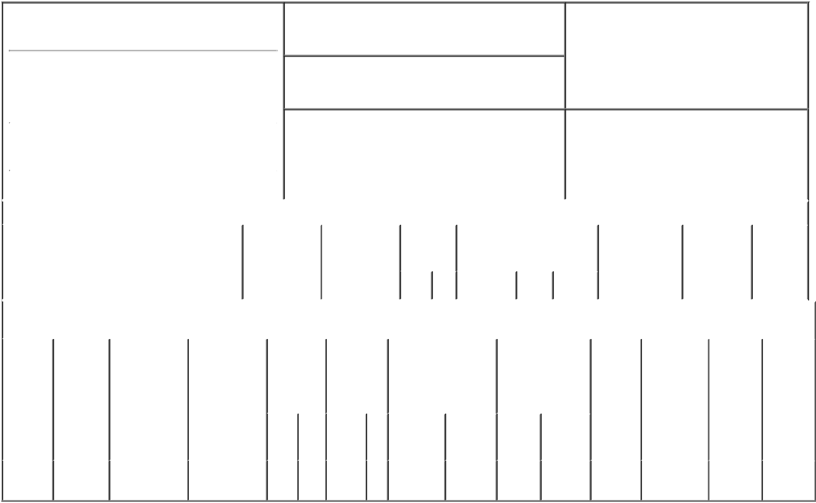

1. Name and Address of Reporting Person*
Beitler Bradley D.

(Last) (First) (Middle)

C/O TECHNIPFMC PLC

ONE ST. PAUL'S CHURCHYARD

2. Issuer Name and Ticker or Trading Symbol

TechnipFMC plc [ FTI ]

3. Date of Earliest Transaction (Month/Day/Year)

10/27/2017

- Relationship of Reporting Person(s) to Issuer (Check all applicable)

 | Director | 10% Owner
X | Officer (give title | Other (specify
 | below) | below)

EVP, Technology and R&D

 |  |  |  |  |  |  |  | 4. If Amendment, Date of Original Filed (Month/Day/Year) |  |  |  |  |  |  |  | 6. Individual or Joint/Group Filing (Check Applicable
 | (Street) |  |  |  |  |  |  |  |  |  |  |  |  |  |  | Line)
 |  |  |  |  |  |  |  |  |  |  |  |  |  |  |  | X Form filed by One Reporting Person
 |  | LONDON |  | X0 |  | EC4M 8AP
 |  |  |  |  |  |  |  |  |  |  |  |  |  |  |  |  |  |  | Form filed by More than One Reporting
 |  |  |  |  |  |  |  |  |  |  |  |  |  |  |  |  |  |  | Person
 |  | (City) |  | (State) |  | (Zip)
 |  |  |  |  | Table I - Non-Derivative Securities Acquired, Disposed of, or Beneficially Owned
 | 1. Title of Security (Instr. 3) |  |  |  |  | 2. Transaction |  |  | 2A. Deemed |  | 3. |  |  | 4. Securities Acquired (A) or |  |  |  |  | 5. Amount of |  | 6. Ownership |  | 7. Nature of
 |  |  |  |  |  | Date |  |  | Execution Date, |  |  | Transaction |  | Disposed Of (D) (Instr. 3, 4 and |  |  |  |  | Securities |  | Form: Direct |  | Indirect
 |  |  |  |  |  | (Month/Day/Year) |  |  | if any |  |  | Code (Instr. |  | 5) |  |  |  |  | Beneficially |  | (D) or Indirect |  | Beneficial
 |  |  |  |  |  |  |  |  | (Month/Day/Year) 8) |  |  |  |  |  |  |  |  |  | Owned Following |  | (I) (Instr. 4) |  | Ownership
 |  |  |  |  |  |  |  |  |  |  |  |  |  |  |  |  |  |  | Reported |  |  |  | (Instr. 4)
 |  |  |  |  |  |  |  |  |  |  |  | Code V |  | Amount | (A) or | Price |  |  | Transaction(s)
 |  |  |  |  |  |  |  |  |  |  |  |  |  |  | (D) |  |  |  | (Instr. 3 and 4)
 |  |  |  |  |  | Table II - Derivative Securities Acquired, Disposed of, or Beneficially Owned
 |  |  |  |  |  | (e.g., puts, calls, warrants, options, convertible securities)
 | 1. Title of |  | 2. |  | 3. Transaction | 3A. Deemed | 4. |  | 5. Number of |  | 6. Date Exercisable and |  |  |  | 7. Title and Amount |  |  | 8. Price of |  | 9. Number of |  | 10. | 11. Nature
 | Derivative |  | Conversion |  | Date | Execution Date, | Transaction |  | Derivative |  | Expiration Date |  |  |  | of Securities |  |  | Derivative |  | derivative |  | Ownership of Indirect
 | Security |  | or Exercise |  | (Month/Day/Year) | if any | Code (Instr. |  | Securities |  | (Month/Day/Year) |  |  |  | Underlying |  |  | Security |  | Securities |  | Form: | Beneficial
 | (Instr. 3) |  | Price of |  |  | (Month/Day/Year) | 8) |  | Acquired (A) |  |  |  |  |  | Derivative Security |  |  | (Instr. 5) |  | Beneficially |  | Direct (D) | Ownership
 |  |  | Derivative |  |  |  |  |  | or Disposed |  |  |  |  |  | (Instr. 3 and 4) |  |  |  |  | Owned |  | or Indirect | (Instr. 4)
 |  |  | Security |  |  |  |  |  | of (D) (Instr. |  |  |  |  |  |  |  |  |  |  | Following |  | (I) (Instr. 4)
 |  |  |  |  |  |  |  |  | 3, 4 and 5) |  |  |  |  |  |  |  |  |  |  | Reported
 |  |  |  |  |  |  |  |  |  |  |  |  |  |  |  |  |  |  |  | Transaction(s)
 |  |  |  |  |  |  |  |  |  |  |  |  |  |  |  | Amount |  |  |  | (Instr. 4)
 |  |  |  |  |  |  |  |  |  |  |  |  |  |  |  | or
 |  |  |  |  |  |  |  |  |  |  | Date |  | Expiration |  |  | Number
 |  |  |  |  |  |  | Code V |  | (A) | (D) | Exercisable |  | Date |  | Title | of Shares
 | Phantom |  | (1) |  |  |  |  |  |  |  | (2) |  |  | (2) | Ordinary | 141.433
 | Stock |  |  |  | 10/27/2017 |  |  | A | 141.433 |  |  |  |  |  |  |  |  | $13.92 |  | 25,106.401 |  | D
 |  |  |  |  |  |  |  |  |  |  |  |  |  |  | Shares⁽³⁾
 | Units

Explanation of Responses:

- N/A

- Phantom Stock Units are payable in cash following termination or retirement of the reporting person's employment with TechnipFMC, or death.

- A participant's interest in the NQ Plan is represented in units (referred to as Phantom Stock Units) which consist of phantom shares of TechnipFMC Ordinary Shares and uninvested cash balances held by the NQ Plan for administrative convenience.

Remarks:

/s/ Lisa P. Wang, Attorney-In- |  |  | 10/31/2017
Fact
** Signature of Reporting Person |  |  | Date

Reminder: Report on a separate line for each class of securities beneficially owned directly or indirectly.

* If the form is filed by more than one reporting person, see Instruction 4 (b)(v).

- Intentional misstatements or omissions of facts constitute Federal Criminal Violations See 18 U.S.C. 1001 and 15 U.S.C. 78ff(a). Note: File three copies of this Form, one of which must be manually signed. If space is insufficient, see Instruction 6 for procedure.
Persons who respond to the collection of information contained in this form are not required to respond unless the form displays a currently valid OMB Number.

