SEC Form 4

FORM 4

Check this box if no longer subject to Section 16. Form 4 or Form 5 obligations may continue. See Instruction 1(b).

UNITED STATES SECURITIES AND EXCHANGE COMMISSION
Washington, D.C. 20549
 |  | OMB APPROVAL
STATEMENT OF CHANGES IN BENEFICIAL OWNERSHIP
 |  | OMB Number: | 3235-0287
 |  | Estimated average burden
Filed pursuant to Section 16(a) of the Securities Exchange Act of 1934 |  | hours per response: | 0.5
or Section 30(h) of the Investment Company Act of 1940
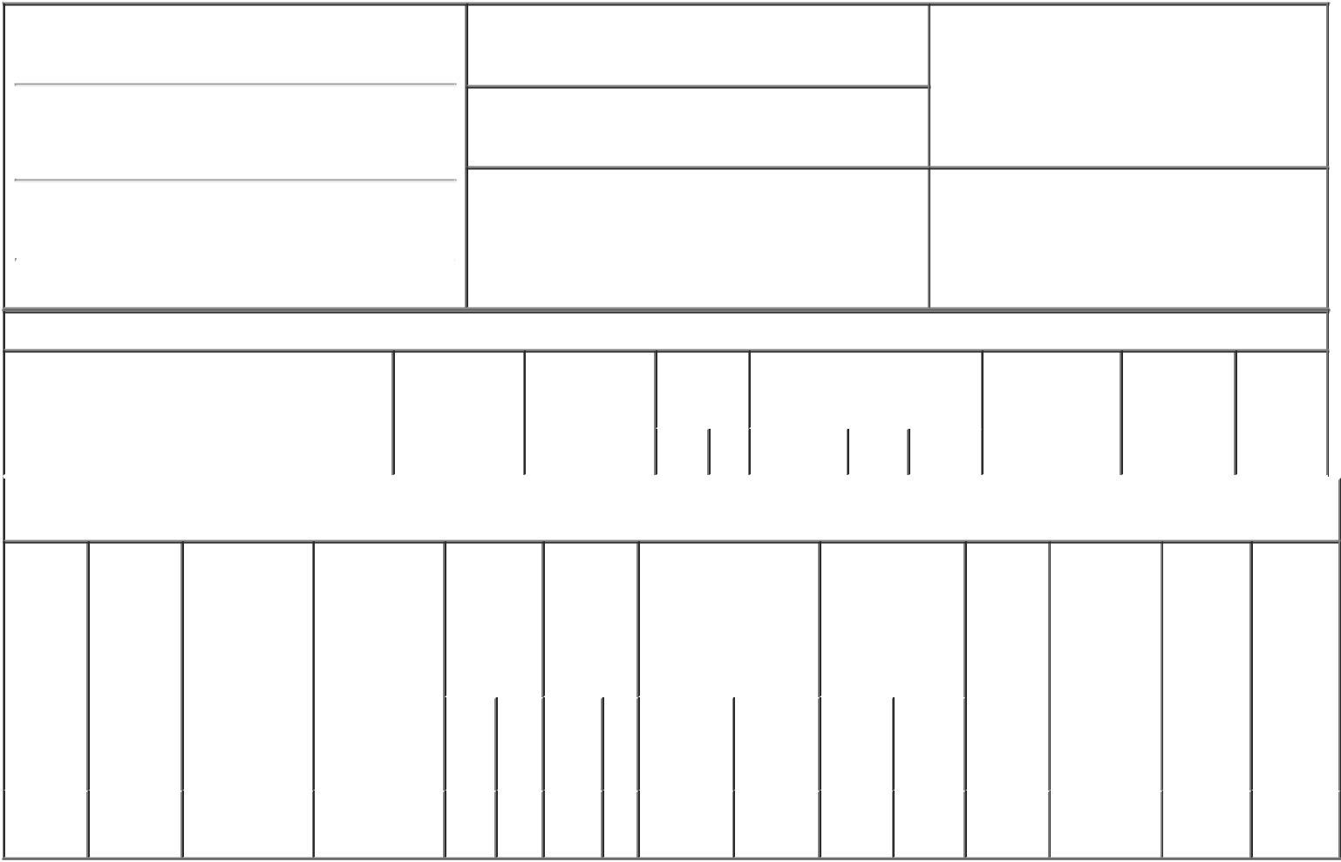

1. Name and Address of Reporting Person*
Beitler Bradley D.

(Last) (First) (Middle)

ONE ST. PAUL'S CHURCHYARD

2. Issuer Name and Ticker or Trading Symbol

TechnipFMC plc [ FTI ]

3. Date of Earliest Transaction (Month/Day/Year)

01/19/2017

- Relationship of Reporting Person(s) to Issuer (Check all applicable)

 | Director | 10% Owner
X | Officer (give title | Other (specify
 | below) | below)

EVP, Technology and R&D

(Street)
 | LONDON | X0 | EC4M 8AP
 | (City) | (State) | (Zip)

4. If Amendment, Date of Original Filed (Month/Day/Year) 6. Individual or Joint/Group Filing (Check Applicable
Line)
X Form filed by One Reporting Person

Form filed by More than One Reporting
Person

Table I - Non-Derivative Securities Acquired, Disposed of, or Beneficially Owned

 | 1. Title of Security (Instr. 3) | 2. Transaction | 2A. Deemed | 3. | 4. Securities Acquired (A) or |  |  | 5. Amount of | 6. Ownership | 7. Nature
 |  | Date | Execution Date, | Transaction | Disposed Of (D) (Instr. 3, 4 and |  |  | Securities | Form: Direct | of Indirect
 |  | (Month/Day/Year) | if any | Code (Instr. | 5) |  |  | Beneficially | (D) or Indirect | Beneficial
 |  |  | (Month/Day/Year) | 8) |  |  |  | Owned Following | (I) (Instr. 4) | Ownership
 |  |  |  |  |  |  |  | Reported |  | (Instr. 4)
 |  |  |  | Code V | Amount | (A) or | Price | Transaction(s)
 |  |  |  |  |  | (D) |  | (Instr. 3 and 4)

Table II - Derivative Securities Acquired, Disposed of, or Beneficially Owned

(e.g., puts, calls, warrants, options, convertible securities)

1. Title of | 2. | 3. Transaction | 3A. Deemed | 4. | 5. Number |  | 6. Date Exercisable and |  | 7. Title and |  | 8. Price of | 9. Number of | 10. | 11. Nature
Derivative | Conversion | Date | Execution Date, | Transaction | of |  | Expiration Date |  | Amount of |  | Derivative | derivative | Ownership | of Indirect
Security | or Exercise | (Month/Day/Year) | if any | Code (Instr. | Derivative |  | (Month/Day/Year) |  | Securities |  | Security | Securities | Form: | Beneficial
(Instr. 3) | Price of |  | (Month/Day/Year) | 8) | Securities |  |  |  | Underlying |  | (Instr. 5) | Beneficially | Direct (D) | Ownership
 | Derivative |  |  |  | Acquired |  |  |  | Derivative Security |  |  | Owned | or Indirect | (Instr. 4)
 | Security |  |  |  | (A) or |  |  |  | (Instr. 3 and 4) |  |  | Following | (I) (Instr. 4)
 |  |  |  |  | Disposed |  |  |  |  |  |  | Reported
 |  |  |  |  | of (D) (Instr. |  |  |  |  |  |  | Transaction(s)
 |  |  |  |  | 3, 4 and 5) |  |  |  |  |  |  | (Instr. 4)
 |  |  |  |  |  |  |  |  |  | Amount
 |  |  |  |  |  |  |  |  |  | or
 |  |  |  |  |  |  |  |  |  | Number
 |  |  |  |  |  |  | Date | Expiration |  | of
 |  |  |  | Code V | (A) | (D) | Exercisable | Date | Title | Shares

Phantom | (1) |  |  |  | (2) | (2) | Ordinary | 39.539
Stock |  | 01/19/2017 | A | 39.539 |  |  |  |  | $17.88 | 23,329.547 | D
 |  |  |  |  |  |  | Shares⁽³⁾
Units

Explanation of Responses:

- N/A

- Phantom Stock Units are payable in cash following termination or retirement of the reporting person's employment with TechnipFMC, or death.

- A participant's interest in the NQ Plan is represented in units (referred to as Phantom Stock Units) which consist of phantom shares of TechnipFMC Ordinary Shares and uninvested cash balances held by the NQ Plan for administrative convenience.

Remarks:

Lisa P. Wang, Attorney-In-Fact 01/23/2017

** Signature of Reporting Person Date

Reminder: Report on a separate line for each class of securities beneficially owned directly or indirectly.

* If the form is filed by more than one reporting person, see Instruction 4 (b)(v).

- Intentional misstatements or omissions of facts constitute Federal Criminal Violations See 18 U.S.C. 1001 and 15 U.S.C. 78ff(a). Note: File three copies of this Form, one of which must be manually signed. If space is insufficient, see Instruction 6 for procedure.
Persons who respond to the collection of information contained in this form are not required to respond unless the form displays a currently valid OMB Number.

