SEC Form 4

FORM 4

Check this box if no longer subject to Section 16. Form 4 or Form 5 obligations may continue. See Instruction 1(b).

UNITED STATES SECURITIES AND EXCHANGE COMMISSION
Washington, D.C. 20549
 |  | OMB APPROVAL
STATEMENT OF CHANGES IN BENEFICIAL OWNERSHIP
 |  | OMB Number: | 3235-0287
 |  | Estimated average burden
Filed pursuant to Section 16(a) of the Securities Exchange Act of 1934 |  | hours per response: | 0.5
or Section 30(h) of the Investment Company Act of 1940
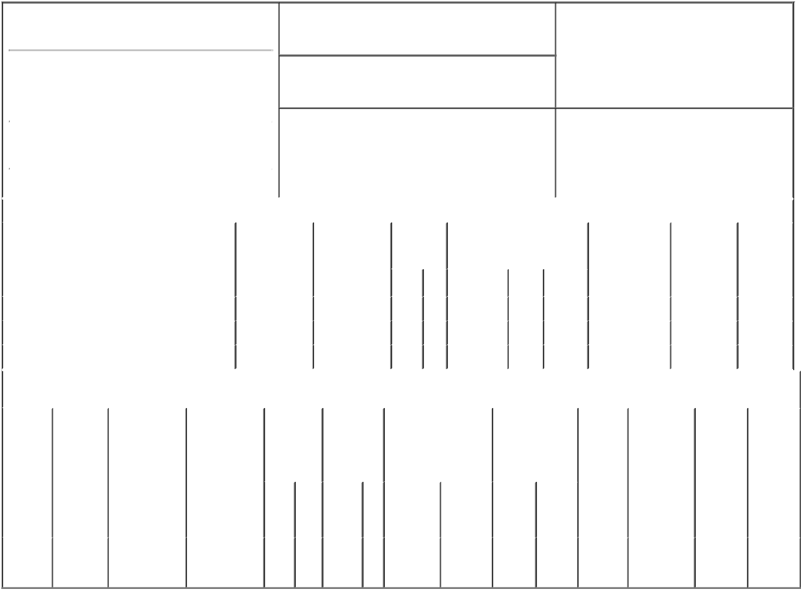

1. Name and Address of Reporting Person*
Hasselknippe Hallvard

(Last) (First) (Middle)

C/O TECHNIPFMC PLC

ONE ST. PAUL'S CHURCHYARD

2. Issuer Name and Ticker or Trading Symbol

TechnipFMC plc [ FTI ]

3. Date of Earliest Transaction (Month/Day/Year)

01/17/2017

- Relationship of Reporting Person(s) to Issuer (Check all applicable)

 | Director | 10% Owner
X | Officer (give title | Other (specify
 | below) | below)

President, Subsea

 |  |  |  |  |  |  |  | 4. If Amendment, Date of Original Filed (Month/Day/Year) |  |  |  |  |  |  |  | 6. Individual or Joint/Group Filing (Check Applicable
 | (Street) |  |  |  |  |  |  |  |  |  |  |  |  |  |  | Line)
 |  |  |  |  |  |  |  |  |  |  |  |  |  |  |  |  | X Form filed by One Reporting Person
 |  | LONDON |  | X0 |  | EC4M 8AP
 |  |  |  |  |  |  |  |  |  |  |  |  |  |  |  |  |  |  | Form filed by More than One Reporting
 |  |  |  |  |  |  |  |  |  |  |  |  |  |  |  |  |  |  | Person
 |  | (City) |  | (State) |  | (Zip)
 |  |  |  |  | Table I - Non-Derivative Securities Acquired, Disposed of, or Beneficially Owned
 | 1. Title of Security (Instr. 3) |  |  |  |  | 2. Transaction |  |  | 2A. Deemed |  | 3. |  | 4. Securities Acquired (A) or |  |  |  |  |  | 5. Amount of |  | 6. Ownership |  | 7. Nature of
 |  |  |  |  |  | Date |  |  | Execution Date, |  |  | Transaction | Disposed Of (D) (Instr. 3, 4 and 5) Securities |  |  |  |  |  |  |  | Form: Direct |  | Indirect
 |  |  |  |  |  | (Month/Day/Year) |  |  | if any |  |  | Code (Instr. |  |  |  |  |  |  | Beneficially |  | (D) or Indirect |  | Beneficial
 |  |  |  |  |  |  |  |  | (Month/Day/Year) |  | 8) |  |  |  |  |  |  |  | Owned Following |  | (I) (Instr. 4) |  | Ownership
 |  |  |  |  |  |  |  |  |  |  |  |  |  |  |  |  |  |  | Reported |  |  |  | (Instr. 4)
 |  |  |  |  |  |  |  |  |  |  |  | Code V | Amount |  | (A) or | Price |  |  | Transaction(s)
 |  |  |  |  |  |  |  |  |  |  |  |  |  |  | (D) |  |  |  | (Instr. 3 and 4)
 | Ordinary Shares |  |  |  |  | 01/17/2017 |  |  |  |  |  | A | 13,600⁽¹⁾ |  | A | $0 | 30,710 |  |  |  |  | D
 | Ordinary Shares |  |  |  |  | 04/24/2017 |  |  |  |  |  | A | 8,600⁽²⁾ |  | A | $0 | 47,045⁽³⁾ |  |  |  |  | D
 | Ordinary Shares |  |  |  |  | 02/19/2018 |  |  |  |  |  | A | 12,800⁽⁴⁾ |  | A | $0 | 59,845 |  |  |  |  | D
 |  |  |  |  |  | Table II - Derivative Securities Acquired, Disposed of, or Beneficially Owned
 |  |  |  |  |  | (e.g., puts, calls, warrants, options, convertible securities)
 | 1. Title of |  | 2. |  | 3. Transaction | 3A. Deemed | 4. |  | 5. Number of |  | 6. Date Exercisable and |  |  | 7. Title and |  |  |  | 8. Price of |  | 9. Number of |  | 10. | 11. Nature
 | Derivative |  | Conversion |  | Date | Execution Date, | Transaction |  | Derivative |  | Expiration Date |  |  | Amount of |  |  |  | Derivative |  | derivative |  | Ownership of Indirect
 | Security |  | or Exercise |  | (Month/Day/Year) | if any | Code (Instr. |  | Securities |  | (Month/Day/Year) |  |  | Securities |  |  |  | Security |  | Securities |  | Form: | Beneficial
 | (Instr. 3) |  | Price of |  |  | (Month/Day/Year) | 8) |  | Acquired (A) |  |  |  |  | Underlying |  |  |  | (Instr. 5) |  | Beneficially |  | Direct (D) | Ownership
 |  |  | Derivative |  |  |  |  |  | or Disposed |  |  |  |  | Derivative Security |  |  |  |  |  | Owned |  | or Indirect | (Instr. 4)
 |  |  | Security |  |  |  |  |  | of (D) (Instr. |  |  |  |  | (Instr. 3 and 4) |  |  |  |  |  | Following |  | (I) (Instr. 4)
 |  |  |  |  |  |  |  |  | 3, 4 and 5) |  |  |  |  |  |  |  |  |  |  | Reported
 |  |  |  |  |  |  |  |  |  |  |  |  |  |  |  |  |  |  |  | Transaction(s)
 |  |  |  |  |  |  |  |  |  |  |  |  |  |  |  | Amount |  |  |  | (Instr. 4)
 |  |  |  |  |  |  |  |  |  |  |  |  |  |  |  | or
 |  |  |  |  |  |  |  |  |  |  |  |  |  |  |  | Number
 |  |  |  |  |  |  |  |  |  |  | Date |  | Expiration |  |  | of
 |  |  |  |  |  |  | Code V |  | (A) | (D) | Exercisable |  | Date | Title |  | Shares
 | Stock
 | Option |  | (5) |  | 01/17/2017 |  |  | A | 4,528⁽⁶⁾ |  | 01/10/2018 |  | 01/10/2022 | Ordinary |  | 4,528 | $0 |  |  | 4,528 |  | D
 | (Right to |  |  |  |  |  |  |  |  |  |  |  |  |  | Shares
Buy)

Explanation of Responses:

- Includes 4,000 restricted stock units that vested on June 14, 2017 (as previously reported on the Form 4 filed by the Reporting Person on June 14, 2017) and 9,600 restricted stock units that vested on January 10, 2018.

- Grant of restricted stock units, each of which represents a contingent right to receive one Ordinary Shares, that will vest on December 10, 2018.

- Includes 7,735 restricted stock units previously reported on the Form 4 filed by the Reporting Person on March 2, 2017.

- Grant of restricted stock units, each of which represents a contingent right to receive one Ordinary Share, that will vest on September 7, 2019.

- The option is fully vested and immediately exercisable at an exercise price of 34.24EUR per Ordinary Share.

- On January 17, 2017, the Reporting Person was granted an option to purchase 4,800 Ordinary Shares at a price of 34.24EUR per Ordinary Share. The vesting of the option was subject to certain performance criteria that were partially met, resulting in the vesting of the option as to 4,528 Ordinary Shares.

Remarks:

/s/ Lisa P. Wang, Attorney-In- |  |  | 02/21/2018
Fact
** Signature of Reporting Person |  |  | Date

Reminder: Report on a separate line for each class of securities beneficially owned directly or indirectly.

* If the form is filed by more than one reporting person, see Instruction 4 (b)(v).

- Intentional misstatements or omissions of facts constitute Federal Criminal Violations See 18 U.S.C. 1001 and 15 U.S.C. 78ff(a). Note: File three copies of this Form, one of which must be manually signed. If space is insufficient, see Instruction 6 for procedure.
Persons who respond to the collection of information contained in this form are not required to respond unless the form displays a currently valid OMB Number.

