SEC Form 4

FORM 4

Check this box if no longer subject to Section 16. Form 4 or Form 5 obligations may continue. See Instruction 1(b).

UNITED STATES SECURITIES AND EXCHANGE COMMISSION
Washington, D.C. 20549
 |  | OMB APPROVAL
STATEMENT OF CHANGES IN BENEFICIAL OWNERSHIP
 |  | OMB Number: | 3235-0287
 |  | Estimated average burden
Filed pursuant to Section 16(a) of the Securities Exchange Act of 1934 |  | hours per response: | 0.5
or Section 30(h) of the Investment Company Act of 1940
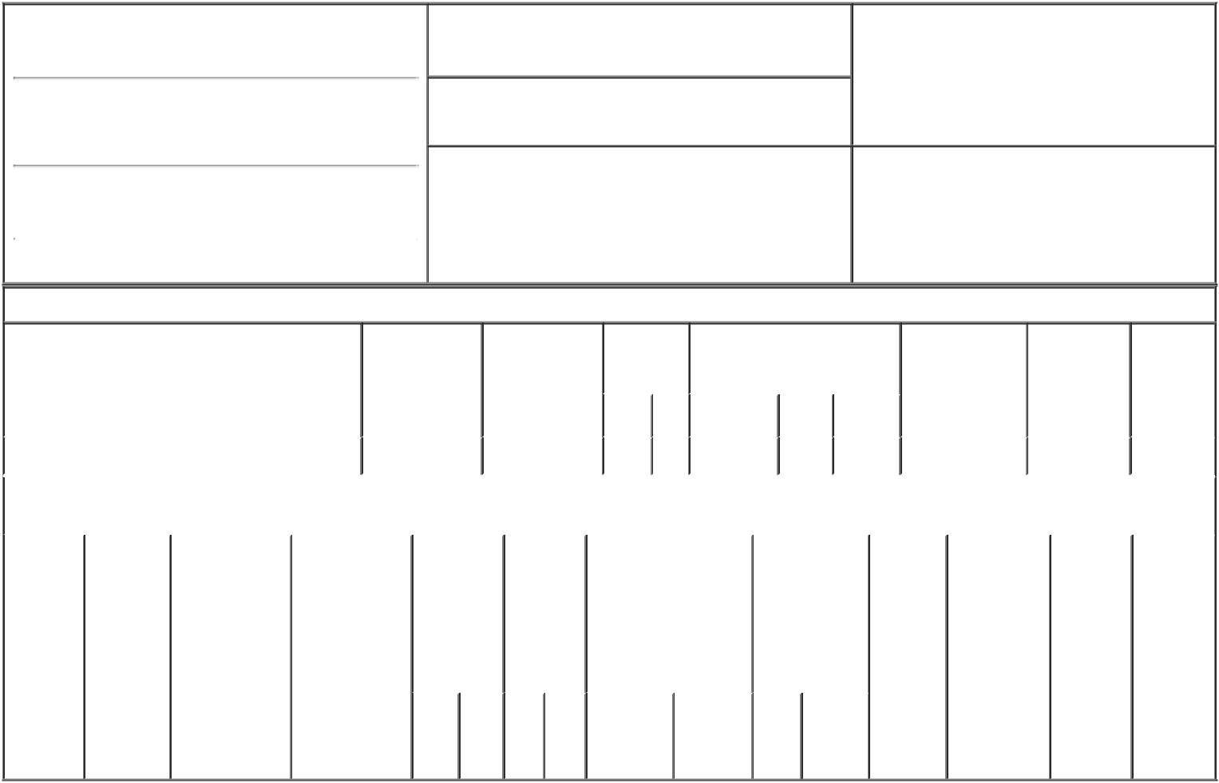

1. Name and Address of Reporting Person*
Colombani Pascal

(Last) (First) (Middle)

ONE ST. PAUL'S CHURCHYARD

2. Issuer Name and Ticker or Trading Symbol

TechnipFMC plc [ FTI ]

3. Date of Earliest Transaction (Month/Day/Year)

01/17/2017

- Relationship of Reporting Person(s) to Issuer (Check all applicable)
X Director 10% Owner

Officer (give title Other (specify
below) below)

(Street)
 | LONDON | X0 | EC4M 8AP
 | (City) | (State) | (Zip)

4. If Amendment, Date of Original Filed (Month/Day/Year) 6. Individual or Joint/Group Filing (Check Applicable
Line)
X Form filed by One Reporting Person

Form filed by More than One Reporting
Person

Table I - Non-Derivative Securities Acquired, Disposed of, or Beneficially Owned

 | 1. Title of Security (Instr. 3) |  |  | 2. Transaction |  | 2A. Deemed |  | 3. |  |  | 4. Securities Acquired (A) or |  |  |  |  |  | 5. Amount of |  | 6. Ownership | 7. Nature
 |  |  |  | Date |  | Execution Date, |  |  | Transaction |  | Disposed Of (D) (Instr. 3, 4 and Securities |  |  |  |  |  |  |  | Form: Direct | of Indirect
 |  |  |  | (Month/Day/Year) |  | if any |  |  | Code (Instr. |  | 5) |  |  |  |  |  | Beneficially |  | (D) or Indirect | Beneficial
 |  |  |  |  |  | (Month/Day/Year) 8) |  |  |  |  |  |  |  |  |  |  | Owned Following |  | (I) (Instr. 4) | Ownership
 |  |  |  |  |  |  |  |  |  |  |  |  |  |  |  |  | Reported |  |  | (Instr. 4)
 |  |  |  |  |  |  |  |  | Code V |  | Amount | (A) or | Price |  |  |  | Transaction(s)
 |  |  |  |  |  |  |  |  |  |  |  | (D) |  |  |  |  | (Instr. 3 and 4)
 | Ordinary Shares |  |  | 01/17/2017 |  |  |  |  | A |  | 820 | A |  | (1) |  |  |  | 820 | D
 |  |  | Table II - Derivative Securities Acquired, Disposed of, or Beneficially Owned
 |  |  |  | (e.g., puts, calls, warrants, options, convertible securities)
 | 1. Title of | 2. | 3. Transaction | 3A. Deemed | 4. |  | 5. Number | 6. Date Exercisable and |  |  |  | 7. Title and |  |  |  | 8. Price of |  | 9. Number of | 10. | 11. Nature
 | Derivative | Conversion | Date | Execution Date, | Transaction |  | of | Expiration Date |  |  |  | Amount of |  |  |  | Derivative |  | derivative | Ownership | of Indirect
 | Security | or Exercise | (Month/Day/Year) | if any | Code (Instr. |  | Derivative | (Month/Day/Year) |  |  |  | Securities |  |  |  | Security |  | Securities | Form: | Beneficial
 | (Instr. 3) | Price of |  | (Month/Day/Year) | 8) |  | Securities |  |  |  |  | Underlying |  |  |  | (Instr. 5) |  | Beneficially | Direct (D) | Ownership
 |  | Derivative |  |  |  |  | Acquired |  |  |  |  | Derivative |  |  |  |  |  | Owned | or Indirect | (Instr. 4)
 |  | Security |  |  |  |  | (A) or |  |  |  |  | Security (Instr. 3 |  |  |  |  |  | Following | (I) (Instr. 4)
 |  |  |  |  |  |  | Disposed |  |  |  |  | and 4) |  |  |  |  |  | Reported
 |  |  |  |  |  |  | of (D) |  |  |  |  |  |  |  |  |  |  | Transaction(s)
 |  |  |  |  |  |  | (Instr. 3, 4 |  |  |  |  |  |  |  |  |  |  | (Instr. 4)
 |  |  |  |  |  |  | and 5)
 |  |  |  |  |  |  |  |  |  |  |  | Amount
 |  |  |  |  |  |  |  |  |  |  |  | or
 |  |  |  |  |  |  |  |  |  |  |  | Number
 |  |  |  |  |  |  |  | Date |  | Expiration |  | of
 |  |  |  |  | Code V |  | (A) (D) | Exercisable |  | Date |  | Title Shares

Explanation of Responses:

- Pursuant to the Business Combination Agreement, dated as of June 14, 2016 (the "BCA") by and among the Issuer, FMC Technologies, Inc. ("FMCTI") and Technip S.A. ("Technip"), each ordinary share of Technip beneficially owned by the Reporting Person at the effective time of the transactions contemplated by the BCA (the "Effective Time") was exchanged for 2.00 ordinary shares of the Issuer (the "Exchange Ratio").

Remarks:

Lisa P. Wang, Attorney-In-Fact 01/18/2017

** Signature of Reporting Person Date

Reminder: Report on a separate line for each class of securities beneficially owned directly or indirectly.

* If the form is filed by more than one reporting person, see Instruction 4 (b)(v).

- Intentional misstatements or omissions of facts constitute Federal Criminal Violations See 18 U.S.C. 1001 and 15 U.S.C. 78ff(a). Note: File three copies of this Form, one of which must be manually signed. If space is insufficient, see Instruction 6 for procedure.
Persons who respond to the collection of information contained in this form are not required to respond unless the form displays a currently valid OMB Number.

